Supplemental figure legends

Fig. S1 Antibody specificity verification. 1. COX IV. 2. Incubate only the secondary antibody. 3. Incubate only the primary antibody.

Fig. S2 Original image of Western blot. 1, 2. Mitochondrial. 3, 4. Cytoplasmic. The inner part of the black frame is the figure used in the manuscript, and the figure of COX IV is only folded horizontally in the manuscript.

Fig. S1

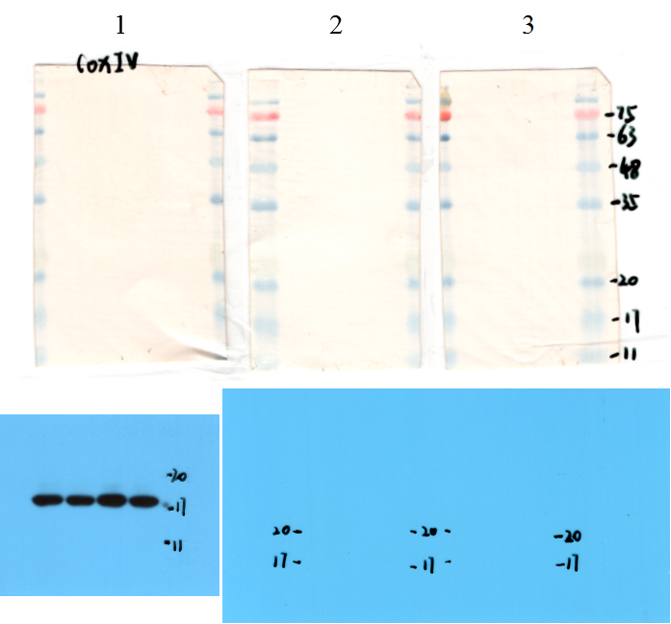

Fig. S2

