Supplementary figures
Figure S1. Flow chart
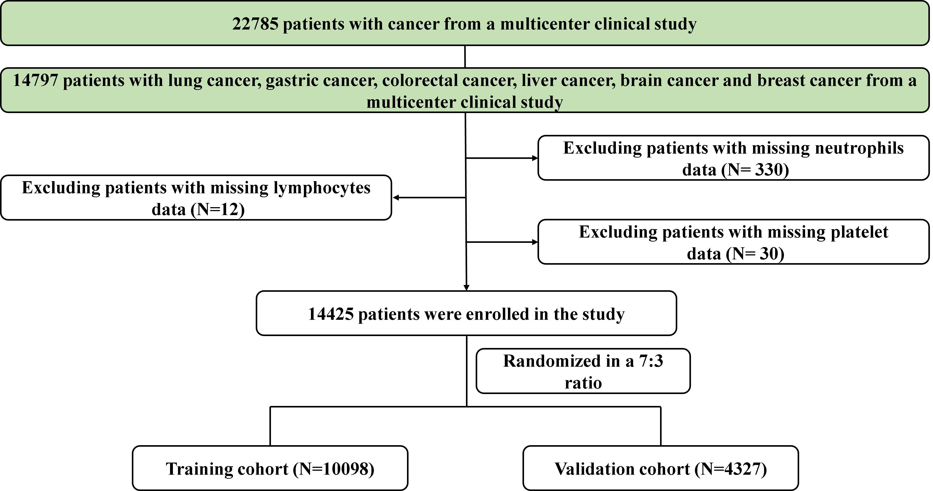

Figure S2. AUC comparison of traditional prognostic indicators.

Figure S3. The cutoff value of NLR index.

Figure S4. Survival curves of different tumor based on NLR index.

Figure S5. Log-hazard ratio of NLR in different cohorts.
Figure S6. Log-hazard ratio of NLR in different models.
Notes:
Model a: No adjusted.
Model b: Adjusted for age, gender, surgery, coronary heart disease, drinking, gender, family history, smoking, chemotherapy, radiotherapy, diabetes, hypertension.

Figure S7. Subgroup analysis of NLR prognostic value.
Notes: The model adjusted for age, gender, tumor types, surgery, radiotherapy, chemotherapy, hypertension, diabetes, smoking, drinking, family history.

Figure S8. Clinical utility and validation of the NLR model
Supplementary tables
Table S1. Inflammatory biomarkers evaluated in this study.
Biomarker name | Biomarker formulas
Neutrophil-to-Lymphocyte ratio (NLR) | Neutrophil (/µL) / lymphocyte (/µL)
Platelet-to-Lymphocyte Ratio (PLR) | Platelet (/µL) / Lymphocyte (/µL)
Systemic Immune-Inflammation Index (SII) | Platelet (/µL) × Neutrophil (/µL) / Lymphocyte (/µL)
Neutrophil-to-Platelet Ratio (NPR) | Neutrophil (/µL) / Platelet (/µL)
Platelet-to-Neutrophil Ratio (PNR) | Platelet (/µL) / Neutrophil (/µL)
Lymphocyte-to-Platelet Ratio (LPR) | Lymphocyte (/µL) / Platelet (/µL)

Table S2. Baseline clinicopathological characteristics.
Variable | Training cohort (n = 10098) | Validation cohort (n = 4327) | P  value
Gender, Male (%) | 5464 (54.1) | 2307 (53.3) | 0.391
Smoking, yes, n (%) | 4150 (41.1) | 1836 (42.4) | 0.141
Drinking, yes, n (%) | 1772 (17.5) | 802 (18.5) | 0.163
Chemotherapy, yes, n (%) | 5201 (51.5) | 2247 (51.9) | 0.653
Radiotherapy, yes, n (%) | 545 (5.4) | 258 (6.0) | 0.188
Diabetes, yes, n (%) | 872 (8.6) | 352 (8.1) | 0.339
Hypertension, yes, n (%) | 1849 (18.3) | 775 (17.9) | 0.585
Coronary disease, yes, n (%) | 406 (4.0) | 181 (4.2) | 0.684
Family history, yes, n (%) | 1492 (14.8) | 698 (16.1) | 0.040
Surgery, yes, n (%) | 2868 (28.4) | 1182 (27.3) | 0.191
Tumor type |  |  | 0.007
Lung cancer | 3455 (34.2) | 1534 (35.5)
Gastric cancer | 1648 (16.3) | 664 (15.3)
Colorectal cancer | 2561 (25.4) | 1017 (23.5)
Liver cancer | 502 (5.0) | 222 (5.1)
Brain cancer | 96 (1.0) | 63 (1.5)
Breast cancer | 1836 (18.2) | 827 (19.1)
Age, years, median (IQR) | 59.00(51.00, 66.00) | 58.00(50.00, 65.00) | 0.009
Neutrophils, 10^9/L, median (IQR) | 3.73(2.62, 5.40) | 3.75(2.60, 5.45) | 0.96
Lymphocyte, 10^9/L, median (IQR) | 1.49(1.08, 1.93) | 1.47(1.07, 1.93) | 0.376
PLT, 10^9/L, median (IQR) | 2.48(1.63, 4.09) | 2.51(1.64, 4.12) | 0.702
NLR (median (IQR)) | 150.36(106.67, 219.54) | 150.80(106.25, 216.94) | 0.737
PLR (median (IQR)) | 558.18(324.17, 984.40) | 554.09(324.82, 981.01) | 0.786
SII (median (IQR)) | 0.02(0.01, 0.02) | 0.02(0.01, 0.03) | 0.592
NPR (median (IQR)) | 58.64(40.20, 84.58) | 58.23(39.01, 85.69) | 0.592
PNR (median (IQR)) | 0.01(0.00, 0.01) | 0.01(0.00, 0.01) | 0.737
LPR (median (IQR)) | 2.48(1.63, 4.09) | 2.51(1.64, 4.12) | 0.702
Abbreviations: PLT, Platelet; NLR, Neutrophil-to-lymphocyte ratio; PLR, Platelet-to-lymphocyte ratio; SII, Systemic immune-inflammation index; NPR, Neutrophil-to-platelet ratio; PNR, Platelet-to-neutrophil ratio; LPR, Lymphocyte-to-platelet ratio.

Table S3. C-index values of NLR, SII, PLR, NPR, PNR and LPR in overall cohort.
Brain cancer
 | c-index | lower.95 | upper.95
NLR | 0.594 | 0.528 | 0.660
PNR | 0.575 | 0.506 | 0.643
PLR | 0.556 | 0.486 | 0.627
LPR | 0.556 | 0.486 | 0.627
SII | 0.426 | 0.356 | 0.496
NPR | 0.425 | 0.357 | 0.494
Breast cancer
 | c-index | lower.95 | upper.95
NLR | 0.535 | 0.501 | 0.568
PLR | 0.522 | 0.487 | 0.557
NPR | 0.520 | 0.487 | 0.554
PNR | 0.520 | 0.487 | 0.554
SII | 0.490 | 0.455 | 0.525
LPR | 0.478 | 0.443 | 0.513
Colorectal cancer
 | c-index | lower.95 | upper.95
NLR | 0.595 | 0.577 | 0.614
SII | 0.587 | 0.568 | 0.606
PLR | 0.562 | 0.542 | 0.581
LPR | 0.562 | 0.542 | 0.581
NPR | 0.554 | 0.534 | 0.573
PNR | 0.554 | 0.534 | 0.573
Gastric cancer
 | c-index | lower.95 | upper.95
NLR | 0.561 | 0.542 | 0.580
SII | 0.553 | 0.534 | 0.572
NPR | 0.540 | 0.521 | 0.559
PNR | 0.540 | 0.521 | 0.559
LPR | 0.538 | 0.519 | 0.557
PLR | 0.462 | 0.443 | 0.481
Liver cancer
 | c-index | lower.95 | upper.95
NLR | 0.633 | 0.603 | 0.663
SII | 0.619 | 0.588 | 0.650
PLR | 0.612 | 0.580 | 0.645
NPR | 0.549 | 0.517 | 0.582
PNR | 0.549 | 0.517 | 0.582
LPR | 0.388 | 0.355 | 0.420
Lung cancer
 | c-index | lower.95 | upper.95
NLR | 0.600 | 0.587 | 0.612
SII | 0.585 | 0.573 | 0.598
PLR | 0.562 | 0.550 | 0.575
NPR | 0.555 | 0.542 | 0.567
PNR | 0.555 | 0.542 | 0.567
LPR | 0.438 | 0.425 | 0.450

Table S4. C-index values of NLR, SII, PLR, NPR, PNR and LPR in different cohorts.
 | Overall cohort |  |  |  | Training cohort |  |  |  | Validation cohort
 | c-index | lower.95 | upper.95 |  | c-index | lower.95 | upper.95 |  | c-index | lower.95 | upper.95
NLR | 0.606 | 0.598 | 0.614 | NLR | 0.607 | 0.597 | 0.617 | NLR | 0.603 | 0.588 | 0.618
SII | 0.585 | 0.577 | 0.594 | SII | 0.589 | 0.579 | 0.599 | SII | 0.576 | 0.561 | 0.592
NPR | 0.567 | 0.559 | 0.576 | NPR | 0.566 | 0.556 | 0.576 | NPR | 0.570 | 0.555 | 0.585
PNR | 0.567 | 0.559 | 0.576 | PNR | 0.566 | 0.556 | 0.576 | PNR | 0.570 | 0.555 | 0.585
PLR | 0.558 | 0.550 | 0.566 | PLR | 0.562 | 0.552 | 0.572 | PLR | 0.549 | 0.533 | 0.564
LPR | 0.442 | 0.434 | 0.450 | LPR | 0.562 | 0.552 | 0.572 | LPR | 0.451 | 0.436 | 0.467

