Supplementary Material for
KAN-Enhanced Contrastive Learning Accelerating Crystal Structure Identification from XRD Patterns
Chenlei Xu^{a,1}, Tianhao Su^{a,1}, Jie Xiong^{a,d}*, Yue Wuª, Shuya Dong ª, Tian Jiangª,
Mengwei He^{b, c}*, Shuai Chen^{a,d}, Tong-Yi Zhang^{a,e}*
ª Materials Genome Institute, Shanghai University, Shanghai 200444 China
^{b} Australian Centre for Microscopy and Microanalysis, School of Aerospace, Mechanical and Mechatronic Engineering, The University of Sydney, Sydney, New South Wales, Australia
^{c} School of Computer Science, The University of Sydney, Sydney, New South Wales, Australia
^{d} State Key Laboratory of Materials for Advanced Nuclear Energy, Shanghai University, Shanghai 20044, PR China
^{e} Guangzhou Municipal Key Laboratory of Materials Informatics, Hong Kong University of Science and Technology (Guangzhou), Guangzhou 511400, China
¹ These authors contributed equally to this work and should be considered co-first authors.
E-mail: xiongjie@shu.edu.cn (J. Xiong), mengwei.he@sydney.edu.au (M. He), zhangty@shu.edu.cn (T.-Y. Zhang)

Content
S1. Architecture details of the XRD encoder
S2. Distribution of peak intensities in different angular range​
S3. Details of Simulated BCC MPEA
S4. Baseline architectures for space-group identification

S1. Architecture details of the XRD encoder
S1.1 ResNet backbone within the DEN-KAN encoder
The DEN-KAN XRD encoder employs a modified one-dimensional ResNet for hierarchical feature extraction from raw X-ray diffraction (XRD) spectra. The backbone uses depth-wise separable convolutions and residual connections to improve parameter efficiency while preserving representational capacity. In DEN-KAN, the low-angle (LA, 0 < 2θ ≤ 10) path and high-angle (HA, 10 < 2θ ≤ 80) path process different 2θ regions. XRD spectra are processed through 17 convolutional layers, each equipped with batch normalization and ReLU activation. To accommodate dense peak spacing at higher angles, the HA path inserts a max-pooling layer (kernel 1 × 3, stride 2) after each residual layer to enlarge the receptive field.
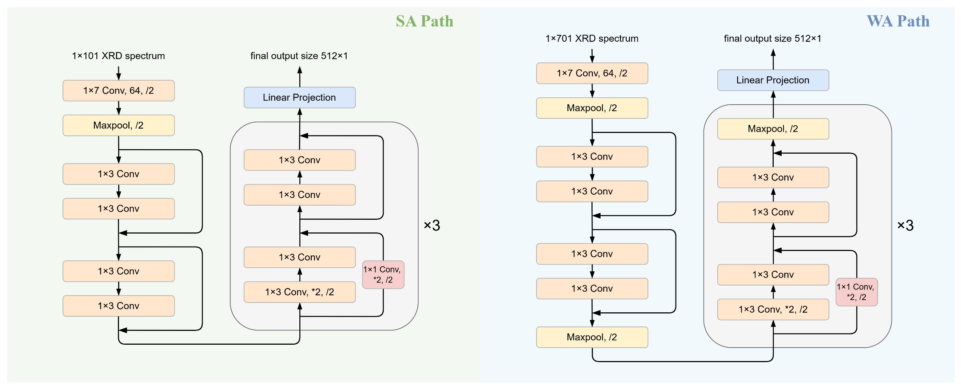
​​Fig. S1. Schematic of the ResNet backbone used in the (a) small-angle (SA) and (b) wide-angle (WA) path of DEN-KAN encoder.

S1.2 WA-KAN XRD encoder
We also consider a single-path encoder that feeds a ResNet backbone into a KAN projection head.
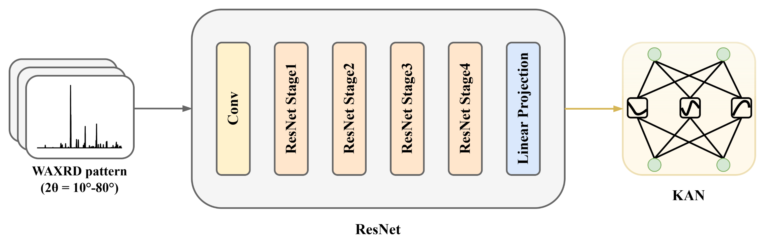
Fig. S2. Schematic diagram of the single-path WA-KAN encoder.

S2. Distribution of peak intensities in different angular range​
To quantify how diffraction intensity varies with scattering angle, we computed box-and-whisker statistics for all XRD spectra in our dataset over 0–80º 2θ range. The results show that, for this dataset, peak intensities within 0–10º are systematically lower than those at higher angles, reflecting weaker small-angle peaks and background characteristics common in laboratory XRD for crystalline materials.

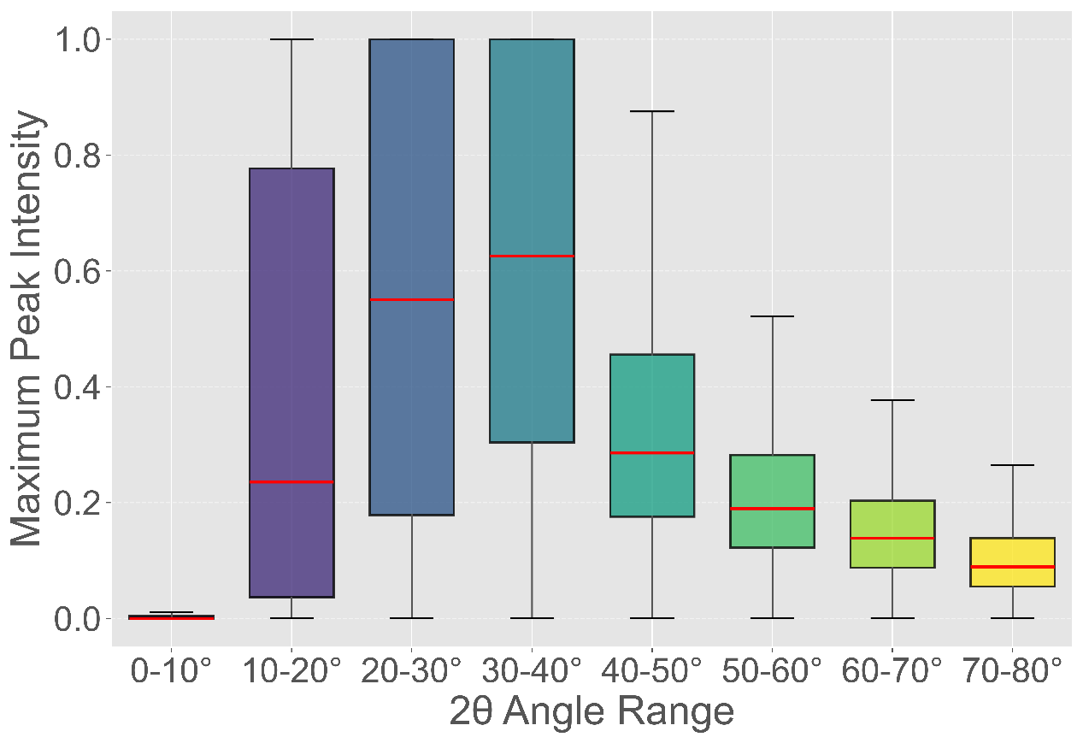
Fig. S3. Distribution of XRD peak intensities (a. u.) over Consecutive 10º intervals across 2θ = 0–80º

S3. Details of Simulated BCC MPEA
We simulated body-centered cubic (BCC) multi-principal element alloys (MPEAs) with compositions summarized in Table S1. Compositions are reported as atomic ratios (unnormalized) unless otherwise noted.
Table S1.​​ Compositions for the FeCrAl-based and TaNbMo-based MPEAs.
No. | Composition
1 | Fe₂₀Cr₁₀Al₂
2 | Fe₂₀Cr₇Al₁
3 | Fe₂₀Cr₈Al₂
4 | Fe₂₀Cr₉Al₃
5 | Fe₂₉Cr₁₂Al₇
6 | Fe₃₃Cr₁₃Al₈
7 | TaNbMo
8 | Ta₁₄Nb₈Mo₁₆W₁₆
9 | Ta₁₄Nb₁₄Mo₁₄Hf₁₂
10 | Ta₁₄Nb₁₄Mo₁₄V₁₂
11 | Ta₁₄Nb₁₄Mo₁₄Zr₁₂
12 | Ta₁₅Mo₁₆V₇W₁₆
13 | Ta₁₅Mo₁₆V₁₅W₈
14 | Ta₁₅Nb₈Mo₁₅V₁₆
15 | Ta₁₅Nb₁₅Mo₁₅Zr₉
16 | Ta₁₆Nb₁₅Mo₁₅V₈
17 | Ta₁₆Nb₁₅Mo₁₆W₇
18 | TaMoVW
19 | Ta₁₈Nb₁₈Mo₁₈Cr₁₈
20 | Ta₁₈Nb₁₈Mo₁₈V₁₈
21 | Ta₁₈Nb₁₈Mo₁₈W₁₈
22 | Ta₁₉Nb₁₉Mo₁₉Hf₁₅

​​S4. Baseline architectures for space-group identification
We benchmarked six baselines covering purely convolutional, transformer-based, and hybrid designs. All Conv1D layers are followed by normalization and ReLU activation unless stated.
- FCN: 10 sequential Conv1D layers, no attention or transformer modules.
- ViT: one Conv1D stem for initial feature extraction, tokenization into 1D patches of size 8, followed by a 6-layer, 8-head transformer encoder, a 3-layer MLP classifier.
- ResNet-MLP: a 17-layer ResNet (1 conv stem and 4 stages, 2 residual blocks per stage, 2 Conv1D layers per block) with a 3-layer MLP head.
- ResNet-MLP: same ResNet backbone as ResNet-MLP, the MLP head is replaced by a 3-layer KAN classifier.
- ResViT-MLP: the 17-layer ResNet backbone feeds a ViT operating on 1D-patches of size 2 (6 layers, 8 heads), classification via a 4-layer MLP head.
- ResViT-KAN: identical ResNet-plus-ViT configuration as ResViT-MLP, the head is replaced by 4 stacked KAN layers.

Table S2.​​ Baseline model configurations. Notation: Conv denotes a 1D convolutional layer with normalization and activation. Init is a convolutional stem. “S Stages × B Blocks” indicates a hierarchical ResNet with S stages and B residual blocks per stage. ViT (P, L, H) is a 1D vision transformer with patch size P, L transformer layers, and H attention heads. FC is a multilayer perceptron head, and KAN is a Kolmogorov-Arnold Network head.
Model | Architecture
FCN | ​10 Conv
ViT | 1 Conv (Init) + ViT (P=8, L=6, H=8) + 3 FC
ResNet-MLP | 17 Conv (Init + 4 Stages × 2 Blocks) + 3 FC
ResNet-KAN | 17 Conv (Init + 4 Stages × 2 Blocks) + 3 KAN
ResViT-MLP | 17 Conv (Init + 4 Stages×2 Blocks) + ​​ViT (P=2, L=6, H=8)​​ + 4 FC
ResViT-KAN | 17 Conv (Init + 4 Stages×2 Blocks) + ​​ViT (P=2, L=6, H=8)​​ + 4 KAN

