Supplementary information

Table S1: Top ten of upregulation and downregulation pathways across the three interfaces.
BCV interface
Upregulation pathway | basemean | log2FC | padj | Downregulation pathway | basemean | log2FC | Padj
glucose degradation (oxidative) | 4101.104 | 4.75626 | 3.05E-09 | p-cymene degradation | 217.4583 | -28.153 | 2.933604
ketogluconate metabolism | 5192.127 | 2.46243 | 7.06E-11 | p-cumate degradation | 217.4583 | -28.153 | 2.933604
CMP-legionaminate biosynthesis I | 5514.551 | 2.44556 | 4.70E-12 | &beta_-alanine biosynthesis II | 73.31401 | -4.6796 | 1.302527
L-arabinose degradation IV | 4700.789 | 2.35996 | 7.73E-05 | 3-hydroxypropanoate cycle | 59.15507 | -4.2442 | 1.624932
gallate degradation I | 4301.397 | 2.11214 | 2.73E-06 | chlorosalicylate degradation | 1182.164 | -4.2308 | 0.881622
syringate degradation | 7055.666 | 1.94694 | 0.040525 | glyoxylate assimilation | 55.16025 | -4.1605 | 1.622223
nitrate reduction I (denitrification) | 7867.676 | 1.83517 | 0.000199 | superpathway of the 3-hydroxypropanoate cycle | 77.58969 | -4.1356 | 1.651202
benzoyl-CoA degradation I (aerobic) | 2197.01 | 1.53535 | 0.014234 | phosphopantothenate biosynthesis III | 6.569433 | -3.5422 | 1.590346
gallate degradation II | 5797.803 | 1.51431 | 0.000133 | aerobactin biosynthesis | 168.8983 | -3.5284 | 0.753011
superpathway of &beta_-D-glucuronide and D-glucuronate degradation | 6735.027 | 1.4346 | 7.10E-08 | nicotinate degradation I | 519.9932 | -3.1834 | 0.554269
methylgallate degradation | 6471.186 | 1.3941 | 0.000199 | superpathway of L-arginine, putrescine, and 4-aminobutanoate degradation | 1080.342 | -3.0999 | 0.578128
Air interface
Upregulation pathway | basemean | log2FC | padj | Downregulation pathway | basemean | log2FC | padj
dTDP-6-deoxy-&alpha_-D-allose biosynthesis | 9.375411 | 23.3558 | 7.39E-13 | L-1,2-propanediol degradation | 1395.223 | -4.6365 | 0.01358
tylosin biosynthesis | 4.916882 | 22.4678 | 4.17E-12 | gallate degradation I | 1663.041 | -1.4903 | 0.02471
 |  |  |  | gallate degradation II | 1830.091 | -1.2236 | 0.04593
 |  |  |  | methylgallate degradation | 2245.798 | -1.2114 | 0.04593
Water interface
Upregulation pathway | basemean | log2FC | padj | Downregulation pathway | basemean | log2FC | padj
flavin biosynthesis II (archaea) | 168.9404 | 2.27112 | 3.62E-32 | L-valine degradation I | 355.1172 | -5.1075 | 1.71E-09
phosphopantothenate biosynthesis III | 107.9218 | 2.08838 | 5.00E-36 | pyruvate fermentation to butanoate | 3117.906 | -3.3652 | 0.000388
chorismate biosynthesis II (archaea) | 46.18544 | 2.07845 | 1.45E-33 | thiazole biosynthesis II (Bacillus) | 2220.335 | -3.213 | 0.000581
superpathway of mycolyl-arabinogalactan-peptidoglycan complex biosynthesis | 29.52024 | 2.93477 | 6.47E-16 | superpathway of Clostridium acetobutylicum acidogenic fermentation | 3402.996 | -3.1602 | 0.000819
mevalonate pathway II (archaea) | 57.2286 | 2.10451 | 1.28E-29 | creatinine degradation II | 1677.736 | -2.8257 | 0.034207
methanogenesis from H2 and CO2 | 12.55734 | 2.55837 | 2.39E-19 | creatinine degradation I | 2381.05 | -2.4794 | 0.001076
pyrimidine deoxyribonucleotides de novo biosynthesis IV | 105.7587 | 2.04795 | 2.99E-05 | purine nucleobases degradation I (anaerobic) | 7822.631 | -2.329 | 0.016281
superpathway of L-threonine metabolism | 46.76207 | 1.80223 | 1.16E-06 | nitrate reduction VI (assimilatory) | 1587.989 | -2.1716 | 0.000904
pyrimidine deoxyribonucleotides biosynthesis from CTP | 150.5273 | 1.92436 | 1.87E-05 | superpathway of thiamin diphosphate biosynthesis II | 4533.779 | -1.9515 | 0.018244
L-arabinose degradation IV | 3405.291 | 1.46711 | 2.52E-07 | catechol degradation to 2-oxopent-4-enoate II | 1582.978 | -1.8183 | 0.001004
mannosylglycerate biosynthesis I | 26.48699 | 2.06699 | 0.001791 | D-glucarate degradation I | 1177.454 | -1.5044 | 0.014439

Table S2: Uniaxial compressive strength of reference 15 cm - cubes (MPa).
Sample age (months) | 0.9 | 2.0 | 3.0 | 5.8 | 36 (T0) | 60 (T4)
Average value (MPa) | 47.6* | 50.8* | 52.3* | 53.5** | 64.5 | 54.4
*Pernicová et al., 2019; **Čítek et al., 2020
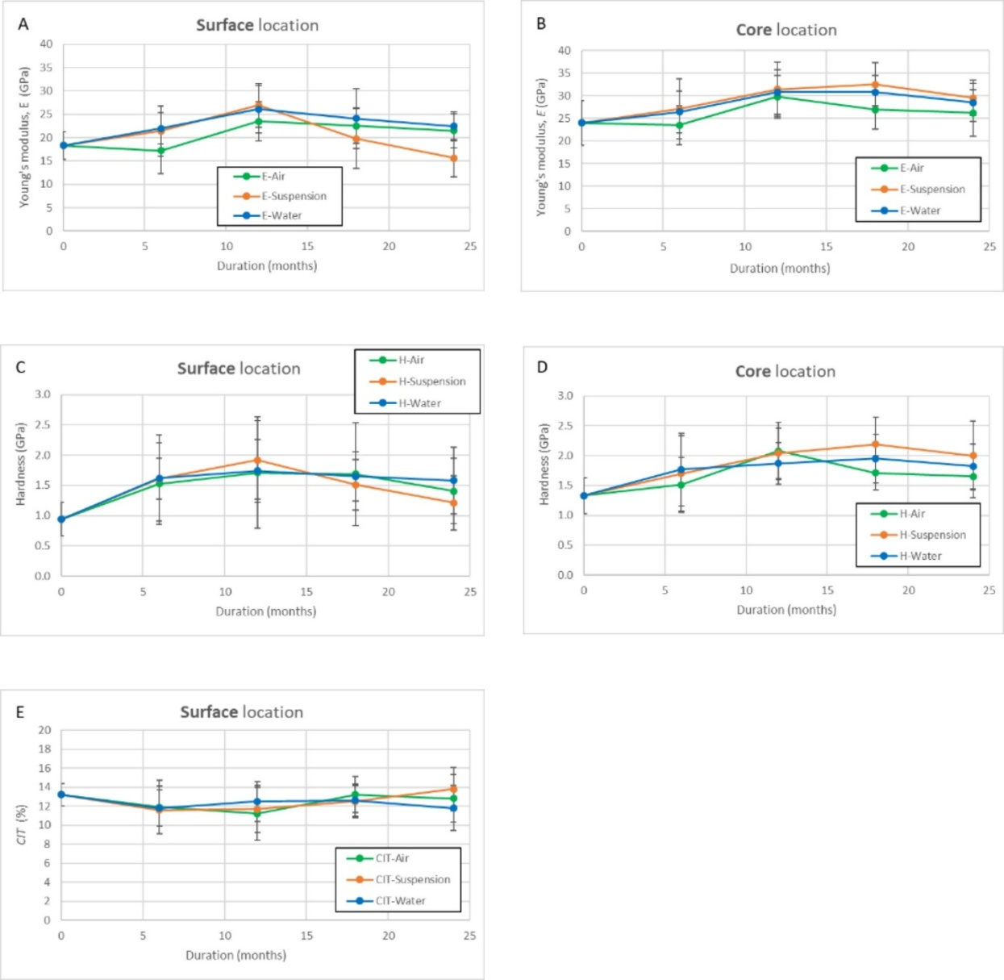
Fig. S1: Nanoindentation results of LPC samples. (A, C) Young’s modulus and hardness of the surface layer, respectively. (B, D) Young’s modulus and hardness of the core, respectively. (E) Creep indentation parameter (CIT) of the samples.

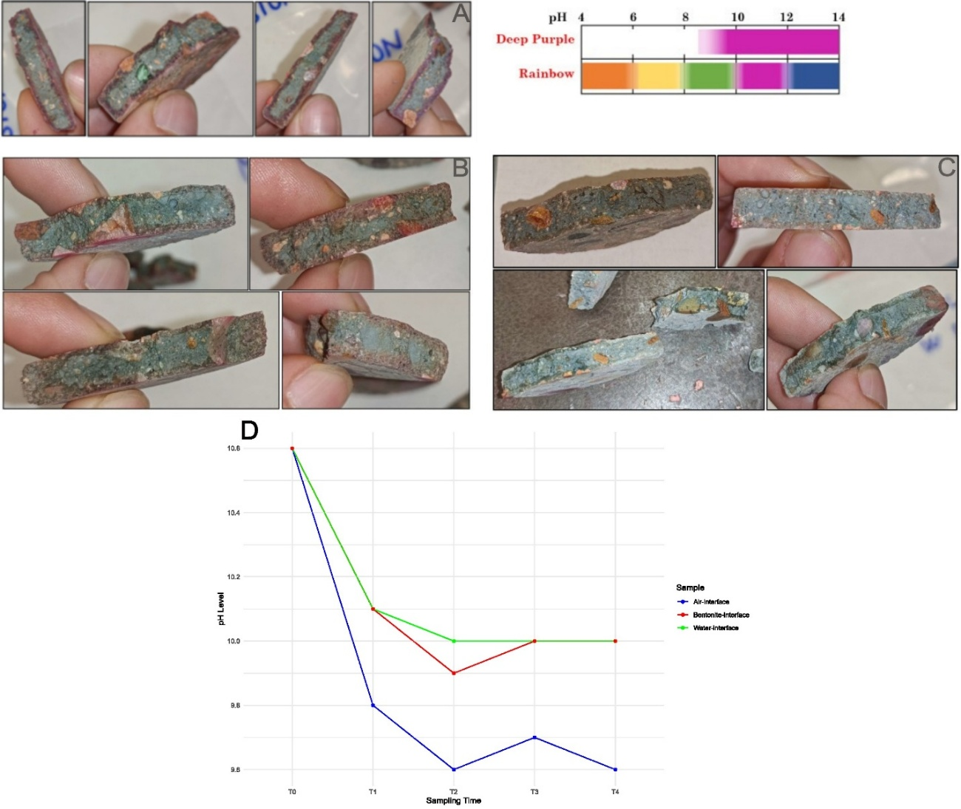
Fig. S2: pH evolution of LPC across the three interfaces. (A–C) pH distribution at T3 determined using rainbow indicators for A) BCV interface, B) air interface, and C) water interface (Vidal et al, 2024). D) Temporal pH changes from T0 to T4 across the three interfaces.

