Supplementary Information
A dual-emitting two-dimensional nickel-based metal-organic framework nanosheets: Eu³⁺/Ag⁺ functionalization synthesis and ratiometric sensing in aqueous solution
Yun Shu,ª Tao Dai,ª Qiuyu Ye,ª Dangqin Jin,^{b} Qin Xu,ª Xiaoya Hu^{a,}*
ªSchool of Chemistry and Chemical Engineering, Yangzhou University, Yangzhou 225002, P.R.China
^{b}Department of Chemical Engineering, Yangzhou Polytechnic Institute, Yangzhou 225127, P.R.China
*Corresponding author. Email: xyhu@yzu.edu.cn
Fig. S1 The emission spectra of Ni-MOF and Eu@Ni-MOF synthesized with different contents of Eu³⁺ (a: 5 mM, b: 50 mM, and c: 100 mM).

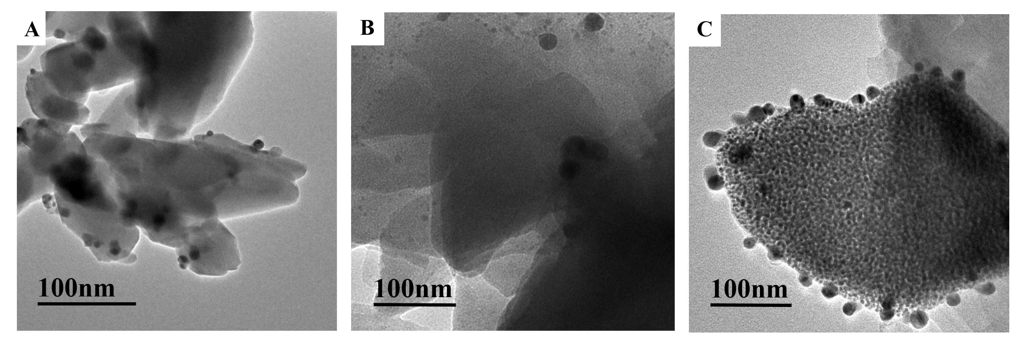
Fig. S2 TEM images of P1(A), P2(B), and P4(C).

Fig. S3 FT-IR spectra of Ni-MOF, Eu@Ni-MOF and Ag/Eu@Ni-MOF (P2).

Fig. S4 The effects of Ag/Eu@Ni-MOF (P2) concentration, reaction time (B), reaction temperature (C) and pH (D) on the ratiometric fluorescence system.
Fig. S5 FT-IR spectra of Cys, Ag/Eu@Ni-MOF (P2) before and after treated by GSH and Cys.
Fig. S6 (A) XRD patterns of Ag/Eu@Ni-MOF (P2) before and after treated by Cys and GSH. TEM image of Ag/Eu@Ni-MOF (P2) after treated by GSH (B) and Cys (C).
Fig. S7 UV-vis adsorption spectra of the aqueous suspension of Cys, GSH, Ni-MOF, Eu@Ni-MOF, Ag/Eu@Ni-MOF (P2), and Ag/Eu@Ni-MOF (P2) treated by Cys and GSH.

Fig. S8 I₅₂₄/I₆₁₅ of Ag/Eu@Ni-MOF in absence and presence of biothiols and other different amino acid solutions.

Fig. S9 I₅₂₄/I₆₁₅ of Ag/Eu@Ni-MOF towards ten different distractors and addition of Cys and GSH.

Tab. S1 Comparison of our work with other MOF-based fluorescence sensors for GSH detection reported recently.
Probe | λ_{em}(nm) | Limit of Detection | Linear range | Refs
Mi-UiO-66 Mi-UiO-67 | 490, 555 | 0.01 nM | 10⁻¹¹-10⁻³M |  | [1]
MOF 1-Ag⁺ | 582 | 13.5 nM | Not Given |  | [2]
MnO₂ NS@Ru(bpy)₃²⁺-UiO-66 | 608 | 0.28 μM | 0-300 μM |  | [3]
UiO-67-sbdc | 471 | 97.5 μM | 0.5-10 mM |  | [4]
Eu³⁺/Cu²⁺@UiO-67-bpydc | 615 | 54.3 nM | 0-10 μM |  | [5]
UiO-66-NH₂ | 450, 530 | 570 nM | 1-70 μM |  | [6]
Ag/Eu@Ni-MOF | 524, 615 | 169 nM | 5-250 μM |  | This work
Tab. S2 Comparison of our work with other MOF-based fluorescence sensors for Cys detection reported recently.
Probe | λ_{em}(nm) | Limit of Detection | Linear range | Refs
Mi-UiO-66 Mi-UiO-67 | 490, 555 | 0.01 nM | 10⁻¹¹-10⁻³M | [1]
MOF 1-Ag+ | 582 | 14.2 nM | Not Given | [2]
RhB@Cu-BTC | 575 | 0.702 μM | 0-40 μM | [7]
PCN-222-Hg²⁺ | 643 | 60 nM | 0-20 μM | [8]
Cu-BDC | 440 | 670 nM | 0.75-150 μM | [9]
PCP-1 | 430 | 30.9 nM | 0-0.5 μM | [10]
Ag/Eu@Ni-MOF | 524, 615 | 169 nM | 5-250 μM | This work
Tab. S3 Determination of biothiols in three human serum samples (n=3).
 | Added (μM) | Found (μM) | Mean Recovery (%) | RSD (%, n=3)
Sample 1 | 0  20  40  60 | 45.35  64.35  84.03  103.75 | 0  95.00  96.71  97.34 | 0  2.3  1.5  2.1
Sample 2 | 0  20  40  60 | 44.57  64.81  84.08  104.31 | 0  101.21  98.79  99.57 | 0  2.8  2.4  1.8
Sample 3 | 0  20  40  60 | 41.89  60.40  83.91  104.99 | 0  92.54  105.05  105.17 | 0  2.5  1.7  1.2

Reference
1. Li YA, Zhao CW, Zhu NX et al. (2015) Nanoscale UiO-MOF-based luminescent sensors for highly selective detection of cysteine and glutathione and their application in bioimaging. Chem Commun (Camb) 51:17672-17675. https://doi.10.1039/c5cc07783d
2. Huang NH, Liu Y, Li RT et al. (2020) Sequential Ag⁺/biothiol and synchronous Ag⁺/Hg²⁺ biosensing with zwitterionic Cu²⁺-based metal-organic frameworks. Analyst 145:2779-2788. https://doi.10.1039/d0an00002g
3. Zhu S, Wang S, Xia M et al. (2019) Intracellular Imaging of Glutathione with MnO₂ Nanosheet@Ru(bpy)₃²⁺-UiO-66 Nanocomposites. ACS Appl Mater Interfaces 11:31693-31699. https://doi.10.1021/acsami.9b11025
4. Zhu J, Xia T, Cui Y et al. (2019) A turn-on MOF-based luminescent sensor for highly selective detection of glutathione. J Solid State Chem 270:317-323. https://doi.10.1016/j.jssc.2018.11.032
5. Zhu J, Tang Y, Yang Y et al. (2019) Post-modified metal-organic framework as a turn-on fluorescent probe for potential diagnosis of neurological diseases. Microporous Mesoporous Mater 288. https://doi.10.1016/j.micromeso.2019.109610
6. Wang N, Xie M, Wang M et al. (2020) UiO-66-NH₂ MOF-based ratiometric fluorescent probe for the detection of dopamine and reduced glutathione. Talanta 220:121352. https://doi.10.1016/j.talanta.2020.121352
7. Zhao X, Zhang Y, Han J et al. (2018) Design of “turn-on” fluorescence sensor for L-Cysteine based on the instability of metal-organic frameworks. Microporous Mesoporous Mater 268:88-92. https://doi.10.1016/j.micromeso.2018.04.019
8. He J, Wu X, Long Z et al. (2019) Fast and sensitive fluorescent and visual sensing of cysteine using Hg-metalated PCN-222. Microchem J 145:68-73. https://doi.10.1016/j.microc.2018.10.001
9. Li X, Zhou H, Qi F et al. (2018) Three hidden talents in one framework: a terephthalic acid-coordinated cupric metal-organic framework with cascade cysteine oxidase- and peroxidase-mimicking activities and stimulus-responsive fluorescence for cysteine sensing. J Mater Chem B 6:6207-6211. https://doi.10.1039/c9tb90044f
10. Bej S, Hazra A, Das R et al. (2020) Exploratory studies of a multidimensionally talented simple MnII-based porous network: selective “turn-on” recognition @ cysteine over homocysteine with an indication of cystinuria and renal dysfunction. New J Chem 44:14712-14722. https://doi.10.1039/d0nj02265a

