Supplementary data

Enhanced olfactory performance in deaf Dalmatians: evidence for neurosensory compensation?

Mathieu Magninª, Emilie Boulard, Géraldine Lucchi^{cd}, Karine Gourrat^{cd}, Clément Chalardª, Jean-Jacques Thiebaultª, Barbara Ferry^{b}

ª Unité de Physiologie, Pharmacodynamie et Thérapeutique, Université de Lyon, Vetagro Sup, 1 avenue Bourgelat, 69280 Marcy l’Etoile, France
^{b}Centre of Research in Neuroscience Lyon CNRS UMR 5292 - INSERM U 1028 - Université Claude Bernard Lyon 1 Centre Hospitalier Le Vinatier - Bâtiment 462 - Neurocampus
95 boulevard Pinel, 69675 Bron Cedex
^{c} Centre des Sciences du Goût et de l’Alimentation, CNRS, INRAE, Institut Agro, Université Bourgogne Europe, F-21000 Dijon, France
^{d} CNRS, INRAE, PROBE research infrastructure, ChemoSens facility, F-21000 Dijon, France

Online Resource S1. Experimental setup: kibble composition and volatile profile, hiding spot classification, training session design, and layout of the search environment
- Kibble composition
Elements | Tapioca, wheat gluten, wheat flour, vegetable fibers, hydrolyzed animal proteins, mineral salts
Analytical constituents | Crude protein: 20% – Crude fat: 1% – Crude ash: 2.3% – Crude fiber: 1.9% – Moisture: 15%

Source: https://www.royalcanin.com/fr/dogs/products/retail-products/educ-3100?srsltid=AfmBOorGcriigG8URqE_9QTC9f0bProJarYj1CYIp9hXysRhco3Kb8Kq
- Kibble volatile profiles
Volatile profiles were analyzed via gas chromatography–mass spectrometry following solid-phase microextraction triple-phase divinylbenzene/carboxen/polydimethylsiloxane (DVB/CAR/PDMS). The volatile compounds were separated using an Agilent 7890A GC (Hewlett-Packard, Palo Alto, Santa Clara, USA) equipped with a fused-silica capillary DB-Wax column (30 m × 0.25 mm id., 0.5-μm film thickness) (Agilent J & W, Santa Clara, USA) and were identified using a 5975C mass selective detector (MSD) (Agilent J & W, Santa Clara, USA).

Chromatograms were overlayed across five kibbles from the same bag and two kibbles from three distinct bags representing different production batches. Compound identification was performed on the 22 most intense peaks of the chromatograms, and peak areas were compared to assess the variability of each sample. Analyses were performed by the Chemosens Laboratory (INRAE, Dijon, France).

- Classification of hiding spot types

Five distinct hiding spot types were defined based on their location, visibility, and elevation:
- Type 1: On the floor, visible, located <2 meters from the room entrance
- Type 2: On the floor, visible, located >2 meters from the entrance
- Type 3: Elevated, visible
- Type 4: On the floor, hidden (kibble not visible)
- Type 5: Elevated, hidden (kibble not visible)
Kibbles were never placed in exactly the same location across trials. However, each trial used a hiding spot consistent with the characteristics defined above to maintain standardization.

- Training session structure
The learning phase consisted of five distinct training session types (A to E), each comprising five trials with pre-assigned hiding spot types:
- Session A: Type 1, Type 1, Type 2, Type 2, Type 1
- Session B: Type 1, Type 2, Type 3, Type 3, Type 1
- Session C: Type 2, Type 3, Type 4, Type 4, Type 1
- Session D: Type 3, Type 4, Type 5, Type 5, Type 1
- Session E: One hiding spot of each type (Types 1 to 5)
Progression through these sessions was required for all dogs before entering the evaluation phase.
- Search environment layout
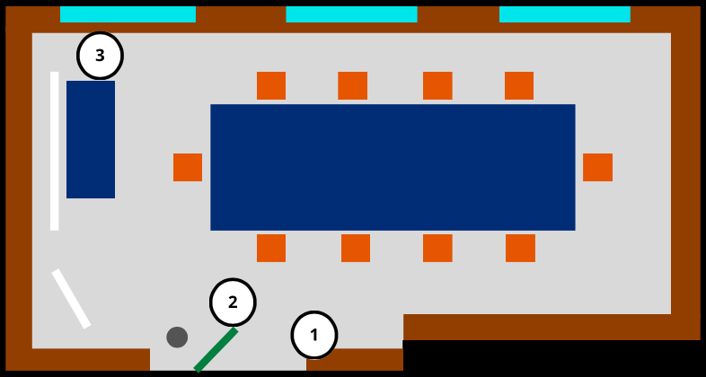
The search task was conducted in a controlled indoor environment—the institutional physiology library. A schematic layout of the room is provided below. After each trial, the hiding areas were wiped with a damp cloth to remove scent traces. The room was ventilated thoroughly between sessions to minimize olfactory cues from previous trials.
Legend:
🟧 Chair
🟦 Table
⬜ Whiteboard
🟩 Door
⚫ Trash can
🟦 (cyan) Window
🟫 Shelf

© Emilie Boulard

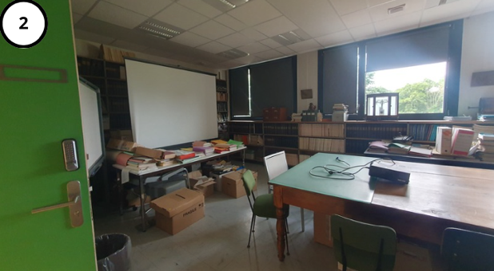
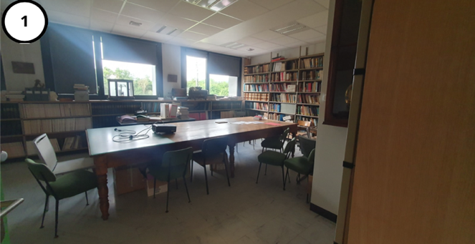
© Emilie Boulard

© Emilie Boulard

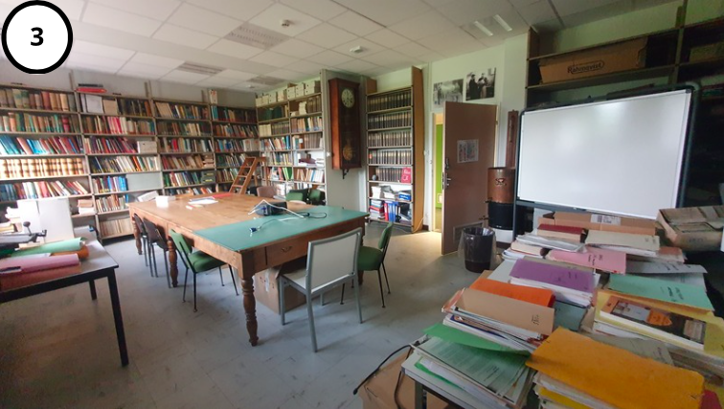
© Emilie Boulard

Online Resource S2. Chromatographic analysis of kibble samples
Volatile compound analyses were conducted by the Chemosens platform (INRAE, Dijon, France), a laboratory specializing in sensory and chemical profiling of food products (see: https://www.chemosens.fr).
  - Intra-bag variability
Chromatographic profiles of five individual kibbles from the same bag were obtained using solid-phase microextraction followed by gas chromatography–mass spectrometry (SPME-GC-MS). The x-axis represents retention time (in minutes), and the y-axis indicates signal intensity. After overlaying, results show highly consistent chromatograms, indicating a stable volatile compound composition across kibbles from a single bag (Chemosens, 2023).

Identification of the 22 most intense volatile organic compounds in six kibble samples from three different bags and two distinct production batches (A14/B14, A23/B23, and A25/B25) (Chemosens, 2024).

No. | RT (min) | Compound | CAS | Exp. RI | Lit. RI | CV (%)
1 | 2.76 | Acetone | 67-64-1 | 800 | 802 | 13.5
2 | 3.37 | 2-Methylfuran | 534-22-5 | 860 | 856 | 19.6
3 | 3.75 | Methanol | 67-66-1 | 891 | 892 | 7.8
4 | 3.79 | Butan-2-one | 78-93-3 | 893 | 894 | 10.7
5 | 3.99 | 2-Methylbutanal | 96-17-3 | 908 | 906 | 19.6
6 | 4.06 | 3-Methylbutanal | 590-86-3 | 911 | 913 | 19.1
7 | 4.39 | Ethanol | 64-17-5 | 933 | 934 | 8.8
8 | 7.75 | Hexanal | 66-25-1 | 1094 | 1094 | 15.4
9 | 9.10 | Pent-3-en-2-one | 625-33-2 | 1138 | 1138 | 11.1
10 | 10.13 | Pent-1-en-3-ol | 616-25-1 | 1171 | 1174 | 8.9
11 | 10.83 | 5-Methylhexan-2-one | 110-12-3 | 1193 | 1188 | 15.4
12 | 10.96 | Dodecane | 112-40-3 | 1197 | 1200 | 4.7
13 | 11.68 | 3-Methylbutanol | 123-51-3 | 1219 | 1218 | 7.1
14 | 12.39 | 2-Pentylfuran | 377-69-3 | 1241 | 1244 | 16.7
15 | 13.09 | Pentan-1-ol | 71-41-0 | 1262 | 1260 | 4.7
16 | 15.58 | 2,5-Dimethylpyrazine | 123-32-0 | 1338 | 1338 | 4.6
17 | 15.79 | 2,6-Dimethylpyrazine | 108-50-9 | 1344 | 1344 | 4.9
18 | 16.48 | Hexan-1-ol | 111-27-3 | 1365 | 1362 | 6.1
19 | 19.58 | Oct-1-en-3-ol | 3391-86-4 | 1462 | 1458 | 6.6
20 | 19.70 | Acetic acid | 64-19-7 | 1465 | 1465 | 6.7
21 | 21.98 | Benzaldehyde | 100-52-7 | 1539 | 1537 | 7.6
22 | 25.36 | Butanoic acid | 107-92-6 | 1651 | 1647 | 13.3
RT (min): Retention time in minutes; CAS: Chemical Abstracts Service registry number; Exp. RI: Experimental retention index on a polar column (DB-Wax, Agilent); Lit. RI: Literature retention index on a polar column (DB-Wax); CV (%): Coefficient of variation across samples.
  - Comparison of kibbles from different bags and production batches
Chromatograms of three individual kibbles from different bags were obtained using SPME-GC-MS. The first chromatogram (top, black) corresponds to a kibble from a different production batch, while the second (middle, blue) and third (bottom, red) represent kibbles from two bags belonging to the same batch. While the overall volatile compound profiles were qualitatively similar across samples, some differences in the intensity of specific peaks were observed (Chemosens, 2024).
An overlay of the three chromatograms (black = A14, blue = A23, red = A25) highlights three compounds with coefficients of variation exceeding 20% across batches.

Hexanal | 2-pentylfuran | 1-pentanol

Identification of the 22 most intense volatile organic compounds in six kibble samples from three different bags and two distinct production batches (A14/B14, A23/B23, and A25/B25) (Chemosens, 2024).

No. | RT (min) | Compound | CAS | Exp. RI | Lit. RI | CV (%)
1 | 2.76 | Acetone | 67-64-1 | 800 | 802 | 6.7
2 | 3.37 | 2-Methylfuran | 534-22-5 | 860 | 856 | 8.8
3 | 3.75 | Methanol | 67-66-1 | 891 | 892 | 11.7
4 | 3.79 | Butan-2-one | 78-93-3 | 893 | 894 | 12.2
5 | 3.99 | 2-Methylbutanal | 96-17-3 | 908 | 906 | 8.5
6 | 4.06 | 3-Methylbutanal | 590-86-3 | 911 | 913 | 9.5
7 | 4.39 | Ethanol | 64-17-5 | 933 | 934 | 10.5
8 | 7.75 | Hexanal | 66-25-1 | 1094 | 1094 | 30.5
9 | 9.10 | Pent-3-en-2-one | 625-33-2 | 1138 | 1138 | 8.5
10 | 10.13 | Pent-1-en-3-ol | 616-25-1 | 1171 | 1174 | 16.1
11 | 10.83 | 5-Methylhexan-2-one | 110-12-3 | 1193 | 1188 | 21.0
12 | 10.96 | Dodecane | 112-40-3 | 1197 | 1200 | 8.7
13 | 11.68 | 3-Methylbutanol | 123-51-3 | 1219 | 1218 | 13.4
14 | 12.39 | 2-Pentylfuran | 377-69-3 | 1241 | 1244 | 23.8
15 | 13.09 | Pentan-1-ol | 71-41-0 | 1262 | 1260 | 25.5
16 | 15.58 | 2,5-Dimethylpyrazine | 123-32-0 | 1338 | 1338 | 16.9
17 | 15.79 | 2,6-Dimethylpyrazine | 108-50-9 | 1344 | 1344 | 10.0
18 | 16.48 | Hexan-1-ol | 111-27-3 | 1365 | 1362 | 15.7
19 | 19.58 | Oct-1-en-3-ol | 3391-86-4 | 1462 | 1458 | 9.6
20 | 19.70 | Acetic acid | 64-19-7 | 1465 | 1465 | 8.0
21 | 21.98 | Benzaldehyde | 100-52-7 | 1539 | 1537 | 7.2
22 | 25.36 | Butanoic acid | 107-92-6 | 1651 | 1647 | 19.3

RT (min): Retention time in minutes; CAS: Chemical Abstracts Service registry number; Exp. RI: Experimental retention index on a polar column (DB-Wax, Agilent); Lit. RI: Literature retention index on a polar column (DB-Wax); CV (%): Coefficient of variation across samples.

Online Resource S3. Dog Characteristics

Group | Sex and Neuter Status | Shoulder Height (cm) | Weight (kg) | Age (years)
Hearing | Neutered male | 75 | 27 | 6
Hearing | Spayed female | 67 | 23 | 6
Deaf | Neutered male | 64 | 22 | 5
Deaf | Intact male | 69 | 24 | 4

Online Resource S4. correlations between search speed, time since last meal, and time since previous session.

Variable | All dogs | Hearing group | Deaf group
Time since last meal | r = –0.04 [–0.26 ; 0.18] | r = –0.01 [–0.31 ; 0.30] | r = 0.07 [–0.24 ; 0.37]
Time since last meal | p = 0.70 | p = 0.96 | p = 0.66
Time since previous session | r = 0.02 [–0.20 ; 0.24] | r = –0.003 [–0.31 ; 0.31] | r = –0.05 [–0.36 ; 0.26]
Time since previous session | p = 0.87 | p = 0.98 | p = 0.74

Pearson correlation coefficients (r), 95% confidence intervals, and p-values are reported for the entire sample, as well as separately for the hearing and deaf groups. Variables considered include (1) the time elapsed since the dog's last meal and (2) the time elapsed since the previous session. These correlations aim to assess whether motivational or temporal factors influenced olfactory search speed.

