Supplementary Material
Plant Ecology
Ecological factors influencing the diversity and distribution of Orchidaceae members in the Intercontinental Biosphere Reserve of the Mediterranean of Northern Morocco
Yahya El Karmoudi¹, Mohamed Libiad^{1,*}, Ioulietta Samartza², Abdelmajid Khabbach³, Maria Lazarina^{4*}, Nikos Krigas^{2*}
¹Ecology, Systematics and Biodiversity Conservation Team, URL-CNRST N◦ 18, FS, Abdelmalek Essaadi University, M’Hannech II, Tetouan, Morocco
²Institute of Plant Breeding and Genetic Resources, Hellenic Agricultural Organization Demeter, Thermi, Greece
³Biotechnology, Environment, Agri-Food and Health Laboratory, Faculty of Sciences Dhar El Mahraz, Sidi Mohamed Ben Abdellah University, Fez, Morocco
⁴Department of Ecology, School of Biology, Aristotle University of Thessaloniki, Greece, Thessaloniki, Greece

*Corresponding authors: Mohamed Libiad (libiad001@gmail.com), Maria Lazarina (mlazarin@bio.auth.gr), Nikos Krigas (nkrigas@elgo.gr)

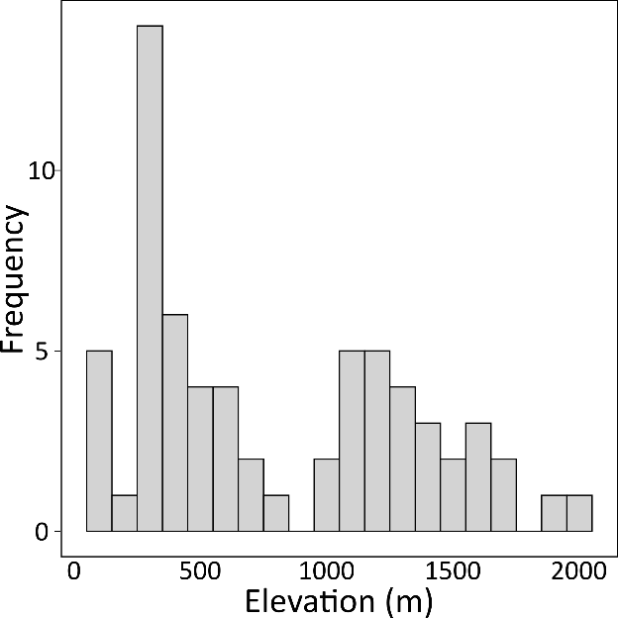
Fig. S1. Frequency distribution of site elevations in IBRM.

Table S1. Importance of Orchidaceae species and individual numbers according to habitat type

Habitat types | total number of orchid individuals/ Habitat types | Number of species/ Habitat types
Chamaephytic vegetation Chamaerops humilis, Stachys fontqueri | 1 | 1
Forest Abies marocana | 183 | 8
Forest degraged Pteridium aquilinum | 18 | 1
Forest Quercus canariensis | 39 | 2
Forest Quercus ilex | 234 | 9
Forest Quercus ilex and Q. faginea | 61 | 4
Forest Quercus pyrenaica | 11 | 1
Forest Quercus suber | 348 | 10
Forest siliceous Quercus suber | 60 | 4
Matorral Pistacia atlantica | 23 | 1
Matorral Pistacia lentiscus, Myrtus communis | 699 | 18
Matorral Quercus coccifera | 90 | 3
Matorral Quercus ilex | 122 | 5
Pelouses with Asteraceae, Boraginaceae, and Poaceae members | 14 | 2

Table S2. Importance of individual numbers of Orchidaceae according to substrate type
Taxa | Number of sites | Number of individuals
Taxa | Number of sites | Calcareous substrate | Siliceous substrate
Cephalanthera longifolia (L.) Fritsch | 7 | 79 | 0
Epipactis tremolsii Pau | 3 | 36 | 0
Gennaria diphylla (Link) Parl. | 2 | 16 | 0
Himantoglossum hircinum (L.) Spreng. | 2 | 5 | 0
Himantoglossum robertianum (Loisel.) P.Delforge | 4 | 166 | 0
Limodorum trabutianum Batt. | 3 | 3 | 5
Neotinea conica (Willd.) R.M.Bateman | 1 | 8 | 0
Neotinea maculata (Desf.) Stearn | 7 | 75 | 0
Neotinea tridentata (Scop.) R.M.Bateman, Pridgeon & M.W.Chase | 4 | 52 | 0
Ophrys apifera Huds. | 8 | 196 | 0
Ophrys battandieri E.G.Camus | 7 | 76 | 0
Ophrys bombyliflora Link | 4 | 54 | 0
Ophrys fusca Link | 5 | 26 | 0
Ophrys lutea Cav. | 13 | 130 | 0
Ophrys lutea subsp. phryganae (Devillers-Tersch. & Devillers) Melki | 2 | 28 | 0
Ophrys scolopax Cav. | 8 | 45 | 0
Ophrys speculum Link | 4 | 61 | 0
Ophrys tenthredinifera Willd. | 11 | 169 | 0
Orchis anthropophora (L.) All. | 5 | 82 | 0
Orchis spitzelii subsp. cazorlensis (Lacaita) D.Rivera & Lopez Velez | 1 | 13 | 0
Orchis mascula (L.) L. | 4 | 17 | 10
Orchis mascula subsp. laxifloriformis Rivas Goday & B.Rodr. | 9 | 104 | 52
Serapias lingua L. | 7 | 61 | 27
Serapias parviflora Parl. | 16 | 259 | 11
Serapias strictiflora Welw. ex Veiga | 3 | 14 | 11
Serapias vomeracea (Burm.f.) Briq. | 1 | 0 | 12

