Supplementary figures for “Evaluation of dip angles of active faults beneath the Osaka Plain inferred from a 2D numerical analysis of visco-elasto-plastic models” by Nishiwaki, Okudaira, Ishii and Mitamura

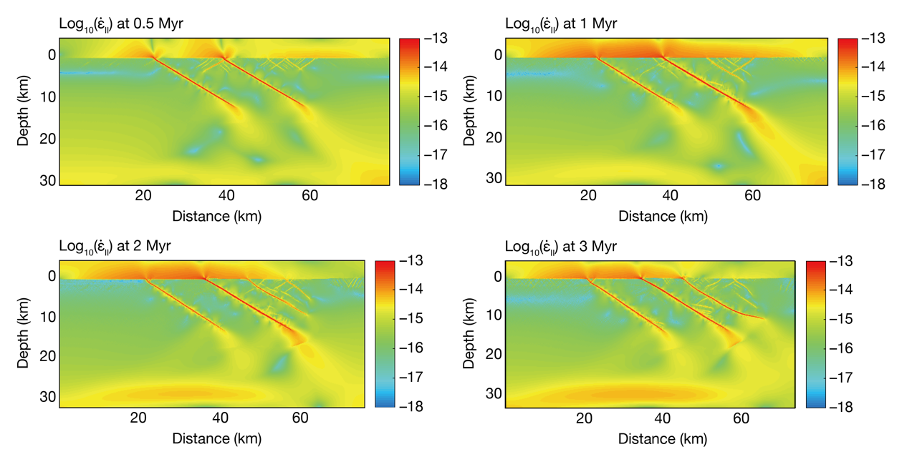
Additional file 1: Fig. S1
Strain rate (${\dot{ε}}_{\text{II}}$) evolution within the model domain for the case of two preexisting fault zones with a dip angle of 30° that is the same as Fig. 9a.

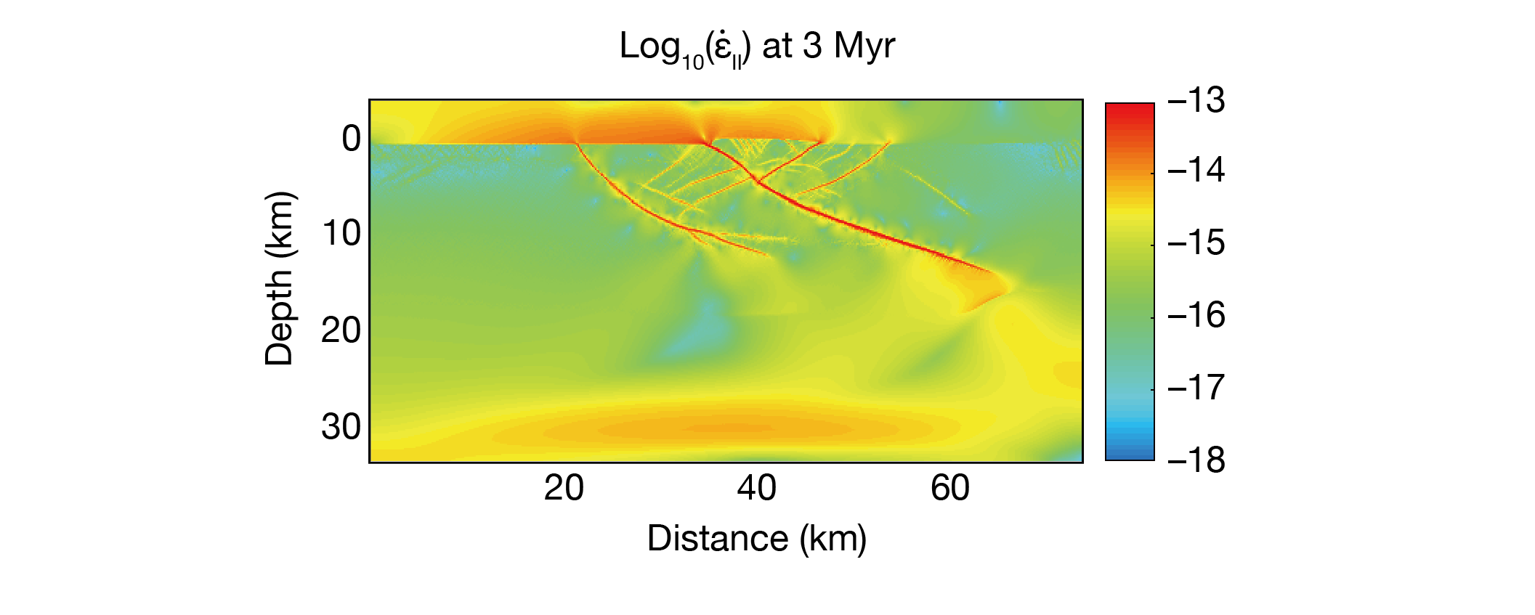
Additional file 1: Fig. S2
Strain rate (${\dot{ε}}_{\text{II}}$) distribution within the model domain for the fault geometry of Sato et al. (2009) that is the same as Fig. 10b.

