Supplementary Information

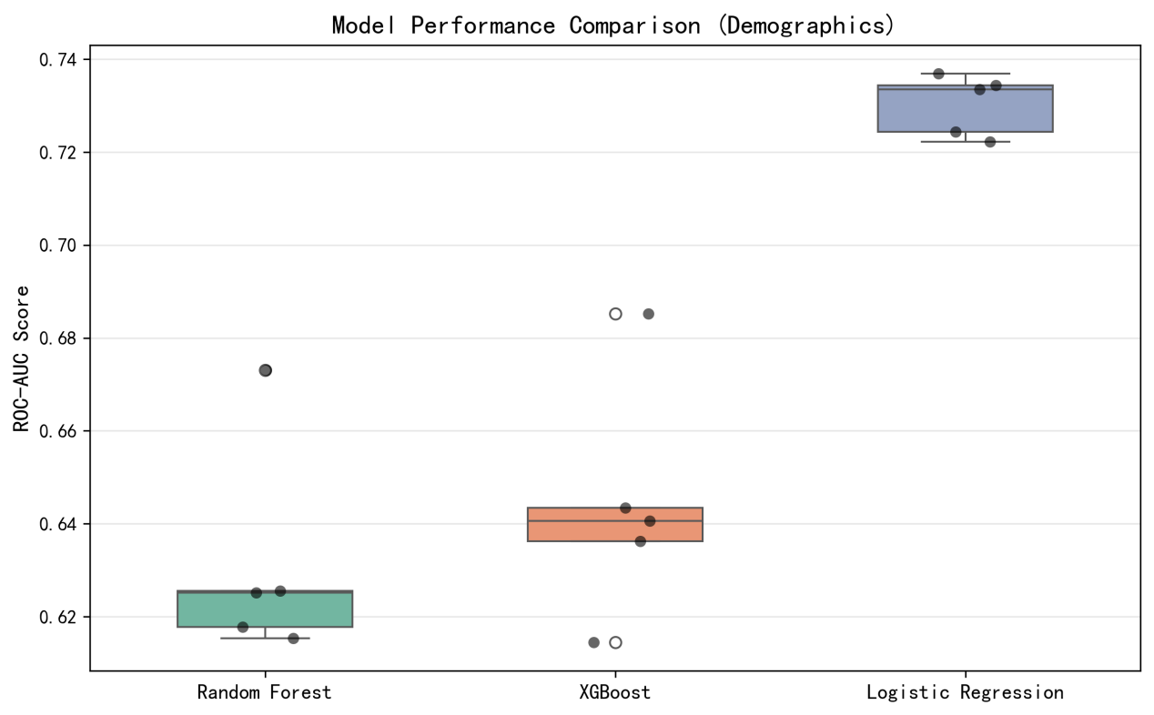
Supplementary Figure 1. Comparative Evaluation of Machine Learning Models for Predicting Cognitive Impairment in Parkinson's Disease based on Demographics

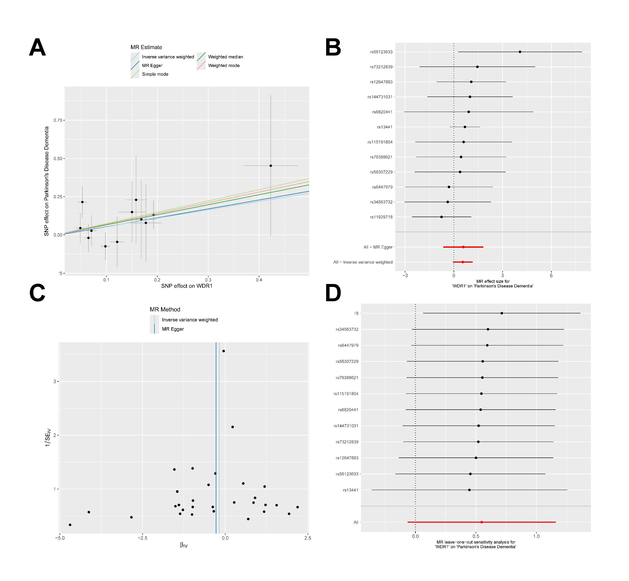
Supplementary Figure 2. Sensitivity, heterogeneity, and pleiotropy analysis for the Mendelian randomization of WDR11 on PDD.
(A) Scatter Plot. (B) Forest Plot. (C) Funnel Plot. (D) Leave-one-out sensitivity analysis.

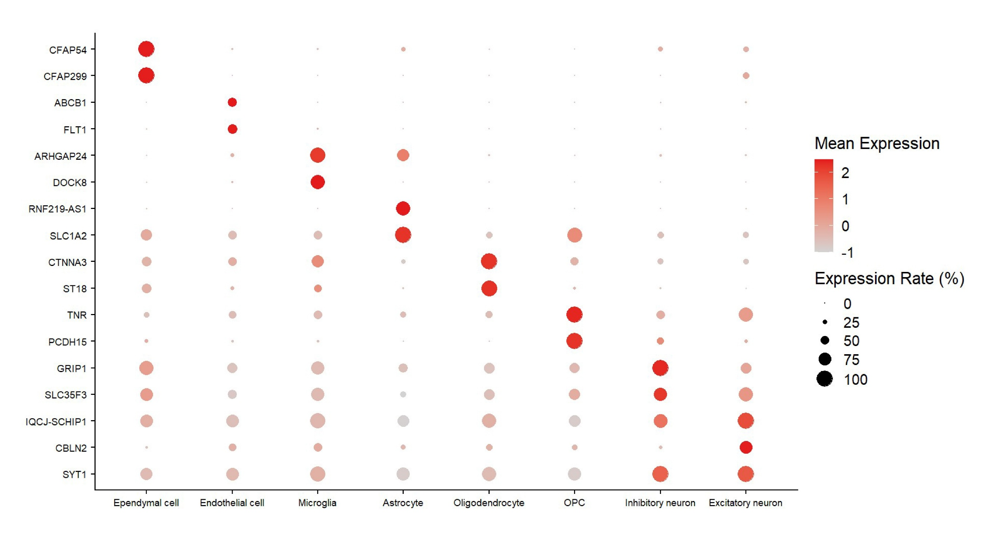
Supplementary Figure 3. Gene Marker Annotation of snRNA-seq Data
Dot plot demonstrating the expression of selected marker genes for individual cell types. The size of each dot indicates the percentage of cells within a cluster that express a specific gene. The colour of the dot represents the average log-normalised expression level of that gene.

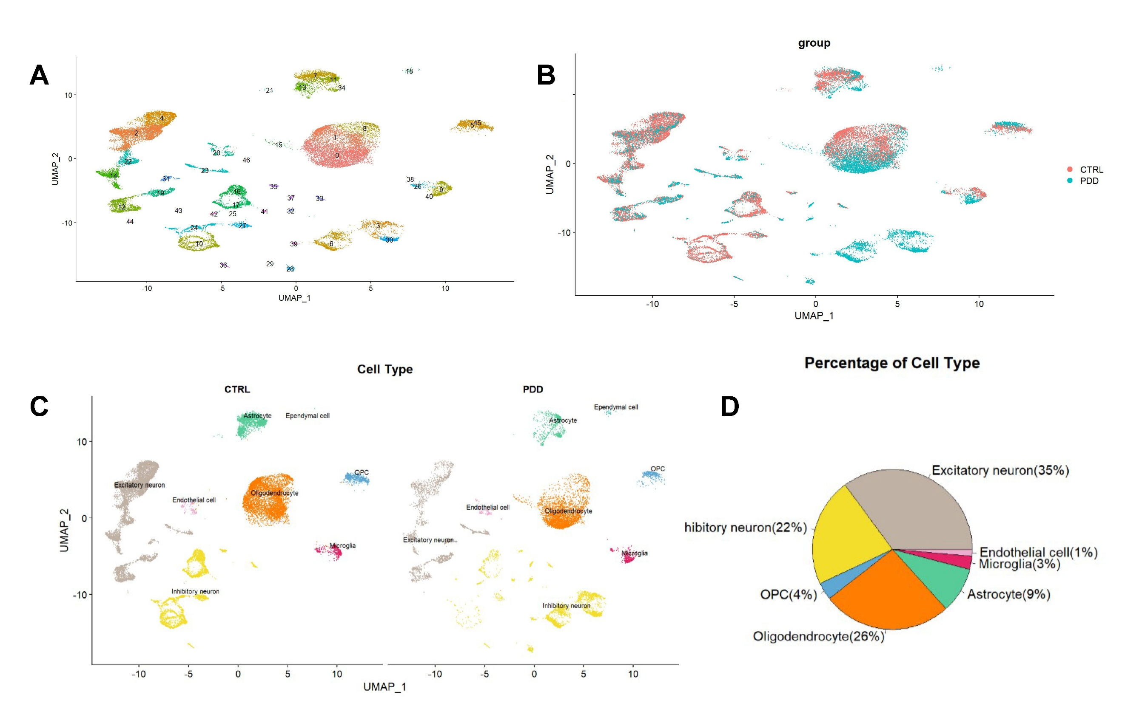
Supplementary Figure 4. Quality Control and Annotation of snRNA-seq Data
(A-C) UMAP visualization. (A) Each digit represents a cell subset, demonstrating finer cellular heterogeneity. (B) Sample-wise. (C) Cell type-specific. (D) Pie chart detailing the percentage of nuclei assigned to each cell type.

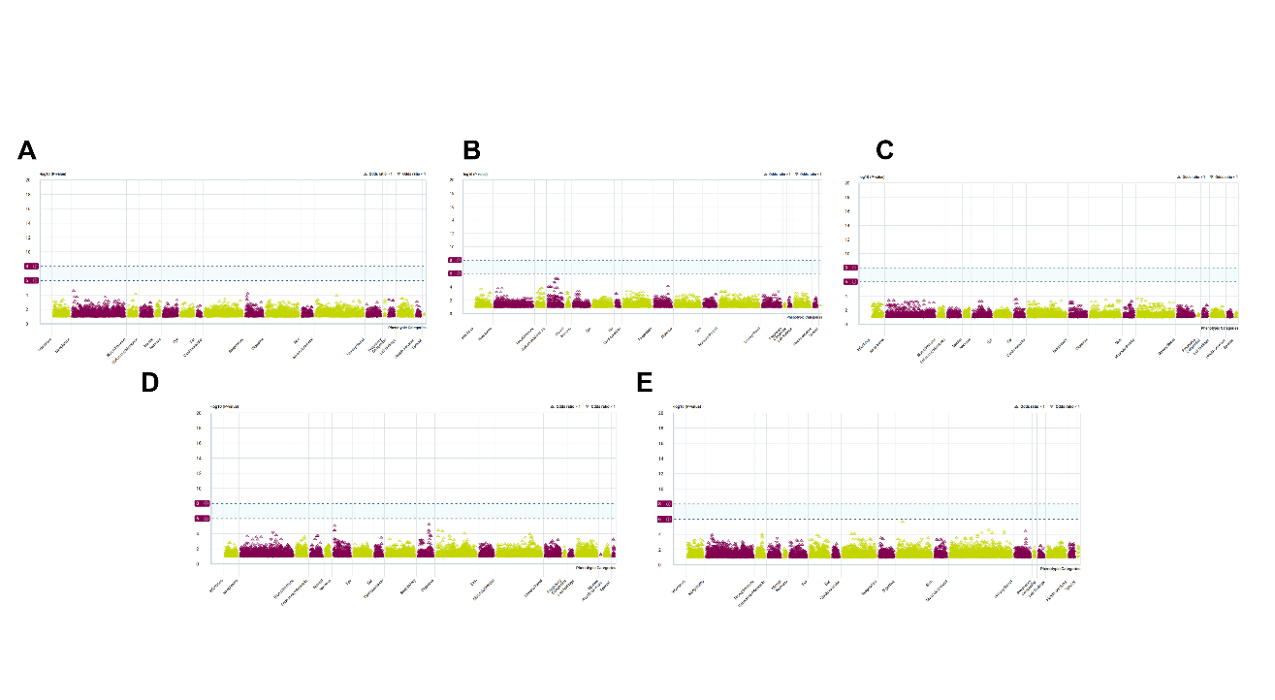Supplementary Figure 5. Phenome-wide Association Study
(A-E) Manhattan plots show associations between SNPs used for instrumental variables and broad human phenotypes. The key finding was that these SNPs were significantly associated with targeted gene levels (in the "biomarker" category), but none of them were significantly associated with other neuropsychiatric, metabolic, or immune phenotypes (no dots above the red horizontal line). This strongly demonstrates the specificity of instrumental variables and greatly reduces the possibility of causal estimation bias due to pleiotropy. (A) CA1; (B) MMP12; (C) MSMB; (D) POSTN; (E) PLEKHH2.

Supplementary Table 1: Drug Targets and Drug Candidates
gene | drug | regulatory approval | indication | interaction score
CA1 | SULFAMIDE | Not Approved |  | 1.305094963972138
CA1 | METHAZOLAMIDE | Approved | Diuretics; Antiglaucoma agents,Antihypertensive Agents | 1.04407597117771
CA1 | ACETAZOLAMIDE | Approved | Anticonvulsants; Diuretics; antiglaucomic agent | 0.745768550841222
CA1 | ETHOXZOLAMIDE | Approved | Diuretics; Antiglaucoma agents,Antihypertensive Agents | 0.6960506474518071
CA1 | MEDRONIC ACID | Approved |  | 1.305094963972138
CA1 | CURCUMIN | Approved |  | 0.03954833224157995
CA1 | CHLOROTHIAZIDE | Approved | Antihypertensive Agents; Diuretics | 0.745768550841222
CA1 | TRICHLORMETHIAZIDE | Approved | Antihypertensive Agents; Diuretics | 0.8700633093147588
CA1 | PHENOL | Approved |  | 1.957642445958207
CA1 | POLMACOXIB | Not Approved | NSAID | 2.610189927944276
CA1 | ACETAZOLAMIDE SODIUM | Approved |  | 0.6525474819860692
CA1 | DICHLORPHENAMIDE | Approved | Antiglaucomic Agents | 2.088151942355421
CA1 | PARABEN | Not Approved |  | 0.6525474819860692
CA1 | ZONISAMIDE | Approved | anticonvulsant,antipsychotic agent,appetite suppressant | 0.104407597117771
CA1 | CATECHOL | Not Approved |  | 0.2372899934494797
CA1 | FERULIC ACID | Approved |  | 0.5220379855888553
CA1 | LEVETIRACETAM | Approved | anticonvulsant | 0.372884275420611
CA1 | METHOCARBAMOL | Approved |  | 0.4350316546573794
CA1 | RESORCINOL | Approved |  | 2.610189927944276
CA1 | SULTHIAME | Approved |  | 0.2175158273286897
MMP12 | MARIMASTAT | Not Approved | Antineoplastic Agents | 0.3866948041398929
MMP12 | ILOMASTAT | Not Approved |  | 0.2320168824839356
MMP12 | ACETAZOLAMIDE | Approved | Anticonvulsants; Diuretics; antiglaucomic agent | 0.8286317231569132
MMP12 | NEOVASTAT | Not Approved |  | 1.160084412419678
MMP12 | DEFEROXAMINE | Approved |  | 0.6824025955409874
MMP12 | CTS-1027 | Not Approved |  | 0.8286317231569132
MMP12 | CAPTOPRIL | Approved | Antihypertensive Agents | 0.8923726249382143
MMP12 | ZILEUTON | Approved | antiinflammatory agent | 1.288982680466309
MMP12 | AZD-1236 | Not Approved |  | 2.900211031049196
MSMB | TIGAPOTIDE | Not Approved |  | 52.2
POSTN | ANTISERUM | Not Approved |  | 2.98
PLEKHH2 | VERAPAMIL | Approved | antihypertensive agent | 1.16
PLEKHH2 | ATENOLOL | Approved | Anti-Arrhythmia Agents; Antihypertensive Agents | 1.45

