Graphical Abstract

- Cytokine storms play a vital role in the progression of inflammatory lung diseases.
- Polysaccharides from Platycodon grandiflorum can target damaged lungs compared to other polysaccharides.
- Platycodon grandiflorum Polysaccharides were fabricated to nanoparticles.
- A dual-targeted nanoparticles can calm local cytokine storms.
- Precise drug release was based on inflammatory microenvironment.


Scheme 1 Illustration of a dual targeting system based on bionics and TCM guide theory to suppress lung inflammation
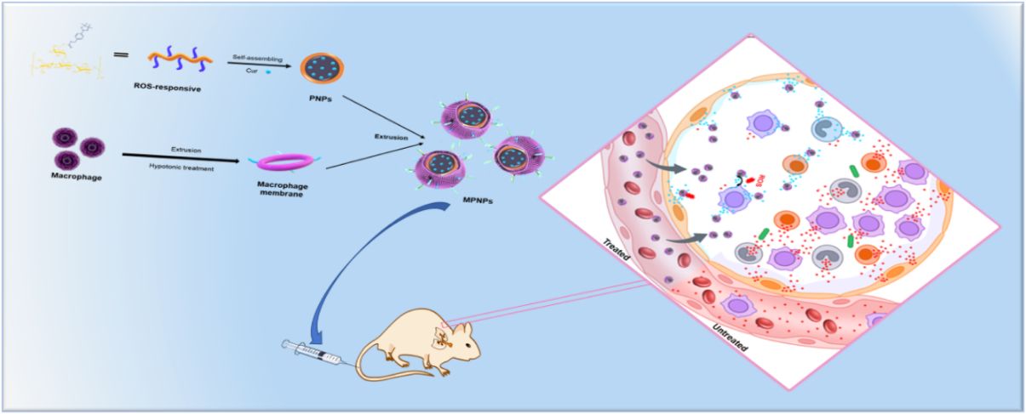
Scheme 2 Illustration of the synthesis process of MNPs@Cur and release triggered by overexpressed ROS in lung inflammation thereby effectively suppressing cytokine storm

