Supplementary Table S1. All significant protein log2-fold changes and FDR-adjusted p values for main analysis.
Gene Symbol | Log2 Fold Change | P-Value | FDR
KDM5B* | -4.16648 | 3.47E-05 | 4.08E-04
MYH1 | -1.51612 | 4.46E-05 | 5.05E-04
AMY1B;AMY1C;AMY1A | -1.3849 | 4.56E-04 | 3.78E-03
TRAP1 | -1.17179 | 4.73E-05 | 5.25E-04
SAA1 | -1.01131 | 2.16E-04 | 1.96E-03
DCD | -0.98698 | 3.10E-03 | 1.96E-02
CRP | -0.7982 | 1.69E-03 | 1.19E-02
EIF2B2 | -0.78986 | 9.96E-07 | 1.97E-05
HSP90AB1 | -0.7072 | 1.62E-05 | 2.09E-04
H4C16 | -0.69812 | 1.13E-04 | 1.10E-03
ATP6V1B2 | -0.60412 | 1.88E-11 | 2.62E-09
POSTN* | -0.59759 | 3.33E-03 | 2.08E-02
ACTA1 | -0.59614 | 5.73E-03 | 3.23E-02
HSPA1A;HSPA1B | -0.50262 | 3.52E-07 | 7.81E-06
JUP | -0.46164 | 1.14E-03 | 8.52E-03
CPAMD8 | -0.4377 | 3.93E-09 | 1.98E-07
S100A9 | -0.4365 | 3.10E-04 | 2.73E-03
GP5 | -0.40559 | 1.82E-11 | 2.62E-09
AGPAT3 | -0.34581 | 8.62E-06 | 1.29E-04
P4HB | -0.33943 | 3.61E-03 | 2.19E-02
MUS81 | -0.27143 | 3.68E-08 | 9.73E-07
GTF2E1 | -0.26767 | 1.09E-08 | 4.32E-07
B2M | -0.22824 | 3.24E-08 | 8.99E-07
DNAAF1 | -0.21314 | 1.23E-08 | 4.54E-07
IL17D | -0.20213 | 1.85E-15 | 1.03E-12
HABP2 | -0.17994 | 3.65E-03 | 2.19E-02
TTC14 | -0.16772 | 7.17E-04 | 5.74E-03
ATP5F1A | -0.16738 | 8.54E-05 | 8.79E-04
PCSK9 | -0.14739 | 3.68E-03 | 2.19E-02
APOL1 | -0.14108 | 3.62E-03 | 2.19E-02
LECT2 | -0.13813 | 2.85E-10 | 2.13E-08
RSC1A1 | -0.13728 | 5.65E-05 | 6.03E-04
TRAF2 | -0.13017 | 9.16E-06 | 1.34E-04
COL6A1 | -0.11023 | 2.17E-14 | 6.03E-12
MYH8 | -0.10492 | 3.76E-04 | 3.17E-03
IGLC2;IGLC3 | -0.10154 | 1.36E-03 | 1.01E-02
HBS1L | -0.10021 | 2.79E-05 | 3.44E-04
FLNA | -0.08958 | 3.41E-04 | 2.96E-03
EZR | -0.07498 | 3.07E-10 | 2.13E-08
SLC26A2 | -0.07285 | 3.53E-05 | 4.08E-04
UBB;UBC;RPS27A;UBA52 | -0.06177 | 8.56E-05 | 8.79E-04
ANXA2 | -0.05839 | 7.46E-04 | 5.83E-03
ZCCHC8 | -0.04782 | 5.18E-06 | 8.46E-05
CKM | -0.04734 | 3.77E-04 | 3.17E-03
PRDX1 | -0.04613 | 9.90E-06 | 1.41E-04
LAMB1 | -0.0451 | 3.51E-05 | 4.08E-04
NAGA | -0.04492 | 1.64E-08 | 5.37E-07
ANGPTL6 | -0.03424 | 1.11E-10 | 1.23E-08
ATP2A2 | -0.02758 | 5.10E-05 | 5.55E-04
ACTN1 | -0.02542 | 1.79E-05 | 2.26E-04
MBL2 | -0.01377 | 7.96E-07 | 1.64E-05
ARF6 | -0.01197 | 1.09E-08 | 4.32E-07
TPM1 | -0.00978 | 3.28E-09 | 1.82E-07
ATP5F1B | -0.00799 | 4.70E-03 | 2.72E-02
H1-4 | -0.00349 | 1.90E-03 | 1.30E-02
VPS9D1 | 0.00122 | 1.11E-04 | 1.10E-03
RPAP3 | 0.005319 | 1.59E-06 | 2.93E-05
TFRC | 0.015506 | 3.53E-06 | 6.13E-05
TPI1 | 0.017542 | 5.11E-06 | 8.46E-05
CDH1 | 0.03553 | 9.25E-09 | 4.28E-07
PON3 | 0.043173 | 2.64E-03 | 1.74E-02
GSR | 0.04561 | 2.07E-04 | 1.92E-03
IGKV3D-15 | 0.046745 | 8.90E-04 | 6.86E-03
FAM135A | 0.046788 | 8.26E-06 | 1.27E-04
A2M | 0.05263 | 8.12E-03 | 4.46E-02
IGKV1-5 | 0.064637 | 2.85E-03 | 1.84E-02
DSG2 | 0.065647 | 4.87E-08 | 1.23E-06
CETP | 0.074314 | 2.49E-09 | 1.54E-07
IGKV1-37;IGKV1D-37 | 0.075623 | 1.07E-06 | 2.04E-05
A1BG | 0.078019 | 5.76E-03 | 3.23E-02
ENO3 | 0.079302 | 7.39E-07 | 1.58E-05
BLVRB | 0.084005 | 1.03E-05 | 1.41E-04
TTN | 0.084013 | 1.30E-04 | 1.22E-03
LDHB | 0.087755 | 1.04E-05 | 1.41E-04
ARG1 | 0.088958 | 2.48E-06 | 4.44E-05
ADGRG1 | 0.095237 | 5.53E-06 | 8.76E-05
ADAMTS13 | 0.101576 | 1.30E-04 | 1.22E-03
IGKV1-39;IGKV1D-39 | 0.103585 | 7.24E-04 | 5.74E-03
ANPEP | 0.104181 | 1.68E-03 | 1.19E-02
FUCA1 | 0.115511 | 4.31E-03 | 2.52E-02
CNTN1 | 0.116862 | 1.60E-08 | 5.37E-07
IGHM | 0.117273 | 7.30E-03 | 4.05E-02
F10 | 0.11774 | 3.04E-03 | 1.94E-02
IGKJ1 | 0.128244 | 5.14E-03 | 2.94E-02
TNC | 0.128265 | 2.17E-03 | 1.47E-02
CPN2 | 0.129113 | 2.23E-03 | 1.49E-02
LRRC37A2;LRRC37A;LRRC37A3 | 0.131348 | 2.62E-10 | 2.13E-08
IGF2R | 0.132118 | 3.86E-03 | 2.28E-02
TNK1 | 0.135388 | 8.46E-08 | 1.96E-06
LDHA | 0.143205 | 9.40E-04 | 7.15E-03
VCAM1 | 0.145112 | 3.01E-04 | 2.70E-03
VASN | 0.170366 | 5.41E-04 | 4.42E-03
IL6ST | 0.181696 | 1.71E-03 | 1.19E-02
OIT3 | 0.182781 | 5.26E-08 | 1.27E-06
PGK1 | 0.184184 | 2.67E-03 | 1.75E-02
PTPRJ | 0.206251 | 2.93E-08 | 8.57E-07
IGHV3-9 | 0.255465 | 1.35E-05 | 1.78E-04
MYL6 | 0.277945 | 9.88E-05 | 9.97E-04
CA2 | 0.594351 | 1.62E-03 | 1.16E-02
HIVEP1 | 0.739016 | 1.58E-03 | 1.16E-02
ALCAM | 0.800885 | 2.54E-08 | 7.84E-07

(Bold values indicate candidates. *Italicised proteins were removed as candidates due to likely imputation-driven findings; FDR, false discovery rate;)

Supplementary Table S2. Candidate proteins in sensitivity analysis investigating VC supplementation vs. control for Period-1 and Period-2 separately.
Tier 1 candidates | Period 1 (first intervention period) |  | Period 2 (second intervention period)
Gene symbol | Log2 fold change | FDR | Log2 fold change | FDR
DCD | -1.270 | 4.596E-03 | 0.192 | 4.117E-01
AMY1 | -1.249 | 3.859E-02 | 0.048 | 2.818E-27
TRAP1 | -0.972 | 7.160E-03 | 0.035 | 6.135E-01
MYH1 | -0.814 | 2.612E-02 | -0.728 | 1.941E-03
EIF2B2 | -0.630 | 1.387E-02 | -0.778 | 6.548E-04
H4C16 | -0.598 | 8.800E-03 | -0.125 | 1.743E-05
ACTA1 | -0.459 | 3.545E-02 | -0.042 | 3.140E-01
SAA1 | -0.454 | 1.147E-09 | -1.095 | 4.226E-03
HSP90AB1 | -0.371 | 7.748E-03 | -0.017 | 4.037E-01
ALCAM | 0.853 | 1.203E-03 | 0.687 | 3.864E-01
Tier 2 candidates | Period 1 (first intervention period) |  | Period 2 (second intervention period)
Gene symbol | Log2 fold change | FDR | Log2 fold change | FDR
ATP6V1B2 | -0.944 | 5.502E-01 | -0.489 | 6.345E-14
HSPA1 | -0.808 | 1.623E-03 | 0.151 | 3.367E-14
CA2 | 0.023 | 5.791E-01 | 0.730 | 1.736E-01
CRP* | 0.234 | 4.214E-01 | -1.815 | 7.029E-05
HIVEP1 | 0.388 | 4.367E-01 | 0.378 | 1.717E-02
(Bold values indicate statistical significance; italicized values represent opposite directions of effect to main analysis; *CRP at baseline differed significantly between VC and placebo in Period 1 [log2 fold change = 1.31, FDR = 1.76 x 10⁻⁷]; FDR, false discovery rate;).

Supplementary Table S3. Candidate proteins in “per-protocol” sensitivity analysis (n=19) investigating VC supplementation vs. Control, with participants removed for either medication changes or supplement non-compliance.
Tier 1 candidates
Gene symbol | Log2 fold change | FDR
MYH1 | -1.882 | 4.917E-03
SAA1 | -1.404 | 4.514E-03
TRAP1 | -1.403 | 4.721E-03
AMY1 | -1.383 | 1.360E-03
HSP90AB1 | -1.155 | 1.065E-02
EIF2B2 | -1.116 | 3.688E-04
DCD | -0.993 | 1.356E-01
H4C16 | -0.908 | 2.060E-03
ACTA1 | -0.898 | 4.724E-02
ALCAM | 0.835 | 2.449E-04
Tier 2 candidates
Gene symbol | Log2 fold change | FDR
CRP | -1.140 | 2.648E-03
ATP6V1B2* | -1.006 | 2.509E-01
HSPA1 | -0.764 | 1.018E-03
HIVEP1* | 0.144 | 7.787E-01
CA2 | 0.198 | 2.760E-01
(Bold values indicate statistically significant; *calculated based on non-filtered/non-imputed data due to their removal after filtering out >40% missing data; FDR – false discovery rate)

Supplementary Table S4: Top 5 gene ontology enriched terms for top 20 correlated baseline proteins* with intervention response for targeted outcomes
Outcome measure
Total Postprandial Area Under the Curve
Biological Process (Gene Ontology)
GO-term | description | count in network | strength | signal | FDR
GO:0098883 | Synapse pruning | 3 of 11 | 2.69 | 1.8 | 0.00051
GO:0006956 | Complement activation | 4 of 60 | 2.08 | 1.69 | 0.00051
GO:0006959 | Humoral immune response | 5 of 268 | 1.52 | 1.32 | 0.00083
GO:0006958 | Complement activation, classical pathway | 3 of 40 | 2.13 | 1.22 | 0.0049
GO:0045087 | Innate immune response | 5 of 754 | 1.07 | 0.53 | 0.0499
Cellular Component (Gene Ontology)
GO-term | description | count in network | strength | signal | FDR
GO:0062167 | Complement component C1q complex | 3 of 3 | 3.25 | 3.07 | 2.81E-06
GO:0005602 | Complement component C1 complex | 3 of 5 | 3.03 | 2.98 | 3.70E-06
GO:0005581 | Collagen trimer | 5 of 95 | 1.97 | 2.6 | 2.81E-06
GO:0062023 | Collagen-containing extracellular matrix | 6 of 407 | 1.42 | 1.69 | 1.41E-05
GO:0072562 | Blood microparticle | 3 of 118 | 1.66 | 1.01 | 0.0082
Time in Hyperglycaemia
Biological Process (Gene Ontology)
GO-term | description | count in network | strength | signal | FDR
GO:0006958 | Complement activation, classical pathway | 6 of 40 | 2.32 | 3.84 | 5.34E-09
GO:0045087 | Innate immune response | 8 of 754 | 1.17 | 1.28 | 1.84E-05
GO:0006952 | Defense response | 10 of 1394 | 1 | 1.09 | 4.90E-06
GO:0098883 | Synapse pruning | 2 of 11 | 2.41 | 0.86 | 0.0204
GO:0002682 | Regulation of immune system process | 8 of 1438 | 0.89 | 0.73 | 0.0012
Cellular Component (Gene Ontology)
GO-term | description | count in network | strength | signal | FDR
GO:0072562 | Blood microparticle | 8 of 118 | 1.98 | 4.24 | 1.32E-11
GO:0005602 | Complement component C1 complex | 4 of 5 | 3.05 | 3.9 | 2.05E-08
GO:0062167 | Complement component C1q complex | 2 of 3 | 2.97 | 1.4 | 0.0019
GO:0005615 | Extracellular space | 13 of 3247 | 0.75 | 0.77 | 5.49E-07
Average 24h glucose
Biological Process (Gene Ontology)
GO-term | description | count in network | strength | signal | FDR
GO:0006958 | Complement activation, classical pathway | 4 of 40 | 2.12 | 1.58 | 0.00045
GO:0098883 | Synapse pruning | 3 of 11 | 2.55 | 1.57 | 0.00067
GO:0051346 | Negative regulation of hydrolase activity | 6 of 354 | 1.35 | 1.15 | 0.00067
GO:0006959 | Humoral immune response | 5 of 268 | 1.39 | 1.08 | 0.0015
GO:0030162 | Regulation of proteolysis | 7 of 739 | 1.09 | 0.91 | 0.001
Cellular Component (Gene Ontology)
GO-term | description | count in network | strength | signal | FDR
GO:0005602 | Complement component C1 complex | 4 of 5 | 3.02 | 3.83 | 1.86E-08
GO:0072562 | Blood microparticle | 7 of 118 | 1.89 | 3.28 | 3.80E-09
GO:0062167 | Complement component C1q complex | 3 of 3 | 3.12 | 2.77 | 2.91E-06
GO:0005581 | Collagen trimer | 4 of 95 | 1.74 | 1.62 | 0.00015
GO:0062023 | Collagen-containing extracellular matrix | 6 of 407 | 1.29 | 1.27 | 0.00012
Systolic blood pressure
Biological Process (Gene Ontology)
GO-term | description | count in network | strength | signal | FDR
GO:0006958 | Complement activation, classical pathway | 6 of 40 | 2.17 | 3.07 | 4.05E-08
GO:0002449 | Lymphocyte mediated immunity | 8 of 159 | 1.7 | 2.54 | 4.05E-08
GO:0006957 | Complement activation, alternative pathway | 4 of 16 | 2.39 | 2.31 | 5.79E-06
GO:0002460 | Adaptive immune response based on somatic recombination of immune receptors built from immunoglobulin superfamily domains | 7 of 169 | 1.61 | 2.12 | 6.30E-07
GO:0019835 | Cytolysis | 4 of 23 | 2.23 | 2.08 | 1.69E-05
Cellular Component (Gene Ontology)
GO-term | description | count in network | strength | signal | FDR
GO:0005579 | Membrane attack complex | 4 of 7 | 2.75 | 3.24 | 6.47E-08
GO:0072562 | Blood microparticle | 5 of 118 | 1.62 | 1.71 | 2.33E-05
GO:0005788 | Endoplasmic reticulum lumen | 7 of 312 | 1.34 | 1.59 | 4.00E-06
GO:1903561 | Extracellular vesicle | 20 of 2120 | 0.97 | 1.48 | 9.71E-17
GO:0070062 | Extracellular exosome | 19 of 2096 | 0.95 | 1.4 | 3.24E-15
Diastolic blood pressure
Biological Process (Gene Ontology)
GO-term | description | count in network | strength | signal | FDR
GO:0006957 | Complement activation, alternative pathway | 3 of 16 | 2.31 | 1.41 | 0.00087
GO:0006958 | Complement activation, classical pathway | 4 of 40 | 2.04 | 1.38 | 0.00083
GO:0019835 | Cytolysis | 3 of 23 | 2.15 | 1.25 | 0.0018
GO:0006959 | Humoral immune response | 6 of 268 | 1.39 | 1.12 | 0.00083
GO:0045087 | Innate immune response | 8 of 754 | 1.06 | 0.89 | 0.00083
Cellular Component (Gene Ontology)
GO-term | description | count in network | strength | signal | FDR
GO:0005579 | Membrane attack complex | 3 of 7 | 2.67 | 2.17 | 2.23E-05
GO:0072562 | Blood microparticle | 4 of 118 | 1.57 | 1.22 | 0.00082
GO:0070062 | Extracellular exosome | 13 of 2096 | 0.83 | 0.9 | 8.07E-07
GO:0005615 | Extracellular space | 16 of 3247 | 0.73 | 0.8 | 6.86E-08
GO:0005576 | Extracellular region | 17 of 4175 | 0.65 | 0.69 | 6.86E-08
(*top 20 proteins are those with the lowest p values determined via Spearman correlation, and with no missing data; strength describes how large the enrichment effect is; signal is defined as a weighted harmonic mean between the observed/expected; FDR, false discovery rate;).

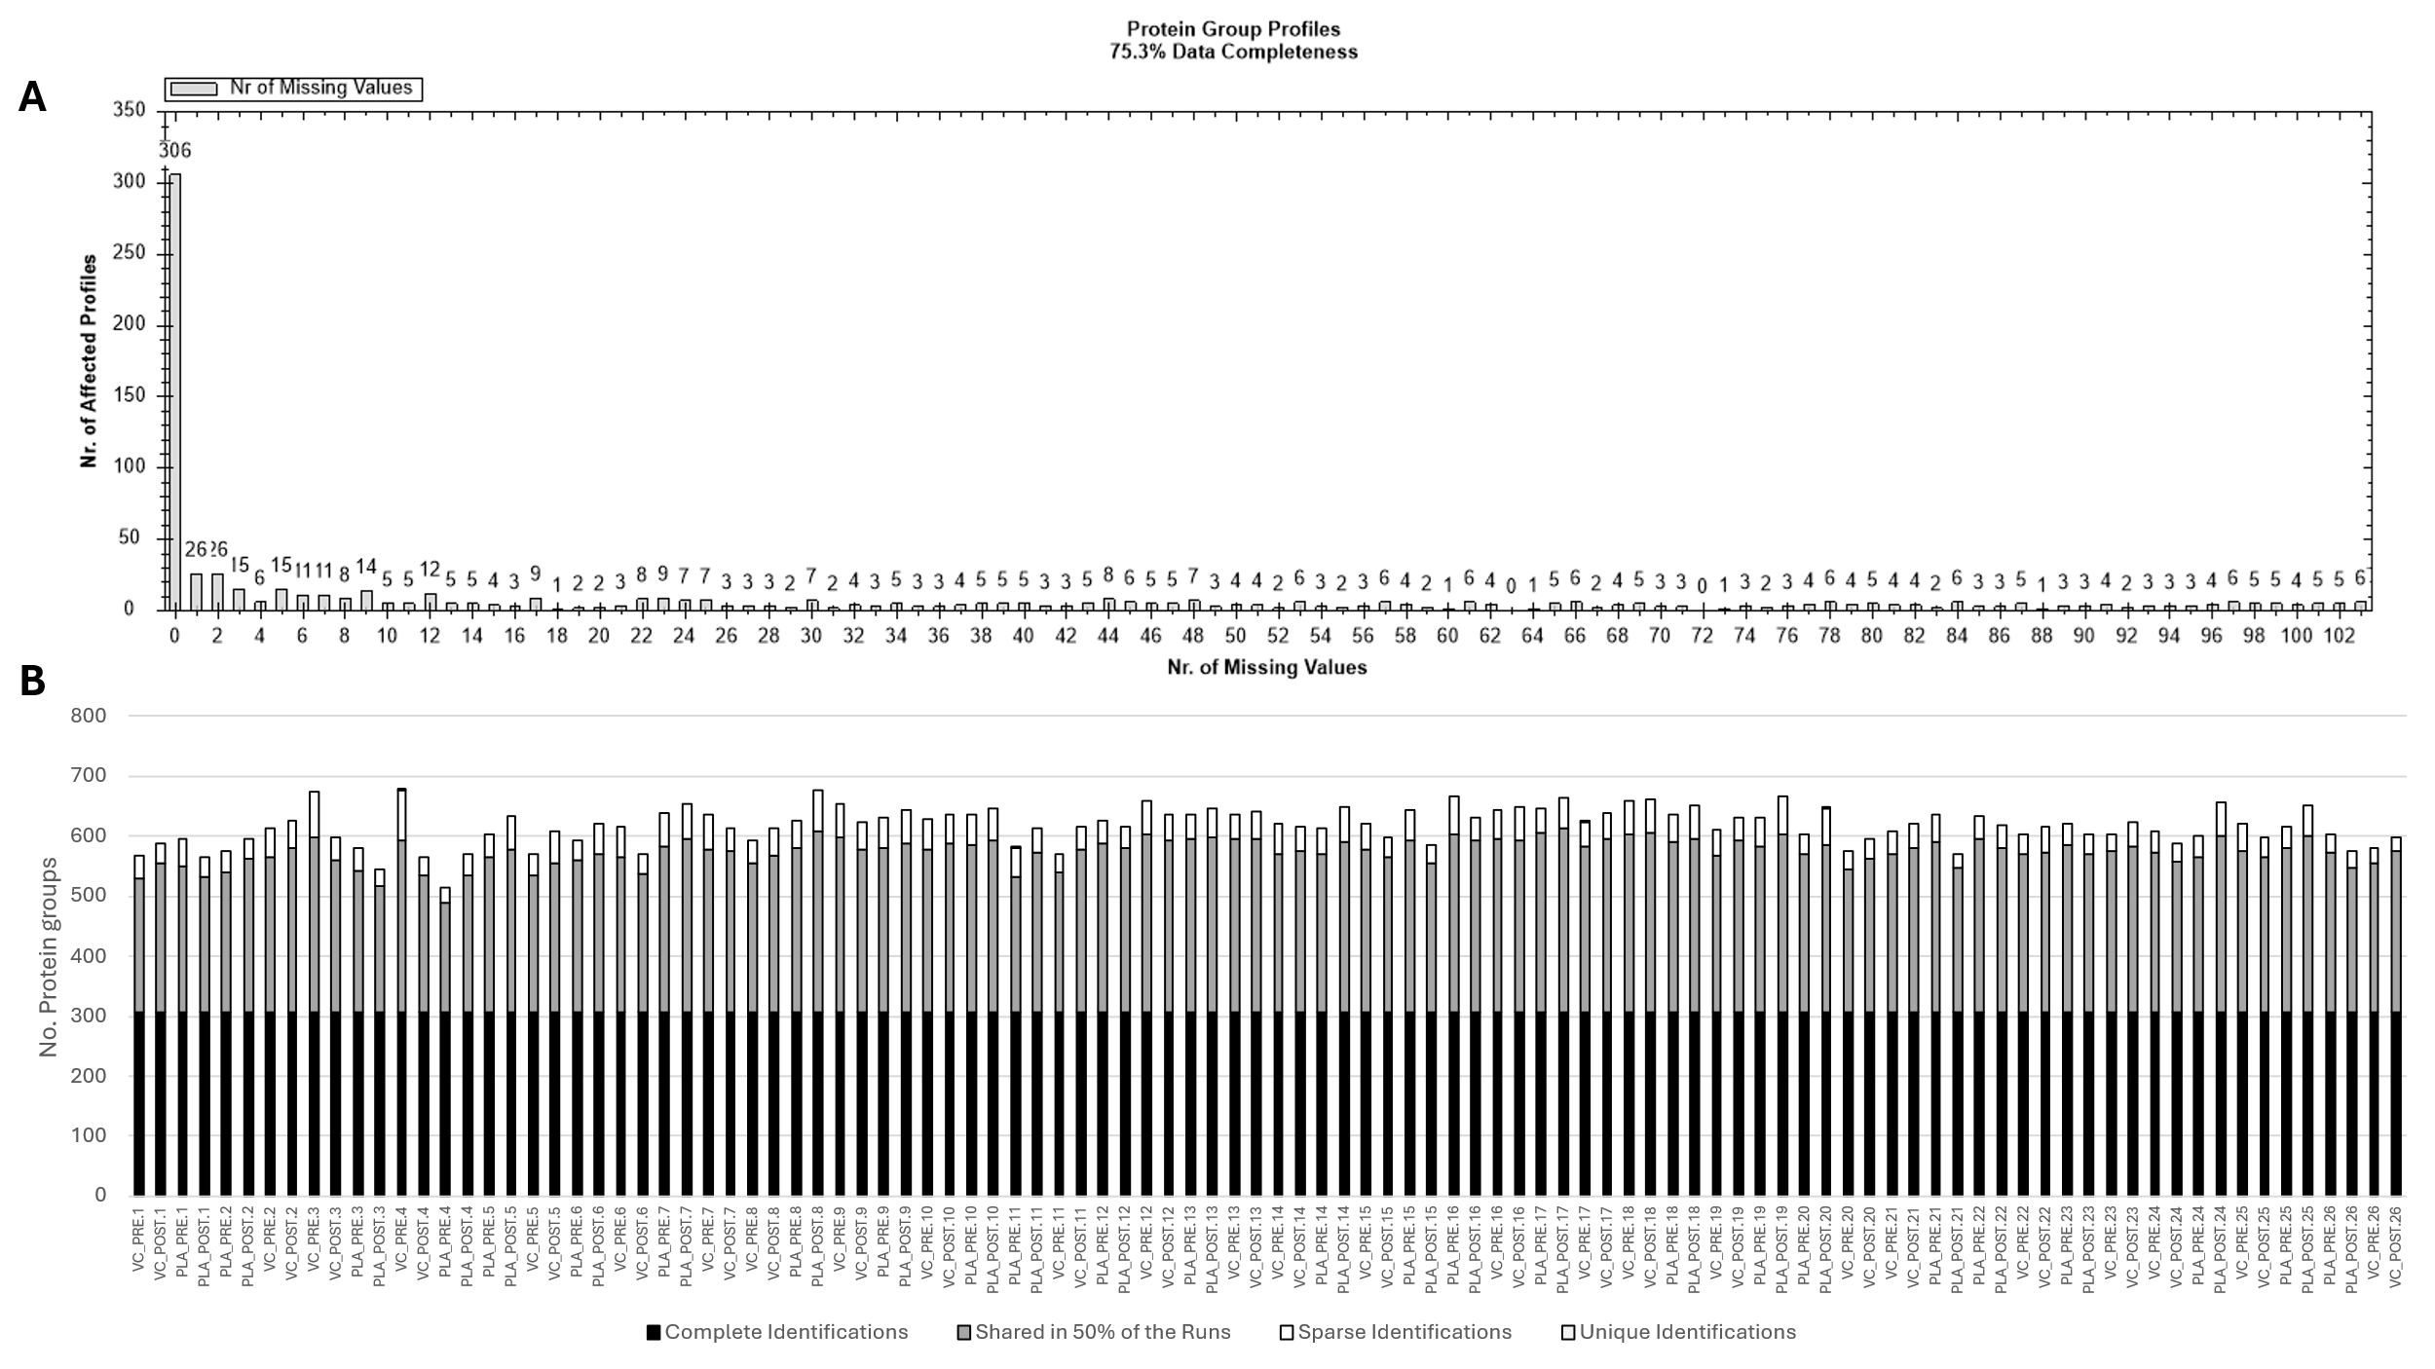
Figure S1. Protein group data completeness across samples showing missing data values (A) and number of protein groups found across all samples noting complete, 50% shared, sparse, and unique identifications (B) (Figure generated using Spectronaut v19.0).
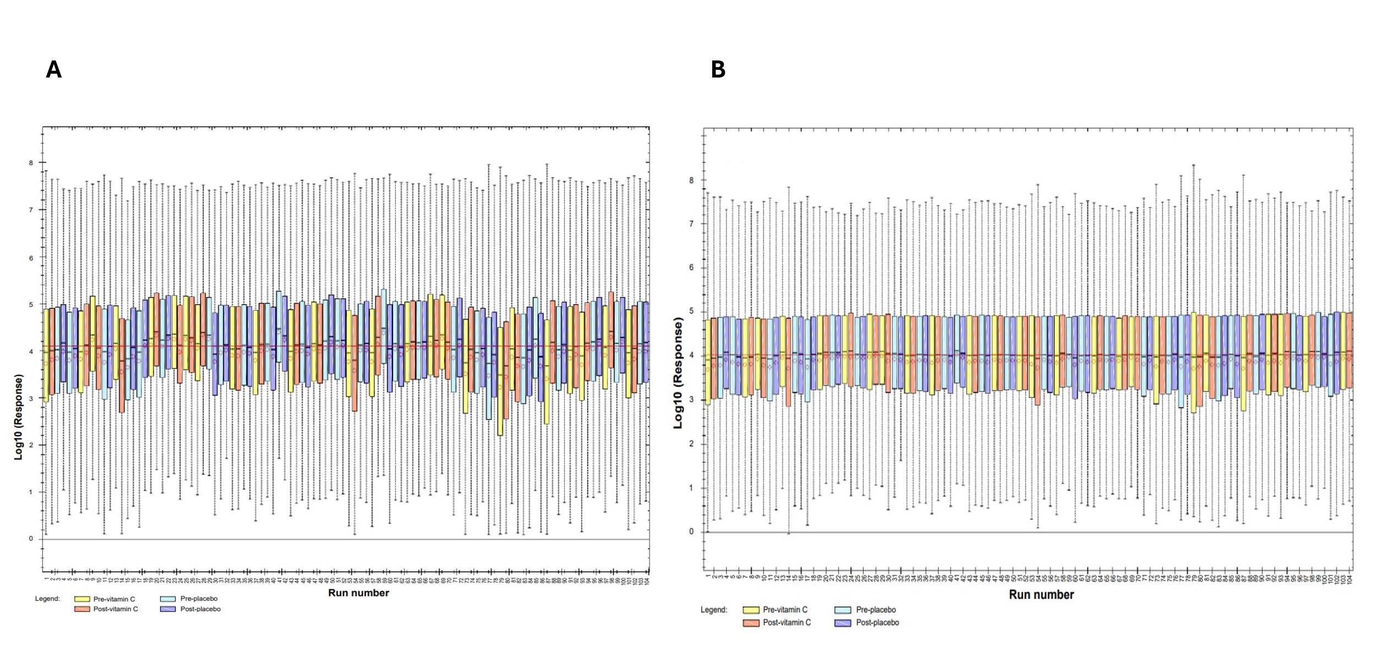
Figure S2. Original (A) and normalised (B) peptide signal responses across samples (Adapted figures generated using Spectronaut v19.0).
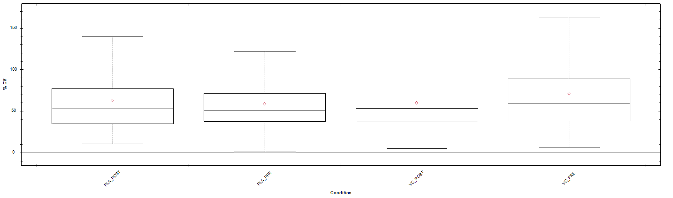
Figure S3. % Coefficient of Variation for each condition. Data shows median, mean, interquartile range, and range of data within each condition (Figure generated using Spectronaut v19.0).
Figure S4. Principal Component Analysis including comparison of all conditions (Figure generated using Spectronaut v19.0).

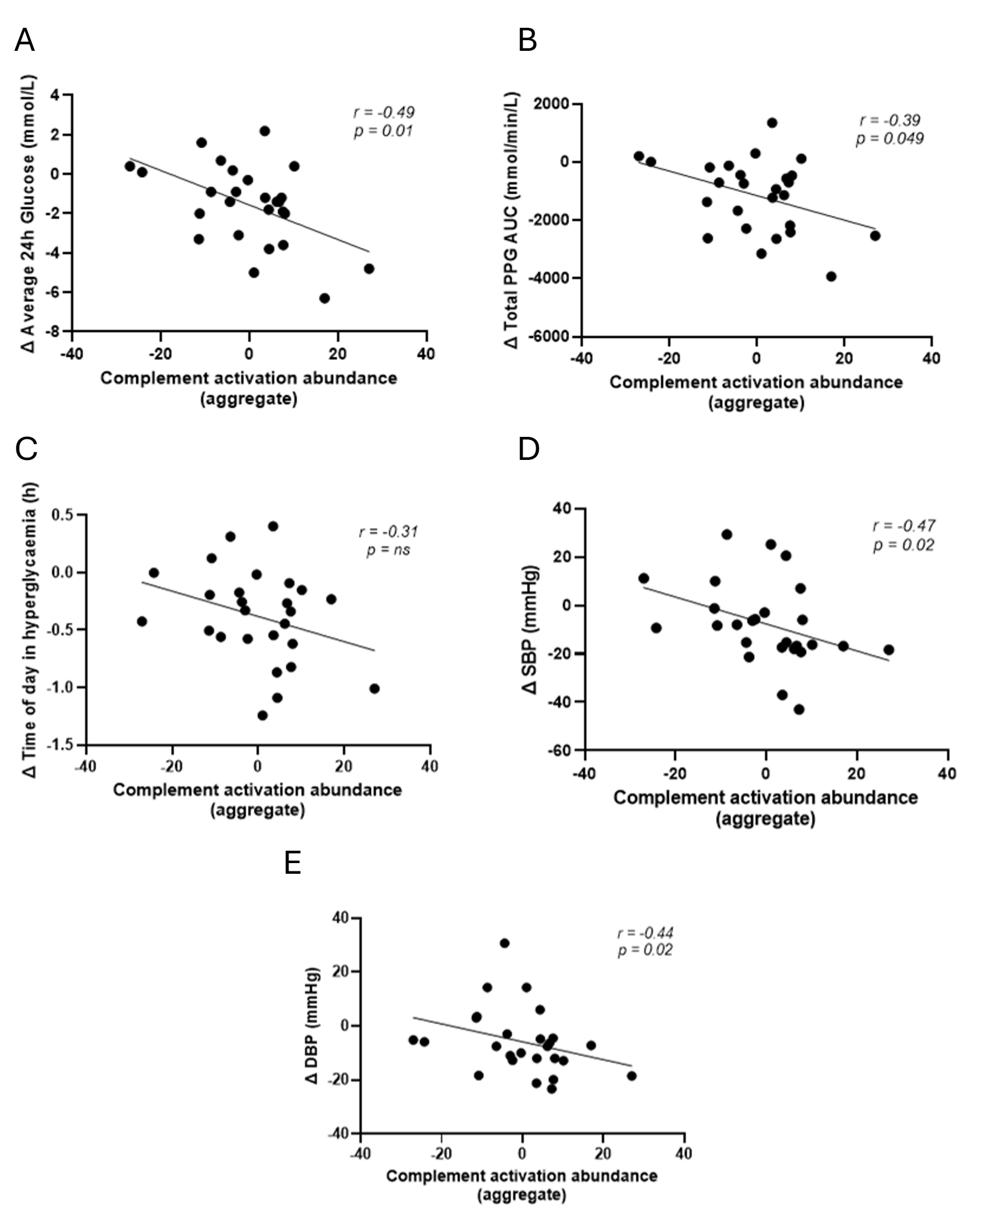
Figure S5. Correlations of aggregated protein abundance at baseline for enriched Gene Ontology term Complement activation (classical pathway; n=30 proteins) and clinical outcomes responsive to VC supplementation. Δ values represent treatment response (Δ VC supplementation minus Δ placebo supplementation); PPG AUC – postprandial glucose area under the curve; SBP – systolic blood pressure; DBP – diastolic blood pressure.

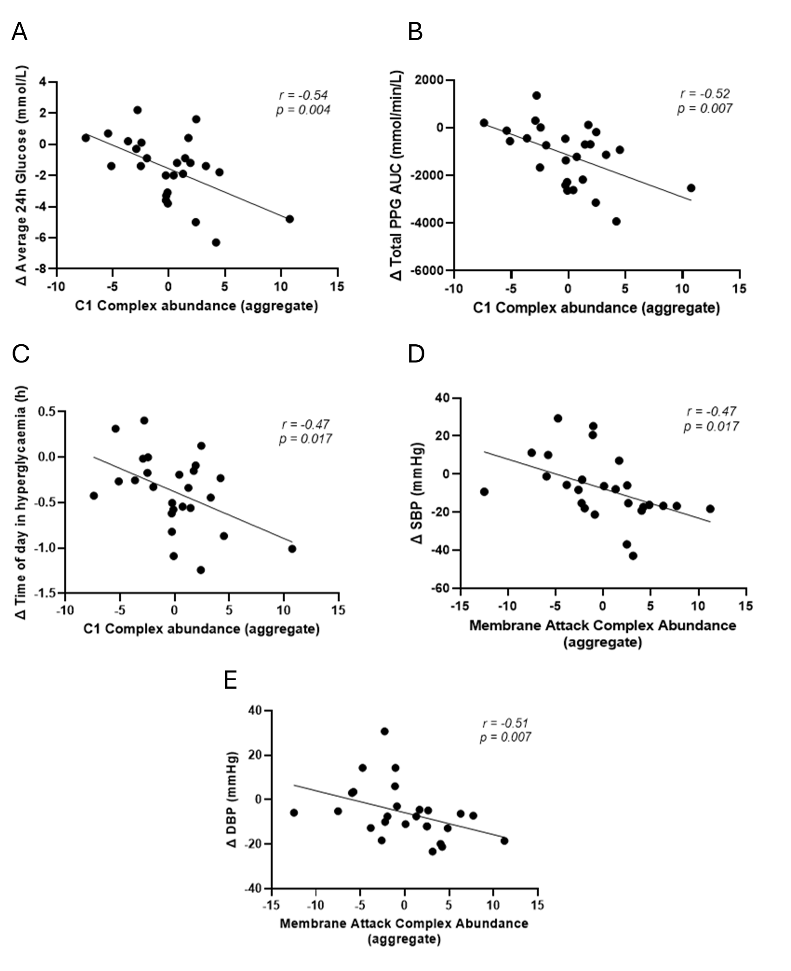 Figure S6. Correlation of aggregate protein abundance at baseline for GO term C1 complex abundance (n=5 proteins) and glycaemic-related clinical outcomes (A-C) and correlation of aggregate protein abundance at baseline for GO term Membrane attack complex (n=7 proteins) and blood pressure-related outcomes (D-E Δ values represent treatment response (Δ VC supplementation minus Δ placebo supplementation); PPG AUC – postprandial glucose area under the curve; SBP – systolic blood pressure; DBP – diastolic blood pressure.

