Supporting Information

Graphite from Pine Resin: Terpenes as Renewable Carbon Material Feedstocks

Abstract
Amid growing geopolitical vulnerabilities in the graphite supply chain and the urgent demand for transition to sustainable materials, technologies enabling the transition to renewable carbon precursors are critically needed. We report a novel method for synthesizing high-quality pitch from biomass, using rosin—a renewable resin derived from pine trees—as a molecular feedstock. Through a two-step chemical transformation involving deoxygenation and aromatization, followed by oligomerization, we successfully produced a synthetic pitch referred to as “green pitch.” This green pitch achieves an outstanding conversion yield of approximately 35%, and is free from nitrogen, sulphur, and ash. It exhibits excellent graphitization characteristics comparable to conventional fossil-derived pitches. The process enables a graphite yield of up to 15% from the original rosin, retaining 20% of its carbon content. Importantly, the approach is not limited to rosin; it is theoretically applicable to a wide range of terpenoid compounds, offering a versatile route to fossil-free pitch production. This work marks a decisive step toward sustainable carbon material manufacturing in the post-fossil fuel era, demonstrating the potential of biomass-derived terpenes as renewable feedstocks for advanced carbon materials.

Table of Contents
Experimental Procedure 3
Analysis 3
Electrochemical evaluation of graphite as LIB anode material 4

Scheme S1. Graphite making processes: conventional method, past trial using biomass, and novel method proposed in this work. 5
Scheme S2. Molecular conversions steps from rosin to Pitch by proposed reaction steps. 5
Figure S1. GC-MS spectrum of gum rosin, and chemical structures of identified major compounds. 6
Figure S2. ¹H-NMR spectrum of each sample. 7
Figure S3. ¹³C-NMR spectra of pitch. 7
Figure S4. LDI-TOF MS spectra of pitch and molecular models estimated. 8
Figure S5. ¹H NMR chemical shift (ppm) predicted for Model 1, 2, and 3. 8
Figure S6. ¹³C NMR chemical shifts (ppm) predicted for Model 1, 2, and 3. 8

Figure S7. Charge-discharge curve of synthesized graphite at the 5th cycle, measured at 0.05 C in a voltage range of 0–1.5 V.
Table S1. Elemental distributions of pitch analysed (Exp.) and constructed models (Cal.). 9

References 10

Experimental Procedure
Analysis
Elemental analysis (C, H, N, S) was performed using CHNS analyser (FLASH2000; Thermo Fisher Scientific). Ash content was measured using CHN analyser (MT-6; Yanako). ¹H, ¹³C, and ¹⁹F NMR spectra of chloroform-d solution were recorded at room temperature on a 500 MHz instrument (ECA-500; JEOL Ltd.). Chemical shifts were referenced to residual solvent peaks (δ in parts per million (ppm) CHCl₃ ¹H: 7.26 ppm; ¹³C: 77.0 ppm). Gas chromatography-mass spectrum of gum rosin was recorded on a GC-MS instrument (7820A-5977E; Agilent Technologies, Inc.) with a injector (EGA/PY-3030D; Frontier Laboratories Ltd.) at 300 °C and a column (DB-5MS; Agilent Technologies, Inc.) heated from 70 to 320 °C in 25 min. High-resolution mass spectra were recorded on an instrument (JMS-S3000, MALDI-SpiralTOF-MS; JEOL Ltd.) without matrix. FT-IR spectra were recorded on an FTIR instrument (FTIR-4000; JASCO) using KBr plates method.
Chemical structure of pitch was estimated based on the Brown−Ladner method.^{[18-20]} Using the NMR results, hydrogens are classified into aromatic hydrogen (H_{a}, 10.0-6.0 ppm), olefin hydrogen (H_{O,} 6.0-5.0 ppm), hydrogens bonded to aliphatic carbons in the α position of an aromatic ring (H_{α}, 5.0-2.0 ppm), hydrogens attached to methyl groups in long side chains (H_{γ}, 1.0-0.5 ppm), and other aliphatic and naphthenic hydrogens (H_{β}, 2.0-1.0 ppm)). Aromatic carbons (C_{a}, 200-90 ppm) are quantified by inverse gated decoupling (NNE) method, divided into aromatic tertiary carbon (C_{ah}) by distortion less enhancement by polarization transfer with 90 degrees pulse (DEPT-90) method, and aromatic quaternary carbon (C_{aq}) by quaternary-only carbon (QUAT) method. Presence of aliphatic hydroxyl group (-OH) was confirmed by ¹⁹F NMR after trifluoroacetylation using trifluoroacetic anhydride. LDI-TOF MS analysis of the pitch revealed three broad peaks in molecular weight distribution at around 478, 678, and 887 g/mol. Accordingly, we constructed molecular models that accurately reflect the analytical values corresponding to each peak. Each molecular structure was constructed with the assistance of chemical shift prediction software (ChemDraw 22.2.0; PerkinElmer Infomatics, Inc.).
Thermogravimetric analysis was performed using a thermobalance (DTG-60AH; Shimadzu Co.) in a stream of nitrogen at 100 mL/min. The sample (~2 mg) was heated up to 900 °C at a heating rate of 10 °C/min. Thermomechanical analysis was performed using a thermomechanical analyser (TMA-60; Shimadzu Co.) under nitrogen atmosphere. The sample (~10 mg) was heated up to 400 °C at a heating rate of 5 °C/min with 1g of load.
Appearance of pitch during heating up under a nitrogen atmosphere at a heating rate of 10 °C/min was recorded using a digital microscope (L-836; HOZAN Co., Ltd.) and a hot stage (10016; Linkam Scientific Instruments). Pitch was heated to 380 °C on a glass container under a nitrogen atmosphere to induce melting and held at this temperature for 1 h. After cooling to room temperature, the sample was examined using polarized optical microscopy (VHX-900; Keyence) equipped with a sensitive colour plate. Observations were performed from the underside of the glass container, opposite to the surface on which the pitch was placed, using the crossed-Nicols method to evaluate optical anisotropy and mesophase structure.
The pitch was carbonized at 900 °C and then graphitized at 2800 °C under an argon atmosphere. X-ray diffraction (XRD) profile and Raman spectrum of the graphitized sample were recorded using a XRD instrument (D8 Advance; Bruker) with 0.15418 nm of wavelength and Raman spectrometer (inVia; Renishaw) with 514.5 nm of wavelength, respectively. XRD profile was analysed to determine interlayer spacing (d₀₀₂, d₀₀₄) and crystallite size (Lc₀₀₂, Lc₀₀₄) of graphite in accordance with a standard method ^{[21]}, following JIS K0131:1996. True density of graphite was measured using an instrument (BELPYCNO; MicrotracBEL Corp.).

Electrochemical evaluation of graphite as LIB anode material
Graphite powders were mixed with 5 wt% carbon black (Denka Company Ltd.), 2 wt% carboxymethyl cellulose (D2200, Daicel FineChem Ltd.) and 3 wt% styrene–butadiene rubber (BM-400B, Zeon Co.) in distilled water to prepare a slurry. The slurry was coated onto a 0.02 mm thick Cu foil using the doctor blade method. The carbon electrodes (10 mm diameter, 0.02–0.06 mm thickness) were dried under vacuum at 120 °C overnight. The electrodes and separators (Celgard 2400) were soaked for 30 min in ethylene carbonate and diethyl carbonate (1:1 v/v) containing 1 M lithium hexafluorophosphate (1 M LiPF₆/EC-DEC, Kishida Chemical Co., Ltd.). Coin-type cells were assembled using a Li foil as the counter electrode. Charge-discharge tests were conducted at room temperature in a voltage range of 0–1.5 V using a multichannel galvanostat-potentiostat (VMP3; BioLogic).

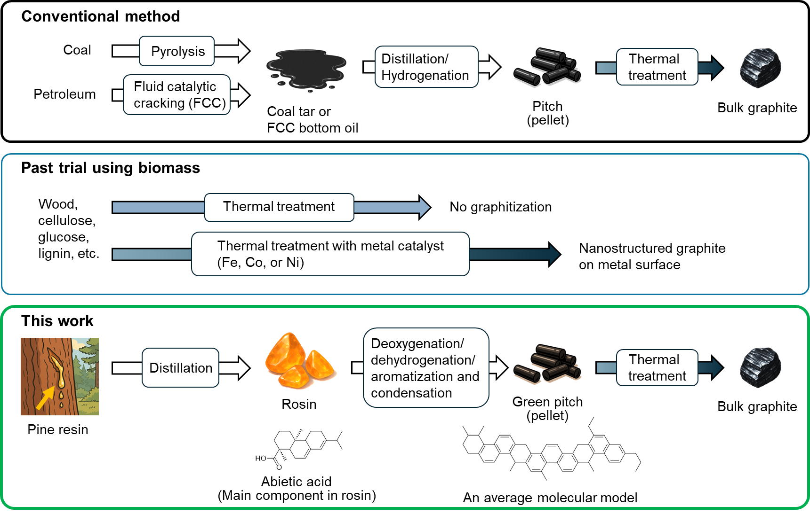
Scheme S1. Graphite making processes: conventional method, past trial using biomass, and novel method proposed in this work.

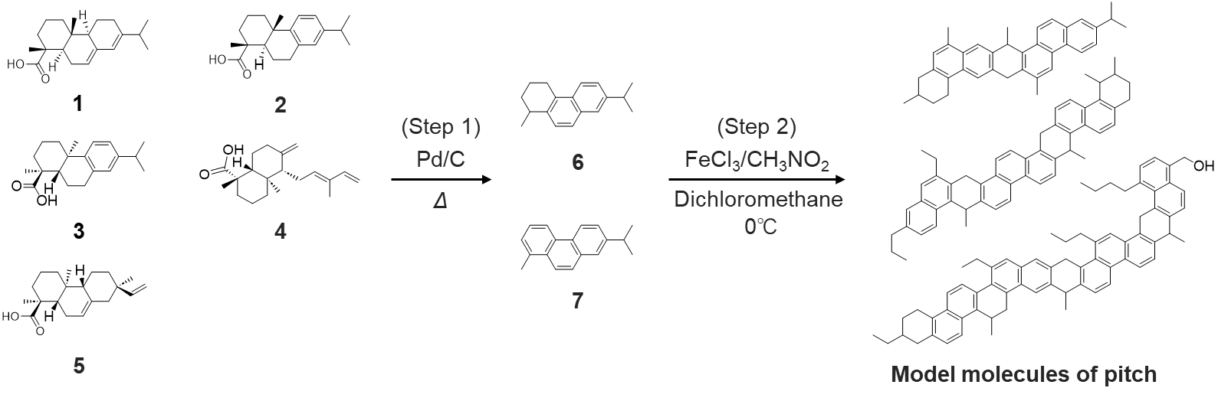
Scheme 2. Molecular conversions steps from rosin to Pitch by proposed reaction steps. Main components in gum rosin, determined using GC-MS: abietic acid (1), dehydroabietic acid (2), 1-phenanthrenecarboxylic acid, 1,2,3,4,4a,9,10,10a-octahydro-1,4a-dimethyl-7-(1-methylethyl)-, [1S-(1α,4aβ,10aβ)]- (3), communic acid (4), and isopimaric acid (5). Main components in Step 1 product: 1,2,3,4-tetrahydro-1-methyl-7-(1-methylethyl)phenanthrene (6) and retene (7). Model molecules of Pitch estimated using CHNS (Figure 1c), ¹H NMR (Figures S2, S5), ¹³C NMR (Figure S3, S6), and LDI-TOF MS (Figure S4).

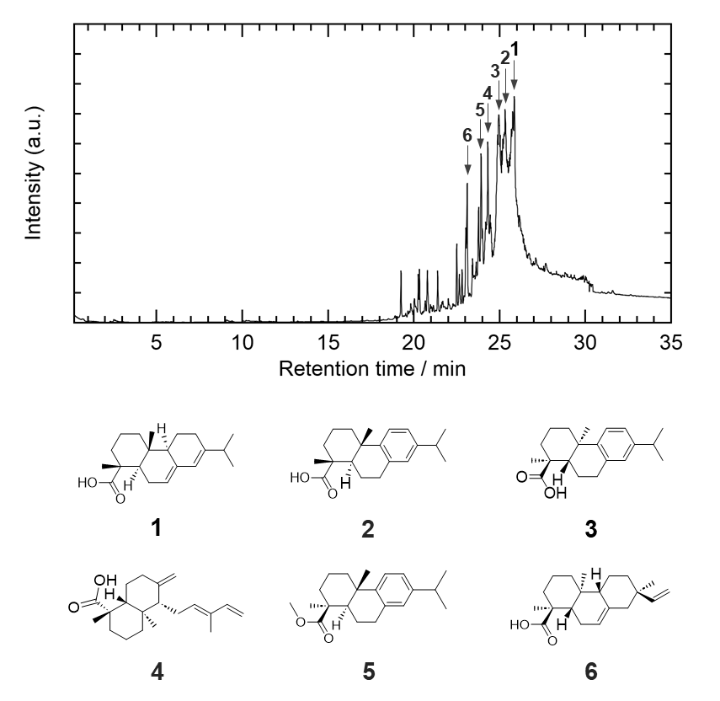
Figure S1. GC-MS spectrum of gum rosin, and chemical structures of identified major compounds: abietic acid (1), dehydroabietic acid (2), 1-phenanthrenecarboxylic acid, 1,2,3,4,4a,9,10,10a-octahydro-1,4a-dimethyl-7-(1-methylethyl)-, [1S-(1.alpha.,4a.alpha.,10a.beta.)]- (3), communic acid (4), methyl dehydroabietate (5), isopimaric acid (6).

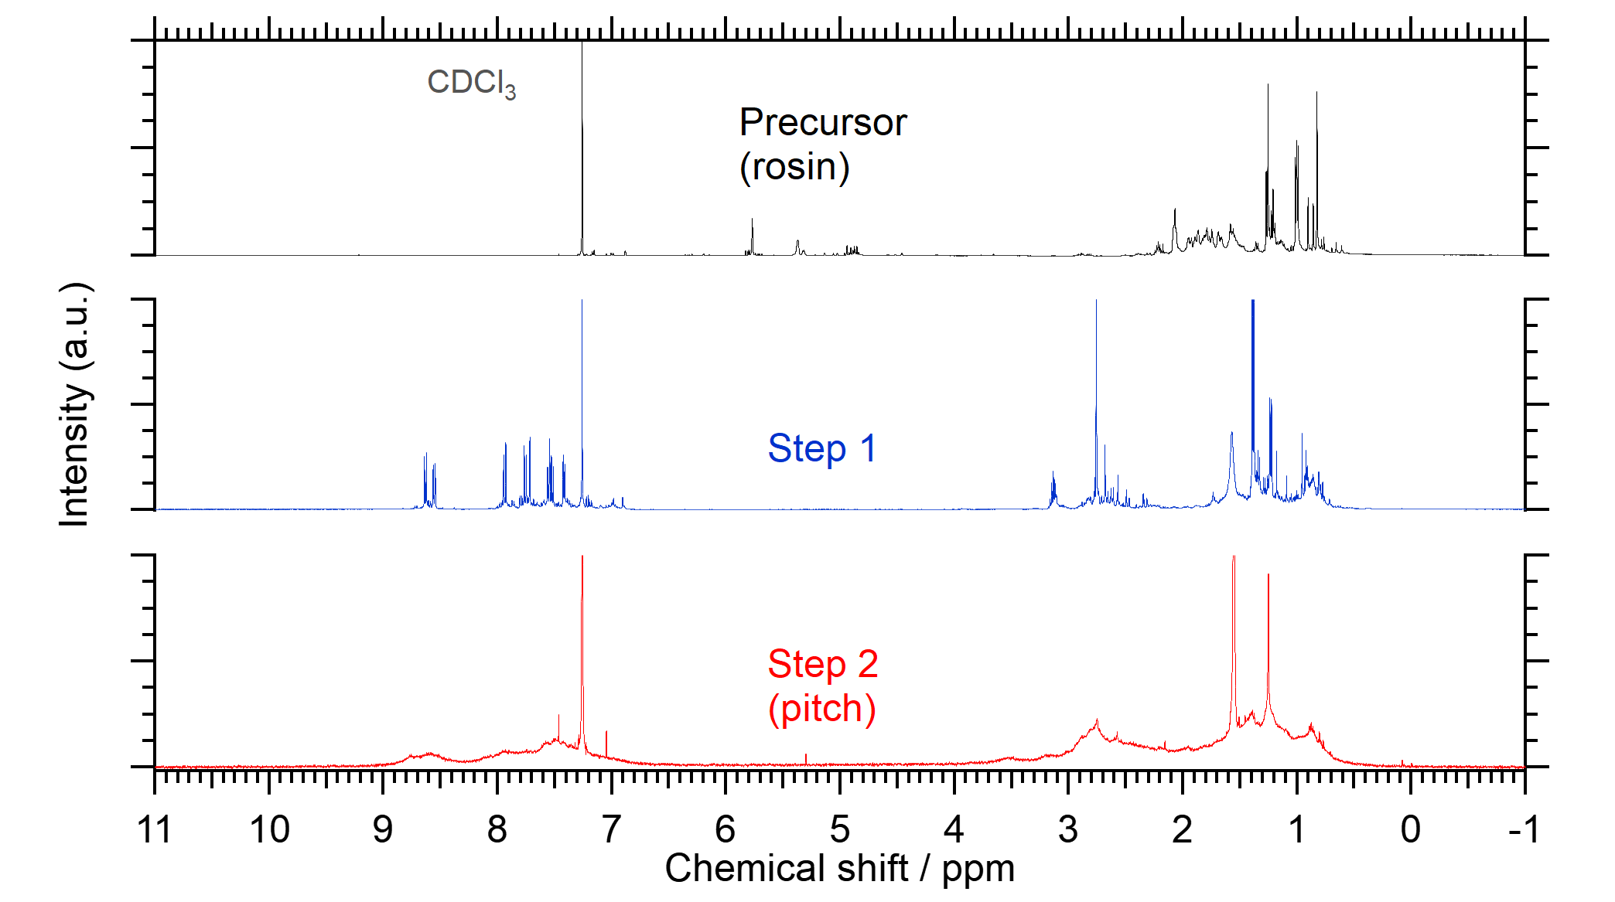
Figure S2. ¹H-NMR spectrum of each sample.
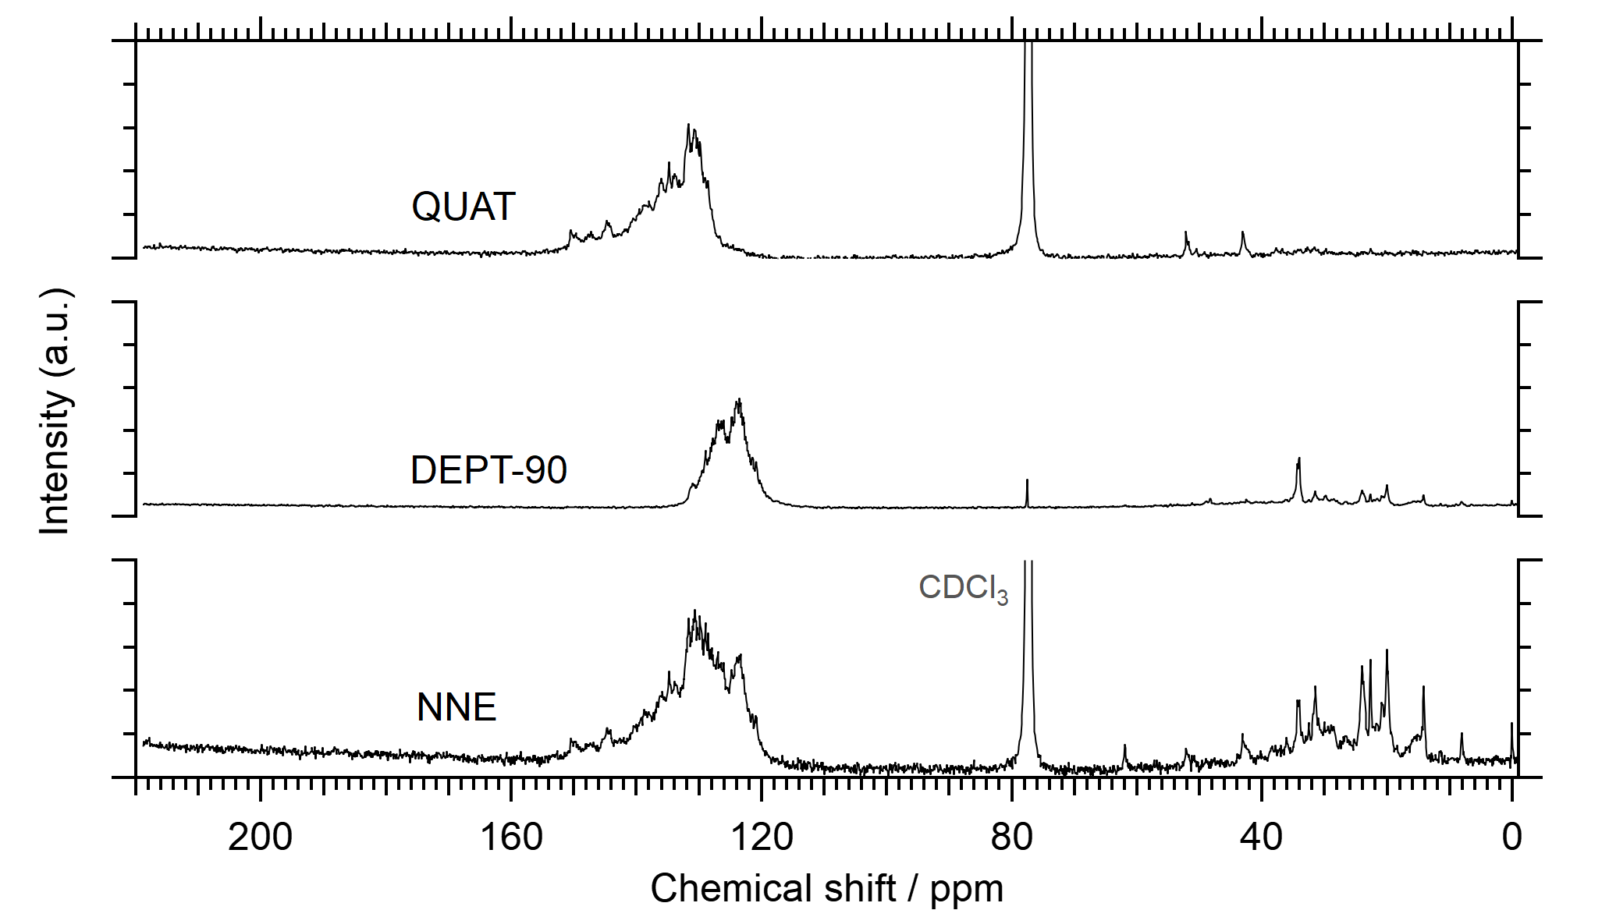
Figure S3. ¹³C-NMR spectra of pitch using inverse gated decoupling (NNE), distortion less enhancement by polarization transfer with 90 degrees pulse (DEPT-90), and quaternary-only carbon (QUAT) methods.

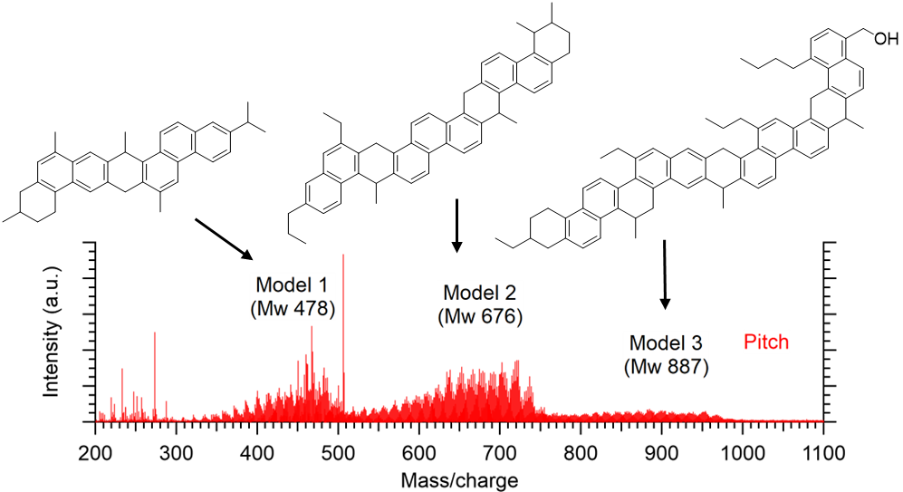
Figure S4. LDI-TOF MS spectra of pitch and molecular models estimated. The amounts of Models 1, 2, and 3 are approximately 4:7:1, which satisfies the analytical results.

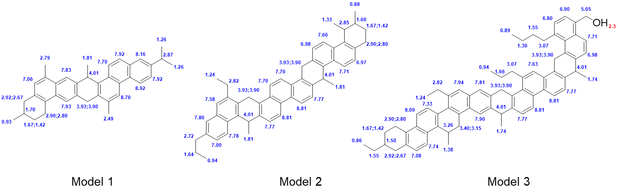
Figure S5. ¹H NMR chemical shift (ppm) predicted for Model 1, 2, and 3. Estimation quality is indicated by colour: good, rough.

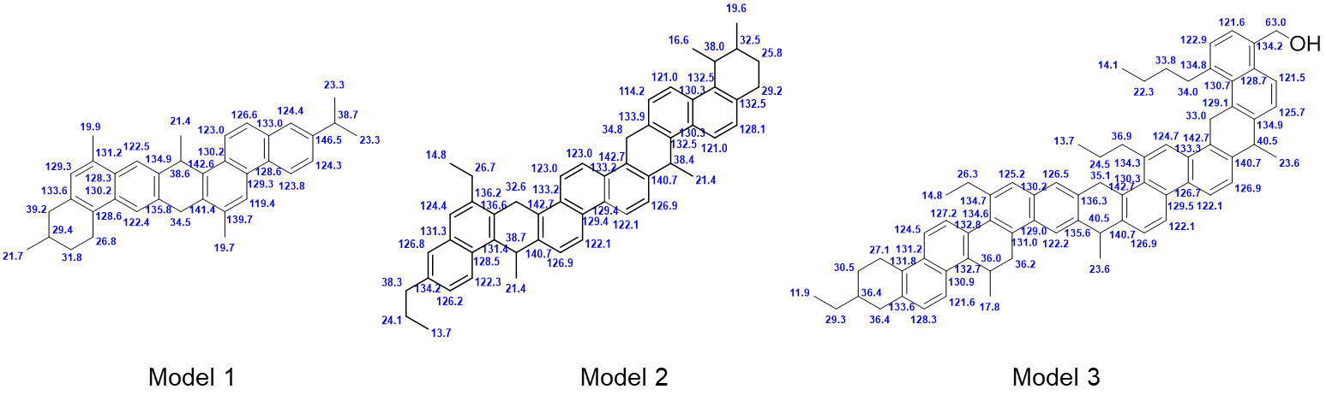
Figure S6. ¹³C NMR chemical shifts (ppm) predicted for Model 1, 2, and 3. Estimation quality is indicated by colour: good.

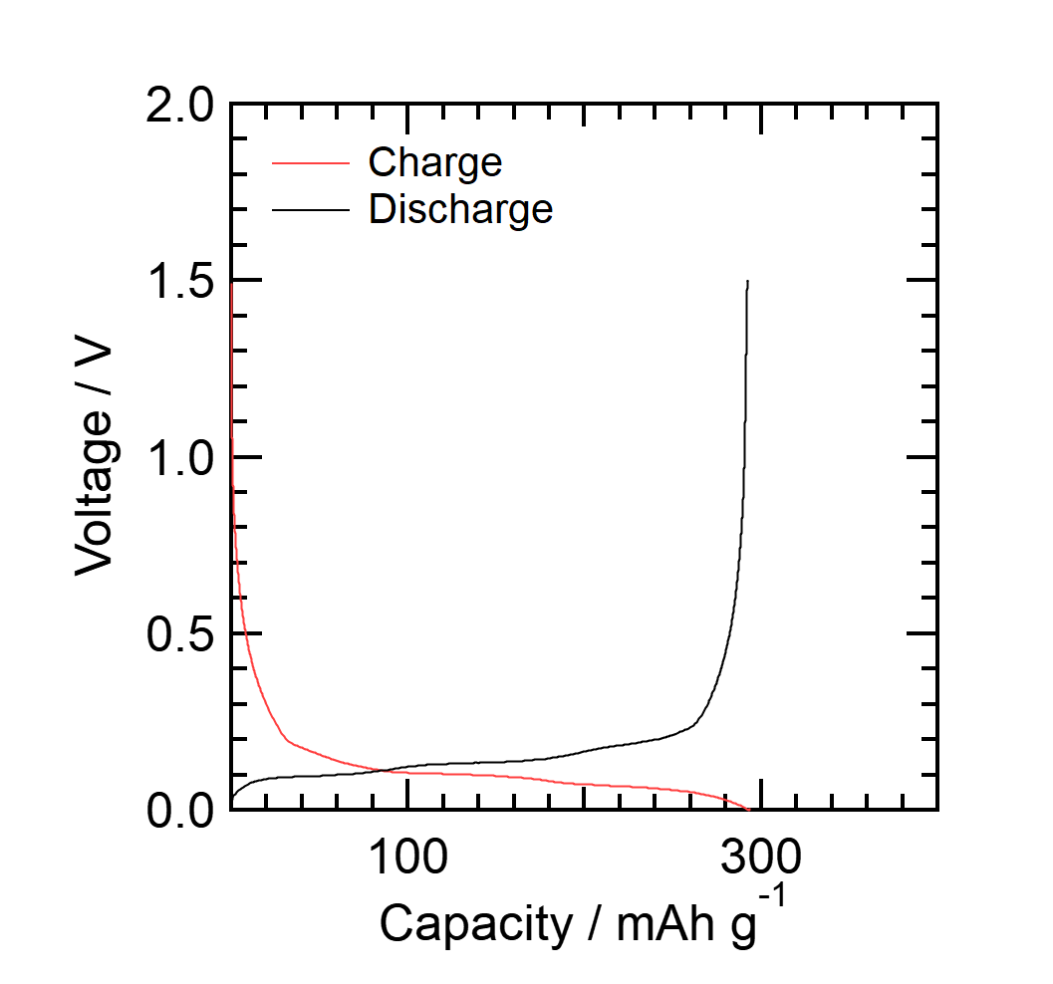
Figure S7. Charge-discharge curve of synthesized graphite at the 5th cycle, measured at 0.05 C in a voltage range of 0–1.5 V.

Table S1. Elemental distributions and molecular weights of experimental data (Exp.) and Models 1 to 3, and calculated values based on model fractions (Cal.).
 | Exp. | Cal. | Model 1 | Model 2 | Model 3
Fraction |  | 1.0 | 0.32 | 0.58 | 0.08
Number of elements
C | 47.5 | 47.5 | 36 | 52 | 68
H | 47.7 | 47.6 | 36 | 52 | 70
N | 0 | 0 | 0 | 0 | 0
S | 0 | 0 | 0 | 0 | 0
O | 0.8 | 0.1 | 0 | 0 | 1
Elemental type distribution
C_{a} | 29.8 | 31.1 | 24 | 34 | 44
C_{ah} | 10.9 | 12.4 | 9 | 14 | 16
C_{aq} | 18.9 | 18.8 | 15 | 20 | 28
H_{a} | 11.7 | 12.4 | 9 | 14 | 16
H_{α} | 14.4 | 14.7 | 13 | 15 | 22
H_{β} | 16.1 | 15.3 | 11 | 17 | 23
H_{γ} | 5.6 | 5.2 | 3 | 6 | 9
Molecular weight | 618 | 618 | 468 | 676 | 887
Number of aromatic carbons (C_{a}), aromatic tertiary carbons (C_{ah}), aromatic quaternary carbons (C_{aq}), aromatic hydrogens (H_{a}), hydrogens bonded to aliphatic carbons in the α position of an aromatic ring (H_{α}), hydrogens attached to methyl groups in long side chains (H_{γ}), and other aliphatic and naphthenic hydrogens. (H_{β}).

References
[12] R. G. R. Bacon, R. S. Irwin, “472. Thiocyanogen, thiocyanates, and isothiocyanates. Part I. Homolytic substitution in arylalkyl hydrocarbons by thiocyanogen” Journal of the Chemical Society (Resumed) 1961, 2447-2454.
[13] A. A. O. Sarhan, C. Bolm, “Iron(iii) chloride in oxidative C–C coupling reactions” Chemical Society Reviews 2009, 38, 2730-2744.
[18] J. K. Brown, W. R. Ladner, “A study of the hydrogen distribution in coal-like materials by high-resolution nuclear magnetic resonance spectroscopy. II. A comparison with infrared measurement and the conversion to carbon structure” Fuel 1960, 39, 87-96.
[19] E. Hirsch, K. H. Altgelt, “Integrated structural analysis. Method for the determination of average structural parameters of petroleum heavy ends” Analytical Chemistry 1970, 42, 1330-1339.
[20] S. Sato, PETROTECH 2010, 33, 581-588 (in Japanese).
[21] The 117 Committee of the Japan Society for the Promotion of Sciences, “Procedure for the measurements of lattice parameters and crystallite sizes of carbon materials by X-ray diffraction” TANSO 2006, 221, 52-60 (in Japanese).

