Table 1: Training Loop for CNN
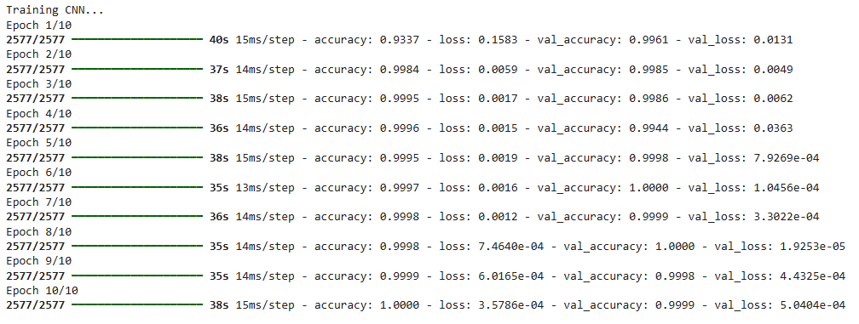

Table 2: Evaluation Report for CNN
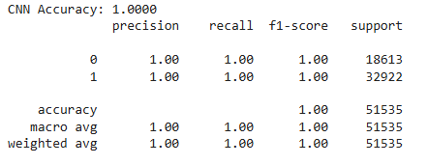

Table 3: Training Loop for LSTM
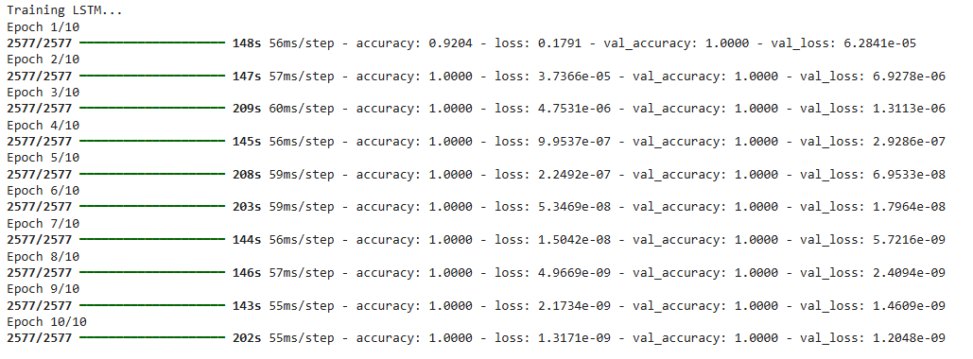

Table 4: Evaluation Report for LSTM
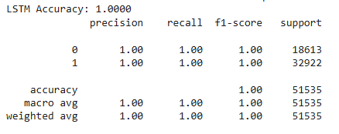

Table 5: Training Loop for Transformer
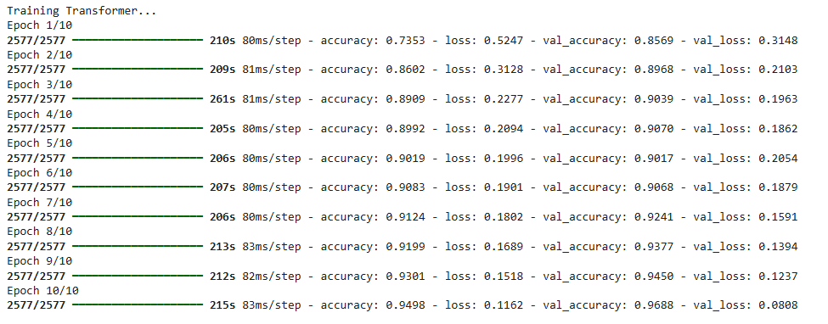

Table 6: Evaluation Report for Transformer
