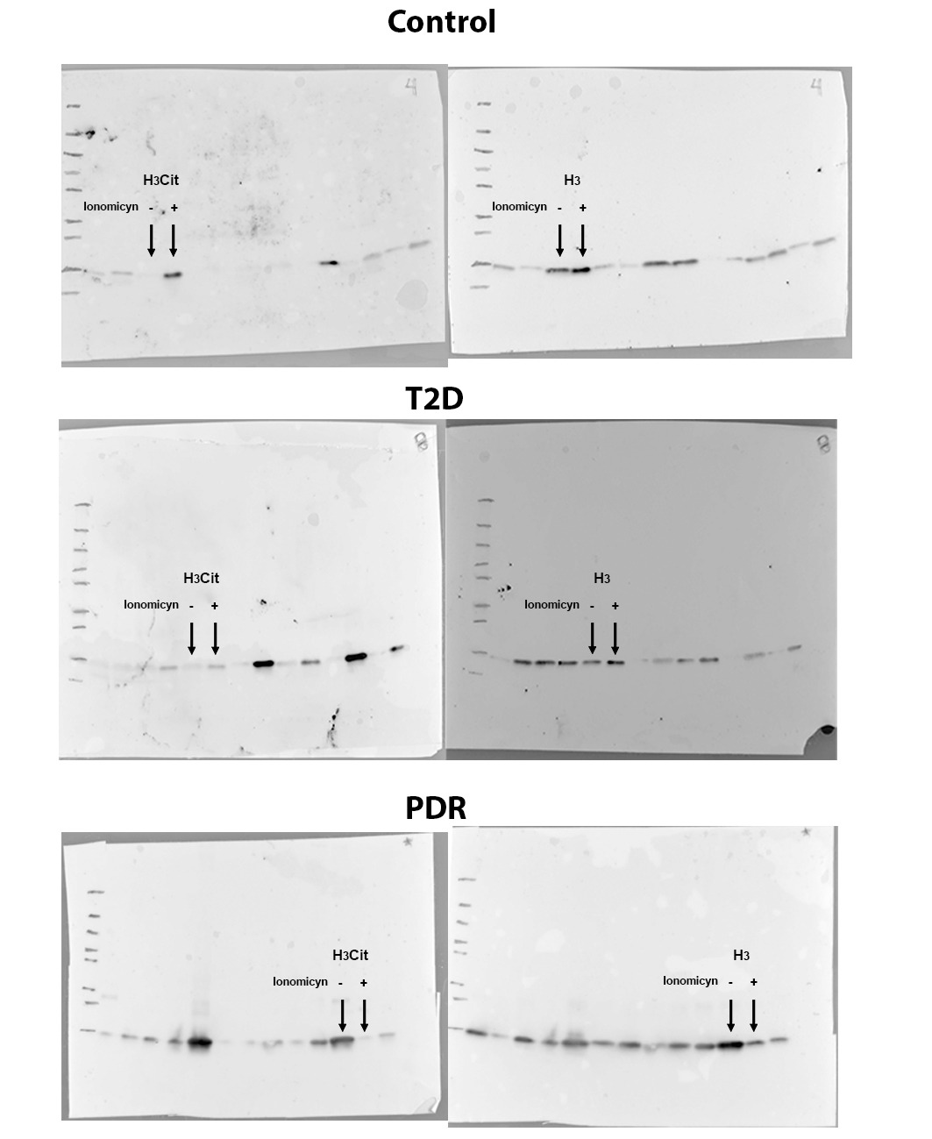
Supplementary Figure 1.
Representative uncropped Blots images showing the expression of citrullinated histone H3 (H3Cit) and total histone H3 (H3) in peripheral neutrophils under non-stimulated (NS) and stimulated (S, ionomycin-treated) conditions from control subjects, individuals with T2D (T2D, without diabetic retinopathy), and patients with proliferative diabetic retinopathy (PDR).

