Supplementary Information
Table S1. Discovery Cohort. Summary of demographic and clinical features for patients with HNSCC (n=39) and control participants (n=17) included in the discovery phase of the study.
 | Patients with HNSCC (n=39) | Controls (n=17)
Age (years) | 69.5 | 60.7
Sex(M/F) | 32/7 | 11/6
Subsite
Oral Cavity | 12
Larynx | 10
Oropharynx | 6
Hypopharynx | 6
Others | 5
TNM staging
T1-2 | 10
T3-4 | 10
N0 | 13
N+ | 7
Stage I-II | 11
Stage III-IV | 9
HPV
+ | 4
- | 19

Table S2. Validation Cohort. Summary of demographic and clinical features for patients with HNSCC (n=39) and control participants (n=17) included in the validation phase of the study.
 | Patients with HNSCC (n=69) | Controls (n=25)
Age (years) | 69 (22-91) | 59.04 (40-80)
Sex(M/F) | 57/12 | 17/8
Subsite
Oral Cavity | 17
Larynx | 13
Oropharynx | 18
Hypopharynx | 13
Others | 8
TNM staging
T1-2 | 42
T3-4 | 26
N0 | 31
N+ | 37
Stage I-II | 23 (12/11)
Stage III-IV | 45 (4/41)
HPV
+ | 7
- | 11

Table S3. Comparison of quality control (QC) pass rates between the ultracentrifugation (UC) and hydrogel-based exosome isolation methods. The table summarizes the number of samples enrolled, passed, and excluded, along with the final sample analysis success rate for the discovery cohort (UC) and the validation cohort (Hydrogel).
Characteristic | Discovery Cohort (UC) | Validation Cohort (Hydrogel)
Initial Samples Enrolled (n) | 56 | 94
Samples Passing QC (n) | 32 | 86
Samples Excluded (n) | 24 | 8
Pass Rate (%) | 57.1% | 91.5%

Figure S1. Relative expression of the five validated candidate miRNAs in patients with HNSCC compared between metastasis-positive (N+) and metastasis-negative (N0) groups in the validation cohort. Statistical significance was determined by Mann-Whitney U-test. *p < 0.05; ns, not significant.
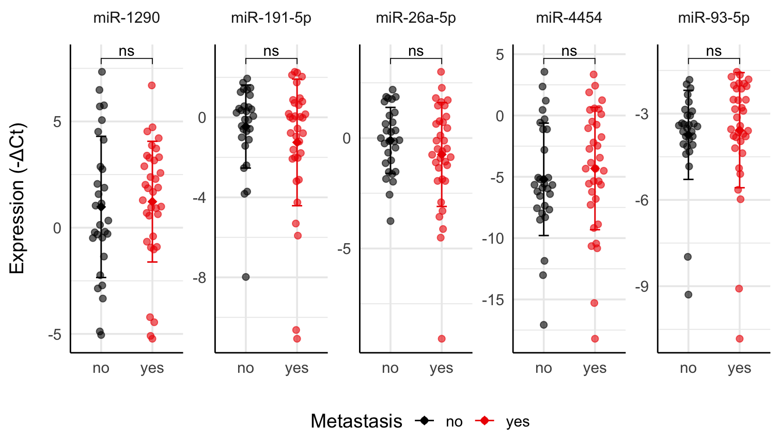

Table S4. Diagnostic performance of single and combined salivary exosomal miRNA panels. ROC curve analysis was performed to distinguish patients with HNSCC from controls using individual miRNAs and all possible combinations up to a five-marker panel. This table lists the area under the curve (AUC), 95% confidence interval (CI), and p-values for each combination. The markers were coded as follows: (a) miR-1290, (b) miR-191-5p, (c) miR-26a-5p, (d) miR-4454, and (e) miR-93-5p. *p < 0.05, **p < 0.01, ***p < 0.001, ****p < 0.0001; ns, not significant.
Combination | AUC | CI_lower | CI_upper | p.value | significance
Single markers
miR-1290, (A) | 0.494824 | 0.360994 | 0.628654 | 0.562 | ns
miR-191-5p, (B) | 0.518979 | 0.377538 | 0.660419 | 0.408 | ns
miR-26a-5p, (C) | 0.687371 | 0.563016 | 0.811725 | 0.001 | **
miR-4454, (D) | 0.529331 | 0.399275 | 0.659386 | 0.313 | ns
miR-93-5p, (E) | 0.574879 | 0.435238 | 0.714521 | 0.136 | ns
Two-marker panel
A + D | 0.518979 | 0.365251 | 0.672707 | 0.373 | ns
A + B | 0.510007 | 0.362444 | 0.657569 | 0.444 | ns
B + D | 0.532091 | 0.397314 | 0.666868 | 0.322 | ns
A + C | 0.68668 | 0.562613 | 0.810748 | 0.002 | **
B + C | 0.73775 | 0.613844 | 0.861657 | 0.002 | **
C + D | 0.687371 | 0.563016 | 0.811725 | 0.002 | **
A + E | 0.604555 | 0.465282 | 0.743828 | 0.064 | ns
B + E | 0.529331 | 0.38376 | 0.674901 | 0.33 | ns
C + E | 0.701863 | 0.576255 | 0.827472 | 0.001 | **
D + E | 0.555556 | 0.420284 | 0.690827 | 0.218 | ns
Three-marker panel
A + B + D | 0.515528 | 0.359323 | 0.671733 | 0.408 | ns
A + C + D | 0.68461 | 0.560808 | 0.808413 | 0.001 | **
A + B + C | 0.739821 | 0.614805 | 0.864836 | <0.001 | ***
B + C + D | 0.741201 | 0.618944 | 0.863457 | <0.001 | ***
A + D + E | 0.575569 | 0.431034 | 0.720105 | 0.144 | ns
A + B + E | 0.536232 | 0.388684 | 0.68378 | 0.324 | ns
B + D + E | 0.52864 | 0.388603 | 0.668678 | 0.391 | ns
A + C + E | 0.706004 | 0.58156 | 0.830449 | 0.001 | **
B + C + E | 0.748102 | 0.625065 | 0.871139 | <0.0001 | ***
C + D + E | 0.710145 | 0.586665 | 0.833625 | 0.003 | **
Four-marker panel
A + B + C + D | 0.740511 | 0.619087 | 0.861934 | <0.0001 | ***
A + B + D + E | 0.531401 | 0.380537 | 0.682265 | 0.324 | ns
A + C + D + E | 0.711525 | 0.588054 | 0.834996 | 0.003 | **
A + B + C + E | 0.745342 | 0.620002 | 0.870682 | <0.0001 | ***
B + C + D + E | 0.752933 | 0.631691 | 0.874175 | <0.0001 | ***
Five-marker panel
A + B + C + D + E | 0.756384 | 0.635682 | 0.877085 | <0.0001 | ***

Figure S2. Expression of salivary exosomal miR-26a-5p according to clinical stage in the HNSCC cohort. Comparison of miR-26a-5p expression levels stratified by T stage (T1-2 vs. T3-4), N stage (N0 vs. N+), and overall cancer stage (I-II vs. III-IV). Expression is presented as -ΔCt values. Statistical significance was determined by the Mann-Whitney U test; ns, not significant.
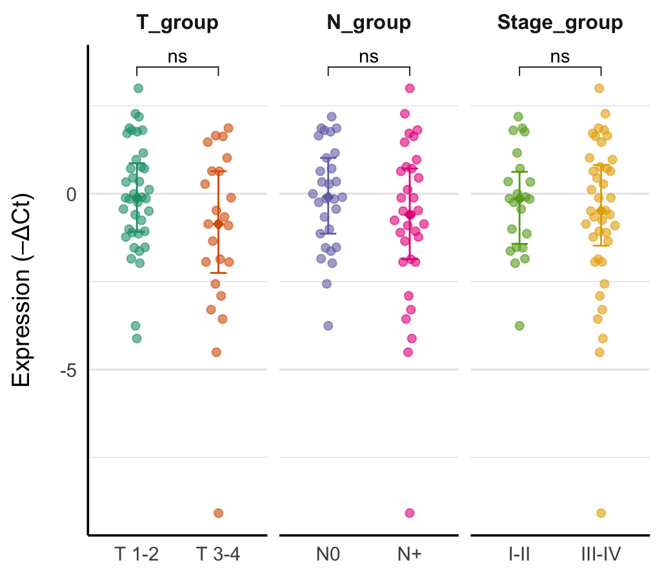

Figure S3. Expression of salivary exosomal miR-26a-5p according to clinical stage in the oral cavity cancer sub-cohort. Comparison of miR-26a-5p expression levels stratified by T stage, N stage, and overall cancer stage specifically within the subgroup of patients with oral-cavity cancer. Expression is presented as -ΔCt values. Statistical significance was determined by the Mann-Whitney U test; ns, not significant.
