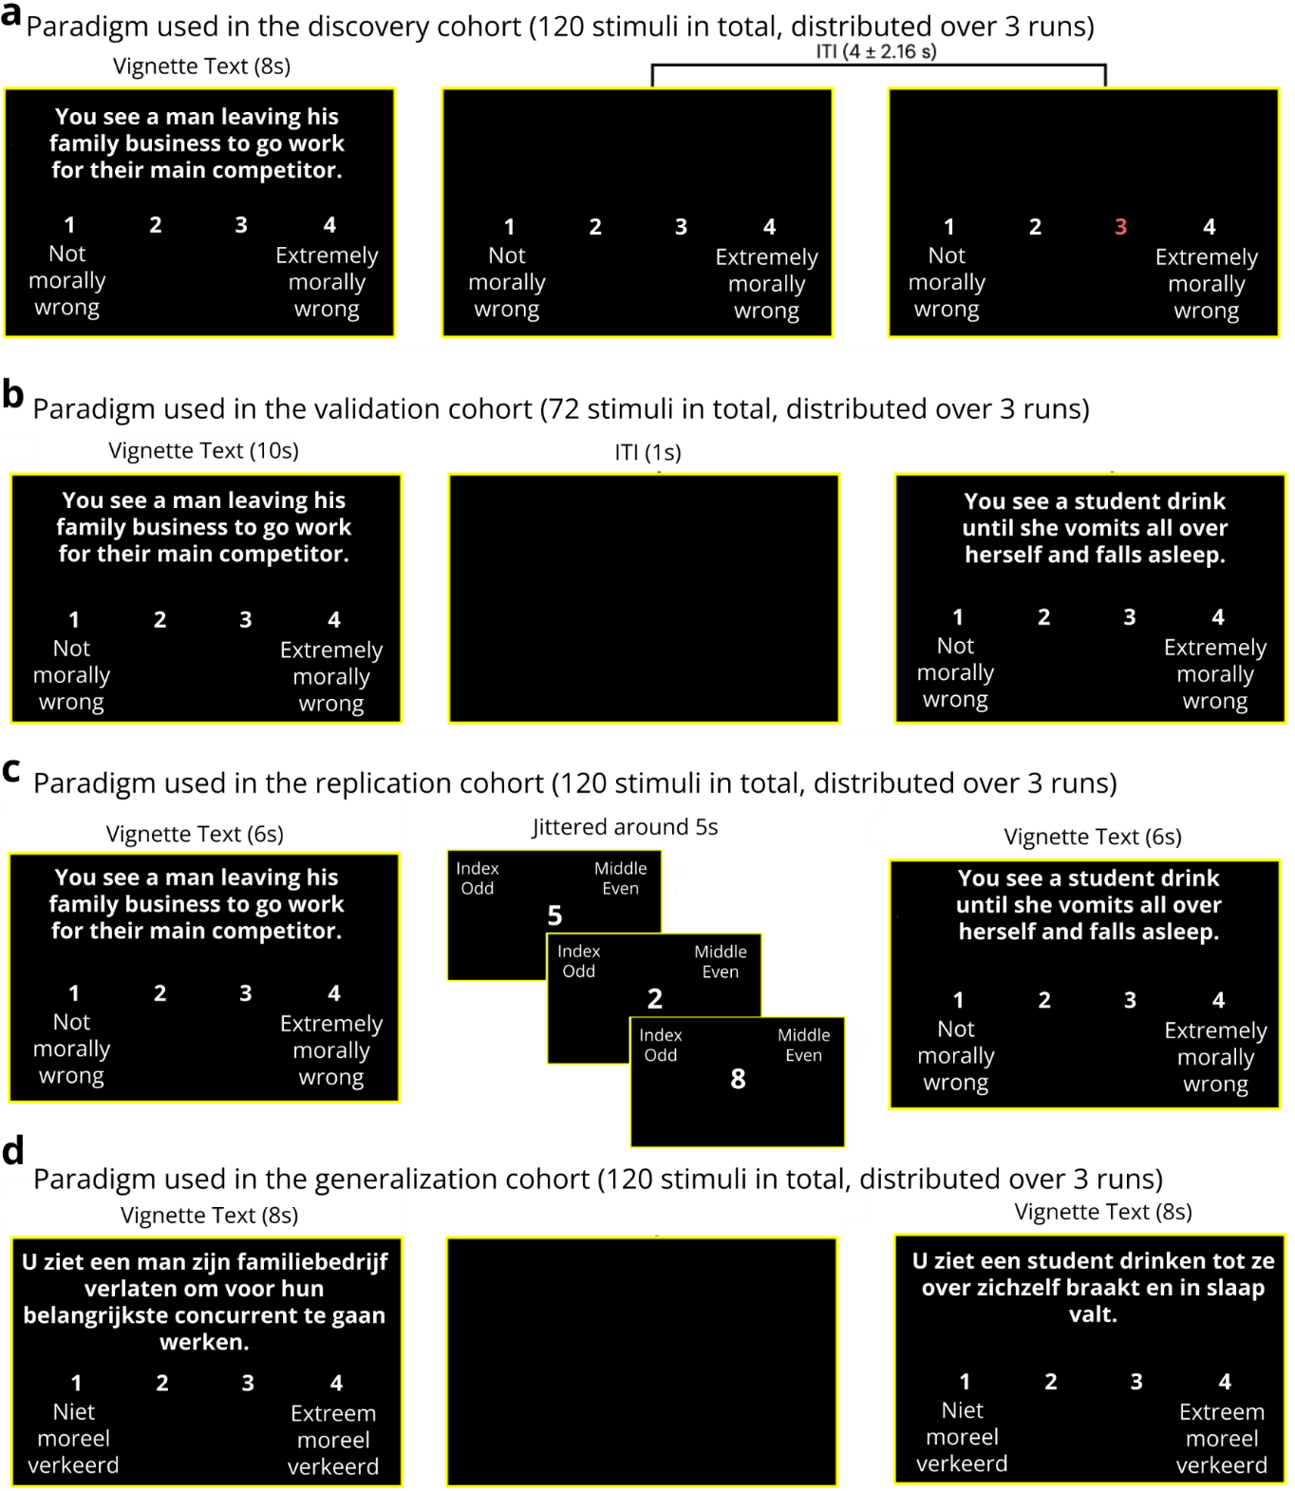

Extended Data Fig. 1 Moral judgment paradigms used across discovery, validation, replication, and generalization cohorts. (a) Discovery cohort; 64 subjects rated the moral wrongness of 120 validated Moral Foundations Vignettes (MFV)³⁴. After 8s, the vignette disappeared but the scale remained on screen and subjects could still respond during the intertrial interval (ITI). (b) Validation cohort; 30 subjects rated the moral wrongness of 72 moral vignettes, of which 42 were drawn from the MFV (6 per category), and 30 vignettes were newly created by the authors to depict violations of six moral domains drawn from the Morality as Cooperation (MAC) framework⁹⁷, including family, reciprocity, bravery, property, respect, and group values (5 per category). A black screen served as the ITI. (c) Replication cohort; 27 subjects rated the moral wrongness of 120 MFV used in (a). Trials were separated by an even-odd discrimination task with a jitter drawn from a Poisson distribution (mean=5s). (d) Generalization cohort; 30 subjects rated the moral wrongness of 120 MFV used in (a) that were translated and validated in the Netherlands. A black screen served as the ITI.
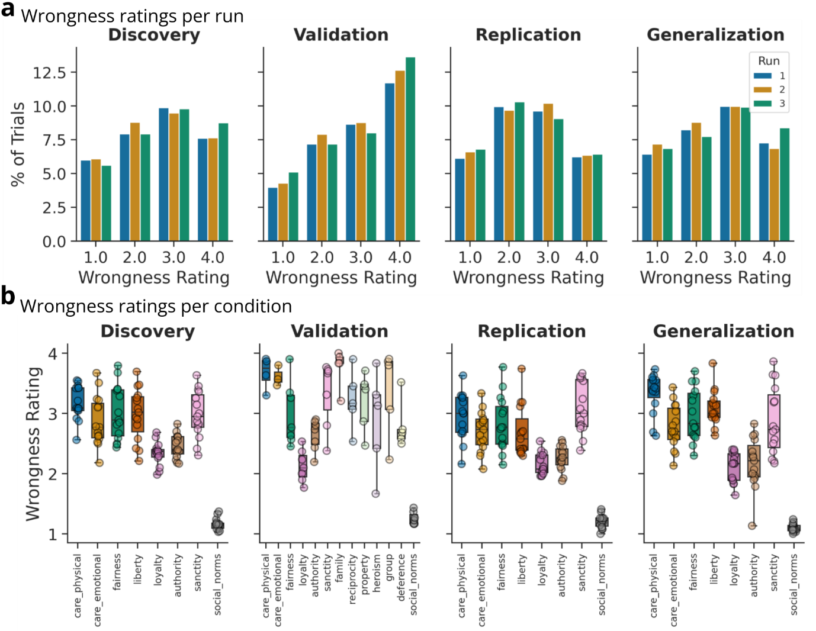

Extended Data Fig. 2 Behavioral responses to moral foundations vignettes across discovery, validation, replication, and generalization cohorts. a. Distribution of moral wrongness ratings per run and rating option shows that ratings did not noticeably differ across runs. b. Distribution of moral wrongness ratings per condition and rating option shows vignettes elicited a wide range of moral wrongness ratings. carep = physical care; carem = emotional care; def = deference; fair = fairness; lib = liberty; loy = loyalty; auth = authority; pur = purity; socn = social norms; fam = family; group = group; prop = property; recip = reciprocity; hero = heroism; prop = proportionality.
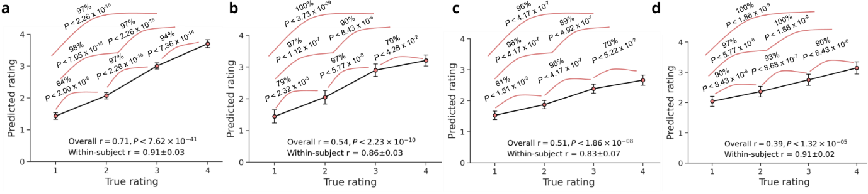

Extended Data Fig. 3 MJS pattern response without occipital lobe. Panels depict the predicted moral wrongness ratings compared to the actual level of wrongness ratings for the cross-validated discovery cohort (a), the independent validation cohort (b), the replication cohort (c), and the generalization cohort (d). Accuracies reflect forced-choice comparisons based on one-tailed permutation tests with 10,000 samples. r indicates the Pearson correlation coefficient between predicted and true ratings. Error bars reflect the standard error of the mean. Occipital lobe region of interest was obtained from (ref. 44).

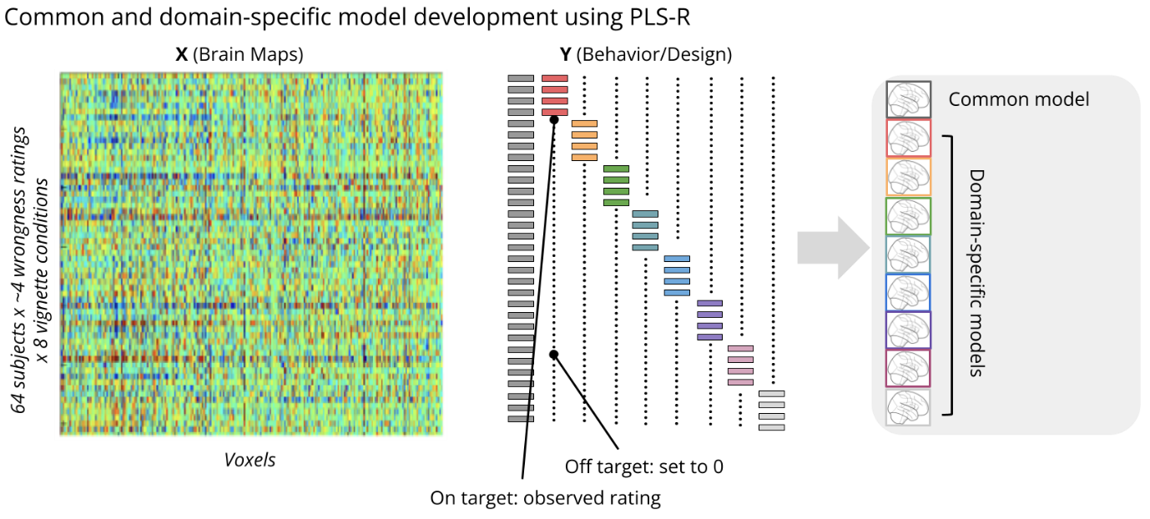

Extended Data Fig. 4 Development of common and domain-specific predictive brain models of moral wrongness. Partial Least Squares Regression (PLS-R) was used to find latent variables that model X (predictor; brain activity) and simultaneously predict Y (outcomes; wrongness ratings). PLS-R jointly estimates multiple solutions (separate brain patterns for common and domain-specific outcomes) simultaneously. Predictors (X) included 1,468 whole-brain activation maps associated with subjects (64) x moral wrongness ratings (~4) x vignette condition (8), aggregated into an images x voxels matrix (stacked across subjects), and split into training and test sets using leave-one-subject-out cross-validation. Outcomes (Y) included wrongness ratings across all vignette conditions (Y₁) and per vignette condition (Y₂ - Y₉, wrongness ratings for each condition separately, with values of 0 for other conditions). By setting the Y of other conditions to 0 we constrained each pattern to be domain specific. The common model (across domain types) is a linear combination of latent brain factors that explains Y. Brain patterns predictive of Y₂- Y₉ are models optimized to be selective to violations of physical care, emotional care, fairness, liberty, loyalty, authority, sanctity, and social norm vignettes. Each model is then projected into a single predictive spatial map, resulting in nine whole-brain predictive patterns.

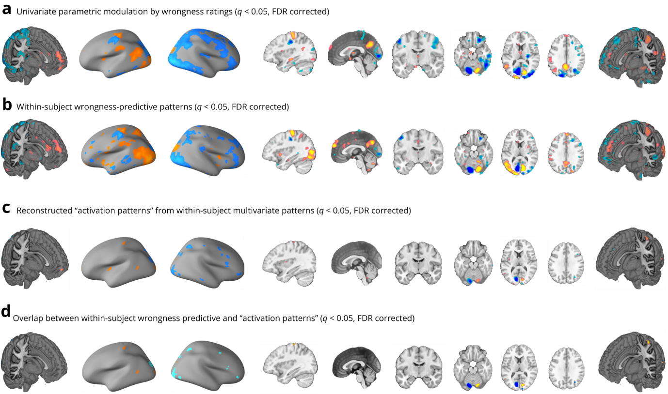

Extended Data Fig. 5 Computations of graded moral wrongness are associated with and predicted by distributed brain regions. a. The univariate parametric effects of moral wrongness judgments. b. Multivariate patterns trained on individual subjects and depicts brain regions consistently predictive of moral wrongness across subjects. c. Thresholded transformed ‘activation patterns’ from within-subject wrongness-predictive patterns. d. Overlapping (that is, from a conjunction analysis) brain regions between (b and c). Hot color indicates positive associations (a and c) or weights (b) whereas cold color indicates negative associations (a and c) or weights (b).

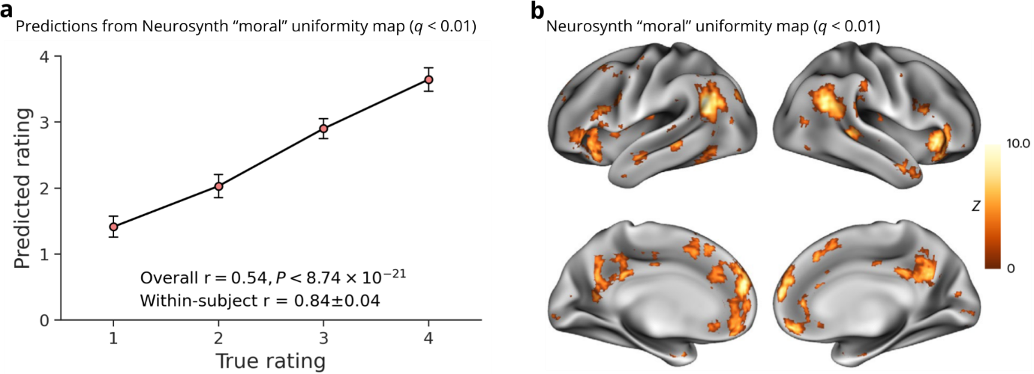

Extended Data Fig. 6 Model predictions based on Neurosynth “moral” map (ref. 54). a. Cross-validated predictions (mean ± s.e.m.) from Neuroynth⁵⁴ “moral” uniformity test map (q < .01). b. Visualization of the thresholded Neurosynth “moral” uniformity test map (q < 0.01).

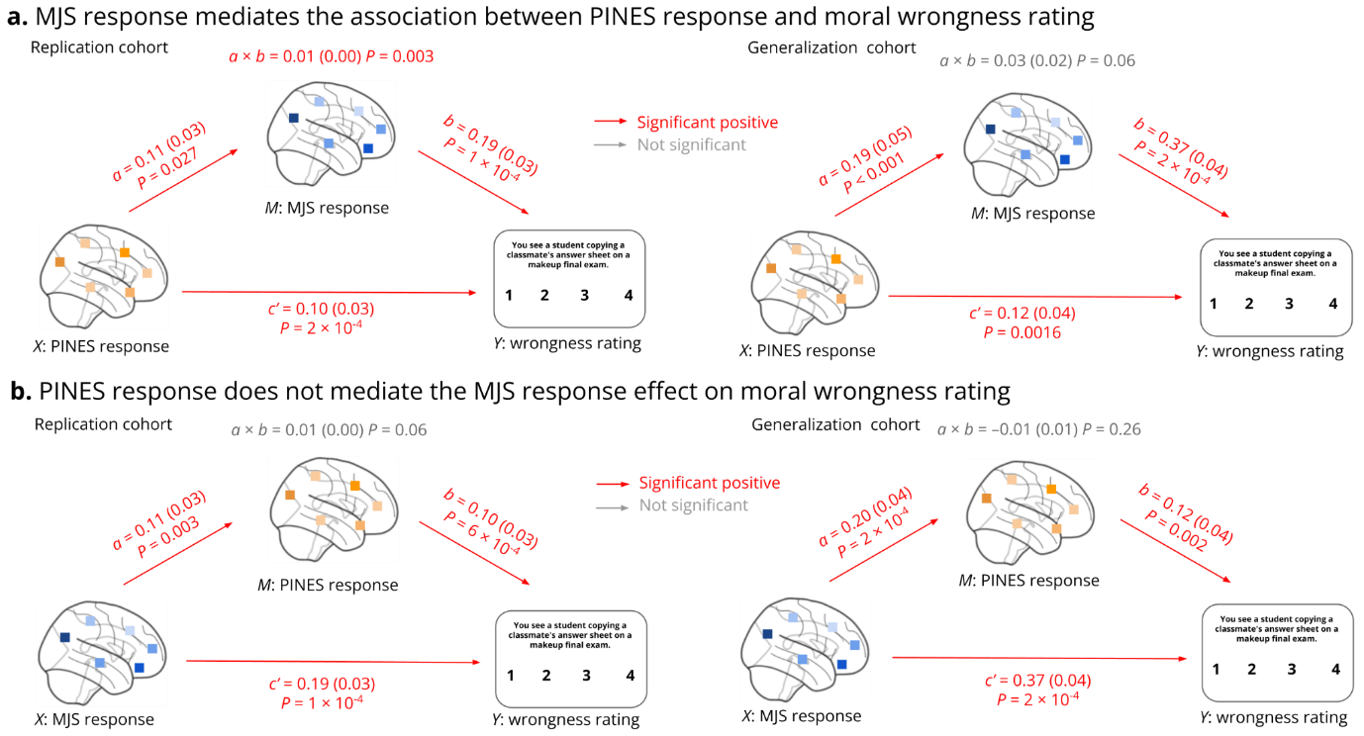

Extended Data Fig. 7 Comparing MJS and PINES predictions on replication and generalization cohorts. a, The multilevel mediation analytic results showing that the MJS response partially mediates the association between PINES response and moral wrongness rating in the replication, but not generalization, cohort. b, PINES response does not mediate the effect of MJS response on wrongness ratings, neither in the replication nor in the generalization cohort. In a and b, the mediation analysis examines whether the observed covariance between the independent variable (X) and the dependent variable (Y) can be explained by the third variable (M, also mediator), details see Methods section. Two-sided P values are based on bootstrap tests with 10,000 samples, uncorrected.

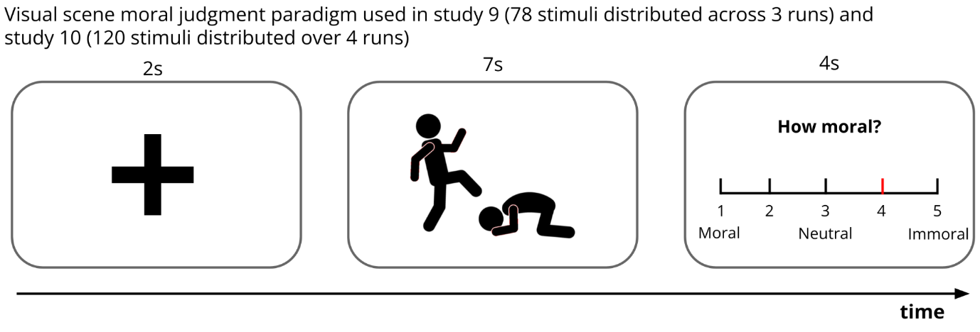
Extended Data Fig. 8 Visual scenes moral judgment paradigms. Subjects (n=30, study 8; n=30, study 9) rated the (im)morality of photographic images (78 images in study 8; 120 images in study 9) sampled representatively from the Socio-Moral Image Database (SMID)⁴³. Of note, schematic figures were used for display purposes only and were not included in the original stimulus set.

