Supplementary File:

Full Uncropped Blots used for Figure 3

Figure 3A. Brainstem pSyn in TBS Fraction (>250 kDa; monomer-normalized) – Blot #1
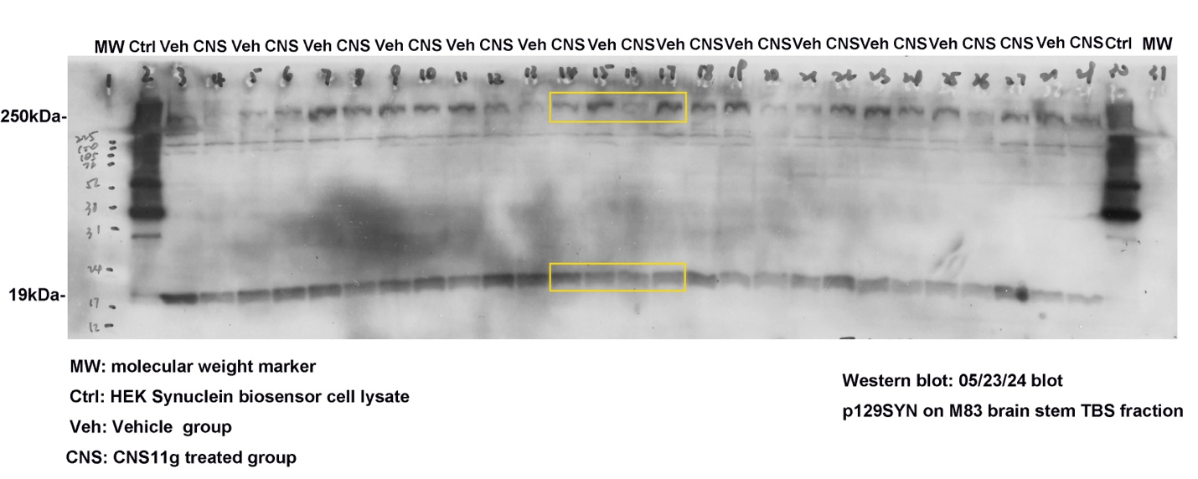

Figure 3B. Brainstem GAPDH in TBS Fraction (for normalization of >250 kDa aSyn) – Blot #1
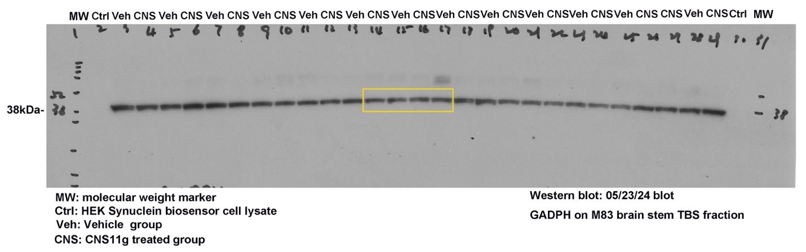

Figure 3B. Spinal Cord pSyn (>250 kDa aSyn; monomer-normalized) – Blot #2
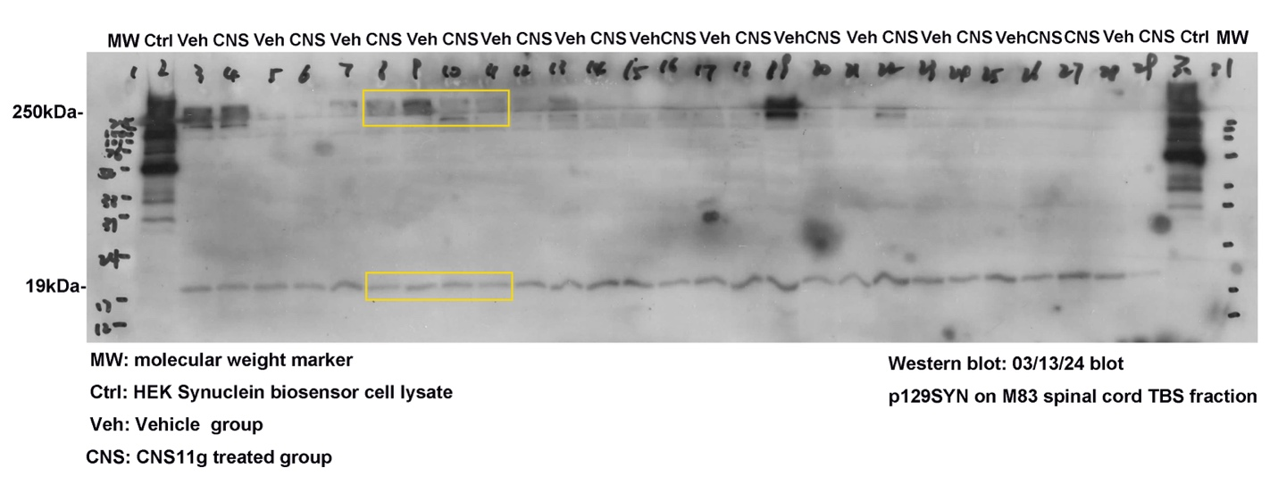

Figure 3B. Spinal Cord GAPDH in TBS Fraction (for normalization of >250 kDa aSyn) – Blot #2

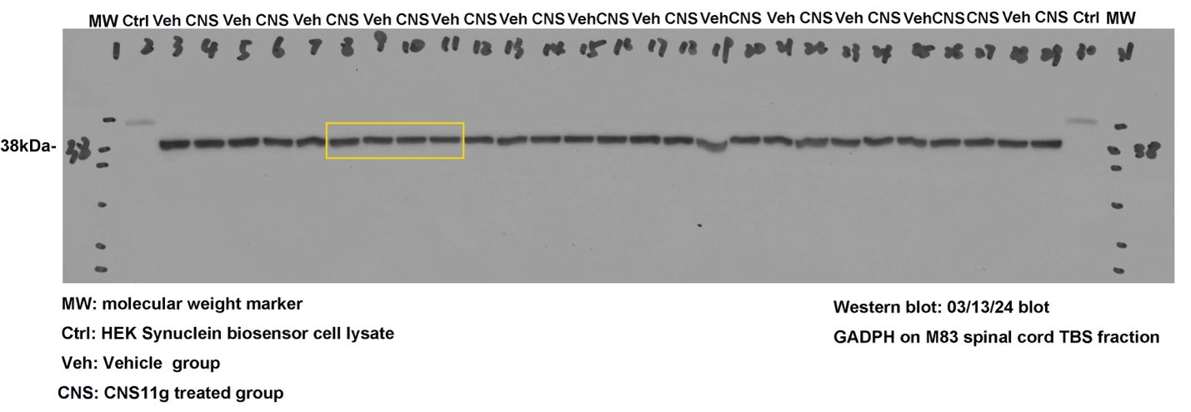

Figure 3C. Brainstem SNAP25 in Lysis Fraction – Blot #3
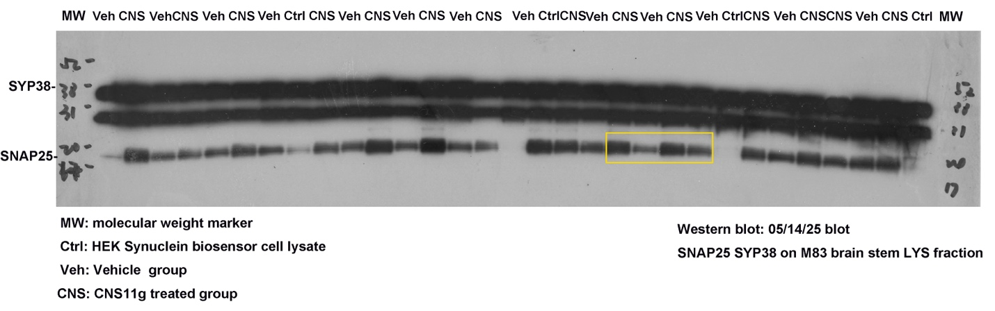

Figure 3C. Brainstem Tubulin in Lysis Fraction – Blot #3
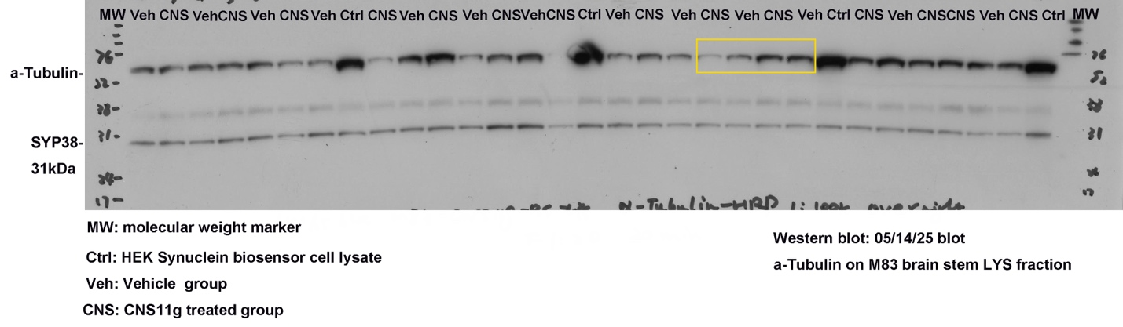

Figure 3C. Brainstem SY38 in Lysis Fraction – Blot #3
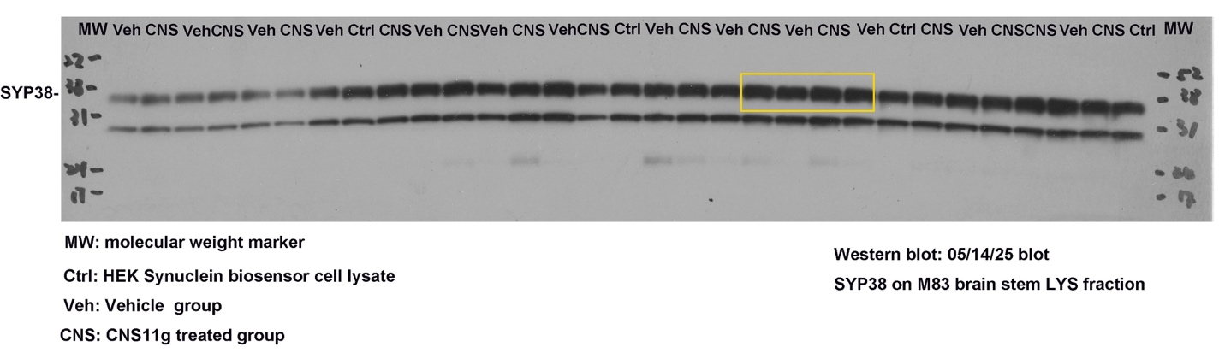

Detergent Insoluble aSyn (not shown in the body of the manuscript)

