Supplementary Information

SI.1 - Baseline Data Collection
In line with the results of our previous studies ^{1,11,20} subjects’ performance at the baseline data collection seven days prior to the bedrest (BDC-7) were characterized by large between-subject differences, both in terms of initial response accuracy and precision, as well as visual dependency. Figure S1 shows that, despite this heterogeneity, the subjects’ performance at BDC-7 consistently varied between sensory conditions: effect of sensory condition is significant on response total deviation (χ²(2)=47.71 p=4e⁻¹¹), on response variability (χ²(2)=43.12 p=4e⁻¹⁰) and on the visual weight (χ²(2)=28.47 p=7e⁻⁰⁷).

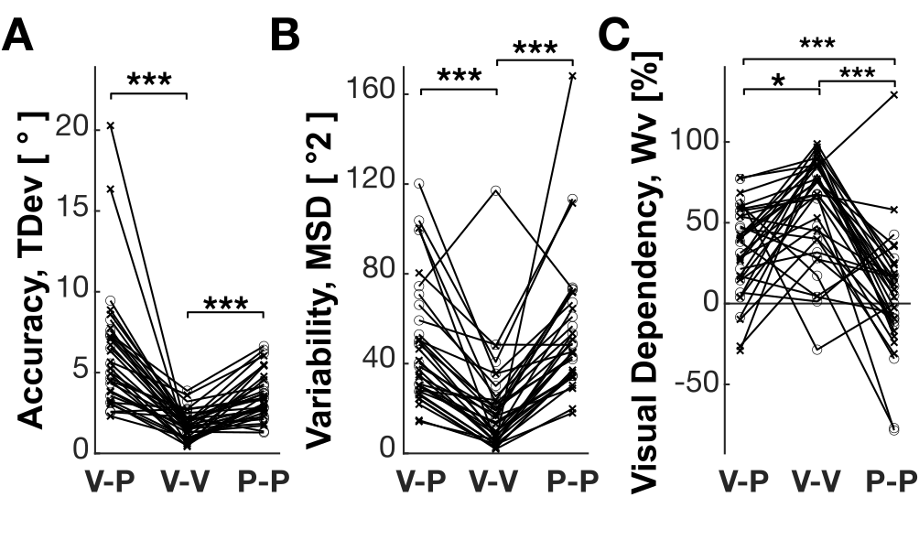 | Figure S1. Initial individual performances at BDC for: cross-modal (V-P) and unimodal (V-V, P-P) sensory conditions. Circles and crosses represent control and bedrest subjects respectively. A) Total deviation of the responses, TDev, representing the subject accuracy. B) Response precision computed as the variability around the average response, MSD. C) Visual dependency, that is the relative weight associated to visual information, W_{V}. * and *** represent statistical significance of Tukey-Kramer Posthoc tests, with p<0.05 and p<0.001 respectively.
Despite the between-subjects variability, the results appear consistent within subjects. For instance, as predicted by our Concurrent Model of multi-sensory integration^{11,6} (see SI.3), the subjects’ precision in the V-P condition correlated significantly with the precision of both unimodal conditions: V-V (R=0.5, p=0.002) and P-P (R=0.65, p=3e⁻⁵). These correlations simply support the idea that subjects with better visual and proprioceptive acuity were more precise in the cross-modal task compared to subjects with lower sensory acuity.
Although the Concurrent Model does not provide clear predictions about possible correlations between the visual weight in the three sensory conditions, it is interesting to notice that, no significant correlations could be experimentally observed. This would mean that visuo-dependency is not necessary an invariant characteristic of an individual, which affects the performances in all conditions, but it is very specific to the available sensory cues.

SI.2 – Measurements’ consistency
The individual results appear consistent also longitudinally. Table S1 shows that the subjects’ precision, accuracy and visual dependency in one experimental session strongly correlate with that of the following session, so that the ranking of the subjects in terms of their variable and constant errors, as well as visual weight, tends to remain the same over time. The same type of results is obtained when the two group of subjects are analyzed separately (see Table S2), suggesting that persistence of the subject ranking in not ascribable to the differences between the two groups induced by the posture effect.

 |  |  | BDC-7 HTD+2 | HTD+2 HTD+30 | HTD+30 HTD+59 | HTD+59 R+2 | R+2 R+13
MSD | V-P | R | 0.55 | 0.55 | 0.84 | 0.80 | 0.85
MSD | V-P | p | 0.0007 | 0.0008 | 4e-10 | 1e-08 | 2e-10
MSD | V-V | R | 0.91 | 0.89 | 0.89 | 0.95 | 0.81
MSD | V-V | p | 7e-14 | 1e-12 | 1e-12 | 4e-17 | 9e-09
MSD | P-P | R | 0.72 | 0.66 | 0.76 | 0.74 | 0.74
MSD | P-P | p | 2e-06 | 2e-05 | 2e-07 | 5e-07 | 5e-07
TDev | V-P | R | 0.66 | 0.53 | 0.66 | 0.50 | 0.64
TDev | V-P | p | 2e-05 | 0.0011 | 2e-05 | 0.0024 | 4e-05
TDev | V-V | R | 0.35 | 0.60 | 0.57 | 0.51 | 0.60
TDev | V-V | p | 0.0424 | 0.0002 | 0.0005 | 0.0022 | 0.0002
TDev | P-P | R | -0.09 | 0.16 | 0.19 | 0.04 | 0.18
TDev | P-P | p | 0.5934 | 0.3621 | 0.2904 | 0.8306 | 0.3037
ω_{V} | V-P | R | 0.33 | 0.64 | 0.73 | 0.47 | 0.70
ω_{V} | V-P | p | 0.058 | 5e-05 | 1e-06 | 0.0046 | 5e-06
ω_{V} | V-V | R | 0.65 | 0.79 | 0.86 | 0.80 | 0.86
ω_{V} | V-V | p | 4e-05 | 3e-08 | 8e-11 | 2e-08 | 4e-11
ω_{V} | P-P | R | 0.41 | 0.11 | 0.29 | 0.35 | 0.59
ω_{V} | P-P | p | 0.016 | 0.5359 | 0.0949 | 0.0434 | 0.0002

Table S1. Correlation of the individual response variability, MSD, total deviation, TDev, and visual weight, ω_{V}, between consecutive experimental sessions for each of the three sensory conditions, V-P, V-V and P-P. Bolded fonts indicate significant correlations.

MSD | Bedrest |  |  |  |  |  |  | Control
 | V-P |  | V-V |  |  | P-P |  | V-P |  | V-V |  | P-P
 | R | p | R | p | R |  | p | R | p | R | p | R |  | p
BDC-7 HTD+2 | 0.65 | 0.0019 | 0.88 | 4E-07 | 0.78 |  | 5E-05 | 0.58 | 0.0303 | 0.90 | 1E-05 | 0.65 |  | 0.0115
HTD+2 HTD+30 | 0.50 | 0.0248 | 0.85 | 2E-06 | 0.73 |  | 0.0002 | 0.67 | 0.0094 | 0.89 | 2E-05 | 0.66 |  | 0.0097
HTD+30 HTD+59 | 0.88 | 3E-07 | 0.84 | 3E-06 | 0.77 |  | 7E-05 | 0.73 | 0.0028 | 0.87 | 4E-05 | 0.70 |  | 0.0052
HTD+59 R+2 | 0.87 | 5E-07 | 0.75 | 0.0001 | 0.79 |  | 4E-05 | 0.52 | 0.0592 | 0.97 | 4E-09 | 0.61 |  | 0.0198
R+2 R+13 | 0.91 | 2E-08 | 0.68 | 0.0011 |  | 0.77 | 6E-05 | 0.65 | 0.0120 | 0.82 | 3E-04 | 0.61 | 0.0194

TDev | Bedrest |  |  |  |  |  |  |  | Control
 | V-P |  | V-V |  |  | P-P |  |  | V-P |  | V-V |  | P-P
 | R | p |  | R | p |  | R | p | R | p | R | p | R | p
BDC-7 HTD+2 | 0.68 | 0.0011 |  | 0.31 | 0.1773 |  | -0.16 | 0.5112 | 0.59 | 0.0276 | 0.07 | 0.8111 | -0.05 | 0.8660
HTD+2 HTD+30 | 0.58 | 0.0073 |  | 0.62 | 0.0033 |  | 0.18 | 0.4591 | 0.41 | 0.1488 | 0.46 | 0.0984 | 0.17 | 0.5703
HTD+30 HTD+59 | 0.62 | 0.0033 |  | 0.72 | 0.0003 |  | 0.02 | 0.9341 | 0.56 | 0.0358 | 0.51 | 0.0624 | 0.49 | 0.0770
HTD+59 R+2 | 0.48 | 0.0314 |  | 0.63 | 0.0029 |  | -0.19 | 0.4331 | 0.16 | 0.5855 | 0.50 | 0.0715 | 0.53 | 0.0492
R+2 R+13 | 0.63 | 0.0027 |  | 0.72 | 0.0003 |  | 0.02 | 0.9169 | 0.45 | 0.1092 | 0.51 | 0.0636 | 0.60 | 0.0247

Wv | Bedrest |  |  |  |  |  |  | Control
 | V-P |  | V-V |  | P-P |  |  | V-P |  | V-V |  | P-P
 | R | p | R | p |  | R | p | R | p | R | p | R | p
BDC-7 HTD+2 | 0.41 | 0.0700 | 0.71 | 0.0005 |  | 0.27 | 0.2449 | 0.46 | 0.1018 | 0.42 | 0.1316 | 0.33 | 0.2562
HTD+2 HTD+30 | 0.52 | 0.0185 | 0.92 | 0.0000 |  | 0.34 | 0.1449 | 0.57 | 0.0328 | 0.43 | 0.1221 | -0.48 | 0.0790
HTD+30 HTD+59 | 0.76 | 0.0001 | 0.89 | 0.0000 |  | 0.24 | 0.3005 | 0.51 | 0.0627 | 0.81 | 0.0004 | 0.41 | 0.1425
HTD+59 R+2 | 0.37 | 0.1044 | 0.73 | 0.0002 |  | 0.43 | 0.0564 | 0.54 | 0.0472 | 0.86 | 0.0001 | 0.31 | 0.2741
R+2 R+13 | 0.64 | 0.0026 | 0.91 | 0.0000 |  | 0.65 | 0.0021 | 0.75 | 0.0020 | 0.80 | 0.0007 | 0.54 | 0.0448

Table S2. Correlation of the individual response variability, MSD, accuracy, Acc, and visual weight, ω_{V}, between consecutive experimental sessions for each of the three sensory conditions, V-P, V-V and P-P for Bedrest and Control subject separately. Bolded fonts indicate significant correlations.

SI.3 – Multi-sensory integration modelling
In order to predict the expected modulation over time of response precision and visual dependency, we used the ‘Concurrent Model’ of optimal multisensory integration ^{6,11} (see Figure S2) whose foundation on the maximum likelihood principle is supported by electrophysiological and computational studies showing that neural activity in multisensory areas reflects the optimal weighting of the available sensory inputs based on their relative reliability^{24–26}. We have previously demonstrated that this model accurately predicts the acute effect of the supine posture that is a greater response imprecision and greater visual dependency when supine than when seated¹. These increases, D, are predicted for cross-modal task, V-P, and not for the unimodal V-V and P-P tasks.

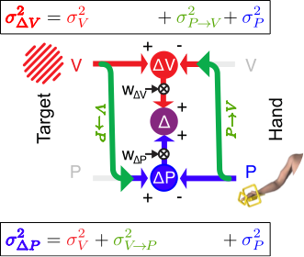 | Figure S2. Graphical representation of the “Concurrent Model” for multisensory integration applied to the cross-modal task, where the subjects have to reproduce the orientation of visually (V) acquired bars with their unseen hand, sensed through proprioceptive (P) signals only. Red and blue represent sensory information encoded in a visual and proprioceptive reference frame, respectively. Gray elements represent missing information. Green arrows represent cross-modal transformations re-encoding the information from the visual to the proprioceptive space and vice-versa. The target and hand orientations are compared in the visual and proprioceptive space (ΔV and ΔP) concurrently. These two task representations are then combined (Maximum Likelihood Principle) to maximize the precision of the motor vector estimation (Δ), by associating to each of them an optimal weight (W_{ΔV}, W_{ΔP}). The weight values depend on the variance of ΔV and ΔP, which is affected by the noise associated to cross-modal transformations.

From equation S21-22 of Bernard-Espina et al. (2022), the predicted increase in the movement execution, ME, variability due to the supine position is
$${Dσ}_{ME}^{2}=(σ_{T}^{2}+σ_{N,TILT}^{2})\left[\frac{1}{2}-\frac{σ_{T}^{2}+σ_{N,UR}^{2}}{2σ_{T}^{2}+σ_{N,UR}^{2}+σ_{N,TILT}^{2}}\right]$$
and from equation S23-24 of Bernard-Espina et al. (2022) the change in visual weight is
$${DW}_{∆V}=\frac{1}{2}-\frac{σ_{T}^{2}+σ_{N,UR}^{2}}{2σ_{T}^{2}+σ_{N,UR}^{2}+σ_{N,TILT}^{2}}$$
Where $σ_{T}^{2}$ is the variability associated with cross-modal transformations (both $V→P$ and $P→V$); $σ_{N,UR}^{2}$ and $σ_{N,TILT}^{2}$ represent the additional noise associated with cross-modal transformations performed with the head upright or misaligned with respect to gravity, respectively. As an example, the transformation $P→V$ performed with the head tilted with respect to gravity is characterized by a variability $σ_{P→V}^{2}=σ_{T}^{2}+σ_{N,TILT}^{2}$.
To describe the subjects’ behavior prior to bedrest (BDC-7) and at the first bedrest session (HDT+2), before adaptation, the model sets $σ_{N,UR}^{2}=0$, representing a lack of specific problems in performing cross-modal transformation with the head aligned with gravity. The value of model parameters $σ_{T}^{2}$ and $σ_{N,TILT}^{2}$ is computed by fitting the predicted ${Dσ}_{ME}^{2}$ and ${DW}_{∆V}$ with the corresponding experimental variables ${MSD}_{HDT+2}-{MSD}_{BDC-7}$ and $ω_{V, HDT+2}-ω_{V, BDC-7}$; in other words, the model parameters are set to replicate the observed acute effect of the posture change.
As explained more in detail in the following, here the model was further upgraded to account for the possibility that, over time, the subjects might be able to learn cross-modal transformations when the head is misaligned with gravity: the modulation of response variability and visual weight during the HDT and recovery phases was predicted by assuming different temporal evolutions of $σ_{N,UR}^{2}$ and $σ_{N,TILT}^{2}$.

Model predictions
To more effectively interpret the present experimental observations, and in particular the participants’ performance during the recovery (R) period, in the cross-modal, visuo-proprioceptive task Figure S3 compares them with the predictions of the Concurrent Model of optimal multi-sensory integration^{6,11}. To focus the analysis on the modulations of the participants performances that are specifically due to the HDT, and to eliminate of the effects of procedural and motor learning that MLP cannot account for, the model is applied to the performance difference between the Bedrest and Control groups.
As explained in the section above, the only two parameters of the model reflect the noise associated with the visuo-proprioceptive transformation with and without head tilt. Their values were set to replicate the observed increase in response imprecision and visual dependency from BDC-7 to HDT+2: variance of cross-modal transformation in upright condition $σ_{T}^{2}$=18.5°² and the noise added to these transformations when the head is misaligned with respect to gravity $σ_{N}^{2}$=48°². The model is then used to compute the expected modulations in response variability and sensory weighting during the whole HDT and recovery (R) phases, under different assumptions. The model cannot make predictions about response accuracy.
To test the fully phylogenetic hypothesis, the original formulation of the model, without any learning features, was used. As illustrated by the red dashed lines in Figure S3, the most striking flaw of this version of the model is its inability to predict the observed persistence of imprecision and visual dependency during the R phase, which remain significantly greater than during BDC.
The model was first upgraded to include the subjects’ ability to learn to perform visuo-proprioceptive cross-modal transformations with the head misaligned with respect to gravity. More precisely, the noise added to these transformations has been computed from HTD+0 to HTD+60 by using the following equation
$σ_{N,TILT}^{2}=σ_{N}^{2}(1-lr{∙day}_{HDT})$,
where $lr$ represents the daily learning rate and ${day}_{HDT}$ represents the number of days spent in the HDT position. Although MSD data do not show a clear decrease during HDT and thus do not justify by them-self the introduction of a learning mechanism, the accuracy data, as previously discussed and shown in Figure S3A, suggest that some form of adaptation is likely to have occurred during the bedrest. Therefore, this first model modification appears reasonable. Importantly, although the choice of a linear learning clearly appears as an over-simplification, it allows to minimize the number of model parameter, and thus the risk of data over-fitting. Moreover, this choice has no strong implications for the results interpretation. With this first modification and by setting $lr$=0.0025 day⁻¹, the model predicts a small improvement in subject precision during HDT (dashed blue lines in Figure S3), but it still fails to replicate participant behavior during the recovery phase.
To attempt to replicate the post-bedrest effects, we incorporated in the model the possibility that during the HDT the participants, not only learned to perform the cross-modal transformations in a supine position, but at the same rate they also gradually unlearned how to perform these transformations with the head upright. This was implemented, without adding parameter to the model, by computing the noise associated to the cross-modal transformations when upright with the following equations:
$σ_{N,UR}^{2}=σ_{N}^{2}∙lr∙{day}_{HDT}$ during HDT
and
$σ_{N,UR}^{2}=σ_{N}^{2}(lr∙60-\left(1-lr{∙day}_{R}\right))$ during R
to represent a gradual recovering of this function. ${day}_{R}$ represents the number of days passed after the end of bedrest. Although this version of the model predicts increased response variability and visual weight during R relative to BDC, the predicted values remain significantly lower than the experimental data (violet dashed lines in Figure S3).
This prediction error can be largely corrected if the model assumes that during HDT the participants forget more quickly their ability to perform the cross-modal transformations upright, that is using gravitational signals, than they learn to perform these transformations tilted, that is without gravitational signals. The model equations thus become:
$\left\{\begin{aligned}σ_{N,TILT}^{2}=σ_{N}^{2}(1-{lr}_{tilt}{∙day}_{HDT}) \\ σ_{N,UR}^{2} =σ_{N}^{2}∙{lr}_{ur}∙{day}_{HDT }\end{aligned}\right.$ during HDT
and
$\left\{\begin{aligned}σ_{N,TILT}^{2}=σ_{N}^{2}\left[1+{lr}_{tilt}(-60+{day}_{R})\right] \\ σ_{N,UR}^{2} =σ_{N}^{2}\left[{lr}_{ur}(60-{day}_{R})\right] \end{aligned}\right.$ during R

with ${lr}_{tilt}<{lr}_{ur}$

The prediction of this assumption, with ${lr}_{tilt}=2.5∙{10}^{-3}$ and ${lr}_{ur}=11.2∙{10}^{-3}$, correspond to the green dashed line in Figure S3.
Interestingly, all versions of the model predict no reduction of W_{ΔV} during the 60 days HDT independently of the learning rate value (Figure S3C). These counter-intuitive results suggests that a progressive return of visual dependency to BDC levels during bedrest was not to be expected. Nonetheless, its only partial drop during the HDT-R transition appears very informative about the adaptation process occurred during bedrest; suggesting that the participants forgot how to perform cross-modal transformations aligned with gravity; or in other words, how to profit of the gravitational, vestibular signals to optimize cross-modal, visuo-proprioceptive transformations. However, the slight reduction of the visual weight, and variability, observed between R+2 and R+13 suggests an ongoing gradual re-acquisition of this ability.

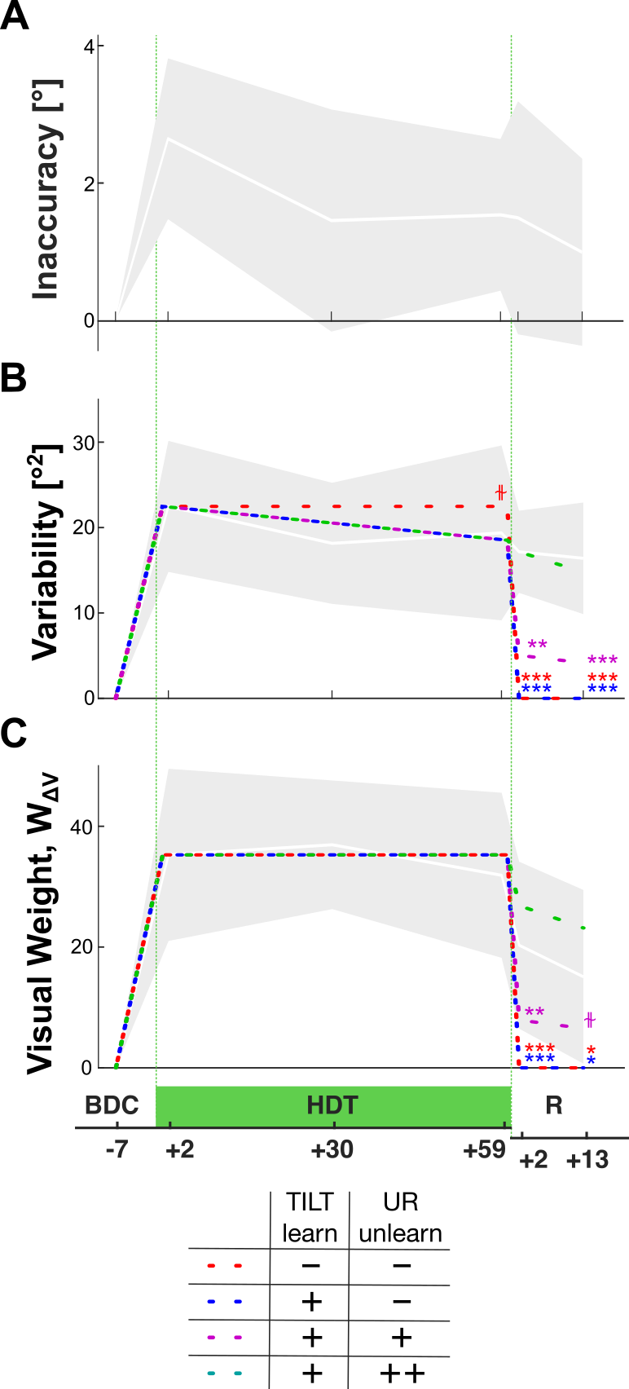 | Figure S3. Comparison between model predictions and the experimental data. The gray area represents the experimentally observed effect of head-down-tilt (HDT) and recovery (R) period over time (difference between bedrest subjects and the control group) on the A) response average deviation, for which the model is not able to make predictions, B) response variability and C) visual dependency. The two parameters of the ‘Concurrent Model’ are set to fit the experimental values at HDT+2, the model is then use to compute the expected variability and visual weight modulation ($Dσ_{∆}^{2}$and $DW_{∆V}$) for the following experimental sessions, under different combinations of assumptions about: i) the subjects’ ability to gradually learn to perform cross-modal transformation with the head tilted (TILT learn); ii) the gradual unlearning of the capability to perform the transformation with the head upright (UR unlearn). The predictions are reported as dashed lines. In the legend reported below the plots, ‘–‘, ‘+’ and ‘++’ denote, respectively, the absence, the presence, and a greater degree of these mechanisms. ⫳, ** and *** represent differences between the prediction and the experimental data with 0.1>p>0.05, p<0.01 and p<0.001 respectively.

