Supplementary Material

Sensitivity Analysis
Impact of admin level

We assess the influence of administration levels on the relationship between conflict and malnutrition. To achieve this, we systematically refitted the model by omitting one administrative level at a time – model with only conflict type and but excludes other moderating variables. The omission of Oromo or West Darfur shows a considerable shift in the posterior estimates for both the GAM and SAM model. Specifically, the omission of West Darfur from GAM and SAM models indicates significant posterior estimates – which is similar to the result obtained with all the administration levels - the effects are not observed with the omission of any other clusters.
Figure S1: Posterior estimates and highest density interval for omission of clusters.
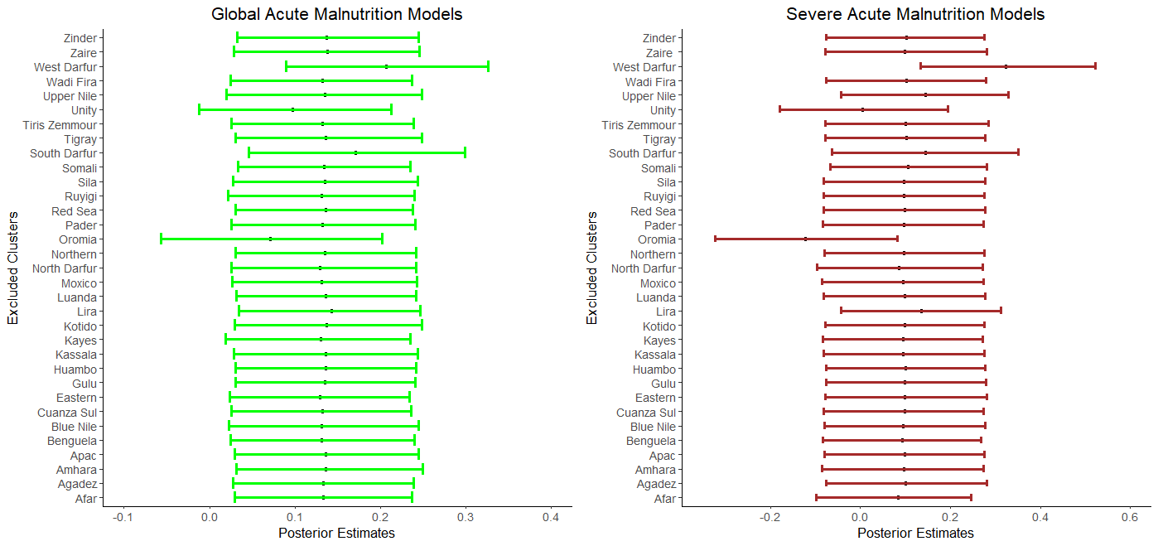

Impact of priors
The degree to which the choice of priors influenced the posterior estimates was evaluated using different prior distributions. We concentrated on the primary covariate of interest, conflict type, and the intercept. The posterior estimates for conflict type for both models seem not to be sensitive to change in priors. The posterior estimates for the intercept for the GAM model likewise show no discernible change.
However, for the SAM model the posterior estimate for the model with N(-0.1, 0.001) indicates a plausible significant differentce when compared with the model with prior distributions N(0,10) and N(-0.1,10). Where the intercept for the SAM model is insensitive to the prior distributions of N(0,10), N(-0.1,100) and N(0,4).

Figure S2: Posterior estimates and highest density interval for different prior distributions.
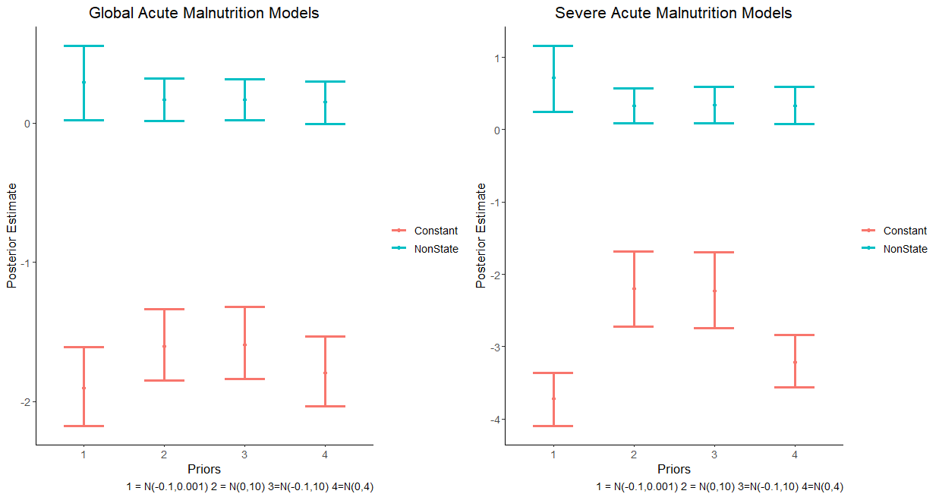

Stationarity
The trace plot indicates the presence of a good mix between the 3 chains, hence, stationarity.
Figure S3: Trace plots of Global Acute Malnutrition Model.
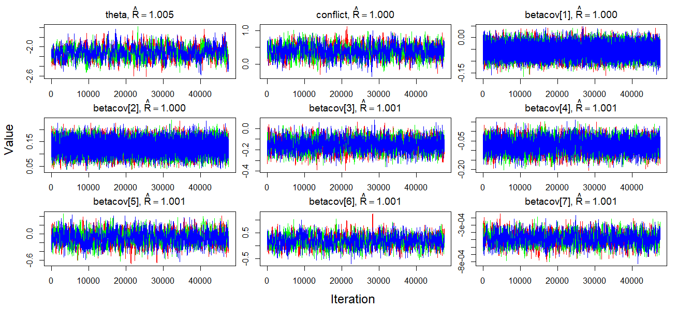
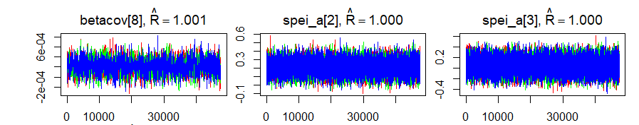

** Where the covariates betacov[1] – betacov[8] are ODA, Military expenditure per GDP, Military expenditure per GDP*Conflict type, ODA*conflict type, Drought*conflict type, Wet*conflict type, GDP per capital, GDP per capital*conflict type, respectively. Spei_a[1] and Spei_a[2] are drought and wet respectively.

The trace plot indicates a good mix between the 3 chains, hence, stationarity.
Figure S4: Trace plots of Severe Acute Malnutrition Model.
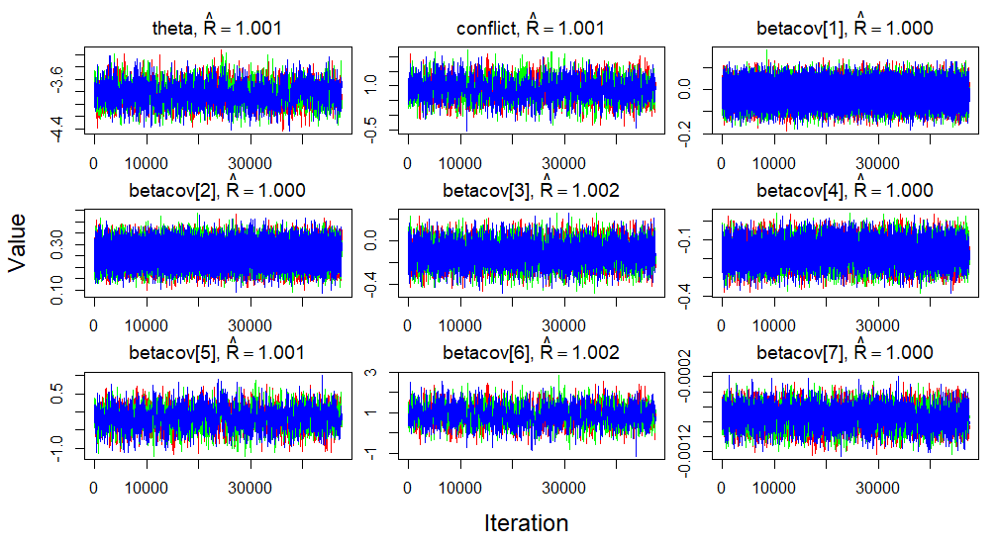
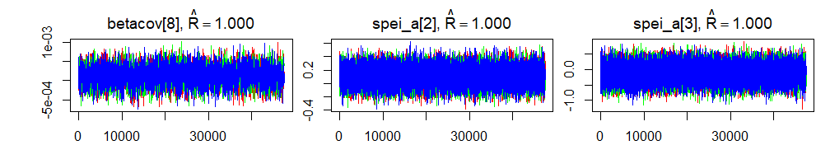

** Where the covariates betacov[1] – betacov[8] are ODA, Military expenditure per GDP, Military expenditure per GDP*Conflict type, ODA*conflict type, Drought*conflict type, Wet*conflict type, GDP per capital, GDP per capital*conflict type, respectively. Spei_a[1] and Spei_a[2] are drought and wet respectively.

Test for outliers
We plotted the inverse conditional posterior ordinate for the observations and the plots indicate that the inverse-cpo values are less than 40, hence, an indication of no extreme value.

Figure S5: Plot of inverse conditional posterior ordinate for the Global Acute Malnutrition and Severe Acute Malnutrition Models.
Global Acute Malnutrition | Severe Acute Malnutrition
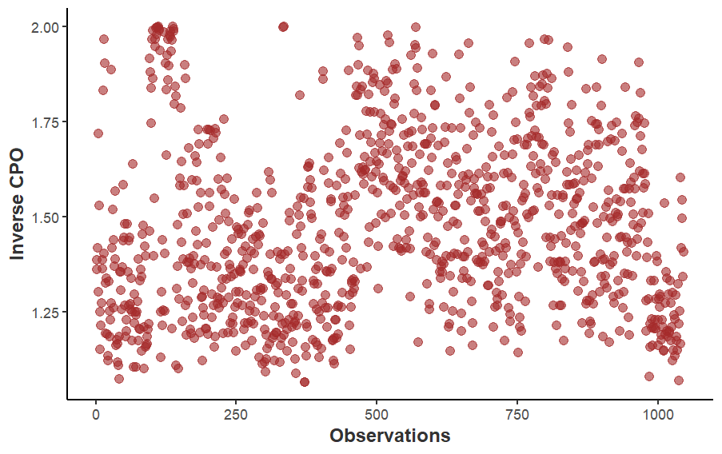 | 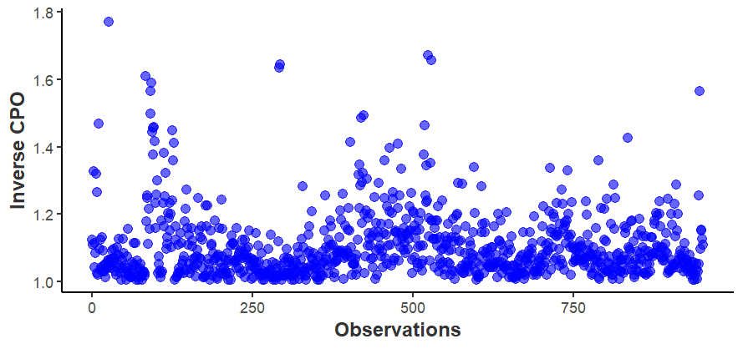

Goodness of fit test
We used posterior predictive checks plot to test for the goodness of fit of the model. The observed values are plotted against he values generated by the model. A posterior p-values were also calculated and the posterior p-value close to 0.5 is an indication that the model fits the data well.
Figure S6: Plot of posterior predictive checks for the Global Acute Malnutrition and Severe Acute Malnutrition Models.
The posterior predictive value close to 0.5 indicates that the model is a good fit for the data.
Global Acute Malnutrition Model | Severe Acute Malnutrition Model
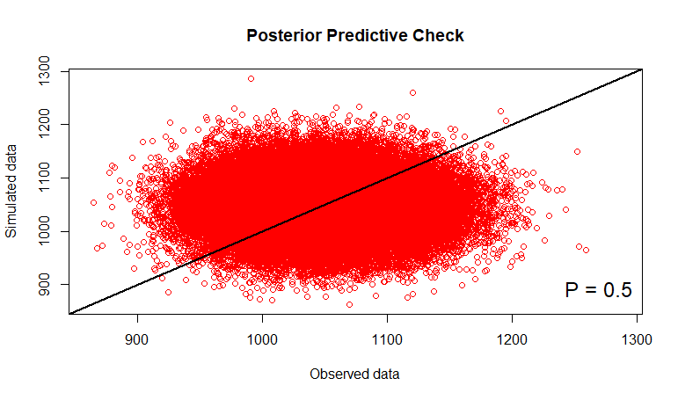 | 