Supplementary Information
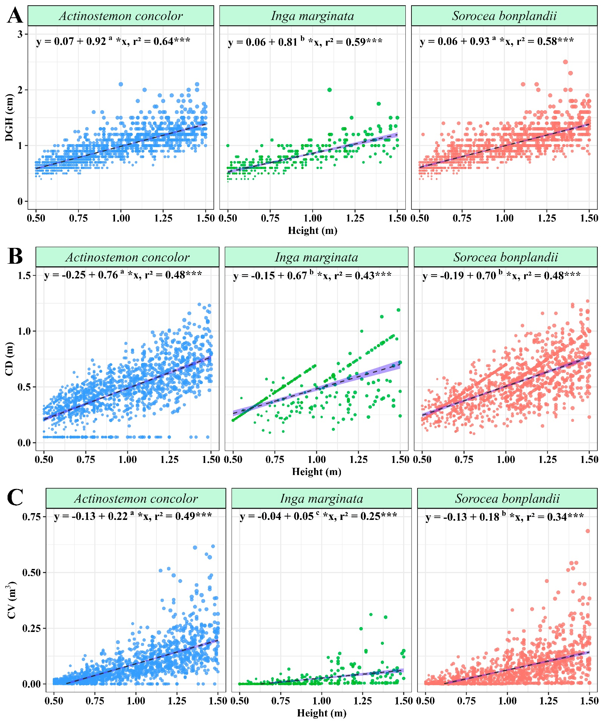
Figure S1. Allometric relationships for the first height class (H1 = 0.5 ≥ H ≤ 1.5 m) of the three species (Actinostemon concolor, Inga marginata and Sorocea bonplandii) sampled in Mata São Francisco State Park (SFFSP). The allometric relationships were followed by: A = DGH × Height; B = CD × Height; C = CV × Height. DGH = diameter at ground height (cm); CD = crown depth (m) CV = crown volume (m³).
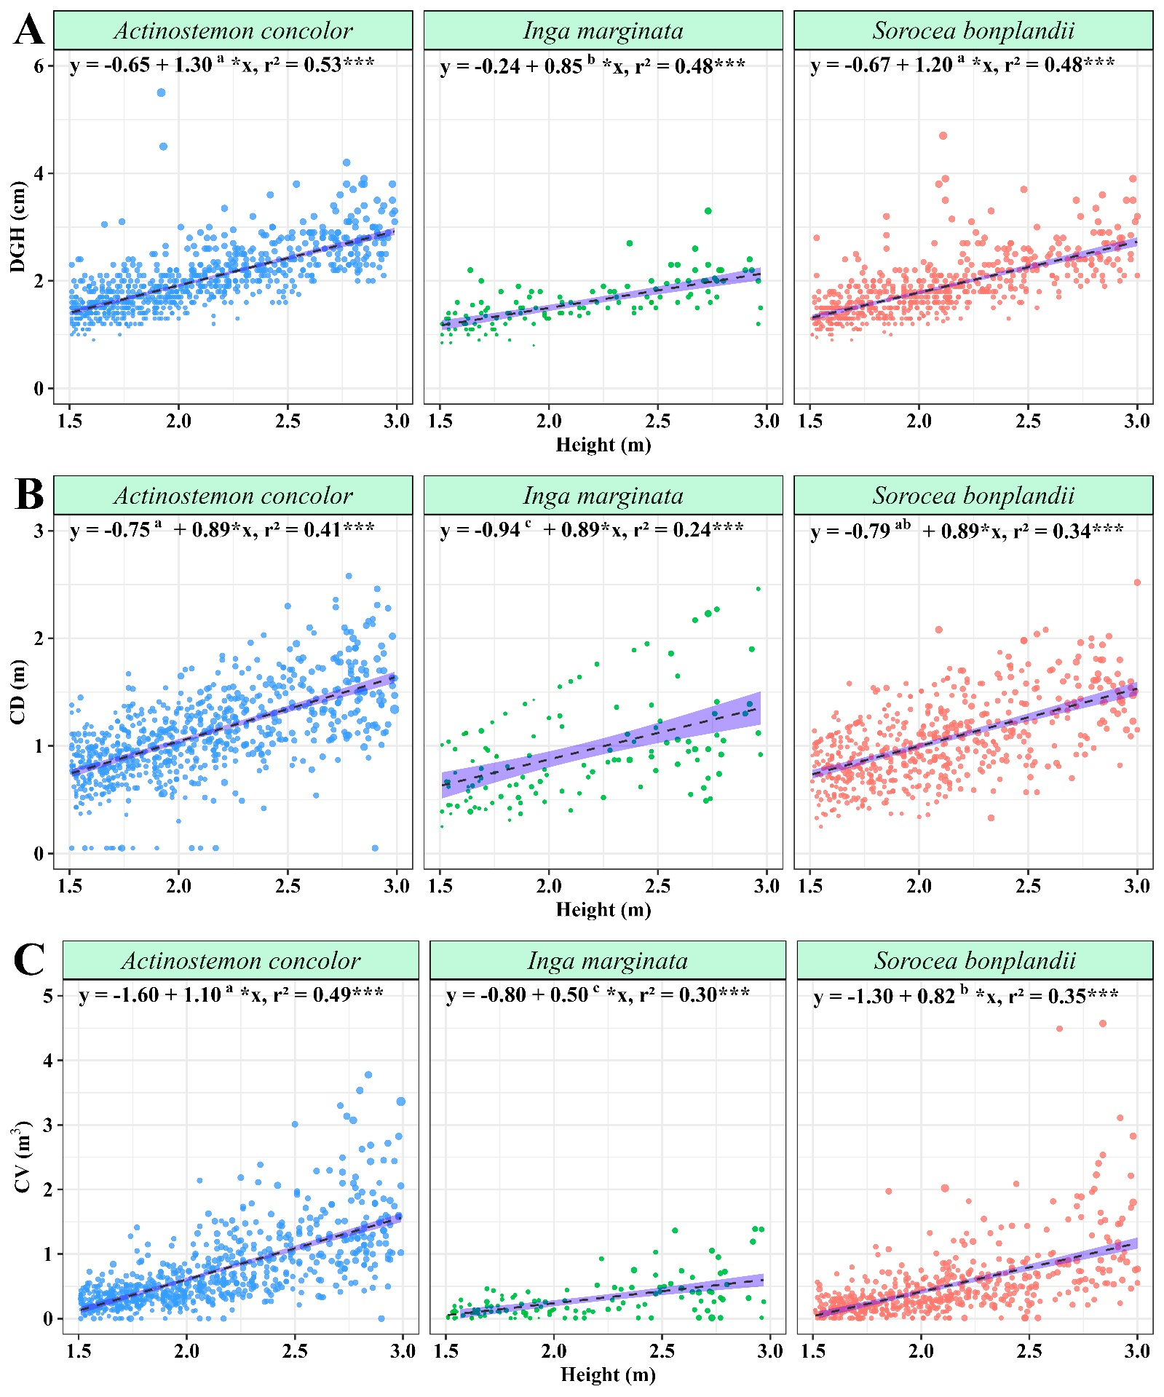
Figure S2. Allometric relationships for the second height class (H2 = 1.5 > H ≤ 3.0 m) of the three species (Actinostemon concolor, Inga marginata and Sorocea bonplandii) sampled in Mata São Francisco State Park (SSFSP). The allometric relationships were followed by: A = DGH × Height; B = CD × Height; C = CV × Height. DGH = diameter at ground height (cm); CD = crown depth (m) CV = crown volume (m³).

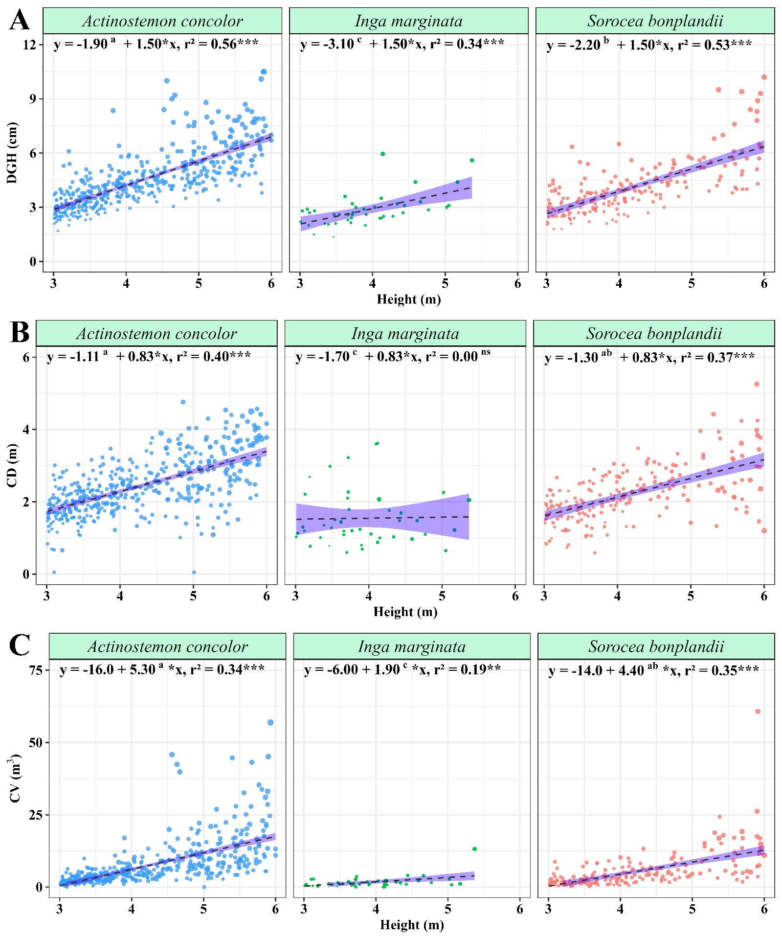
Figure S3. Allometric relationships for the third height class (H3 = 3.0 > H ≤ 6.0 m) of the three species (Actinostemon concolor, Inga marginata and Sorocea bonplandii) sampled in Mata São Francisco State Park (SSFSP). The allometric relationships were followed by: A = DGH × Height; B = CD × Height; C = CV × Height. DGH = diameter at ground height (cm); CD = crown depth (m) CV = crown volume (m³).
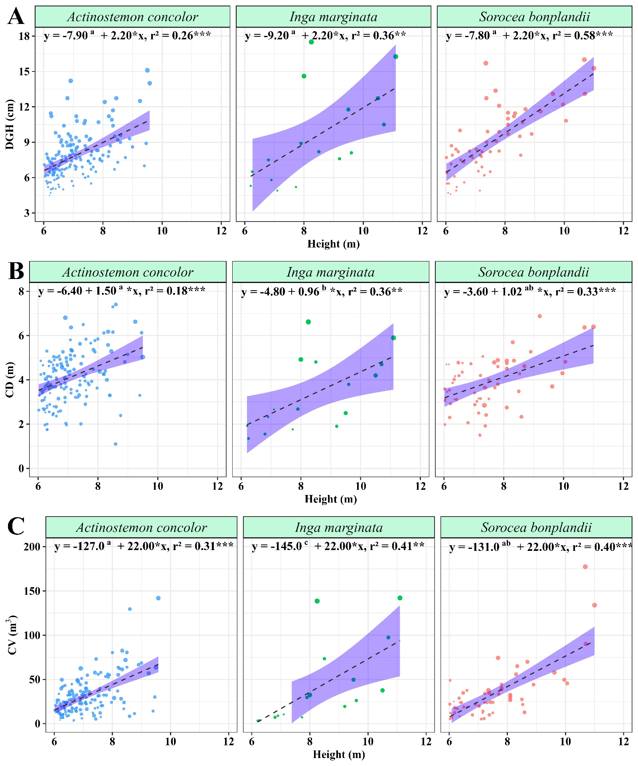
Figure S4. Allometric relationships for the fourth height class (H4 = H > 6.0 m) of the three species (Actinostemon concolor, Inga marginata and Sorocea bonplandii) sampled in Mata São Francisco State Park (MSFSP). The allometric relationships were followed by: A = DGH × Height; B = CD × Height; C = CV × Height. DGH = diameter at ground height (cm); CD = crown depth (m) CV = crown volume (m³).

Table S1. Summary of number of individuals divided by height classes. N = number of individuals. First height class (H1 = 0.5 ≥ H ≤ 1.5 m); second height class (H2 = 1.5 > H ≤ 3.0 m); Third height class (H3 = 3.0 > H ≤ 6.0 m); Fourth height class (H4 = H > 6.0 m).
 | Number of Individuals divided by height classes
 | First Class  N = 3195¹ | Second Class  N = 1449¹ | Third Class  N = 703¹ | Fourth Class  N = 232¹
Species
Actinostemon concolor | 1529 (47.86%) | 753 (51.97%) | 462 (65.72%) | 157 (67.67%)
Inga marginata | 331 (10.36%) | 120 (8.282%) | 42 (5.974%) | 16 (6.897%)
Sorocea bonplandii | 1335 (41.78%) | 576 (39.75%) | 199 (28.31%) | 59 (25.43%)
¹n (%).
Table S2. Summary of the forest stand data. Range and number of stems per hectare (trees ha⁻¹) for each species sampled in Mata São Francisco State Park (MSFSP). (AC – Actinostemon concolor; IM – Inga marginata; SB – Sorocea bonplandii). H = height (m); DGH = diameter at ground height (cm); CD = crown depth (m); HCA = horizontal crown area (m²); VCA, vertical crown area (m²); CV = crown volume (m³).
Species | Range |  |  |  | Trees ha^{–1}
 | H (m) | DGH (cm) | CD (m) | CV (m³)
AC | 0.5–9.58 | 0.4–15.1 | 0.05–8.14 | 0.0003–141.84 | 2417.50
IM | 0.5–11.10 | 0.35–17.5 | 0.09–6.62 | 0.0003–142.07 | 424.50
SB | 0.5–11.0 | 0.4–16.0 | 0.08–8.24 | 0.0003–259.07 | 1807.50

Table S3. Summary of the forest stand data. Mean of architectural variables for each species sampled in Mata São Francisco State Park (MSFSP). (AC – Actinostemon concolor; IM – Inga marginata; SB – Sorocea bonplandii). SD = Standard deviation; H = Height (m); DGH = Diameter at ground height (cm); CD = Crown depth (m); HCA = Horizontal crown area (m²); VCA, Vertical crown area (m²); CV = Crown volume (m³).
Species | Mean ± SD
 | H (m) | DGH (cm) | CD (m) | CV (m³)
AC | 2.09 ± 1.73 | 2.16 ± 2.06 | 1.13 ± 1.11 | 3.09 ± 9.49
IM | 1.65 ± 1.58 | 1.41 ± 1.76 | 0.73 ± 0.74 | 1.57 ± 10.92
SB | 1.74 ± 1.42 | 1.71 ± 1.68 | 0.89 ± 0.82 | 1.64 ± 9.34
Figure S5: Path diagram shows the correlation between crown traits, total height, stem diameter, growth and survival. Single-headed arrows refer to causal relationships; double-headed arrows to correlations. This Path diagram is adapted from Sterck et al. (2003). DGH = diameter at ground height (cm); H = height (m); CD = crown depth (m); HCA = horizontal crown area (m²); VCA, vertical crown area (m²); CV = crown volume (m³).

