Supplementary Information for

Polar and subpolar shelf seas dominate enhanced coastal CO₂ uptake during marine heatwaves
Zhentao Hu^{1,2}, Moritz Mathis¹, Hongmei Li^{1,3}, Tatiana Ilyina^{1,2,3}, Yoana G. Voynova⁴, Vlad A. Macovei⁴, Feng Zhou^{5,6}, Qicheng Meng^{5,6}, Corinna Schrum^{1,2} & Wenyan Zhang¹*
¹Institute of Coastal Systems – Analysis and Modeling, Helmholtz-Zentrum Hereon, Geesthacht, Germany.
²Institute of Oceanography, Center for Earth System Research and Sustainability, University of Hamburg, Hamburg, Germany.
³Department of Climate Variability, Max Planck Institute for Meteorology, Hamburg, Germany.
⁴Department of Coastal Productivity, Institute of Carbon Cycles, Helmholtz-Zentrum Hereon, Geesthacht, Germany.
⁵State Key Laboratory of Satellite Ocean Environment Dynamics, Second Institute of Oceanography, Ministry of Natural Resources, Hangzhou, China.
⁶Observation and Research Station of Yangtze River Delta Marine Ecosystems, Ministry of Natural Resources, Zhoushan, China.

*Corresponding author: Wenyan Zhang (wenyan.zhang@hereon.de)
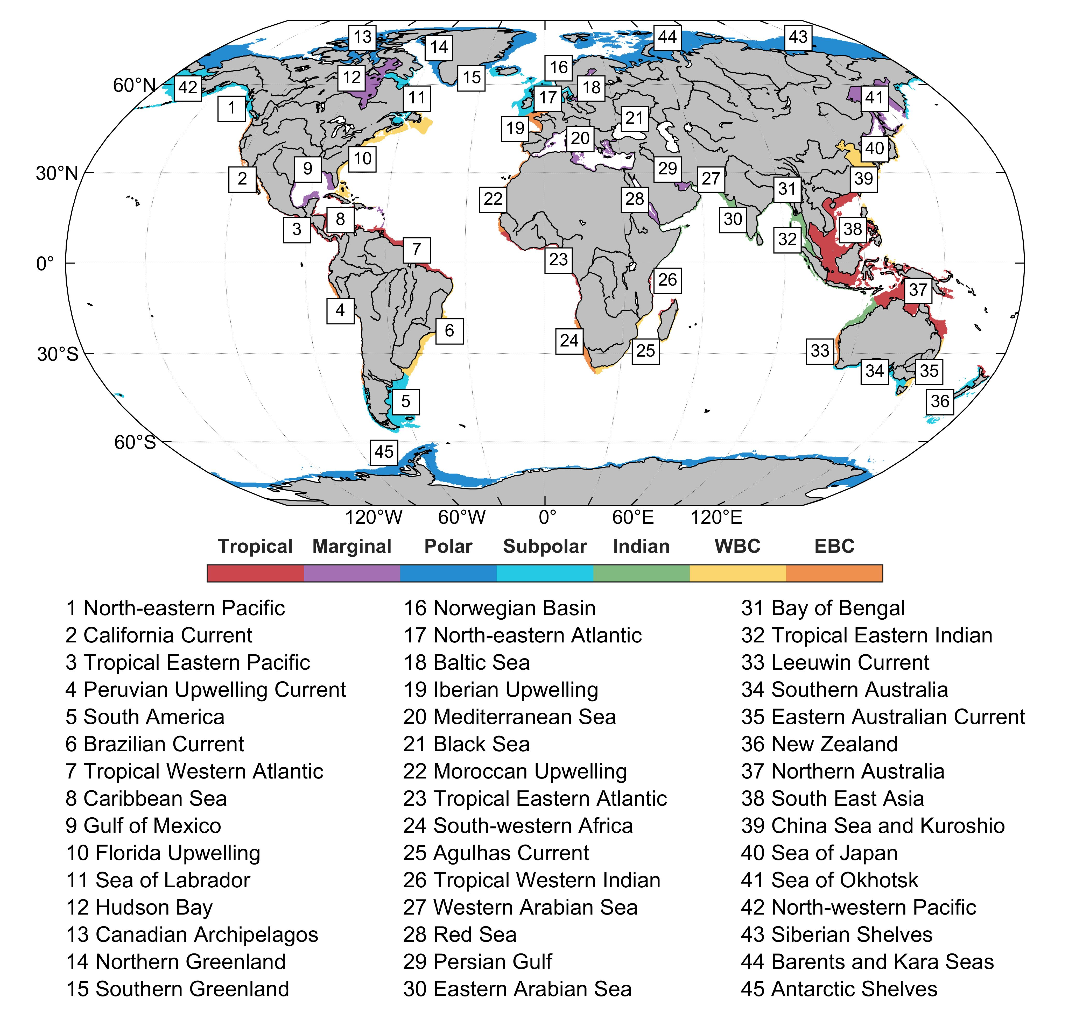
Supplementary Fig. 1 | Segmentation of the coastal ocean. Global continental shelf seas divided into 45 MARCATS regions¹, grouped into seven categories: eastern boundary currents (EBC), western boundary currents (WBC), Indian margins, subpolar margins, polar margins, marginal seas, and tropical margins. The figure is adopted from Roobaert et al.², with major rivers added for context.
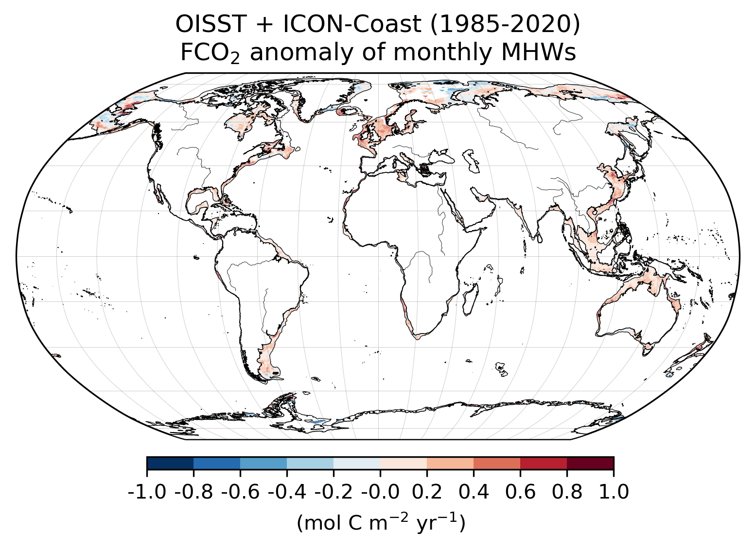
Supplementary Fig. 2 | Coastal FCO₂ responses to MHWs simulated by ICON-Coast. Spatial distribution of averaged air–sea FCO₂ anomalies (mol C m⁻² yr⁻¹) across the global coastal regions, derived from ICON-Coast simulations.

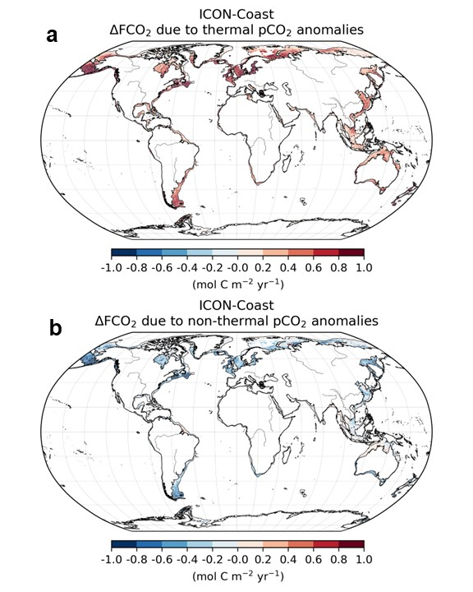
Supplementary Fig. 3 | Averaged contributions to FCO₂ anomalies simulated by ICON-Coast. Spatial distribution of thermal (a) and non-thermal (b) components of pCO_{2,sea} contributing to air–sea FCO₂ anomalies (1985–2020), as simulated by ICON-Coast.
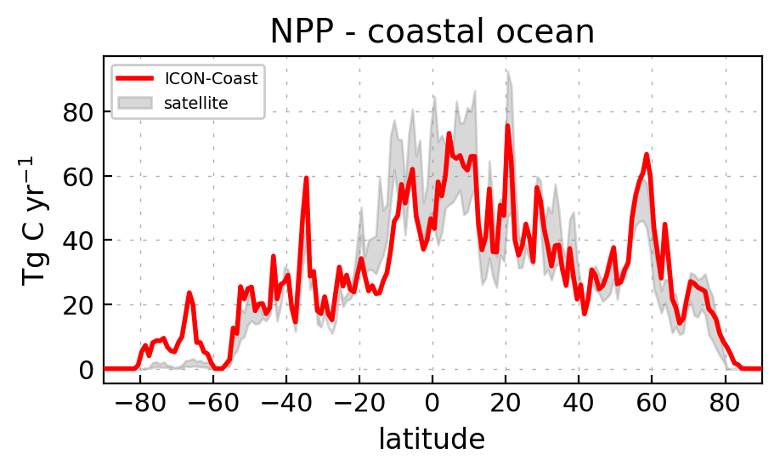
Supplementary Fig. 4 | Primary productivity in the coastal ocean. Zonally integrated annual net primary production in the coastal ocean, simulated by ICON-Coast (2001–2020, red) and calculated from the two satellite products (shaded grey) CBPM-VIIRS (2012–2020) and CAFE-MODIS (2003–2020).

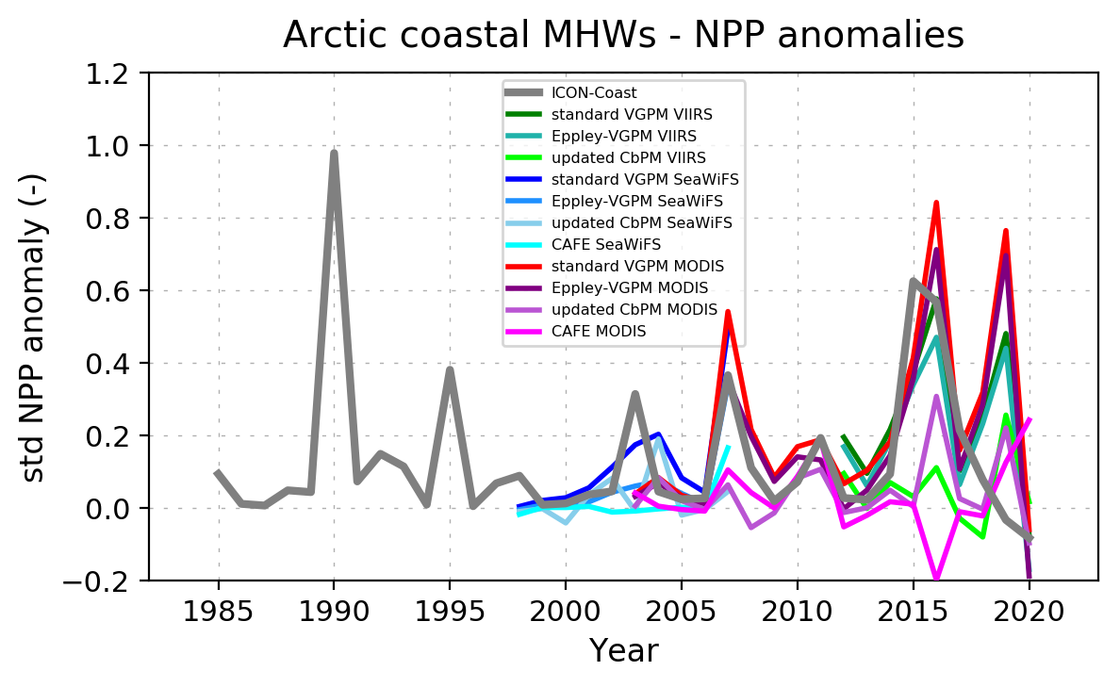
Supplementary Fig. 5 | Impact of MHWs on Arctic primary productivity. Standardized anomalies of annual net primary production (NPP) on Arctic shelves (>66°N) induced by MHWs, simulated by ICON-Coast (grey) and calculated from various satellite products named in the figure legend.

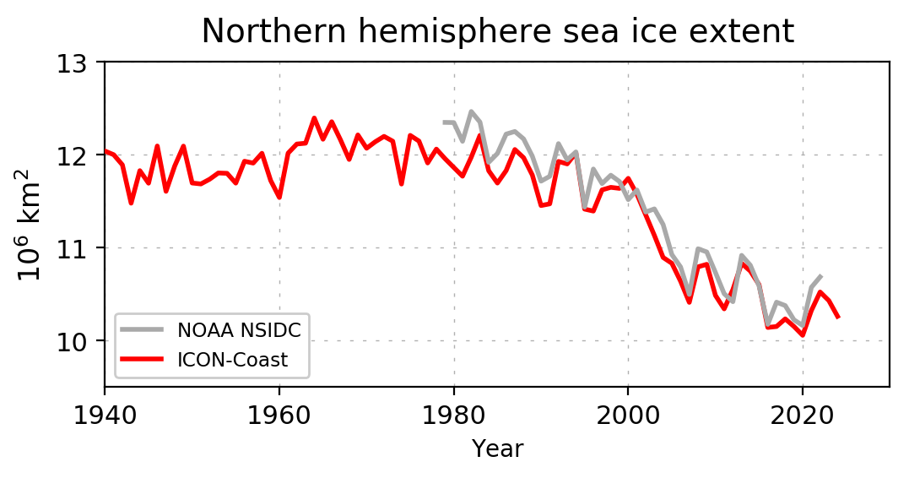
Supplementary Fig. 6 | Sea ice cover in the Arctic Ocean. Annual mean sea ice extent in the northern hemisphere, simulated by ICON-Coast (red) and compared with NOAA-NSIDC remote sensing observations.
Supplementary Table 1 | Trends in sea ice loss and MHW month grids for typical polar and subpolar shelf seas
MARCATS identifier | Region name | Class | Trend of sea ice: Slope ± 95% CI (P value) | Trend of MHW month grids: Slope ± 95% CI (P value)
12 | Hudson Bay | Marginal / Subpolar | –0.69×10³ ± 2.56×10³ yr⁻¹ (P = 0.586) | 95 ± 65 yr⁻¹ (P = 0.006)
13 | Canadian Archipelagos | Polar | –2.09×10³ ± 1.43×10³ yr⁻¹ (P = 0.006) | 344 ± 117 yr⁻¹ (P < 0.001)
14 | Northern Greenland | Polar | –0.42×10³ ± 1.38×10³ yr⁻¹ (P = 0.541) | 83 ± 56 yr⁻¹ (P = 0.004)
15 | Southern Greenland | Polar | –0.27×10³ ± 1.05×10³ yr⁻¹ (P = 0.606) | 43 ± 32 yr⁻¹ (P = 0.010)
41 | Sea of Okhotsk | Marginal / Subpolar | –0.32×10³ ± 2.23×10³ yr⁻¹ (P = 0.774) | 96 ± 40 yr⁻¹ (P < 0.001)
42 | North-western Pacific | Subpolar | –6.15×10³ ± 4.94×10³ yr⁻¹ (P = 0.016) | 325 ± 144 yr⁻¹ (P < 0.001)
43 | Siberian Shelves | Polar | –9.27×10³ ± 1.18×10³ yr⁻¹ (P = 0.119) | 941 ± 385 yr⁻¹ (P < 0.001)
44 | Barents and Kara Seas | Polar | –9.94×10³ ± 7.58×10³ yr⁻¹ (P = 0.012) | 842 ± 340 yr⁻¹ (P < 0.001)
45 | Antarctic Shelves | Polar | 6.11×10³ ± 4.28×10³ yr⁻¹ (P = 0.007) | –184 ± 69 yr⁻¹ (P < 0.001)

Supplementary References
1. Laruelle, G. G. et al. Global multi-scale segmentation of continental and coastal waters from the watersheds to the continental margins. Hydrol. Earth Syst. Sc. 17, 2029–2051 (2013).
2. Roobaert, A. et al. The spatiotemporal dynamics of the sources and sinks of CO₂ in the global coastal ocean. Glob. Biogeochem. Cycles 33, 1693–1714 (2019).

