Table S1: Biochemical Characteristics of bacterial isolates from the ruminant gut
Isolate  codes | Raffinose | H₂S Production | Indole | Starch Hydrolysis | Catalase | Citrate | Nitrate | Gelation | Glucose | Fructose | MR | VP | Maltose | Galactose | Lactose | Glucose Gas | Sucrose | Suspected organisms
A1 | + | + | - | + | + | + | + | + | + | + | + | - | + | + | - | - | - | Clostridium sphenoid
A2 | - | + | - | + | + | - | + | + |  | + | + | + | + | + | - | - | - | C. clostridofonne
A3a | - | + | - | + | - | - | + | + | + | + | + | + | + | + | + | - | + | C. perfringens
A3b | - | + | - | + | - | - | + | + | + | + | + | - | + | + | - | - | - | -
B1 | - | + | - | + | - | - | + | + | + | + | + | - | + | + | - | - | - | -
B2 | + | + | - | - | - | - | + | + | + | + | + | - | + | + | - | - | - | C. perfringens
B3 | + | + | - | + | + | - | + | + | + | + | + | - | + | + | - | - | - | -
B4a | + | + | + | + | - | + | + | + | + | + | + | - | + | + | + | - | + | -
B4b | - | + | + | + | - | - | + | + | + | + | + | - | + | + | + | - | + | C. perfringens
C3a | - | + | - | + | - | - | + | + | + | + | + | - | + | + | + | - | + | C. perfringens
C3b | + | - | - | - | + | - | + | + | + | + | + | - | + | + | + | - | + | C. felsineum
D1 | + | - | - | - | - | - | + | + | + | + | + | - | + | + | + | - | + | C. perfringens
D2 | - | + | - | + | - | + | + | + | + | + | + | - | + | + | + | - | + | C. perfringens
D3a | - | - | - | + | + | - | + | + | + | + | + | - | + | + | + | + | + | C. perfringens
D3b | - | - | - | - | - | - | + | + | + | + | + | - | + | + | + | - | + | C. cnauvoei
E1 | - | - | - | - | - | - | + | + | + | + | + | + | + | + | + | - | + | C. cnauvoei
E2 | + | - | - | - | + | - | + | + | + | + | + | + | + | + | + | + | + | C. perfringens
E3 | - | - | - | + | - | + | + | + | + | + | + | - | + | + | + | - | + | C. perfringens
F1 | + | - | - | - | - | + | + | + | + | + | + | - | + | + | - | - | - | C. novyi type A
F2 | - | - | - | + | + | - | + | + | + | + | + | + | + | + | + | + | + | C. perfringens

Table S2: Fourier transform infra-red (FTIR) showing biobutanol production through the presence of bonds
Range (cm⁻¹) | Group and Class | Assignment
3337 | ̶ OH in alcohols and phenols | ̶ OH stretch
2117 | N-C triple bond in isonitriles | N-C triple bond isonitriles
1988 | substituted benzene ring | Several bands from overtones and C₆H₆ ring
1636 | C=O | C=O stretch
1097 | C ̶ O ̶ H in 2º or 3º alcohol | C-O-H stretch
667 | C ̶ OH in alcohols | C ̶ OH bending

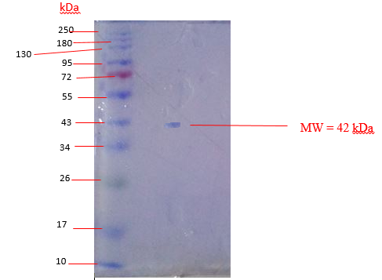
Figure S2: Electrophoregram of purified β-mannanase from Clostridium cnauvoei

Figure S3a: Effect of temperature on the activity of purified β-mannanase from C. cnauvoei

Figure S3b: Effect of pH on the activity of purified β-mannanase from C. cnauvoei

.

Figure S4: Kinetic parameters of the purified β-mannanase from C. cnauvoei

Figure S5a: Thermal inactivation of purified β-mannanase from C. chauvoei

Figure S5b: Arrhenius plot for heat inactivation of purified β-mannanase from C. chauvoei

Figure S5c: Temperature dependence of the decimal reduction (D-value) for purified β-mannanase

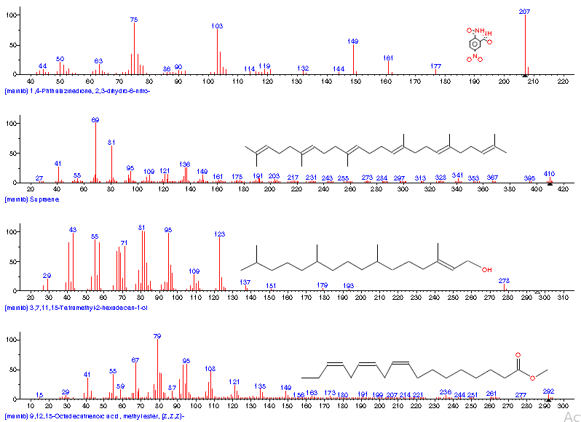

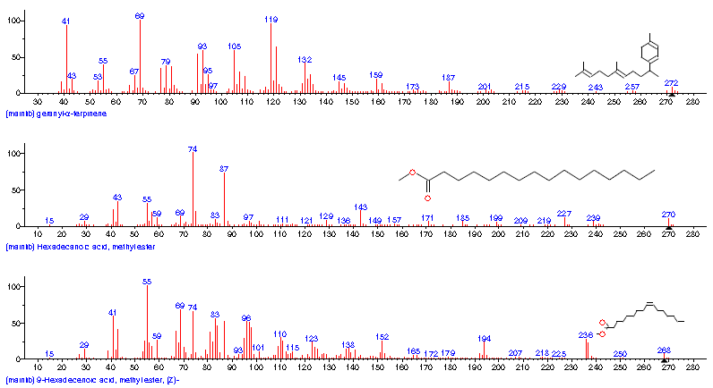
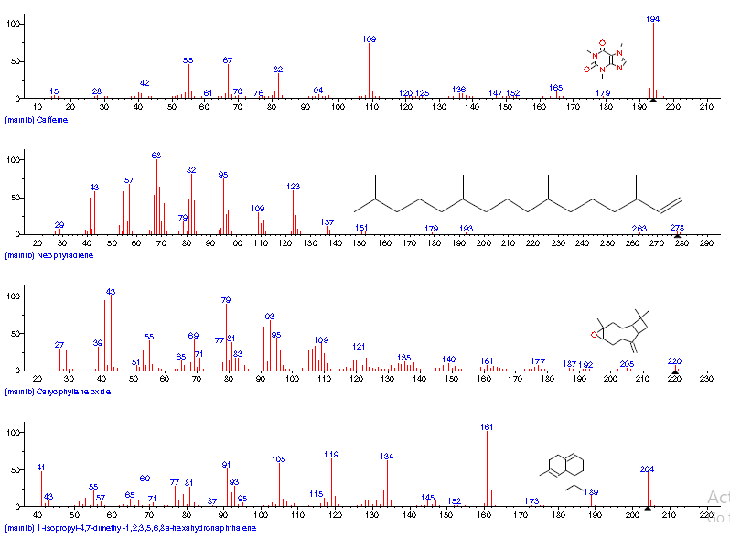

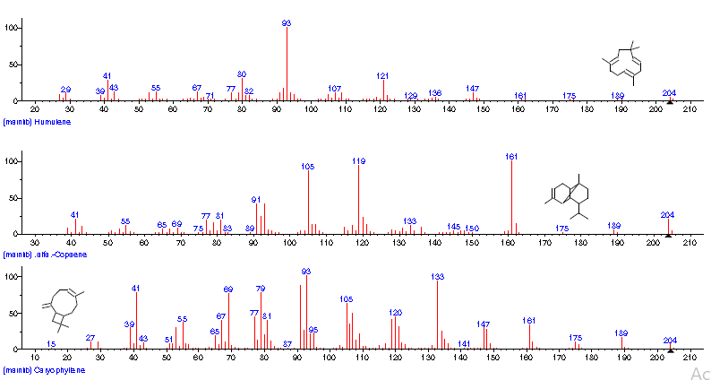
Figure S6: Gas chromatography analysis of fermented palm kernel cake reveals several volatile compounds, among which compounds 3, 7, 11, and 15-tetramethyl-2-hexadecen-1-ol corresponded to the expected biofuel product

