Supplementary Material
Low CCL19 Expression is associated with Adverse Clinical Outcomes for Patients with Advanced Stage Follicular Lymphoma
Yu Zhou, Shasha Wang, Yunxia Tao, Haizhu Chen, Yan Qin, Xiaohui He, Shengyu Zhou, Jianliang Yang, Sheng Yang, Lin Gui, Ning Lou, Zhishang Zhang, Jiarui Yao, Xiaohong Han, Yuankai Shi
Content
Supplementary Table S1. Patient characteristics of validation cohorts. 2
Supplementary Fig S1. Gene Set Enrichment Analysis of Follicular lymphoma. 3
Supplementary Fig S2. Cluster dendrogram identifying outlined samples in WGCNA analysis 4
Supplementary Fig S3. Scale independence and mean connectivity under different soft threshold powers for scale-free network in WGCNA analysis. 5
Supplementary Fig S4. Network plot displaying pathways enriched in GO (A) and KEGG (B) analysis for genes of turquoise module in WGCNA analysis. 6
Supplementary Fig S5. (A) Top 50 genes ranked by weighted degree in turquoise module. (B) PPI network of the 8 hub genes. 7
Supplementary Fig S6. mRNA expression of eight hub genes among different tumors. 8
Supplementary Fig S7. Cutoff value of eight hub genes for GSE119214. 9
Supplementary Fig S8. Cutoff value of CCL19 for CHCAMS cohort. 10

Supplementary Table S1. Patient characteristics of validation cohorts.
Characteristics | GSE119214 (n=137) | CHCAMS cohort (n=32)
Sample source | Pre-treatment FFPE samples | Pre-treatment serum samples
Gender
Male | NA | 16 (50.0%)
Female | NA | 16 (50.0%)
Age, median (range) | NA | 47 (26-72)
Age over 60
Yes | NA | 8 (25.0%)
No | NA | 24 (75.0%)
Rituximab maintenance
Yes | NA | 10 (31.2%)
No | NA | 22 (68.8%)
FLIPI group
Low-risk | NA | 9 (28.1%)
Intermediate-risk | NA | 15 (46.9%)
High-risk | NA | 8 (25.0%)
PFS, median (range) (months) | 83.8 (0.6-170.4) | 46.5 (6.0-76.0)
OS, median (range) (months) | 102 (1.3-170.4) | 51.0 (12.0-98.0)
Median follow-up time (months) | NA | 58.0
Abbreviations: FFPE, formalin-fixed and paraffin-embedded; FLIPI, Follicular Lymphoma International Prognostic Index; PFS, progression-free survival; OS, overall survival.

Supplementary Fig S1. Gene Set Enrichment Analysis of genes in dataset GSE65135.
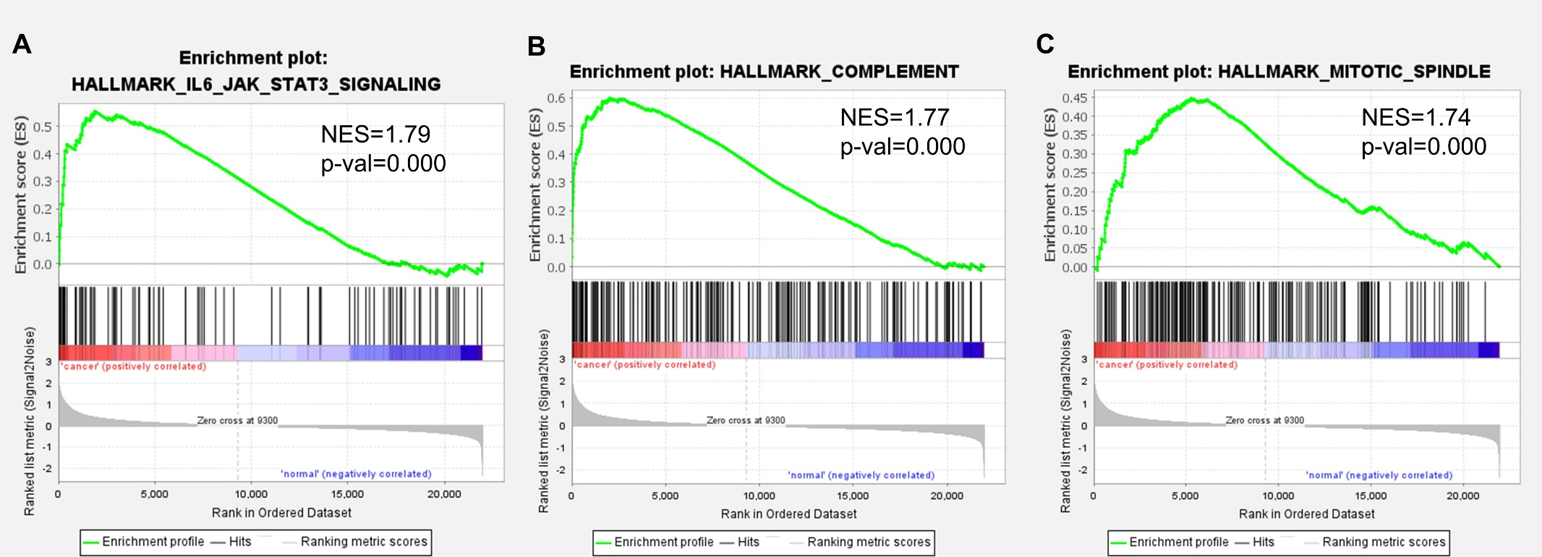

Supplementary Fig S2. Cluster dendrogram identifying outlined samples in WGCNA analysis.

Supplementary Fig S3. Scale independence and mean connectivity under different soft threshold powers for scale-free network in WGCNA analysis. Soft thresholding power was set at 6 to ensure a scale-free network, with scale-free R² >0.8 (in the left graph) and mean k >100 (in the right graph).

Supplementary Fig S4. Network plot displaying pathways enriched in GO (A) and KEGG (B) analysis for genes of turquoise module in WGCNA analysis.
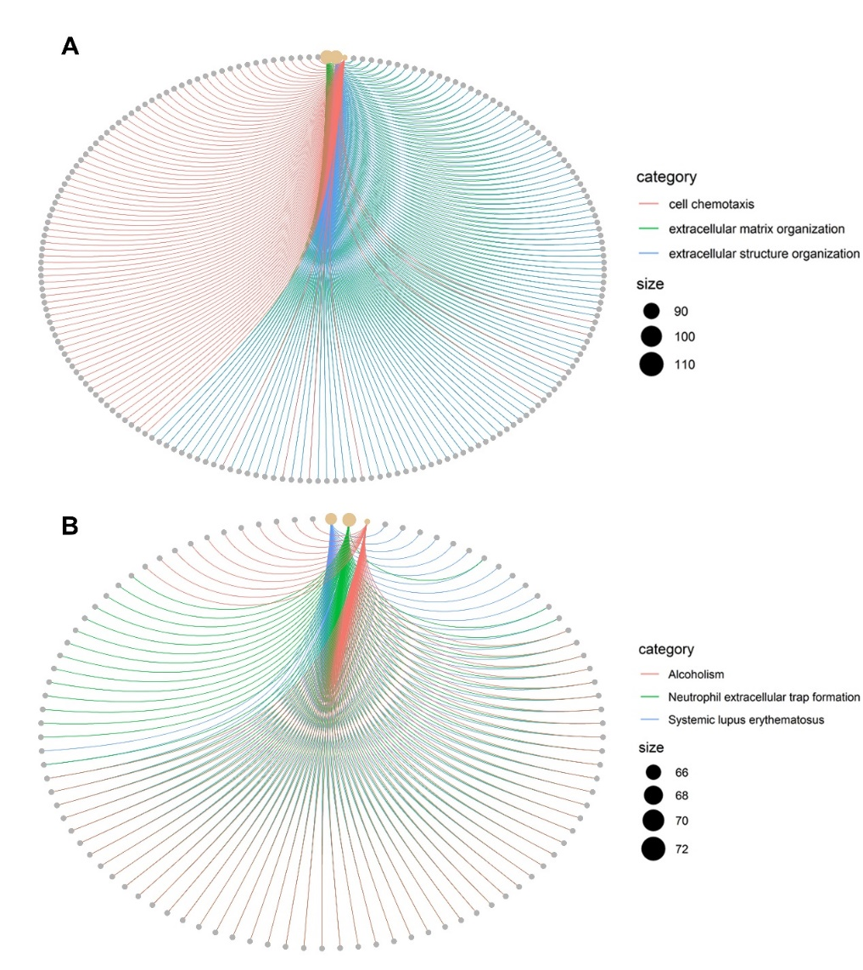
Supplementary Fig S5. (A) Top 50 genes ranked by weighted degree in turquoise module. Color of nodes are ordered according to their degree with red nodes representing higher degree while yellow nodes representing lower degree. (B) PPI network of the 8 hub genes.

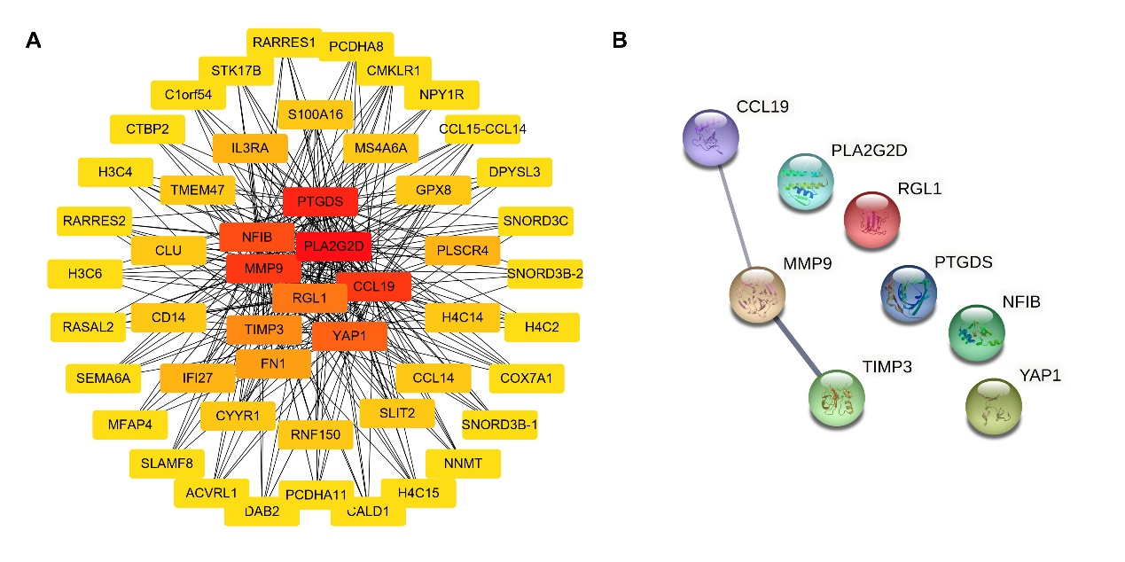

Supplementary Fig S6. mRNA expression of hub genes among different tumors. Graph showed the datasets which mRNA of the hub genes were significantly overexpressed (red) and down-regulated (blue). The threshold for p value were 0.01. Numbers in each cell indicated the number of analyses that met the threshold within each cancer type.
Note: *Cell color is determined by the best gene rank percentile for the analyses within the cell.
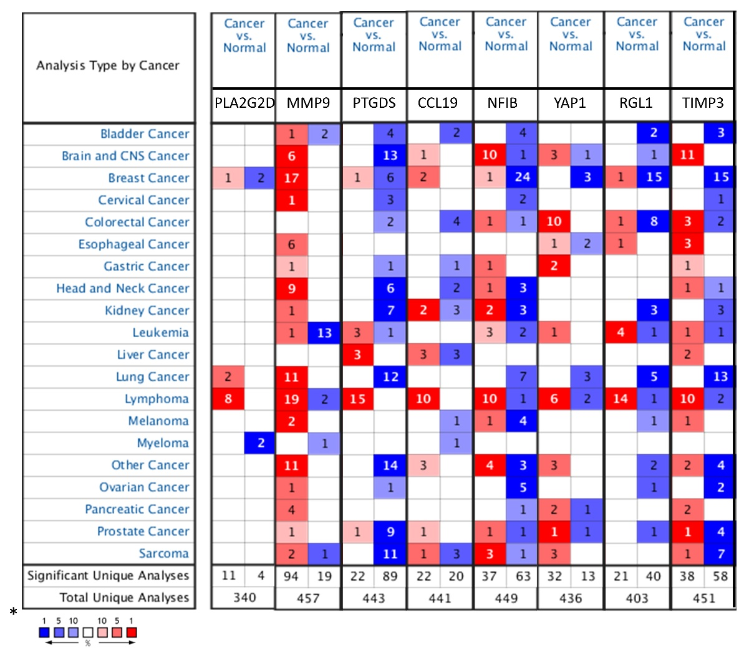
Supplementary Fig S7. Cutoff value of eight hub genes for GSE119214. Samples were grouped into high expression and low expression groups based on the cutpoint of gene expression value, with expression value lower than cutpoint defined as low expression group and expression value higher than cutpoint defined as high expression group.
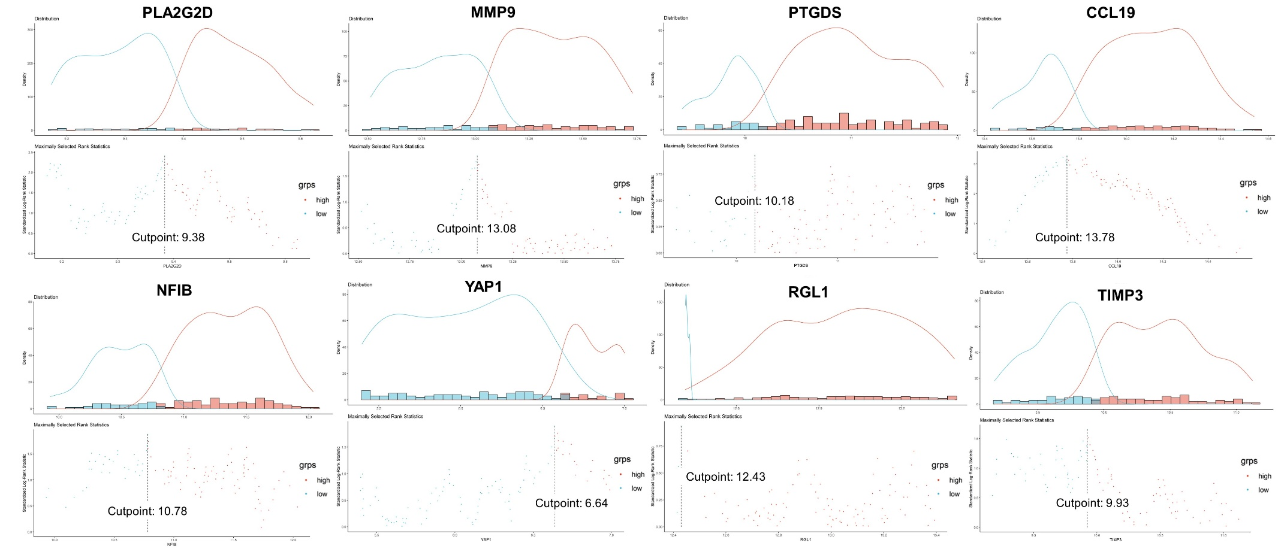

Supplementary Fig S8. Cutoff value of CCL19 for CHCAMS cohort. Samples were grouped into high expression and low expression groups based on the cutpoint of CCL19 concentration, with expression value lower than 0.94 defined as low expression group and expression value hihger than 0.94 defined as high expression group.

