Supplemental materials | Page
Appendix 1. Completed PRISMA-NMA checklist. | 2-5
Appendix 2. Search strategy of PubMed, Embase, Cochrane, Web of Science, and EBSCO. | 6-7
Appendix 3. The classifications of exercise training. | 8
Appendix 4. Characteristics of the included studies. | 9-15
Appendix 5. List of included studies. | 15-19
Appendix 6. Risk of bias assessment. | 20
Appendix 7. Contributions of direct and indirect comparisons to NMA and the number of studies of each direct comparison of leptin and adiponectin. | 21-24
Appendix 8. Inconsistency of leptin and adiponectin tested by loop-specific heterogeneity estimates, inconsistency model and node splitting analysis. | 25-28
Appendix 9.Interval plots of network meta-analysis for TC,HDL,LDL,TG. | 29-30

Appendix 1. PRISMA NMA checklist of items to include when reporting a systematic review involving a network meta-analysis
Section/Topic | Item # | Checklist Item | Reported on Page #
TITLE
Title | 1 | Identify the report as a systematic review incorporating a network meta-analysis (or related form of meta-analysis). | 1
ABSTRACT
Structured summary | 2 | Provide a structured summary including, as applicable:  Background: main objectives  Methods: data sources; study eligibility criteria, participants, and interventions; study appraisal; and synthesis methods, such as network meta-analysis.  Results: number of studies and participants identified; summary estimates with corresponding confidence/credible intervals; treatment rankings may also be discussed. Authors may choose to summarize pairwise comparisons against a chosen treatment included in their analyses for brevity.  Discussion/Conclusions: limitations; conclusions and implications of findings.  Other: primary source of funding; systematic review registration number with registry name. | 1
INTRODUCTION
Rationale | 3 | Describe the rationale for the review in the context of what is already known, including mention of why a network meta-analysis has been conducted. | 2
Objectives | 4 | Provide an explicit statement of questions being addressed, with reference to participants, interventions, comparisons, outcomes, and study design (PICOS). | 2-3
METHODS
Protocol and registration | 5 | Indicate whether a review protocol exists and if and where it can be accessed (e.g., Web address); and, if available, provide registration information, including registration number. | 3
Eligibility criteria | 6 | Specify study characteristics (e.g., PICOS, length of follow-up) and report characteristics (e.g., years considered, language, publication status) used as criteria for eligibility, giving rationale. Clearly describe eligible treatments included in the treatment network, and note whether any have been clustered or merged into the same node (with justification). | 3
Information sources | 7 | Describe all information sources (e.g., databases with dates of coverage, contact with study authors to identify additional studies) in the search and date last searched. | 3-4
Search | 8 | Present full electronic search strategy for at least one database, including any limits used, such that it could be repeated. | 3  Appendix 2
Study selection | 9 | State the process for selecting studies (i.e., screening, eligibility, included in systematic review, and, if applicable, included in the meta-analysis). | 3
Data collection process | 10 | Describe method of data extraction from reports (e.g., piloted forms, independently, in duplicate) and any processes for obtaining and confirming data from investigators. | 4
Data items | 11 | List and define all variables for which data were sought (e.g., PICOS, funding sources) and any assumptions and simplifications made. | 4
Geometry of the network | S1 | Describe methods used to explore the geometry of the treatment network under study and potential biases related to it. This should include how the evidence base has been graphically summarized for presentation, and what characteristics were compiled and used to describe the evidence base to readers. | 4
Risk of bias within individual studies | 12 | Describe methods used for assessing risk of bias of individual studies (including specification of whether this was done at the study or outcome level), and how this information is to be used in any data synthesis. | 4
Summary measures | 13 | State the principal summary measures (e.g., risk ratio, difference in means). Also describe the use of additional summary measures assessed, such as treatment rankings and surface under the cumulative ranking curve (SUCRA) values, as well as modified approaches used to present summary findings from meta-analyses. | 4
Planned methods of analysis | 14 | Describe the methods of handling data and combining results of studies for each network meta-analysis. This should include, but not be limited to:  - Handling of multi-arm trials;  - Selection of variance structure;  - Selection of prior distributions in Bayesian analyses; and  - Assessment of model fit. | 4
Assessment of Inconsistency | S2 | Describe the statistical methods used to evaluate the agreement of direct and indirect evidence in the treatment network(s) studied. Describe efforts taken to address its presence when found. | 4
Risk of bias across studies | 15 | Specify any assessment of risk of bias that may affect the cumulative evidence (e.g., publication bias, selective reporting within studies). | 4
Additional analyses | 16 | Describe methods of additional analyses if done, indicating which were pre-specified. This may include, but not be limited to, the following:  - Sensitivity or subgroup analyses;  - Meta-regression analyses;  - Alternative formulations of the treatment network; and  - Use of alternative prior distributions for Bayesian analyses (if applicable). | 4
RESULTS†
Study selection | 17 | Give numbers of studies screened, assessed for eligibility, and included in the review, with reasons for exclusions at each stage, ideally with a flow diagram. | 4-5
Presentation of network structure | S3 | Provide a network graph of the included studies to enable visualization of the geometry of the treatment network. | Fig.2、3、4、5
Summary of network geometry | S4 | Provide a brief overview of characteristics of the treatment network. This may include commentary on the abundance of trials and randomized patients for the different interventions and pairwise comparisons in the network, gaps of evidence in the treatment network, and potential biases reflected by the network structure. | 5
Study characteristics | 18 | For each study, present characteristics for which data were extracted (e.g., study size, PICOS, follow-up period) and provide the citations. | 5,  Appendix4、5
Risk of bias within studies | 19 | Present data on risk of bias of each study and, if available, any outcome level assessment. | 6, Appendix 6
Results of individual studies | 20 | For all outcomes considered (benefits or harms), present, for each study: 1) simple summary data for each intervention group, and 2) effect estimates and confidence intervals. Modified approaches may be needed to deal with information from larger networks. | Not applicable
Synthesis of results | 21 | Present results of each meta-analysis done, including confidence/credible intervals. In larger networks, authors may focus on comparisons versus a particular comparator (e.g., placebo or standard care), with full findings presented in an appendix. League tables and forest plots may be considered to summarize pairwise comparisons. If additional summary measures were explored (such as treatment rankings), these should also be presented. | 5-6
Exploration for inconsistency | S5 | Describe results from investigations of inconsistency. This may include such information as measures of model fit to compare consistency and inconsistency models, P values from statistical tests, or summary of inconsistency estimates from different parts of the treatment network. | 6,  Appendix 8
Risk of bias across studies | 22 | Present results of any assessment of risk of bias across studies for the evidence base being studied. | Not Applicable
Results of additional analyses | 23 | Give results of additional analyses, if done (e.g., sensitivity or subgroup analyses, meta-regression analyses, alternative network geometries studied, alternative choice of prior distributions for Bayesian analyses, and so forth). | Not Applicable
DISCUSSION
Summary of evidence | 24 | Summarize the main findings, including the strength of evidence for each main outcome; consider their relevance to key groups (e.g., healthcare providers, users, and policy-makers). | 7-8
Limitations | 25 | Discuss limitations at study and outcome level (e.g., risk of bias), and at review level (e.g., incomplete retrieval of identified research, reporting bias). Comment on the validity of the assumptions, such as transitivity and consistency. Comment on any concerns regarding network geometry (e.g., avoidance of certain comparisons). | 8
Conclusions | 26 | Provide a general interpretation of the results in the context of other evidence, and implications for future research. | 8
FUNDING
Funding | 27 | Describe sources of funding for the systematic review and other support (e.g., supply of data); role of funders for the systematic review. This should also include information regarding whether funding has been received from manufacturers of treatments in the network and/or whether some of the authors are content experts with professional conflicts of interest that could affect use of treatments in the network. | 11-12
PICOS = population, intervention, comparators, outcomes, study design.
* Text in italics indicate wording specific to reporting of network meta-analyses that has been added to guidance from the PRISMA statement.
† Authors may wish to plan for use of appendices to present all relevant information in full detail for items in this section.

Appendix 2. Search strategy of PubMed, Embase, Cochrane, Web of Science, and EBSCO
Database | Search Terms
 | Exercise | Obesity | Child | Blood Lipids | Randomized controlled trial
PubMed  [Title/Abstract] | Exercise[MeSH Terms] OR exercise OR training OR aerobic exercise OR aerobic training OR resistance training OR resistance exercise OR strength training OR strength exercise OR combined training OR combined exercise OR concurrent training OR high intensity interval training OR HIIT OR sprint interval training OR physical activity | Obesity [MeSH Terms] OR obese OR overweight | Child [MeSH Terms]OR adolescent OR youth OR teen OR pediatric | Blood Lipids[MeSH Terms] OR blood lipid OR lipid profile OR dyslipidemia OR triglyceride OR TG OR high density lipoprotein OR HDL OR low density lipoprotein OR LDL OR total cholesterol OR TC | Randomized controlled trial OR randomized OR placebo
Embase  [Title/Abstract] | training [Emtree term] or aerobic exercise OR aerobic training OR moderate intensity continuous training OR resistance training OR resistance exercise OR strength training OR strength exercise OR combined training OR combined exercise OR concurrent training OR high intensity interval training OR sprint interval training OR walking OR physical activity | Obesity [Emtree term] OR obese OR overweight | Child[Emtree term]OR adolescent OR youth OR teen OR pediatric | Blood Lipids[Emtree term] OR blood lipid OR lipid profile OR dyslipidemia OR triglyceride OR TG OR high density lipoprotein OR HDL OR low density lipoprotein OR LDL OR total cholesterol OR TC | randomized controlled trial OR randomized OR placebo
Cochrane  [Title/Abstract/keywords] | Exercise [MeSH descriptor] OR training OR aerobic exercise OR aerobic training OR moderate intensity continuous training OR resistance training OR resistance exercise OR strength training OR strength exercise OR combined training OR combined exercise OR concurrent training OR high intensity interval training OR sprint interval training OR physical activity | Obesity [MeSH descriptor] OR obese OR overweight | Child [MeSH Terms]OR adolescent OR youth OR teen OR pediatric | Blood Lipids[MeSH Terms] OR blood lipid OR lipid profile OR dyslipidemia OR triglyceride OR TG OR high density lipoprotein OR HDL OR low density lipoprotein OR LDL OR total cholesterol OR TC | —
Web of Science | exercise OR training OR aerobic exercise OR aerobic training OR continuous training OR resistance training OR resistance exercise OR strength training OR strength exercise OR combined training OR combined exercise OR concurrent training OR high intensity interval training OR sprint interval training OR physical activity | obesity OR obese OR overweight | Child OR adolescent OR youth OR teen OR pediatric | Blood Lipids[MeSH Terms] OR blood lipid OR lipid profile OR dyslipidemia OR triglyceride OR TG OR high density lipoprotein OR HDL OR low density lipoprotein OR LDL OR total cholesterol OR TC | randomized controlled trial OR randomized OR placebo
EBSCO [Abstract] | exercise OR training OR aerobic exercise OR aerobic training OR continuous training OR resistance training OR resistance exercise OR physical activity OR strength training OR strength exercise OR combined training OR combined exercise OR sprint interval training OR high intensity interval training OR physical activity  OR concurrent training | obesity OR obese OR overweight | Child OR adolescent OR youth OR teen OR pediatric AND Obesity OR obese OR overweight OR childhood obesity | Blood Lipids[MeSH Terms] OR blood lipid OR lipid profile OR dyslipidemia OR triglyceride OR TG OR high density lipoprotein OR HDL OR low density lipoprotein OR LDL OR total cholesterol OR TC | randomized controlled trial OR randomized OR placebo

Appendix 3. The classifications of exercise training
Type | Definition
CON | No exercise
AE | Type: Any continuous traditional mode of aerobic training only (e.g., walking, running, cycling, rowing, aerobics and elliptical exercise) [1].
RT | Type: Any mode of resistance training, including circuit-based programmers (e.g., free weights, weights machines and resistance bands) [1].
COM | Type: AE combined with RT
HIIT | Type: Exercise training involves repeated short-to-long bouts of rather high-intensity exercise interspersed with recovery periods, including interval sprint training [2, 3].
CON, control; AE, aerobic exercise; RT, resistance training; COM, aerobic exercise combined with resistance training; HIIT, high-intensity interval training; D, dietary restriction; D+AE. dietary restriction and aerobic exercise; D+RT, dietary restriction with resistance training; D+COM, dietary restriction with aerobic and resistance training; D+HIIT, dietary restriction and high-intensity interval training. MHR, maximum heart rate; HRR, heart rate reserve;

Reference

1. O'Donoghue, G., et al., What exercise prescription is optimal to improve body composition and cardiorespiratory fitness in adults living with obesity? A network meta-analysis. Obes Rev, 2021. 22(2): p. e13137.
2. Buchheit, M. and P.B. Laursen, High-intensity interval training, solutions to the programming puzzle: Part I: cardiopulmonary emphasis. Sports Med, 2013. 43(5): p. 313-38.
3. Wang, S., et al., Effect of Exercise Training on Body Composition and Inflammatory Cytokine Levels in Overweight and Obese Individuals: A Systematic Review and Network Meta-Analysis. Front Immunol, 2022. 13: p. 921085.

Appendix 4 Characteristics of the included studies
Author  Year | Country | Mode | Age | Obesity–BMI (percentile or kg/m2 or BMI-z) | Gender | N | Exercise Prescription |  |  | Results
 |  |  |  |  |  |  | Exercise intensity | Exercise Frequency | Exercise Period | Results
Lira et al.2017¹ | Brazil | AE | 14.95±1.35 | BMI >95th | female、male | 25 | VT1 | 4/7 | 12weeks | a,b,c,d
Lira et al.2017¹ | Brazil | AE | 14.77±0.94 | BMI >95th | female、male | 26 | 80%VT1 | 4/7 | 12weeks | a,b,c,d
Lira et al.2017¹ | Brazil | CON | 14.72±1.35 | BMI >95th | female、male | 33 |  |  | 12weeks | a,b,c,d
Monteiro et al.2015² | Brazil | AE | 11.00±1.02 | 30.15±2.90 | 21/27(F/M) | 18 | 65%-85% VO2peak | 3/7，50-60mins | 20weeks | a,b,c,d
Monteiro et al.2015² | Brazil | COM | 11.03±1.34 | 33.17±4.7 | 21/27(F/M) | 14 | AE：65%-85% VO2peak  RT：Minimum loads-75 % RM | 3/7，50-60mins | 20weeks | a,b,c,d
Monteiro et al.2015² | Brazil | CON | 11.04±1.90 | 30.95±3.42 | 21/27(F/M) | 16 |  |  | 20weeks | a,b,c,d
Horner et al.2015³ | Canada | AE | 14.7±1.8 | BMI >95th | 31/35(F/M) | 27 | 60-75%VO2peak | 3/7，60mins | 3 Months | a,b,c,d
Horner et al.2015³ | Canada | RT | 14.6±1.9 | BMI >95th | 31/35(F/M) | 23 | NA | 3/7，60mins | 3 Months | a,b,c,d
Horner et al.2015³ | Canada | CON | 14.9±1.8 | BMI >95th | 31/35(F/M) | 16 |  |  | 3 Months | a,b,c,d
Tadiotto et al.2023⁴ | Brazil | AE |  | BMI z-score ≥1 | 26/26(F/M) | 13 | 35-75%HRres reserve heart rate | 3/7，60mins | 12weeks | a,b,c,d
Tadiotto et al.2023⁴ | Brazil | HIIT | 11-16 | BMI z-score ≥1 | 26/26(F/M) | 15 | 90-100%HRres | 3/7，35mins | 12weeks | a,b,c,d
Tadiotto et al.2023⁴ | Brazil | CON |  | BMI z-score ≥1 | 26/26(F/M) | 24 |  |  | 12weeks | a,b,c,d
Lopes et al.2016⁵ | Brazil | COM | 14.6±1.15 | BMI >85th | female | 17 | AE:50-80%Vo2peak  RT:60-70%1RM | 3/7，60mins | 12weeks | a,b,c,d
Lopes et al.2016⁵ | Brazil | CON | 14.4±1.16 | BMI >85th | female | 16 |  |  | 12weeks | a,b,c,d
Chae et al.2010⁶ | Korea | COM | 10.4±3.1 | BMI >95th | 17/21(F/M) | 19 | 6-7 METs to burn about 370-430 kcal/hr | 2/7，70mins | 12weeks | a,b,c,d
Chae et al.2010⁶ | Korea | CON | 10.6±3.8 | BMI >95th | 17/21(F/M) | 19 |  |  | 12weeks | a,b,c,d

Jairo et al.2023⁷ | Spain | COM | 10.0±1.1 | BMI >85th | 41/58(F/M) | 47 | AE：≥80% HRmax  RT：Load prescribed based on 1RM (bench press and leg press); | 5/7，90mins | 20weeks | b,c,d
Jairo et al.2023⁷ | Spain | CON |  | BMI >85th | 41/58(F/M) | 52 |  |  | 20weeks | b,c,d
Racil et al.2013⁸ | Tunisia | AE | 16.3±0.52 | BMI >97th | female | 11 | AE:70-80%MAS |  | 12weeks | a,b,c,d
Racil et al.2013⁸ | Tunisia | HIIT | 15.6±0.7 | BMI >97th | female | 11 | HIIT:100%-110%MAS | 3/7，40mins | 12weeks | a,b,c,d
Racil et al.2013⁸ | Tunisia | CON | 15.9±1.2 | BMI >97th | female | 12 |  |  | 12weeks | a,b,c,d
Meng et al.2022⁹ | China | AE | 11.2±0.7 | BMI >95th | male | 11 | AE:60-70%MAS |  | 12weeks | a,b,c,d
Meng et al.2022⁹ | China | HIIT | 11.4±0.8 | BMI >95th | male | 12 | HIIT:90%-100%MAS | 3/7，30mins | 12weeks | a,b,c,d
Meng et al.2022⁹ | China | CON | 11.0±0.7 | BMI >95th | male | 13 |  |  | 12weeks | a,b,c,d
Khaliltahmasebi et al.2022¹⁰ | Iran | HIIT |  | 26.2±2.3 | male | 13 | 85%-100%MAS | 3/7，20-45mins | 12weeks | a,b,c,d
Khaliltahmasebi et al.2022¹⁰ | Iran | COM | 12±1 | 26.8±2.2 | male | 13 | NA | 3/7，60-90mins | 12weeks | a,b,c,d
Khaliltahmasebi et al.2022¹⁰ | Iran | CON |  | 26.2±2.5 | male | 12 |  |  | 12weeks | a,b,c,d
Lai et al.2013¹¹ | China | AE | 14.11±3.63 | 29.2±3.93 | 40/48(F/M) | 14 | 20-40% HRR | 5/7，120mins | 4weeks | a,b,c,d
Lai et al.2013¹¹ | China | CON | 14.11±3.63 | 29.27±4.56 | 40/48(F/M) | 74 |  |  | 4weeks | a,b,c,d
Kim et al.2007¹² | Korea | AE | 17±0.11 | 29.6±0.6 | male | 14 | Jump rope:60-90(jumps/min) | 5/7，40mins | 6weeks | a,b,c,d
Kim et al.2007¹² | Korea | CON | 17±0.11 | 29.4±0.7 | male | 12 |  |  | 6weeks | a,b,c,d

Aaron et al.2004¹³ | America | AE | 11.0±1.99 | BMI >85th | 11/9(F/M) | 10 | 50-60%VO2peak | 4/7，30mins | 8weeks | a,b,c,d
Aaron et al.2004¹³ | America | CON | 11.0±2.24 | BMI >85th | 11/9(F/M) | 10 |  |  | 8weeks | a,b,c,d
Park et al.2007¹⁴ | Korea | AE | 14.2±0.5 | BMI >95th | female | 21 | 55–75%HRmax | 6/7，10-40mins | 12weeks | a,b,c,d
Park et al.2007¹⁴ | Korea | CON | 14.1±0.5 | BMI >95th | female | 19 |  |  | 12weeks | a,b,c,d
Farpour et al.2009¹⁵ | Switzerland | COM | 9.1±1.4 | BMI >97th | 28/16(F/M) | 22 | AE：55%-65%VO₂max  RT：NA | 3/7，60mins | 3 Months | a,b,c,d
Farpour et al.2009¹⁵ | Switzerland | CON | 8.8±1.6 | BMI >97th | 28/16(F/M) | 22 |  |  | 3 Months | a,b,c,d
Kang et al.2002¹⁶ | America | AE | 13-16 | BMI >85th | female、male | 21 | 55-60%VO2peak | 6/7，29mins | 12weeks | a,b,c,d
Kang et al.2002¹⁶ | America | AE | 13-16 | BMI >85th | female、male | 20 | 75-80%VO2peak | 6/7，43mins | 12weeks | a,b,c,d
Kang et al.2002¹⁶ | America | CON | 13-16 | BMI >85th | female、male | 18
Leite et al.2021¹⁷ | Brazil | AE | 13.5±1.6 | BMI z-score ≥1 | NA | 55 | 35–75% HRR | 3/7，100mins | 12weeks | b,d
Leite et al.2021¹⁷ | Brazil | CON | 12.7±1.6 | BMI z-score ≥1 | NA | 17 |  |  | 12weeks | b,d
Seo et al.2019¹⁸ | Korea | COM | 12.80±1.72 | BMI >85th | 25/45(F/M) | 26 | AE:60–90%HRmax  RT:NA | 3/7，60mins | 12weeks | b,c,d
Seo et al.2019¹⁸ | Korea | CON | 12.09±2.20 | BMI >85th | 25/45(F/M) | 44 |  |  | 12weeks | b,c,d

Sefat et al.2019¹⁹ | Iran | COM | 12.40±1.71 | 26.02±2.2 | female | 10 | AE：60%-80%HRR  RT：40–65% intensity of a maximum replication | 3/7，75mins | 8weeks | a,b,c,d
Sefat et al.2019¹⁹ | Iran | CON | 11.80±2.20 | 24.49±3.3 | female | 10 |  |  | 8weeks | a,b,c,d
Ahmadi et al.2020²⁰ | Iran | RT | 13.89±2.80 | 28.80±4.83 | 55/31(F/M) | 29 |  |  | 8weeks | a,b,c,d
Ahmadi et al.2020²⁰ | Iran | HIIT | 14.55±2.55 | 29.97±5.15 | 55/31(F/M) | 28 | NA | 3/7，30mins | 8weeks | a,b,c,d
Ahmadi et al.2020²⁰ | Iran | CON | 12.70±2.64 | 28.48±6.00 | 55/31(F/M) | 27 |  |  | 8weeks | a,b,c,d
Piano et al.2012²¹ | Brazil | AE | 16.48±1.42 | BMI >95th | female、male | 15 | ventilatory threshold Iª | 3/7，60mins | 1year | a,b,c,d
Piano et al.2012²¹ | Brazil | COM | 16.48±1.42 | BMI >95th | female、male | 15 | AE：ventilatory threshold Iª  RT：NA |  | 1year | a,b,c,d
Dias et al.2018²² | Australia | AE | 11.9±2.4 | 30.4±5.0 | female、male | 22 | 60–70%HRmax | 3/7，40mins | 12weeks | a,b,c,d
Dias et al.2018²² | Australia | HIIT | 12.4±1.9 | 28.8±3.8 | female、male | 19 | 85–95%HRmax | 3/7，44mins | 12weeks | a,b,c,d
Dias et al.2018²² | Australia | CON | 11.8±2.4 | 29.6±4.3 | female、male | 19 |  |  | 12weeks | a,b,c,d

Chuensiri et al.2018²³ |  | Thailand | HIIT | 11.0±0.3 | 24.2±1.0 | male | 11 | 90%peak power output^{b} | 3/7，24mins | 12weeks | a,b,c,d
 |  | Thailand | HIIT | 11.1±0.2 | 26.5±0.9 | male | 11 | 90%peak power  output | 3/7，4mins | 12weeks | a,b,c,d
 |  | Thailand | CON | 10.6±0.3 | 26.1±1.0 | male | 15 |  |  | 12weeks | a,b,c,d
Zehsaz et al.2016²⁴ |  | Iran | COM | 10. 8±0.9 | BMI >95th | male | 14 | AE:55–75%HRmax  RT:70% 1RM | 2/7，85-90mins | 16weeks | a,b,c,d
 |  | Iran | CON | 10.3±0.9 | BMI >95th | male | 14 |  |  | 16weeks | a,b,c,d
Karacabey et al.2009²⁵ |  | Turkey | AE | 11.8±0.5 | 34.9±4.1 | male | 20 | 60-65% HRR | 3/7，30-65mins | 12weeks | b,c
 |  | Turkey | CON | 11.2±0.8 | 35.5±3.2 | male | 20 |  |  | 12weeks | b,c
Lee et al.2010²⁶ |  | Korea | AE | 12–14 | BMI >95th | 9/45(F/M) | 16 | 60%-80% VO2max | 3/7，60mins | 10weeks | a,b,c,d
 |  | Korea | COM | 12–14 | BMI >95th | 9/45(F/M) | 20 | AE：NA  RT：70%-80% 1RM |  | 10weeks | a,b,c,d
 |  | Korea | CON | 12–14 | BMI >95th | 9/45(F/M) | 18 |  |  | 10weeks | a,b,c,d
Wong et al.2008²⁷ |  | Singapore | COM | 13.75±1.06 | 30.6±2.1 | male | 12 | AE:65–85%HRmax  RT:NA | 2/7，45-62mins | 12weeks | a,b,c,d
 |  | Singapore | CON | 14.25±1.54 | 31.8±4.4 | male | 12 |  |  | 12weeks | a,b,c,d
Ferguson et al.1999²⁸ |  | America | AE | 9.5±1.0 | BMI >85th | female、male | 40 | HR > 150 bpm | 5/7，40mins | 16weeks | a,b,c,d
 |  | America | CON | 9.5±1.0 | BMI >85th | female、male | 37 |  |  | 16weeks | a,b,c,d
Ghorbanian et al.2013²⁹ |  | Iran | AE | 17.35±1.07 | 28.24±2.56 | male | 15 | NA | 4/7，40mins | 8weeks | a,b,c,d
 |  | Iran | CON | 16.90±1.15 | 28.31±2.49 | male | 15 |  |  | 8weeks | a,b,c,d
Araujo et al.2012³⁰ | Brazil |  | AE | 10.4±0.9 | BMI >95th | 21/9(F/M) | 15 | 80% of the HRpeak | 3/7，30-60mins | 12weeks | a,b,c,d
Araujo et al.2012³⁰ |  |  | HIIT | 10.7±0.7 | BMI >95th | 21/9(F/M) | 15 | 50-100% of the peak  velocity^{c} | 2/7，10-20mins | 12weeks | a,b,c,d
Koubaa et al.2013³¹ | Tunisia |  | AE | 12.9±0.5 | BMI >97th | male | 15 | 60%-70% VO2max | 3/7，30-40mins | 12weeks | a,b,c,d
Koubaa et al.2013³¹ |  |  | HIIT | 13±0.8 | BMI >97th | male | 14 | 80%-95% VO2max |  | 12weeks | a,b,c,d
Zehsaz et al.2017³² | Iran |  | COM | 10.8±0.9 | 29.3±1.8 | male | 16 | 50–85%HRmax | 2/7，45-65mins | 16weeks | a,b,c,d
Zehsaz et al.2017³² |  |  | CON | 10.3±0.9 | 28.6±1.8 | male | 16 |  |  | 16weeks | a,b,c,d
Park et al.2012³³ | Korea |  | COM | 12.1±0.1 | BMI >85th | 15/14(F/M) | 15 | AE：50%-70%  RT：60%1RM | 3/7，80mins | 12weeks | a,b,c,d
Park et al.2012³³ |  |  | CON | 12.2±0.1 | BMI >85th | 15/14(F/M) | 14 |  |  | 12weeks | a,b,c,d
Jeon et al.2013³⁴ | Korea |  | COM | NA | BMI >95th | NA | 8 | AE:55–75% HRmax  RT:70% 1RM | 2/7，80-85mins | 12weeks | b,d
Jeon et al.2013³⁴ |  |  | CON | NA | BMI >95th | NA | 7 |  |  | 12weeks | b,d
Duft et al.2020³⁵ | Brazil |  | COM | 14.44±1.04 | BMI z-score ≥1 | female、male | 16 | AE:50-85%Vo2peak  RT:NA | 3/7，60mins | 12weeks | a
Duft et al.2020³⁵ |  |  | CON | 14.72±1.07 | BMI z-score ≥1 | female、male | 19 |  |  | 12weeks | a
Note:MAS, maximal aerobic speed;HRR,heart rate reserve;VO2max, maximal oxygen uptake;VO2peak,Peak Oxygen Uptake;HRmax,Maximum Heart Rate;HRpeak ,Peak Heart Rate;RM, repetition maximum.
ª 50–70% of oxygen uptake test;
^{b} Peak power output was determined by maximal work load at peak oxygen consumption (VO2peak) during the incremental exercise test;
^{c} determined by the maximal graded cardiorespiratory test.
Appendix 5. List of included studies.
1. De Lira, C. T., Dos Santos, M. A., Gomes, P. P., Fidelix, Y. L., Dos Santos, A. C., Tenório, T. R., Lofrano-Prado, M. C., & Do Prado, W. L. (2017). Aerobic training performed at ventilatory threshold improves liver enzymes and lipid profile related to non-alcoholic fatty liver disease in adolescents with obesity. Nutrition and Health, 23(4), 281–288. https://doi.org/10.1177/0260106017720350
2. Monteiro, P. A., Chen, K. Y., Lira, F. S., Saraiva, B. T. C., Antunes, B. M. M., Campos, E. Z., & Freitas, I. F. (2015). Concurrent and aerobic exercise training promote similar benefits in body composition and metabolic profiles in obese adolescents. Lipids in Health and Disease, 14(1), 153. https://doi.org/10.1186/s12944-015-0152-9
3. Horner, K., Barinas-Mitchell, E., DeGroff, C., Kuk, J. L., Drant, S., & Lee, S. (2015). Effect of Aerobic versus Resistance Exercise on Pulse Wave Velocity, Intima Media Thickness and Left Ventricular Mass in Obese Adolescents. Pediatric Exercise Science, 27(4), 494–502. https://doi.org/10.1123/pes.2015-0067
4. Tadiotto, M. C., Corazza, P. R. P., Menezes-Junior, F. J. D., Moraes-Junior, F. B. D., Tozo, T. A. A., Purim, K. S. M., Mota, J., & Leite, N. (2023). Effects and individual response of continuous and interval training on adiponectin concentration, cardiometabolic risk factors, and physical fitness in overweight adolescents. European Journal of Pediatrics, 182(6), 2881–2889. https://doi.org/10.1007/s00431-023-04974-6
5. Lopes, W. A., Leite, N., Da Silva, L. R., Brunelli, D. T., Gáspari, A. F., Radominski, R. B., Chacon-Mikahil, M. P. T., & Cavaglieri, C. R. (2016). Effects of 12 weeks of combined training without caloric restriction on inflammatory markers in overweight girls. Journal of Sports Sciences, 34(20), 1902–1912. https://doi.org/10.1080/02640414.2016.1142107
6. Chae, H.-W., Kwon, Y.-N., Rhie, Y.-J., Kim, H.-S., Kim, Y.-S., Paik, I.-Y., Suh, S.-H., & Kim, D.-H. (2010). Effects of a Structured Exercise Program on Insulin Resistance, Inflammatory Markers and Physical Fitness in Obese Korean Children. Journal of Pediatric Endocrinology and Metabolism, 23(10). https://doi.org/10.1515/jpem.2010.168
7. Migueles, J. H., Cadenas-Sanchez, C., Lubans, D. R., Henriksson, P., Torres-Lopez, L. V., Rodriguez-Ayllon, M., Plaza-Florido, A., Gil-Cosano, J. J., Henriksson, H., Escolano-Margarit, M. V., Gómez-Vida, J., Maldonado, J., Löf, M., Ruiz, J. R., Labayen, I., & Ortega, F. B. (2023). Effects of an Exercise Program on Cardiometabolic and Mental Health in Children With Overweight or Obesity: A Secondary Analysis of a Randomized Clinical Trial. JAMA Network Open, 6(7), e2324839. https://doi.org/10.1001/jamanetworkopen.2023.24839
8. Racil, G., Ben Ounis, O., Hammouda, O., Kallel, A., Zouhal, H., Chamari, K., & Amri, M. (2013). Effects of high vs. Moderate exercise intensity during interval training on lipids and adiponectin levels in obese young females. European Journal of Applied Physiology, 113(10), 2531–2540. https://doi.org/10.1007/s00421-013-2689-5
9. Meng, C., Yucheng, T., Shu, L., & Yu, Z. (2022). Effects of school-based high-intensity interval training on body composition, cardiorespiratory fitness and cardiometabolic markers in adolescent boys with obesity: A randomized controlled trial. BMC Pediatrics, 22(1), 112. https://doi.org/10.1186/s12887-021-03079-z
10. Khaliltahmasebi, R., Minasian, V., & Hovsepian, S. (2022). Effects of two different school-based training on serum miR15b expression and lipid profile of adolescents with obesity. International Journal of Preventive Medicine, 13(1), 139. https://doi.org/10.4103/ijpvm.ijpvm_6_21
11. Lai, A., Chen, W., & Helm, K. (2013). Effects of Visfatin Gene Polymorphism RS4730153 on Exercise-induced Weight Loss of Obese Children and Adolescents of Han Chinese. International Journal of Biological Sciences, 9(1), 16–21. https://doi.org/10.7150/ijbs.4918
12. Kim, E. S., Im, J., Kim, K. C., Park, J. H., Suh, S., Kang, E. S., Kim, S. H., Jekal, Y., Lee, C. W., Yoon, Y., Lee, H. C., & Jeon, J. Y. (2007). Improved Insulin Sensitivity and Adiponectin Level after Exercise Training in Obese Korean Youth. Obesity, 15(12), 3023–3030. https://doi.org/10.1038/oby.2007.360
13. Kelly, A. S., Wetzsteon, R. J., Kaiser, D. R., Steinberger, J., Bank, A. J., & Dengel, D. R. (2004). Inflammation, insulin, and endothelial function in overweight children and adolescents: The role of exercise. The Journal of Pediatrics, 145(6), 731–736. https://doi.org/10.1016/j.jpeds.2004.08.004
14. Park, T.-G., Hong, H.-R., Lee, J., & Kang, H.-S. (2007). Lifestyle plus Exercise Intervention Improves Metabolic Syndrome Markers without Change in Adiponectin in Obese Girls. Annals of Nutrition and Metabolism, 51(3), 197–203. https://doi.org/10.1159/000104137
15. Farpour-Lambert, N. J., Aggoun, Y., Marchand, L. M., Martin, X. E., Herrmann, F. R., & Beghetti, M. (2009). Physical Activity Reduces Systemic Blood Pressure and Improves Early Markers of Atherosclerosis in Pre-Pubertal Obese Children. JACC, 54(25), 2396–2406. https://doi.org/10.1016/j.jacc.2009.08.030
16. Kang, H.-S., Gutin, B., Barbeau, P., Owens, S., Lemmon, C. R., Allison, J., Litaker, M. S., & Le, N.-A. (2002). Physical training improves insulin resistance syndrome markers in obese adolescents: Medicine & Science in Sports & Exercise, 34(12), 1920–1927. https://doi.org/10.1097/00005768-200212000-00010
17. Leite, N., Tadiotto, M. C., Corazza, P. R. P., De Menezes Junior, F. J., Carli, M. E. C., Milano-Gai, G. E., Lopes, W. A., Gaya, A. R., Brand, C., Mota, J., & Radominski, R. B. (2021). Responsiveness on metabolic syndrome criteria and hepatic parameters after 12 weeks and 24 weeks of multidisciplinary intervention in overweight adolescents. Journal of Endocrinological Investigation, 45(4), 741–752. https://doi.org/10.1007/s40618-021-01699-x
18. Seo, Y.-G., Lim, H., Kim, Y., Ju, Y.-S., Lee, H.-J., Jang, H. B., Park, S. I., & Park, K. H. (2019). The Effect of a Multidisciplinary Lifestyle Intervention on Obesity Status, Body Composition, Physical Fitness, and Cardiometabolic Risk Markers in Children and Adolescents with Obesity. Nutrients, 11(1), Article 1. https://doi.org/10.3390/nu11010137
19. Mohammadi Sefat, S., Shabani, R., & Nazari, M. (2019). The effect of concurrent aerobic-resistance training on thyroid hormones, blood glucose hemostasis, and blood lipid indices in overweight girls with hypothyroidism. Hormone Molecular Biology and Clinical Investigation, 40(3), 20190031. https://doi.org/10.1515/hmbci-2019-0031
20. Ahmadi, A., Moheb-Mohammadi, F., Navabi, Z. S., Dehghani, M., Heydari, H., Sajjadi, F., & Khodarahmi, S. (2020). The effects of aerobic training, resistance training, combined training, and healthy eating recommendations on lipid profile and body mass index in overweight and obese children and adolescents: A randomized clinical trial. ARYA Atherosclerosis, 16(5), 226. https://doi.org/10.22122/arya.v16i5.1990
21. De Piano, A., De Mello, M. T., Sanches, P. D. L., Da Silva, P. L., Campos, R. M. S., Carnier, J., Corgosinho, F., Foschini, D., Masquio, D. L., Tock, L., Oyama, L. M., Oller Do Nascimento, C. M. D. P., Tufik, S., & Dâmaso, A. R. (2012). Long-term effects of aerobic plus resistance training on the adipokines and neuropeptides in nonalcoholic fatty liver disease obese adolescents: European Journal of Gastroenterology & Hepatology, 1. https://doi.org/10.1097/MEG.0b013e32835793ac
22. Dias, K. A., Ingul, C. B., Tjønna, A. E., Keating, S. E., Gomersall, S. R., Follestad, T., Hosseini, M. S., Hollekim-Strand, S. M., Ro, T. B., Haram, M., Huuse, E. M., Davies, P. S. W., Cain, P. A., Leong, G. M., & Coombes, J. S. (2018). Effect of High-Intensity Interval Training on Fitness, Fat Mass and Cardiometabolic Biomarkers in Children with Obesity: A Randomised Controlled Trial. Sports Medicine, 48(3), 733–746. https://doi.org/10.1007/s40279-017-0777-0
23. Chuensiri, N., Suksom, D., & Tanaka, H. (2018). Effects of High-Intensity Intermittent Training on Vascular Function in Obese Preadolescent Boys. Childhood Obesity, 14(1), 41–49. https://doi.org/10.1089/chi.2017.0024
24. Zehsaz, F., Farhangi, N., & Ghahramani, M. (2016). The response of circulating omentin-1 concentration to 16-week exercise training in male children with obesity. The Physician and Sportsmedicine, 44(4), 355–361. https://doi.org/10.1080/00913847.2016.1248223
25. Karacabey, K. (2009). The Effect of Exercise on Leptin, Insulin, Cortisol and Lipid Profiles in Obese Children. Journal of International Medical Research, 37(5), 1472–1478. https://doi.org/10.1177/147323000903700523
26. Lee, Y. H., Song, Y. W., Kim, H. S., Lee, S. Y., Jeong, H. S., Suh, S.-H., Park, J. K., Jung, J. W., Kim, N. S., Noh, C. I., & Hong, Y. M. (2010). The Effects of an Exercise Program on Anthropometric, Metabolic, and Cardiovascular Parameters in Obese Children. Korean Circulation Journal, 40(4), 179–184. https://doi.org/10.4070/kcj.2010.40.4.179
27. Wong, P. C. H., Chia, M., Tsou, I. Y. Y., Wansaicheong, G. K. L., Tan, B., Wang, J. C. K., Tan, J. C. C., Kim, C. G., Boh, G. B. T., & Lim, D. (2008). Effects of a 12-week exercise training programme on aerobic fitness, body composition, blood lipids and c-reactive protein in adolescents with obesity. Annals of the Academy of Medicine, Singapore. https://hdl.handle.net/10497/11532
28. Ferguson, M., Gutin, B., Le, N.-A., Karp, W., Litaker, M., Humphries, M., Okuyama, T., Riggs, S., & Owens, S. (1999). Effects of exercise training and its cessation on components of the insulin resistance syndrome in obese children. International Journal of Obesity, 23(8), 889–895. https://doi.org/10.1038/sj.ijo.0800968
29. Ghorbanian, B., Ravassi, A., Reza, M., & Hedayati, M. (2013). The Effects of Rope Training on Lymphocyte ABCA1 Expression, Plasma ApoA-I and HDL-c in Boy Adolescents. International Journal of Endocrinology and Metabolism, 11(2). https://doi.org/10.5812/ijem.8178
30. Corte De Araujo, A. C., Roschel, H., Picanço, A. R., Do Prado, D. M. L., Villares, S. M. F., De Sá Pinto, A. L., & Gualano, B. (2012). Similar Health Benefits of Endurance and High-Intensity Interval Training in Obese Children. PLoS ONE, 7(8), e42747. https://doi.org/10.1371/journal.pone.0042747
31. Koubaa, A. (2013). Effect Of Intermittent And Continuous Training On Body Composition Cardiorespiratory Fitness And Lipid Profile In Obese Adolescents. IOSR Journal of Pharmacy (IOSRPHR), 3(2), 31–37. https://doi.org/10.9790/3013-32103137
32. Zehsaz, F., Farhangi, N., & Ghahramani, M. (2017). Exercise training lowers serum chemerin concentration in obese children. Science & Sports, 32(1), 39–45. https://doi.org/10.1016/j.scispo.2016.07.007
33. Park, J.-H., Miyashita, M., Kwon, Y.-C., Park, H.-T., Kim, E.-H., Park, J.-K., Park, K.-B., Yoon, S.-R., Chung, J.-W., Nakamura, Y., & Park, S.-K. (2012). A 12-week after-school physical activity programme improves endothelial cell function in overweight and obese children: A randomised controlled study. BMC Pediatrics, 12(1), 111. https://doi.org/10.1186/1471-2431-12-111
34. Jeon, J.-Y., Han, J., Kim, H.-J., Park, M. S., Seo, D. Y., & Kwak, Y.-S. (2013). The combined effects of physical exercise training and detraining on adiponectin in overweight and obese children. Integrative Medicine Research, 2(4), 145–150. https://doi.org/10.1016/j.imr.2013.10.001
35. Duft, R. G., Castro, A., Bonfante, I. L. P., Lopes, W. A., Da Silva, L. R., Chacon-Mikahil, M. P. T., Leite, N., & Cavaglieri, C. R. (2020). Altered metabolomic profiling of overweight and obese adolescents after combined training is associated with reduced insulin resistance. Scientific Reports, 10(1), 16880. https://doi.org/10.1038/s41598-020-73943-y

Appendix 6. Risk of bias assessment
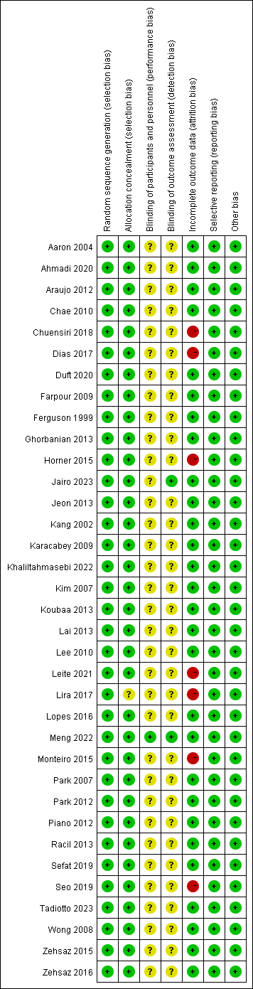
Appendix 7. Contributions of direct and indirect comparisons to NMA and the number of studies of each direct comparison of TC,HDL,LDL,TG.

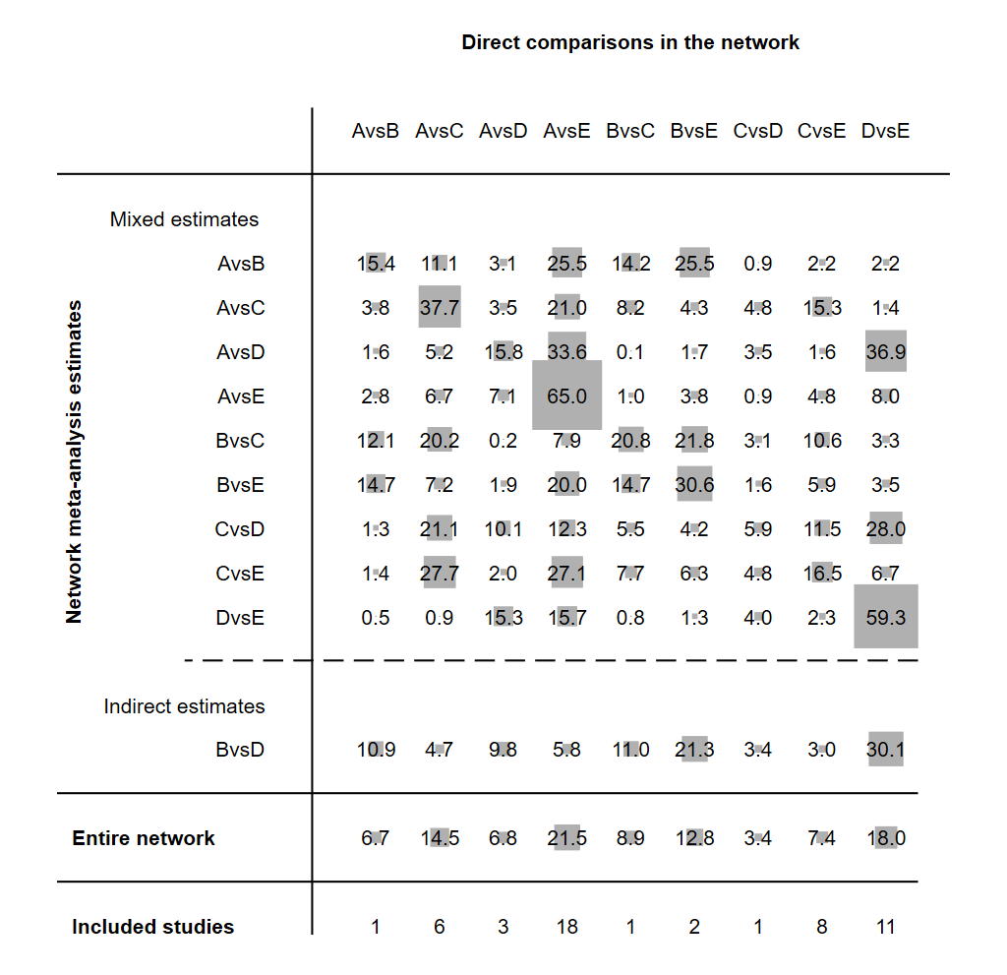
Fig 1. Network meta-analysis net weight plots for TC.
Note: A-AE, B-RT, C-HIIT, D-CON, E-CON.

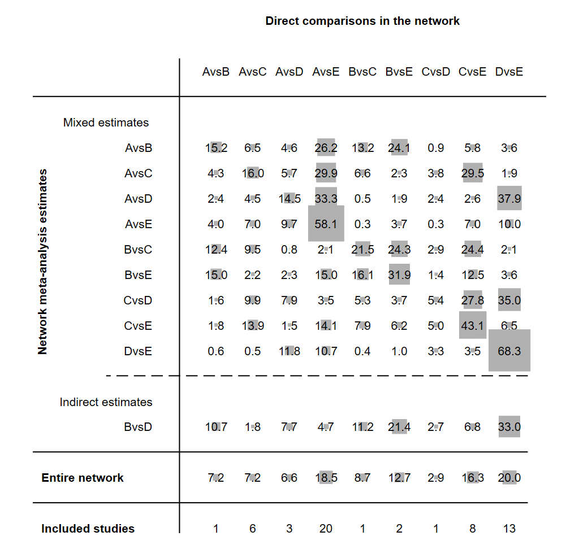
Fig 2. Network meta-analysis net weight plots for HDL.
Note: A-AE, B-RT, C-HIIT, D-CON, E-CON.

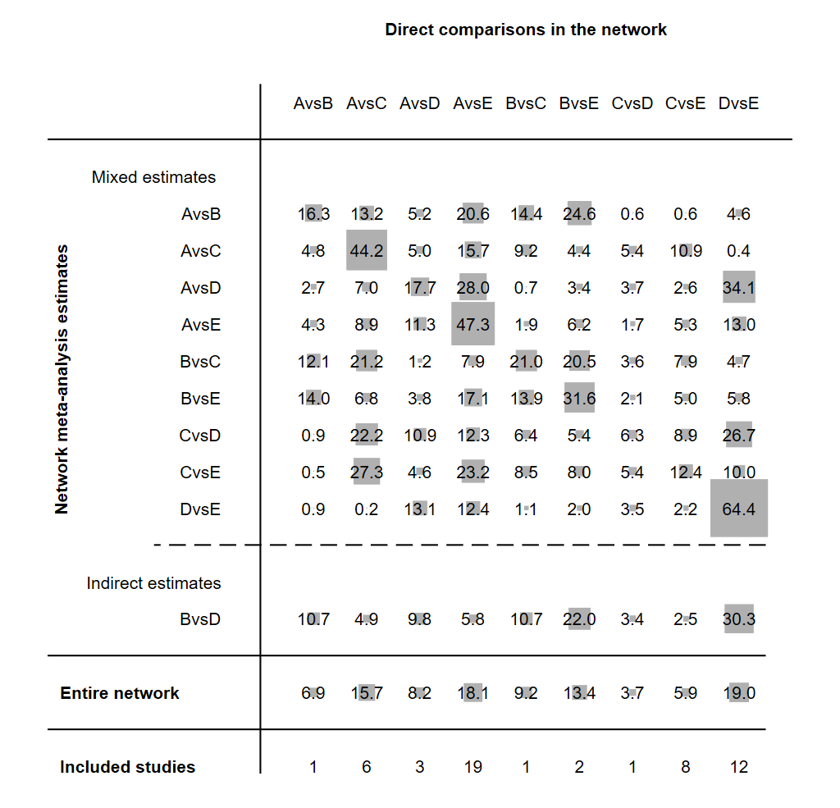
Fig 3. Network meta-analysis net weight plots for LDL.
Note: A-AE, B-RT, C-HIIT, D-CON, E-CON.

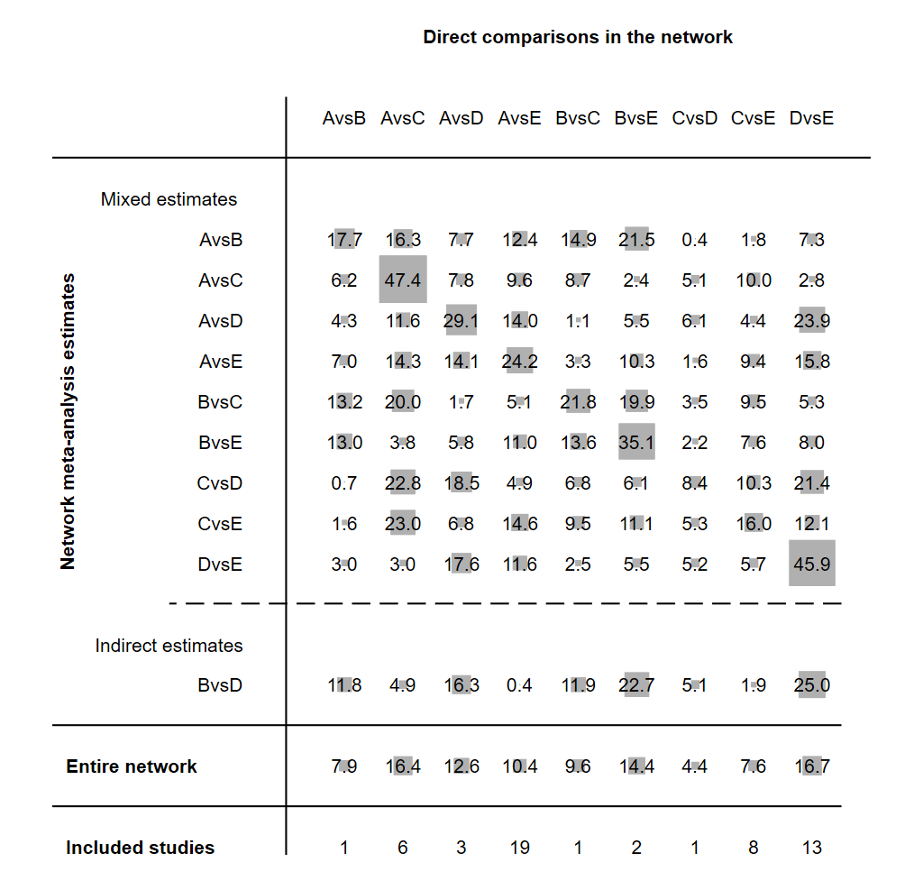
Fig 4. Network meta-analysis net weight plots for TG.
Note: A-AE, B-RT, C-HIIT, D-CON, E-CON.

Appendix 8. Inconsistency of TC,HDL,LDL,TG tested by loop-specific heterogeneity estimates, inconsistency model and node splitting analysis

Table 1 Inconsistency of TC tested by loop inconsistency test
Loop | IF | seIF | z_value | p_value | CI_95 | Loop_Heterog_tau2
TC
A-C-E | 0.307 | 0.271 | 1.133 | 0.257 | (0.00,0.84) | 0.055
C-D-E | 0.234 | 0.589 | 0.397 | 0.692 | (0.00,1.39) | 0.107
A-D-E | 0.226 | 0.25 | 0.904 | 0.366 | (0.00,0.72) | 0.005
A-B-C | 0.206 | 0.419 | 0.491 | 0.624 | (0.00,1.03) | 0.000
B-C-E | 0.167 | 0.81 | 0.206 | 0.837 | (0.00,1.75) | 0.247
A-C-D | 0.132 | 0.468 | 0.283 | 0.778 | (0.00,1.05) | 0.000
A-B-E | 0.026 | 0.376 | 0.069 | 0.945 | (0.00,0.76) | 0.006
Note: A-AE, B-RT, C-HIIT, D-CON, E-CON.

Table 2 Inconsistency of HDL tested by loop inconsistency test
Loop | IF | seIF | z_value | p_value | CI_95 | Loop_Heterog_tau2
HDL
A-B-C | 0.431 | 0.743 | 0.58 | 0.562 | (0.00,1.89) | 0.157
A-B-E | 0.371 | 0.481 | 0.771 | 0.44 | (0.00,1.31) | 0.059
A-C-E | 0.331 | 0.255 | 1.299 | 0.194 | (0.00,0.83) | 0.045
B-C-E | 0.255 | 0.371 | 0.687 | 0.492 | (0.00,0.98) | 0.002
C-D-E | 0.167 | 0.423 | 0.395 | 0.693 | (0.00,1.00) | 0.000
A-D-E | 0.081 | 0.258 | 0.314 | 0.753 | (0.00,0.59) | 0.021
A-C-D | 0.049 | 0.619 | 0.079 | 0.937 | (0.00,1.26) | 0.096
Note: A-AE, B-RT, C-HIIT, D-CON, E-CON.

Table 3 Inconsistency of LDL tested by loop inconsistency test
Loop | IF | seIF | z_value | p_value | CI_95 | Loop_Heterog_tau2
LDL
B-C-E | 0.556 | 0.989 | 0.562 | 0.574 | (0.00,2.49) | 0.396
A-C-E | 0.397 | 0.375 | 1.057 | 0.29 | (0.00,1.13) | 0.196
A-C-D | 0.352 | 0.469 | 0.75 | 0.453 | (0.00,1.27) | 0.000
A-B-E | 0.078 | 0.625 | 0.125 | 0.901 | (0.00,1.30) | 0.137
A-B-C | 0.054 | 0.419 | 0.128 | 0.898 | (0.00,0.87) | 0.000
A-D-E | 0.037 | 0.334 | 0.109 | 0.913 | (0.00,0.69) | 0.093
C-D-E | 0.024 | 0.695 | 0.034 | 0.973 | (0.00,1.39) | 0.177
Note: A-AE, B-RT, C-HIIT, D-CON, E-CON.

Table 4 Inconsistency of TG tested by loop inconsistency test
Loop | IF | seIF | z_value | p_value | CI_95 | Loop_Heterog_tau2
TG
A-C-D | 0.713 | 0.469 | 1.52 | 0.128 | (0.00,1.63) | 0.000
B-C-E | 0.408 | 1.039 | 0.392 | 0.695 | (0.00,2.44) | 0.402
C-D-E | 0.371 | 0.755 | 0.491 | 0.624 | (0.00,1.85) | 0.294
A-D-E | 0.357 | 0.636 | 0.562 | 0.574 | (0.00,1.60) | 0.485
A-B-C | 0.217 | 0.418 | 0.518 | 0.604 | (0.00,1.04) | 0.000
A-B-E | 0.121 | 1.392 | 0.087 | 0.931 | (0.00,2.85) | 0.663
A-C-E | 0.093 | 0.626 | 0.149 | 0.882 | (0.00,1.32) | 0.569
Note: A-AE, B-RT, C-HIIT, D-CON, E-CON.

Inconsistency model
Table 5 Inconsistency of TC,HDL,LDL,TG tested by inconsistency model
 | TC | HDL | LDL | TG
chi2 | 16.54 | 15.62 | 16.98 | 7.40
Prob > chi2 | 0.1221 | 0.1560 | 0.1085 | 0.7657

Node splitting analysis
Table 6 Inconsistency of TC tested by node-splitting method
Side | Direct |  | Indirect |  | Difference
 | Coef. | Std. Err. | Coef. | Std. Err. | Coef. | Std. Err. | P>z
TC
A B | -0.385 | 0.310 | -0.313 | 0.251 | -0.072 | 0.396 | 0.856
A C | -0.055 | 0.159 | -0.441 | 0.183 | 0.386 | 0.242 | 0.111
A D | 0.082 | 0.209 | -0.167 | 0.147 | 0.249 | 0.255 | 0.329
A E | 0.038 | 0.078 | 0.469 | 0.228 | -0.432 | 0.240 | 0.072
B C | 0.131 | 0.291 | 0.112 | 0.289 | 0.019 | 0.411 | 0.963
B E | 0.398 | 0.225 | 0.528 | 0.410 | -0.130 | 0.477 | 0.785
C D | 0.012 | 0.407 | 0.157 | 0.164 | -0.145 | 0.439 | 0.741
C E | 0.370 | 0.136 | 0.133 | 0.223 | 0.237 | 0.259 | 0.361
D E | 0.170 | 0.116 | 0.175 | 0.294 | -0.005 | 0.316 | 0.987
Note: A-AE, B-RT, C-HIIT, D-CON, E-CON.

Table 7 Inconsistency of HDL tested by node-splitting method
Side | Direct |  | Indirect |  | Difference
 | Coef. | Std. Err. | Coef. | Std. Err. | Coef. | Std. Err. | P>z
HDL
A B | -0.494 | 0.312 | -0.091 | 0.250 | -0.404 | 0.398 | 0.311
A C | -0.023 | 0.161 | -0.459 | 0.178 | 0.436 | 0.238 | 0.067
A D | -0.057 | 0.218 | -0.165 | 0.133 | 0.108 | 0.255 | 0.673
A E | -0.301 | 0.079 | -0.151 | 0.233 | -0.149 | 0.246 | 0.545
B C | 0.023 | 0.300 | 0.033 | 0.295 | 0.010 | 0.421 | 0.981
B E | -0.175 | 0.222 | 0.395 | 0.406 | -0.569 | 0.473 | 0.229
C D | -0.047 | 0.415 | 0.104 | 0.157 | -0.151 | 0.443 | 0.733
C E | -0.007 | 0.136 | -0.230 | 0.227 | 0.224 | 0.263 | 0.395
D E | -0.152 | 0.102 | -0.132 | 0.296 | -0.020 | 0.313 | 0.949
Note: A-AE, B-RT, C-HIIT, D-CON, E-CON.

Table 8 Inconsistency of LDL tested by node-splitting method
Side | Direct |  | Indirect |  | Difference
 | Coef. | Std. Err. | Coef. | Std. Err. | Coef. | Std. Err. | P>z
LDL
A B | -0.314 | 0.469 | -0.282 | 0.383 | -0.031 | 0.604 | 0.959
A C | -0.040 | 0.212 | -0.598 | 0.259 | 0.558 | 0.335 | 0.096
A D | -0.201 | 0.296 | -0.160 | 0.194 | -0.041 | 0.354 | 0.908
A E | 0.072 | 0.113 | 0.499 | 0.317 | -0.427 | 0.336 | 0.204
B C | 0.212 | 0.455 | -0.128 | 0.418 | 0.340 | 0.619 | 0.583
B E | 0.302 | 0.334 | 0.788 | 0.613 | -0.486 | 0.705 | 0.491
C D | 0.202 | 0.539 | 0.077 | 0.220 | 0.125 | 0.582 | 0.830
C E | 0.498 | 0.189 | 0.086 | 0.306 | 0.412 | 0.358 | 0.251
D E | 0.289 | 0.147 | 0.326 | 0.404 | -0.038 | 0.430 | 0.930
Note: A-AE, B-RT, C-HIIT, D-CON, E-CON.

Table 9 Inconsistency of TG tested by node-splitting method
Side | Direct |  | Indirect |  | Difference
 | Coef. | Std. Err. | Coef. | Std. Err. | Coef. | Std. Err. | P>z
TG
A B | 0.170 | 0.817 | 0.224 | 0.667 | -0.053 | 1.054 | 0.960
A C | -0.228 | 0.349 | -0.220 | 0.432 | -0.009 | 0.555 | 0.987
A D | 0.284 | 0.483 | -0.070 | 0.314 | 0.354 | 0.577 | 0.539
A E | 0.461 | 0.190 | 1.036 | 0.509 | -0.575 | 0.543 | 0.289
B C | -0.168 | 0.809 | -0.626 | 0.709 | 0.458 | 1.076 | 0.670
B E | 0.179 | 0.579 | 0.838 | 1.065 | -0.659 | 1.217 | 0.588
C D | -0.221 | 0.856 | 0.343 | 0.354 | -0.563 | 0.926 | 0.543
C E | 0.708 | 0.306 | 0.895 | 0.508 | -0.187 | 0.591 | 0.752
D E | 0.514 | 0.236 | 0.360 | 0.658 | 0.155 | 0.699 | 0.825
Note: A-AE, B-RT, C-HIIT, D-CON, E-CON.

Appendix 9. interval plots of network meta-analysis for TC,HDL,LDL,TG.

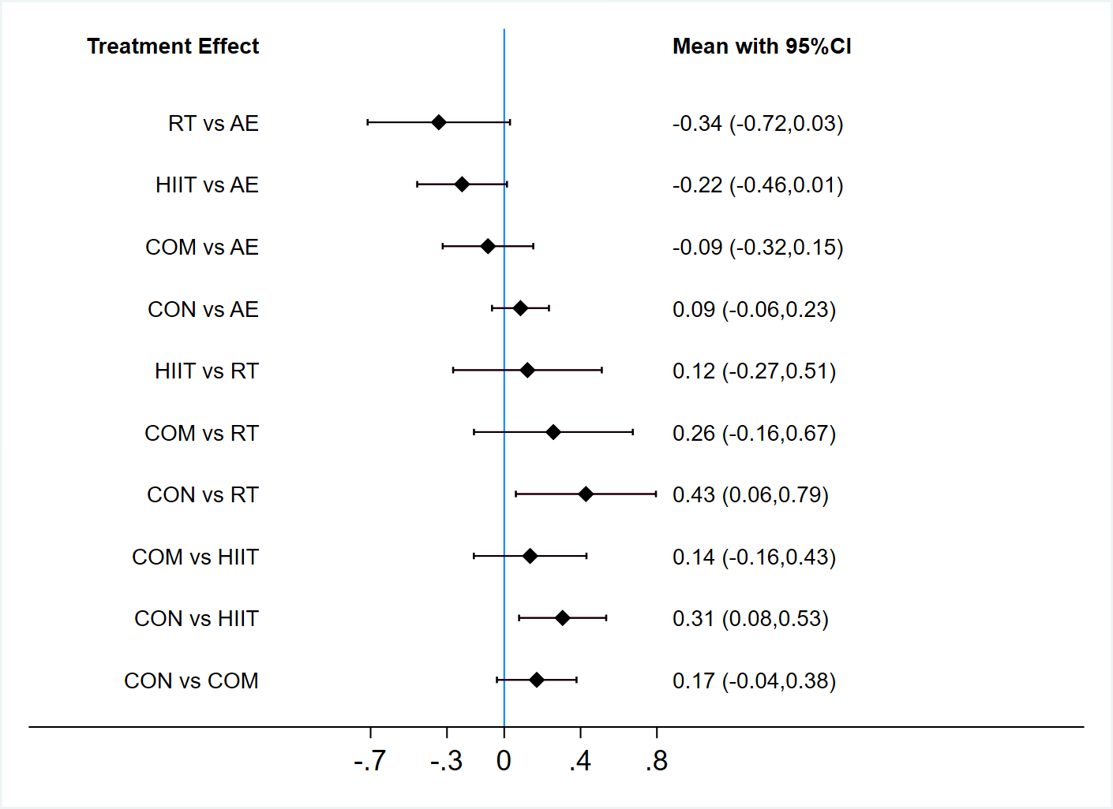
Appendix 10-1. interval plot of TC.

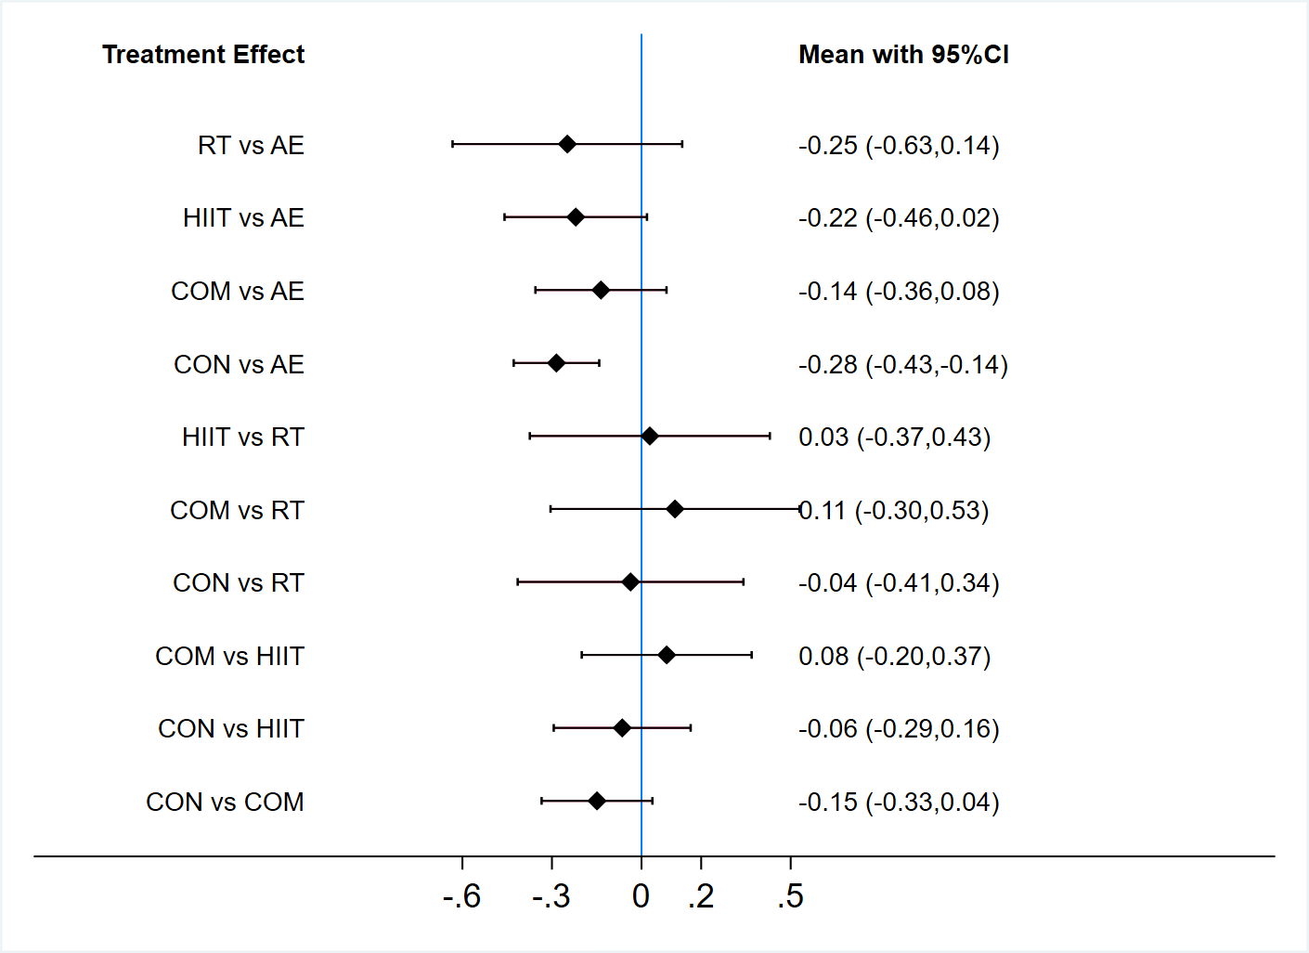
Appendix 10-2. interval plot of HDL.
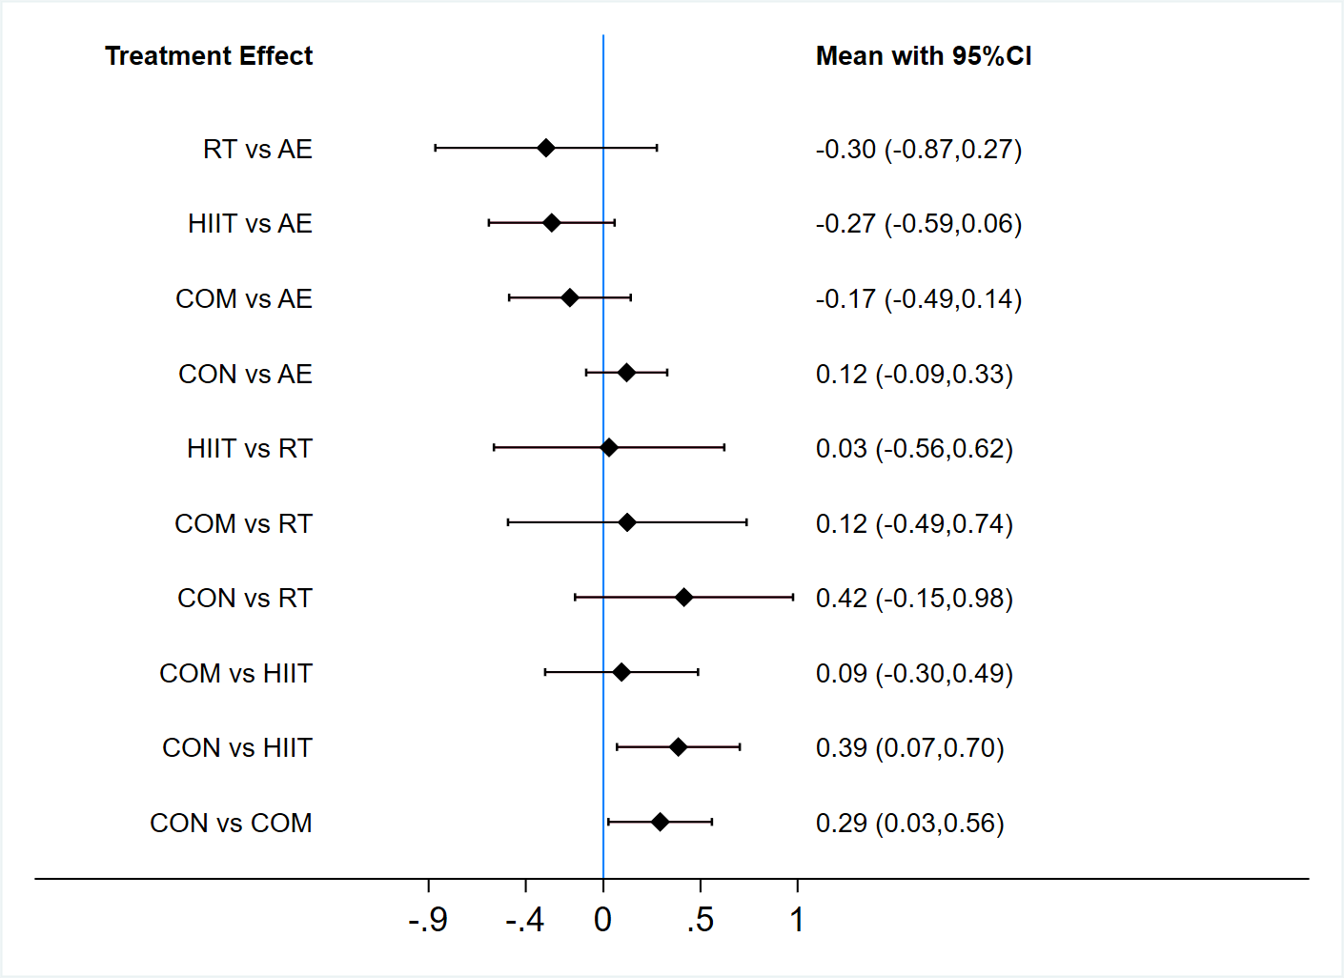
Appendix 10-3. interval plot of LDL.

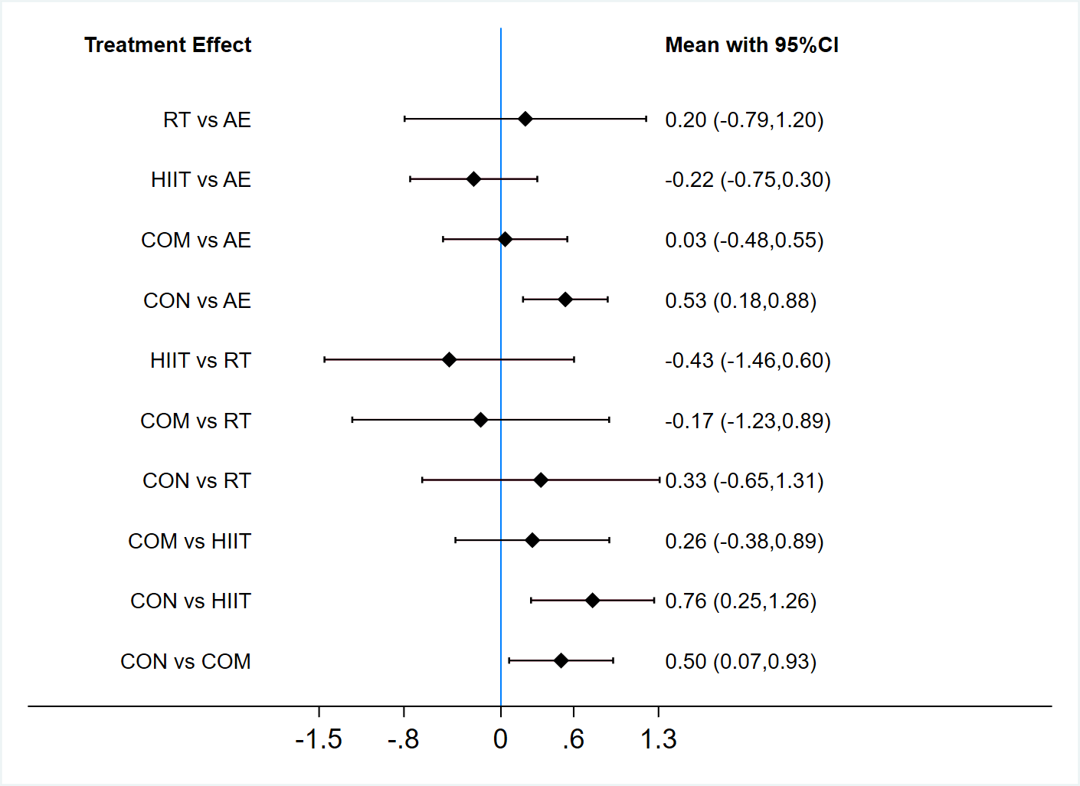
Appendix 10-4. interval plot of TG.

