Stem-FIT and Soil-FIT: Integrated Plant and Soil Nitrogen-Hormone Sensing with Machine Learning-based Forecasting for Next-Generation Precision Agriculture
Nafize I. Hossain^{1,2+}, Mohammad Solaiman^{1,3+}, and Shawana Tabassum^{1*}

¹Department of Electrical and Computer Engineering, The University of Texas at Tyler, Tyler, TX, USA
²Department of Electrical and Computer Engineering, Tufts University, Medford, MA, USA
³Department of Electrical and Computer Engineering, The University of New Mexico, Albuquerque, NM, USA
+These authors contributed equally
*Corresponding author: stabassum@uttyler.edu

Supporting Information

Supplementary Note 1 | Materials and Methods

Device Fabrication. The sensor suite consists of three modules: two stem modules and a soil module.
- Stem Module-1: This module integrates a sensor suite with eight microneedles arranged on two sides of a rectangular structure, with four microneedles per side (Fig. S1a). On each side, one microneedle serves as a common reference electrode (RE) and another as a common counter electrode (CE). The remaining microneedles function as working electrodes for detecting salicylic acid (WE_{SA}), indole-3-acetic acid (WE_{IAA}), methyl jasmonate (WE_{MeJA}), and pH (WE_{pH}). Each microneedle has a pyramidal shape with a base width of approximately 800 μm, a tip angle of 60°, and a height of about 1200 μm. SA, IAA, and MeJA each works based on three electrode-based electrochemistry, while the pH sensor is based on two electrodes. The central section of the rectangular structure is designed as a 1 cm x 0.3 cm chamber to accumulate ethylene (ET), which is then detected using a resistive sensor consisting of an RE and a working electrode, WE_{ET}. The circular area of each electrode measures 3mm. The entire rectangular stem module-1 measures about 1.5 cm x 0.5 cm.
- Stem Module-2: This module integrates two electrode-based potentiometric stem nitrate (NO₃) and ammonium (NH₄) sensors (Fig. S1b). Their working principle is based on potentiometry, with one microneedle serving as the common reference electrode (RE), one as the working electrode for nitrate detection (WE_{NO₃}), and another as the working electrode for ammonium detection (WE_{NH₄}). This rectangular structure measures about 1.5 cm x 0.2 cm.
- Soil Module: This module includes two electrode-based potentiometric sensors for monitoring soil pH, NO₃, and NH₄ (Fig. S1c). These sensors are designed to measure pH, NO₃, and NH₄ at three different soil depths: 1 cm, 5 cm, and 10 cm. At each depth, there is a common RE. The remaining electrodes function as working electrodes for detecting soil pH (WE_{pHs}), nitrate (WE_{NO3s}), and ammonium (WE_{NH4s}) levels. A 10 cm long structure was printed with sensors placed at the three mentioned depths.
All the modules were 3D printed using biocompatible BioMed Clear resin with a Form 3B stereolithography 3D printer (Formlabs, Somerville, MA, USA). They were first designed in Fusion 360 software (AutoCAD, Autodesk Inc., San Rafael, CA) and exported as an STL file for printing. After fabrication, the devices were cleaned with isopropyl alcohol for 30 minutes, then cured using UV light at 60°C for 60 minutes. The REs were coated with silver/silver chloride paste (Sigma Aldrich, MO, USA), while the CEs and WEs were fabricated using graphene ink (Sigma Aldrich, MO, USA). The REs were cured at 100°C for 30 minutes, while the graphene-based CEs and WEs were cured at 200°C for 15 minutes.
Electrode Functionalization Procedure:
All chemicals were purchased from Sigma Aldrich, MO, USA and were used without further purification.
Copper metal organic framework-carbon black-nafion (CuMOF-CB-nafion) composite for SA detection. The synthesis procedure for the copper metal-organic framework (CuMOF) follows the method described in our previous work¹. Initially, 8 mL of dimethylformamide (DMF) is mixed with 8 mL of ethanol, followed by centrifugation and sonication to ensure uniformity. Next, 400 mg of polyvinyl pyrrolidone (PVP) is added to the mixture, which is sonicated for 10 minutes. Separately, 0.04664 g of cupric nitrate trihydrate and 0.01086 g of 2-aminobenzene-1,4-dicarboxylic acid are added to 4 mL of DMF and ultrasonicated for 30 minutes. These two mixtures are then combined and sonicated for an additional hour to achieve a uniform solution. The resultant mixture is heated at 100°C for 5 hours, during which a green precipitate forms. This precipitate is separated and dissolved in 40 mL of DMF. The solution is then heated again at 100°C for 8 hours, and the green precipitate is collected by centrifugation at 1000 rpm for 30 minutes. The precipitate is thoroughly washed and dried at 50°C for 60 minutes, yielding the CuMOF powder. To optimize the CuMOF for use, it is mixed with carbon black (CB) in varying weight ratios (1:3, 1:2, 1:1, 2:1, and 3:1). The optimal ratio of CuMOF to CB is found to be 2:1, based on limit of detection (LOD) and sensitivity analysis. The CuMOF/CB mixture is then dissolved in deionized (DI) water to make a 2 mg/mL solution. To this, 5 μL of 0.01% (w/v) nafion is added, and the mixture is sonicated for 30 minutes for uniformity. Finally, 5 μL of the CuMOF/CB/nafion solution is drop-cast onto the working electrode of the SA sensor (WE_{SA}) for selective detection of SA.

Gold nanoparticles decorated graphene hydrogel and nafion nanocomposites (AuNP-GH-nafion) for IAA sensing. The synthesis and preparation of AuNP-GHs have been adopted from our previous work^{2,3}. In summary, a 1 mg/mL dispersion of graphene oxide is prepared in DI water following 24 hours of sonication. Different concentrations of tetrachloroauric(III) acid (0.0426, 0.6383, 0.8511, and 1.0638 mg/mL) are then added to 20 mL of the graphene oxide dispersion, followed by sonication for approximately 1 hour to obtain a homogenous mixture. The mixture is heated at 140°C in an autoclave for 12 hours, after which AuNP-GHs form at the top of the solution. The AuNP-GH is then cooled, freeze-dried for 12 hours, and desiccated. A 1 mg/mL AuNP-GH solution is prepared in 0.5% nafion in ethanol and sonicated for 5 hours to ensure uniformity. Subsequently, 5 μL of the AuNP-GH/nafion solution is drop-cast onto the working electrode of the IAA sensor (WE_{IAA}). Through optimization, it was found that a concentration of 0.8511 mg/mL of tetrachloroauric(III) acid provided the highest sensitivity and the lowest LOD for the IAA sensor.

Phosphotungstic acid/neutral red intercalated montmorillonite composite (PTA/NR–MMT) for MeJA sensing. First, 2 g of nano-calcium montmorillonite (MMT) with a particle size of 25 nm is added to 200 mL of 2 M sodium chloride solution and placed on a vortex shaker for 30 minutes. The solution is then sonicated at 60°C for 5 hours. After sonication, the mixture is left undisturbed to allow the formation of a dispersion layer at the bottom, while the upper portion of the solution is carefully removed using a syringe. This process is repeated five times, after which the precipitate is collected via filtration. To remove any residual chlorine, the precipitate is thoroughly washed with water. The resulting Na-MMT is dried at 80°C for 12 hours to obtain the powdered form of the compound. A 20 mg/mL Na-MMT solution is prepared in DI water by stirring vigorously at 650 rpm for 2.5 days. Separately, 0.15 g of neutral red (NR) is dissolved in 12.5 mL of DI water, and the pH of the solution is adjusted to 6.0 by adding 6 M HCl, which is necessary to generate amino groups in the NR solution. The Na-MMT suspension and NR solution are then combined, heated at 50°C, and stirred continuously at 500 rpm for 2 days. The resulting mixture is filtered using 0.02 μm Whatman filter paper and thoroughly washed to remove excess NR from the composite. The composite is then dried at 60°C for 12 hours. Next, a 2 mg/mL NR-MMT solution is stirred for 48 hours and centrifuged at 3000 rpm for 30 minutes to create the coating composite. The NR-MMT is drop-cast onto the working electrode of the MeJA sensor (WE_{MeJA}), which is then immersed in 15 mM phosphotungstic acid (PTA) for 1 hour. The electrode is thoroughly washed before use.

Copper complex (I)- single walled carbon nanotube composite coating for ET sensing. The preparation method of the copper complex is adopted from our prior work^{1,4}. Typically, 0.4 g of sodium borohydride and 7.55 g of [3,5-(CF₃)₂-pyrazol-1-yl] are added to kerosene. The mixture is sonicated for 20 minutes, resulting in a homogeneous solution, which is then transferred to a conical flask. The solution is heated to 190°C at a ramp rate of 1°C/min and maintained at that temperature for 4 hours while submerged in silicone oil. Every 15 minutes, the solution is heated with a heat gun to melt the pyrazol. After heating, the solution is cooled to room temperature, and diethyl ether is added to filter out any unreacted reagents. A white solid is obtained, and nuclear magnetic resonance (NMR) confirms the presence of Na[HB(3,5-(CF₃)₂-pz)₃]. Next, 8 mL of copper(I) trifluoromethanesulfonate benzene complex is added to 3 mL of dry toluene, and the mixture is degassed to remove air molecules. Then, 17 mg of Na[HB(3,5-(CF₃)₂-pz)₃] is added, and the solution is stirred for 24 hours at 500 rpm at 25°C. After filtration using a 0.02 μm syringe filter, the copper(I) complex is obtained. In parallel, 500 mg of single-walled carbon nanotubes (SWCNTs) is introduced into 0.8 mL of 1,2-dichlorobenzene, and 1.16 mL of toluene is added. This mixture is sonicated for 2 hours to achieve a homogeneous solution. The copper(I) complex is then added, and the solution is sonicated for another 2 hours. Finally, 10 μL of the resulting solution is applied in the area between the working electrode (WE_{ET}) and RE of the ET sensor, thereby creating a resistive path.

Copper hexacyanoferrate (CuHCF) for ammonium sensing. The synthesis of CuHCF follows the method described in a previous report⁵, with some modifications. First, 50 mL of a 5 mmol solution of copper(II) nitrate trihydrate and 50 mL of a 2.5 mmol solution of potassium ferricyanide are combined, followed by the addition of 25 mL of DI water. This mixture is stirred at 600 rpm in the dark for 3 hours and then left undisturbed in the dark for 12 hours. Afterward, the resulting precipitate is collected and thoroughly washed several times with DI water. The washed precipitate is then dried at 60°C for 12 hours, yielding brown CuHCF powder. To prepare the sensor coating, 4 mg of CuHCF and 1 mg of polyvinyl chloride (PVC) are dissolved in 200 μL of N-methyl-2-pyrrolidone (NMP) to create a 20 mg/mL dispersion. Finally, 5 μL of this solution is drop-cast onto the working electrode of the NH₄ sensor (WE_{NH4} and WE_{NH4s}).

Poly(3-octyl-thiophene), molybdenum disulfide nanocomposite and ion-selective membrane (ISM) for nitrate sensing. The synthesis process for the nanocomposite follows the method described in a previous report^{6,7}. To begin, different weight ratios of poly(3-octyl-thiophene) (POT) and molybdenum disulfide (MoS₂) (1:1, 1:2, 1:4, 1:6, 1:8, 1:10) are prepared to optimize the nanocomposite. The 1:4 ratio of POT and MoS₂ is found to be the most effective. To create this ratio, 2.3 mg of POT is dissolved in 1 mL of tetrahydrofuran (THF) using a vortex shaker for 10 minutes. Then, 9.2 mg of MoS₂ is added to the solution and vortexed for another minute. The mixture undergoes 4 hours of ultrasonication to achieve a uniform solution, as the opposite charges of MoS₂ and POT aid in forming a homogeneous nanocomposite. The ion-selective membrane (ISM) is prepared in a THF solution (74.3 wt%) containing 0.25 wt% methyltriphenylphosphonium bromide, 1.93 wt% nitrocellulose, 16.25 wt% 2-nitrophenyl octyl ether, 5.75 wt% polyvinyl chloride (PVC), and 1.5 wt% tridodecylmethylammonium nitrate. This mixture is sonicated for 15 minutes and then stored at -20°C for future use. To fabricate the sensor, 5 μL of the POT/MoS₂ nanocomposite is drop-cast onto the working electrode of the NO₃ sensor (WE_{NO3} and WE_{NO3s}) and cured at 65°C for 1 hour. Following this, 5 μL of the ISM solution is drop-cast on top of the POT/MoS₂ nanocomposite and dried at 25°C for 12 hours before the sensor is ready for use.

Polyaniline (PANI) nanofiber growth for pH sensing. The pH sensor comprises one working electrode (WE_{pH}) and one RE. The working electrode is modified with polyaniline (PANI) nanofibers, which are introduced through cyclic voltammetry. In this process, the electrodes are immersed in a solution containing 0.1M aniline and 1M hydrochloric acid, and 80 cycles of cyclic voltammetry are applied, ranging from -0.2V to 0.6V at a scan rate of 50mV/s. The PANI nanofibers are selective to H₃O⁺ ions, enabling equilibrium to be established between the nanofibers and H₃O⁺ ions.

Supplementary Note 2 | Sensing Mechanism

The sensing mechanism for SA, IAA, and MeJA is based on electrochemical principles. The redox reactions occurring at the functionalized working electrodes for SA, IAA, and MeJA facilitate electron flow, which is then converted into current flow. This current flow allows for the determination of the concentrations of SA, IAA, and MeJA. The working electrodes are modified with CuMOF/CB/nafion, AuNP-GH, and PTA/NR–MMT for SA, IAA, and MeJA, respectively. Our electrochemical workstation generates a staircase voltage waveform, which is applied between the working electrodes (WE_{SA}, WE_{IAA}, WE_{MeJA}) and a common RE. During oxidation, SA⁺, IAA⁺, and MeJA⁺ are produced on their respective working electrodes, while the coating material is reduced. This redox reaction results in electron flow between the CE and the respective WE, with the current flow being correlated with the hormone concentration. The concentration of SA is measured using ratiometric studies, while the direct peak current is used to measure IAA and MeJA.

The pH and ethylene sensors operate based on resistance changes, where variations in pH level or ethylene concentration alter the sensor’s resistance. The sensors are connected in series with a known resistance, allowing the unknown resistance of the pH and ethylene sensors to be determined using the voltage divider rule. The resistance change is converted into a voltage change, which is then detected by a microcontroller. In the voltage divider, R_{known} represents a known resistance, R_{sensor} is the sensor resistance, V_{i} represents the supply voltage of 3.3V, and V₀ is the voltage measured across the pH/ethylene sensor. The auto-ranging functionality was adopted to select R_{known} from some previously known resistor values. Then, the resistance of the sensor, R_{sensor}, can be measured using the following voltage divider formula:

R_{sensor} = (R_{known}) /((V_{i}/V₀) -1) (1)

The nitrate sensor functions as a two electrode-based potentiometric sensor. The POT-MoS₂ nanocomposite acts as an ion-to-electron transducer, facilitating the transfer of nitrate ions from the ion-selective membrane (ISM) to the electrode by leveraging the high conductivity and hydrophobicity of MoS₂, while the POT component provides redox properties, allowing for a measurable electrical signal proportional to the nitrate concentration. The redox reaction mechanism of POT-MoS₂ during nitrate sensing is described elsewhere⁸. The combination of redox and ion-exchange processes at the working electrode establishes an equilibrium at the aqueous-nanocomposite-ISM interfaces, creating charge separation at each interface and generating a phase-boundary potential. This potential change at the interface leads to a measurable electrical signal proportional to the nitrate concentration.

The ammonium sensor also functions as a two electrode-based potentiometric sensor. For ammonium ions, the sensing mechanism relies on the redistribution of electrons during redox reactions. Ammonium ions are incorporated into the lattice of CuHCF, where they interact with and couple to the lattice. The reaction can be represented as:

CuHCF + xNH₄⁺ + xe⁻ (NH₄⁺)_{x} CuHCF (2)

The potential associated with this lattice-ion coupling is dependent on the concentration of ammonium ions. As the concentration of ammonium ions increases, the resulting potential also increases.

Supplementary Note 3 | Morphological and Chemical Characterizations

The surface morphology of the copper metal-organic framework (CuMOF) coating is examined using a Hitachi TM 4000 plus scanning electron microscope (SEM), while a Nicolet Avatar 360 E.S.P ATR-FTIR (Attenuated Total Reflectance-Fourier Transform Infrared) spectrometer is employed to assess the coating’s composition. The FTIR spectrum (Fig. S2a) reveals the presence of amino groups, indicated by two peaks at 3550 cm⁻¹ and 3390 cm⁻¹, which correspond to the asymmetric and symmetric vibrations of NH₂ groups. The stretching peak at 2950 cm⁻¹ is attributed to -OH groups, which are affected by the interaction between copper ions and carboxylic groups, consistent with previous studies⁹. For surface characterization, the SEM image of the CuMOF/CB/nafion composite coating (Fig. S2b) displays a wrinkled structure, confirming that the introduction of composite coating nanosheets has increased the surface area.

The gold-doped graphite was analyzed using Shimadzu UV-1280 ultraviolet-visible (UV-Vis) Spectrophotometer, as shown in Fig. S2c. The UV-Vis spectrum reveals two prominent peaks: one at 230 nm, which is a cluster of peaks, and another at 330 nm. The 230 nm peaks are associated with the π-π* transitions in the aromatic C-C bonds, while the 330 nm peak corresponds to the n→π* transitions in C=O bonds. Hydrothermal treatment can cause a red shift of the 230 nm peak to around 270 nm, indicating a restoration of electronic conjugation in the graphite sheets¹⁰. Additionally, the main peak at 550 nm is attributed to surface plasmon resonance due to the presence of gold nanoparticles^{11,12}.

FTIR spectroscopy was employed to characterize the NR-MMT coating. The FTIR spectrum (Fig. S2d) exhibits peaks at 1027 cm⁻¹, 2845 cm⁻¹, 2924 cm⁻¹, and 3384 cm⁻¹, which correspond to the Si-O-Si bonds of SiO, the O-H bonds of alkyl groups, the C-H bonds of alkyl groups, and hydroxyl bonds from water, respectively. These peaks are mainly attributed to the vibrations of silicates¹³. Peaks at 1198 cm⁻¹ and 1329 cm⁻¹ are associated with carbon-nitrate bonds resulting from the aliphatic and aromatic structures between carbon and nitrogen. Notably, the electrostatic interaction between the amino group and the negatively charged silicate layer causes a shift in the amino peak from 1517 cm⁻¹ (if only NR were present) to 1501 cm⁻¹.

To prepare an ethylene coating, it is essential to synthesize the intermediate product Na[HB(3,5-(CF₃)₂-pz)₃] for the formation of a copper(I) complex. Nuclear magnetic resonance (NMR) spectroscopy was employed to characterize this intermediate product (Fig. S2e), with a peak at 7 ppm confirming the presence of Na[HB(3,5-(CF₃)₂-pz)₃]. Additionally, the size distribution and surface properties of the copper(I) complex were validated using SEM imaging (Fig. S2f). The average size of the copper complex nanoparticles is approximately 10 nm⁴.

The structure of the POT-MoS₂ nanocomposite was analyzed using SEM imaging. As shown in Fig. S2g, the MoS₂ sheets are encased within the POT structure, attributable to the electrostatic interactions between MoS₂ and POT. This surface morphology aligns with previous observations⁸. Similarly, SEM was used to characterize the surface morphology of the CuHCF coating (Fig. S2h). The CuHCF particles display a quasi-cubic shape with an average diameter of 90 nm, which is consistent with earlier studies¹⁴.

Supplementary Note 4 | Repeatability, Drift and Selectivity Analyses

Repeatability results. All seven sensors (SA, IAA, MeJA, ET, NO₃, NH₄, and pH) were evaluated for repeatability to ensure suitability for practical agricultural applications. The repeatability tests (Fig. S3) involved cycling analytes from low to high concentrations and back, over four cycles. The following concentrations were tested for the SA sensor: 0.1, 1, 50, 100, 200, 400, 600, 800, and 1000 µM; the following for the IAA sensor: 0.1, 1, 2, 5, 10, 20, 50, 80, 100, and 200 µM; the following for the MeJA sensor: 0.5, 5, 10, 50, 100, 150, and 200 µM; the following for the ET sensor: 0.1, 1, 10, 30, 50, 75, and 115 ppm; the following for the pH sensor: 2.1, 4.1, 7.1, 9.4, 10.14, and 13.04; the following for the nitrate sensor: 1, 10, 80, 100, 120, 500, 800, 1000, 1500, and 2000 ppm; and the following for the ammonium sensor: 0.17, 0.54, 1.70, 5.38, 17.03, 53.85, 170.31, 538.18, and 1703.09 ppm. Ammonium and nitrate sensors were tested using both plant sap and soil samples, enabling simultaneous detection of these ions. The coefficient of variance for repeatability was less than 3.25%.

Drift results. Sensor drift was analyzed in two phases. First, short-term drift was measured over an hour with intervals at 5, 30, and 60 minutes, as shown in Fig. S4. Then, long-term drift was assessed over 12 hours at 1, 6, and 12-hour intervals, as shown in Fig. S5. The overall mean coefficient of variance for drift was below 1.23%.

Selectivity results. The successful field deployment of sensors in plants and soil also depends on their selective response, as real plant sap and soil contain various interfering species. Fig. S6 depicts all the results from selectivity analyses. To evaluate selectivity, the SA, IAA, and MeJA sensors were tested in plant sap against the following interferents: (i) 50 µM glucose, (ii) 50 µM sucrose, (iii) 50 µM soluble starch, (iv) 50 µM L-tryptophan, (v) 50 µM L-cysteine, (vi) 50 µM abscisic acid (ABA), (vii) 50 µM gibberellic acid (GA), (viii) 50 µM rasmonic acid (RA), (ix) 50 µM oleic acid (OA), (x) 50 µM IAA (interferent for SA and MeJA sensors) or 50 µM SA (interferent for IAA sensor), (xi) 50 µM citric acid (CA), (xii) a mixture of interferents: 50 µM each of glucose, soluble starch, L-tryptophan, L-cysteine, ABA, GA, RA, OA, CA, (xiii) 100 µM of the target hormone: SA/IAA/MeJA, (xiv) the same interferent mixture with 100 µM of the target: SA/IAA/MeJA, (xv) target hormone: 900 µM SA/200 µM IAA/200 µM MeJA, and (xvi) the same interferent mixture with the target hormone: 900 µM SA/200 µM IAA/200 µM MeJA. Selectivity was assessed by calculating the relative signal: (Ra - Rb)/Rb, where Ra = sensor response to the analyte solution and Rb =baseline sensor response without the analyte solution.

For the ethylene sensor, selectivity was tested using these gaseous samples: (i) 50 ppm nitrogen (N₂), (ii) 50 ppm methane (CH₄), (iii) 50 ppm nitrous oxide (N₂O), (iv) 50 ppm ammonia (NH₃), (v) a mixture of 50 ppm each of N₂, CH₄, N₂O, NH₃, (vi) 10 ppm ethylene, (vii) a mixture of 50 ppm each of the interferents (N₂, CH₄, N₂O, NH₃) and 10 ppm ethylene, (viii) 115 ppm ethylene, and (ix) a mixture of 50 ppm each of the interferents (N₂, CH₄, N₂O, NH₃) and 115 ppm ethylene.

It was observed that for all the hormone and ethylene sensors, the measured response for the interfering compounds was significantly lower compared to that with the target analyte. Furthermore, when interfering species were introduced alongside a fixed concentration of the target analyte, no notable change in sensor response was observed. These findings demonstrate the excellent selectivity of the developed sensors.

For nitrate sensor testing, the following interferents were used: 0.5 M PO₄³⁻, 0.5 M K⁺, 0.5 M NH₄⁺, 0.5 M CO₃²⁻, and 0.5 M SO₄²⁻. When the sensor was subjected to 0.001 M NO₃⁻, the response was found to be approximately -130 mV. Upon successive addition of 0.5 M PO₄³⁻, 0.5 M K⁺, 0.5 M NH₄⁺, 0.5 M CO₃²⁻, and 0.5 M SO₄²⁻ , the response changed to -121 mV, -129 mV, -126 mV, -123 mV, and -128 mV, respectively. This shows that the addition of interferents (each at a 500-fold concentration relative to nitrate) caused a maximum variation of only ~7% in the sensor response. However, upon adding 0.01 M NO₃⁻, the response shifted to -202 mV, reflecting a 55.38% change compared to the response at 0.001 M NO₃⁻ for a 10-fold increase in NO₃⁻ concentration.

The ammonium sensor was tested using the same interferents as those used for the nitrate sensor testing. When the ammonium sensor was subjected to 0.1 M NH₄⁺, the response was found to be approximately 711 mV. Upon successive addition of 0.5 M PO₄³⁻, 0.5 M K⁺, 0.5 M NO₃⁻, 0.5 M CO₃²⁻, and 0.5 M SO₄²⁻ , the response changed to 709 mV, 706 mV, 708 mV, 712 mV, and 710 mV, respectively. This shows that the addition of interferents (each at a 5-fold concentration relative to ammonium) caused a maximum variation of only 0.7% in the sensor response. However, upon adding 0.01 M NH₄⁺, the response shifted to 651 mV, reflecting an 8.44% change for a 10-fold decrease in NH₄⁺ concentration.

These results confirm the excellent selectivity of the two ion sensors.

Supplementary Note 5 | Dynamic Response

The dynamic response of an electrochemical sensor refers to how quickly and accurately the sensor can detect changes in the concentration of the target analyte over time. This response is critical in real-time applications, where rapid fluctuations in analyte levels require immediate detection and signal processing. Fig. S7 presents the dynamic response of all sensors as the analyte concentration was progressively increased from the lowest to the highest level. These responses were recorded using the data acquisition unit described in the main manuscript. All sensors exhibited a fast response time, with measurements stabilizing in under a minute.

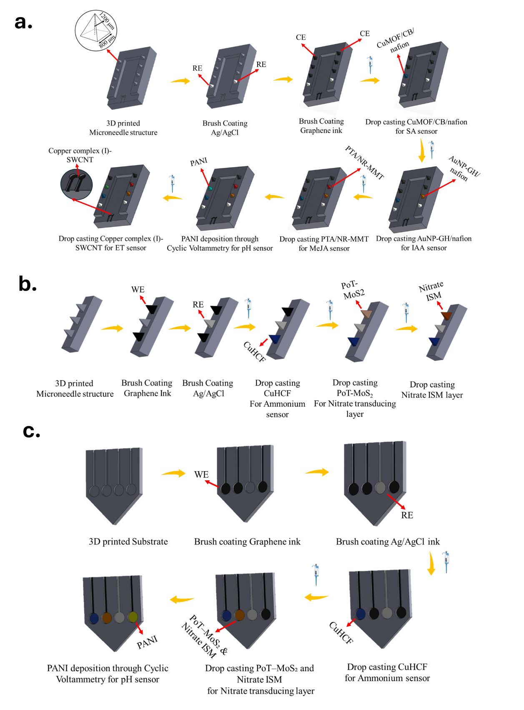
Supplementary Fig. S1: (a) Fabrication steps for SA, IAA, MeJA, pH, and ET sensors, starting with a 3D-printed microneedle structure, followed by sequential coatings of Ag/AgCl, graphene ink, and functionalization layers specific to the target analytes. (b) Fabrication process for plant nitrate and ammonium sensors, involving 3D-printed microneedle arrays coated with graphene ink, Ag/AgCl, and selective layers. (c) Fabrication scheme for soil ammonium, nitrate, and pH sensors, beginning with a 3D-printed flat substrate and ending with the deposition of selective coatings.
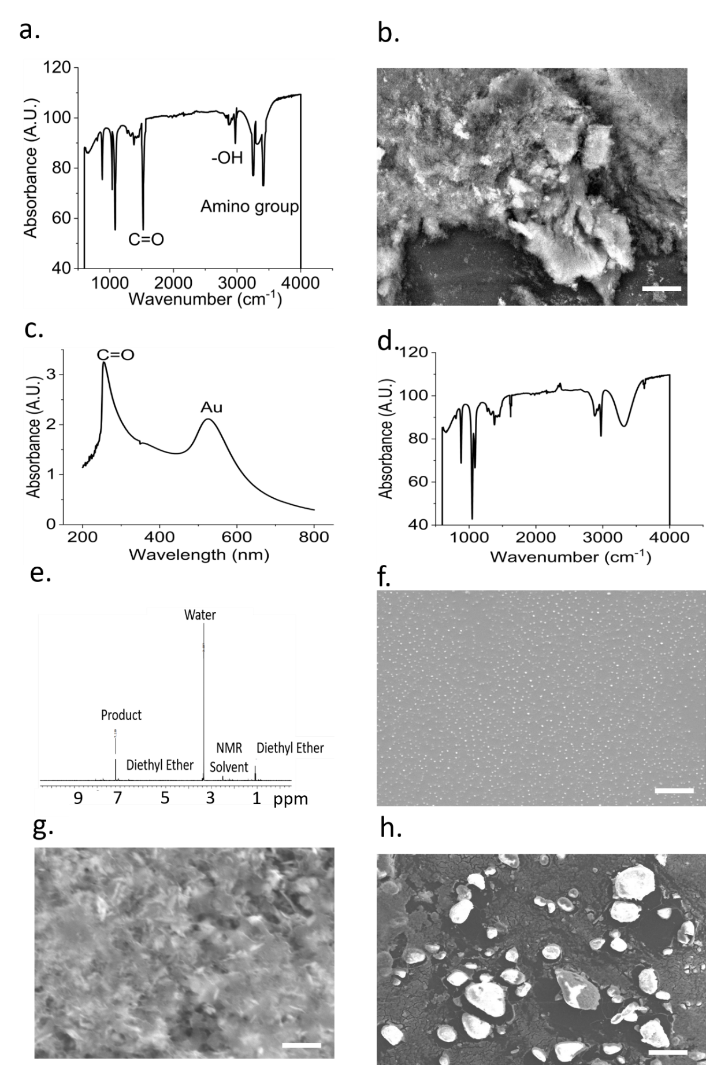
Supplementary Fig. S2: (a) FTIR and (b) SEM characterizations of CuMOF. (c) UV-Vis of Au decorated graphite. (d) FTIR spectrum of the PTA/NR-MMT. (e) NMR and (f) SEM characterizations of the Cu complex. SEM images of the (g) POT-MoS₂ composite and (h) CuHCF. The scale bars in the SEM images represent a magnification of 10µm.
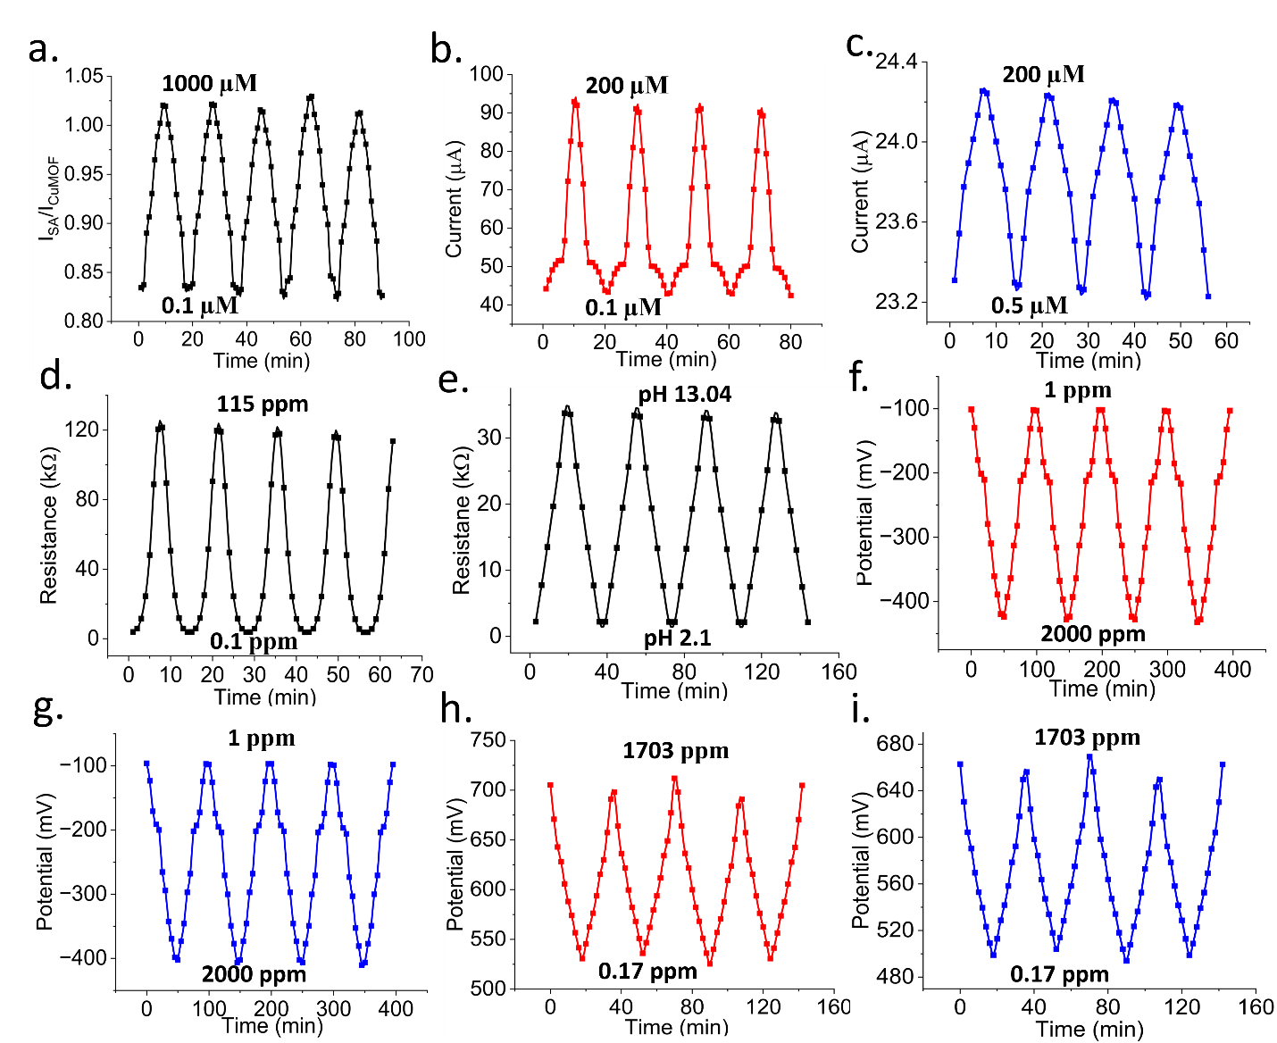
Supplementary Fig. S3: Repeatability tests for (a) SA sensor, (b) IAA sensor, (c) MeJA sensor, (d) ethylene sensor, (e) pH sensor, (f) nitrate sensor in sap, (g) nitrate sensor in soil, (h) ammonium sensor in sap, and (i) ammonium sensor in soil.

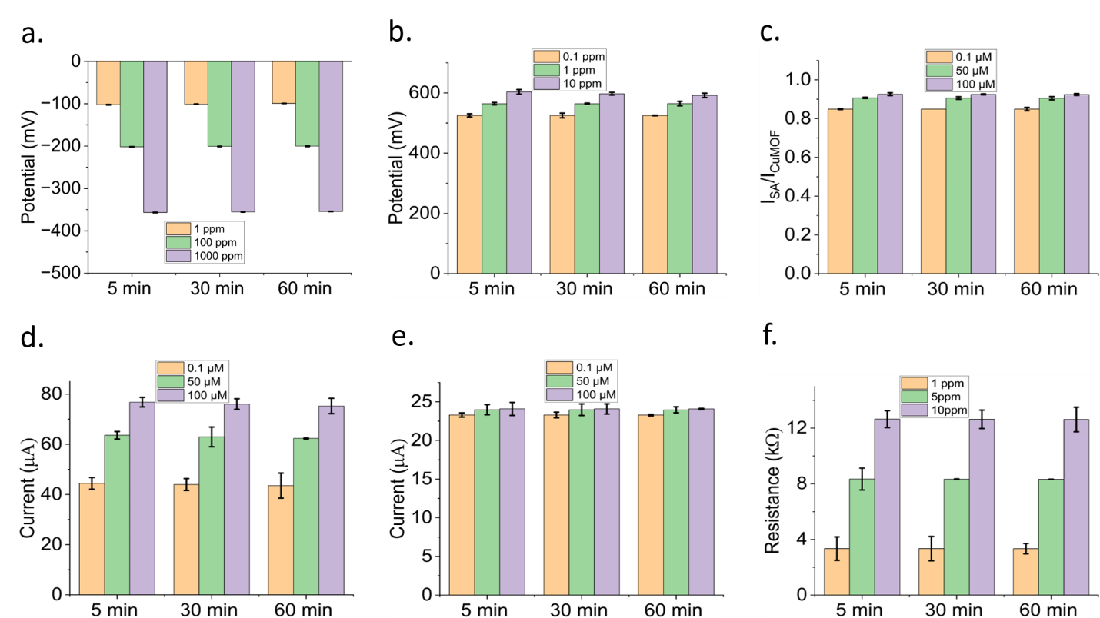
Supplementary Fig. S4: 1 hr drift analysis of the (a) nitrate, (b) ammonium, (c) SA, (d) IAA, (e) MeJA, and (f) ethylene sensors. Error bars represent standard deviations for 3 repeated measurements.

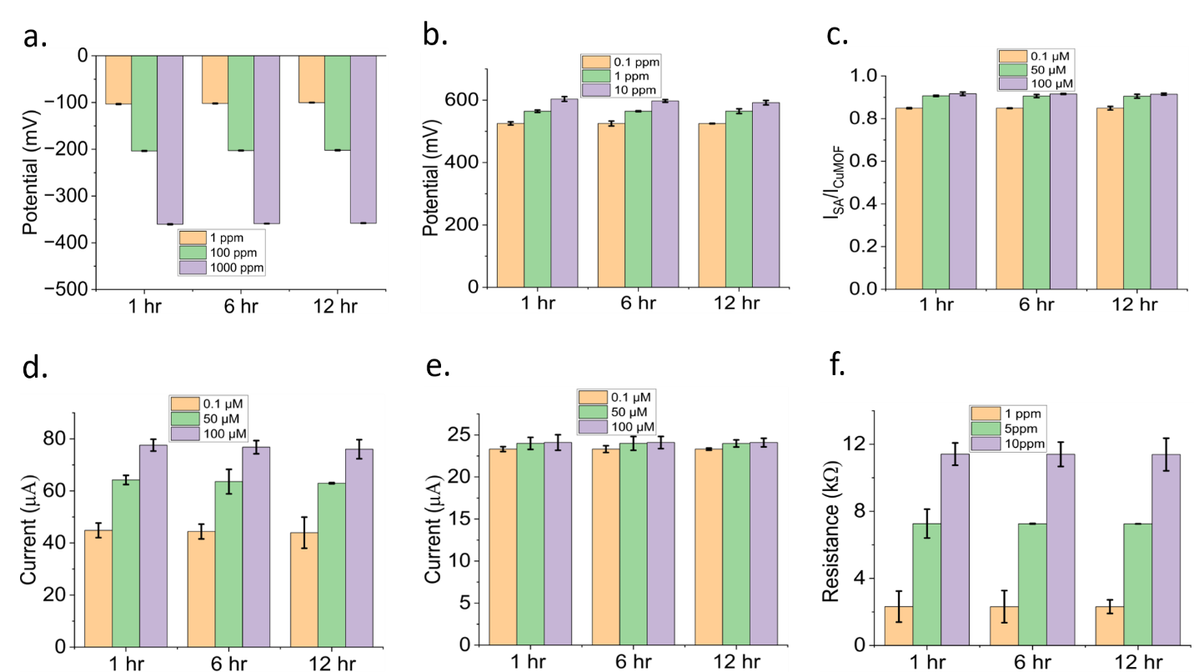
Supplementary Fig. S5: 12 hr drift analysis of the (a) nitrate, (b) ammonium, (c) SA, (d) IAA, (e) MeJA, and (f) ethylene sensors. Error bars represent standard deviations for 3 repeated measurements.

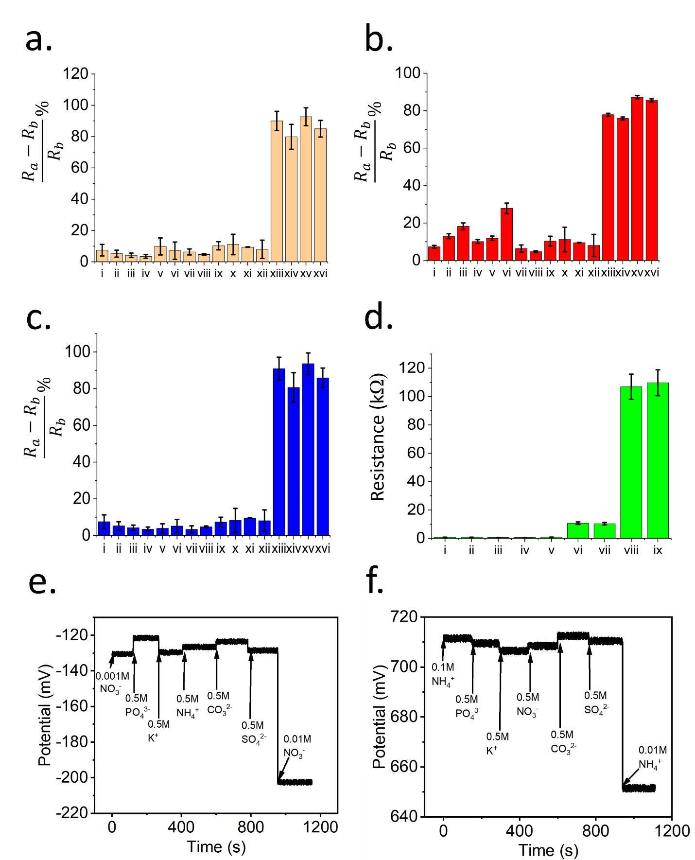
Supplementary Fig. S6: Selectivity tests of the (a) SA, (b) IAA, (c) MeJA, (d) ethylene, (e) nitrate, and (f) ammonium sensors.

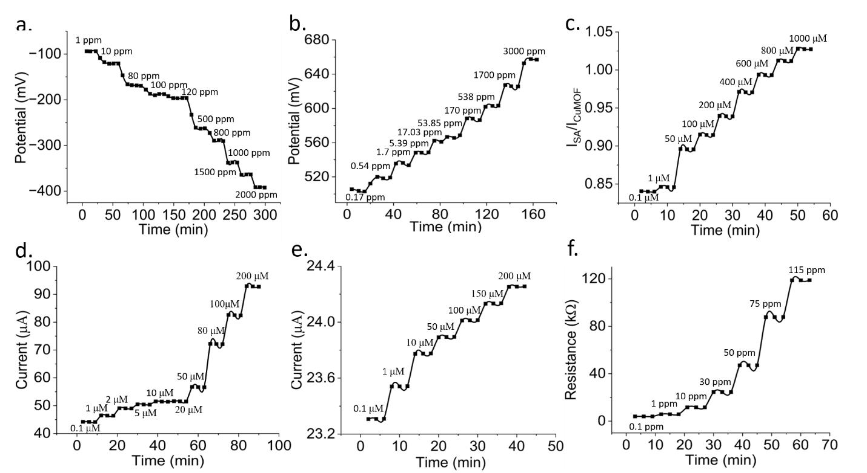
Supplementary Fig. S7: Dynamic measurements conducted with the (a) nitrate, (b) ammonium, (c) SA, (d) IAA, (e) MeJA, and (f) ethylene sensors.

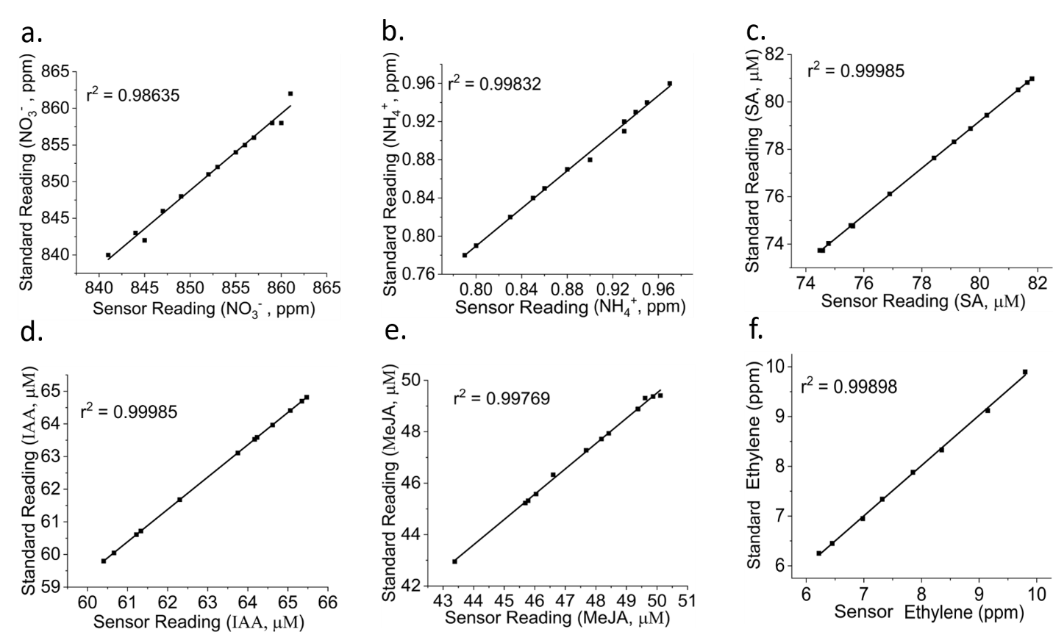
Supplementary Fig. S8: Regression plots showing the accuracy of (a) nitrate, (b) ammonium, (c) SA, (d) IAA, (e) MeJA, and (f) ethylene sensors.

Supplementary References
1. Hossain, N. I. & Tabassum, S. A hybrid multifunctional physicochemical sensor suite for continuous monitoring of crop health. Sci Rep 13, 9848 (2023).
2. Hossain, N. I. & Tabassum, S. Fruit-FIT: Drone Interfaced Multiplexed Sensor Suite to Determine the Fruit Ripeness. in 2022 IEEE Sensors 1–4 (2022). doi:10.1109/SENSORS52175.2022.9967097.
3. Hossain, N. I. & Tabassum, S. Leaf-mounted microneedle-based multisensory platform for multiplexed monitoring of phytohormones in live plants. in Proc. Hilton Head 2022: A Solid-State Sensors, Actuators and Microsystems (2022).
4. Tabassum, S., Kumar, D. P. & Kumar, R. Copper Complex-Coated Nanopatterned Fiber-Tip Guided Mode Resonance Device for Selective Detection of Ethylene. IEEE Sensors Journal 21, 17420–17429 (2021).
5. Trócoli, R. & La Mantia, F. An aqueous zinc-ion battery based on copper hexacyanoferrate. ChemSusChem 8, 481–485 (2015).
6. Riam, S. Z. et al. AQUA-FINS: Advanced Quantitative Underwater Analysis by a Flexible Integrated Nitrate Sensor. Advanced Sensor Research 4, 2500010 (2025).
7. Solaiman, M., Galib, A. R., Riam, S. Z., Sarwar Inam, A. & Tabassum, S. Real-time potentiometric sensing of soil nitrate: Depth-resolved monitoring across plant species with varying root structures. Computers and Electronics in Agriculture 239, 110929 (2025).
8. Ali, Md. A. et al. Continuous Monitoring of Soil Nitrate Using a Miniature Sensor with Poly(3-octyl-thiophene) and Molybdenum Disulfide Nanocomposite. ACS Appl. Mater. Interfaces 11, 29195–29206 (2019).
9. Wang, S. et al. Copper-Based Metal–Organic Framework Nanoparticles with Peroxidase-Like Activity for Sensitive Colorimetric Detection of Staphylococcus aureus. ACS Appl. Mater. Interfaces 9, 24440–24445 (2017).
10. Nancy, P., Nair, A. K., Antoine, R., Thomas, S. & Kalarikkal, N. In Situ Decoration of Gold Nanoparticles on Graphene Oxide via Nanosecond Laser Ablation for Remarkable Chemical Sensing and Catalysis. Nanomaterials 9, 1201 (2019).
11. Jain, P. K., Huang, X., El-Sayed, I. H. & El-Sayed, M. A. Review of Some Interesting Surface Plasmon Resonance-enhanced Properties of Noble Metal Nanoparticles and Their Applications to Biosystems. Plasmonics 2, 107–118 (2007).
12. Huang, X. & El-Sayed, M. A. Gold nanoparticles: Optical properties and implementations in cancer diagnosis and photothermal therapy. Journal of Advanced Research 1, 13–28 (2010).
13. Darder, M., Colilla, M. & Ruiz-Hitzky, E. Biopolymer−Clay Nanocomposites Based on Chitosan Intercalated in Montmorillonite. Chem. Mater. 15, 3774–3780 (2003).
14. Xu, L. et al. Beyond Nonactin: Potentiometric Ammonium Ion Sensing Based on Ion-selective Membrane-free Prussian Blue Analogue Transducers. Anal. Chem. 94, 10487–10496 (2022).

