Supplementary material
From manual search to artificial intelligence: A methodological framework for developing patient journey models from electronic health records using natural language processing

Rose Zhang¹, Tara Raftery², Thirupathi Pattipaka³, Petra Nathan⁴

Fig.S1 Workflow to apply Natural language processing (NLP) for medical notes. SDS structured data storage
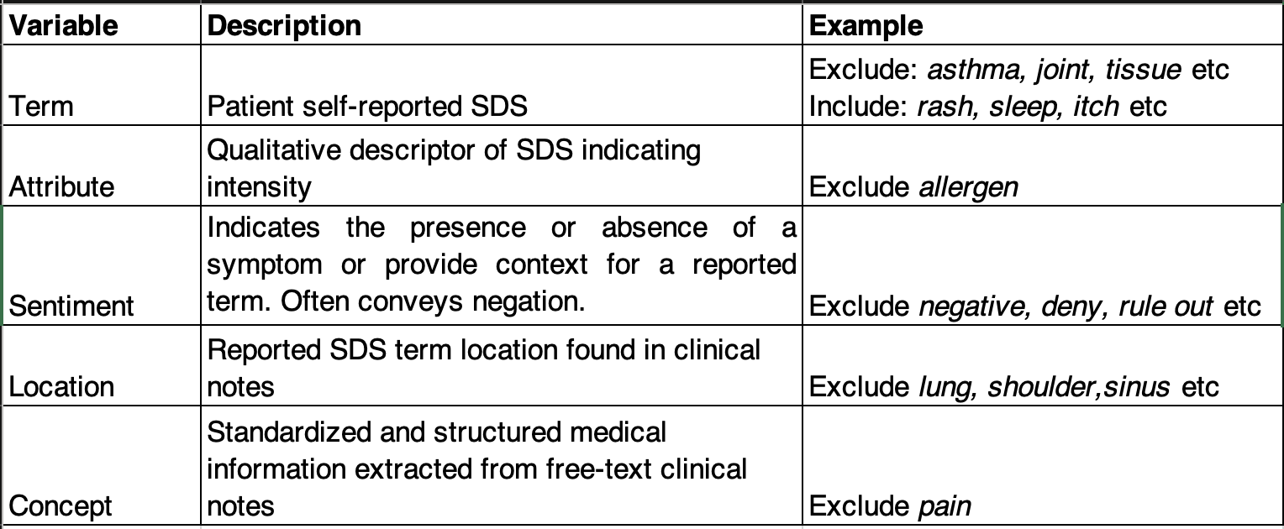
Table S1 Applied variables within to extract unstructured data from HER upon NLP technique.#

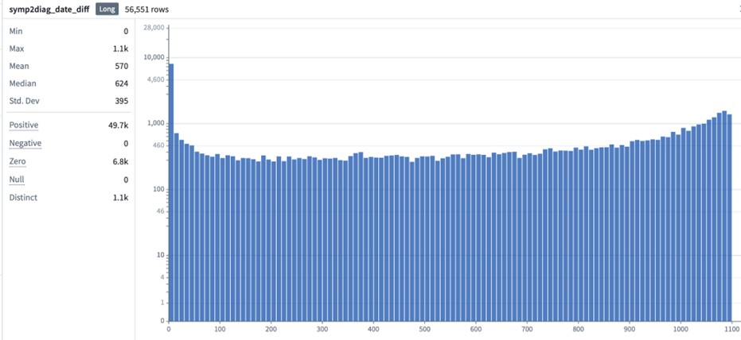
Figure S2 Plot from extracted data to calculate mean time between symptom start and diagnosis .

