Supplemental Information

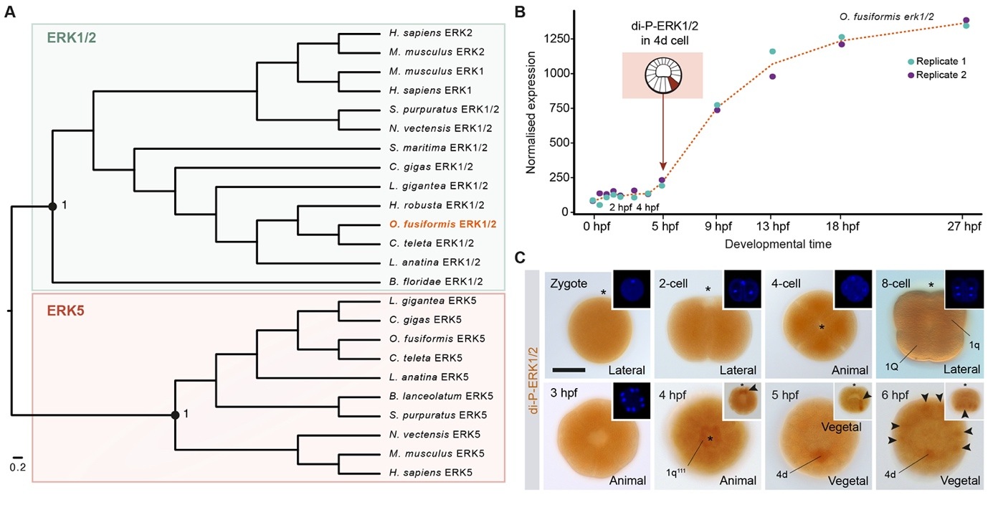

Figure S1. ERK1/2 activity during O. fusiformis early embryogenesis. (A) Maximum likelihood orthology assignment for ERK1/2, using ERK5 as outgroup. Only bootstrap values for major nodes are shown. (B) Normalised expression of erk1/2 during O. fusiformis development, from the active oocyte to the mitraria larval stage. The time of the specification of 4d is highlighted with a schematic drawing. Coloured dots indicate values of expression for each replicate and the dotted red line shows the mean value of expression. (C) Whole mount immunohistochemistry against di-phosphorylated-ERK1/2 (dark orange) during spiral cleavage in O. fusiformis. ERK1/2 is active at low levels during early divisions, and later enriched in the four 1q¹¹¹ animal micromeres at 4 hours post fertilisation (hpf), the 4d micromere at the time of its specification (5 hpf) and finally in six vegetal cells forming a bilaterally symmetrical pattern (arrowheads) at 6 hpf. Insets in (C) show either nuclear staining (blue) or lateral views. Asterisks point to the animal pole.

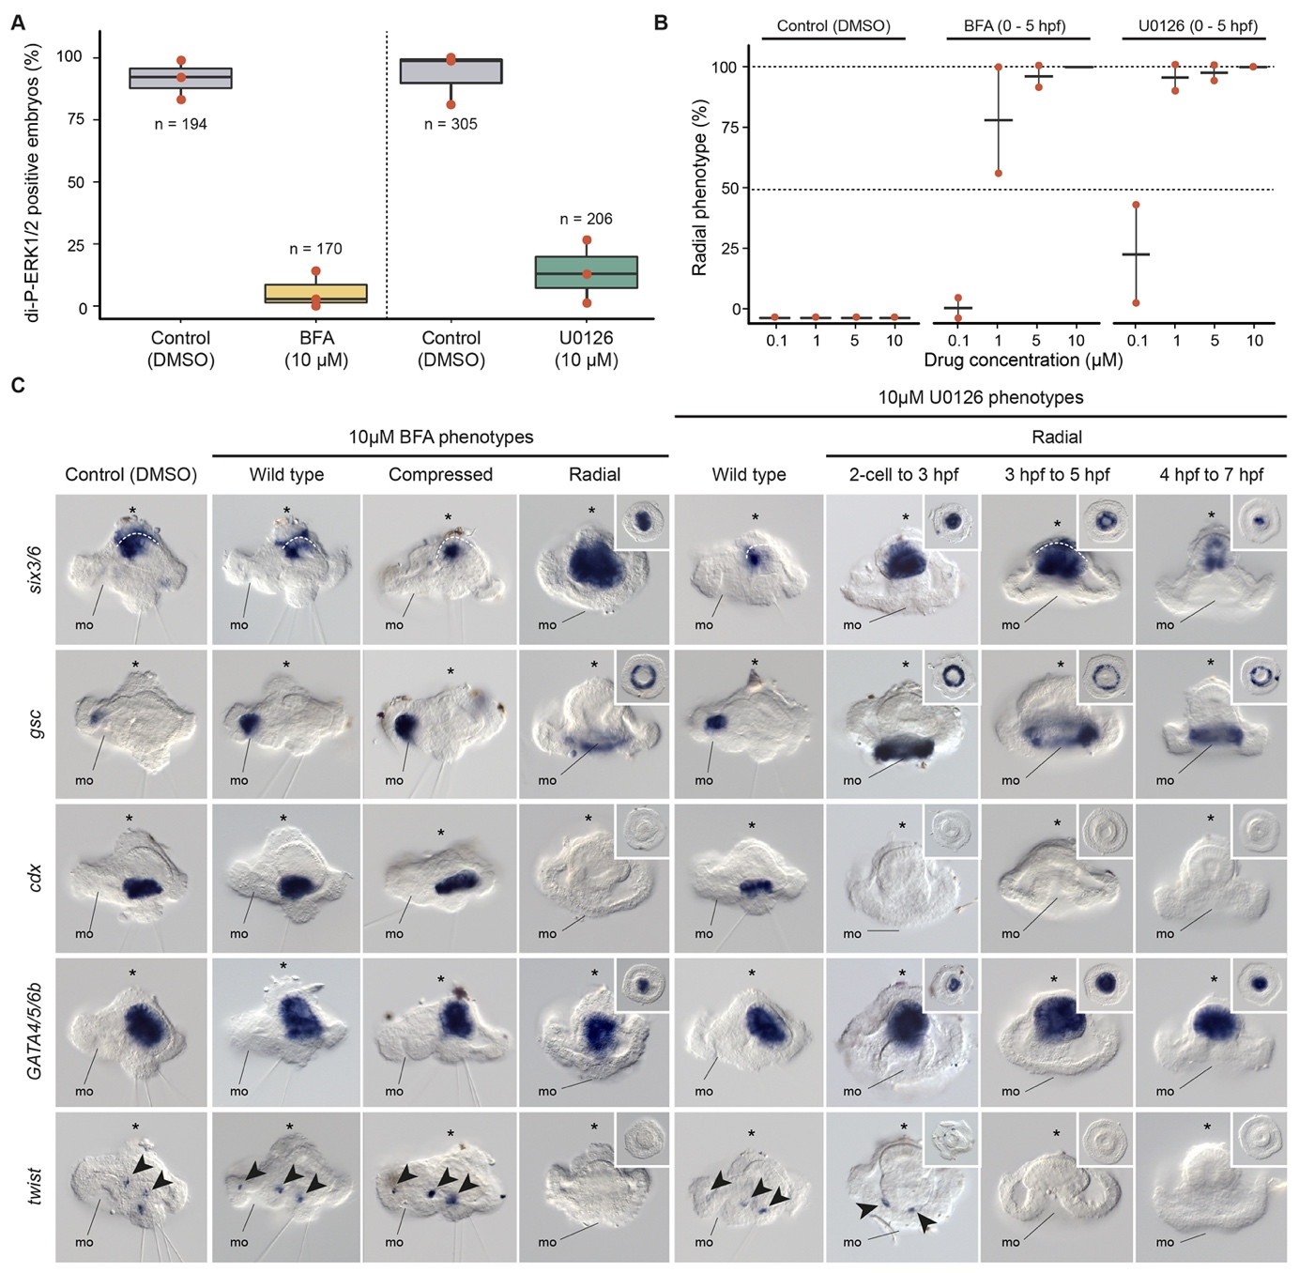

Figure S2. The effect of BFA and U0126 treatment in O. fusiformis development. (A) Percentage of coeloblastula showing di-phosphorylated ERK1/2 (di-P-ERK1/2) enrichment in the 4d micromere after 0.5 to 5 hours post fertilisation (hpf) treatment with brefeldin A (BFA), U0126 or DMSO (control). (B) Percentage of radial phenotypes obtained when treating embryos from 0.5 to 5 hpf with a range of BFA and U0126 concentrations. (C) Whole mount in situ hybridisation of apical (six3/6), oral (gsc), posterior/hindgut (cdx), midgut (GATA4/5/6b) and trunk mesodermal (twist) gene markers in control and treated larvae. Radial phenotypes have a reduction of the apical marker, radial expansion of an oral gene, loss of posterior structures (chaetae) and posterior/trunk mesoderm gene expression and retain the expression of a midgut gene. Radial larvae treated with U0126 from the 2-cell stage to 3 hpf show scattered twist expression in some embryos (arrowheads) and embryos treated from 4 to 6 hpf are seemingly more elongated along the apical-oral axis. The compressed larval phenotype after BFA treatment from 0.5 to 4 hpf have a reduced apical organ and apical tuft (first row) and reduced expression of apical markers (six3/6), but otherwise normal morphology besides an obliterated internal blastocele. Asterisks indicate the apical pole and arrowheads point to expression domains. Insets are ventral views. mo: mouth.

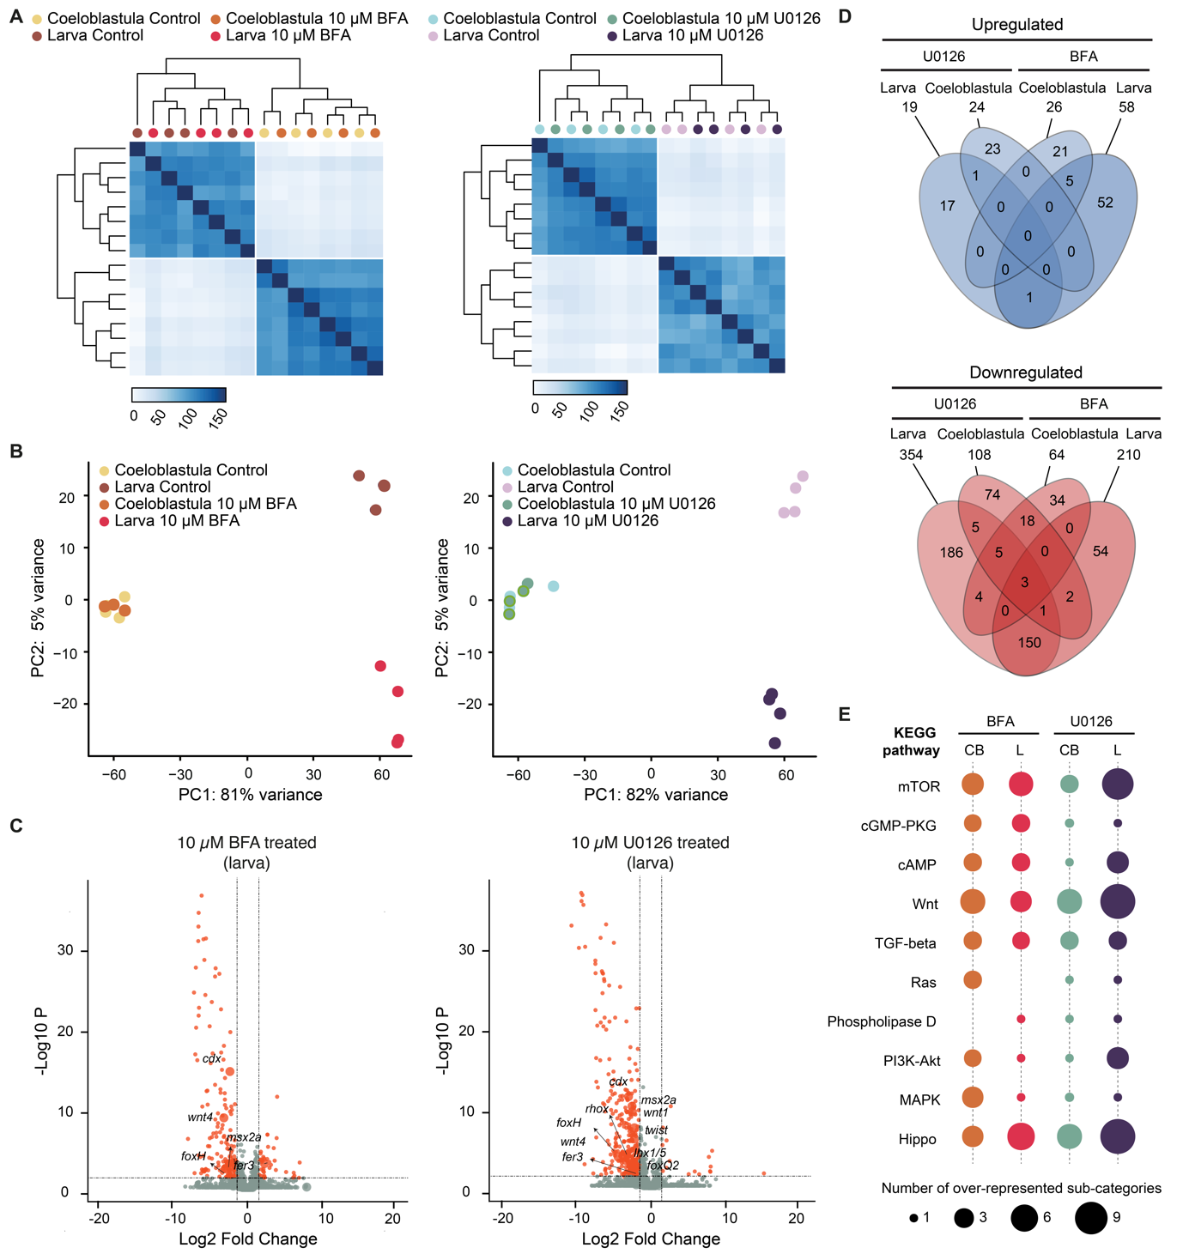

Figure S3. Differential expression analyses in BFA and U0126 treated embryos. (A) Hierarchically clustered pairwise correlation matrix between brefeldin A (BFA) and U0126 treated and control samples. (B) Principal component analysis (PCA) plot for BFA (left) and U0126 (right) RNA-seq analyses. (C) Volcano plots for BFA and U0126 treated larva. Red dots show differentially expressed (DE) genes and analysed candidate genes are labelled in each comparison. (D) Venn diagrams showing the number of up- (top) and downregulated (bottom) DE genes shared between different conditions. (E) Ten most overrepresented KEGG pathways in each of the four conditions analysed by RNA-seq. The size of the coloured dots is proportional to the number of overrepresented sub-categories nested into a given KEGG pathway.

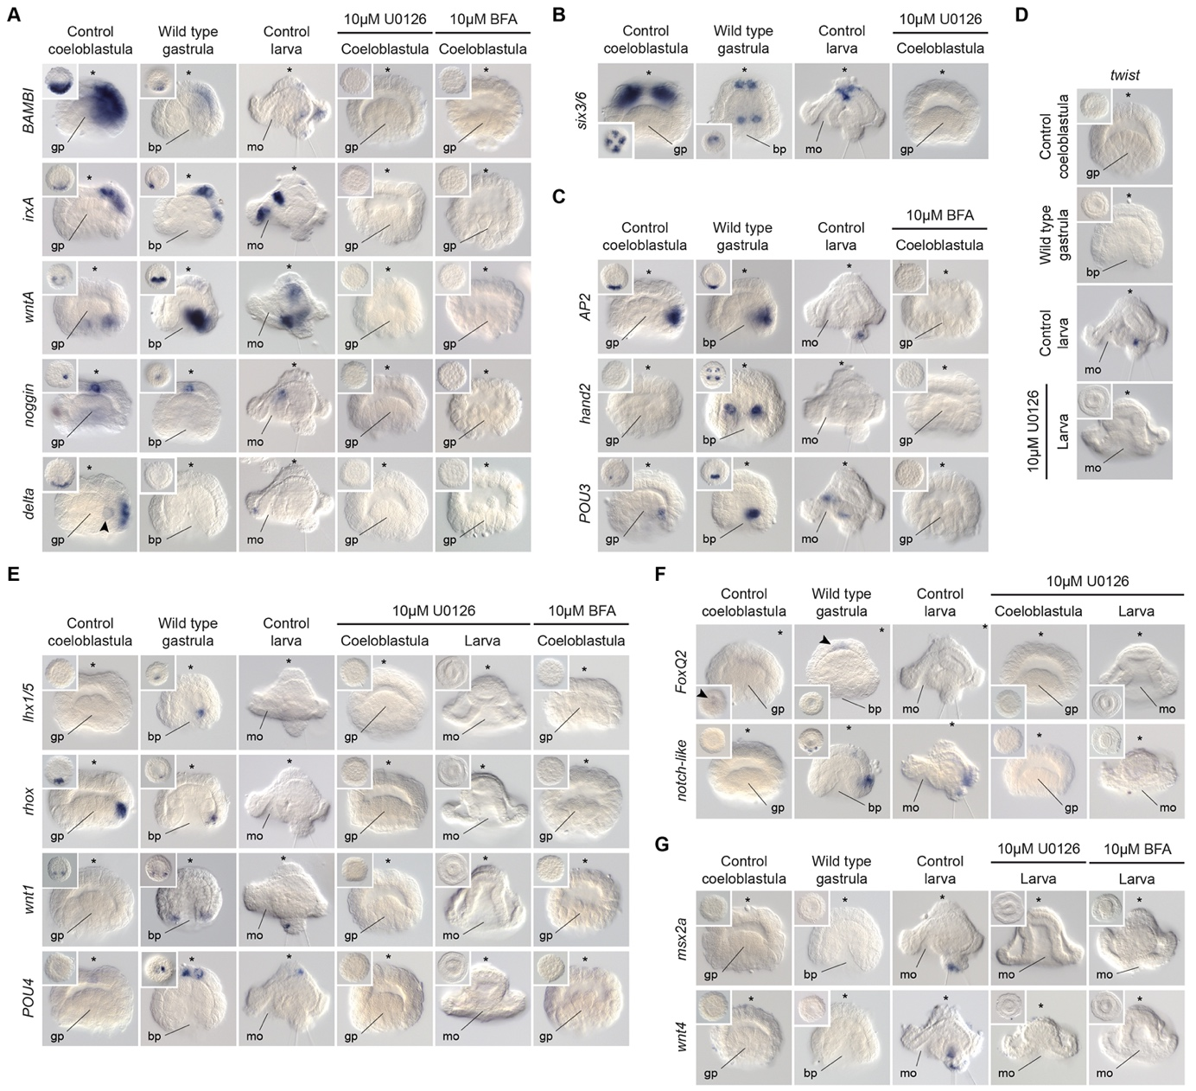

Figure S4. Validation of the differential expression analyses. (A–G) Whole mount in situ hybridisation of control and treated embryos showing in addition a wild type gastrula stage to reconstruct the time course of expression of each gene. In all cases, the expression patterns disappear in BFA and U0126 treated embryos. Insets are ventral views. Asterisk point to the animal/apical pole. Arrowheads point to 4d in (A) and to the apical organ in (F). bp: blastopore; gp: gastral plate; mo: mouth.

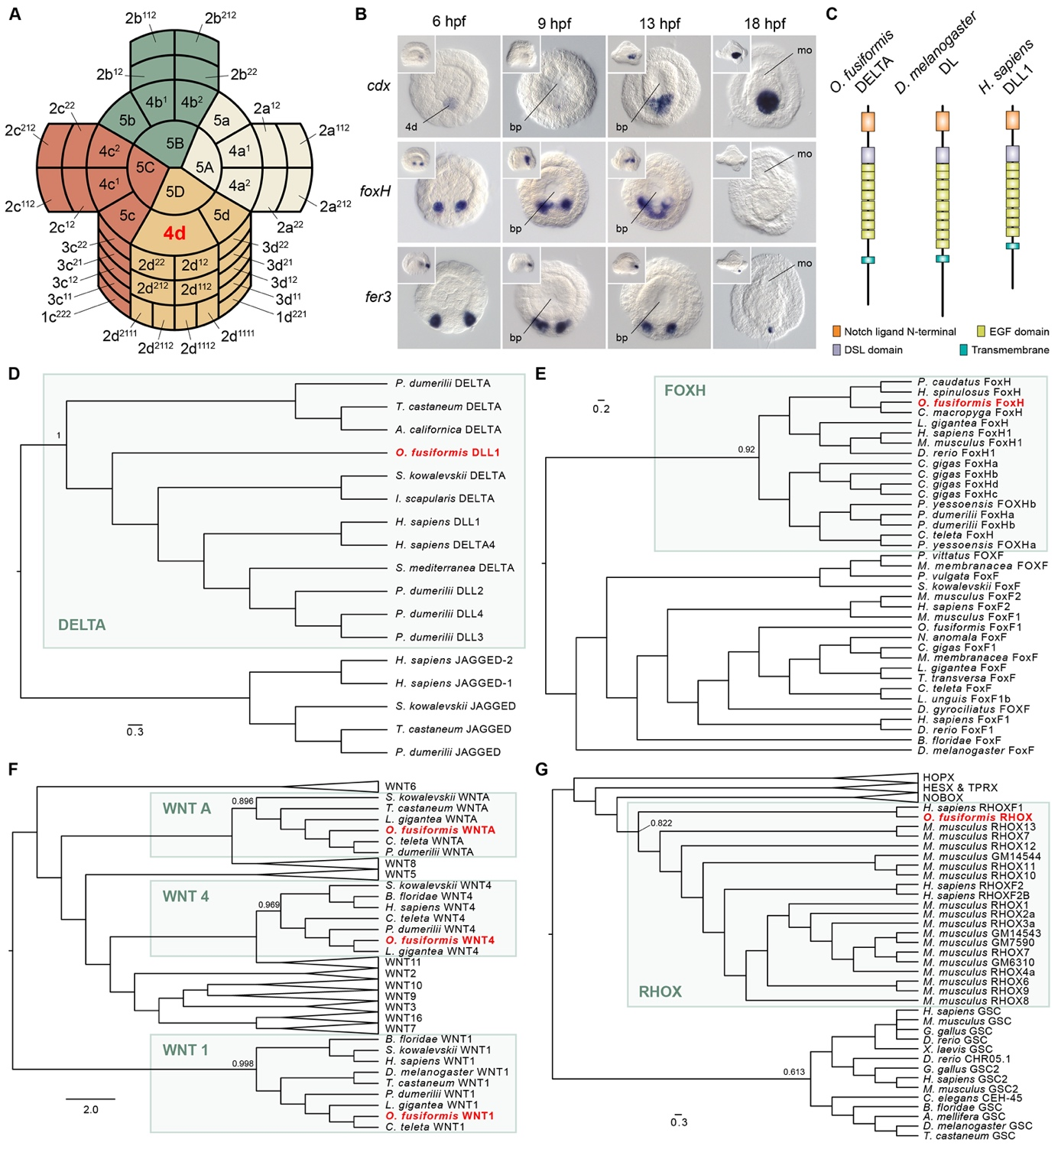

Figure S5. Genes patterning the D-quadrant after the specification of the 4d-organiser cell. (A) Schematic drawing of the cellular arrangements and cell nomenclature of the vegetal pole just after the specification of the 4d micromere in O. fusiformis embryo at 5.5 hours post fertilisation (hpf). Different colours depict different quadrants. (B) Time course of expression of cdx, foxH and fer3 via whole mount in situ hybridisation from 6 hpf to 18 hpf during O. fusiformis embryogenesis. While cdx is expressed in the cells forming the hindgut, foxH appears to upregulate at the earliest stages of cells giving rise to mesodermal derivatives. The gene fer3 is expressed in two posterior most cells of unknown function in the gastrula and larva. Insets are lateral views. (C) The protein domain architecture of the Notch ligand DELTA in O. fusiformis in comparisons with the domain structures of the Delta orthologs in D. melanogaster and H. sapiens. (D–G) Maximum likelihood orthology assignments of DELTA, FOXH, WNT ligands, and RHOX in O. fusiformis. Only bootstrap values supporting each major clade are shown. bp: blastopore; mo: mouth.

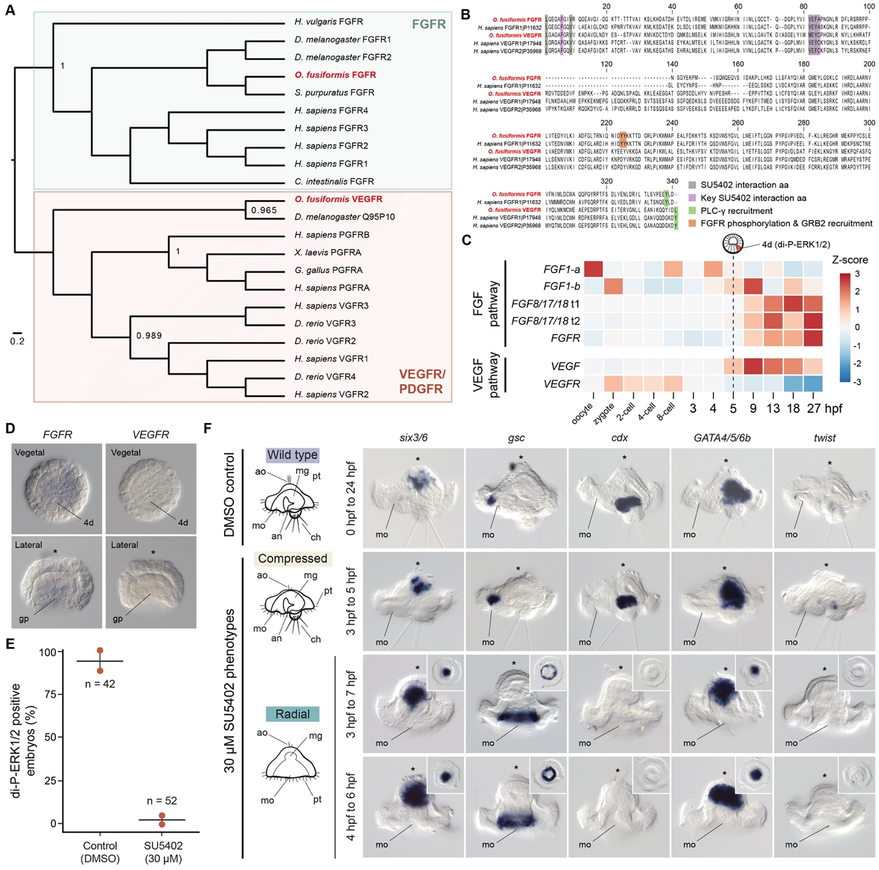

Figure S6. The FGF pathway and FGFR activity during 4d specification in O. fusiformis. (A) Maximum likelihood orthology assignment of fibroblast growth factor receptor (FGFR) and vascular endothelial growth factor receptor (VEGFR). Only bootstrap values for key nodes are shown. (B) Multiple protein alignment between O. fusiformis and H. sapiens FGFR and VEGFR orthologs indicating conserved residues for the interaction of the drug SU5402 with these receptors. (C) Temporal time course of expression of members of the FGF and VEGF pathways in O. fusiformis. The heatmap depicts the normalised z-score value of expression for each gene, with red blocks indicating high levels of expression and blue blocks indicating low levels of expression. The horizontal dotted line highlights the specification of the 4d micromere. (D) Whole mount in situ hybridisation for FGFR and VEGFR at the coeloblastula stage of O. fusiformis. FGFR is expressed weakly at the gastral plate at the time of 4d-instructed posterior re-pattering. VEGFR, which SU5402 treatment can also inhibit, is not expressed at this stage. (E) Proportion of treated and control embryos exhibiting di-phosphorylated ERK1/2 enrichment in the 4d cell at 5 hpf after SU5402 drug treatment from 0.5 to 5 hours post fertilisation (hpf). (F) Morphological and molecular characterisation of SU5402 treated embryos fixed at the larval stage. The first column shows diagrams of lateral views of the wild type, compressed and radial phenotypes. From the second column onwards, whole mount in situ hybridisations of control and SU5402 treated larvae. The compressed larvae are phenocopies of brefeldin A (BFA) compressed larvae, with reduced apical organ and apical tuft (second row) and reduced expression of apical markers (six3/6), but other tissues are not affected. Radial larvae are phenocopies of BFA and U0126 radial larvae with reduction of apical markers (six3/6), radial expansion of oral genes (gsc), loss of posterior structures (chaetae) and expression of posterior endomesodermal markers (cdx, twist), but normal expression of an endodermal gene (GATA4/5/6b). Insets are ventral views. Asterisks point to the animal/apical pole. ao: apical organ; an: anus; ch: chaetae; gp: gastral plate; mg: midgut; mo: mouth; pt: prototroch. Scale bars are 50 μm.
Supplementary Tables and Files
Table S1. Di-P-ERK1/2 activation in spiralians.
Table S2. Di-P-ERK1/2 activation at 5 hpf in control, BFA and U0126 treated embryos.
Table S3. Larval phenotypes in control, BFA and U0126 treatments.
Table S4. Larval phenotypes at different concentrations of BFA and U0126.
Table S5. Larval phenotypes during staggered time windows of BFA and U0126 treatments.
Table S6. List of all differentially expressed genes at 5.5 hpf and 24 hpf.
Table S7. List of enriched gene ontology terms.
Table S8. List of enriched KEGG pathways.
Table S9. List of candidate genes and their gene IDs in differential gene expression analyses.
File S1. Multiple protein alignments.

