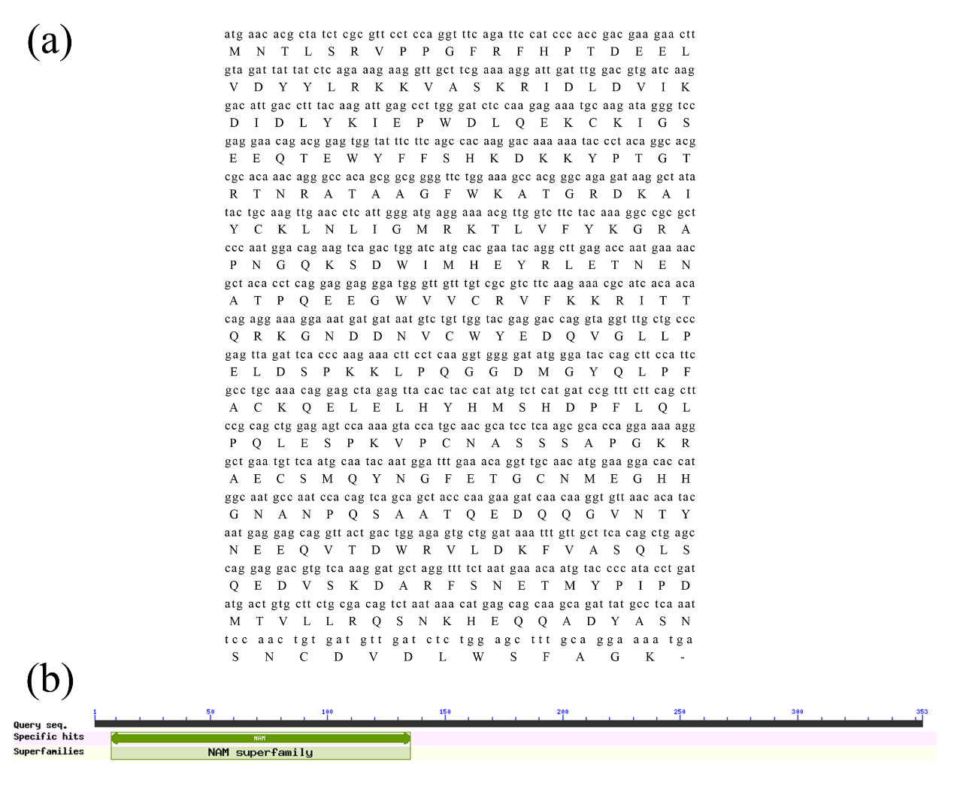
Figure S1. (a) Nucleotide sequence and amino acid sequence of PmVNS2 (353 amino acids in total). (b) The presence of a typical NAM conserved structural domain in the PmVNS2 protein, which belongs to the NAC gene family.

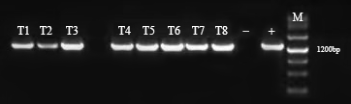
Figure S2. DNA molecular detection of PmVNS2 transgenic plants was performed using the 35S::PmVNS2 construct as a positive control (+) and wild-type (CK) plants as a negative control (-). Specific target bands corresponding to PmVNS2 were observed in all eight transgenic lines, aligning with the positive control (+), while no target bands were detected in CK plants.

