Information flow causality reveals climate regime shifts during compound dry–hot events

Yikui Zhang^{1,2*}, Daniel Hagan³, Diego G. Miralles³, Klaus Goergen^{1,2}, Stefan Kollet^{1,2}

(1) Agrosphäre (IBG-3), Institute of Bio- and Geosciences, Forschungszentrum Jülich, Germany
(2) Centre for High-Performance Scientific Computing in Terrestrial Systems, Geoverbund ABC/J, Jülich, Germany
(3) Hydro-Climate Extremes Lab (H-CEL), Ghent University, Ghent 9000, Belgium

*Correspondence: yik.zhang@fz-juelich.de.

Supplementary Information
A. Information flow rate calculation
Explanations on $\frac{Cov(X_{1},\dot{X_{1}})}{σ_{X_{1}}^{2}}$ in Eq. 1 and Eq. 2:
Given a linear relationship between $X_{1}$ and $\dot{X_{1}}$:
(1)

Where:
$X_{1}$ is the independent variable
$\dot{X_{1}}$ is the dependent variable (tendency)
$β$ is the regression coefficient
$ε$ is the residual, assumed to satisfy $E\left[X_{1}ε\right]=0$ (uncorrelated with $X_{1}$)

The least-squares estimate minimizes the mean-squared residual:
(2)
Taking the derivative with respect to $β$ and setting it to zero:
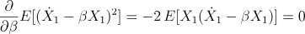 (3)
Solving for $β$:
(4)
Rearranging:
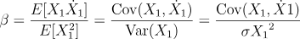 (5)
Thus, the ratio $\frac{Cov(X_{1},\dot{X_{1}})}{σ_{X_{1}}^{2}}$ is simply the regression slope of $\dot{X_{1}}$ on $X_{1}$, which represents how much $X_{1}$’s current deviation explains its future rate of change

B. Additional information flow analysis results

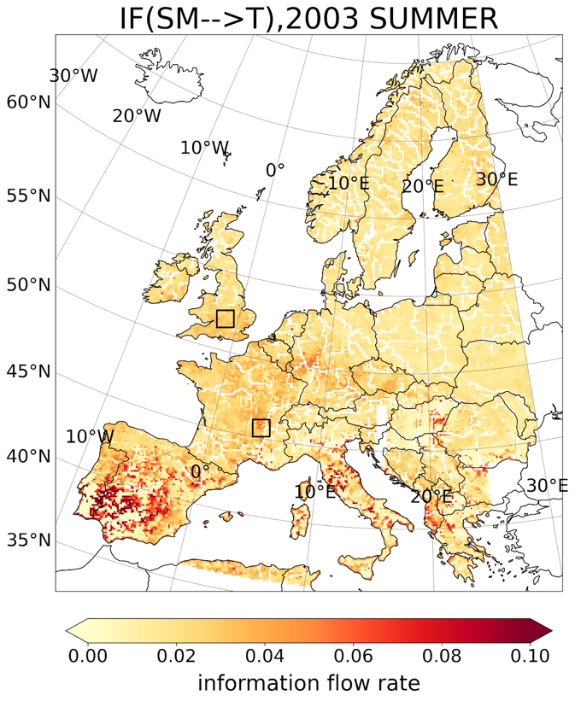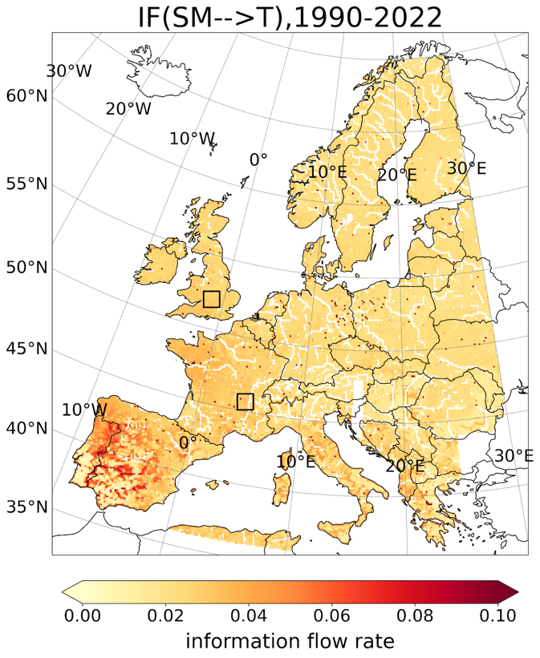
Figure B1. Maps for time-averaged IF of SM–>T over the entire analysis domain in 2003 summer (left) and over 1990-2022 (right). The two black boxes indicate the two selected domains in FR and BI. The Unit of IF is in nats/h.

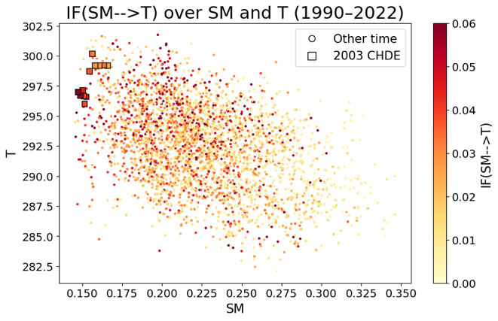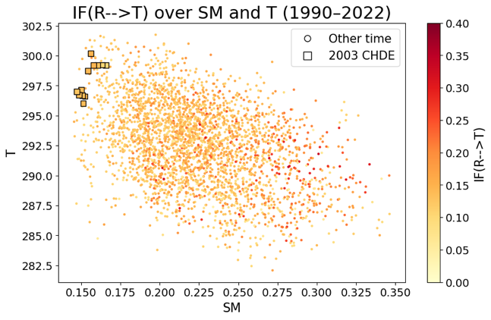
Figure B2. Scatter plots of daily SM–>T (first column) and R–>T (second column) from 1990 to 2022 in selected domains in Iberian Peninsula (IP). The CDHE period ranges from August 3rd to August 14th, 2003. Each grid point represents the average value over a domain at daily timescales and the colorbar represents the magnitude of SM–>T. The Unit of IF is in nats/h.

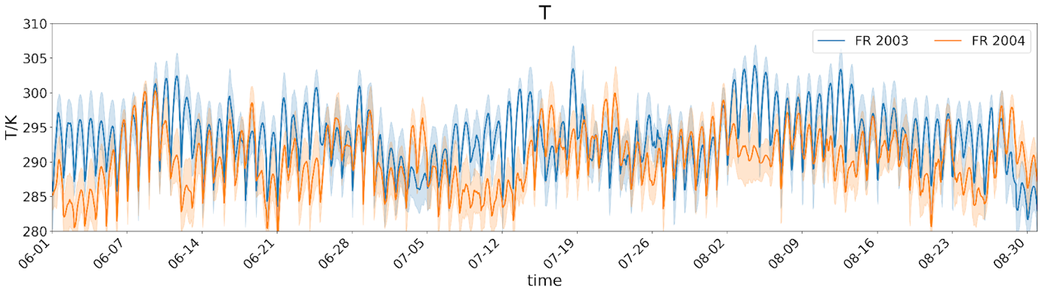
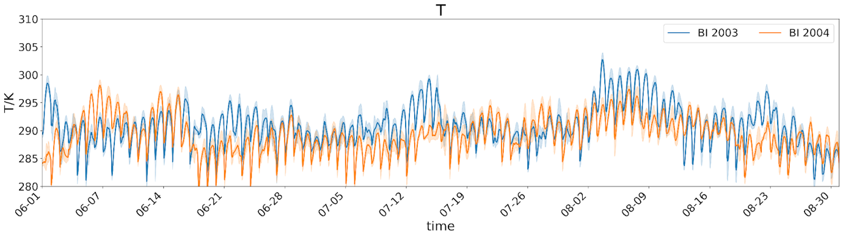

Figure B3. Domain-averaged hourly time series of 2-meter temperature (T) in a 10*10 grid domain in as in figure 3, in 2003 (blue) and 2004 (orange) summer. a). France (FR); b). British Isle (BI). The red dashed box highlights the 2003 CDHE period and the shaded area represents the confidence interval over the 10*10 domain.

