Achieving High-Performance Room-Temperature Organic Ferromagnetic Semiconductor Films via Topochemical Reduction

Yanuo Zhu^{1, 2}, Qinglin Jiang^{1, 2*}, Hanlin Gan^{1, 2}, Jiaji Yang^{1, 2}, Xiandong He^{1, 2}, Wei Cui^{1, 2}, Shaohua Tong^{1, 2}, Liang Yao^{1, 2}, Jiang Zhang^{3*}, Yuguang Ma^{1, 2*}

¹Institute of Polymer Optoelectronic Materials and Devices, Guangdong Basic Research Center of Excellence for Energy and Information Polymer Materials, State Key Laboratory of Luminescent Materials and Devices, South China University of Technology, Guangzhou 510640, P. R. China
²Guangdong Provincial Key Laboratory of Luminescence from Molecular Aggregates (South China University of Technology), Guangzhou 510640, P. R. China
³Department of Physics, South China University of Technology, Guangzhou 510640, P. R. China

*Corresponding emails: jiangql@scut.edu.cn; jonney@scut.edu.cn; ygma@scut.edu.cn

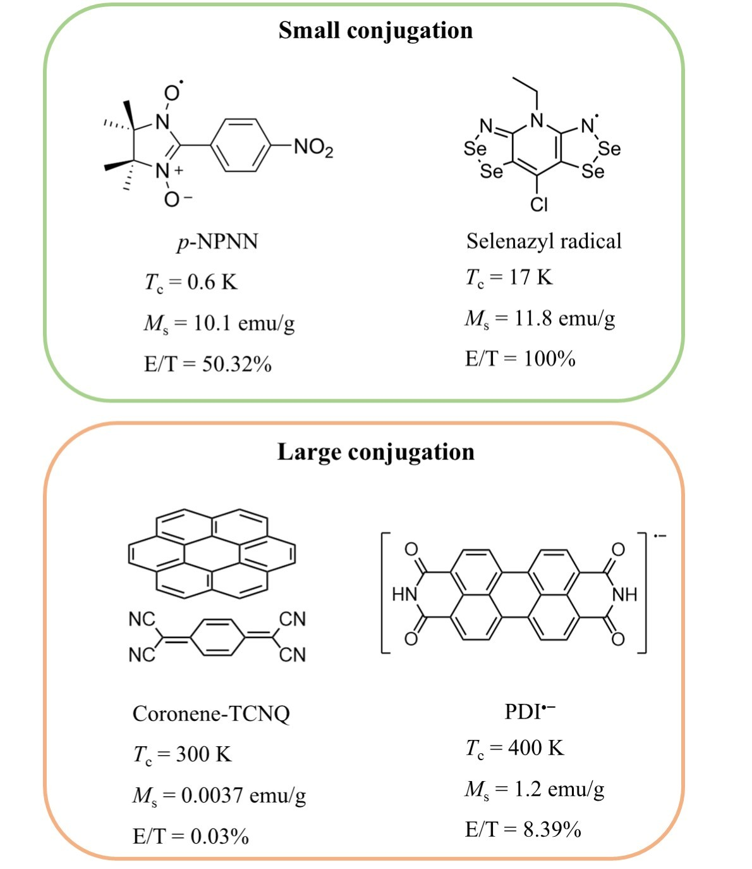
Supplementary Fig. 1 Molecular structure, Curie temperature (T_{c}), saturation magnetization (M_{s}), and experimental/theoretical M_{s} of p-NPNN¹, selenazyl radical², Coronene-TCNQ³, PDI^{•―4}.

Neutral PDI was deposited on Si. We treated the film in a sealed Schott bottle containing hydrazine hydrate solution, and the treated films were obtained after certain hours.
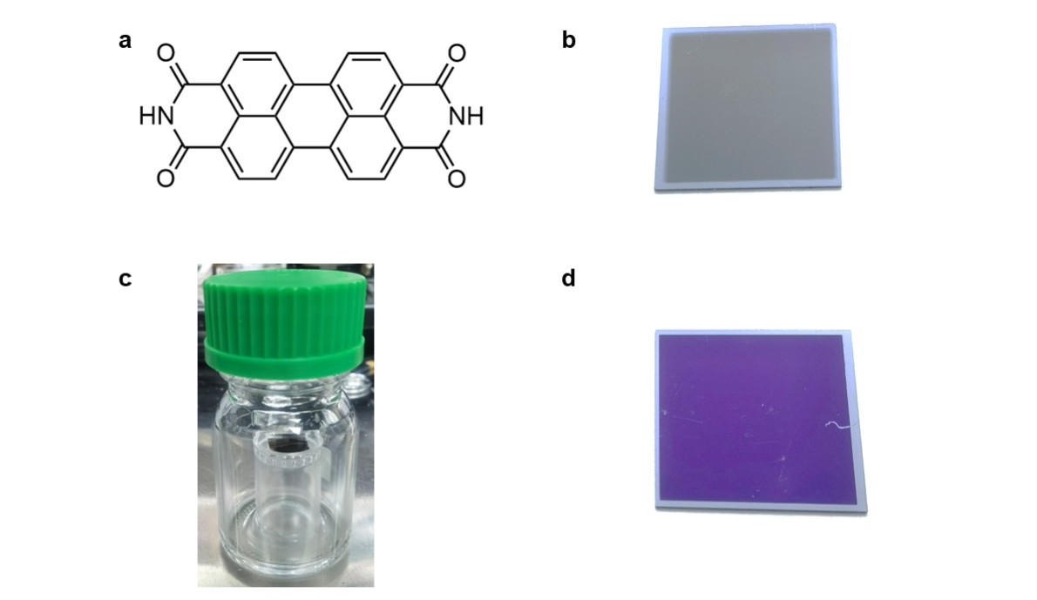
Supplementary Fig. 2 Digital photos of testing equipment and films. a Molecular formula of PDI. b Digital photo of raw film. c Homemade bottle used to reduce films. d Digital photo of the film after reduction.

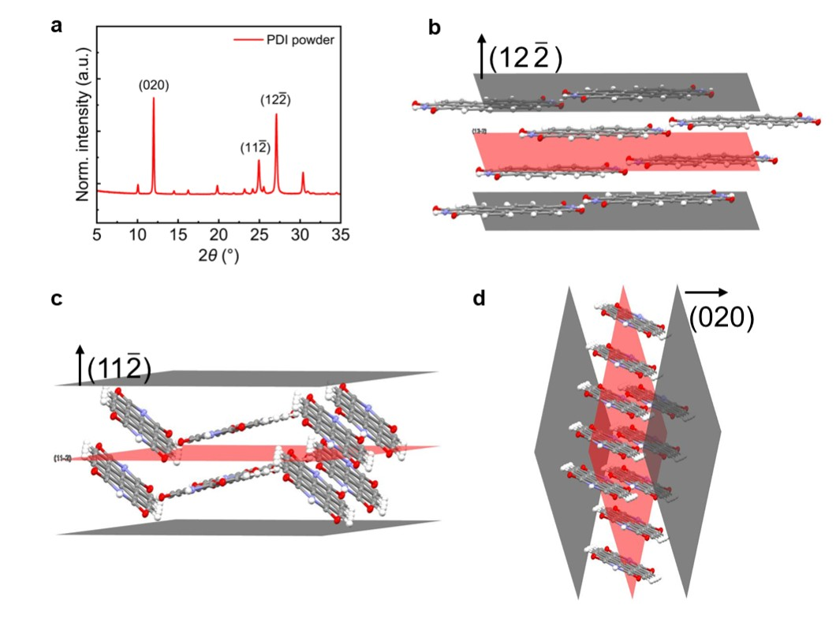
Supplementary Fig. 3 Structure of PDI powders. a Powder-XRD patterns of PDI. Molecular arrangements on crystal planes extracted from PDI single crystal and powder diffraction data are presented in b (12$\overline{\text{2}}$), c (11$\overline{\text{2}}$), d (020).

The signal intensity increased for the first 6h and then decreased. So it was chosen to be the best topochemical reducing time. UV spectra confirmed that the EPR signal came out from ionized PDI.
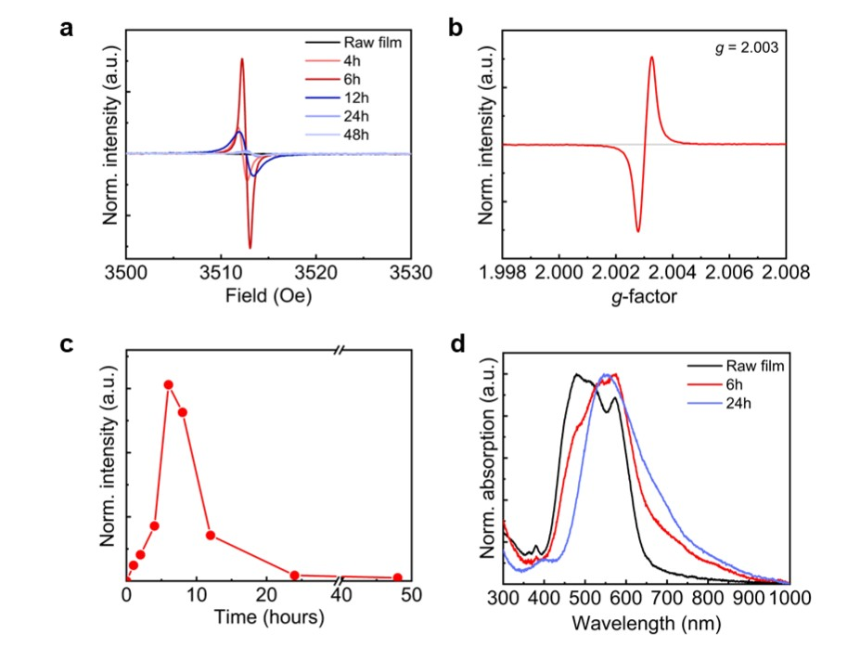
Supplementary Fig. 4 Film composition. a EPR spectra of raw films and films reduced for 4h, 6h, 12h, 24h, 48h. b g-factor of the electrons in the films. c Changes of relative concentration of radicals in the films over reducing time. d UV-vis spectra of raw films and films reduced for 6h, 24h.

The roughness of topochemical-reduced films increased a little from 2.44 nm to 4.83 nm.
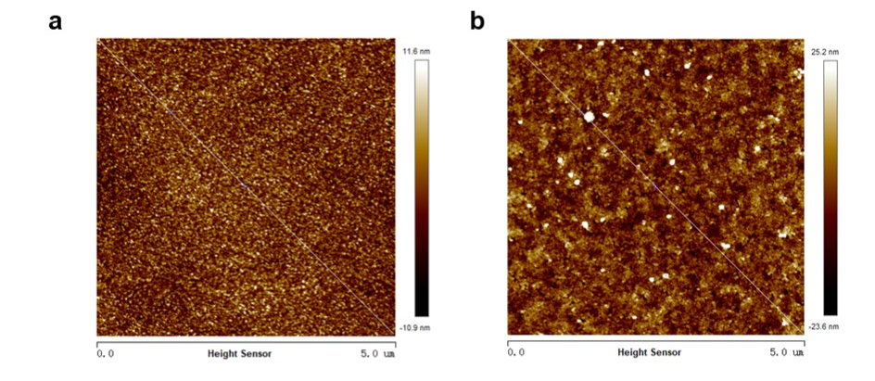
Supplementary Fig. 5 Surface morphology of films. a AFM image of raw films, showing a flat surface without obvious morphological features. b AFM image of topochemical-reduced films.

By fitting the standard curve, we calculated its slope to be 26540 and intercept to be 1.6508×10⁻⁴. After fully dissolving the film in hydrazine hydrate, the absorbance of the solution at 553 nm was 0.08097, which was incorporated into the curve to obtain a film weight of 5.95 μg.
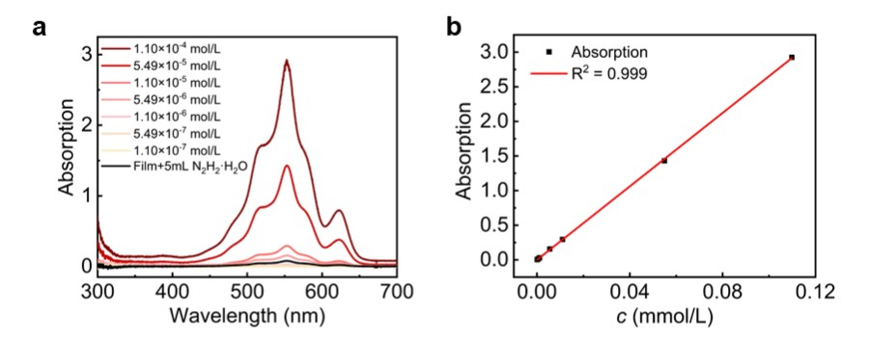
Supplementary Fig. 6 Determination of film weight. a UV-Vis spectra of hydrazine solution of PDI with different concentrations. b Standard curve of absorption-weight.

M_{s} and coercivity of topochemical-reduced films increased with the cooling temperature due to the reduced interference on spin magnetic moment caused by external thermal disturbances
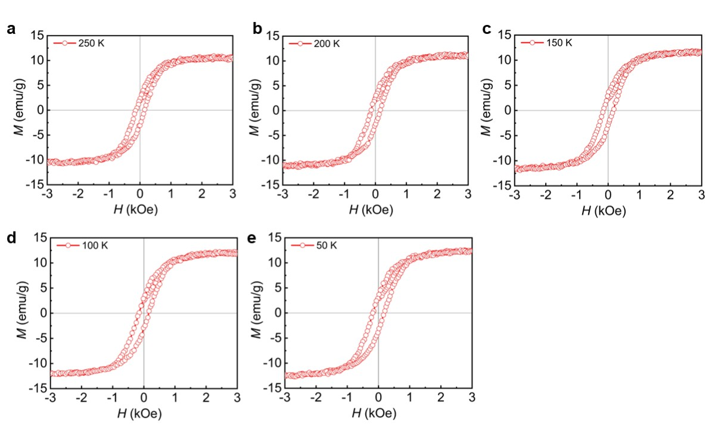
Supplementary Fig. 7 M-H curves at different temperature. a 250 K. b 200 K. c 150 K. d 100 K. e 50 K.

Due to its close-shell characterization, raw PDI films were diamagnetism. M_{s} of ferromagnetic films got weaker in glove box because of trace amounts of water and oxygen. PDI radical anions were oxidized into neutral PDI after exposing to air, and the films show diamagnetism. After high-temperature ablation, PDI species decomposed into carbon and exhibited diamagnetism, indicating that the ferromagnetism came out from PDI radicals.
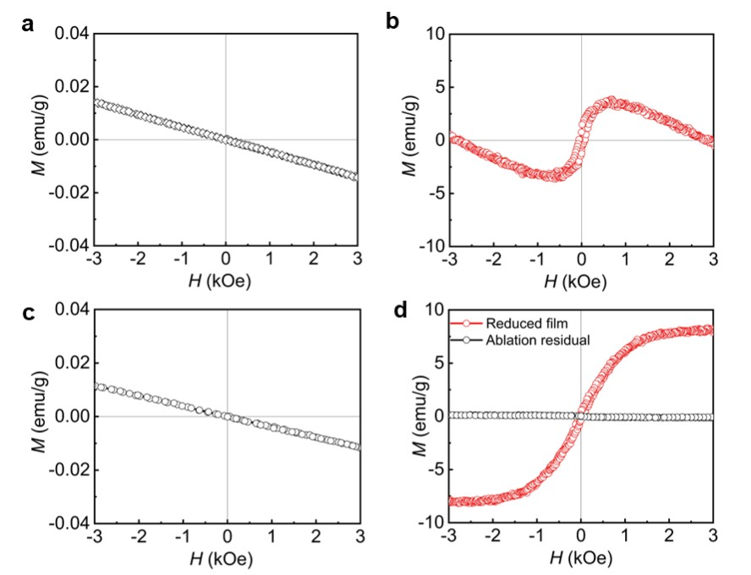
Supplementary Fig. 8 Magnetic properties after exposure in air and high-temperature digestion. a Raw films presented a diamagnetic M-H curve b Topochemical-reduced films show weaker ferromagnetism after 5 months in N₂ glove box. c Reduced films stored 30 days in air, exhibiting diamagnetism. d M-H curve of the reduced film and the ablation residual, the latter presenting diamagnetism.

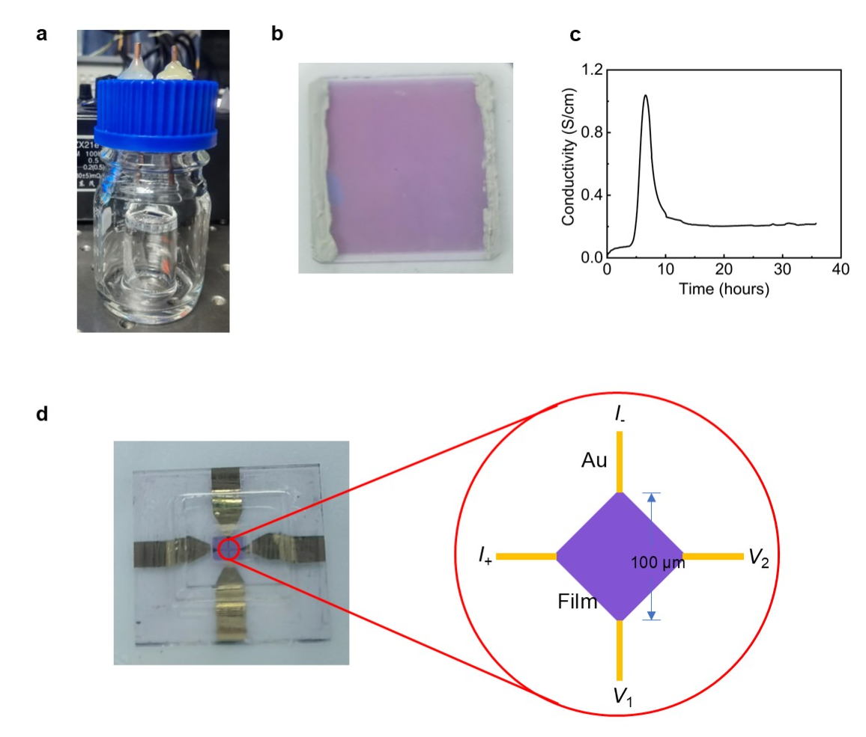
Supplementary Fig. 9 Electrical properties tests. a Homemade bottles used to monitor the conductivity while treating films. b Electrode configuration of R-t tests. c In site test of conductivity of the film during treatment measured by Keithley 2700 in a N₂ glove box. d Electrode configuration of four-point probe method in R-T tests. The distance between the opposite electrodes was100 μm.

100 nm NDI neutral films were prepared by thermal evaporation. The films had high crystallinity and orientation. NDI molecules had a face-on orientation on the substrate.
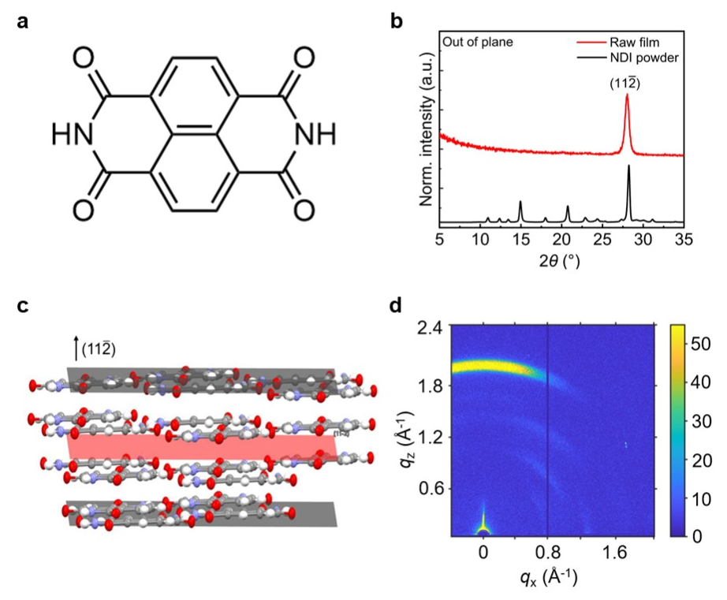
Supplementary Fig. 10 Structure of raw NDI films. a Molecular formula of NDI. b Comparison of GI-XRD patterns of raw films and Powder-XRD patterns of NDI. The peak of the two correspond well, indicating that the films are composed of NDI polycrystals. Molecular arrangements on crystal planes extracted from NDI single crystal and powder diffraction data are presented in c (11$\overline{\text{2}}$). d GIWAXS pattern of raw NDI films. Raw films exhibit face-on orientation.

We captured the EPR signal of the films reduced for different time. The intensity increased for the first 6 h and then decreased. So we chose 6 h to be the best reducing time. UV spectra confirmed the existence of ionized NDI in the films.
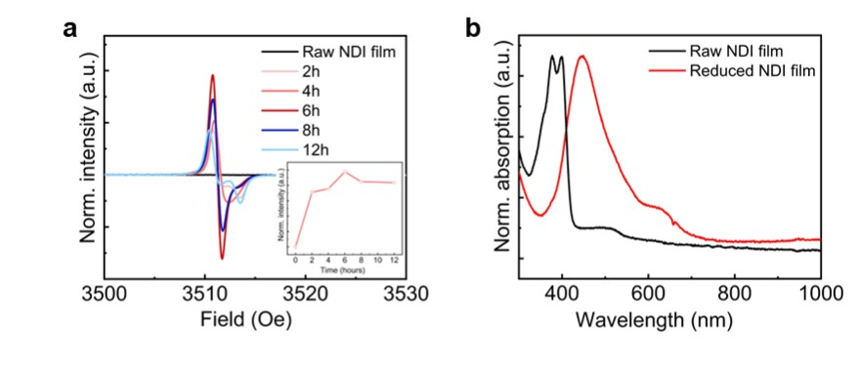
Supplementary Fig. 11 Composition of reduced NDI film. a EPR spectra of raw films and films reduced for 2 h, 4 h, 6 h, 8h, 12 h. Inset: Changes of relative concentration of radicals in the films over reducing time. b UV-vis spectra of raw films and films reduced for 6 h.

After topochemical reduction, the films show weaker crystallinity and orientation. The (11$\overline{\text{2}}$) peak shifted to smaller angle with a π-π distance of 3.26 Å, in agreement with the NDI radical powder reported before.
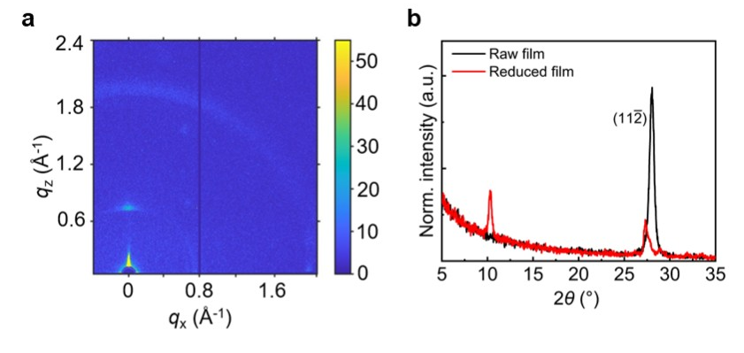
Supplementary Fig. 12 Changes in structure of NDI film after topochemical reduction. a GIWAXS pattern of reduced films with a weaker face-on orientation. b Comparison of XRD pattern between raw films and reduced films. The crystallinity decreased, and the peak at 28.05°in raw films moved to 27.30°in reduced films, implying the π-π distance changed 3.18 Å from to 3.26 Å.

Topochemical-reduced NDI films had a room-temperature ferromagnetism of 10.0 emu/g and a coercivity of 64.3 Oe, while that at 10 K was 11.8 emu/g and 78.6 Oe, respectively.
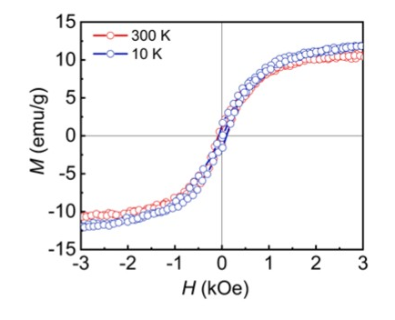
Supplementary Fig. 13 Magnetic properties of NDI radical films. M-H hysteresis loops of NDI films reduced in the same way taken at 300 K and 10 K, exhibiting an M_{s} of 10.0 emu/g at room-temperature and 11.8 emu/g at 10 K.

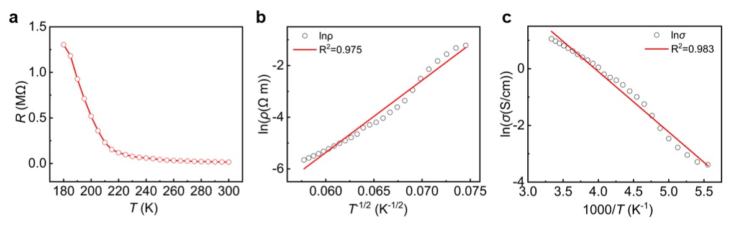
Supplementary Fig. 14 Semiconductivity of reduced NDI films. a Film resistance at different temperature. As the temperature decreases, the resistance increases exponentially, showing a typical characteristic of semiconductors. b The relationship between lnρ and T^{-1/2} indicates a 1D-VRH conduction model in the film. c The relationship between natural logarithm of conductivity (lnσ) and 1/T, and the result of linear fitting gives an activating energy of 183.7 meV.

The spin density distribution of radicals was given through M05-2X/6-31+G(d).
Based on the above research, we believe that the key to designing room temperature organic ferromagnetic semiconductors is to first select radical molecules with large π-conjugated structures to achieve moderate orbital overlap; Secondly, by precisely regulating the molecular packing, spin interactions that are conducive to ferromagnetic coupling can be achieved; Finally, by constructing a long-range ordered molecular assembly system, the ferromagnetic phase is thermodynamically stabilized. This strategy provides important guidance for the development of new room temperature organic magnetic materials.
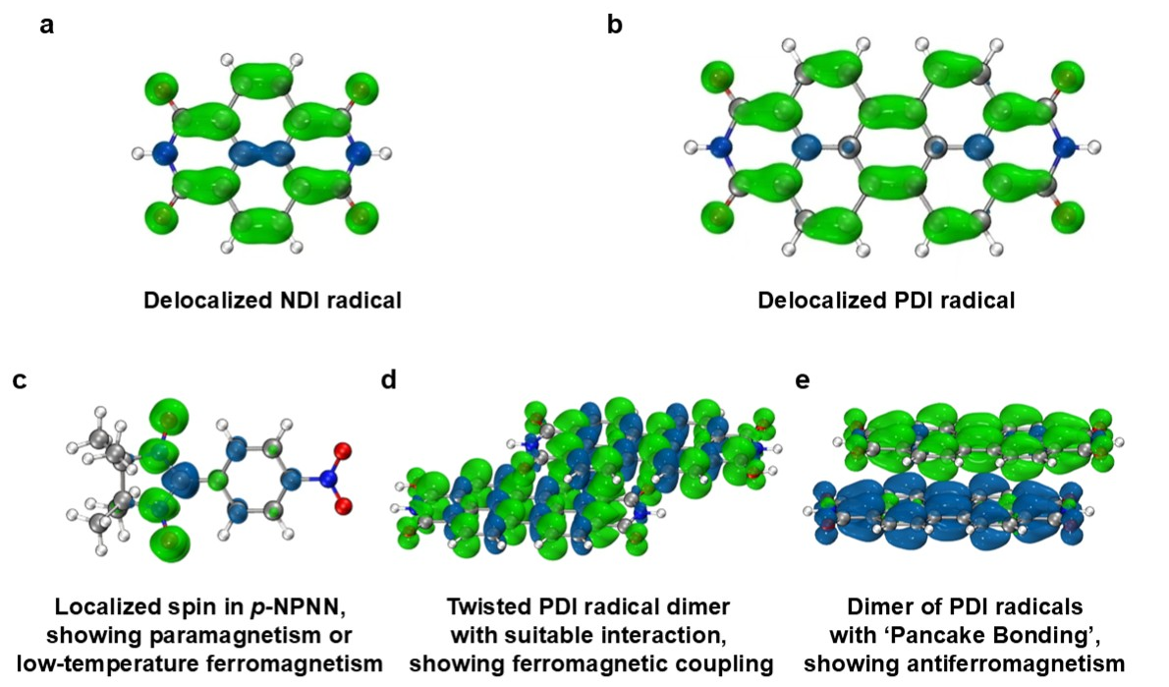
Supplementary Fig. 15 Guidance for the development of new room temperature organic magnetic materials. A Spin density distribution of NDI radical. b Spin density distribution of PDI radical. c Spin density distribution of p-NPNN. d Dimer of PDI radicals with ‘Pancake Bonding’ configuration. e Dimer of PDI radicals with ferromagnetic coupling.

Supplementary Table 1. Orientation degree and Herman’s parameter of crystal plane (12$\overline{\text{2}}$) in raw films and topochemical-reduced films
 | Raw film | Topochemical-reduced film
FWHM | 58.0 | 89.9
Π (Orientation degree) | 67.8% | 50.0%
f (Herman’s parameter) | -0.276 | -0.162

Two approaches⁵ were employed to describe the crystal orientation: the degree of orientation (Π) and Herman’s orientation parameter (f)
$$Π=\frac{180-FWHM}{180}*100\%$$
$$〈\cos^{2}θ〉=\frac{\sum_{0}^{π/2}{I\left(θ\right)sinθ}\cos^{2}θ}{\sum_{0}^{π/2}{I\left(θ\right)sinθ}}$$
$$f=\frac{3〈\cos^{2}θ〉-1}{2}$$

θ is the azimuthal angle and I(θ)is the intensity along the Debye-Scherrer ring.
The degree of orientation (Π) formula estimates the orientation by the full width at half-maximum (FWHM) measurements of the peaks in a plot of intensity versus azimuthal angle at the relevant value of 2θ. The value of f ranges between -0.5 and 1 for perfect orientation perpendicular to and parallel to the fiber direction, respectively. Random orientation yields a value of f of 0.
After topochemical reduction the orientation of plane (12$\overline{\text{2}}$) in the films decreased.

Supplementary Table 2. Metal impurities analysis by ICP-MS for sublimated neutral PDI powders.
Element | Content (ppm)
Fe | 11.5
Co | None
Ni | 1.12
Mn | 0.408

Supplementary Table 3. Metal impurities analysis by ICP-MS for topochemical-reduced PDI films.
Element | Content (ppm)
Fe | <15
Co | None
Ni | None
Mn | None

Metal impurities in PDI raw materials can only provide an M_{s} of 2.6×10⁻³ emu/g, and 3.3×10⁻³ emu/g in reduced PDI films, ruling out the interference of impurities on the results.

Supplementary Table 4. The M_{s} and T_{c} in purely organic magnets.
Material | M_{s} (emu/g) | T_{c} (K) | Ref.
π-conjugated polymer | 0.002 | 10 | 6
S-N radical | 0.03 | 36 | 7
TDAE-C₆₀ | 0.84 | 17.5 | 8
p-NPNN | 10.1 | 0.6 | 9
Pyrene-F4TCNQ | 0.0016 | 305 | 10
p-TCNQ | 0.0025 | 495 | 11
Coronene-TCNQ | 0.0037 | >300 | 3
Hydrogenated C₆₀ film | 0.17 | >300 | 12
Porous Organic  Radical Frameworks | 0.4 | 465 | 13
NDI radical aggregates | 1.1 | >300 | 14
PDI radical aggregates | 1.2 | >400 | 4
PDI radical film | 10.5 | >300 | This work

Metal impurities in reduced NDI films can only provide an M_{s} of 6.6×10⁻³ emu/g, ruling out the interference of impurities on the results.

Supplementary Table 5. Metal impurities analysis by ICP-MS for reduced NDI films.
Element | Content (ppm)
Fe | <30
Co | None
Ni | None
Mn | None

Supplementary references

1. Tamura, M. et al. Bulk ferromagnetism in the β-phase crystal of the p-nitrophenyl nitronyl nitroxide radical. Chem. Phys. Lett. 186, 401-404 (1991).
2. Robertson, C. M. et al. Enhanced Conductivity and Magnetic Ordering in Isostructural Heavy Atom Radicals. J. Am. Chem. Soc. 130, 8414-8425 (2008).
3. Wei, M. et al. Organic Multiferroic Magnetoelastic Complexes. Adv. Mater. 32, 2003293 (2020).
4. Jiang, Q. et al. Room-Temperature Ferromagnetism in Perylene Diimide Organic Semiconductor. Adv. Mater. 34, 2108103 (2022).
5. Peng, J., Ellingham, T., Sabo, R., Turng, L.-S. & Clemons, C. M. Short cellulose nanofibrils as reinforcement in polyvinyl alcohol fiber. Cellulose 21, 4287-4298 (2014).
6. Rajca, A., Wongsriratanakul, J. & Rajca, S. Magnetic Ordering in an Organic Polymer. Science 294, 1503-1505 (2001).
7. Banister, A. J. et al. Spontaneous Magnetization in a Sulfur–Nitrogen Radical at 36 K. Angew. Chem. Int. Ed. Engl. 35, 2533-2535 (1996).
8. Tanaka, K. et al. Magnetic properties of TDAE-C₆₀ and TDAE-C₇₀, where TDAE is tetrakis(dimethylamino)ethylene. Phys. Rev. B 47, 7554-7559 (1993).
9. Nakazawa, Y. et al. Low-temperature magnetic properties of the ferromagnetic organic radical, p-nitrophenyl nitronyl nitroxide. Phys. Rev. B 46, 8906-8914 (1992).
10. Yang, Y., Wei, M. & Qin, W. Polarized spin-photon coupling in organic ferromagnetic magneto-optic crystals. Appl. Mater. Today 25, 101229 (2021).
11. Mahmood, J. et al. Organic Ferromagnetism: Trapping Spins in the Glassy State of an Organic Network Structure. Chem 4, 2357-2369 (2018).
12. Makarova, T. L. et al. Laser controlled magnetism in hydrogenated fullerene films. J. Appl. Phys. 109, 083941 (2011).
13. Phan, H. et al. Room-Temperature Magnets Based on 1,3,5-Triazine-Linked Porous Organic Radical Frameworks. Chem 5, 1223-1234 (2019).
14. He, X. et al. Magnetic Properties of Self-Assemble Naphthalene Diimide Radical Aggregates. Small 20, 2311766 (2024).

