Supplementary Information
Host-guest interactions of chiral Schiff-base macrocyclic Zn(II) complexes with α-amino acids
Chao Huang, Xiao-Mao Tian, Li-Xia Chen*, Bi-Xue Zhu*
Key Laboratory of Macrocyclic and Supramolecular Chemistry of Guizhou Province, Guizhou University, Guiyang 550025, China
*E-mail: chenlx4780@163.com (L.-X. Chen), bxzhu@gzu.edu.cn (B.-X. Zhu)

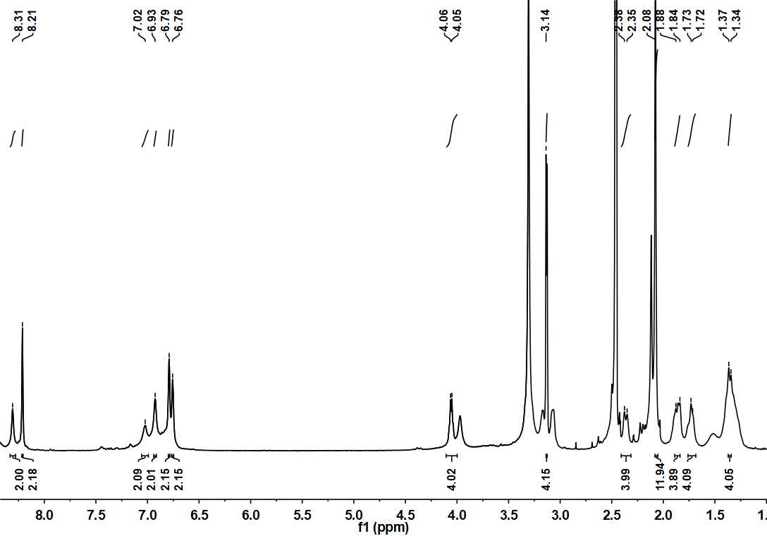
Fig. S1 ¹H NMR for M_{R,R}.

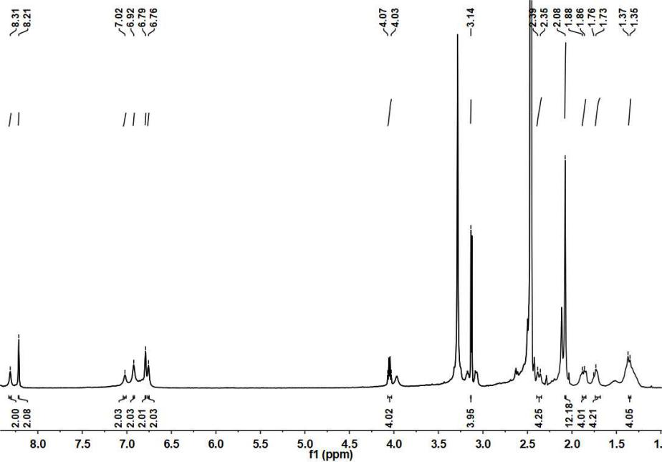

Fig. S2 ¹H NMR for M_{S,S}.

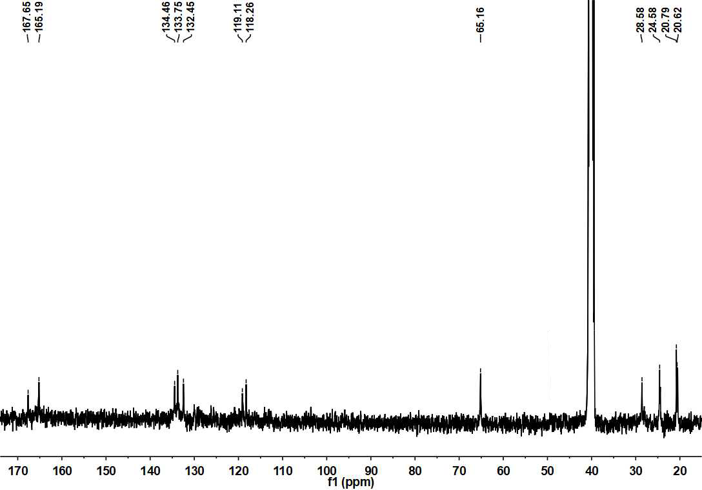
Fig. S3 ¹³C NMR for M_{R,R}.

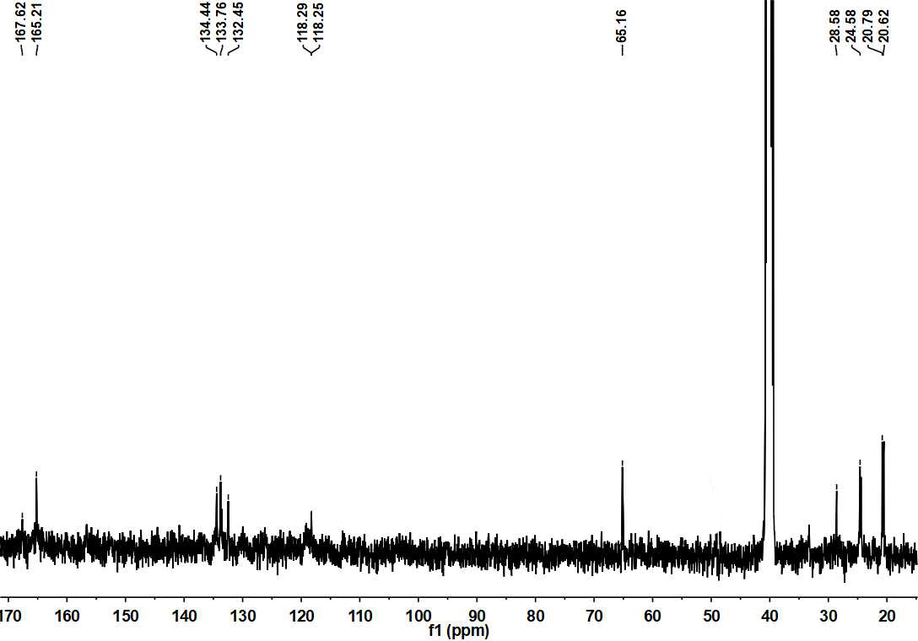
Fig. S4 ¹³C NMR for M_{S,S}.

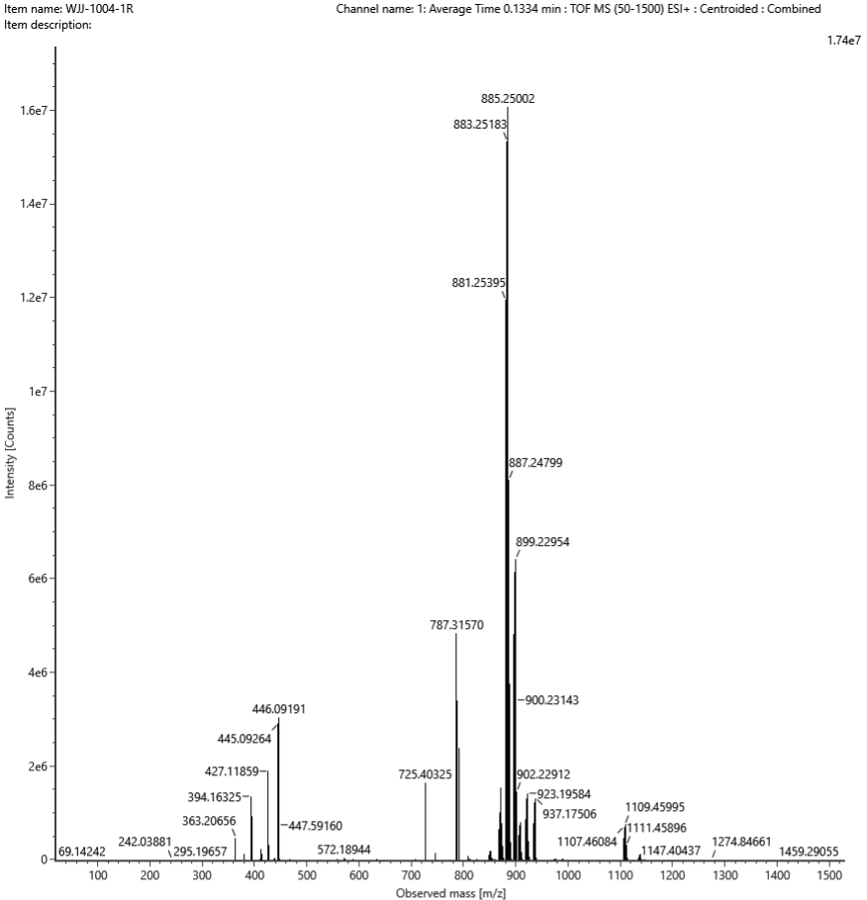
Fig. S5 ESI-MS for M_{R,R}.
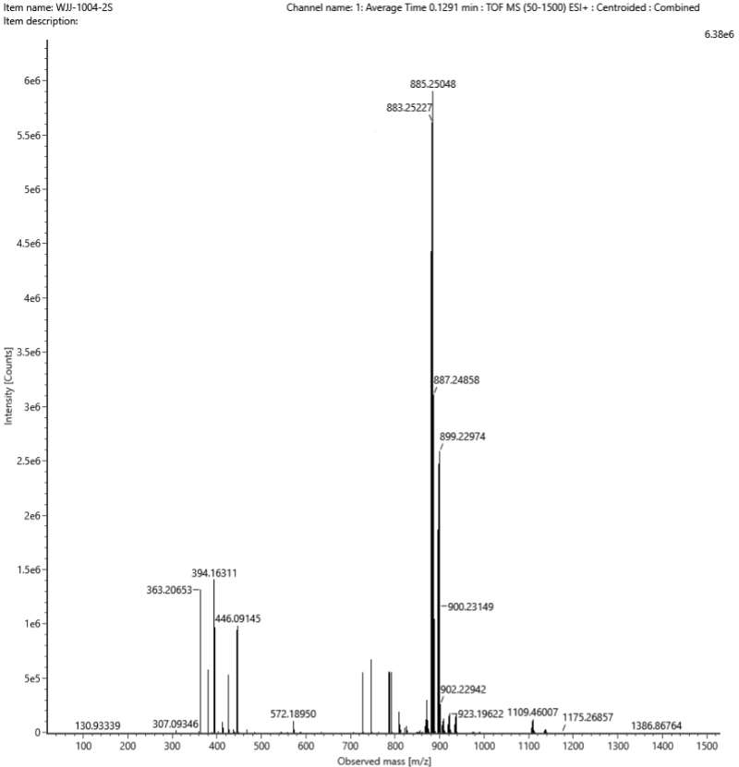
Fig. S6 ESI-MS for M_{S,S}.
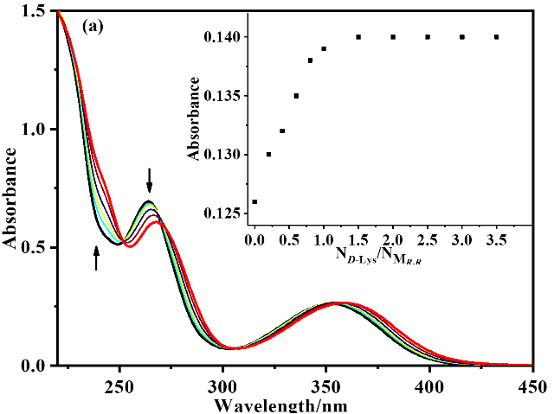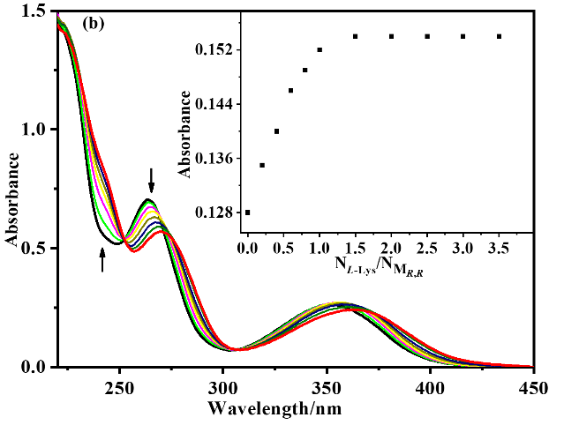
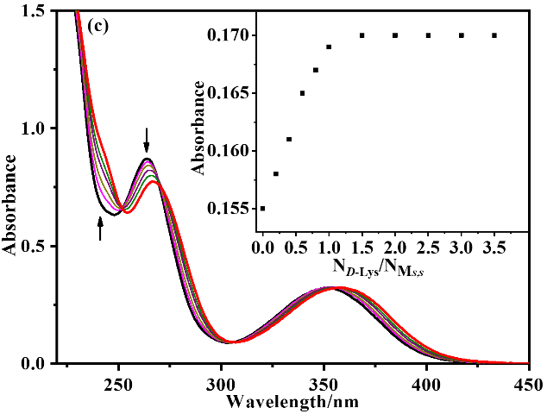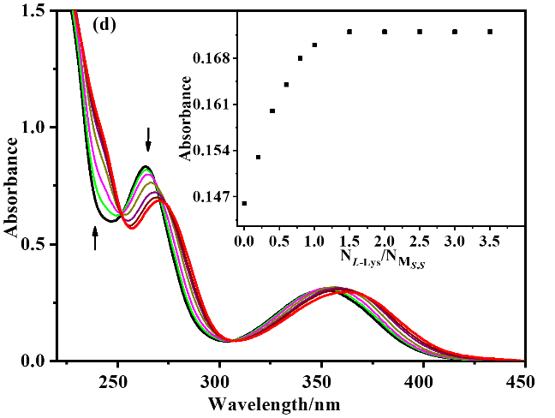
Fig. S7 UV-Vis spectral changes of M_{R,R} upon addition of D-Lys (a) and L-Lys (b). UV-Vis spectral changes of M_{S,S} upon addition of D-Lys (c) and L-Lys (d).

Fig. S8 Job’s plots of M_{R,R} with D-Arg (a) and L-Arg (b). Job’s plots of M_{S,S} with D-Arg (c) or L-Arg (d).
Fig. S9 Job’s plots of M_{R,R} with D-Lys (a) or L-Lys (b); Job’s plots of M_{S,S} with D-Lys (c) or L-Lys (d).
Fig. S10 Job’s plots of M_{R,R} with D-Glu (a) or L-Glu (b); Job’s plots of M_{S,S} with D-Glu (c) or L-Glu (d).
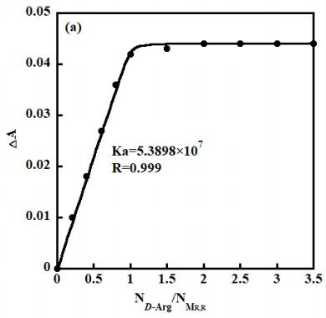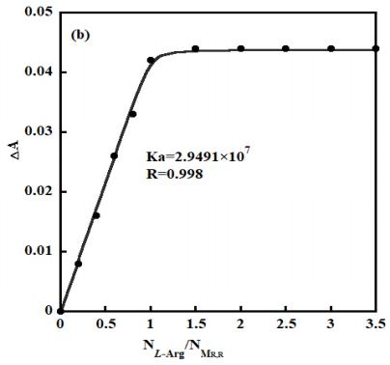
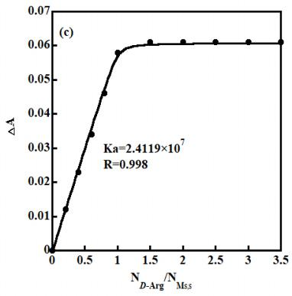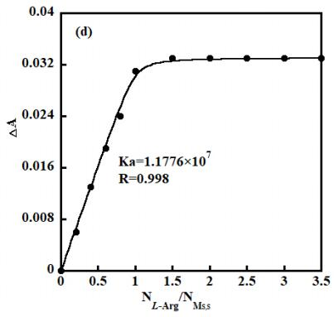
Fig. S11 The binding constants of M_{R,R} with D-Arg (a) or L-Arg (b) calculated from the nonlinear curve fitting. The binding constants of M_{S,S} with D-Arg (c) or L-Arg (d) calculated from the nonlinear curve fitting. λ= 364 nm
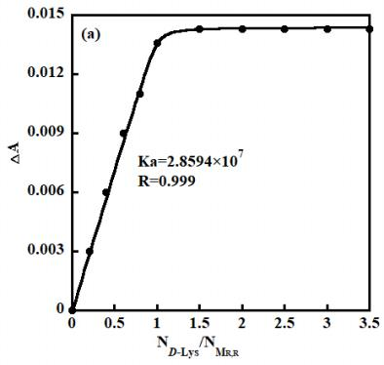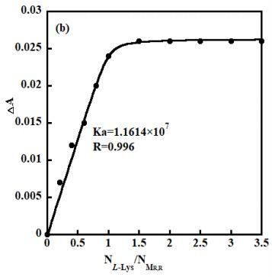
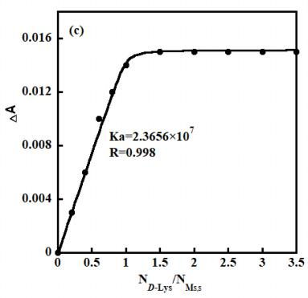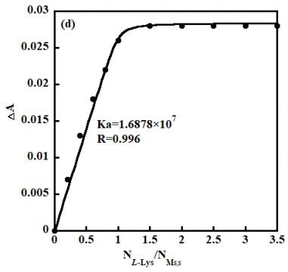
Fig. S12 The binding constants of M_{R,R} with D-Lys (a) or L-Lys (b) calculated from the nonlinear curve fitting. The binding constants of M_{S,S} with D-Lys (c) or L-Lys (d) calculated from the nonlinear curve fitting. λ= 380 nm

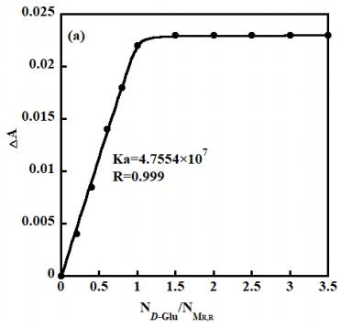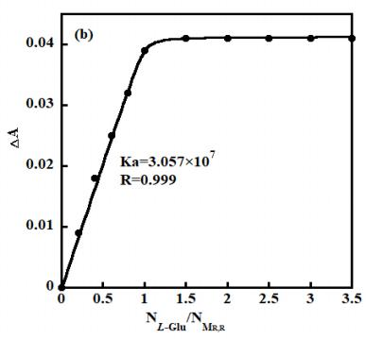
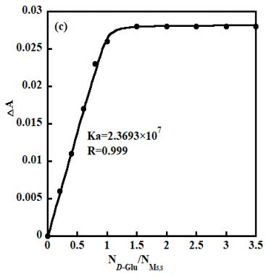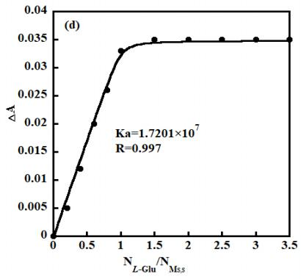
Fig. S13 The binding constants of M_{R,R} with D-Glu (a) or L-Glu (b) calculated from the nonlinear curve fitting. The binding constants of M_{S,S} with D-Glu (c) or L-Glu (d) calculated from the nonlinear curve fitting. λ = 285 nm.

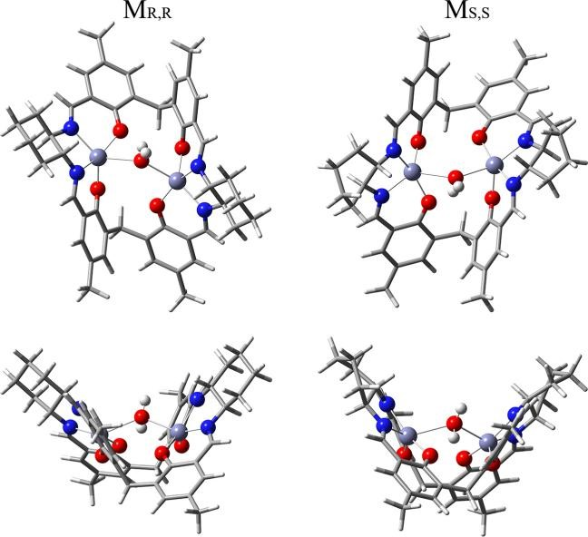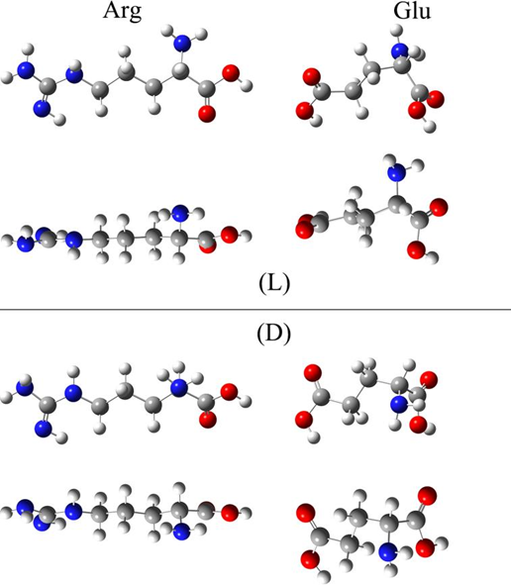
M_{S,S}
D-Arg
L-Arg
D-Glu
L-Glu
Fig. S14 Lowest-energy configurations of M_{S,S}, D-/L-Arg, and D-/L-Glu.
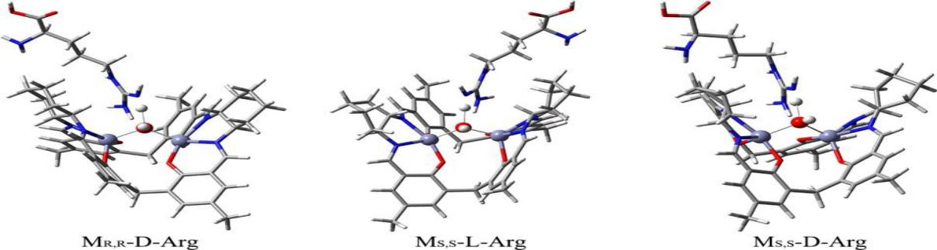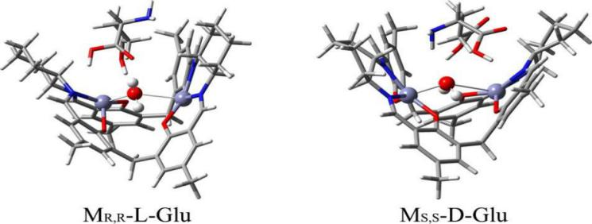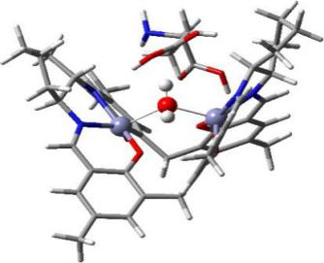
M_{S,S}-L-Arg
M_{S,S}-D-Arg
M_{S,S}-L-Glu
M_{S,S}-D-Glu
Fig. S15 Optimized structures of M_{S,S} with D-/L-Arg and D-/L-Glu.
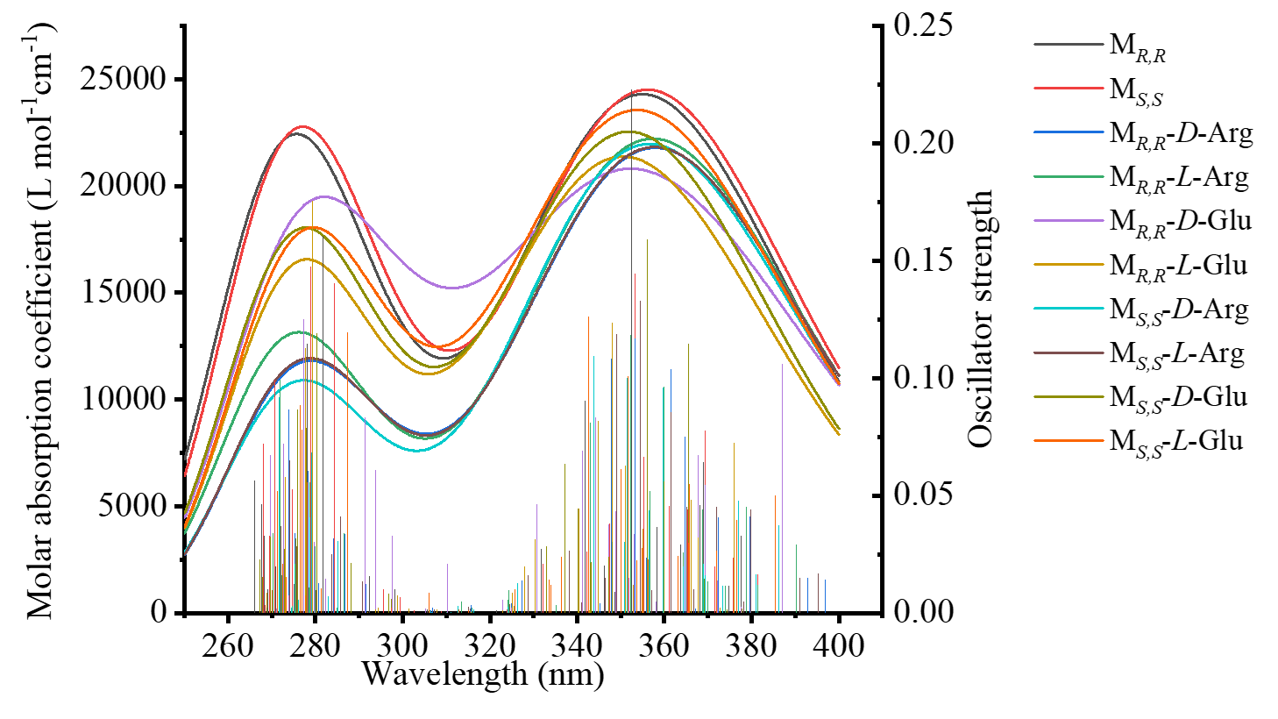
Fig. S16 The corresponding UV-Vis spectra calculated by TD-DFT.
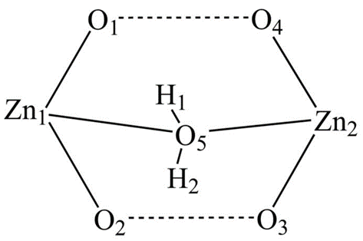
Fig. S17 Schematic diagram of the macrocycle structure.

Table S1 Crystal data and structure refinements of complex M_{R,R}.
Complex | M_{R,R}
CCDC | 2191564
Empirical formula | C₄₆H₄₈N₄O₅Zn₂
Formula weight | 867.62
Crystal system | triclinic
Space group | P1
a / (Å) | 12.114(4)
b / (Å) | 14.667(5)
c / (Å) | 16.255(5)
α / (°) | 63.933(8)
β / (°) | 68.135(9)
γ / (°) | 89.986(9)
V / (Å³) | 2361.1(13)
Z | 2
D_{c} / (g·cm⁻³) | 1.220
θ range / (°) | 2.65~24.50
Absorption coefficient/ mm⁻¹ | 1.061
F (000) | 904
Reflections collected | 43811
Independent reflections | 14682
Observed reflections (I >2σ(I)) | 5704
Number of parameters | 1035
Goodness-of-fit on F ² | 0.864
Final R indices(I >2σ(I)) | R₁ = 0.0858, wR₂ = 0.1857
R indices (all data) | R₁ = 0.2163, wR₂ = 0.2306
Largest diff. Peak and hole (eÅ⁻³) | 0.531 and -0.497

Table S2 Maximum absorption peaks of host-guest adducts.
 | λ_{max} (nm) | +L-Arg (nm) | +D-Arg (nm) | +L-Glu (nm) | +D-Glu (nm)
M_{R,R} | 275.7 | 276.3 | 279.0 | 278.0 | 282.0
M_{R,R} | 354.9 | 357.4 | 357.9 | 350.5 | 352.3
M_{S,S} | 277.1 | 278.8 | 277.3 | 279.5 | 277.7
M_{S,S} | 356.1 | 357.7 | 356.5 | 353.7 | 351.8

Table S3 Mulliken charges of partial atoms in M_{R,R} and M_{S,S}.
 | Zn1 | Zn2 | O1 | O2 | O3 | O4 | O5 | H1 | H2
M_{R,R} | 1.01 | 1.01 | -0.73 | -0.70 | -0.68 | -0.68 | -0.84 | 0.51 | 0.44
M_{S,S} | 1.01 | 1.00 | -0.68 | -0.68 | -0.70 | -0.73 | -0.84 | 0.51 | 0.44

