Supplementary Material

Supplementary Tables
Table S1. Identification of known miRNAs.
miRNA id | nt | CK count | IBA300 count | Mature sequences
miR156c_1 | 19 | 44 | 22 | TGACAGAAGAGAGGGAGCA
miR156f | 22 | 111 | 91 | TTGACAGAAGAGAGAGAGCACA
miR159a- 5p | 20 | 345 | 82 | TTTGGATTGAAGGGAGCTCTA
miR159a_1 | 20 | 168003 | 203532 | AGCTGCTGAGCTATGGATCCC
miR160 | 21 | 28022 | 136 | TGGCATACAGGGAGCCAGGCA
miR160a3p_2 | 21 | 516 | 448 | GCGTATGAGGAGCCATGCATA
miR160a-5p | 20 | 12889 | 2661 | TGCCTGGCTCCCTGTATGCCA
miR160a5p_1 | 20 | 138 | 7 | GCCTGGCTCCCTGTATGCCAT
miR160b_1 | 19 | 1407 | 1199 | TGCCTGGCTCCCTGTATGCC
miR160h | 22 | 5 | 4 | TGCCTGGCTCCCTGTATGCCATT
miR162a-5p | 22 | 118 | 110 | TGGAGGCAGCGGTTCATCGATC
miR162a5p_1 | 21 | 97 | 31 | GGAGGCAGCGGTTCATCGATC
miR166 | 22 | 1527 | 928 | TCGGACCAGGCTTCATTCCCCC
miR166a-3p | 21 | 331208 | 319279 | TCGGACCAGGCTTCATTCCCC
miR166a5p_1 | 21 | 184 | 229 | GGAATGTTGTCTGGTTCAAGG
miR166d5p_2 | 21 | 7321 | 3740 | GGAATGTTGTCTGGCTCGAGG
miR166e | 19 | 2618 | 1114 | GGACCAGGCTTCATTCCCC
miR166e-3p | 21 | 2374 | 3616 | CTCGGACCAGGCTTCATTCCC
miR166h-3p | 20 | 3019 | 4114 | TCGGACCAGGCTTCATTCCC
miR166m_2 | 20 | 2751 | 6874 | CGGACCAGGCTTCATTCCCC
miR167a_2 | 22 | 12597 | 23314 | TGAAGCTGCCAGCATGATCTGA
miR167d-5p | 20 | 5834 | 11457 | TGAAGCTGCCAGCATGATCT
miR167d_1 | 21 | 7940 | 10458 | TGAAGCTGCCAGCATGATCTG
miR171a-3p | 21 | 5871 | 11564 | TGATTGAGCCGCGCCAATATC
miR171a3p_1 | 20 | 29 | 39 | TGATTGAGCCGCGCCAATAT
miR171d_1 | 20 | 2817 | 891 | TTGAGCCGCGCCAATATCAC
miR171f_3 | 21 | 2339 | 1622 | TTGAGCCGCGCCAATATCACT
miR172a_2 | 20 | 20 | 47 | AGAATCTTGATGATGCTGCA
miR172a_3 | 21 | 28 | 30 | AGAATCTTGATGATGCTGCAT
miR172b5p_2 | 20 | 6 | 12 | GTAGCATCATCAAGATTCAC
miR172c-3p | 19 | 3 | 5 | AGAATCTTGATGATGCTGC
miR172c-5p | 21 | 45 | 67 | GTAGCATCATCAAGATTCACA
miR172e3p_1 | 20 | 22 | 59 | GAATCTTGATGATGCTGCAT
miR390a-5p | 22 | 8733 | 5935 | AAGCTCAGGAGGGATAGCGCC
miR390e | 21 | 416 | 712 | AGCTCAGGAGGGATAGCGCC
miR396-3p_1 | 22 | 1 | 1 | AAGCTCAAGAAAGCTGTGGGA
miR396a3p_1 | 20 | 2738 | 1130 | CACAGCTTTCTTGAACTTTCT
miR396a3p_4 | 21 | 2173 | 1696 | GTTCAATAAAGCTGTGGGAAG
miR396a_1 | 20 | 5 | 3 | GTTCAATAAAGCTGTGGGAA
miR396b | 19 | 11423 | 6604 | TTCCACAGCTTTCTTGAACT
miRNA id | nt | CK count | IBA300 count | Mature sequences
miR396b3p_2 | 21 | 474 | 336 | GCTCAAGAAAGCTGTGGGAGA
miR396b-5p | 19 | 10020 | 15876 | TTCCACAGCTTTCTTGAACTT
miR396e3p_3 | 20 | 264 | 323 | CTCAAGAAAGCTGTGGGAGA
miR482d3p_2 | 22 | 9610 | 18291 | TCCCTACTCCACCCATGCCATA
miR5021 | 20 | 0 | 1 | TGAGAAGAAGAAGAAGAAAA
miR5532 | 21 | 0 | 1 | ATGGAATATATGACAAAGGTGG
miR8175 | 20 | 415 | 438 | GATCCCCGGCAACGGCGCCA
miR827_2 | 20 | 94 | 15 | TTAGATGACCATCAACGAACA

Table S2. Number of miRNA-mRNA pairs identified by the degradome libraries
SmallRNA | SmallRNA_seq | Transcript
miR172a_2 | AGAATCTTGATGATGCTGCA | Unigene10671_All
miR160a_5p | TGCCTGGCTCCCTGTATGCCA | CL3897.Contig1_All
miR5021 | TGAGAAGAAGAAGAAGAAAA | CL11694.Contig1_All
miR172c_3p | AGAATCTTGATGATGCTGC | CL321.Contig8_All
miR172a_3 | AGAATCTTGATGATGCTGCAT | Unigene8113_All
miR160h | TGCCTGGCTCCCTGTATGCCATT | CL3897.Contig1_All
miR171d_1 | TTGAGCCGCGCCAATATCAC | Unigene23148_All
miR5021 | TGAGAAGAAGAAGAAGAAAA | Unigene15695_All
miR5021 | TGAGAAGAAGAAGAAGAAAA | CL10877.Contig2_All
miR172a_2 | AGAATCTTGATGATGCTGCA | CL321.Contig7_All
miR172a_2 | AGAATCTTGATGATGCTGCA | Unigene8113_All
miR396b | TTCCACAGCTTTCTTGAACT | Unigene25911_All
novel_mir41 | AGATGGTTCGATTAGTCTTTCGCC | CL7474.Contig1_All
miR171f_3 | TTGAGCCGCGCCAATATCACT | CL2444.Contig4_All
miR172a_2 | AGAATCTTGATGATGCTGCA | CL321.Contig9_All
miR166h_3p | TCGGACCAGGCTTCATTCCC | CL5602.Contig1_All
miR166a_3p | TCGGACCAGGCTTCATTCCCC | CL5602.Contig1_All
miR172a_2 | AGAATCTTGATGATGCTGCA | CL321.Contig8_All
miR171d_1 | TTGAGCCGCGCCAATATCAC | CL2444.Contig4_All
miR160a_5p | TGCCTGGCTCCCTGTATGCCA | Unigene5190_All
miR172c_3p | AGAATCTTGATGATGCTGC | Unigene8113_All
miR160h | TGCCTGGCTCCCTGTATGCCATT | Unigene5190_All
miR160b_1 | TGCCTGGCTCCCTGTATGCC | Unigene5190_All
miR171f_3 | TTGAGCCGCGCCAATATCACT | Unigene23148_All
miR172c_3p | AGAATCTTGATGATGCTGC | CL321.Contig9_All
miR172a_3 | AGAATCTTGATGATGCTGCAT | Unigene10671_All
miR160b_1 | TGCCTGGCTCCCTGTATGCC | CL3897.Contig1_All
miR171a_3p_1 | TGATTGAGCCGCGCCAATAT | Unigene10315_All
miR172a_3 | AGAATCTTGATGATGCTGCAT | CL321.Contig9_All
miR172a_3 | AGAATCTTGATGATGCTGCAT | CL321.Contig8_All
miR172a_3 | AGAATCTTGATGATGCTGCAT | CL321.Contig7_All
miR166 | TCGGACCAGGCTTCATTCCCCC | CL5602.Contig1_All
miR172c_3p | AGAATCTTGATGATGCTGC | Unigene10671_All
miR171a_3p | TGATTGAGCCGCGCCAATATC | Unigene10315_All
miR172c_3p | AGAATCTTGATGATGCTGC | CL321.Contig7_All
miR156f | TTGACAGAAGAGAGAGAGCACA | CL2023.Contig4_All
miR156f | TTGACAGAAGAGAGAGAGCACA | CL2023.Contig5_All
miR156f | TTGACAGAAGAGAGAGAGCACA | CL2023.Contig2_All
miR156f | TTGACAGAAGAGAGAGAGCACA | CL2023.Contig1_All
miR156f | TTGACAGAAGAGAGAGAGCACA | CL2023.Contig3_All
miR171a_3p | TGATTGAGCCGCGCCAATATC | Unigene23148_All
miR171a_3p_1 | TGATTGAGCCGCGCCAATAT | Unigene23148_All
miR5021 | TGAGAAGAAGAAGAAGAAAA | CL14529.Contig1_All
miR5021 | TGAGAAGAAGAAGAAGAAAA | Unigene868_All
novel_mir21 | AATGGTTCACATTCTTCGTCCTAATATATT | Unigene18173_All
novel_mir21 | AATGGTTCACATTCTTCGTCCTAATATATT | CL9773.Contig2_All
miR172a_2 | AGAATCTTGATGATGCTGCA | CL4031.Contig4_All
miR172c_3p | AGAATCTTGATGATGCTGC | CL4031.Contig4_All
miR172c_3p | AGAATCTTGATGATGCTGC | CL4031.Contig3_All
SmallRNA | SmallRNA_seq | Transcript
miR172a_2 | AGAATCTTGATGATGCTGCA | CL4031.Contig3_All
miR396b_5p | TTCCACAGCTTTCTTGAACTT | Unigene16323_All
miR396b | TTCCACAGCTTTCTTGAACT | Unigene16323_All
miR390e | AGCTCAGGAGGGATAGCGCC | Unigene18779_All
miR171a_3p_1 | TGATTGAGCCGCGCCAATAT | CL2444.Contig4_All
miR171a_3p | TGATTGAGCCGCGCCAATATC | CL2444.Contig4_All
miR156c_1 | TGACAGAAGAGAGGGAGCA | Unigene23422_All
miR5021 | TGAGAAGAAGAAGAAGAAAA | CL8284.Contig1_All
miR5021 | TGAGAAGAAGAAGAAGAAAA | CL10745.Contig1_All
miR172c_5p | GTAGCATCATCAAGATTCACA | Unigene5271_All
miR5021 | TGAGAAGAAGAAGAAGAAAA | CL10745.Contig2_All
miR172b_5p_2 | GTAGCATCATCAAGATTCAC | Unigene5271_All
miR396b | TTCCACAGCTTTCTTGAACT | CL104.Contig3_All
novel_mir78 | GAAGAATGTGGACCACTAG | CL464.Contig2_All
miR172a_3 | AGAATCTTGATGATGCTGCAT | CL11586.Contig1_All
miR172c_3p | AGAATCTTGATGATGCTGC | CL11586.Contig3_All
miR172a_2 | AGAATCTTGATGATGCTGCA | CL11586.Contig3_All
miR172a_2 | AGAATCTTGATGATGCTGCA | CL11586.Contig1_All
miR172c_3p | AGAATCTTGATGATGCTGC | CL11586.Contig1_All
miR172a_3 | AGAATCTTGATGATGCTGCAT | CL11586.Contig3_All
novel_mir82 | TAGTGGTTCACATTTTTCGTCCTAATA | CL9773.Contig2_All
miR5021 | TGAGAAGAAGAAGAAGAAAA | CL913.Contig2_All
novel_mir23 | ATGTGGGATGTGGGATAAGGGATAAAAAGT | CL501.Contig1_All
novel_mir82 | TAGTGGTTCACATTTTTCGTCCTAATA | Unigene18173_All
novel_mir23 | ATGTGGGATGTGGGATAAGGGATAAAAAGT | CL501.Contig2_All
miR5021 | TGAGAAGAAGAAGAAGAAAA | CL913.Contig1_All
miR172b_5p_2 | GTAGCATCATCAAGATTCAC | Unigene10671_All
miR172c_5p | GTAGCATCATCAAGATTCACA | Unigene10671_All
miR396b | TTCCACAGCTTTCTTGAACT | Unigene51067_All
miR5021 | TGAGAAGAAGAAGAAGAAAA | Unigene3346_All
miR396a_1 | CACAGCTTTCTTGAACTTTCT | Unigene170_All
miR5021 | TGAGAAGAAGAAGAAGAAAA | Unigene13254_All
miR390a_5p | AAGCTCAGGAGGGATAGCGCC | Unigene13128_All
novel_mir45 | TGGACCACTAGATTTACATACTTTGACTCA | Unigene53632_All
miR172e_3p_1 | GAATCTTGATGATGCTGCAT | CL321.Contig7_All
miR172e_3p_1 | GAATCTTGATGATGCTGCAT | CL321.Contig8_All
miR172e_3p_1 | GAATCTTGATGATGCTGCAT | CL321.Contig9_All
miR5021 | TGAGAAGAAGAAGAAGAAAA | Unigene8209_All
novel_mir9 | TCCACATTCTTCGTCATAATATATCTT | Unigene35117_All
miR5021 | TGAGAAGAAGAAGAAGAAAA | CL11071.Contig1_All
miR172e_3p_1 | GAATCTTGATGATGCTGCAT | Unigene8113_All
miR5021 | TGAGAAGAAGAAGAAGAAAA | CL11682.Contig2_All
miR5021 | TGAGAAGAAGAAGAAGAAAA | Unigene809_All
miR396a_1 | CACAGCTTTCTTGAACTTTCT | Unigene3038_All
novel_mir78 | GAAGAATGTGGACCACTAG | CL2847.Contig2_All
novel_mir78 | GAAGAATGTGGACCACTAG | CL3860.Contig2_All
novel_mir78 | GAAGAATGTGGACCACTAG | Unigene53632_All
miR166e_3p | CTCGGACCAGGCTTCATTCCC | CL5602.Contig1_All
novel_mir20 | CGGTAAGGACCACCATGAAATCATATCGA | CL32.Contig12_All
miR396b | TTCCACAGCTTTCTTGAACT | Unigene23737_All
SmallRNA | SmallRNA_seq | Transcript
miR5021 | TGAGAAGAAGAAGAAGAAAA | CL12966.Contig1_All
miR5021 | TGAGAAGAAGAAGAAGAAAA | CL3248.Contig5_All
novel_mir39 | GATCTGGAAGAGAGTCGACCGTTGGAGAAG | Unigene15343_All
novel_mir68 | CCACATTGTTCGTCCTGATATATTTTATA | Unigene18173_All
novel_mir68 | CCACATTGTTCGTCCTGATATATTTTATA | CL9773.Contig2_All
miR156f | TTGACAGAAGAGAGAGAGCACA | CL4258.Contig2_All
miR5021 | TGAGAAGAAGAAGAAGAAAA | CL11576.Contig2_All
miR156f | TTGACAGAAGAGAGAGAGCACA | CL4258.Contig1_All
miR156f | TTGACAGAAGAGAGAGAGCACA | CL4258.Contig3_All
miR396b_5p | TTCCACAGCTTTCTTGAACTT | Unigene11965_All
miR396b_5p | TTCCACAGCTTTCTTGAACTT | Unigene8418_All
novel_mir45 | TGGACCACTAGATTTACATACTTTGACTCA | Unigene20588_All
miR396b_5p | TTCCACAGCTTTCTTGAACTT | CL13632.Contig1_All
miR396b | TTCCACAGCTTTCTTGAACT | Unigene8418_All
novel_mir39 | GATCTGGAAGAGAGTCGACCGTTGGAGAAG | Unigene15344_All
novel_mir46 | AATTCTATCGGGATATTGAATGTGA | CL2566.Contig3_All
miR396b | TTCCACAGCTTTCTTGAACT | Unigene11965_All
miR172c_3p | AGAATCTTGATGATGCTGC | Unigene3299_All
miR5021 | TGAGAAGAAGAAGAAGAAAA | CL6955.Contig2_All
miR396b | TTCCACAGCTTTCTTGAACT | CL13632.Contig1_All
miR156c_1 | TGACAGAAGAGAGGGAGCA | CL12778.Contig2_All
miR5021 | TGAGAAGAAGAAGAAGAAAA | Unigene35466_All
miR5021 | TGAGAAGAAGAAGAAGAAAA | Unigene13046_All
novel_mir78 | GAAGAATGTGGACCACTAG | CL14128.Contig3_All
miR5021 | TGAGAAGAAGAAGAAGAAAA | CL11682.Contig2_All
miR396b | TTCCACAGCTTTCTTGAACT | Unigene20721_All
novel_mir78 | GAAGAATGTGGACCACTAG | CL14128.Contig4_All
miR5021 | TGAGAAGAAGAAGAAGAAAA | Unigene7463_All
miR5021 | TGAGAAGAAGAAGAAGAAAA | Unigene20660_All
novel_mir83 | TGTCACAAAGTTTGCCAATA | CL12673.Contig1_All
miR5021 | TGAGAAGAAGAAGAAGAAAA | Unigene8237_All
miR172c_3p | AGAATCTTGATGATGCTGC | Unigene5441_All
novel_mir78 | GAAGAATGTGGACCACTAG | CL14128.Contig2_All
miR5021 | TGAGAAGAAGAAGAAGAAAA | Unigene10493_All
miR396b | TTCCACAGCTTTCTTGAACT | CL13612.Contig2_All
novel_mir80 | AAAATATATCAGGACGAAGAATGT | CL2847.Contig2_All
miR172c_3p | AGAATCTTGATGATGCTGC | CL1676.Contig3_All
miR172a_2 | AGAATCTTGATGATGCTGCA | CL1676.Contig3_All
miR172e_3p_1 | GAATCTTGATGATGCTGCAT | CL930.Contig2_All
miR5021 | TGAGAAGAAGAAGAAGAAAA | CL4763.Contig1_All
miR5021 | TGAGAAGAAGAAGAAGAAAA | CL11576.Contig3_All
miR5021 | TGAGAAGAAGAAGAAGAAAA | Unigene58291_All
novel_mir83 | TGTCACAAAGTTTGCCAATA | CL1072.Contig8_All
miR156c_1 | TGACAGAAGAGAGGGAGCA | CL219.Contig1_All
miR396b_5p | TTCCACAGCTTTCTTGAACTT | Unigene11378_All
miR396b | TTCCACAGCTTTCTTGAACT | Unigene11378_All
miR160a_5p_1 | GCCTGGCTCCCTGTATGCCAT | CL3897.Contig1_All
miR167d_1 | TGAAGCTGCCAGCATGATCT | Unigene23399_All
miR396b_5p | TTCCACAGCTTTCTTGAACTT | Unigene25263_All
miR396b | TTCCACAGCTTTCTTGAACT | Unigene25263_All
SmallRNA | SmallRNA_seq | Transcript
miR172a_2 | AGAATCTTGATGATGCTGCA | CL1676.Contig2_All
miR172c_3p | AGAATCTTGATGATGCTGC | CL1676.Contig1_All
miR172c_3p | AGAATCTTGATGATGCTGC | CL1676.Contig2_All
miR172a_2 | AGAATCTTGATGATGCTGCA | CL1676.Contig1_All
miR166e | GGACCAGGCTTCATTCCCC | CL8627.Contig2_All
miR5021 | TGAGAAGAAGAAGAAGAAAA | Unigene25143_All
miR5021 | TGAGAAGAAGAAGAAGAAAA | CL12892.Contig1_All
miR396b_3p_2 | GCTCAAGAAAGCTGTGGGAGA | CL4192.Contig3_All
miR156c_1 | TGACAGAAGAGAGGGAGCA | CL11698.Contig2_All
miR172c_3p | AGAATCTTGATGATGCTGC | Unigene33332_All
miR172c_3p | AGAATCTTGATGATGCTGC | CL8944.Contig2_All
novel_mir81 | CACTCGTTTTACATACTTTGACTC | CL9773.Contig2_All
miR5021 | TGAGAAGAAGAAGAAGAAAA | Unigene18296_All
miR156f | TTGACAGAAGAGAGAGAGCACA | CL219.Contig1_All
miR172b_5p_2 | GTAGCATCATCAAGATTCAC | Unigene47979_All
miR172c_5p | GTAGCATCATCAAGATTCACA | Unigene47979_All
novel_mir47 | CCTGAAGTCATTGTAGTAT | CL2930.Contig1_All
novel_mir26 | CATTTCGTTGTGAGAAAGGT | Unigene41272_All
miR5021 | TGAGAAGAAGAAGAAGAAAA | CL5225.Contig1_All
miR5021 | TGAGAAGAAGAAGAAGAAAA | Unigene5455_All
novel_mir26 | CATTTCGTTGTGAGAAAGGT | CL13384.Contig1_All
miR166h_3p | TCGGACCAGGCTTCATTCCC | CL5710.Contig1_All
novel_mir77 | GTCCTAACTTTGTTATATCAGTTCCTTGAA | Unigene473_All
novel_mir69 | AACTTCTCCATAATCTATGGTCCACATTCT | Unigene81133_All
miR166h_3p | TCGGACCAGGCTTCATTCCC | CL5710.Contig2_All
miR5021 | TGAGAAGAAGAAGAAGAAAA | Unigene9862_All
miR5021 | TGAGAAGAAGAAGAAGAAAA | CL3119.Contig2_All
miR5021 | TGAGAAGAAGAAGAAGAAAA | Unigene21193_All
miR156f | TTGACAGAAGAGAGAGAGCACA | Unigene2962_All
novel_mir47 | CCTGAAGTCATTGTAGTAT | CL2930.Contig2_All
novel_mir87 | GGATATTGAATGTGAACCACTCATTTATA | CL2566.Contig3_All
novel_mir3 | ACGAAAAATGTGGACCACTAGATTTACAT | Unigene20588_All
miR396b | TTCCACAGCTTTCTTGAACT | Unigene37961_All
miR396b_5p | TTCCACAGCTTTCTTGAACTT | Unigene37961_All
miR5021 | TGAGAAGAAGAAGAAGAAAA | CL9139.Contig2_All
novel_mir27 | TTTGGGCCCAATTGAATGAAATGTT | CL7116.Contig2_All
miR172e_3p_1 | GAATCTTGATGATGCTGCAT | CL11586.Contig3_All
miR5021 | TGAGAAGAAGAAGAAGAAAA | CL840.Contig2_All
novel_mir80 | AAAATATATCAGGACGAAGAATGT | Unigene85839_All
novel_mir27 | TTTGGGCCCAATTGAATGAAATGTT | CL7116.Contig1_All
novel_mir80 | AAAATATATCAGGACGAAGAATGT | CL6435.Contig1_All
miR5021 | TGAGAAGAAGAAGAAGAAAA | CL840.Contig3_All
miR5021 | TGAGAAGAAGAAGAAGAAAA | Unigene23120_All
miR5021 | TGAGAAGAAGAAGAAGAAAA | CL840.Contig1_All
miR5021 | TGAGAAGAAGAAGAAGAAAA | CL840.Contig4_All
miR172e_3p_1 | GAATCTTGATGATGCTGCAT | CL11586.Contig1_All
novel_mir80 | AAAATATATCAGGACGAAGAATGT | CL9773.Contig2_All
novel_mir80 | AAAATATATCAGGACGAAGAATGT | Unigene35034_All
miR396e_3p_3 | CTCAAGAAAGCTGTGGGAGA | CL3152.Contig8_All
miR396e_3p_3 | CTCAAGAAAGCTGTGGGAGA | CL3152.Contig7_All
SmallRNA | SmallRNA_seq | Transcript
miR396e_3p_3 | CTCAAGAAAGCTGTGGGAGA | CL3152.Contig6_All
miR396e_3p_3 | CTCAAGAAAGCTGTGGGAGA | Unigene12687_All
miR396e_3p_3 | CTCAAGAAAGCTGTGGGAGA | Unigene12667_All
miR5021 | TGAGAAGAAGAAGAAGAAAA | Unigene49561_All
miR172c_5p | GTAGCATCATCAAGATTCACA | CL2759.Contig1_All
miR172b_5p_2 | GTAGCATCATCAAGATTCAC | CL2759.Contig1_All
miR172c_3p | AGAATCTTGATGATGCTGC | CL2295.Contig2_All
miR5021 | TGAGAAGAAGAAGAAGAAAA | CL7711.Contig1_All
miR5021 | TGAGAAGAAGAAGAAGAAAA | CL4978.Contig1_All
miR5021 | TGAGAAGAAGAAGAAGAAAA | CL3044.Contig3_All
miR5021 | TGAGAAGAAGAAGAAGAAAA | CL1476.Contig2_All
miR5021 | TGAGAAGAAGAAGAAGAAAA | CL13522.Contig5_All
novel_mir47 | CCTGAAGTCATTGTAGTAT | CL5972.Contig3_All
miR5021 | TGAGAAGAAGAAGAAGAAAA | CL5446.Contig2_All
miR5021 | TGAGAAGAAGAAGAAGAAAA | CL13522.Contig1_All
novel_mir47 | CCTGAAGTCATTGTAGTAT | CL5972.Contig1_All
miR5021 | TGAGAAGAAGAAGAAGAAAA | CL3044.Contig4_All
miR5021 | TGAGAAGAAGAAGAAGAAAA | CL1476.Contig3_All
miR5021 | TGAGAAGAAGAAGAAGAAAA | CL3044.Contig2_All
novel_mir80 | AAAATATATCAGGACGAAGAATGT | CL13238.Contig1_All
miR5021 | TGAGAAGAAGAAGAAGAAAA | CL3044.Contig6_All
novel_mir21 | AATGGTTCACATTCTTCGTCCTAATATATT | CL3974.Contig2_All
miR5021 | TGAGAAGAAGAAGAAGAAAA | CL1072.Contig13_All
novel_mir21 | AATGGTTCACATTCTTCGTCCTAATATATT | CL3974.Contig1_All
novel_mir3 | ACGAAAAATGTGGACCACTAGATTTACAT | Unigene43866_All
miR5021 | TGAGAAGAAGAAGAAGAAAA | CL394.Contig4_All
miR5021 | TGAGAAGAAGAAGAAGAAAA | CL394.Contig5_All
miR5021 | TGAGAAGAAGAAGAAGAAAA | CL394.Contig3_All
miR5021 | TGAGAAGAAGAAGAAGAAAA | Unigene34772_All
miR5021 | TGAGAAGAAGAAGAAGAAAA | CL464.Contig1_All
miR5021 | TGAGAAGAAGAAGAAGAAAA | CL1075.Contig1_All
miR5021 | TGAGAAGAAGAAGAAGAAAA | CL1075.Contig4_All
miR5021 | TGAGAAGAAGAAGAAGAAAA | CL1075.Contig3_All
novel_mir28 | ATTTATGAGAGTTCAGGGGGTT | Unigene72882_All
novel_mir3 | ACGAAAAATGTGGACCACTAGATTTACAT | CL9773.Contig2_All
novel_mir50 | ATAATCTATGATCCACATTCTTCGTCCTGA | CL9773.Contig2_All
novel_mir80 | AAAATATATCAGGACGAAGAATGT | Unigene52145_All
miR5021 | TGAGAAGAAGAAGAAGAAAA | CL394.Contig6_All
miR5021 | TGAGAAGAAGAAGAAGAAAA | CL5651.Contig3_All
miR5021 | TGAGAAGAAGAAGAAGAAAA | CL394.Contig2_All
novel_mir71 | ATCAGTTCCTTGAATGTGAGCCACTCATTT | Unigene83003_All
novel_mir50 | ATAATCTATGATCCACATTCTTCGTCCTGA | Unigene20588_All
miR5021 | TGAGAAGAAGAAGAAGAAAA | CL5651.Contig2_All
miR5021 | TGAGAAGAAGAAGAAGAAAA | CL5651.Contig5_All
miR5021 | TGAGAAGAAGAAGAAGAAAA | CL394.Contig1_All
miR166e | GGACCAGGCTTCATTCCCC | Unigene8233_All
miR171d_1 | TTGAGCCGCGCCAATATCAC | Unigene10315_All
miR171f_3 | TTGAGCCGCGCCAATATCACT | Unigene10315_All
miR166a_3p | TCGGACCAGGCTTCATTCCCC | CL1805.Contig7_All
miR166h_3p | TCGGACCAGGCTTCATTCCC | CL1805.Contig7_All
SmallRNA | SmallRNA_seq | Transcript
miR166 | TCGGACCAGGCTTCATTCCCCC | CL1805.Contig7_All
miR5021 | TGAGAAGAAGAAGAAGAAAA | Unigene18535_All
novel_mir21 | AATGGTTCACATTCTTCGTCCTAATATATT | Unigene35117_All
miR5021 | TGAGAAGAAGAAGAAGAAAA | Unigene4853_All
miR5021 | TGAGAAGAAGAAGAAGAAAA | Unigene71692_All
miR5021 | TGAGAAGAAGAAGAAGAAAA | CL6192.Contig1_All
miR5021 | TGAGAAGAAGAAGAAGAAAA | CL1648.Contig1_All
miR5021 | TGAGAAGAAGAAGAAGAAAA | Unigene14276_All
miR5021 | TGAGAAGAAGAAGAAGAAAA | CL14287.Contig1_All
novel_mir69 | AACTTCTCCATAATCTATGGTCCACATTCT | CL11495.Contig1_All
novel_mir49 | TCAGGACGAAGAATGTGGATCATAGA | Unigene53632_All
novel_mir49 | TCAGGACGAAGAATGTGGATCATAGA | CL3860.Contig2_All
miR5021 | TGAGAAGAAGAAGAAGAAAA | CL6247.Contig2_All
miR156c_1 | TGACAGAAGAGAGGGAGCA | CL4485.Contig4_All
miR156c_1 | TGACAGAAGAGAGGGAGCA | CL4485.Contig7_All
miR156c_1 | TGACAGAAGAGAGGGAGCA | CL4485.Contig1_All
miR172b_5p_2 | GTAGCATCATCAAGATTCAC | CL7206.Contig2_All
miR172b_5p_2 | GTAGCATCATCAAGATTCAC | Unigene35145_All
miR172b_5p_2 | GTAGCATCATCAAGATTCAC | CL7206.Contig3_All
novel_mir69 | AACTTCTCCATAATCTATGGTCCACATTCT | Unigene52396_All
novel_mir69 | AACTTCTCCATAATCTATGGTCCACATTCT | CL9773.Contig2_All
miR160a_5p_1 | GCCTGGCTCCCTGTATGCCAT | Unigene5190_All
novel_mir69 | AACTTCTCCATAATCTATGGTCCACATTCT | Unigene35116_All
miR167d_1 | TGAAGCTGCCAGCATGATCT | Unigene236_All
miR156f | TTGACAGAAGAGAGAGAGCACA | Unigene23422_All
miR172c_3p | AGAATCTTGATGATGCTGC | Unigene13446_All
novel_mir69 | AACTTCTCCATAATCTATGGTCCACATTCT | Unigene35118_All
miR5021 | TGAGAAGAAGAAGAAGAAAA | CL13087.Contig2_All
miR5021 | TGAGAAGAAGAAGAAGAAAA | CL13087.Contig1_All
miR5021 | TGAGAAGAAGAAGAAGAAAA | Unigene35366_All
miR5021 | TGAGAAGAAGAAGAAGAAAA | CL3732.Contig1_All
novel_mir81 | CACTCGTTTTACATACTTTGACTC | Unigene7811_All
novel_mir81 | CACTCGTTTTACATACTTTGACTC | Unigene35643_All
novel_mir81 | CACTCGTTTTACATACTTTGACTC | Unigene473_All
miR396_3p_1 | AAGCTCAAGAAAGCTGTGGGA | Unigene13441_All
miR5021 | TGAGAAGAAGAAGAAGAAAA | CL14097.Contig2_All
novel_mir71 | ATCAGTTCCTTGAATGTGAGCCACTCATTT | Unigene17792_All
novel_mir71 | ATCAGTTCCTTGAATGTGAGCCACTCATTT | CL10610.Contig8_All
miR5021 | TGAGAAGAAGAAGAAGAAAA | CL5994.Contig1_All
miR5021 | TGAGAAGAAGAAGAAGAAAA | CL5994.Contig3_All
miR5021 | TGAGAAGAAGAAGAAGAAAA | CL5994.Contig2_All
novel_mir69 | AACTTCTCCATAATCTATGGTCCACATTCT | Unigene20588_All
novel_mir71 | ATCAGTTCCTTGAATGTGAGCCACTCATTT | Unigene35643_All
miR5021 | TGAGAAGAAGAAGAAGAAAA | CL10170.Contig2_All
miR5021 | TGAGAAGAAGAAGAAGAAAA | CL10170.Contig1_All
miR172a_3 | AGAATCTTGATGATGCTGCAT | CL930.Contig2_All
miR172a_2 | AGAATCTTGATGATGCTGCA | CL930.Contig2_All
miR172c_3p | AGAATCTTGATGATGCTGC | CL930.Contig2_All
miR172e_3p_1 | GAATCTTGATGATGCTGCAT | CL930.Contig11_All
miR172c_3p | AGAATCTTGATGATGCTGC | CL930.Contig11_All
SmallRNA | SmallRNA_seq | Transcript
miR172a_2 | AGAATCTTGATGATGCTGCA | CL930.Contig11_All
miR172a_3 | AGAATCTTGATGATGCTGCAT | CL930.Contig11_All
miR5021 | TGAGAAGAAGAAGAAGAAAA | Unigene20593_All
miR5021 | TGAGAAGAAGAAGAAGAAAA | CL7886.Contig2_All
miR5021 | TGAGAAGAAGAAGAAGAAAA | CL7886.Contig1_All
miR5021 | TGAGAAGAAGAAGAAGAAAA | CL7886.Contig3_All
novel_mir3 | ACGAAAAATGTGGACCACTAGATTTACAT | CL3860.Contig2_All
novel_mir3 | ACGAAAAATGTGGACCACTAGATTTACAT | Unigene53632_All
miR156c_1 | TGACAGAAGAGAGGGAGCA | CL2023.Contig5_All
miR156c_1 | TGACAGAAGAGAGGGAGCA | CL2023.Contig1_All
miR156c_1 | TGACAGAAGAGAGGGAGCA | CL2023.Contig2_All
miR156c_1 | TGACAGAAGAGAGGGAGCA | CL2023.Contig4_All
miR156c_1 | TGACAGAAGAGAGGGAGCA | CL2023.Contig3_All

Table S3. Primers used for qRT-PCR
Genes |  | Primers |  | Sequences
Ar-miR160 | Forward Primer |  | TGGCATACAGGGAGCCAGGCA
Ar-miR159a-5p | Forward Primer |  | AGCTGCTGAGCTATGGATCCC
Ar-miR160a-3p_2 | Forward Primer |  | GGCGTATGAGGAGCCATGCATA
Ar-miR160a | Forward Primer |  | TGCCTGGCTCCCTGTATGCCA
Ar-miR160a-5p | Forward Primer |  | GCCTGGCTCCCTGTATGCCAT
Ar-miR160h | Forward Primer |  | TGCCTGGCTCCCTGTATGCCATT
Ar-miR390a-5p | Forward Primer |  | AAGCTCAGGAGGGATAGCGCC
Ar-miR172e-3p_1 | Forward Primer |  | GAATCTTGATGATGCTGCAT
Ar-miR827_2 | Forward Primer |  | TTAGATGACCATCAACGAACA
Ar-miR166m_2 | Forward Primer |  | CGGACCAGGCTTCATTCCCC
Ar-miR156c_1 | Forward Primer |  | TGACAGAAGAGAGGGAGCA
 | Universal Reverse Primer |  | CTCAACTGGTGTCGTGGAGTC
U6 | Forward Primer |  | ACAGAGAAGATTAGCATGGCC
 | Reverse Primer |  | GACCAATTCTCGATTTGTGCG
CL1805.Contig7_All | Forward Primer |  | AAGGTGGTGGTTCAATCATA
 | Reverse Primer |  | TCTGGCTAAGTGCTCGTA
CL219. Contig1_All | Forward Primer |  | TGGAATCATCATCAGCATCT
 | Reverse Primer |  | TCTTGACCACGAATTGTAAC
CL3897.Cont ig1_All | Forward Primer |  | GTAGACTTCAGGAACTGCCAGAGA
 | Reverse Primer |  | ACCAGGCTCGTTGTTGCTTATTG
Unigene5190_All | Forward Primer |  | CCGCCTTCCATCTATCTAC
 | Reverse Primer |  | CCAGCAGGAGTGTTGTTAT
CL321.Contig8_All | Forward Primer |  | GATGAAGAATCTGACCAAGGA
 | Reverse Primer |  | GCTTCTACTTCGCTGTCG
CL2901.Contig4_All | Forward Primer |  | TTGCTGTTGGAGGTGATG
 | Reverse Primer |  | TGCTGTCCTTCCTTCTGA
Actin6 | Forward Primer |  | GGATTCAGTTTCACCCAC
 | Reverse Primer |  | TTGATAGCACGATACGAGA
AtGH3.2 | Forward Primer |  | CCATAATTCCGCTCCACAGT
 | Reverse Primer |  | ACGCATTCTCCACTGCTTTT
AtGH3.3 | Forward Primer |  | ACAATTCCGCTCCACAGTTC
 | Reverse Primer |  | ACGAGTTCCTTGCTCTCCAA
AtGH3.4 | Forward Primer |  | CGTTGGAGATACGTGTGGTG
 | Reverse Primer |  | GCAGTTTCATGATCGGTGTG
AtGH3.5 | Forward Primer |  | GTCTTCGAGGACTGCTGCTT
 | Reverse Primer |  | ATGTCCCTGGCTCAACAATC
AtGH3.6 | Forward Primer |  | CCTTGTTCCGTTTGATGCTT
 | Reverse Primer |  | CGTGTTACCGTTCAAGCAGA
AtGH3.9 | Forward Primer |  | GCAGGACGAAAGAGAGATCG
 | Reverse Primer |  | AACGACCCTCCTTGGCTTAT
AtGH3.17 | Forward Primer |  | ATGACCCACCAAAGCTTGAC
 | Reverse Primer |  | AATCAAACGTGCCCAAACTC
ArARF10 | Forward Primer |  | GTAGACTTCAGGAACTGCCAGAGA
 | Reverse Primer |  | ACCAGGCTCGTTGTTGCTTATTG
AtARF10 | Forward Primer |  | TGTCGTCTCCGTGAAGTTCCTC
 | Reverse Primer |  | CGTTACCGTTACCGTCAGAAGAAG
AtARF16 | Forward Primer |  | GGATTCCGTGGTGCTCAGGTAT
 | Reverse Primer |  | TAGAAGCCGCCAAGGAGAGTTAG
Genes |  | Primers |  | Sequences
AtARF17 | Forward Primer |  | GCACCTGATCCAAGTCCTTC
 | Reverse Primer |  | GGTGAATAGCTGGGGAGGAT
AtActin11 | Forward Primer |  | GTTCTTTCCCTCTACGCT
 | Reverse Primer |  | CTTACGATTTCACGCTCT

Table S4.
Expression data of the differentially expressed gene enrich pathways
Pathway Name | CK | IBA300
ko04712//Circadian rhythm - plant | 1.576533 | 1.878826
ko04626//Plant-pathogen interaction | 0.924806 | 1.68726
ko04146//Peroxisome | 0.721806 | 1.63556
ko04145//Phagosome | 0.832248 | 1.676157
ko04144//Endocytosis | 0.897339 | 1.616785
ko04141//Protein processing in endoplasmic reticulum | 0.93024 | 1.728017
ko04136//Autophagy - other | 0.268748 | 1.49338
ko04130//SNARE interactions in vesicular transport | 0.660552 | 2.089436
ko04122//Sulfur relay system | 3.380139 | 3.988311
ko04120//Ubiquitin mediated proteolysis | 0.713735 | 1.835474
ko04075//Plant hormone signal transduction | 1.35701 | 1.880097
ko04071//Phosphatidylinositol signaling system | 0.576289 | 1.726927
ko04016//MAPK signaling pathway - plant | 1.445126 | 1.965945
ko03450//Non-homologous end-joining | 0.733069 | 1.25377
ko03440//Homologous recombination | 0.589123 | 1.400485
ko03430//Mismatch repair | 0.822697 | 1.253174
ko03420//Nucleotide excision repair | 0.546926 | 0.763442
ko03410//Base excision repair | 0.937654 | 1.255207
ko03060//Protein export | 0.513948 | 1.356776
ko03050//Proteasome | 0.641811 | 1.514599
ko03040//Spliceosome | 0.37368 | 1.689137
ko03030//DNA replication | 0.875627 | 1.543164
ko03022//Basal transcription factors | 0.323986 | 1.609888
ko03020//RNA polymerase;ko00230 | 1.34172 | 1.79596
ko03018//RNA degradation | 0.651981 | 1.679237
ko03015//mRNA surveillance pathway | 0.614998 | 1.688096
ko03013//RNA transport | 0.787017 | 1.603741
ko03010//Ribosome | 1.029789 | 1.410388
ko03008//Ribosome biogenesis in eukaryotes | 0.563272 | 1.528712
ko02010//ABC transporters | 0.705889 | 1.416108
ko01230//Biosynthesis of amino acids | 0.84266 | 1.600544
ko01212//Fatty acid metabolism | 1.304566 | 1.792671
ko01210//2-Oxocarboxylic acid metabolism | 0.307066 | 1.518113
ko01200//Carbon metabolism | 1.140248 | 1.773567
ko01110//Biosynthesis of secondary metabolites | 1.453317 | 1.802142
ko01100//Metabolic pathways | 1.16667 | 1.761188
ko01040//Biosynthesis of unsaturated fatty acids;ko01213//Fatty acid metabolism | 0.692603 | 1.544106
Pathway Name | CK | IBA300
ko00970//Aminoacyl-tRNA biosynthesis | 0.518748 | 1.538332
ko00966//Glucosinolate biosynthesis | 0.627022 | 1.335659
ko00965//Betalain biosynthesis | 0.588901 | 1.552984
ko00960//Tropane, piperidine and pyridine alkaloid biosynthesis | 1.445666 | 1.296673
ko00950//Isoquinoline alkaloid biosynthesis | 0.903564 | 0.541778
ko00945//Stilbenoid, diarylheptanoid and gingerol biosynthesis | 1.980625 | 2.618864
ko00944//Flavone and flavonol biosynthesis | 1.465948 | 2.528804
ko00943//Isoflavonoid biosynthesis | 2.352211 | 2.008853
ko00942//Anthocyanin biosynthesis | 2.020757 | 1.896012
ko00941//Flavonoid biosynthesis | 1.354028 | 2.812499
ko00940//Phenylpropanoid biosynthesis | 1.899148 | 1.91823
ko00920//Sulfur metabolism | 1.03356 | 2.064465
ko00910//Nitrogen metabolism | 2.079246 | 1.292353
ko00909//Sesquiterpenoid and triterpenoid biosynthesis | 1.111216 | 1.159815
ko00908//Zeatin biosynthesis | 1.80879 | 2.080867
ko00906//Carotenoid biosynthesis | 1.004958 | 1.406154
ko00905//Brassinosteroid biosynthesis | 0.97753 | 2.449144
ko00904//Diterpenoid biosynthesis | 1.446593 | 1.339651
ko00902//Monoterpenoid biosynthesis | 0.468583 | 1.245831
ko00901//Indole alkaloid biosynthesis | 1.560026 | 1.573657
ko00900//Terpenoid backbone biosynthesis | 0.851185 | 1.903329
ko00860//Porphyrin and chlorophyll metabolism | 0.701853 | 2.01118
ko00790//Folate biosynthesis | 0.52904 | 1.688034
ko00785//Lipoic acid metabolism | 0.213803 | -0.113
ko00780//Biotin metabolism | 0.069098 | 1.621385
ko00770//Pantothenate and CoA biosynthesis | -0.12515 | 1.914686
ko00760//Nicotinate and nicotinamide metabolism | 0.525285 | 1.567643
ko00750//Vitamin B6 metabolism | 0.980975 | 1.361214
ko00740//Riboflavin metabolism | 1.013079 | 1.287438
ko00730//Thiamine metabolism | 1.144587 | 2.128749
ko00710//Carbon fixation in photosynthetic organisms | 1.307151 | 2.031151
ko00670//One carbon pool by folate | 2.501801 | 1.886382
ko00660//C5-Branched dibasic acid metabolism | -3.64386 | 3.531693
ko00650//Butanoate metabolism | 1.070827 | 3.284424
ko00640//Propanoate metabolism | 1.692095 | 1.76362
ko00630//Glyoxylate and dicarboxylate metabolism | 0.947906 | 1.705131
ko00620//Pyruvate metabolism | 0.815258 | 1.873939
ko00604//Glycosphingolipid biosynthesis - ganglio series | 0.962291 | 1.999611
ko00603//Glycosphingolipid biosynthesis - globo and isoglobo series | 1.150622 | 0.568215
ko00600//Sphingolipid metabolism | 0.605954 | 2.043934
Pathway Name | CK | IBA300
ko00592//alpha-Linolenic acid metabolism | 1.650235 | 1.207351
ko00591//Linoleic acid metabolism | 0.655914 | 1.752079
ko00590//Arachidonic acid metabolism | 1.525008 | 1.98365
ko00565//Ether lipid metabolism | 0.958827 | 1.278085
ko00564//Glycerophospholipid metabolism | 1.265825 | 2.169772
ko00563//Glycosylphosphatidylinositol (GPI)-anchor biosynthesis | 0.317769 | 1.589839
ko00562//Inositol phosphate metabolism | 0.721291 | 1.218164
ko00561//Glycerolipid metabolism | 0.876562 | 1.848519
ko00531//Glycosaminoglycan degradation | 2.059861 | 1.559395
ko00520//Amino sugar and nucleotide sugar metabolism | 1.401533 | 2.221641
ko00515//Mannose type O-glycan biosynthesis | 0.526556 | 1.460623
ko00514//Other types of O-glycan biosynthesis | 1.10534 | 1.5725
ko00511//Other glycan degradation | 1.105116 | 1.116371
ko00510//N-Glycan biosynthesis | 1.057319 | 1.497939
ko00500//Starch and sucrose metabolism | 1.47532 | 1.729918
ko00480//Glutathione metabolism | 1.254772 | 1.946483
ko00460//Cyanoamino acid metabolism | 1.148971 | 1.435003
ko00450//Selenocompound metabolism | 2.40108 | 2.175781
ko00440//Phosphonate and phosphinate metabolism | -0.55503 | 2.048487
ko00430//Taurine and hypotaurine metabolism | 1.116967 | 1.597858
ko00410//beta-Alanine metabolism | 1.762436 | 1.697019
ko00402//Benzoxazinoid biosynthesis | 1.484989 | 0.49553
ko00400//Phenylalanine, tyrosine and tryptophan biosynthesis | 1.197491 | 0.946259
ko00380//Tryptophan metabolism | 1.159663 | 1.641375
ko00360//Phenylalanine metabolism | 1.017935 | 1.382203
ko00350//Tyrosine metabolism | 1.237355 | 1.632062
ko00340//Histidine metabolism | -0.96233 | 1.847576
ko00330//Arginine and proline metabolism | 0.911101 | 1.673687
ko00310//Lysine degradation | -0.38913 | 1.398948
ko00300//Lysine biosynthesis | 1.777816 | 0.271134
ko00290//Valine, leucine and isoleucine biosynthesis | 1.356543 | 0.767742
ko00280//Valine, leucine and isoleucine degradation | 0.522988 | 1.22073
ko00270//Cysteine and methionine metabolism | 1.317067 | 2.294268
ko00261//Monobactam biosynthesis | 0.122444 | 1.790337
ko00260//Glycine, serine and threonine metabolism | 0.950836 | 1.439793
ko00250//Alanine, aspartate and glutamate metabolism | 1.13463 | 2.24793
ko00240//Pyrimidine metabolism | 0.956483 | 1.583733
ko00232//Caffeine metabolism | 5.236638 | 3.123383
ko00230//Purine metabolism | 1.258125 | 1.746474
ko00220//Arginine biosynthesis | 1.29094 | 1.059311
ko00196//Photosynthesis - antenna proteins | 0.801312 | 2.101445
Pathway Name | CK | IBA300
ko00195//Photosynthesis | 0.876629 | 2.197603
ko00190//Oxidative phosphorylation | 1.325512 | 1.982602
ko00130//Ubiquinone and other terpenoid-quinone biosynthesis | 2.123788 | 1.939391
ko00100//Steroid biosynthesis | 1.952249 | 3.382544
ko00073//Cutin, suberine and wax biosynthesis | 1.4004 | 2.138886
ko00072//Synthesis and degradation of ketone bodies | 2.2435 | 2.168081
ko00071//Fatty acid degradation | 1.600554 | 1.996225
ko00062//Fatty acid elongation | 0.722015 | 1.979645
ko00061//Fatty acid biosynthesis | 1.455039 | 1.346513
ko00053//Ascorbate and aldarate metabolism | 1.58019 | 1.831276
ko00052//Galactose metabolism | 1.048041 | 1.949978
ko00051//Fructose and mannose metabolism | 0.836303 | 1.902684
ko00040//Pentose and glucuronate interconversions | 1.236698 | 1.501583
ko00030//Pentose phosphate pathway | 0.985901 | 1.890445
ko00020//Citrate cycle (TCA cycle) | 0.725204 | 1.716275
ko00621//Pyruvate metabolism | 1.692408 | 1.947744

Table S5. ArARF genes encoding ARF proteins along with their molecular details.
Gene | Gene ID | Length(aa) | pI | MW(kDa) | Domain
ArARF1 | CL12499.Contig1_All | 682 | 6.08 | 75.74 | DBD,ARF,CTD
ArARF2 | CL1603.Contig1_All | 848 | 6.34 | 94.59 | DBD,ARF,CTD
ArARF2 | CL999.Contig2_All | 743 | 6.37 | 83.4 | DBD,ARF,CTD
ArARF3 | CL8458.Contig2_All | 754 | 6.12 | 81.74 | DBD,ARF
ArARF4 | CL4652.Contig2_All | 796 | 6.31 | 88.37 | DBD,ARF
ArARF5 | CL11296.Contig1_All | 940 | 5.3 | 103.97 | DBD,ARF,CTD
ArARF6 | CL6338.Contig1_All | 910 | 5.92 | 100.71 | DBD,ARF,CTD
ArARF7 | Unigene23399_All | 914 | 6.23 | 101.6 | DBD,ARF,CTD
ArARF8 | Unigene2668_All | 840 | 5.87 | 93.89 | DBD,ARF,CTD
ArARF9 | CL12892.Contig1_All | 690 | 6.26 | 77.21 | DBD,ARF,CTD
ArARF10 | CL3897.Contig1_All | 733 | 8.39 | 80.61 | DBD,ARF
ArARF16 | CL7048.Contig1_All | 704 | 6.76 | 77.76 | DBD,ARF
ArARF17 | CL5608.Contig3_All | 707 | 5.96 | 78.05 | DBD,ARF,CTD
ArARF18-1 | Unigene5190_All | 612 | 5.95 | 67.17 | DBD,ARF
ArARF18-2 | Unigene426_All | 612 | 5.95 | 67.17 | DBD,ARF
ArARF19-1 | CL1642.Contig1_All | 1108 | 6.24 | 122.56 | DBD,ARF,CTD
ArARF19-2 | CL1642.Contig5_All | 1108 | 6.24 | 122.52 | DBD,ARF,CTD
ArARF19-3 | CL4170.Contig3_All | 1170 | ·6.19 | 131.19 | DBD,ARF,CTD

Supplementary Figures
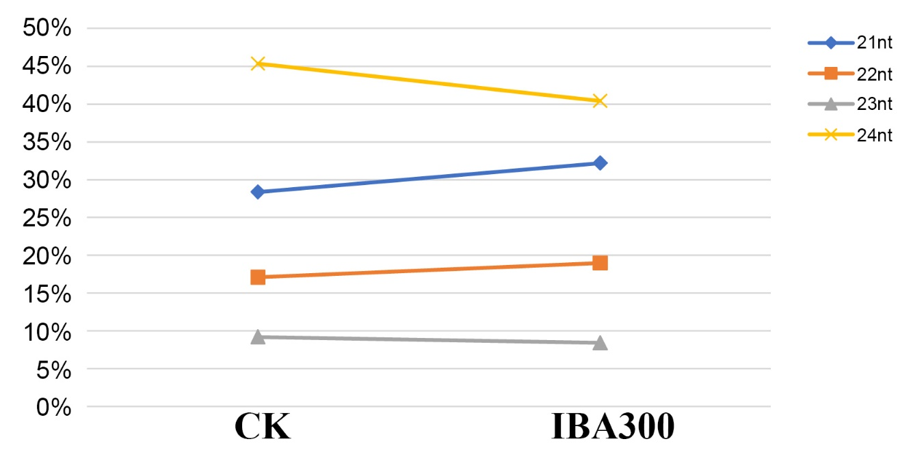
Fig.S1. The distribution of 21–24 nt small RNAs (sRNAs) across the two sRNA libraries.
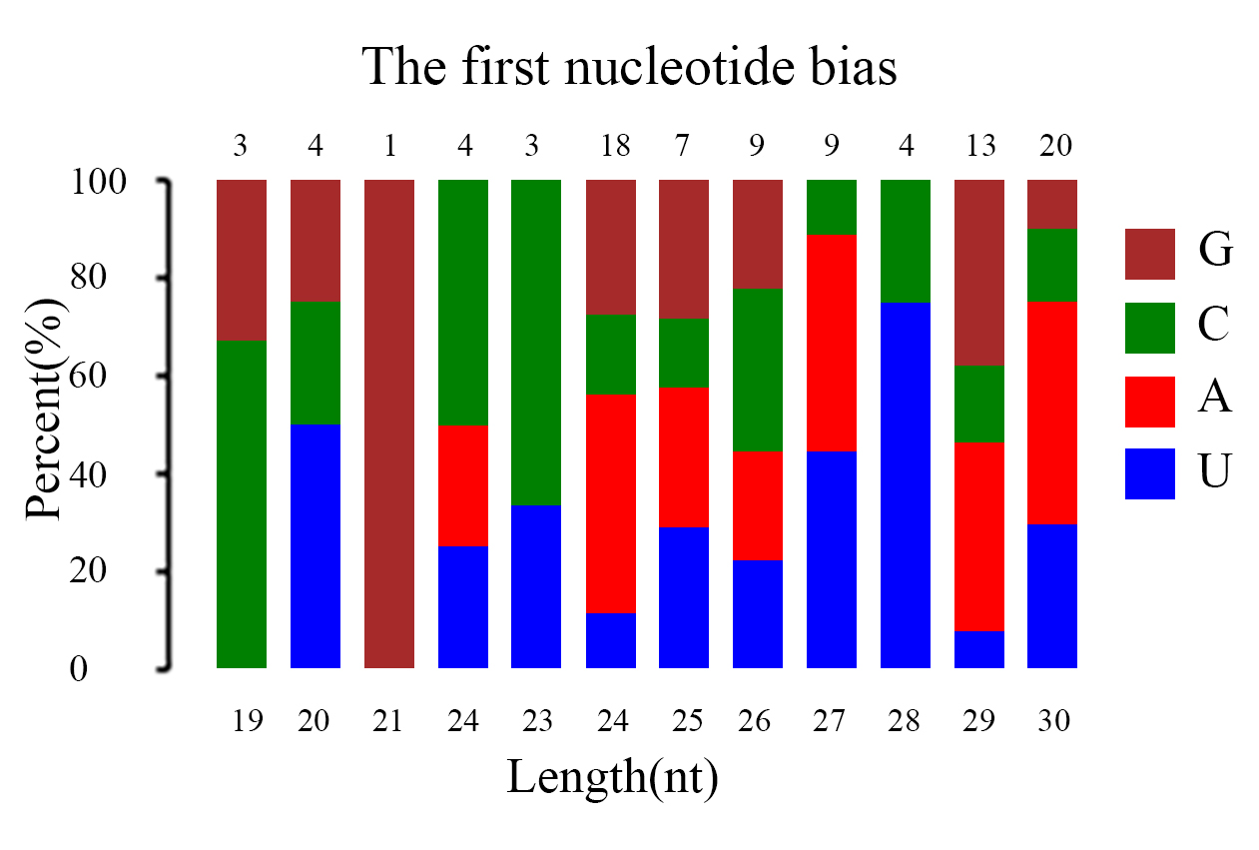
Fig.S2. First nucleotide bias across the novel microRNAs. X-axis represented length of miRNA (19–30 nt long), Y-axis showed the percent of the first nucleotide in each length miRNA.
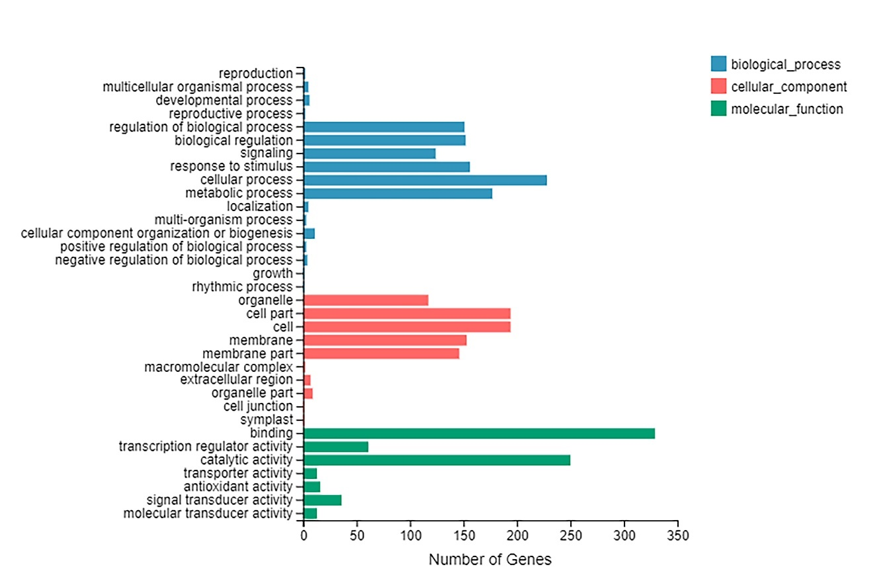Fig.S3. GO annotation of the DEGs.
Fig.S4. KEGG pathway enrichment of the DEGs.
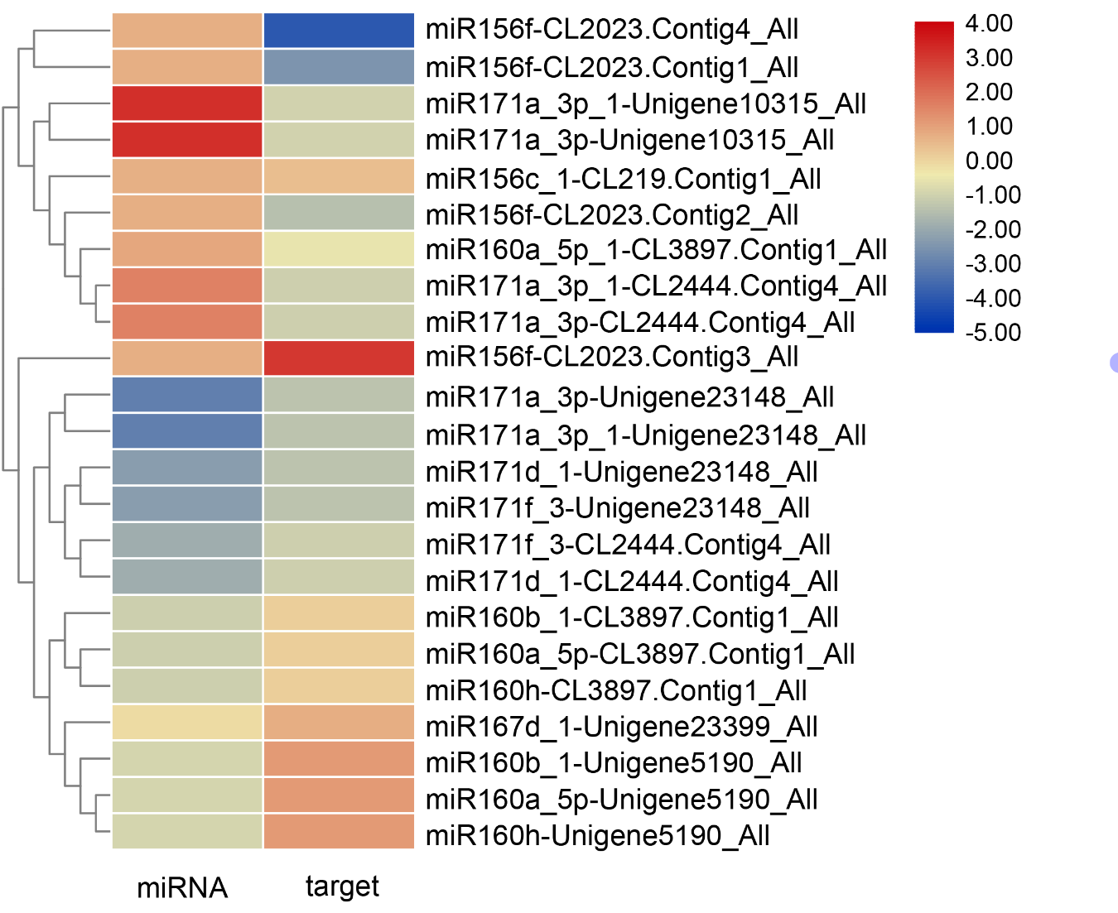Fig.S5. Heat map showing the differentially expressed miRNAs and the corresponding 10 targets. Upregulated genes/miRNAs were shown in red; downregulated genes/miRNAs were shown in blue.

Fig.S6. Expression patterns of nine selected miRNAs in the adventitious roots of A. rubrum cuttings treated with auxin (IBA300) and untreated water (CK). U6 snRNA was used as a reference for qRT-PCR, and miRNA expression in the control was set to 1.0. Mean values of three replicates were shown with standard error bars. “*” indicated significant difference at p-value < 0.05, “**” indicated significant difference at p-value < 0.01.
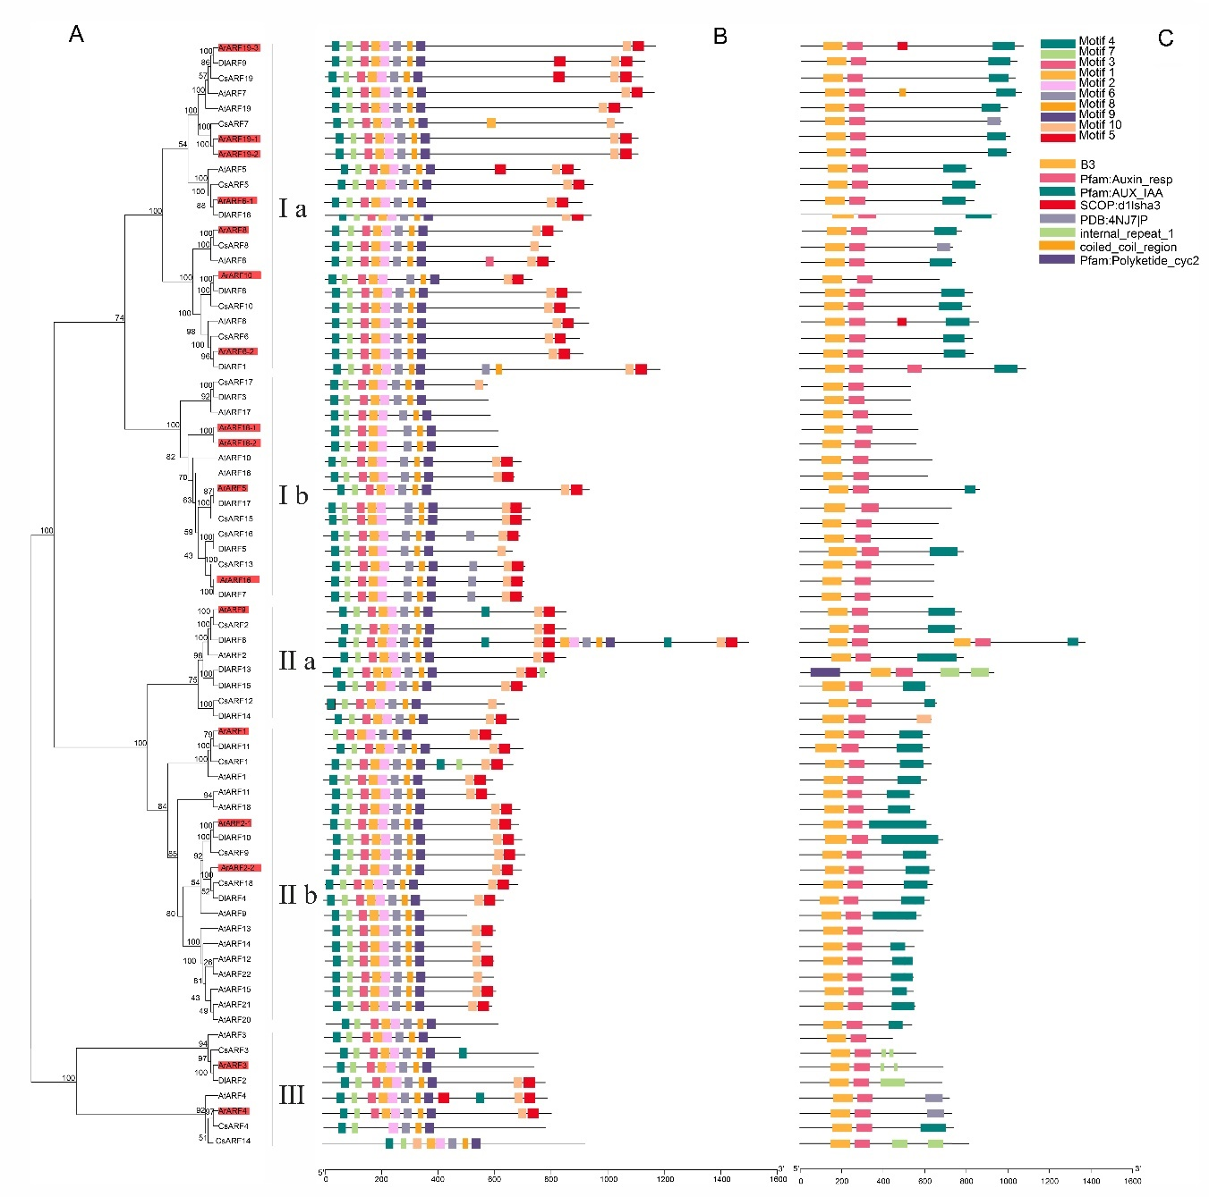Figure S7. Neighboring-joining (NJ) phylogenies and representative conserved motif patterns in ARF proteins from A. rubrum, longan, citrus, and A.thaliana. (A) A phylogenetic tree was constructed for full-length ARF proteins from four plant species, including A.rubrum (Ar), Dimocarpus longan (Di), citrus (Cs), Arabidopsis thaliana (At). (B) Distribution of ARF proteins of 10 motifs in four species. (C) Conservative domain of ARF proteins of 10 motifs in four species.
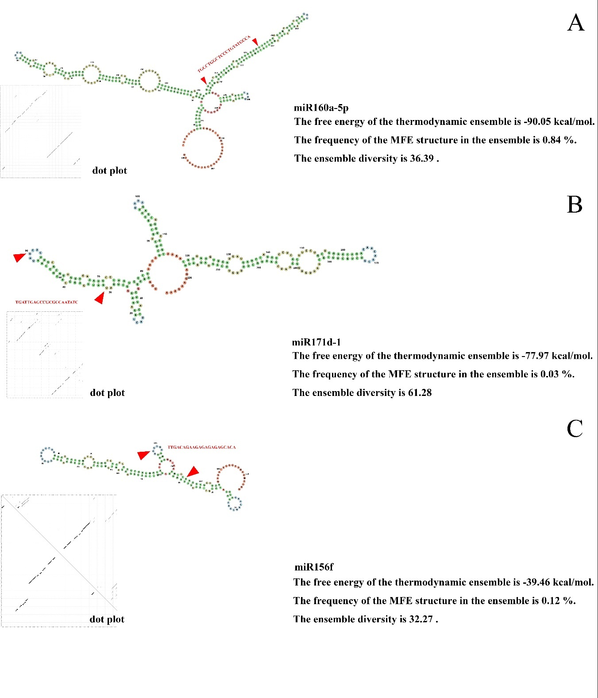Fig. S8. The precursor sequences of three miRNAs.
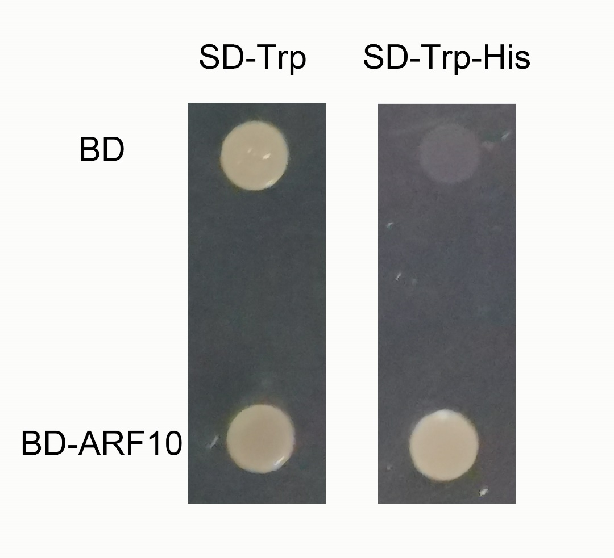
Fig. S9. Transcriptional activation analysis of ArARF10.
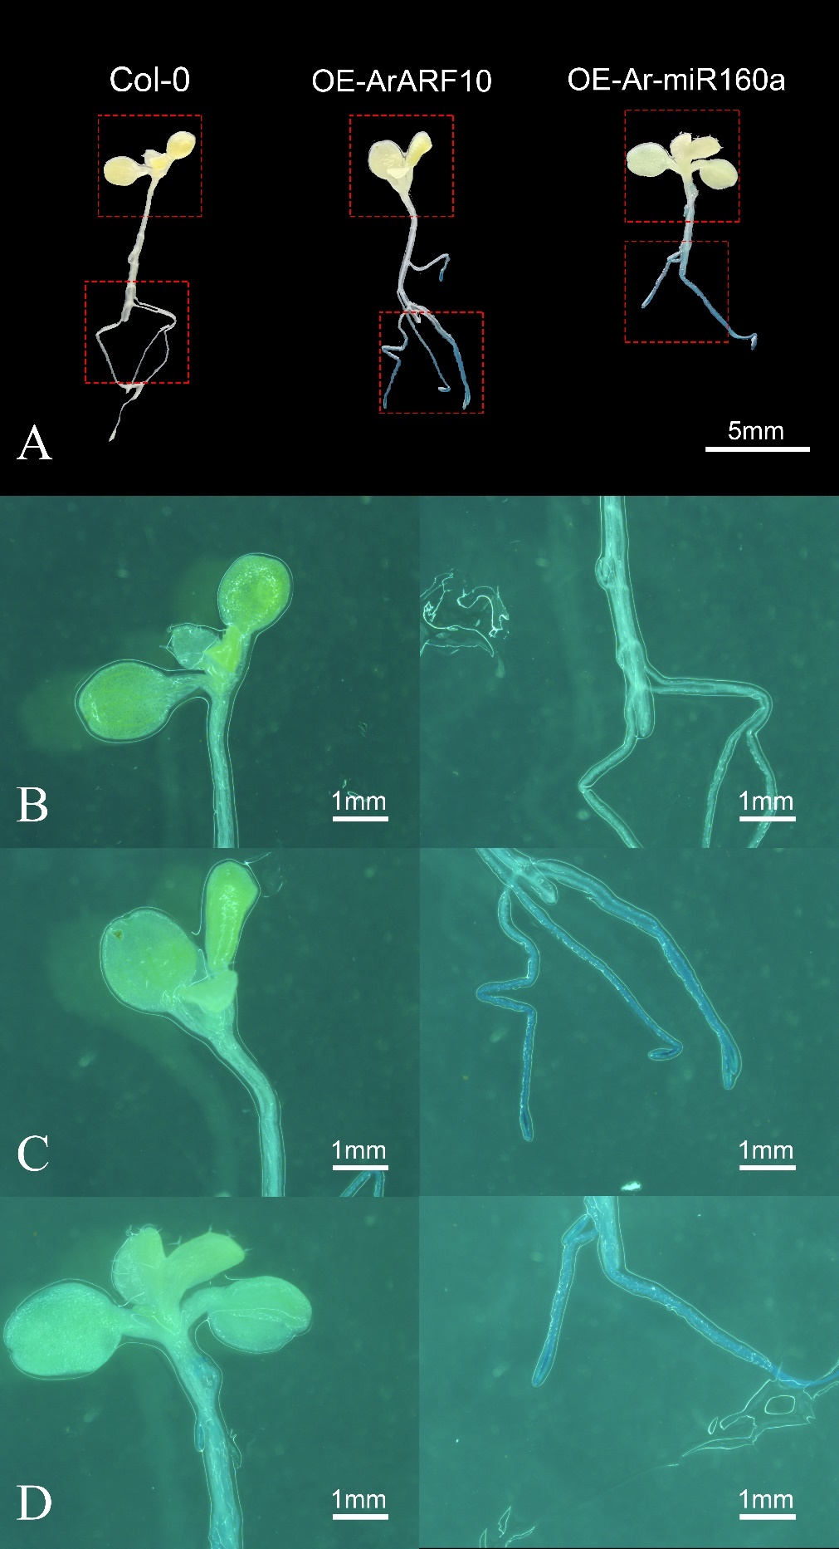
Fig.S10. GUS-stained seedlings, showing successful expression of the Ar-miR160 and its target gene (ArARF10). (A) Hypocotyls and ARs of OE-ArARF10 and OE-Ar-miR160a plants showed blue color compared with Col-0 plants, and the inserted GUS gene expression indicated successful gene transformation. bar=5 mm (B) Col-0 plants showed no change in color after GUS staining. (C) OE-ARARF10 plants turned blue after staining and changed significantly in the AR site. (D) OE-AR-miR160a plants turned blue and the color change of AR was obvious, Bar=1mm.

