Supplementary Materials

Figure S1. The chemical structure of the AEO7 molecule [1].

Table S1. Acute Toxicity Rating Scale by the U.S. Fish and Wildlife Service (USFWS) (El-Harbawi, 2014).
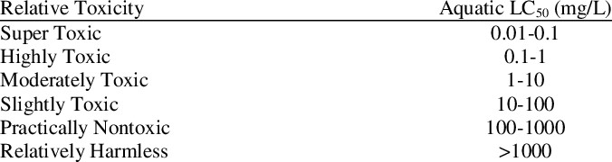

1. Sliem, M.H., et al., AEO7 Surfactant as an Eco-Friendly Corrosion Inhibitor for Carbon Steel in HCl solution. Scientific reports, 2019. 9(1): p. 2319-2319.

