Supplementary
Implementation details

Batch Size Configuration
- LoRA fine-tuning: batch size = 8 (optimized for memory efficiency)
- Partial fine-tuning: batch size = 32 (leveraging increased throughput capability)

Optimization Parameters
- Optimizer: AdamW (chosen for its adaptive learning rate capabilities)
  - Weight decay coefficient: 1e-3
  - (for regularization)
  - β1 = 0.9, β2 = 0.999 (default momentum parameters)

Learning rate schedule
The learning rate schedule followed a two-phase approach:
- Warm-up phase:
  - Duration: Initial 10 epochs
  - Learning rate: Linear increase from 0 to 5e-4
- Decay Phase:
  - Duration: Remaining 90 epochs
  - Schedule: Cosine annealing decay
  - Final learning rate: 1e-6

Training Duration and Loss Function
- Total epochs: 100 (determined through empirical validation)
- Loss function: Mean squared error (MSE)
  - Selected for regression task optimization
  - MSE = 1/n Σ(yi - ŷi)² where yi represents the true haemoglobin value and ŷi represents the predicted value.
Supplementary Table 1. Characteristics of pretrained models used in this study
Model | Modality | Num. of parameters | Pretrained domain | Dataset | Num. of pretrained image
DINOv2  (ViT giant) | Image | 1.14 B | Natural Image | LVD-142 M | 142 M
OpenCLIP  (ViT giant) | Image & Text | 1.01 B | Natural Image | LAION-2B | 2B
MAE  (ViT large) | image | 631 M | Natural Image | ImageNet-1k | 1.2 M
RetFound  (ViT large) | Image | 303 M | Retinal Fundus Image | MEH-MIDAS  Public datasets | 904K
VisionFM  (ViT base) | Image | 86 M | Retinal Fundus Image | Private dataset  Public datasets | 1 M

Supplementary Table 2. Anemia prevalence by cohort subgroup
 | Train | Valid | Test
Subject Population | 27581 | 3472 | 3458
Female, n (%) | 13496 | 1674 | 1706
Mild anemia | 707 (5.24%) | 85 (5.08%) | 96 (5.63%)
Moderate anemia | 335 (2.48%) | 49 (2.93%) | 42 (2.46%)
Severe anemia | 335 (2.48%) | 49 (2.93%) | 42 (2.46%)
Male, n (%) | 14085 | 1798 | 1752
Mild anemia | 264 (1.87%) | 26 (1.45%) | 26 (1.48%)
Moderate anemia | 42 (0.3%) | 6 (0.33%) | 5 (0.29%)
Severe anemia | 42 (0.3%) | 6 (0.33%) | 5 (0.29%)
Young age (<50), n (%) | 5901 | 738 | 745
Mild anemia | 215 (3.64%) | 28 (3.79%) | 29 (3.89%)
Moderate anemia | 140 (2.37%) | 22 (2.98%) | 22 (2.95%)
Severe anemia | 140 (2.37%) | 22 (2.98%) | 22 (2.95%)
Old age (≥ 65), n (%) | 7732 | 993 | 994
Mild anemia | 369 (4.77%) | 49 (4.93%) | 51 (5.13%)
Moderate anemia | 65 (0.84%) | 11 (1.11%) | 3 (0.3%)
Severe anemia | 65 (0.84%) | 11 (1.11%) | 3 (0.3%)
Hypertension, n (%) | 9119 | 1135 | 1178
Mild anemia | 291 (3.19%) | 27 (2.38%) | 37 (3.14%)
Moderate anemia | 94 (1.03%) | 12 (1.06%) | 11 (0.93%)
Severe anemia | 94 (1.03%) | 12 (1.06%) | 11 (0.93%)
Diabetes Mellitus, n (%) | 5071 | 654 | 622
Mild anemia | 224 (4.42%) | 29 (4.43%) | 21 (3.38%)
Moderate anemia | 64 (1.26%) | 10 (1.53%) | 8 (1.29%)
Severe anemia | 64 (1.26%) | 10 (1.53%) | 8 (1.29%)
Dyslipidemia, n (%) | 13333 | 1661 | 1631
Mild anemia | 374 (2.81%) | 37 (2.23%) | 39 (2.39%)
Moderate anemia | 139 (1.04%) | 13 (0.78%) | 16 (0.98%)
Severe anemia | 139 (1.04%) | 13 (0.78%) | 16 (0.98%)

Supplementary Table 3. Predictive performance of models for haemoglobin estimation and anaemia prediction in the female subgroup
Model | Finetuning Method | Estimation of haemoglobin |  | Prediction of anaemia
Model | Finetuning Method | MAE  (95% CI) | R squared  (95% CI) | Accuracy  (95% CI) | AUROC  (95% CI) | Sens.  (95% CI) | Sens. ≥ Mod.  (95% CI) | NPV  (95% CI)
DINOv2 | Partial Finetuning | 0.889  (0.863 - 0.913) | -0.059  (-0.135 - 0.012) | 0.919  (0.909 - 0.929) | 0.771  (0.740 - 0.799) | 0.102  (0.070 - 0.145) | 0.256  (0.175 - 0.357) | 0.925  (0.915 - 0.934)
DINOv2 | LoRA tuning | 0.662  (0.644 - 0.680) | 0.418  (0.370 - 0.463) | 0.930  (0.921 - 0.939) | 0.887  (0.867 - 0.907) | 0.379  (0.322 - 0.440) | 0.791  (0.693 - 0.863) | 0.946  (0.938 - 0.954)
OpenCLIP | Partial Finetuning | 0.910  (0.885 - 0.934) | -0.100  (-0.186 - -0.023) | 0.917  (0.906 - 0.926) | 0.768  (0.738 - 0.798) | 0.105  (0.074 - 0.149) | 0.256  (0.175 - 0.357) | 0.925  (0.915 - 0.934)
OpenCLIP | LoRA tuning | 0.714  (0.696 - 0.733) | 0.324  (0.269 - 0.371) | 0.924  (0.914 - 0.933) | 0.851  (0.827 - 0.874) | 0.281  (0.230 - 0.339) | 0.581  (0.476 - 0.680) | 0.939  (0.929 - 0.947)
MAE | Partial Finetuning | 0.768  (0.746 - 0.789) | 0.207  (0.140 - 0.267) | 0.924  (0.914 - 0.933) | 0.841  (0.815 - 0.865) | 0.246  (0.197 - 0.302) | 0.512  (0.408 - 0.614) | 0.936  (0.927 - 0.944)
MAE | LoRA tuning | 0.696  (0.677 - 0.714) | 0.361  (0.307 - 0.411) | 0.927  (0.917 - 0.935) | 0.878  (0.856 - 0.900) | 0.355  (0.299 - 0.416) | 0.674  (0.570 - 0.764) | 0.944  (0.935 - 0.952)
RetFound | Partial Finetuning | 0.746  (0.727 - 0.767) | 0.266  (0.208 - 0.319) | 0.930  (0.921 - 0.938) | 0.848  (0.822 - 0.873) | 0.293  (0.241 - 0.351) | 0.558  (0.453 - 0.658) | 0.940  (0.931 - 0.948)
RetFound | LoRA tuning | 0.739  (0.720 - 0.760) | 0.265  (0.203 - 0.321) | 0.928  (0.919 - 0.937) | 0.850  (0.822 - 0.876) | 0.281  (0.230 - 0.339) | 0.547  (0.442 - 0.647) | 0.939  (0.930 - 0.947)
VisionFM | Partial Finetuning | 0.838  (0.815 - 0.862) | 0.061  (-0.007 - 0.125) | 0.916  (0.906 - 0.925) | 0.799  (0.770 - 0.829) | 0.180  (0.138 - 0.231) | 0.407  (0.309 - 0.513) | 0.930  (0.921 - 0.939)
VisionFM | LoRA tuning | 0.762  (0.740 - 0.784) | 0.212  (0.153 - 0.267) | 0.923  (0.913 - 0.932) | 0.840  (0.816 - 0.863) | 0.242  (0.194 - 0.298) | 0.512  (0.408 - 0.614) | 0.936  (0.926 - 0.944)

Supplementary Table 4. Predictive performance of models for haemoglobin estimation and anaemia prediction in the male subgroup
Model | Finetuning Method | Estimation of haemoglobin |  | Prediction of anaemia
Model | Finetuning Method | MAE  (95% CI) | R squared  (95% CI) | Accuracy  (95% CI) | AUROC  (95% CI) | Sens.  (95% CI) | Sens. ≥ Mod.  (95% CI) | NPV  (95% CI)
DINOv2 | Partial Finetuning | 0.895  (0.871 - 0.919) | 0.030  (-0.028 - 0.084) | 0.979  (0.973 - 0.983) | 0.816  (0.755 - 0.869) | 0.034  (0.010 - 0.117) | 0.167  (0.047 - 0.448) | 0.983  (0.977 - 0.987)
DINOv2 | LoRA tuning | 0.742  (0.722 - 0.761) | 0.344  (0.289 - 0.394) | 0.983  (0.978 - 0.987) | 0.931  (0.899 - 0.958) | 0.293  (0.192 - 0.420) | 0.917  (0.646 - 0.985) | 0.987  (0.983 - 0.991)
OpenCLIP | Partial Finetuning | 0.906  (0.881 - 0.930) | 0.020  (-0.048 - 0.082) | 0.984  (0.979 - 0.987) | 0.825  (0.771 - 0.872) | 0.172  (0.096 - 0.289) | 0.500  (0.254 - 0.746) | 0.985  (0.980 - 0.989)
OpenCLIP | LoRA tuning | 0.789  (0.768 - 0.810) | 0.264  (0.208 - 0.317) | 0.983  (0.978 - 0.987) | 0.911  (0.879 - 0.938) | 0.241  (0.150 - 0.365) | 0.667  (0.391 - 0.862) | 0.986  (0.982 - 0.990)
MAE | Partial Finetuning | 0.821  (0.799 - 0.842) | 0.195  (0.137 - 0.248) | 0.982  (0.977 - 0.986) | 0.885  (0.842 - 0.920) | 0.155  (0.084 - 0.269) | 0.500  (0.254 - 0.746) | 0.985  (0.980 - 0.988)
MAE | LoRA tuning | 0.782  (0.761 - 0.802) | 0.277  (0.221 - 0.330) | 0.982  (0.977 - 0.986) | 0.912  (0.879 - 0.939) | 0.259  (0.163 - 0.384) | 0.833  (0.552 - 0.953) | 0.987  (0.982 - 0.990)
RetFound | Partial Finetuning | 0.826  (0.802 - 0.846) | 0.198  (0.139 - 0.258) | 0.980  (0.975 - 0.984) | 0.887  (0.845 - 0.923) | 0.155  (0.084 - 0.269) | 0.500  (0.254 - 0.746) | 0.985  (0.980 - 0.988)
RetFound | LoRA tuning | 0.853  (0.829 - 0.875) | 0.134  (0.071 - 0.195) | 0.981  (0.976 - 0.986) | 0.860  (0.815 - 0.900) | 0.155  (0.084 - 0.269) | 0.500  (0.254 - 0.746) | 0.985  (0.980 - 0.988)
VisionFM | Partial Finetuning | 0.916  (0.890 - 0.940) | -0.000  (-0.073 - 0.059) | 0.979  (0.974 - 0.984) | 0.820  (0.768 - 0.865) | 0.103  (0.048 - 0.208) | 0.250  (0.089 - 0.532) | 0.984  (0.979 - 0.988)
VisionFM | LoRA tuning | 0.843  (0.819 - 0.865) | 0.152  (0.090 - 0.208) | 0.980  (0.974 - 0.984) | 0.869  (0.816 - 0.911) | 0.172  (0.096 - 0.289) | 0.500  (0.254 - 0.746) | 0.985  (0.980 - 0.989)

Supplementary Table 5. Predictive performance of models for haemoglobin estimation and anaemia prediction in the young age(< 50) subgroup
Model | Finetuning Method | Estimation of haemoglobin |  | Prediction of anaemia
Model | Finetuning Method | MAE  (95% CI) | R squared  (95% CI) | Accuracy  (95% CI) | AUROC  (95% CI) | Sens.  (95% CI) | Sens. ≥ Mod.  (95% CI) | NPV  (95% CI)
DINOv2 | Partial Finetuning | 0.921  (0.886 - 0.960) | 0.579  (0.544 - 0.609) | 0.937  (0.923 - 0.948) | 0.868  (0.832 - 0.900) | 0.190  (0.125 - 0.278) | 0.341  (0.219 - 0.489) | 0.943  (0.929 - 0.954)
DINOv2 | LoRA tuning | 0.723  (0.692 - 0.751) | 0.743  (0.716 - 0.766) | 0.951  (0.938 - 0.961) | 0.936  (0.914 - 0.954) | 0.460  (0.366 - 0.557) | 0.818  (0.680 - 0.905) | 0.961  (0.949 - 0.970)
OpenCLIP | Partial Finetuning | 0.946  (0.910 - 0.986) | 0.555  (0.517 - 0.588) | 0.931  (0.916 - 0.943) | 0.833  (0.787 - 0.871) | 0.170  (0.109 - 0.255) | 0.364  (0.238 - 0.511) | 0.941  (0.927 - 0.952)
OpenCLIP | LoRA tuning | 0.783  (0.753 - 0.816) | 0.700  (0.672 - 0.724) | 0.940  (0.926 - 0.951) | 0.902  (0.873 - 0.928) | 0.370  (0.282 - 0.468) | 0.636  (0.489 - 0.762) | 0.954  (0.942 - 0.964)
MAE | Partial Finetuning | 0.812  (0.780 - 0.845) | 0.667  (0.635 - 0.696) | 0.938  (0.925 - 0.950) | 0.898  (0.866 - 0.926) | 0.310  (0.228 - 0.406) | 0.614  (0.466 - 0.743) | 0.950  (0.938 - 0.961)
MAE | LoRA tuning | 0.753  (0.724 - 0.783) | 0.720  (0.691 - 0.744) | 0.940  (0.926 - 0.951) | 0.920  (0.893 - 0.945) | 0.360  (0.273 - 0.458) | 0.636  (0.489 - 0.762) | 0.954  (0.941 - 0.964)
RetFound | Partial Finetuning | 0.823  (0.790 - 0.857) | 0.671  (0.638 - 0.700) | 0.943  (0.930 - 0.954) | 0.903  (0.870 - 0.933) | 0.410  (0.319 - 0.508) | 0.682  (0.534 - 0.800) | 0.957  (0.945 - 0.967)
RetFound | LoRA tuning | 0.839  (0.805 - 0.875) | 0.651  (0.616 - 0.683) | 0.941  (0.928 - 0.952) | 0.895  (0.863 - 0.926) | 0.380  (0.291 - 0.478) | 0.682  (0.534 - 0.800) | 0.955  (0.943 - 0.965)
VisionFM | Partial Finetuning | 0.902  (0.869 - 0.941) | 0.599  (0.566 - 0.630) | 0.931  (0.916 - 0.943) | 0.885  (0.858 - 0.912) | 0.230  (0.158 - 0.322) | 0.455  (0.317 - 0.599) | 0.945  (0.932 - 0.956)
VisionFM | LoRA tuning | 0.824  (0.792 - 0.861) | 0.662  (0.628 - 0.688) | 0.938  (0.924 - 0.949) | 0.919  (0.897 - 0.939) | 0.350  (0.264 - 0.447) | 0.659  (0.511 - 0.781) | 0.953  (0.940 - 0.963)

Supplementary Table 6. Predictive performance of models for haemoglobin estimation and anaemia prediction in the old age(≥ 65) subgroup
Model | Finetuning Method | Estimation of haemoglobin |  | Prediction of anaemia
Model | Finetuning Method | MAE  (95% CI) | R squared  (95% CI) | Accuracy  (95% CI) | AUROC  (95% CI) | Sens.  (95% CI) | Sens. ≥ Mod.  (95% CI) | NPV  (95% CI)
DINOv2 | Partial Finetuning | 0.872  (0.837 - 0.904) | 0.390  (0.349 - 0.429) | 0.938  (0.925 - 0.949) | 0.765  (0.717 - 0.810) | 0.021  (0.006 - 0.074) | 0.200  (0.057 - 0.510) | 0.945  (0.933 - 0.955)
DINOv2 | LoRA tuning | 0.704  (0.677 - 0.732) | 0.592  (0.548 - 0.627) | 0.940  (0.928 - 0.951) | 0.875  (0.842 - 0.904) | 0.202  (0.133 - 0.294) | 0.700  (0.397 - 0.892) | 0.954  (0.943 - 0.963)
OpenCLIP | Partial Finetuning | 0.889  (0.854 - 0.921) | 0.373  (0.326 - 0.415) | 0.947  (0.935 - 0.957) | 0.765  (0.715 - 0.814) | 0.117  (0.067 - 0.198) | 0.500  (0.237 - 0.763) | 0.950  (0.938 - 0.959)
OpenCLIP | LoRA tuning | 0.754  (0.726 - 0.783) | 0.546  (0.502 - 0.581) | 0.942  (0.930 - 0.952) | 0.850  (0.814 - 0.884) | 0.138  (0.083 - 0.222) | 0.600  (0.313 - 0.832) | 0.951  (0.939 - 0.960)
MAE | Partial Finetuning | 0.794  (0.766 - 0.824) | 0.497  (0.453 - 0.535) | 0.946  (0.934 - 0.956) | 0.823  (0.782 - 0.862) | 0.128  (0.075 - 0.210) | 0.600  (0.313 - 0.832) | 0.950  (0.939 - 0.960)
MAE | LoRA tuning | 0.743  (0.714 - 0.770) | 0.559  (0.516 - 0.596) | 0.944  (0.932 - 0.954) | 0.850  (0.812 - 0.885) | 0.223  (0.151 - 0.318) | 0.700  (0.397 - 0.892) | 0.955  (0.944 - 0.964)
RetFound | Partial Finetuning | 0.779  (0.749 - 0.809) | 0.517  (0.474 - 0.555) | 0.941  (0.929 - 0.951) | 0.819  (0.775 - 0.859) | 0.106  (0.059 - 0.185) | 0.400  (0.168 - 0.687) | 0.949  (0.937 - 0.959)
RetFound | LoRA tuning | 0.787  (0.757 - 0.818) | 0.501  (0.453 - 0.541) | 0.945  (0.933 - 0.955) | 0.811  (0.765 - 0.853) | 0.149  (0.091 - 0.235) | 0.500  (0.237 - 0.763) | 0.952  (0.940 - 0.961)
VisionFM | Partial Finetuning | 0.878  (0.842 - 0.907) | 0.390  (0.337 - 0.435) | 0.937  (0.925 - 0.948) | 0.761  (0.712 - 0.807) | 0.096  (0.051 - 0.172) | 0.500  (0.237 - 0.763) | 0.948  (0.937 - 0.958)
VisionFM | LoRA tuning | 0.805  (0.775 - 0.835) | 0.474  (0.430 - 0.512) | 0.942  (0.929 - 0.952) | 0.803  (0.758 - 0.848) | 0.117  (0.067 - 0.198) | 0.400  (0.168 - 0.687) | 0.950  (0.938 - 0.959)

Supplementary Table 7. Predictive performance of models for haemoglobin estimation and anaemia prediction in the hypertension subgroup
Model | Finetuning Method | Estimation of haemoglobin |  | Prediction of anaemia
Model | Finetuning Method | MAE  (95% CI) | R squared  (95% CI) | Accuracy  (95% CI) | AUROC  (95% CI) | Sens.  (95% CI) | Sens. ≥ Mod.  (95% CI) | NPV  (95% CI)
DINOv2 | Partial Finetuning | 0.887  (0.857 - 0.917) | 0.440  (0.406 - 0.472) | 0.958  (0.948 - 0.966) | 0.793  (0.742 - 0.841) | 0.026  (0.007 - 0.089) | 0.095  (0.027 - 0.289) | 0.964  (0.955 - 0.971)
DINOv2 | LoRA tuning | 0.723  (0.698 - 0.748) | 0.624  (0.595 - 0.653) | 0.965  (0.956 - 0.972) | 0.893  (0.855 - 0.927) | 0.321  (0.227 - 0.430) | 0.762  (0.549 - 0.894) | 0.974  (0.967 - 0.980)
OpenCLIP | Partial Finetuning | 0.911  (0.880 - 0.942) | 0.416  (0.381 - 0.450) | 0.962  (0.953 - 0.969) | 0.794  (0.742 - 0.842) | 0.090  (0.044 - 0.174) | 0.143  (0.050 - 0.346) | 0.966  (0.957 - 0.973)
OpenCLIP | LoRA tuning | 0.774  (0.749 - 0.802) | 0.575  (0.547 - 0.603) | 0.963  (0.954 - 0.970) | 0.882  (0.846 - 0.916) | 0.179  (0.110 - 0.279) | 0.524  (0.324 - 0.717) | 0.969  (0.961 - 0.976)
MAE | Partial Finetuning | 0.813  (0.787 - 0.842) | 0.526  (0.492 - 0.559) | 0.961  (0.952 - 0.969) | 0.842  (0.799 - 0.883) | 0.167  (0.100 - 0.265) | 0.476  (0.283 - 0.676) | 0.969  (0.960 - 0.975)
MAE | LoRA tuning | 0.759  (0.731 - 0.785) | 0.590  (0.559 - 0.620) | 0.964  (0.955 - 0.971) | 0.885  (0.850 - 0.917) | 0.321  (0.227 - 0.430) | 0.810  (0.600 - 0.923) | 0.974  (0.967 - 0.980)
RetFound | Partial Finetuning | 0.804  (0.779 - 0.833) | 0.545  (0.513 - 0.576) | 0.960  (0.951 - 0.968) | 0.866  (0.827 - 0.900) | 0.179  (0.110 - 0.279) | 0.429  (0.245 - 0.635) | 0.969  (0.961 - 0.976)
RetFound | LoRA tuning | 0.828  (0.799 - 0.856) | 0.507  (0.473 - 0.540) | 0.961  (0.952 - 0.969) | 0.834  (0.790 - 0.876) | 0.167  (0.100 - 0.265) | 0.429  (0.245 - 0.635) | 0.969  (0.960 - 0.975)
VisionFM | Partial Finetuning | 0.886  (0.857 - 0.915) | 0.450  (0.414 - 0.484) | 0.957  (0.948 - 0.965) | 0.820  (0.776 - 0.862) | 0.154  (0.090 - 0.250) | 0.429  (0.245 - 0.635) | 0.968  (0.960 - 0.975)
VisionFM | LoRA tuning | 0.821  (0.794 - 0.849) | 0.511  (0.476 - 0.542) | 0.957  (0.947 - 0.965) | 0.847  (0.801 - 0.887) | 0.128  (0.071 - 0.220) | 0.286  (0.138 - 0.500) | 0.967  (0.959 - 0.974)

Supplementary Table 8. Predictive performance of models for haemoglobin estimation and anaemia prediction in the diabetes mellitus subgroup
Model | Finetuning Method | Estimation of haemoglobin |  | Prediction of anaemia
Model | Finetuning Method | MAE  (95% CI) | R squared  (95% CI) | Accuracy  (95% CI) | AUROC  (95% CI) | Sens.  (95% CI) | Sens. ≥ Mod.  (95% CI) | NPV  (95% CI)
DINOv2 | Partial Finetuning | 0.895  (0.850 - 0.939) | 0.491  (0.445 - 0.531) | 0.953  (0.939 - 0.964) | 0.819  (0.759 - 0.874) | 0.111  (0.052 - 0.222) | 0.333  (0.163 - 0.563) | 0.955  (0.941 - 0.966)
DINOv2 | LoRA tuning | 0.714  (0.680 - 0.750) | 0.676  (0.635 - 0.713) | 0.962  (0.949 - 0.972) | 0.920  (0.879 - 0.953) | 0.500  (0.371 - 0.629) | 0.944  (0.742 - 0.990) | 0.974  (0.963 - 0.982)
OpenCLIP | Partial Finetuning | 0.920  (0.876 - 0.962) | 0.470  (0.420 - 0.517) | 0.957  (0.943 - 0.967) | 0.808  (0.749 - 0.863) | 0.167  (0.090 - 0.287) | 0.389  (0.203 - 0.614) | 0.958  (0.944 - 0.969)
OpenCLIP | LoRA tuning | 0.749  (0.716 - 0.785) | 0.643  (0.606 - 0.679) | 0.960  (0.947 - 0.971) | 0.899  (0.858 - 0.937) | 0.370  (0.254 - 0.504) | 0.667  (0.437 - 0.837) | 0.968  (0.955 - 0.977)
MAE | Partial Finetuning | 0.802  (0.769 - 0.838) | 0.603  (0.561 - 0.643) | 0.957  (0.943 - 0.967) | 0.881  (0.835 - 0.925) | 0.278  (0.176 - 0.409) | 0.556  (0.337 - 0.754) | 0.963  (0.950 - 0.973)
MAE | LoRA tuning | 0.732  (0.699 - 0.767) | 0.658  (0.618 - 0.695) | 0.965  (0.952 - 0.974) | 0.909  (0.867 - 0.947) | 0.500  (0.371 - 0.629) | 0.833  (0.608 - 0.942) | 0.974  (0.963 - 0.982)
RetFound | Partial Finetuning | 0.797  (0.763 - 0.837) | 0.599  (0.554 - 0.640) | 0.961  (0.948 - 0.971) | 0.882  (0.829 - 0.929) | 0.370  (0.254 - 0.504) | 0.611  (0.386 - 0.797) | 0.968  (0.955 - 0.977)
RetFound | LoRA tuning | 0.803  (0.765 - 0.841) | 0.593  (0.548 - 0.635) | 0.963  (0.950 - 0.973) | 0.877  (0.817 - 0.927) | 0.333  (0.222 - 0.466) | 0.556  (0.337 - 0.754) | 0.966  (0.954 - 0.975)
VisionFM | Partial Finetuning | 0.872  (0.828 - 0.914) | 0.514  (0.462 - 0.564) | 0.953  (0.939 - 0.964) | 0.850  (0.794 - 0.900) | 0.259  (0.161 - 0.389) | 0.389  (0.203 - 0.614) | 0.962  (0.949 - 0.972)
VisionFM | LoRA tuning | 0.796  (0.757 - 0.836) | 0.585  (0.544 - 0.625) | 0.957  (0.943 - 0.967) | 0.881  (0.825 - 0.929) | 0.333  (0.222 - 0.466) | 0.556  (0.337 - 0.754) | 0.966  (0.953 - 0.975)

Supplementary Table 9. Predictive performance of models for haemoglobin estimation and anaemia prediction in the dyslipidemia subgroup
Model | Finetuning Method | Estimation of haemoglobin |  | Prediction of anaemia
Model | Finetuning Method | MAE  (95% CI) | R squared  (95% CI) | Accuracy  (95% CI) | AUROC  (95% CI) | Sens.  (95% CI) | Sens. ≥ Mod.  (95% CI) | NPV  (95% CI)
DINOv2 | Partial Finetuning | 0.882  (0.857 - 0.907) | 0.485  (0.458 - 0.510) | 0.964  (0.957 - 0.971) | 0.843  (0.806 - 0.874) | 0.129  (0.077 - 0.208) | 0.333  (0.202 - 0.497) | 0.970  (0.964 - 0.976)
DINOv2 | LoRA tuning | 0.703  (0.682 - 0.722) | 0.679  (0.656 - 0.700) | 0.968  (0.961 - 0.974) | 0.931  (0.908 - 0.950) | 0.396  (0.306 - 0.494) | 0.861  (0.713 - 0.939) | 0.979  (0.973 - 0.984)
OpenCLIP | Partial Finetuning | 0.898  (0.874 - 0.924) | 0.472  (0.444 - 0.496) | 0.966  (0.959 - 0.972) | 0.830  (0.793 - 0.867) | 0.139  (0.084 - 0.219) | 0.333  (0.202 - 0.497) | 0.971  (0.964 - 0.976)
OpenCLIP | LoRA tuning | 0.745  (0.723 - 0.766) | 0.633  (0.607 - 0.655) | 0.967  (0.960 - 0.973) | 0.903  (0.875 - 0.928) | 0.307  (0.225 - 0.403) | 0.611  (0.449 - 0.752) | 0.976  (0.970 - 0.981)
MAE | Partial Finetuning | 0.779  (0.755 - 0.802) | 0.597  (0.570 - 0.622) | 0.968  (0.961 - 0.974) | 0.893  (0.860 - 0.921) | 0.287  (0.208 - 0.382) | 0.583  (0.422 - 0.729) | 0.976  (0.969 - 0.981)
MAE | LoRA tuning | 0.732  (0.711 - 0.752) | 0.649  (0.626 - 0.671) | 0.967  (0.960 - 0.973) | 0.915  (0.887 - 0.937) | 0.366  (0.279 - 0.464) | 0.806  (0.650 - 0.902) | 0.978  (0.972 - 0.983)
RetFound | Partial Finetuning | 0.784  (0.762 - 0.806) | 0.595  (0.569 - 0.619) | 0.967  (0.960 - 0.973) | 0.888  (0.859 - 0.914) | 0.277  (0.199 - 0.371) | 0.583  (0.422 - 0.729) | 0.975  (0.969 - 0.980)
RetFound | LoRA tuning | 0.805  (0.782 - 0.828) | 0.571  (0.541 - 0.597) | 0.967  (0.960 - 0.973) | 0.882  (0.850 - 0.910) | 0.257  (0.182 - 0.350) | 0.556  (0.396 - 0.705) | 0.975  (0.968 - 0.980)
VisionFM | Partial Finetuning | 0.876  (0.850 - 0.900) | 0.494  (0.464 - 0.523) | 0.962  (0.955 - 0.968) | 0.852  (0.817 - 0.885) | 0.188  (0.124 - 0.275) | 0.389  (0.248 - 0.551) | 0.972  (0.966 - 0.978)
VisionFM | LoRA tuning | 0.803  (0.780 - 0.827) | 0.574  (0.546 - 0.597) | 0.966  (0.959 - 0.972) | 0.895  (0.864 - 0.925) | 0.297  (0.217 - 0.392) | 0.611  (0.449 - 0.752) | 0.976  (0.970 - 0.981)

Supplementary Figure 1. Bland-Altman Plot and Linear Regression Analysis for Haemoglobin Concentration Estimation by DINOv2 with LoRA Fine-Tuning.
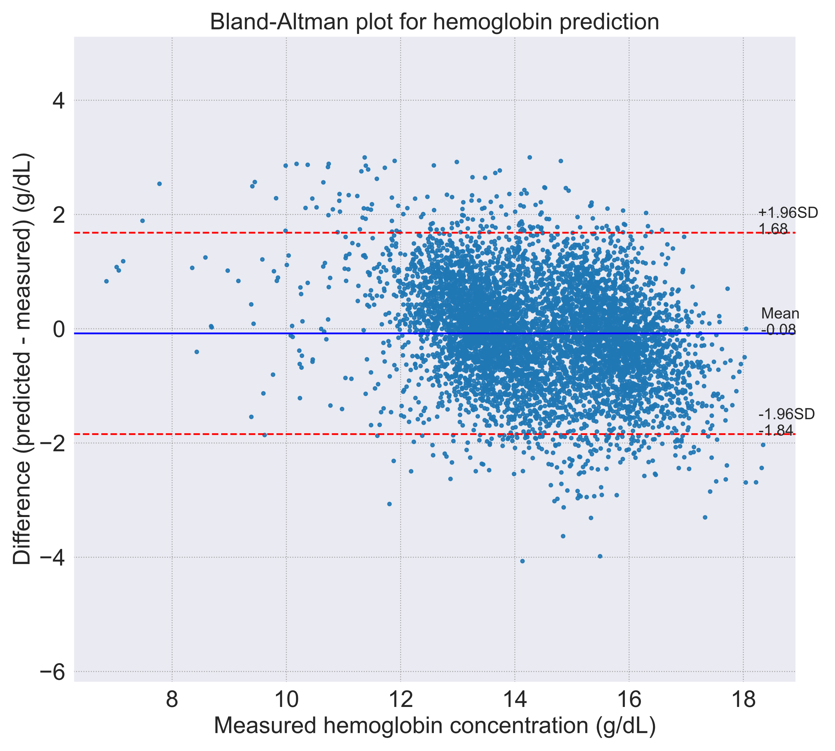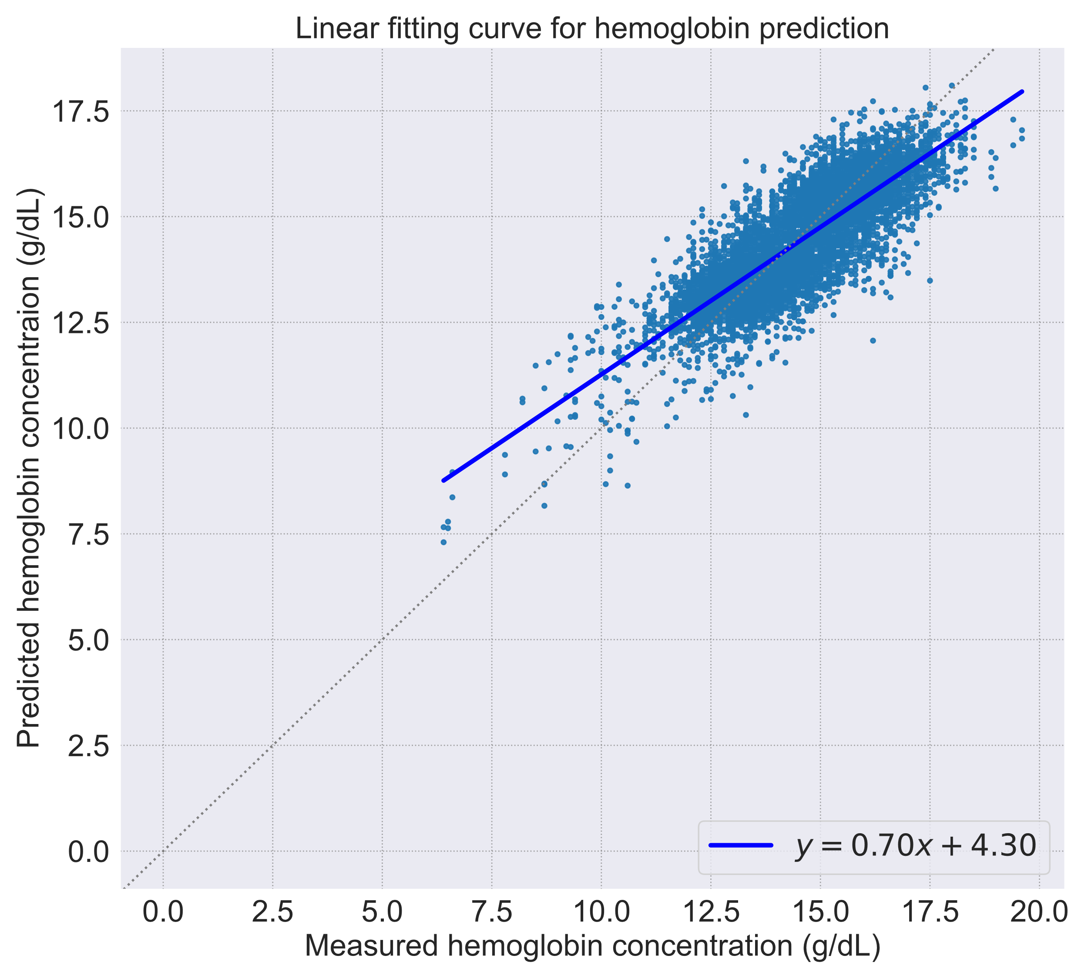
This figure visualizes the agreement and correlation between the haemoglobin concentration predicted by the best-performing model, DINOv2 fine-tuned with LoRA, and the laboratory-measured haemoglobin concentration in the test dataset (n=3,458).

