Supplemetary materials
Table 1: supplementary
Quadriceps | Hamstrings | Glutes
Vastus lateralis | Biceps femoris long head | Gluteus maximum
Vastus medialis | Biceps femoris short head
Vastus intermedialis | Semimebranosus
Rectus femoris | Semitendinosus

Hip joint contact force projection
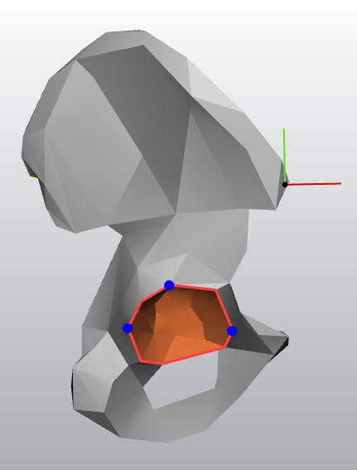
Step 1: Select the surface of the acetabular cup. The acetabular cup is “painted” to define a surface. Here, orange indicated the surfaces in the acetabular cup that are used to calculate a sphere.

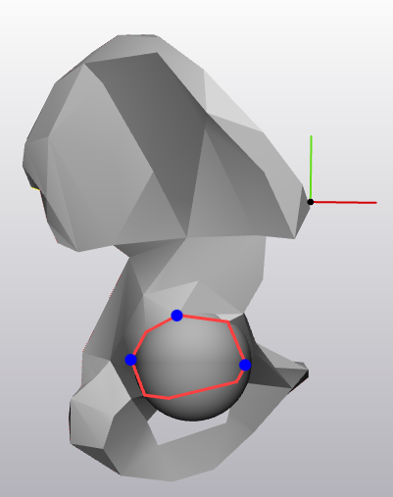
Step 2: Fit a sphere to the selected surface to get the acetabular cup.

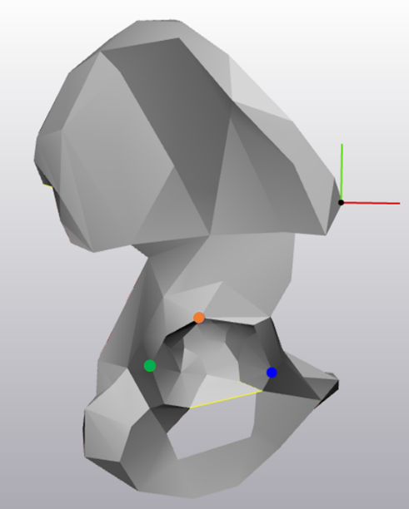
Step 3: Select three points on the acetabular cup to define the surface of the acetabulum. These points were used previously in [ref evy]. These three points can be used to define a plane that is called here the acetabular cup plane.

Superior Point
Anterior Point
Posterior Point

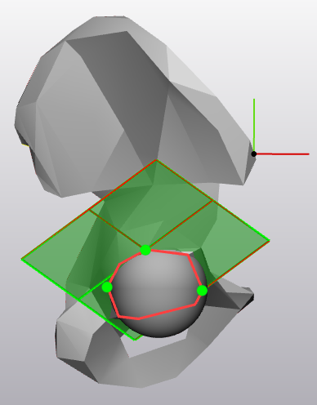
Step 4: Use the three points to create a datum plane for the acetabular cup plane. The three points are used to define the acetabular cup plane. The vector normal to this surface points in the direction of the centre of the acetabulum. This plane can also be used to cut the sphere fitted to the acetabulum.

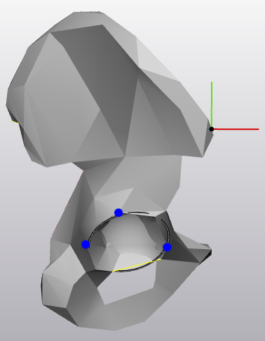
Step 5: Hollow the acetabular cup sphere then cut it with the datum plane of step 4.

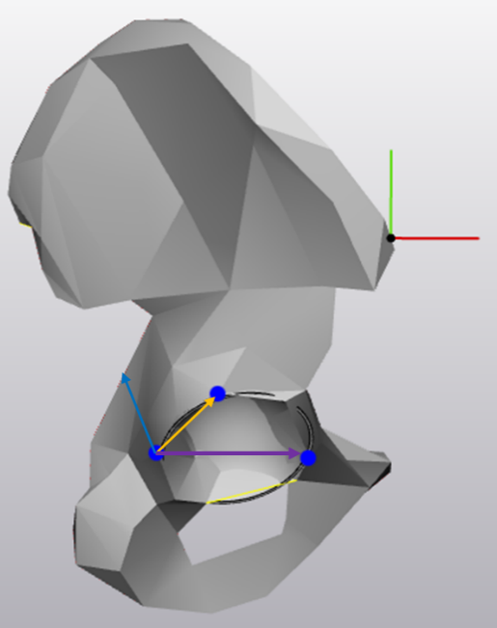
Step 6: Find the vector pointing into the acetabulum. The vector perpendicular to the cup is calculated by finding the cross product of the vector pointing from the posterior point to the superior point (Vector A) and the vector pointing from the posterior point to the anterior point (Vector B).
Cross product:
VectorA = Superior – Posterior
VectorB = Anterior – Posterior
VectorA × VectorB = PerpendicularVector

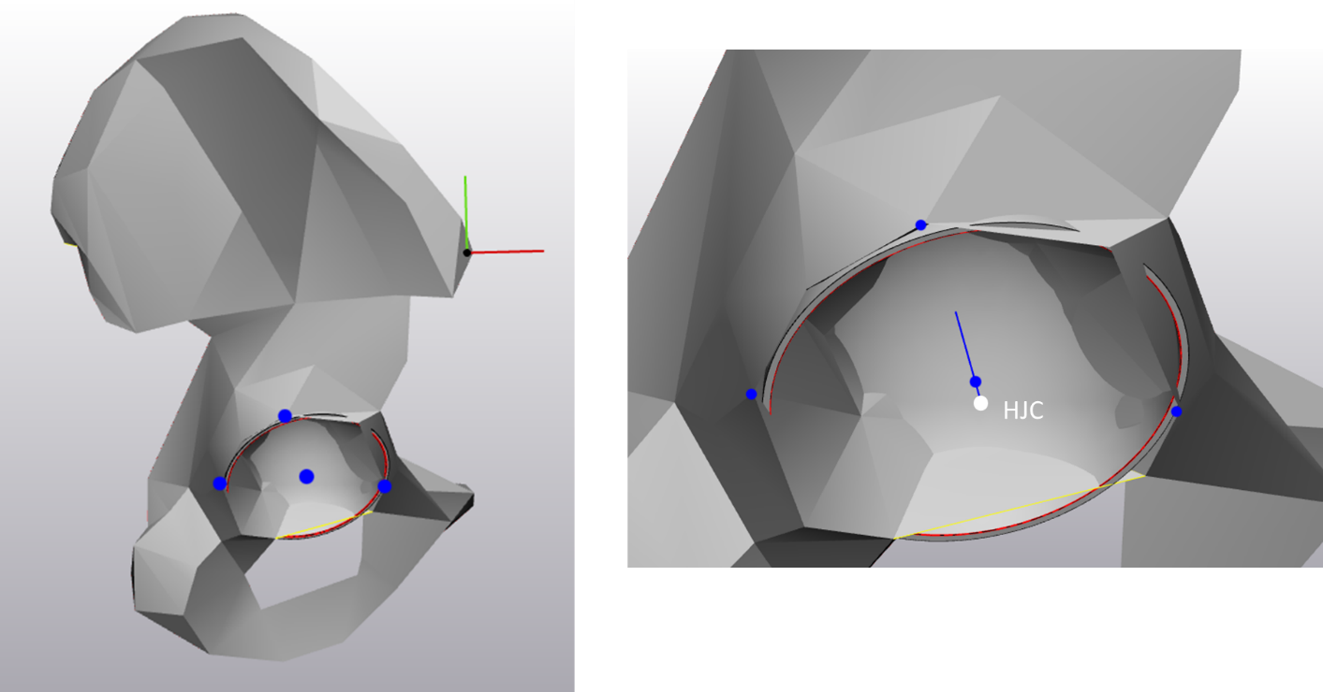
Step 7: Relocate the normal vector the hip joint centre (HJC). The HJC is the centre of the sphere that was fit to the acetabulum. The perpendicular vector calculated above (step 6) can be moved to the HJC and this line that goes from the HJC, and is normal to the acetabular cup plane, is our acetabular vector.

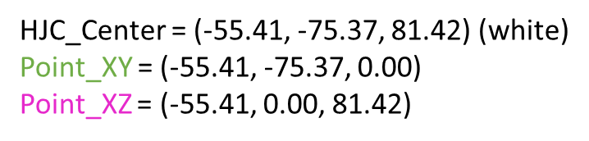
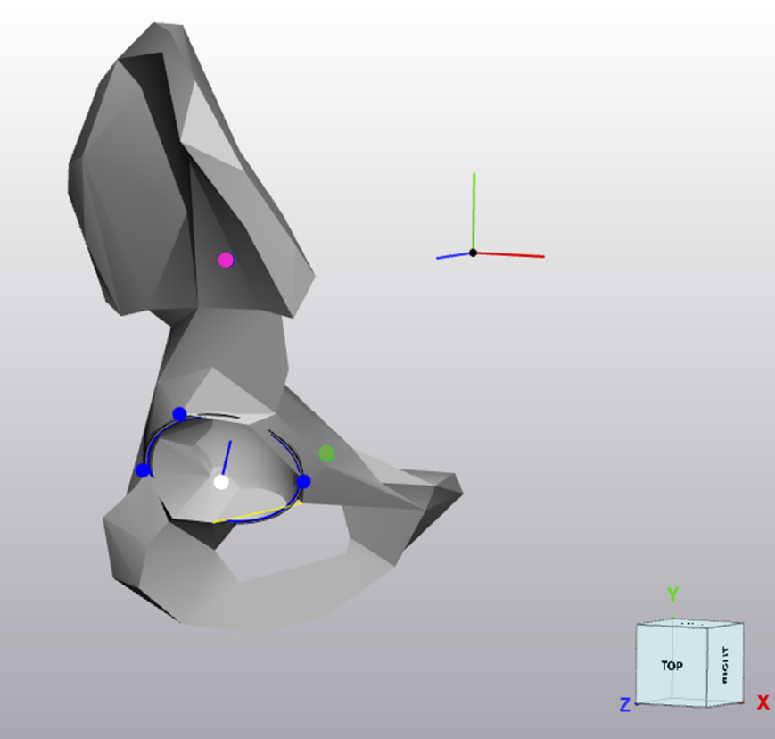
Step 8: We can cut the acetabular sphere in the coronal plane. This is done by using the points of the HJC and creating a plane in line with the coronal plane of the pelvis.
Point XY is the HJC point along the Z-axis and the point XZ is the HJC along the Y-axis.

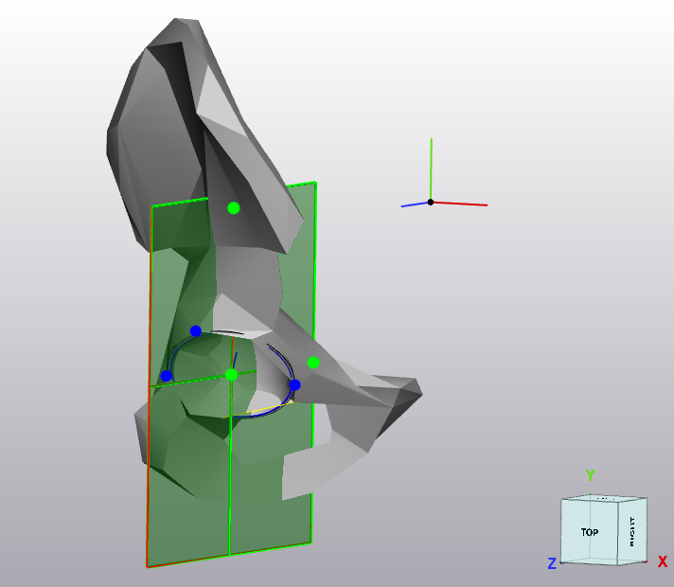
Step 9: The coronal plane is fitted to these points and the acetabular cup is cut again to form the posterior half of the acetabular cup.

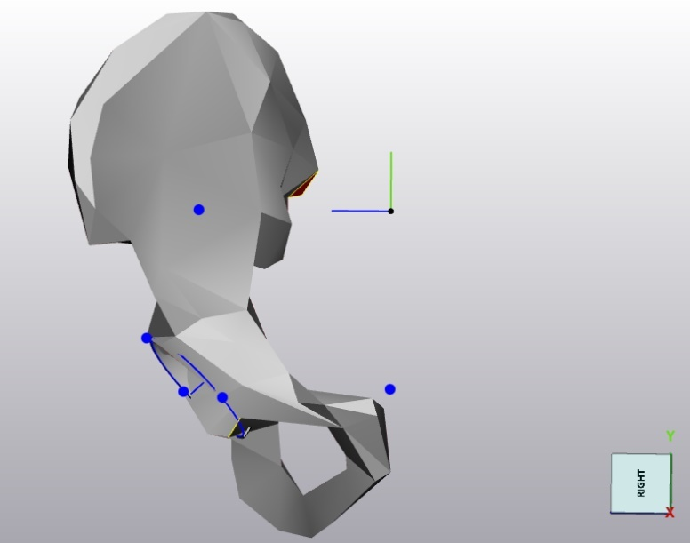
The resulting visual is that the acetabular cup has been fitted with a sphere. That sphere has been hollowed out. That sphere is then cut with the acetabular surface plane. It is cut again through the coronal plane intersecting the centre of the hip (HJC).

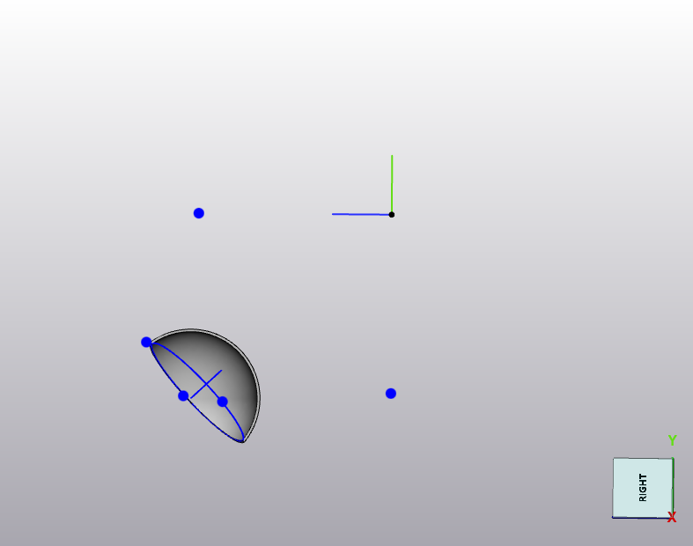
We now have a section of the acetabular cup that is not quite a quarter sphere. It is the posterior part of the acetabular cup. This is saved as an stl file and can be plotted in Python along with the hip joint contact forces to visualise the forces within the hip.

