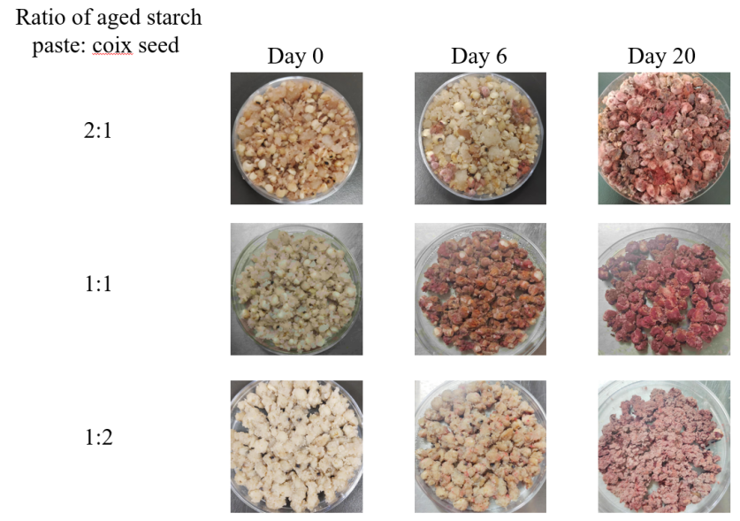
Fig. S1 The growth of five Monascus strains on solid medium of different contents of aged maize amylopectin
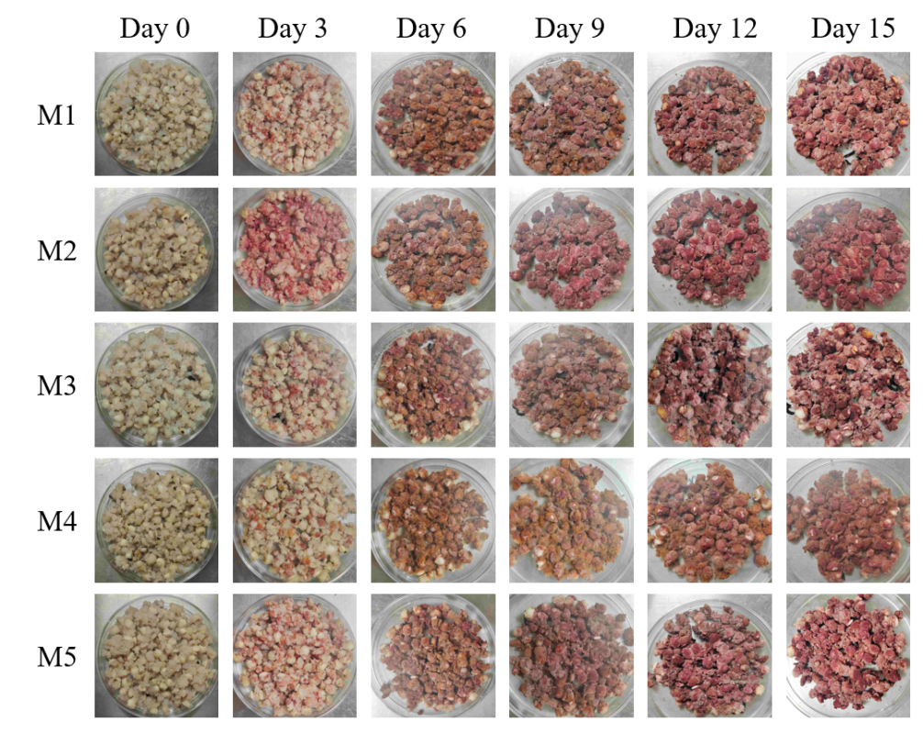
Fig. S2 Pictures for the growth of five Monascus strains on solid medium of aged starch paste and coix seeds at 32 ℃ for varying durations

