Supplemental

VPS array setup
The 20 m x 20 m experimental grid was set up by divers and marked with cinder blocks to which surface floats were attached on 16 September 2013. Acoustic receivers were deployed on 26 September 2013, ~20 m outside of the experimental plot - with an inter-receiver distance of 30 m. A pentagonal shape was determined by InnovaSea (Dana Allen, pers. comm.) to be the most suitable configuration for optimizing estimates of spatial position in the experimental grid. Receivers were attached with cable ties to rebar stakes set in cement within 5-gal buckets and synchronization tags were attached to the tops of rebar stakes. Three additional fixed reference tags were deployed (center of the array, southwest and northwest corners of the grid) to improve positioning accuracy. Spatial acoustic coverage was calibrated on 30 September 2013, prior to field experiments, by having divers swim through the array with an acoustic tag. Finally, cement blocks tied to lines with surface buoys were placed ~ 2-3 m beyond the acoustic receivers to mark and protect the area from boat disturbance. A Trimble® GPS receiver with sub-meter resolution was used to record positions of the experimental grid corners and receivers; coordinates at the center of the grid were 41.03722936º N, 72.38780288º W.
Environmental parameters and measurements
Water temperature during each field experiment was recorded every 30 min with a submersible Tidbit® automatic temperature recorder. Salinity was measured with a YSI Pro 2030 multi-probe meter at the start and end of each experimental trial. Ranges of surface water temperature and salinity through all of the field experiments were 12.7 - 30.6 ºC and 29.0 - 29.6, respectively (Table 2). Three replicate surficial sediment samples (to a depth of 5 cm) were taken at each of three locations within the 20 x 20 m grid; grain size fractions were later characterized according to Folk & Ward (1957). A 1-way ANOVA revealed no differences in mean proportion of sand at the three locations within the grid, so all subsamples were pooled; mean (SE) proportions for gravel, sand, and silt + clay fractions, respectively, were 0.060 (0.009); 0.926 (0.014) and 0.014 (0.008).
Hyperbolic positioning error (HPE) filter acoustic telemetry data
For acoustic telemetry data, a Hyperbolic Position Error (HPE) was estimated to provide a relative measure of the accuracy of each detection within the acoustic receiver array (Meckley et al. 2014). HPE filtering was based on criteria from Scheel and Bisson (2012). In general, the lower the HPE score, the more accurate the position estimate. In this study, the telemetry positioning array yielded over 32,424 detections across all 48 hr trials and, overall, HPEs were very low: 90% of the HPE's were < 1; mean = 1.5, median = 0.7, SE = 0.1. Higher HPE values only occurred when whelks moved far outside the pentagonal acoustic array. Scheel and Bisson (2012) estimated that HPE scores < 20 are of sufficient accuracy for tracking fine-scale movements of octopus on the order of meters; therefore, we elected to filter our data to eliminate position estimates that were greater than 20. Using this approach, less than 0.004% of all the detections were removed.
Hidden markov model (HMM) setup and fitting procedures
HMMs can identify several animal behavioral states, but users need to use realistic biological inference when constructing HMMs. Given the expected movement behavior of whelk is limited relative to other marine species, we employed two-state HMMs (encamped and exploratory) - which is the most common in the movement ecology literature (Bacheler et al. 2019). Encamped behaviors consisted of small step lengths and reduced angle direction variability; whereas, exploratory behavior is comprised of longer step lengths and wide variability of movement directionality. All models had gamma and von Mises family error distributions, for step length and angle, respectively (Bacheler et al. 2019).
Prior to fitting HMMs for each trial, we accounted for temporal irregularity and location measurement error by fitting our data to continuous-time correlated random walk models to each individual whelk track and specified the model to predict locations from observed data every four minutes (Johnson et al. 2008). Numerical maximum likelihood approaches were used to fit HMM models. Given that the maximum likelihood estimator could find a local maximum compared to the global maximum, initial values of step length and angle were selected randomly across a range of values and selected the model with the highest likelihood (Adam et al. 2019). To minimize the risk of parameter inestimability, each model was fitted 12 times across the random selection of parameters within the range of observed values. Parameter outputs from the base model with the global likelihood with no covariates were used as starting values in the HMMs with covariates to optimize model convergence (Michelot et al. 2016). Models with Akaike weights > .10 and delta AIC values < 7 were considered to have moderate support (Burnam and Anderson 2002).

Table S1. Summary of 2012-2014 laboratory experiments examining predation on bay scallops (Argopecten irradians irradians) by channeled (Busycotypus canaliculatus) and knobbed whelks (Busycon carica). Two size classes of channeled whelks (small = 113 - 139 mm shell length (SL); jumbo = 188 – 218 mm SL) were presented with two size classes of scallops (small = 25-30 mm shell height (SH) ; large = 49-60 mm SH) that were stocked at two densities (low = 10/m²; high = 75/m²). One size class of knobbed whelks (106-145 mm SL) was presented with the same sizes and densities of bay scallops. Damage to shells of predated scallops: No = no visible damage; Cr = cracked; Nch = notch: thin (<2 mm) chip at ventral margin, parallel to hinge; ND = not determined.

Water Whelk Whelk Scallop Scallop # of Total # of # Scallops Eaten Shell
Dates Temp. (C) Species Size Size Density Replicates Scallops Eaten per Whelk Per Day Damage

7/26-8/2/12 24.2-27.3 chan small large low 5 0 0
high 5 7 0.200 7 No
overall: 0.100

8/16-22/12 ~26.8 chan small small low 5 0 0
high 5 0 0
overall: 0

8/27-9/3/13 24.0-25.6 chan jumbo large low 3 2 0.095 2 No
high 3 3 0.143 2 No, 1 Cr
overall: 0.119

8/27-9/3/13 24.0-25.6 chan small large low 2 2 0.143 1 No, 1 Cr
high 2 0 0
overall: 0.071

9/24-30/13 17.6-18.9 chan small small low 4 0 0
high 5 1 0.033 1 ND
overall: 0.019

10/23-30/13 11.4-11.5 chan small small low 5 0 0
high 5 0 0
overall: 0

Water Whelk Whelk Scallop Scallop # of Total # of # Scallops Eaten Shell
Dates Temp. (C) Species Size Size Density Replicates Scallops Eaten per Whelk Per Day Damage

11/6-12/13 10.1-13.1 chan small large low 5 0 0
high 5 0 0
overall: 0

10/18-24/14 14.2-16.3 knob small small low 4 2 0.083 1 Ch, 1 Nch high 4 8 0.333 6 Nch, 1 No, 1 Cr
overall: 0.208

10/31-11/6/14 8.3-14.3 knob small small low 4 1 0.042
high 4 1 0.042 1 Nch, 1 ND
overall: 0.042

Table S2. Numbers/sizes of live wild scallops (0+ yr = juvenile, 1+ yr = adult) and whelks (channeled and knobbed) which were removed from the four 10 m x 10 m sectors of the experimental grid off Cedar Beach, Southold immediately prior to the start of field predation trials conducted in 2013. Whelks were removed out to ~3 m beyond the perimeter of the four sectors. Scallop shell height (SH) and whelk shell length (SL) were measured to the nearest mm. NM = not measured.

Wild Wild Wild Wild
Start Scallops (0+ yr) Scallops (1+ yr) Channeled Whelk Knobbed Whelk
Date # Mean (SE) SH # Mean (SE) SH # Mean (SE) SH # Mean (SE) SH

7 Oct 704 NM 68 NM 0 6 NM

16 Oct 173 42.0 (0.3) 23 67.6 (0.7) 3 156.0 (15.0) 32 155.8 (3.3)

21 Oct 16 44.1 (1.0) 7 69.5 (2.7) 0 39 161.2 (3.8)

28 Oct 16 NM 3 NM 4 142.5 (4.5) 36 152.5 (3.3)

30 Oct 82 NM 4 NM 3 139.3 (6.1) 4 142.2 (4.5)

Table S3. Size and sex of tagged channeled whelks released in field telemetry experiments off Cedar Beach, Southold, NY, October – November 2013. Individuals with blank sex information did not have sex recorded.

Start Burial Acoustic Shell Shell Total
Date Tag # Tag ID # Height (mm) Width (mm) Wet Wt (g) Sex

7 Oct 1 12715 131 68.5 126.8
2 12716 130 69 116.2
3 12717 131 77.5 123.5
4 12718 132 32? 122.6
5 12719 135.5 78.5 171.1
6 12720 134 74 141.9
7 12721 134 74 140.3 F
8 12722 135.5 73.5 148.0
9 12723 127 71 155.2 M
10 12724 134.5 68 139.8
All 10 whelks: 7 males, 3 females

16 Oct 11 12715 125 72 137.3 F
13 12716 135 69 132.2 M
14 12717 132 69 145.5 F
16 12718 137 70 142.1 F
17 12719 137 71 146.0 M
19 12720 134 69 145.4 M
28 12721 125 67 110.4 F
33 12722 134 72 158.8 F
45 12723 132 70 141.4 F
56 12724 132 68 144.1 F
All 10 whelks: 3 males, 7 females

21 Oct 12 12715 134 70 174.2 M
15 12716 135 71 148.3 M
18 12717 128 72 169.9 M
21 12718 134 69 129.5 M
22 12719 137 73 166.7
23 12720 134 73 159.4 M
24 12721 134 77 183.7 M
26 12722 136 72 143.3
30 12723 131 70 138.2
31 12724 130 71 165.6
All 10 whelks: 8 males, 2 females

Start Burial Acoustic Shell Shell Total
Date Tag # Tag ID # Height (mm) Width (mm) Wet Wt (g) Gender

28 Oct 59 12715 123 67 102.2 M
34 12716 131 72 109.1 F
49 12717 135 69 130.8 F
38 12718 104 50 68.1 M
25 12719 134 70 119.6 M
27 12720 135 68 120.6
40 12721 131 67 114.0 M
54 12722 116 61 83.2 F
51 12723 134 71 133.8
36 12724 132 68 128.9 M
All 10 whelks: 6 males, 4 females

30 Oct 55 12715 125 71 137.4 M
47 12716 131 69 143.4 M
43 12717 135 69 189.8 M
37 12718 140 76 181.5 M
46 12719 134 73 185.7 M
35 12720 133 71 132.8 F
42 12721 135 73 154.4 M
50 12722 137 77 179.2 M
53 12723 134 74 137.2 M
48 12724 134 72 153.1 M
All 10 whelks: 9 males, 1 female

Overall: 33 males, 17 females

Appendix S4. Numbers of cluckers recovered before (pre) and at the end of (post) field predation experiments conducted off Cedar Beach, Southold in 2013. Sectors # 1, 2, 3 4 represent the NE, NW, SW and SE quadrants, respectively, of the 10 m x 10 m experimental grid. Numbers of cluckers (post) were those which had accumulated after removal of all cluckers at the end of the prior experiment - except on 30 October, when this experiment was run immediately after the prior one. Total clucker numbers for a given sector represent those found inside that sector plus cluckers that were collected beyond the perimeter of adjacent sectors (out to ~3 m to the W, E and ~5 m to the N, S); numbers in parentheses = # of natural scallop cluckers; ND = not determined. Shading indicates that sector was planted at the high scallop density (target = 75/m²). ↄ = wild cluckers; * = includes 8 cluckers that were directly observed to have been eaten by knobbed whelks on 16 October 2013 in unspecified sectors.

Expt Sector 1 Sector 2 Sector 3 Sector 4
Dates Inside Outside Total Inside Outside Total Inside Outside Total Inside Outside Total Total

16 Oct (pre) 1 ND 1 ND ND ND 1 ND 1 ND ND ND 2^{ↄ}

18 Oct (post) 48 ND 48 1 ND 1 15 ND 15 15 ND 15 87*

21 Oct (pre) 147 12 159 0 0 0 78 ND 78 36(1) 6 42 279

24 Oct (post) 22 ND 22 16 ND 16 71 ND 71 87 ND 87 196

28 Oct (pre) 25 15 40 10 3 13 50 17 67 61 67 128 248

30 Oct (post) 41 5 46 41 6 47 29 22 51 78 35 113 257

Grand Total = 1069

Appendix S5. Cumulative numbers of live planted scallops recovered from the experimental area off Cedar Beach, Southold at the end of the last predation experiment on 30 October 2013. Totals include scallops recovered from inside the four 10 m x 10 m sectors and beyond the perimeter of respective sectors (out to ~3 m to the W, E and ~5 m to the N, S). Low, high = low and high planting densities: target = 10 and 75/m², respectively.

Live
Inside Outside Total

Sector 1 (Low) 1900 91 1991

Sector 2 (High) 1900 184 2084

Sector 3 (Low) 1300 270 1570

Sector 4 (High) 4400 359 4759

9500 904 10404

Appendix S6. Opportunistic observations of (A) channeled and (B) knobbed whelk predation on bay scallops made while diving in the Peconic Bays, 2011-2015. Off CB = in and near experimental plot off Cedar Beach; Sh= shell; SL= whelk shell length; SH= scallop shell height.

- Channeled Whelks
Sediment Depth Water Whelk Scallop
Date Location Type (m) Temp (ºC) SL (mm) SH (mm) Notes
11 Oct 2011 Great Peconic Bay Sand 4.3 18.6 174 48 mostly buried; scallop entirely engulfed
16 Oct 2013 Southold (off CB) Sand 3 17.7 135 75
28 Oct 2014 Southold (off CB) Sand 3 15.6 160 65 outer lip of whelk was inserted between scallop
valves at ventral margin, with hinge held firmly in place by foot and perhaps operculum which was immediately distal
22 Oct 2015 Flanders Bay Sand 3.1 15.0 171 60 scallop entirely engulfed by whelk foot

- Knobbed Whelks
Sediment Depth Water Whelk Scallop
Date Location Type (m) Temp (ºC) SL (mm) SH (mm) Notes
27 Sep 2012 Northwest Harbor Sand 1-2 21.7 238 81
27 Sep 2012 Northwest Harbor Sand 1-2 21.7 213 76
27 Sep 2012 Northwest Harbor Sand 1-2 21.7 216 78
25 Oct 2012 Southold Bay Sand 2.8 16.7 161 57 scallop entirely engulfed by whelk foot
16 Oct 2013 Southold (off CB) Sand 2-3 17.4-17.6 133 27
16 Oct 2013 Southold (off CB) Sand 2-3 17.4-17.6 132 22
16 Oct 2013 Southold (off CB) Sand 2-3 17.4-17.6 190 29 scallop completely inside whelk shell aperture
16 Oct 2013 Southold (off CB) Sand 2-3 17.4-17.6 143 31 scallop completely inside whelk shell aperture
16 Oct 2013 Southold (off CB) Sand 2-3 17.4-17.6 156 26 scallop already consumed
16 Oct 2013 Southold (off CB) Sand 2-3 17.4-17.6 195 29 scallop still alive
16 Oct 2013 Southold (off CB) Sand 2-3 17.4-17.6 163 27
16 Oct 2013 Southold (off CB) Sand 2-3 17.4-17.6 155 29
2 Nov 2013 Southold (off CB) Sand 4 13.9 146 61
4 Nov 2013 Sag Harbor Mud 3-5 12.8 173 69
14 Jul 2014 Orient Harbor Mud 5-6 23.9 147 56
28 Oct 2014 Southold (off CB) Sand 3 15.6 215 67
29 Jun 2015 Hog Neck Bay Sand/Sh 3.7 22.8 164 31 notch evident at ventral margin of scallop shell

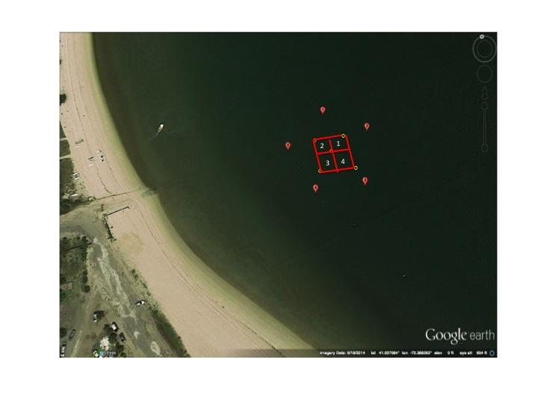Figure 1. Experimental 20 x 20 m grid and acoustic positioning receiver array located ~75-100 m off Cedar Beach, Southold, NY. Numbers within the grid represent 10 m x 10 m sectors where bay scallop plantings were done at low or high densities. Sector 1 is the Northeast quadrant.

Figure 2. Notching of the ventral margins of bay scallop shell valves, a characteristic type of damage inflicted by knobbed whelks, Busycon carica, during predatory attacks – as seen in laboratory experiments and field observations.

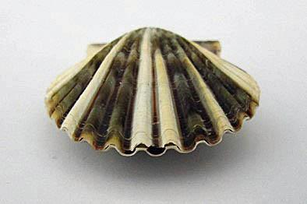

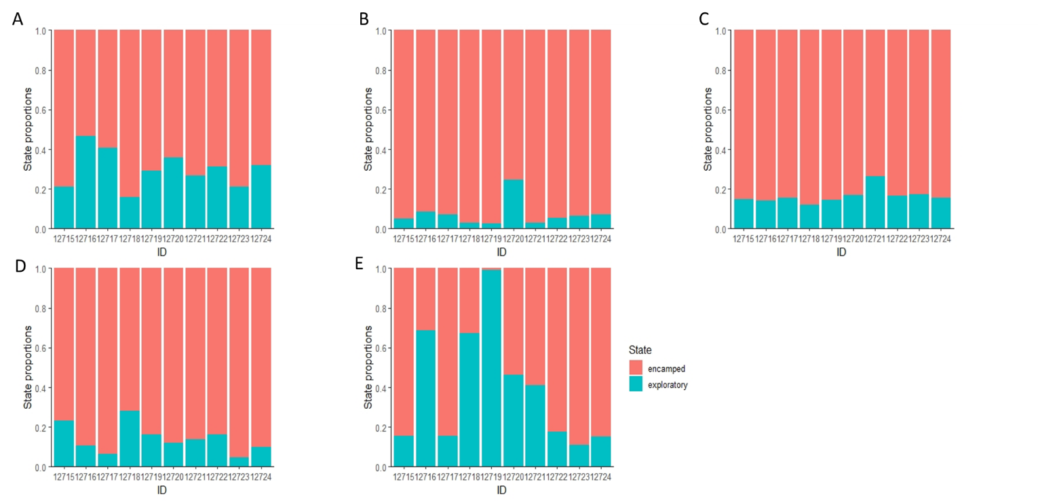
Figure 3: Amount of time each individual tagged whelk spent in each of the two states, encamped (pink) and exploratory blue), in the best fit 2-state hidden Markov models for each respective trials. Trials 1,2,3,4,5 are denoted by figures A,B,C,D,and E, respectively.

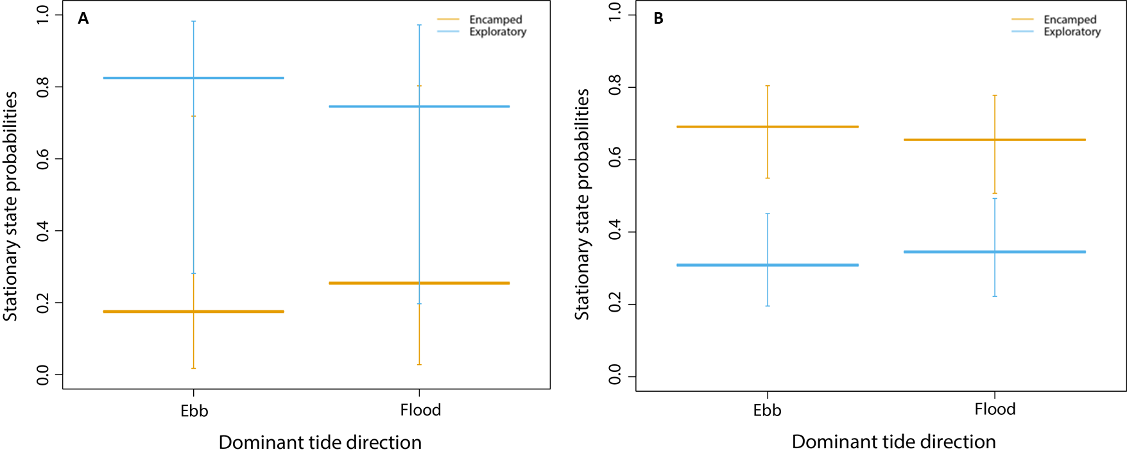
Figure 4. Mean stationary state distributions between predominant tide cycles (flood or ebb) of whelk behavorial states from trials 3 (A) and (B). Error bars indicated 95% confidence intervals.

