Superior Mechanoluminescence of ZnS:Mn/ZnO Heterostructure Array Chip Boosted by Type Ⅱ Electron Transition

Jiateng Fan^{1,3}, Yunkai Wang³, Aihua Zhong^{1,3*}, Hang Yang², Zhiheng Ma^{1,3}, Shuangmei Xue¹, Dengfeng Peng^{1,3}, Longbiao Huang³, Jingting Luo^{1,3}, Dong Tu^{2*}, Kazuhiro Hane⁴
¹State Key Laboratory of Radio Frequency Heterogeneous Integration, College of Physics and Optoelectronic Engineering, Shenzhen University, Shenzhen 518060, P.R. China
²Faculty of Materials Science and Chemistry, China University of Geosciences, 388 Lumo Road, Wuhan 430074, China
³Key Laboratory of Optoelectronic Devices and Systems of Ministry of Education and Guangdong Province, College of Physics and Optoelectronic Engineering, Shenzhen University, Shenzhen 518060, China
⁴New Industry Creation Hatchery Center, Tohoku University, Sendai, 980-8579, Japan
Corresponding authors: Aihua Zhong (zhongah@szu.edu.cn), Dong Tu (tudong@cug.edu.cn)

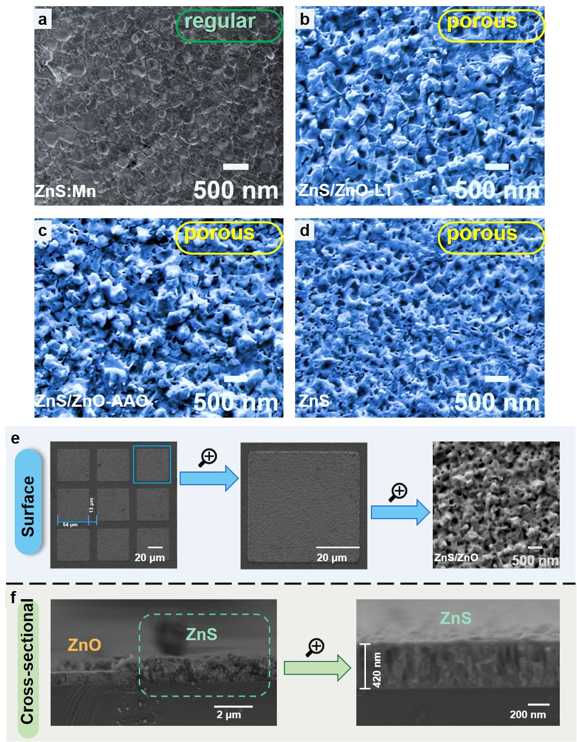
Figure S1 SEM images of (a) the compact ZnS:Mn film directly grown by ZnS target, (b) the ZnS:Mn /ZnO-LT heterostructure, (c) the ZnS:Mn /ZnO-AAO heterostructure, and (d) the ZnS:Mn film prepared by sulfidation of ZnO:Mn. (e) SEM images of the ZnS:Mn/ZnO-LT heterostructure array. (f) Cross-sectional images of the ZnS:Mn /ZnO-LT heterostructure.

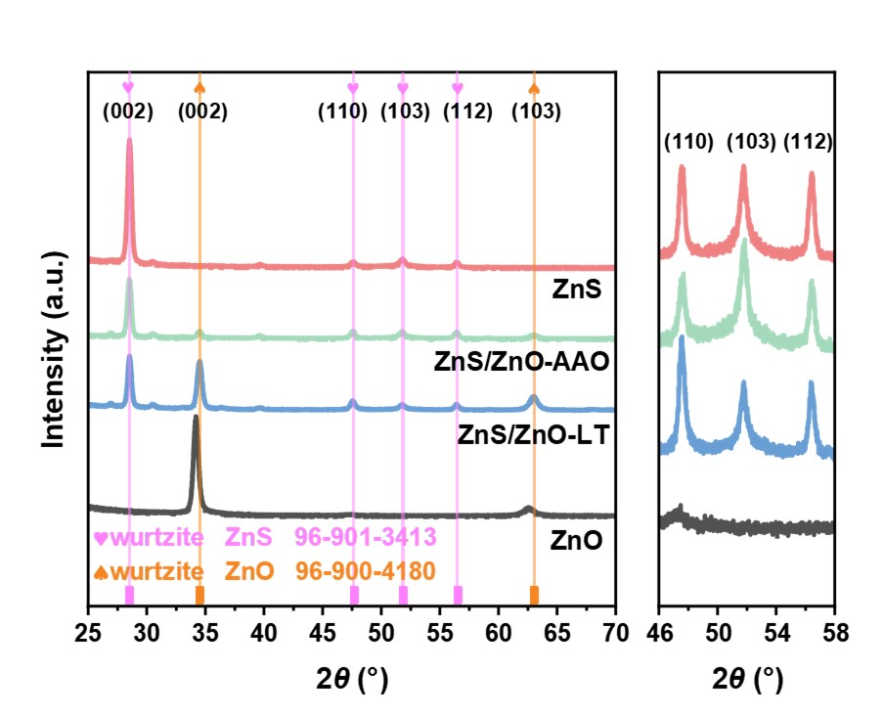
Figure S2 XRD patterns of the ZnS:Mn, the ZnO, the ZnS:Mn/ZnO-AAO, and the ZnS:Mn/ZnO-LT heterostructure thin films. Parts of the ZnO film were successfully protected from sulfidation by AlN barrier or the AAO.
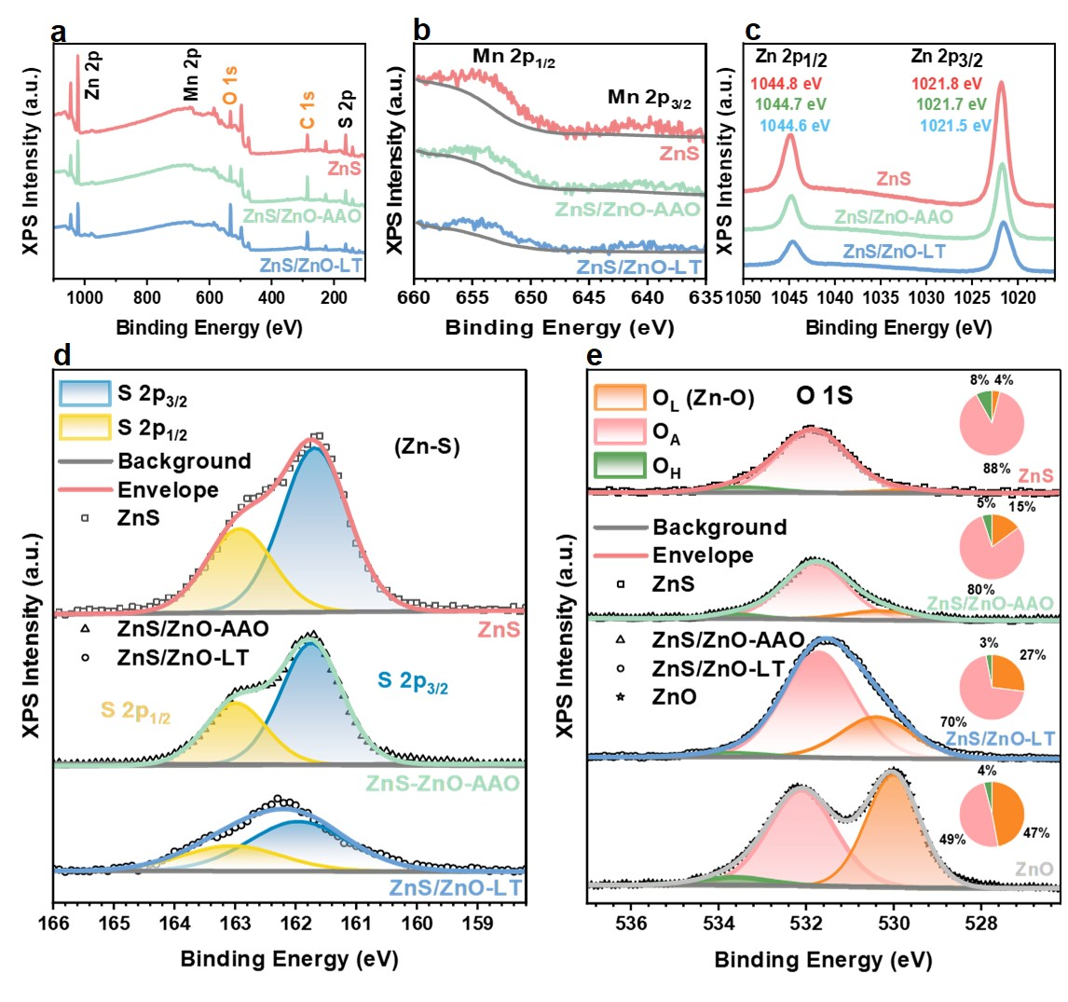
Figure S3 a) XPS survey curve of the sulfidated ZnS:Mn, the ZnS:Mn /ZnO-AAO, and the ZnS:Mn /ZnO-LT heterostructure thin films, and the corresponding high-resolution XPS curves of b) Mn 2p, c) Zn 2p, d) S 2p and e) O 1S, respectively. Mn 2p peaks centered at 653.4 eV and 639.5 eV, corresponding to Mn 2p1/2 and Mn 2p3/2, respectively^{1,2}. The asymmetric S 2p peak of sulfur was resolved into two subpeaks at 161.1 eV and 162.2 eV. The binding energy peak at 161.1 eV corresponds to the sulfur ion (S²⁻) within the ZnS structure^{3,4}. The binding energy peak at 529.7 eV corresponding to the oxygen ions (O²⁻) within the lattice (O_{L}), confirming the existence of Zn-O chemical bonds in the film^{5–7}. For the ZnS film, no O_{L} is observed, suggesting the completed sulfidation of the ZnO to ZnS film.

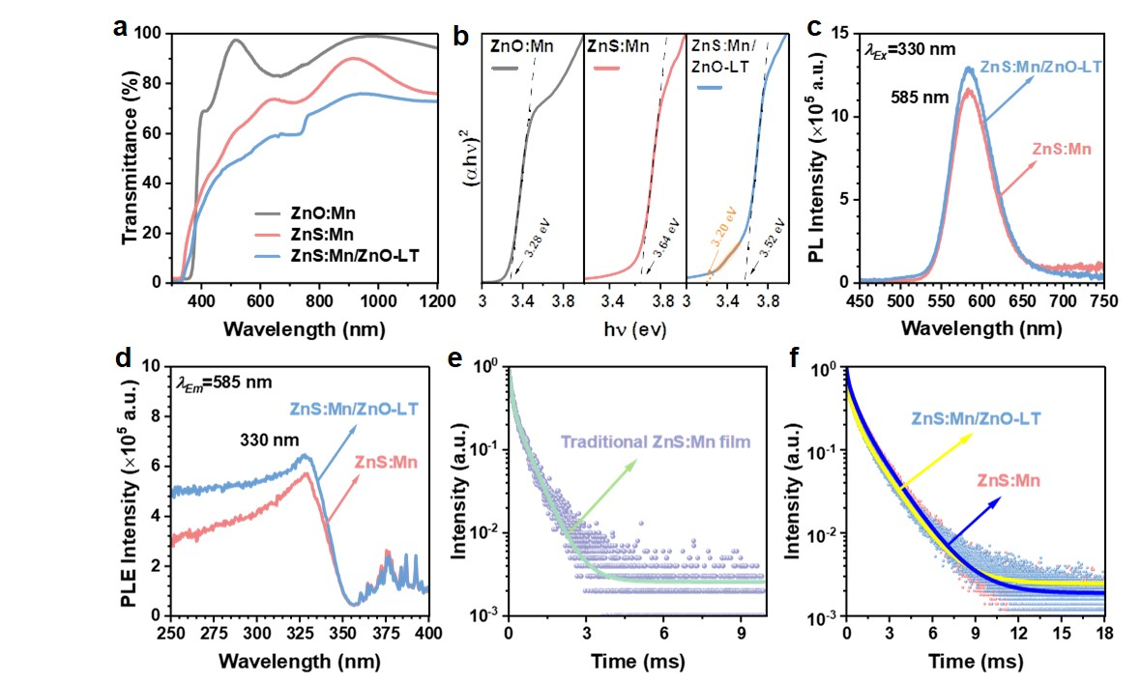
Figure S4 a) The transmittance spectra of the ZnO, the ZnS, and the ZnS:Mn/ZnO-LT heterostructure films. b) optical band gap of three films. c) PL spectra of ZnS:Mn films and the ZnS:Mn/ZnO-LT heterostructure. d) PLE spectra of ZnS and the ZnS:Mn/ZnO-LT films. PL decay curves of e) traditional ZnS: Mn films and f) porous ZnS:Mn film and ZnS:Mn/ZnO-LT heterostructure (λ_{Em} = 585 nm, λ_{Ex} = 330 nm).
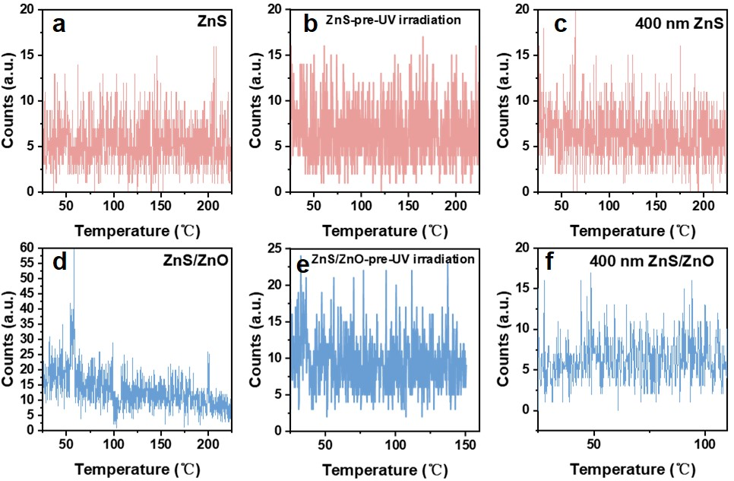
Figure S5 Thermoluminescence spectra of ZnS and ZnS/ZnO films with different thicknesses and substrates. a) 200 nm thick ZnS films on quartz substrates. b) 200 nm thick ZnS/ZnO films on quartz substrates. c) 200 nm thick ZnS films on a Si substrate with an oxide layer. d) 200 nm thick ZnS/ZnO films on a Si substrate with an oxide layer. e) 400 nm thick ZnS films on quartz substrates. f) 400 nm thick ZnS/ZnO films on quartz substrates
Figure S6 ML spectrum of 200 nm thick (a) ZnS:Mn, (b)ZnS:Mn/ZnO-AAO, and (c) ZnS:Mn/ZnO-LT heterostructure thin films grown on quartz glass substrates. (d) and (e) Summarized ML intensity of three films.
Figure S7 ML spectrum of 400 nm thick (a) ZnS:Mn, (b)ZnS:Mn/ZnO-AAO, and (c) ZnS:Mn/ZnO-LT heterostructure thin films grown on sapphire substrates. (d) and (e) Summarized ML intensity of three films.
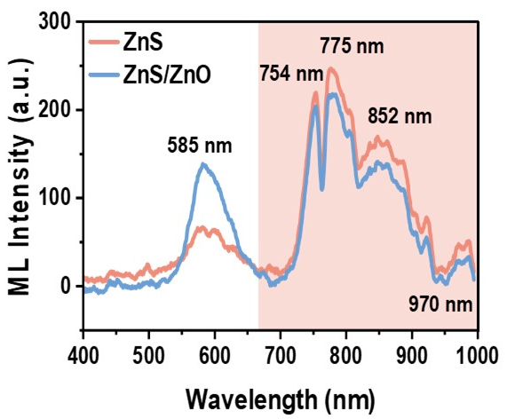
Figure S8 ML performances of the sulfidated ZnS:Mn, and the ZnS:Mn /ZnO-LT heterostructure thin films upon mechanical stimulus with frequency of 500 Hz.

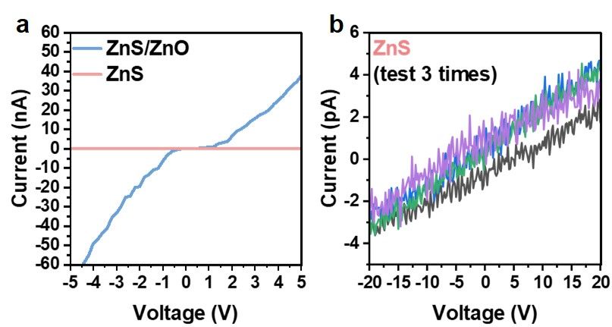
Figure S9 (a) Current-voltage curve of the sulfidated ZnS:Mn, and the ZnS:Mn /ZnO-LT heterostructure thin films; (b) Represented current-voltage curve of the sulfidated ZnS:Mn.

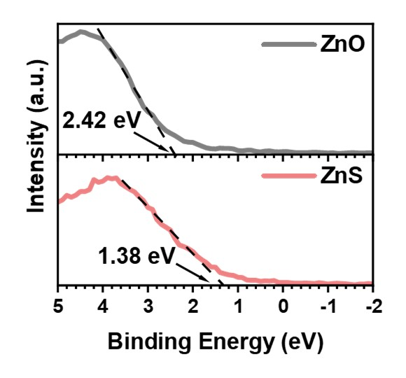
Figure S10 Valence-band edge (VBE) spectra of the ZnO and ZnS films.

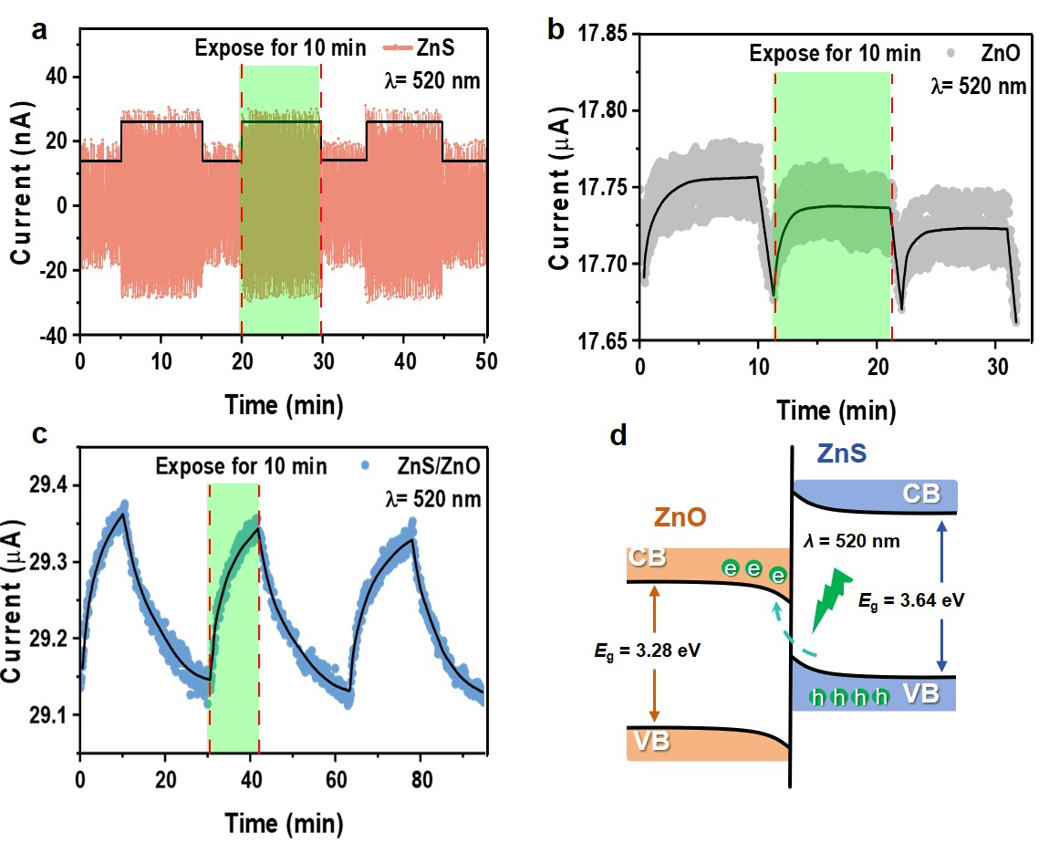
Figure S11 Current response of (a) the sulfidated ZnS:Mn film, (b) the ZnO film, and (c) the ZnS:Mn/ZnO-LT heterostructure under a 520 nm light illumination. The photon response in (a) and (b) are negligible since the bandgaps of the ZnS and the ZnO are 3.64 and 3.28 eV, respectively, larger than the energy of 520 nm (2.39 eV). Thus the electrons in the valence band of these two materials could not be directly activated to their conduction band. Interestingly, the photon response of the ZnS:Mn/ZnO-LT heterostructure in (c)is significant, suggesting the type Ⅱ electron transition. (d) Illustration of the type Ⅱ electron transition, where the electrons in the valence band of ZnS are activated to the conduction band of the ZnO by the 2.39 eV photons.

Figure S12 Photoluminescence spectra of the films deposited with various powers of the Mn targets while the power of ZnO target was kept at a constant of 100 W.

Figure S13 Temperature process during annealing and sulfur powder heating process.

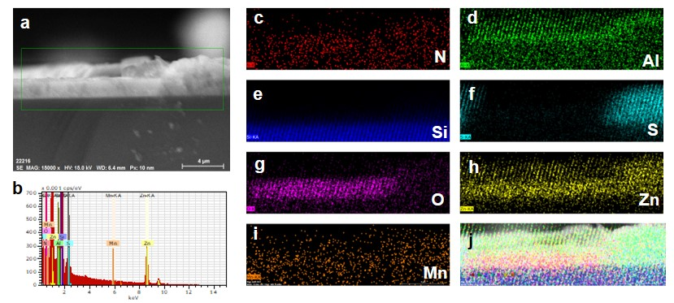
Figure S14 (a）Cross-sectional image of the ZnS:Mn/ZnO-LT film. (b) EDS measurement. (c)-(j) EDS mappings of elements.

Table S1.
Lifetime of the traditional ZnS:Mn, ZnS:Mn, ZnS:Mn/ZnO-LT films.
Sample | A₁ | 𝜏₁(ms) | A₂ | 𝜏₂(ms) | A₃ | 𝜏₃(ms) | 𝜏_{ave}(ms)
Traditional ZnS:Mn | 541 | 0.111 | 364 | 0.571 | null | null | 0.468
ZnS:Mn | 236 | 0.098 | 39 | 0.546 | 342 | 1.679 | 1.32
ZnS:Mn/ZnO-LT | 335 | 0.041 | 218 | 0.405 | 281 | 1.631 | 1.33
Table S2.
Peak positions of core level and VBM positions used to calculate the VBO and CBO.
Sample | Region | Binding Energy (eV)
ZnS | S 2P | 161.68
 | VBM | 1.38
ZnO | O 1S | 530.01
 | VBM | 2.42
ZnS/ZnO | S 2P | 161.95
 | O 1S | 530.4
Determination of the energy band alignment of the ZnS:Mn/ZnO heterostructure:
Utilizing XPS core-level spectra results in Figure S10 and Table S2, the energy band diagram of the ZnS:Mn/ZnO heterostructure could be precisely determined. The position of the valence band maximum (VBM) can be determined through a linear extrapolation of the leading edges of the valence band spectra, as shown in Figure S9, which were recorded on ZnO and ZnS films. The VBM values of ZnO and ZnS are 2.42 eV and 1.38 eV, respectively, relative to Fermi energy level. The valence band offset (VBO, ∆$E_{V}$) and conduction band offset (CBO, ∆$E_{C}$) are described by the formula^{8,9}:
∆$E_{V}$=($E_{O1s}^{ZnO}$-$E_{S2p}^{ZnS}$)_{interface}-($E_{O1s}^{ZnO}$-$E_{VBM}^{ZnO}$)+($E_{S2p}^{ZnS}$-$E_{VBM}^{ZnS}$) (1)
∆$E_{C}$=$E_{g}^{ZnO}$-$E_{g}^{ZnS}$-∆$E_{V}$ (2)
Where $E_{g}^{ZnO}$and $E_{g}^{ZnS}$ is meaured by Tauc plot and depicted in Figure 6b. ($E_{O1s}^{ZnO}$-$E_{S2p}^{ZnS}$)_{interface} is the energy difference between O 1s and S 2p core levels, which is measured from the ZnS/ZnO films, ($E_{O1s}^{ZnO}$-$E_{VBM}^{ZnO}$) is the energy difference between O 1s and VBM in the ZnO films, ($E_{S2p}^{ZnS}$-$E_{VBM}^{ZnS}$) is the energy difference between S 2p and VBM in the ZnS films. The above values in detail are summarized in Table S2.
Based on the data in Table S2, the energy band diagrams of isolated ZnS and ZnO before forming the ZnO/ZnS heterostructure could be precisely determined. The valence band offset ∆$E_{V }$and the conduction band offset ∆$E_{C}$between the ZnO and ZnS were calculated according to eq (1) and (2), 1.16 and 1.52 eV, respectively. The difference between the conduction band (CB) of the ZnO and the valence band (VB) of the ZnS is 2.12 eV. After contacting, some electrons in the ZnS flow into the ZnO to achieve thermal equilibrium, leading to a band-bending in the ZnS/ZnO interface. Herein, the difference between the CB_{ZnO} and the VB_{ZnS} is smaller than the energy gap of the ZnS. This kind of energy band is called as type Ⅱ energy band.
References:
1 Zhou T, Chen H, Guo J, Zhao Y, Du X, Zhang Q et al. Unrevealing Temporal Mechanoluminescence Behaviors at High Frequency via Piezoelectric Actuation. Small 2023; 19: 2207089.
2 Wang Y, Fan J, Su H, Wu Y, Tu D, Peng D et al. The Determining Role of Stacking Fault in The Mechanoluminescence Properties of ZnS: Mn Thin Films. Applied Surface Science 2024; 656: 159583.
3 Kim S, Yang F, Jung HS, Hong G, Hahn SK. Mechanoluminescence and Mechanical Quenching of Afterglow Luminescent Particles for Wearable Photonic Display. Adv Funct Materials 2024; 34: 2314861.
4 Liang Y-C, Wang C-C. Surface Crystal Feature-dependent Photoactivity of ZnO–ZnS Composite Rods via Hydrothermal Sulfidation. RSC Adv 2018; 8: 5063–5070.
5 Bera S, Khan H, Biswas I, Jana S. Polyaniline Hybridized Surface Defective ZnO Nanorods with Long-term Stable Photoelectrochemical Activity. Applied Surface Science 2016; 383: 165–176.
6 Han J, Liu W, Zhang T, Xue K, Li W, Jiao F et al. Mechanism Study on The Sulfidation of ZnO with Sulfur and Iron Oxide at High Temperature. Sci Rep 2017; 7: 42536.
7 Liu W, Zhu L, Han J, Jiao F, Qin W. Sulfidation Mechanism of ZnO Roasted with Pyrite. Sci Rep 2018; 8: 9516.
8 Guo P, Jiang J, Shen S, Guo L. ZnS/ZnO Heterojunction as Photoelectrode: Type II Band Alignment Towards Enhanced Photoelectrochemical Performance. International Journal of Hydrogen Energy 2013; 38: 13097–13103.
9 Gu X, Zhang S, Zhao Y, Qiang Y. Band Alignment of ZnO/ZnS Heterojunction Prepared through Magnetron Sputtering and Measured by X-ray Photoelectron Spectroscopy. Vacuum 2015; 122: 6–11.

