Supplement 1
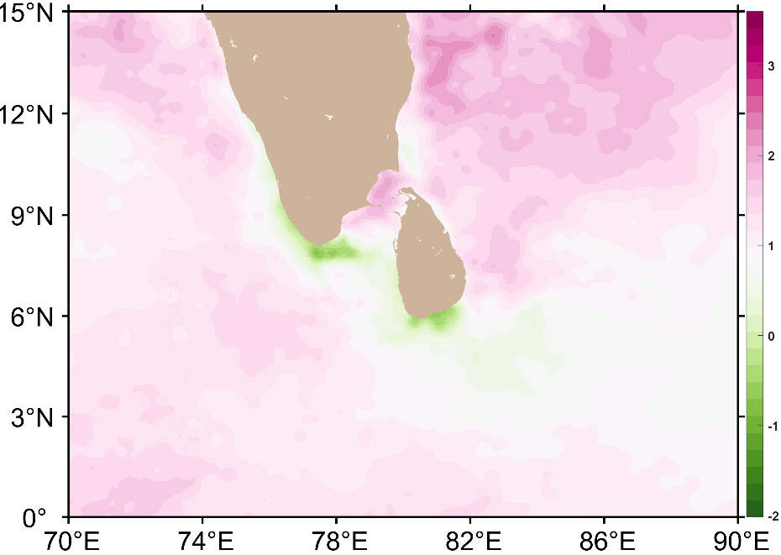
a
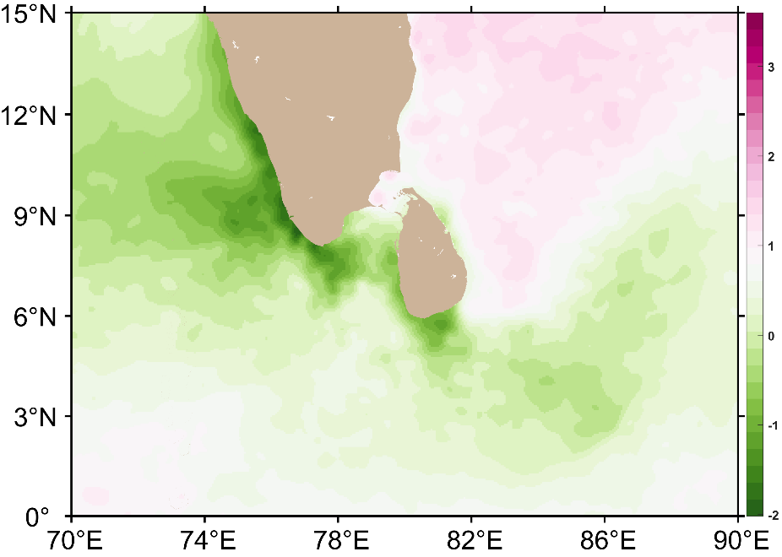
b
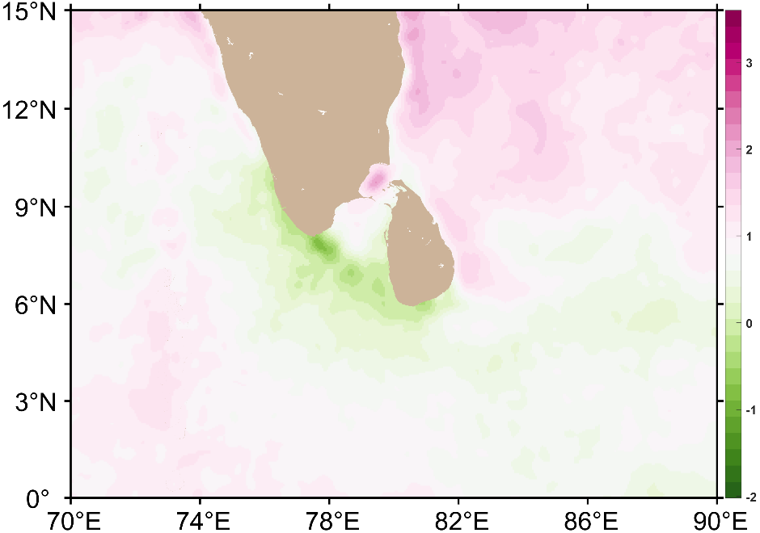
c
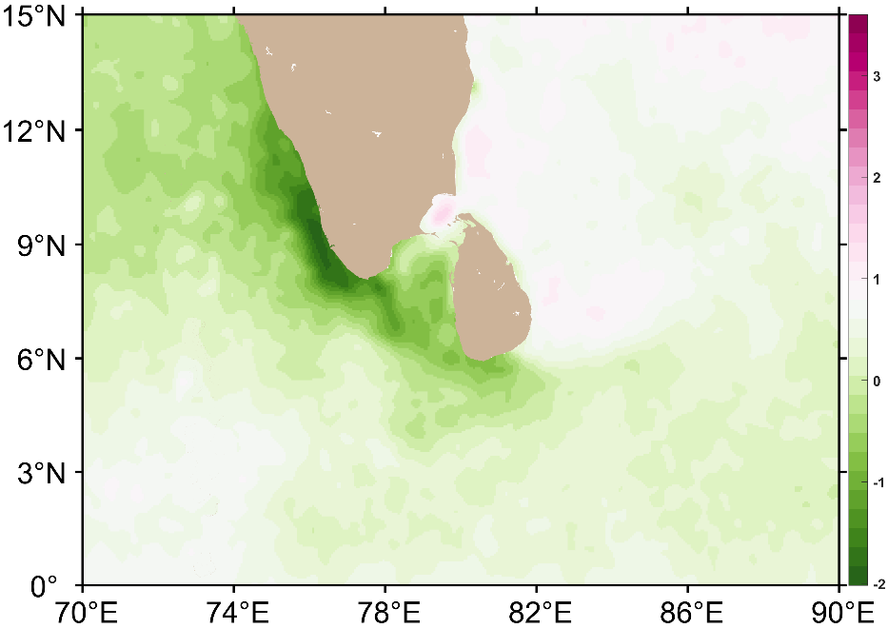
d
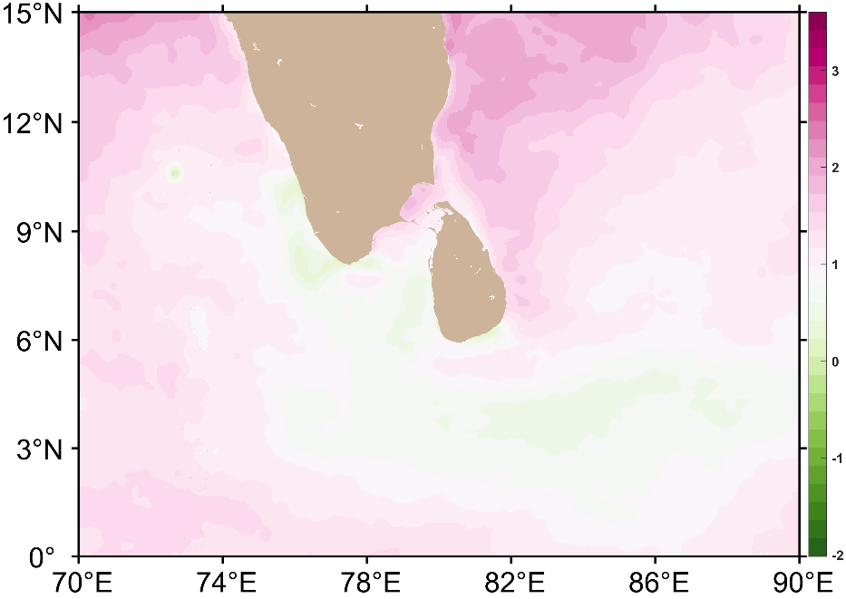
e
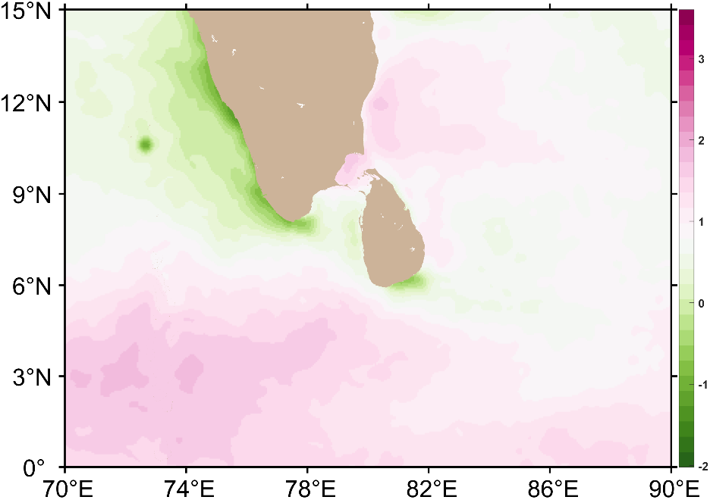
f
Fig. 1 Sea Surface Temperature (SST) anomaly in the Indian Ocean around Sri Lanka during June and July of 1998, 2016, and 2024 ENSO years. The anomaly was calculated as the difference between the monthly mean and the long-term (1984-1996) mean SST in the same region. a,c, and e SST anomaly of April in 1998, 2016, and 2024, b,d, and f SST anomaly of May in 1998, 2016, and 2024

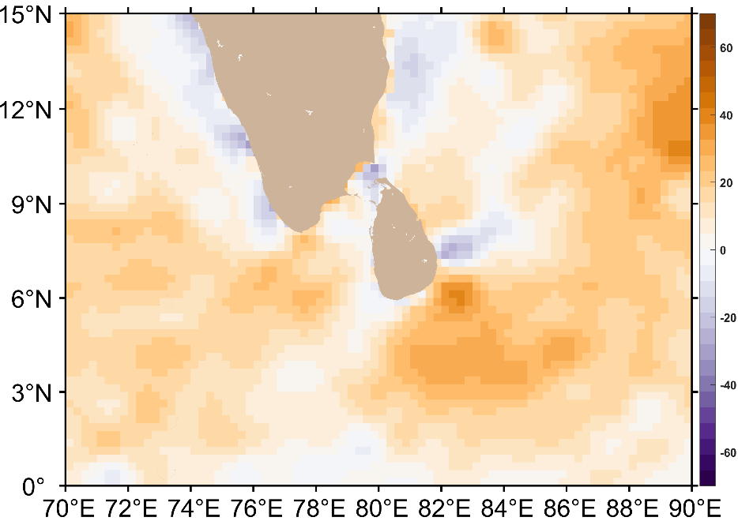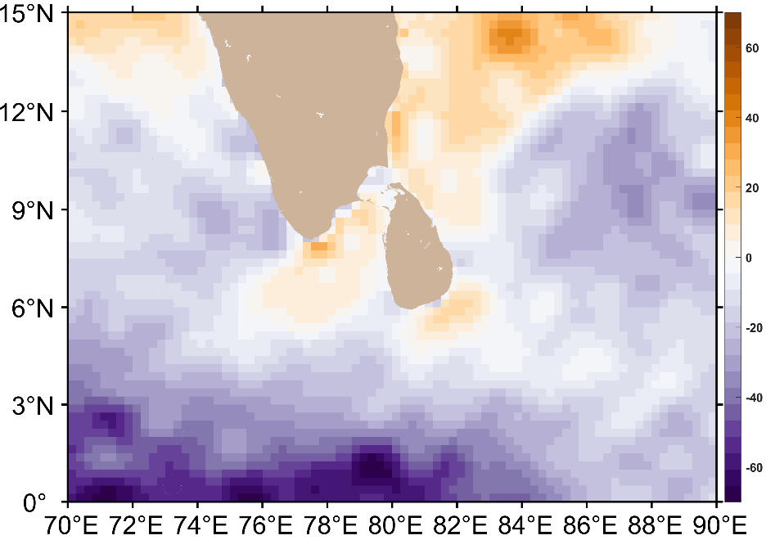
b
a
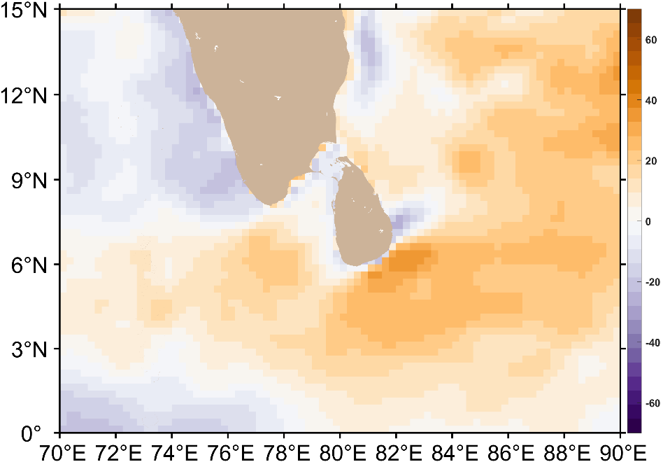
c
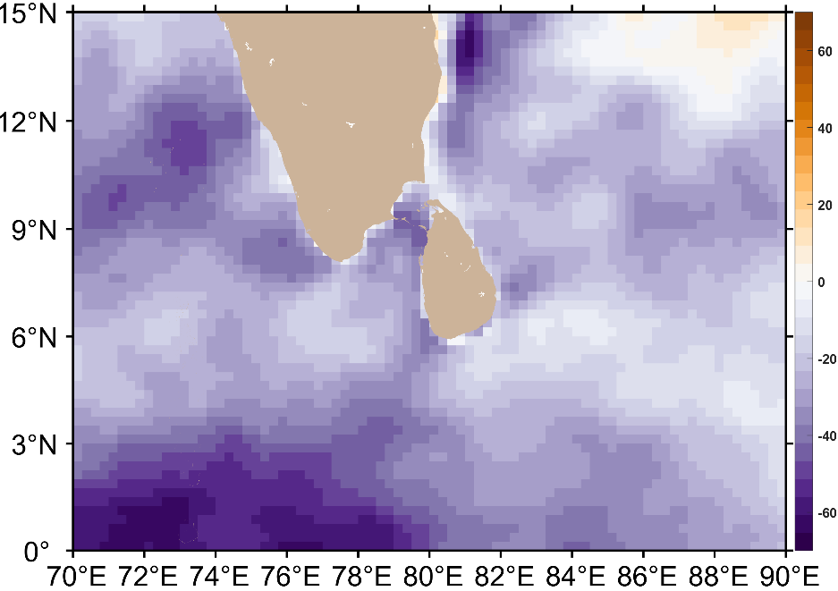
d
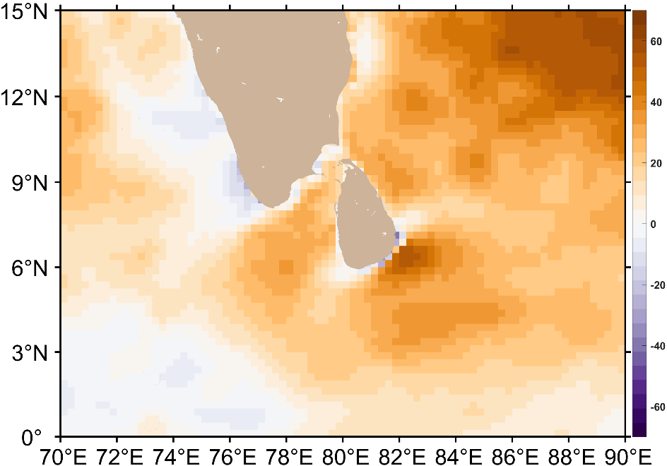
e
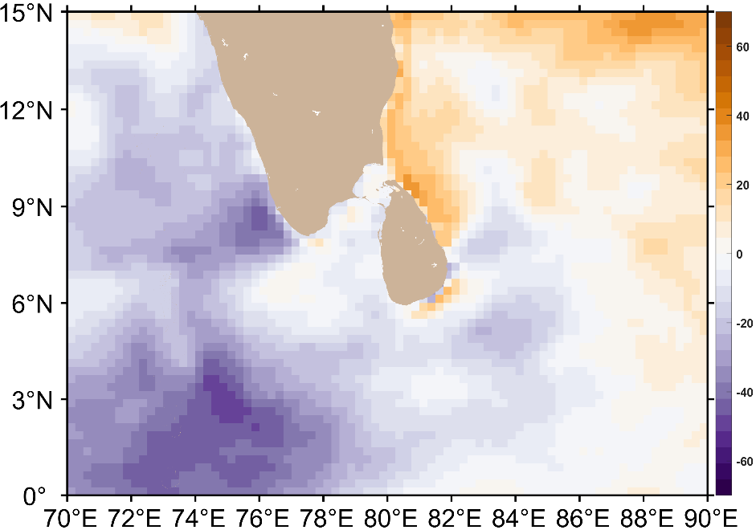
f

Fig. 2 The anomalous latent heat flux in April and May during the three ENSO years around Sri Lanka. The anomaly was the difference between the monthly mean and the long-term (1984-1996) average, a,c,e Solar radiation anomaly during April of 1998,2016, and 2024, respectively, b,d,f Solar radiation anomaly during May of 1998,2016, and 2024, respectively

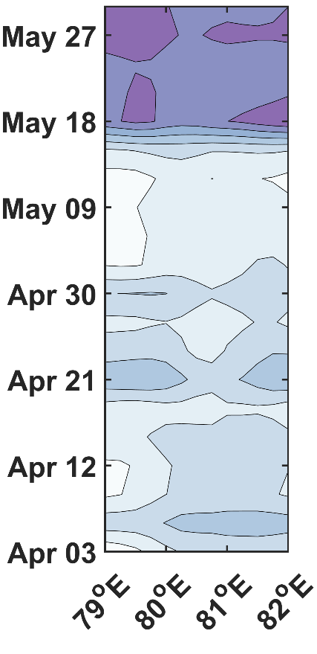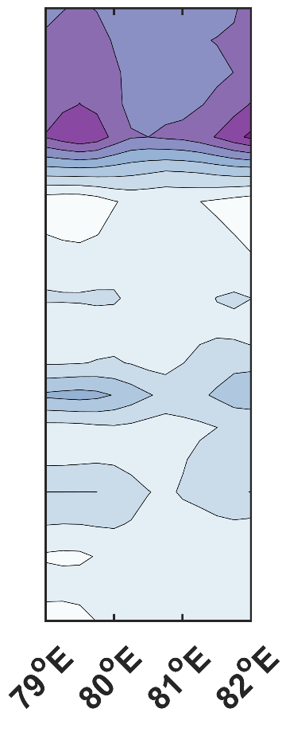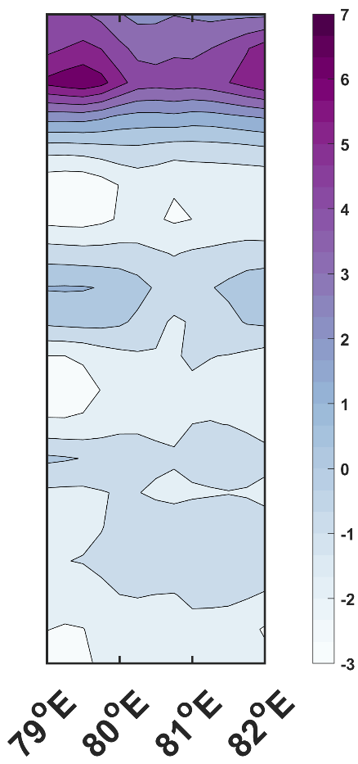
c
b
a

Fig.3 The latitudinal averaged 3-day mean wind speed anomaly across the 79-82 E section during April-May period of a 1998, b 2016, and c 2024 ENSO events. The anomaly was constructed by subtracting the 3-day mean wind speed from long term (1984-1996) wind speed mean

