Table 1. Optimisation of N,N-dibenzyl thiocarbamoyl fluorides^{c}
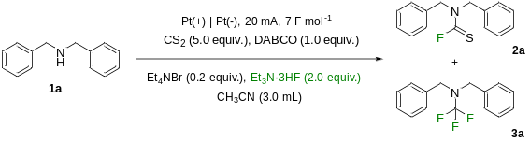
entry | deviation from the above conditions | Ratio (2a:3a) | yield (%)^{a,b}
1 | Amine, CS₂ and Et₃N·3HF, no base | 1: 1.10 | 22^{b}
2 | With KOH | 1:0.00 | 13 ^{b}
3 | Et₄NBr, with no base | 1: 0.00 | 23 ^{b}
4 | KOH and Et₄NBr | 1:0.18 | 78ª
5 | stainless steel as cathode, | 1:0.00 | 30^{b}
6 | nickel as cathode, | 1:0.00 | 47^{b}
7 | carbon as cathode, | 1:0.00 | 28^{b}
8 | carbon as anode | 1:0.06 | 53^{b}
9 | carbon as cathode and anode | 1:0.04 | 42^{b}
10^{c} | ACN:DMSO (1:1) as solvent, 20 Fmol⁻¹ | 1:0.00 | 87^{b}
11 | 15 mA | 1:0.00 | 51^{b}
12 | 25 mA | 1:0.03 | 72^{b}
13 | 1.0 eq Et₃N·3HF | 1:0.00 | 56^{b}
14 | 3.0 equiv. Et₃N·3HF | 1:0.00 | 83^{b}
15 | 0.5 equiv. Et₄NBr | 1:0.02 | 95^{b}
16 | 1.0 equiv. Et₄NBr | 1: 0.02 | 85^{b}
17 | 0.5 equiv. DABCO | 1: 0.03 | 72^{b}
18 | No deviation | 1:0.00 | 91ª
19 | 2.0 equiv. DABCO | 1: 0.16 | 95^{b}
[a] isolated yield. [b] Determined by ¹H NMR, bromoform as internal standard. [c] Dibenzylamine 1a (39.5 mg, 0.2 mmol, 1.0 equiv.), DABCO (22.4 mg, 0.2 mmol, 1.0 equiv.), carbon disulfide [(CS₂), 76.1 mg, 1.0 mmol, 5.0 equiv.], ACN [3.0 mL, 0.067 M)], Et₄NBr (8.4 mg, 0.04 mmol, 0.2 equiv.), Et₃N·3HF (64.5 mg, 0.4 mmol, 2.0 equiv.).
Table 2. Optimisation of N-trifluoromethyl amines.
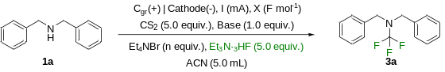
Entry | Cathode (-) | I (mA) | C (F mol⁻¹) | Et₄NBr equiv. | yield (%)^{[a]}
1 | Pt | 20 | 8 | -- | 9
2 | Pt | 20 | 8 | 0.2 | 28
3 | Pt | 20 | 8 | 2 | 30
4^{[b]} | Pt | 20 | 8 | 2 | 5
5^{[c]} | Pt | 20 | 8 | 2 | 0
6 | Ni | 20 | 8 | 2 | 17
7 | SS | 20 | 8 | 2 | 5
8 | Cgr | 40 | 8 | 2 | 14
9 | Pt | 40 | 8 | 2 | 40
10 | Pt | 20 | 20 | 1 | 74
11 | Pt | 20 | 30 | 1 | 81
12^{[d]} | Pt | 20 | 20 | 1 | 94
13^{[d], [e]} | Pt | 20 | 20 | 1 | 95
14^{[d], [e]} | Pt | 40 | 20 | 1 | 92
[a] ¹H NMR yield, bromoform as internal standard. [b] Et₄NCl instead of Et₄NBr. [c] Et₄NI instead of Et₄NBr. [d] Pt as anode (+). [e] 3 equiv. of Et₃N·3HF. [f] Dibenzylamine 1a (39.5 mg, 0.2 mmol, 1.0 equiv.), KOH (11.2 mg, 0.2 mmol, 1.0 equiv.), carbon disulfide [(CS₂), 76.1 mg, 1.0 mmol, 5.0 equiv.], ACN [3 mL, 0.067 M)], Et₄NBr (42.0 mg, 0.2 mmol, 1.0 equiv.), Et₃N·3HF (96.7 mg, 0.6 mmol, 3.0 equiv.).
Table 3: Substrate scope of N,N-dialkyl thiocarbamoyl fluorides.^{[a]} and N-trifluoromethyl amines.^{[i]}
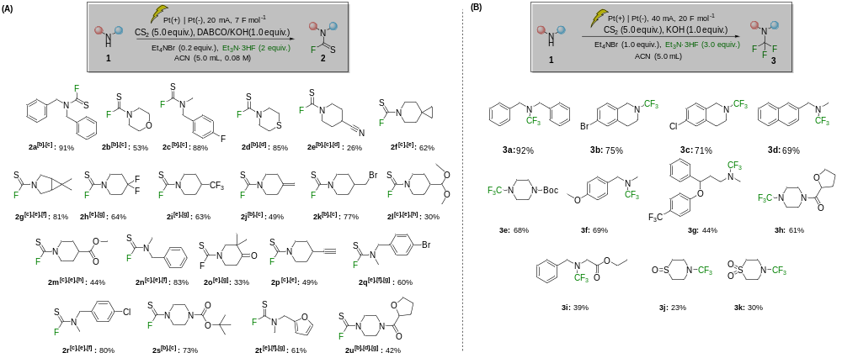
(A): [a] Amine (0.4 mmol, 1.0 equiv.), DABCO (0.4 mmol, 1.0 equiv.), carbon disulfide [(CS₂), 2.0 mmol, 5.0 equiv.], ACN [5.0 mL, 0.067 M)], Et₄NBr (0.08 mmol, 0.2 equiv.), Et₃N·3HF (0.8 mmol, 2.0 equiv.). [b] KOH instead of DABCO. [c] Silica pad filtration. [d] 10 mA. [e] DABCO. [f] 9 Fmol⁻¹. [g] Column purification. [h] 6 Fmol⁻¹. (B): [i] Amine (0.4 mmol, 1.0 equiv.), KOH (0.4 mmol, 1.0 equiv.), carbon disulfide [(CS₂), 2.0 mmol, 5.0 equiv.], ACN [5 mL, 0.067 M)], Et₄NBr (0.4 mmol, 1.0 equiv.), Et₃N·3HF (1.2 mmol, 3.0 equiv.)

