Supplementary File 2

This supplementary file details the methods used to generate the population count variable used as the denominator for the exit interview-based geographic accessibility outcome measure, and the socioeconomic class (SEC) variable. These are based on several years of aiSight.ai’s research in population estimation and poverty mapping.

For population estimation, aiSight.ai uses machine learning on satellite imagery to detect human settlements, segment built-up areas, classify settlement types, and predicts population based on the number and size of housing units.

For socio-economic classification (SEC), aiSight.ai’s platform uses different types of satellite imagery and several open and administrative datasets to train machine mearning models of socio-economic classification of human settlements. Different machine learning models are trained for different settlement types and geographies, and transfer learning is used to improve the accuracy of the models for new geographies. Transfer learning is “is a machine learning method where a model developed for one task is reused as the starting point for a model on a second task”. These methods are described in more detail below.

Population Estimation

Recent advances in machine learning have significantly improved the accuracy of artificial intelligence (AI) models which can detect human settlements using commonly available, moderate-to-low resolution, satellite imagery.

aiSight.ai’s machine learning platform uses the following steps to generate population estimations:

- Instance segmentation is used to identify built-up structures. Instance segmentation is used to identify and separate individual objects within an image, including detecting the boundaries of objects and assigning a unique label to each object;
- Building density heat-maps are generated from step 1. Building density is measured according to the built-up area in a given satellite image tile;
- Masks from built-structures instances are passed to a deep-learning based regression technique to generate building counts. A segmentation mask is a specific portion of an image that is isolated from the rest of the image, and is used to identify the part of the image of particular interest;
- Micro-census data from field surveys are used for training a supervised learning model which uses built-up structure counts and building density to generate population estimations;
- Ground-truthing data from field surveys and the government census is then used to validate the results.

The methodology and models used to complete these steps are described below:
2.1 Building segmentation

There are several different approaches to segment (or delineate) buildings. aiSight.ai uses its proprietary Instance Segmentation Machine Learning models, based on Mask R-CNN, for this purpose. aiSight.ai’s trained models of instance segmentation use a Siamese convolutional network, and a U-Net architecture with a pre-trained ResNet-34 as an encoder for efficient processing and segmentation of large-scale satellite images. An extended annotation dataset similar to SpaceNet8 is used for training. The instance segmentation model is passed patches of satellite imagery and the output is a segmentation mask containing the segmentation of the predicted buildings. An example of this process is shown below in Figure 1.
Figure 1: Example of segmentation mask
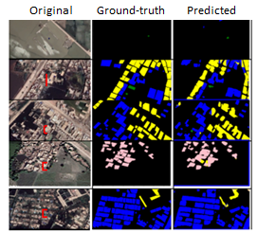

2.2 Building density and population estimation

Once the built-up area is segmented as above, the output is fed into another machine learning model that counts built-up structures in the satellite imagery. aiSight.ai uses deep-learning based regression techniques for counting built-up structures. It combines information drawn from three different models in a so-called “fusion network”, or “Fusion Net”. It combines information from a standard machine learning model called DenseNet (which for accurate counts would require higher resolution imagery that is not available for Pakistan), with two other deep regression models that use attention-based re-weighting to decrease the influence of deep features from non-built up areas such as fields or streets, so permitting the algorithms to predict building count with more accuracy. These models were first trained on satellite imagery collected from diverse geographical areas (plains, urban centers, deserts, etc.,) across the globe (Asia, Europe, North America, and Africa) that capture the wide density of built structures and are refined by comparing the output of the built-up regression layer the periodic micro-census data collected by aiSight.ai field teams. The Fusion Net has been shown to have an accuracy of 88% when compared to the testing data, an example of which is shown in Figure 2 above.
Figure 2: Example of comparison between predicted and actual building count in test data using aiSight.ai’s methodology

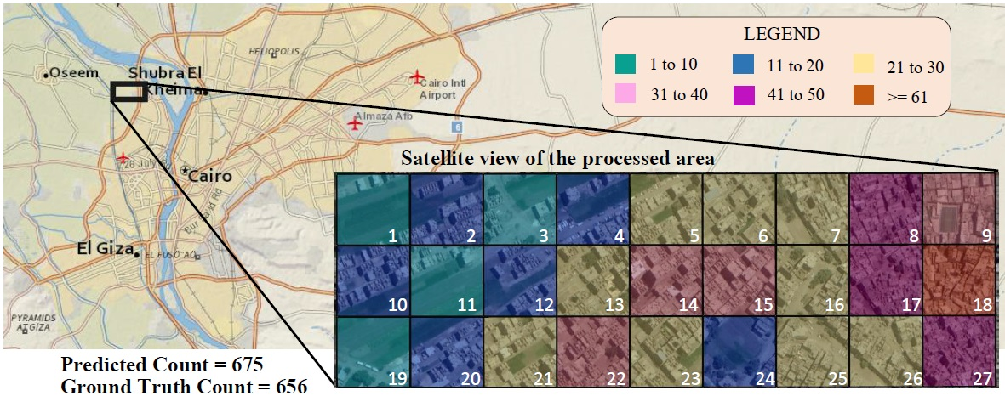
The national view of population distribution is shown in Figure 3.
Figure 3: National view of population distribution in Pakistan from the portal
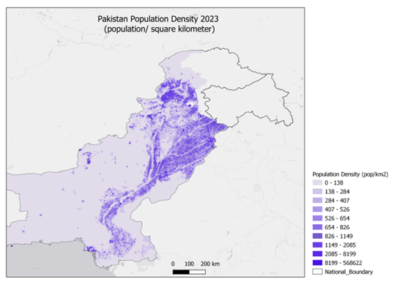

Socio-economic Classification (SEC)

aiSight.ai’s SEC maps are used in Pakistan as the standard measurement of neighbourhood-level affluence. These build on the models described above but combine these with a variety of other data inputs to produce estimates of neighbourhood-level affluence. The supervised learning model is trained by using aiSight.ai’s proprietary annotated geospatial layer and combining it with features from datasets including night-light imagery, settlement layer, population density, property valuation and rental values, average house size, community organization, utilities, road network to generate a high-resolution socio-economic profile.

  - Satellite imagery inputs

Four types of satellite images are used in the model. These are monochromatic imagery (from Maxar/Airbus), multi-spectral imagery (Sentinel), night-light imagery and Radar(SAR) for Digital Elevation Mapping (Sentinel SAR). Monochromatic images use different amounts of light instead of colours to represent images. Multi-spectral imagery measures light emission, and different wavelengths can be used to distinguish between vegetation and man-made objects amongst other things. SAR or Synthetic Aperture Radar is where successive pulses of radio waves are transmitted, and a record made of the amount of that signal that is reflected back. These images are often created using antenna that move so that records are taken of the ground from different angles and at different times, this allowing building heights to be estimated. Many different studies have explored the linkage between night light and poverty using the average light index of night light data.

  - Open street map inputs

Open street maps help to distinguish between commercial and residential areas, road networks and can be used to identify parks, hospitals, and universities helping further to identify residential areas.

  - Administrative and health data inputs

Administrative data used in the models include property valuations and rental values as well as information found in the Pakistan Social and Living Standards Measurements (PSLM) survey and health information from UNICEF’s Multiple Index Cluster Survey (MICS).

  - Training dataset

The training geospatial layer is derived from a neighbourhood-level Multidimensional Poverty Index (MPI) from field surveys carried out by aiSight.ai. In the dataset, ten socio-economic indicators are selected under three broad parameters (education, health and living standards), similar to those used by the Global Multidimensional Poverty Index. These parameters are reported from the periodic household establishment surveys conducted by aiSight.ai’s field teams. The SEC estimation is generated by Bayesian inference for Latent Gaussian Models using Integrated Nested Laplace Approximation (INLA).

The SEC estimates are provided to the model as a grid consisting of 1km X 1km squares, providing very granular estimates of poverty. A view of SEC variation at national level broken down by tehsil is shown in Figure 5 below. The definition of each SEC class is provided below.
Figure 5: SEC variation – national view
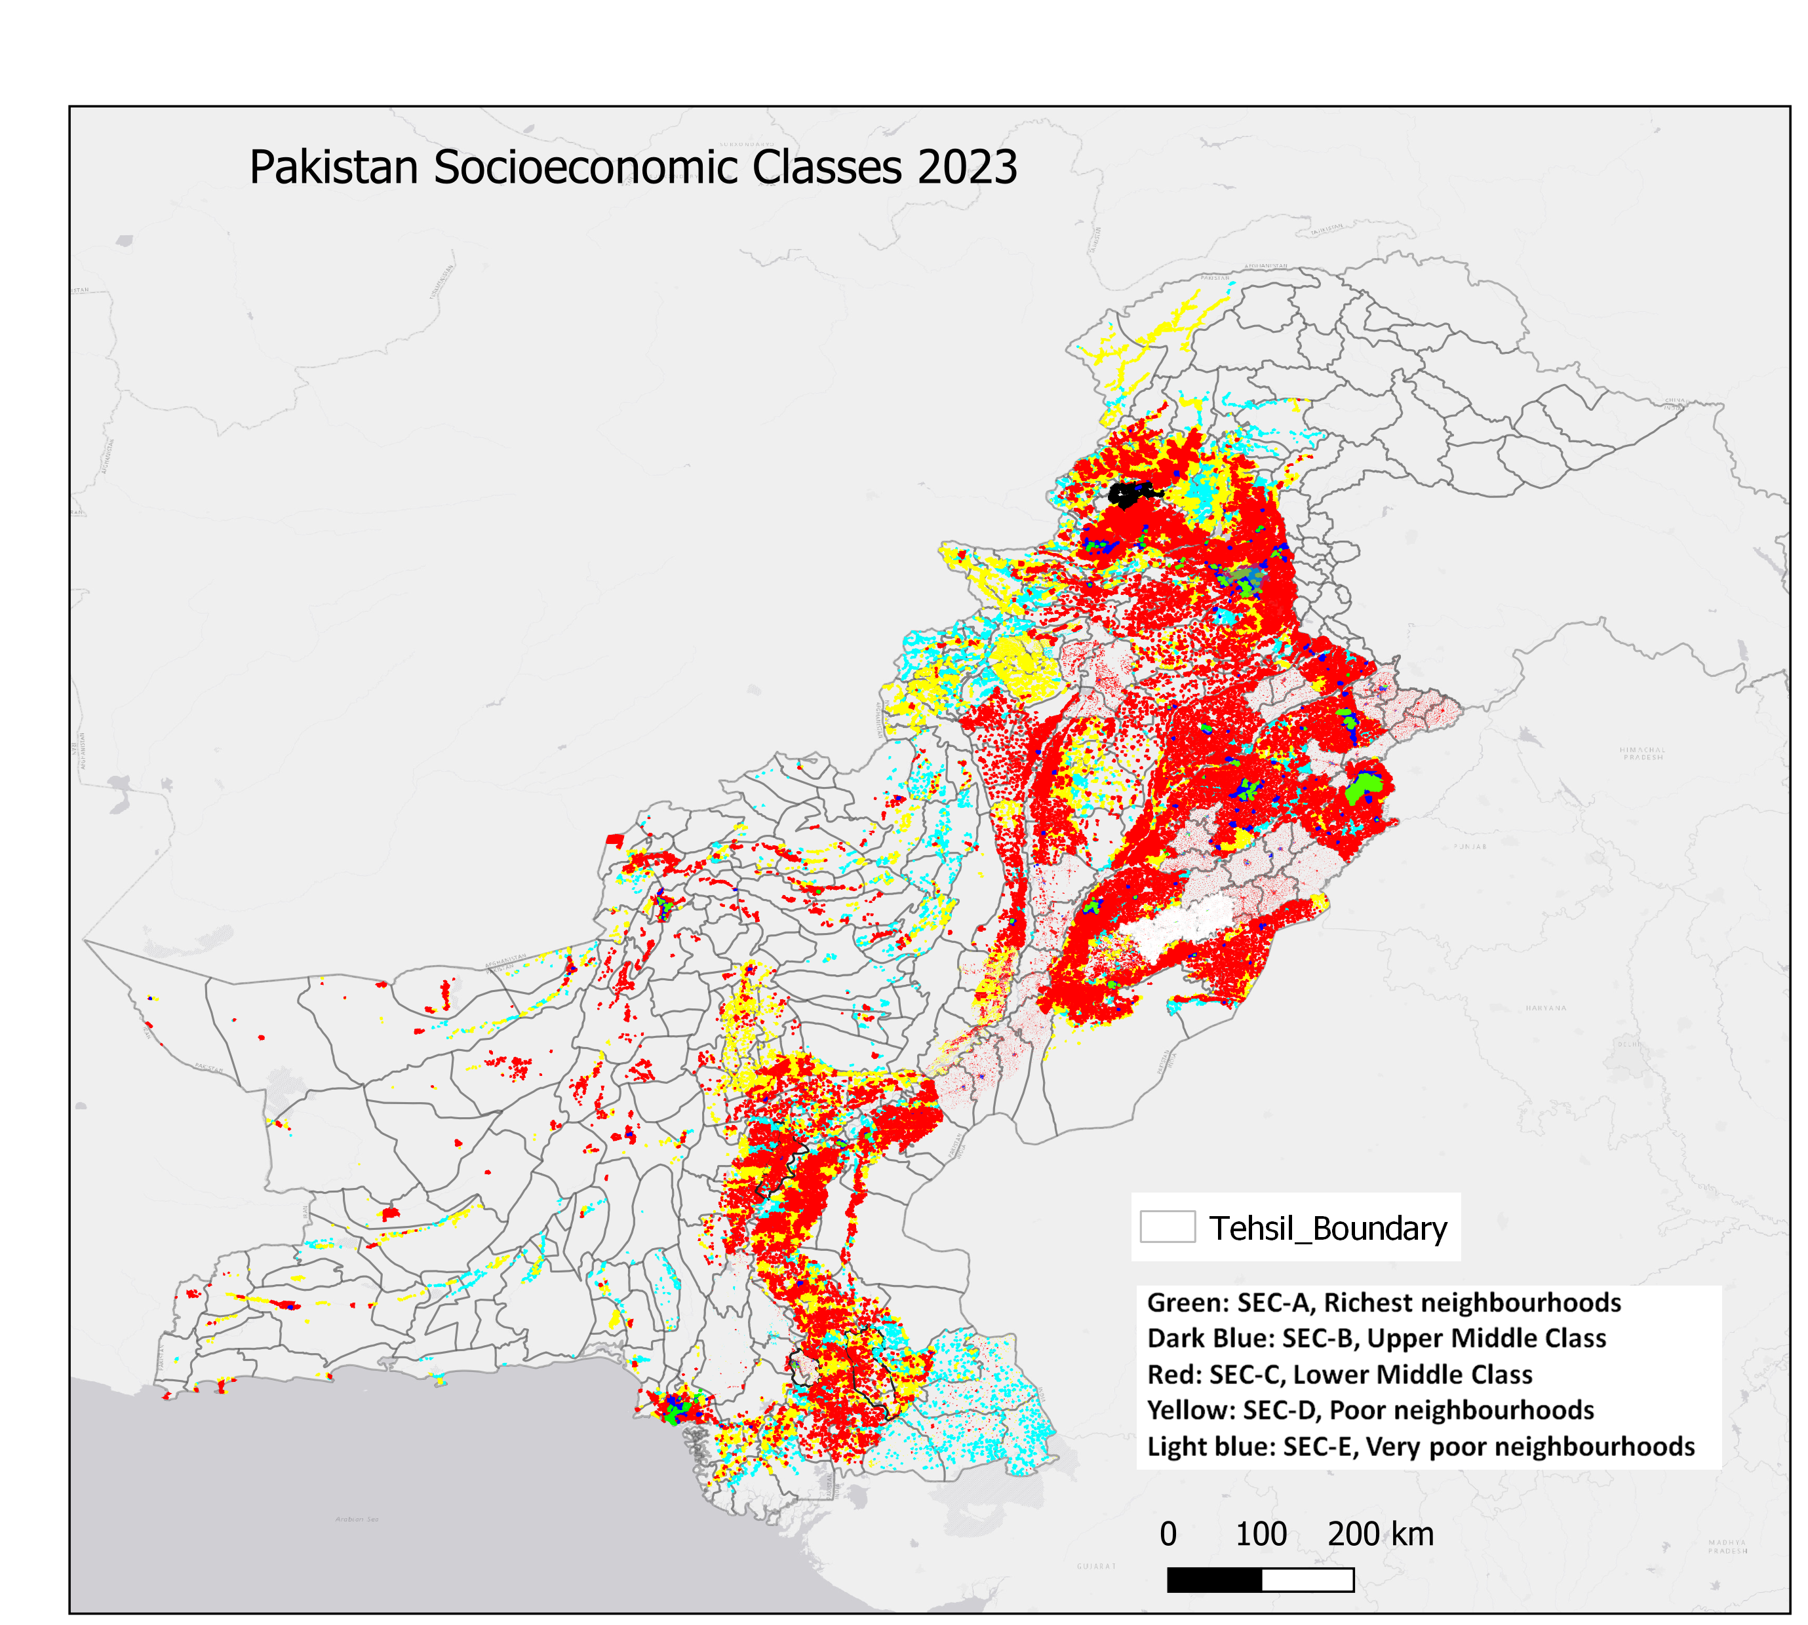

Description of SEC classes used
SEC A: Assigned to an area that is occupied by rich neighborhoods (high-income areas with developed infrastructure, big houses, better economic lifestyle, availability of better facilities/utilities, expensive cars, etc.). SEC A constitutes ~5% of the population.
SEC B: Assigned to an area where the upper middle-class population resides (comes next to the rich class but varies in terms of facilities and economic lifestyle). Reasonable house sizes; good access to infrastructure, good economic lifestyle, and decent access to facilities/utilities. SEC B constitutes ~10% of the population.
SEC C: Assigned to an area where the lower middle-class population resides. These are mostly densely populated areas with lower-income households. Compared with B-class, the available facilities vary in nature and accessibility; with high demand for cheap alternatives and little/no regard for expensive goods/services. SEC C constitutes ~68% of the population.
SEC D: Assigned to an area where poor neighborhoods reside (the infrastructure, in general, is poor and accessibility of basic needs is a challenge in these areas; covers population living very close to poverty levels). SEC D constitutes ~13% of the population.
SEC E: Generally regarded as very poor neighborhoods (slums in many cases). SEC E constitutes ~4% of the population.

https://machinelearningmastery.com/transfer-learning-for-deep-learning/
Bagwari, N., Kumar, S. & Verma, V.S. A Comprehensive Review on Segmentation Techniques for Satellite Images. Arch Computat Methods Eng 30, 4325–4358 (2023). https://doi.org/10.1007/s11831-023-09939-4
K. He, G. Gkioxari, P. Dollár and R. Girshick, "Mask R-CNN," in IEEE Transactions on Pattern Analysis and Machine Intelligence, vol. 42, no. 2, pp. 386-397, 1 Feb. 2020, doi: 10.1109/TPAMI.2018.2844175.
Spacenet: A remote sensing dataset and challenge series. arXiv 2018, A Van Etten, D Lindenbaum, TM Bacastow - arXiv preprint arXiv:1807.01232, 1807
Xu, Jianbin & Song, Jie & Li, Baochao & Liu, Dan & Cao, Xiaoshu. (2021). Combining night time lights in prediction of poverty incidence at the county level. Applied Geography. 135. 102552. 10.1016/j.apgeog.2021.102552.
https://www.pbs.gov.pk/content/pakistan-social-and-living-standards-measurement
https://mics.unicef.org/surveys
https://www.undp.org/sites/g/files/zskgke326/files/2023-07/2023mpireportenpdf.pdf
Integrated nested Laplace approximations (INLA). https://arXiv:1907.01248.

