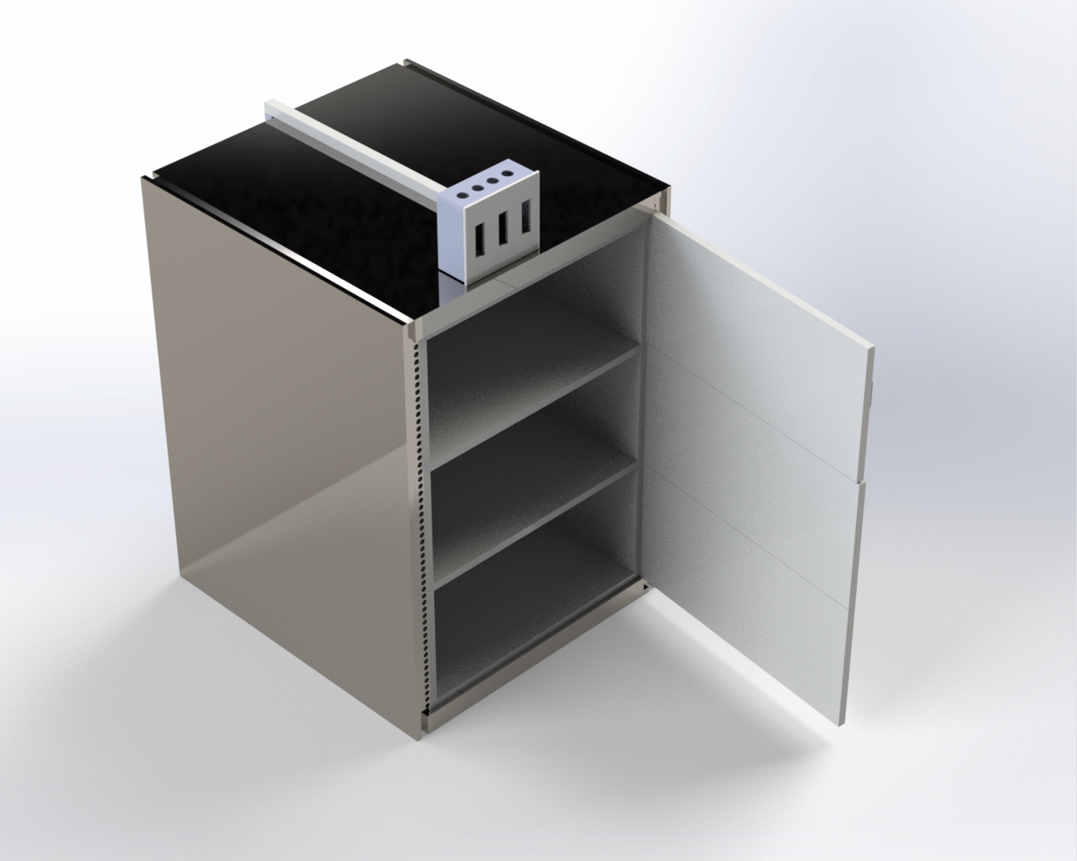
Plate I: A Picture of the front view of the storage structure

