Supplementary Information for
Global disparities in compound hazard exposure and infrastructure access jeopardize health equity

Table of contents
Supplementary Figures S1-5
Supplementary Tables S1-2
Supplementary References

Supplementary Figures
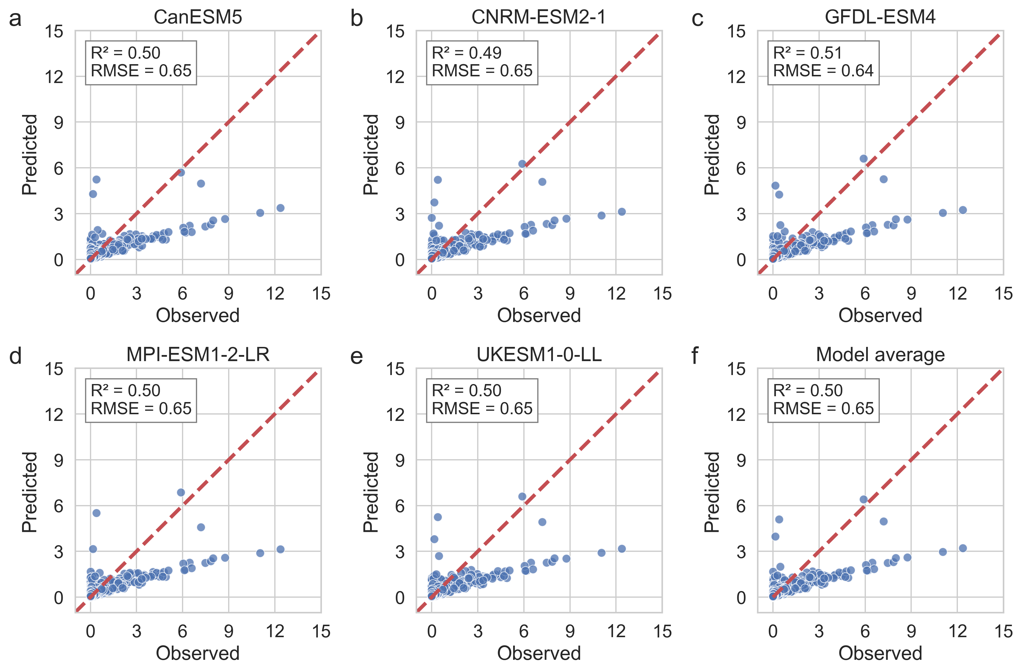
Supplementary Figure S1. Scatter plots of training data comparing observed annual flood duration from GFD with predictions from the RF machine learning models based on five GCMs (a–e). Panel (f) shows the ensemble mean prediction of the five models. The red dashed line represents the 1:1 diagonal.
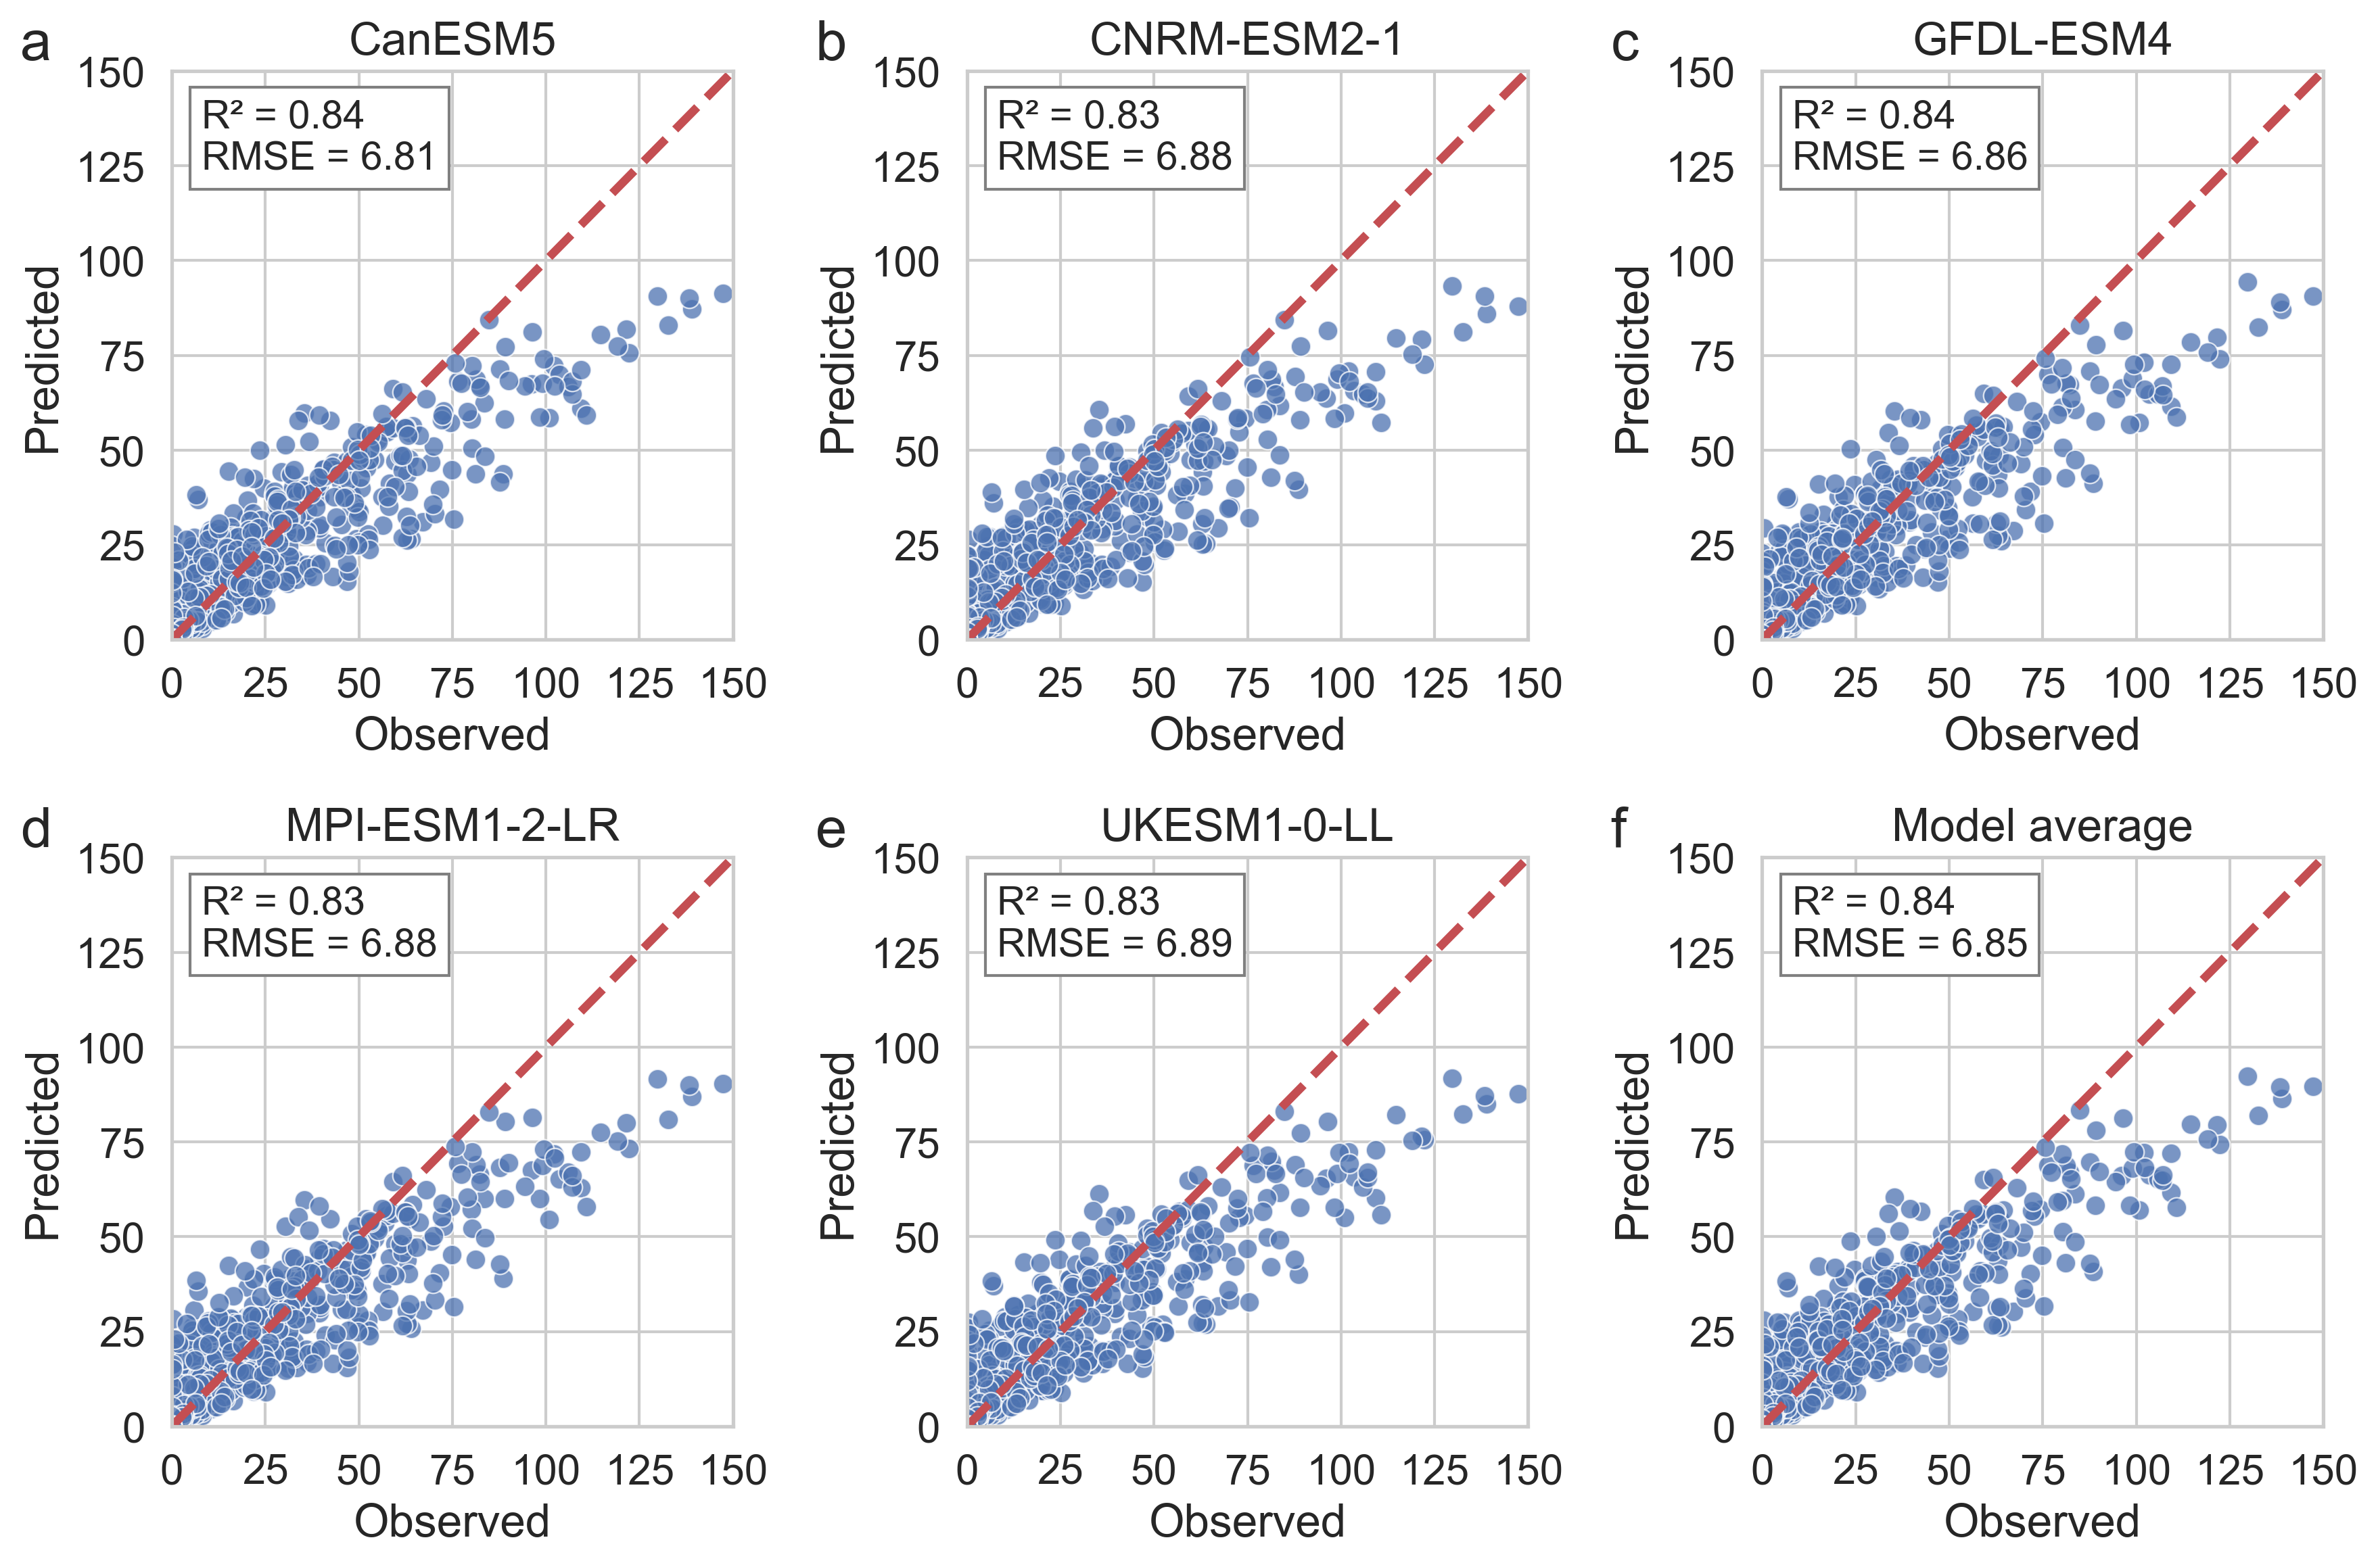
Supplementary Figure S2. Scatter plots of training data comparing observed annual extreme heat days from GEHE with predictions from the RF machine learning models based on five GCMs (a–e). Panel (f) shows the ensemble mean prediction of the five models. The red dashed line represents the 1:1 diagonal.

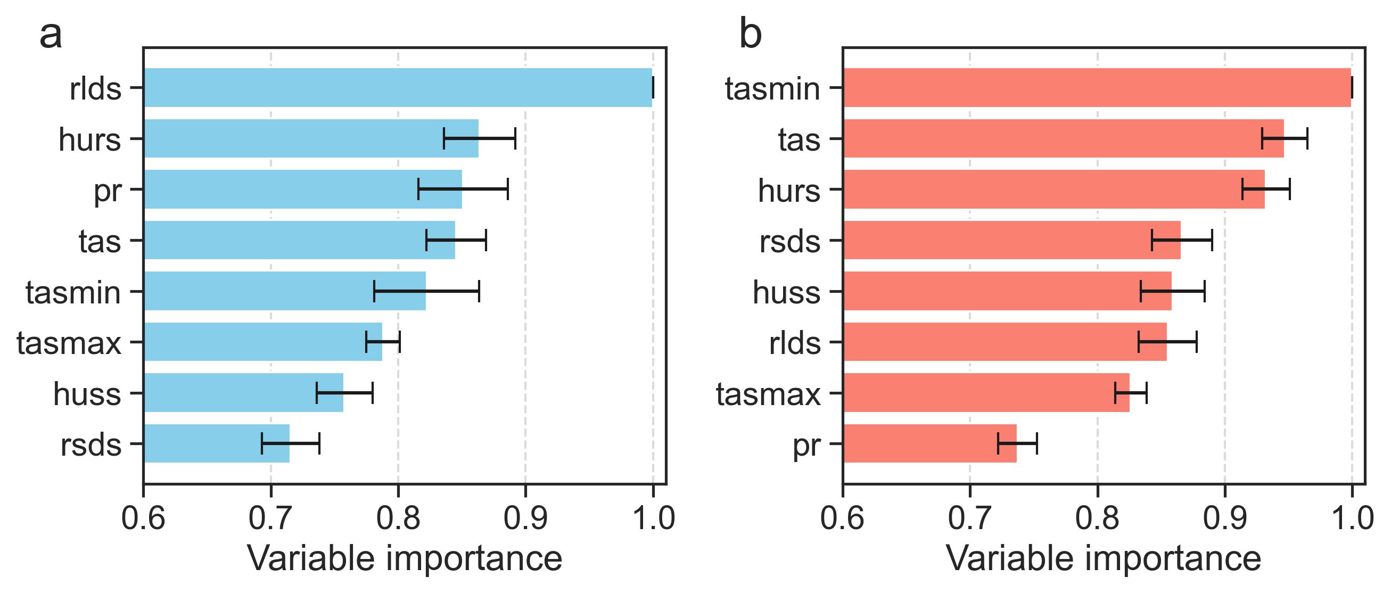
Supplementary Figure S3. Relative variable importance in the five GCM-based RF models for predicting annual flood duration (a) and extreme heat days (b). Error bars indicate the standard deviation across models.

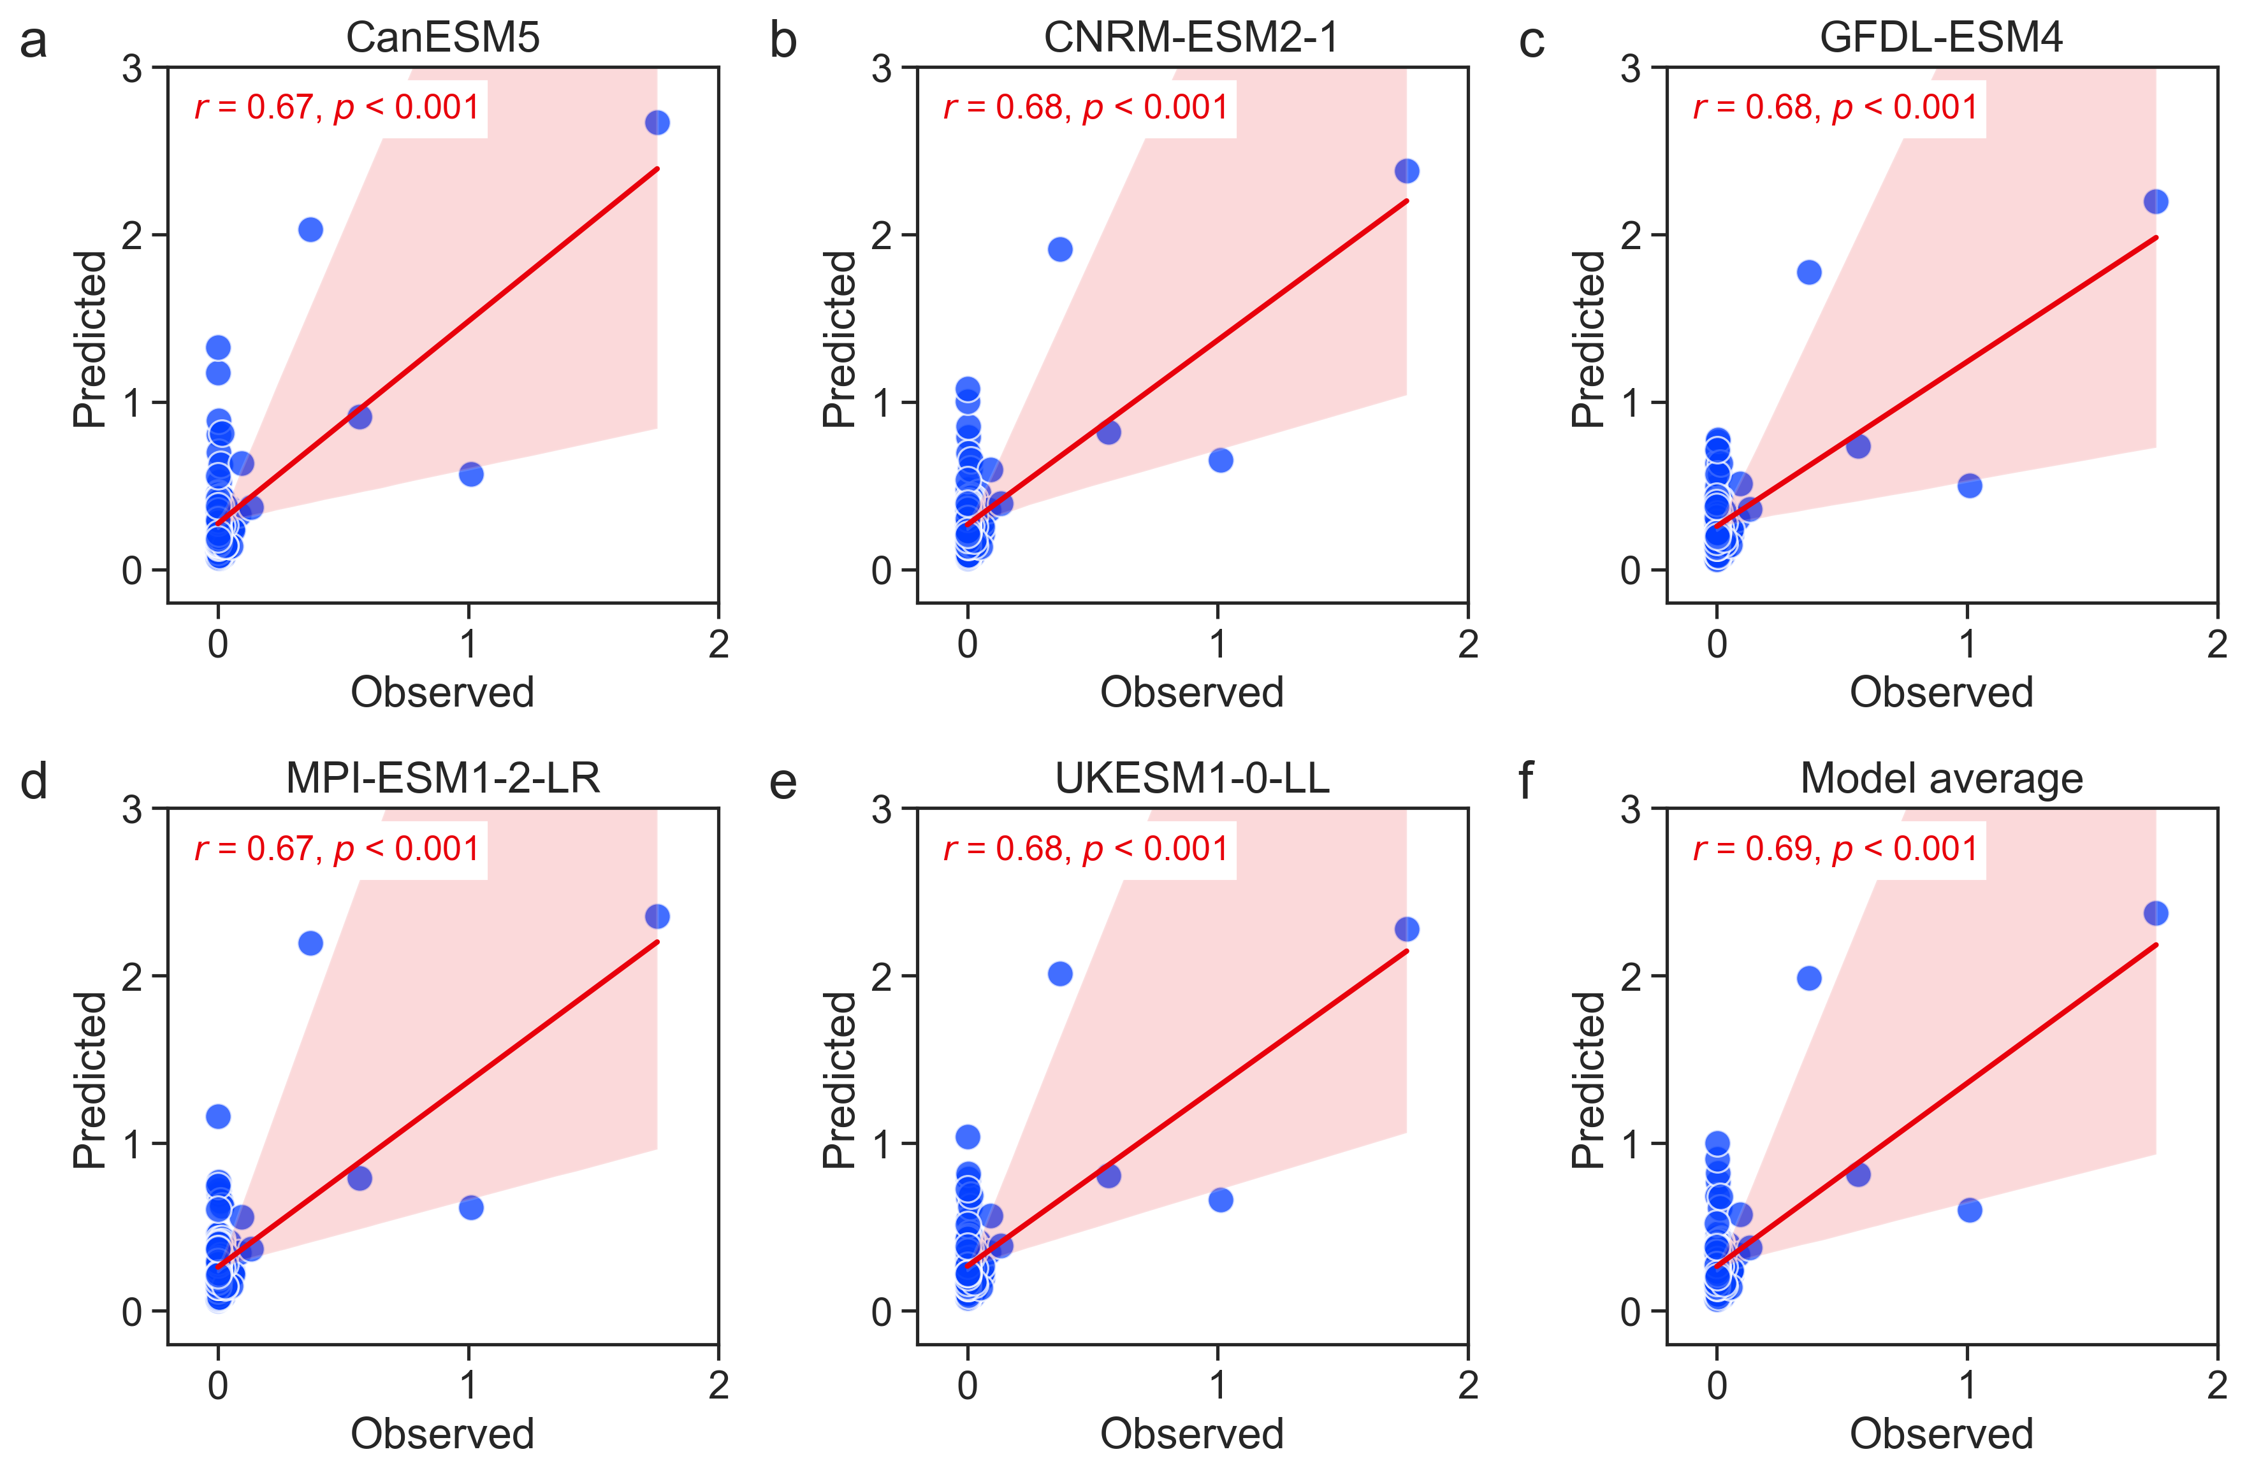
Supplementary Figure S4. Comparisons of country-level flood exposure for 2000–2014, derived from GFD data and predicted by the RF machine learning models based on five GCMs (a–e). Panel (f) shows the ensemble mean prediction across the five models. The red line represents the linear regression fit, with the shaded area indicating the 95% confidence interval. The Pearson correlation coefficient (r) and p-value for each linear regression model are displayed in the upper left corner of each panel.

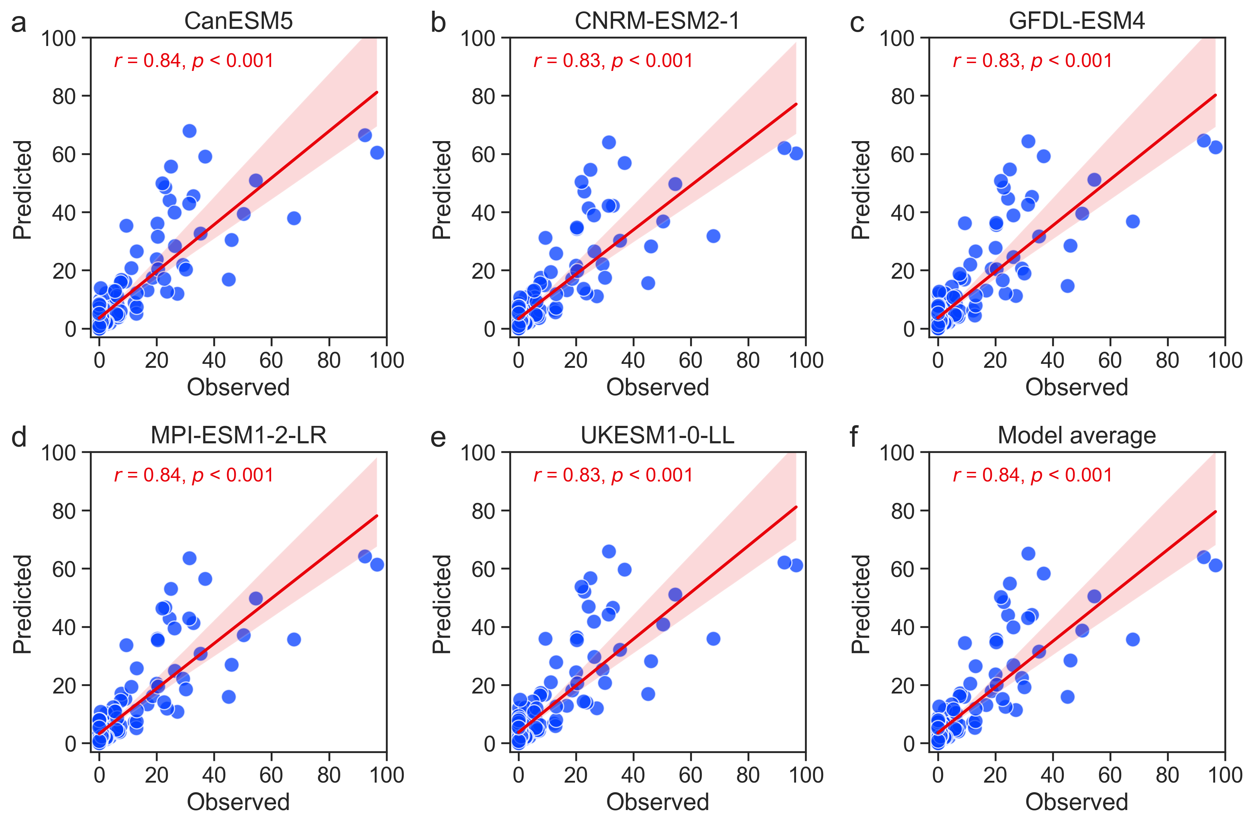
Supplementary Figure S5. Comparisons of country-level heat exposure for 2000–2014, derived from GEHE data and predicted by the RF machine learning models based on five GCMs (a–e). Panel (f) shows the ensemble mean prediction across the five models. The red line represents the linear regression fit, with the shaded area indicating the 95% confidence interval. The Pearson correlation coefficient (r) and p-value for each linear regression model are displayed in the upper left corner of each panel.

Supplementary Tables
Supplementary Table S1. Five global climate models (GCMs) from the Coupled Model Intercomparison Project Phase 6 (CMIP6) database used in this study.
No. | Model | Ensemble information | Spatial resolution  (lon × lat) | Institution (country)
1 | CanESM5 | r1i1p1f1 | 2.8° × 2.8° | Canadian Earth System Model version 5, Canadian Center for Climate Modeling and Analysis (Canada)¹
2 | CNRM-ESM2-1 | r1i1p1f2 | 1.4° × 1.4° | National Center for Meteorological Research (France)²
3 | GFDL-ESM4 | r1i1p1f1 | 1.25° × 1° | NOAA/Geophysical Fluid Dynamics Laboratory, Earth System Model version 4 (USA)³
4 | MPI-ESM-LR | r1i1p1f1 | 1.9° × 1.9° | Max Planck Institute for Meteorology (Germany)⁴
5 | UKESM1-0-LL | r1i1p1f2 | 1.9° × 1.25° | Met Office Hadley Center (UK)⁵

Supplementary Table S2. Eight CMIP6 climate variables used as predictors in the RF machine learning model to estimate future flooding and extreme heat.
No. | Name | Units | Description
1 | hurs | % | Near-surface relative humidity
2 | huss | Mass fraction | Near-surface specific humidity
3 | pr | kg/m^2/s | Precipitation (mean of the daily precipitation rate)
4 | rlds | W/m^2 | Surface downwelling longwave radiation
5 | rsds | W/m^2 | Surface downwelling shortwave radiation
6 | tas | K | Daily near-surface air temperature
7 | tasmin | K | Daily minimum near-surface air temperature
8 | tasmax | K | Daily maximum near-surface air temperature

Supplementary References
1. Swart NC, et al. The Canadian Earth System Model version 5 (CanESM5.0.3). Geosci Model Dev 12, 4823-4873 (2019).
2. Séférian R, et al. Evaluation of CNRM Earth System Model, CNRM-ESM2-1: Role of Earth System Processes in Present-Day and Future Climate. Journal of Advances in Modeling Earth Systems 11, 4182-4227 (2019).
3. Dunne JP, et al. The GFDL Earth System Model Version 4.1 (GFDL-ESM 4.1): Overall Coupled Model Description and Simulation Characteristics. Journal of Advances in Modeling Earth Systems 12, e2019MS002015 (2020).
4. Mauritsen T, et al. Developments in the MPI-M Earth System Model version 1.2 (MPI-ESM1.2) and Its Response to Increasing CO2. Journal of Advances in Modeling Earth Systems 11, 998-1038 (2019).
5. Sellar AA, et al. UKESM1: Description and Evaluation of the U.K. Earth System Model. Journal of Advances in Modeling Earth Systems 11, 4513-4558 (2019).

