SUPPLEMENTARY INFORMATION
SUPPLEMENTARY FIGURES
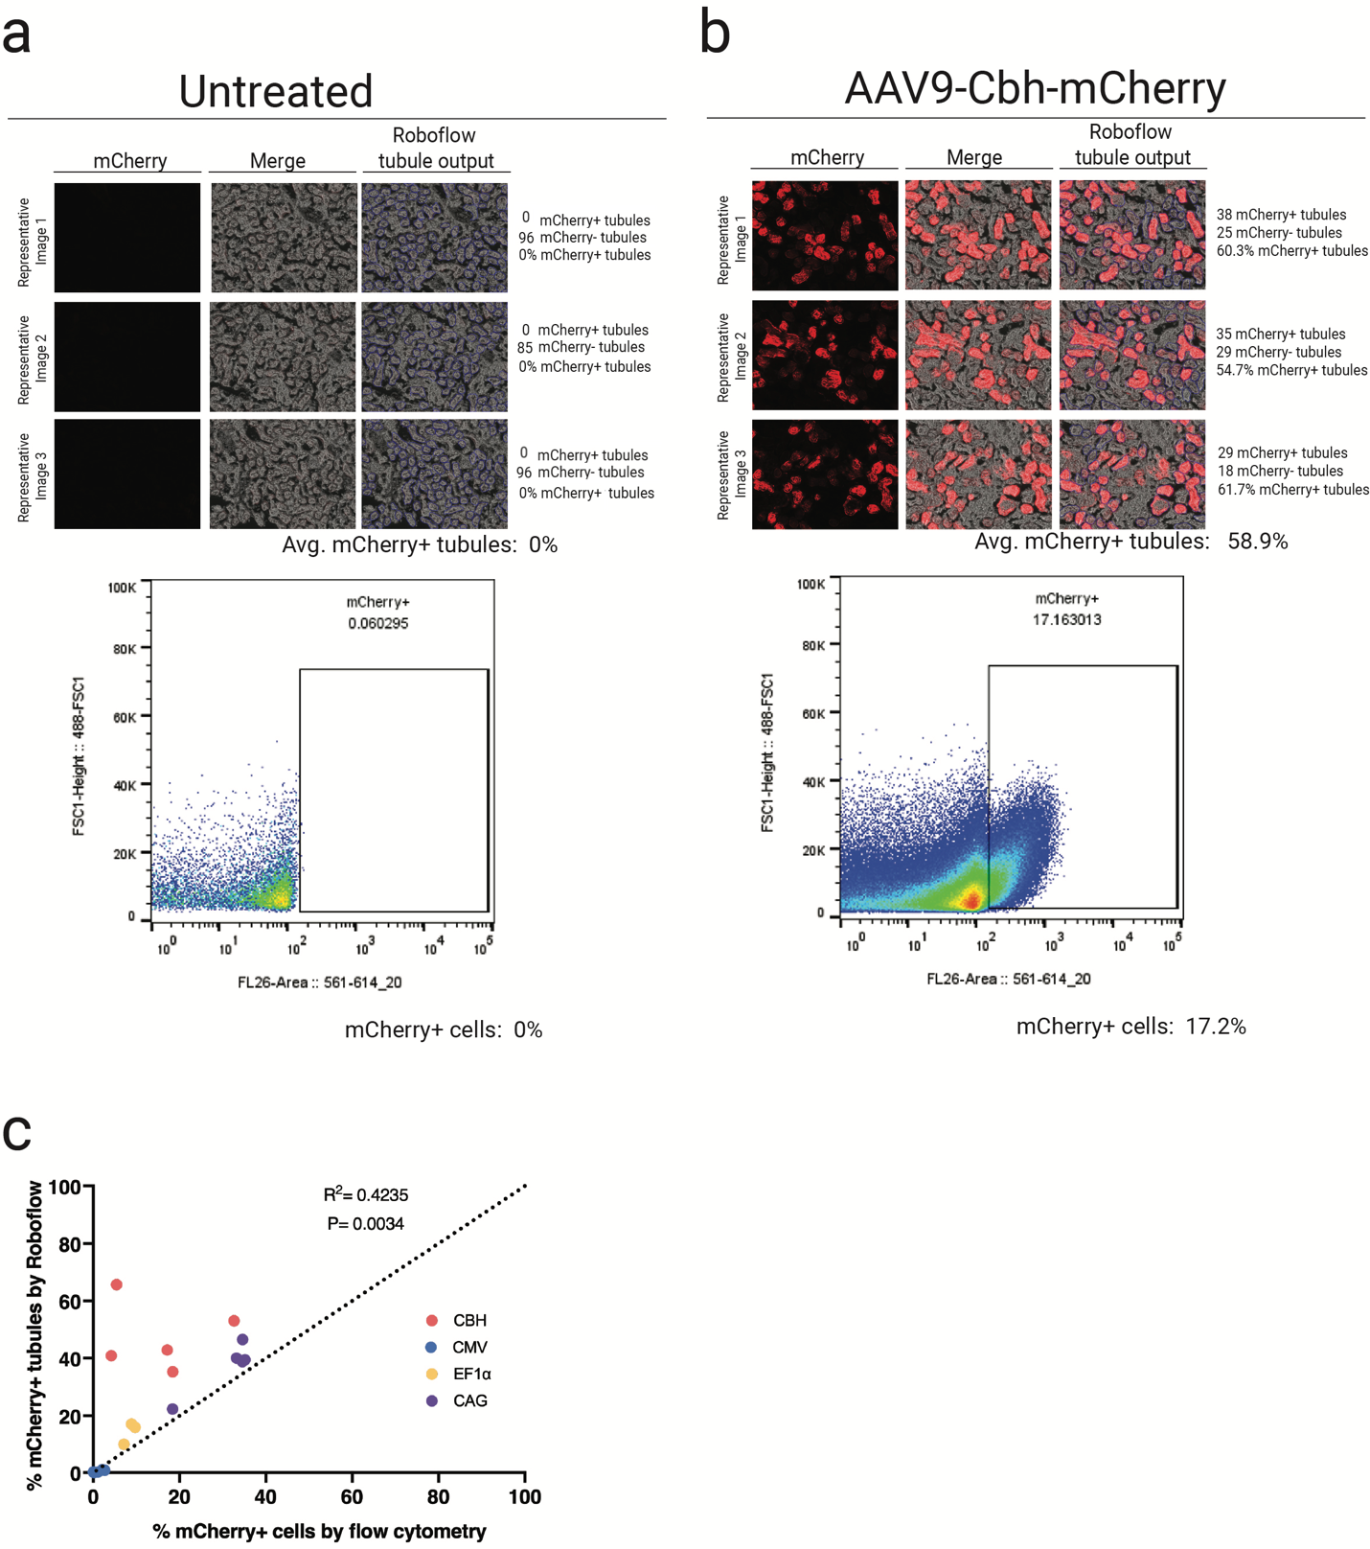
Supplementary Figure 1: Comparison of tubule quantification with machine-learning-based image analysis tool vs. cell quantification via flow cytometry. a,b, Top: Representative images of mCherry fluorescence, merged images (mCherry + bright field), and Roboflow tubule output in kidneys from AAV-treated and untreated mice. The average percentage of mCherry+ tubules, quantified using a machine learning-guided image analysis tool developed in Roboflow, is shown. Bottom: Representative dot plots showing the percentage of mCherry+ cells as assessed by flow cytometry. c, Scatter plot showing the correlation between the number of mCherry-positive tubules per kidney, quantified using Roboflow image analysis, and the percentage of mCherry-positive cells, determined by flow cytometry, for each individual mouse treated with AAV9-CBH-mCherry-WPRE.

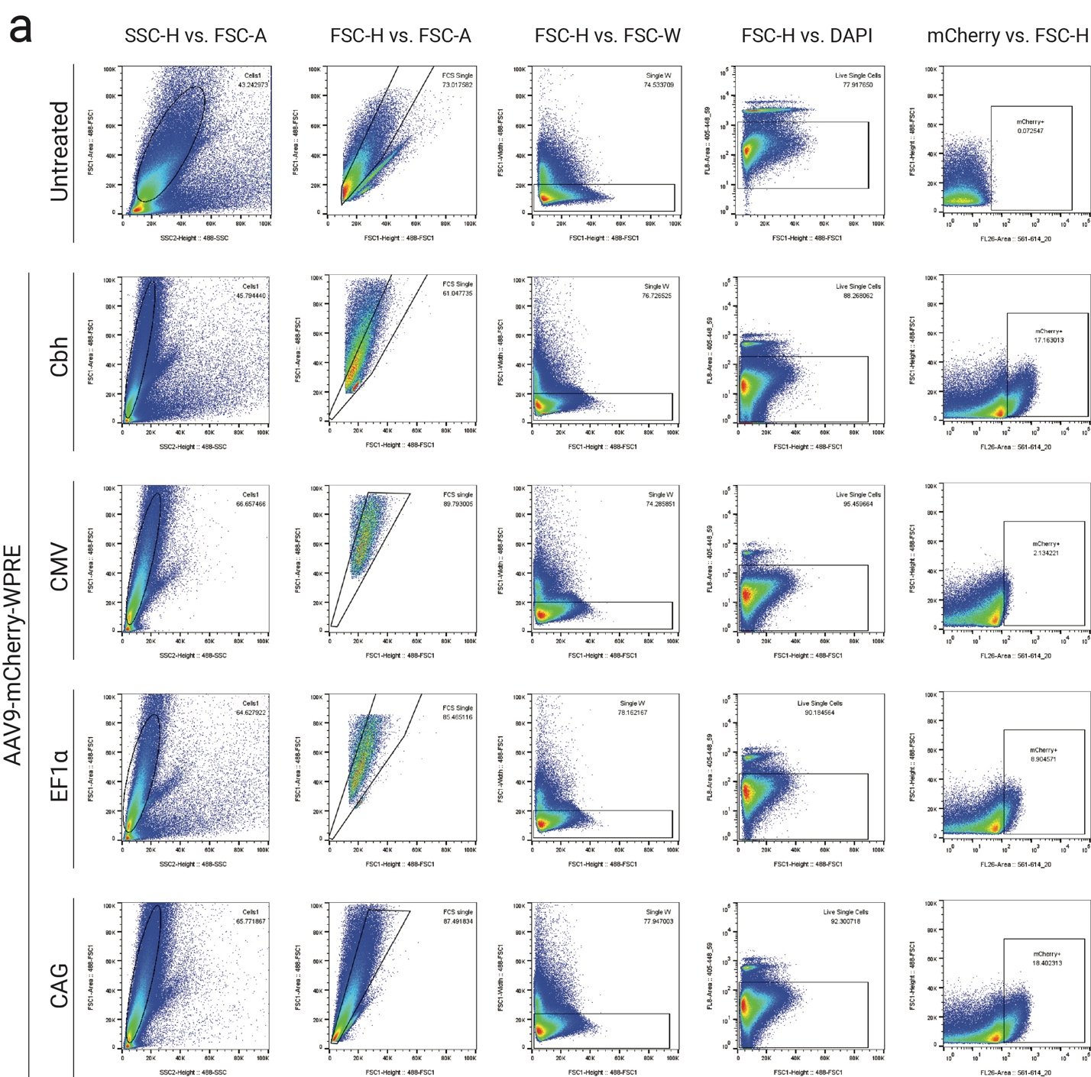
Supplementary Figure 2: Representative flow cytometry gating for quantifying percentage of mCherry positive cells. a, Representative dot plots showing the sequential gating strategy applied to analyze mCherry expression in kidney cells from untreated mice and mice injected with AAV9 encoding mCherry under the control of various promoters (CBH, CMV, EF1α, CAG). Samples were analyzed using two different laser configurations to confirm mCherry expression and DAPI staining. SSC-H vs. FSC-A: Initial gating on total cell population based on forward and side scatter. FSC-H vs. FSC-A: Selection of single cells using forward scatter height vs area. FSC-H vs. FSC-W: Confirmation of singlets by width vs area gating. FSC-H vs. DAPI: Live single-cell population selected based on viability dye exclusion. mCherry vs. FSC-H: Quantification of mCherry-positive cells using fluorescence intensity (FL3 channel; 561–614 nm). Numbers indicate the percentage of cells falling within each gate. Data illustrate differences in transduction efficiency and promoter strength across tested constructs.

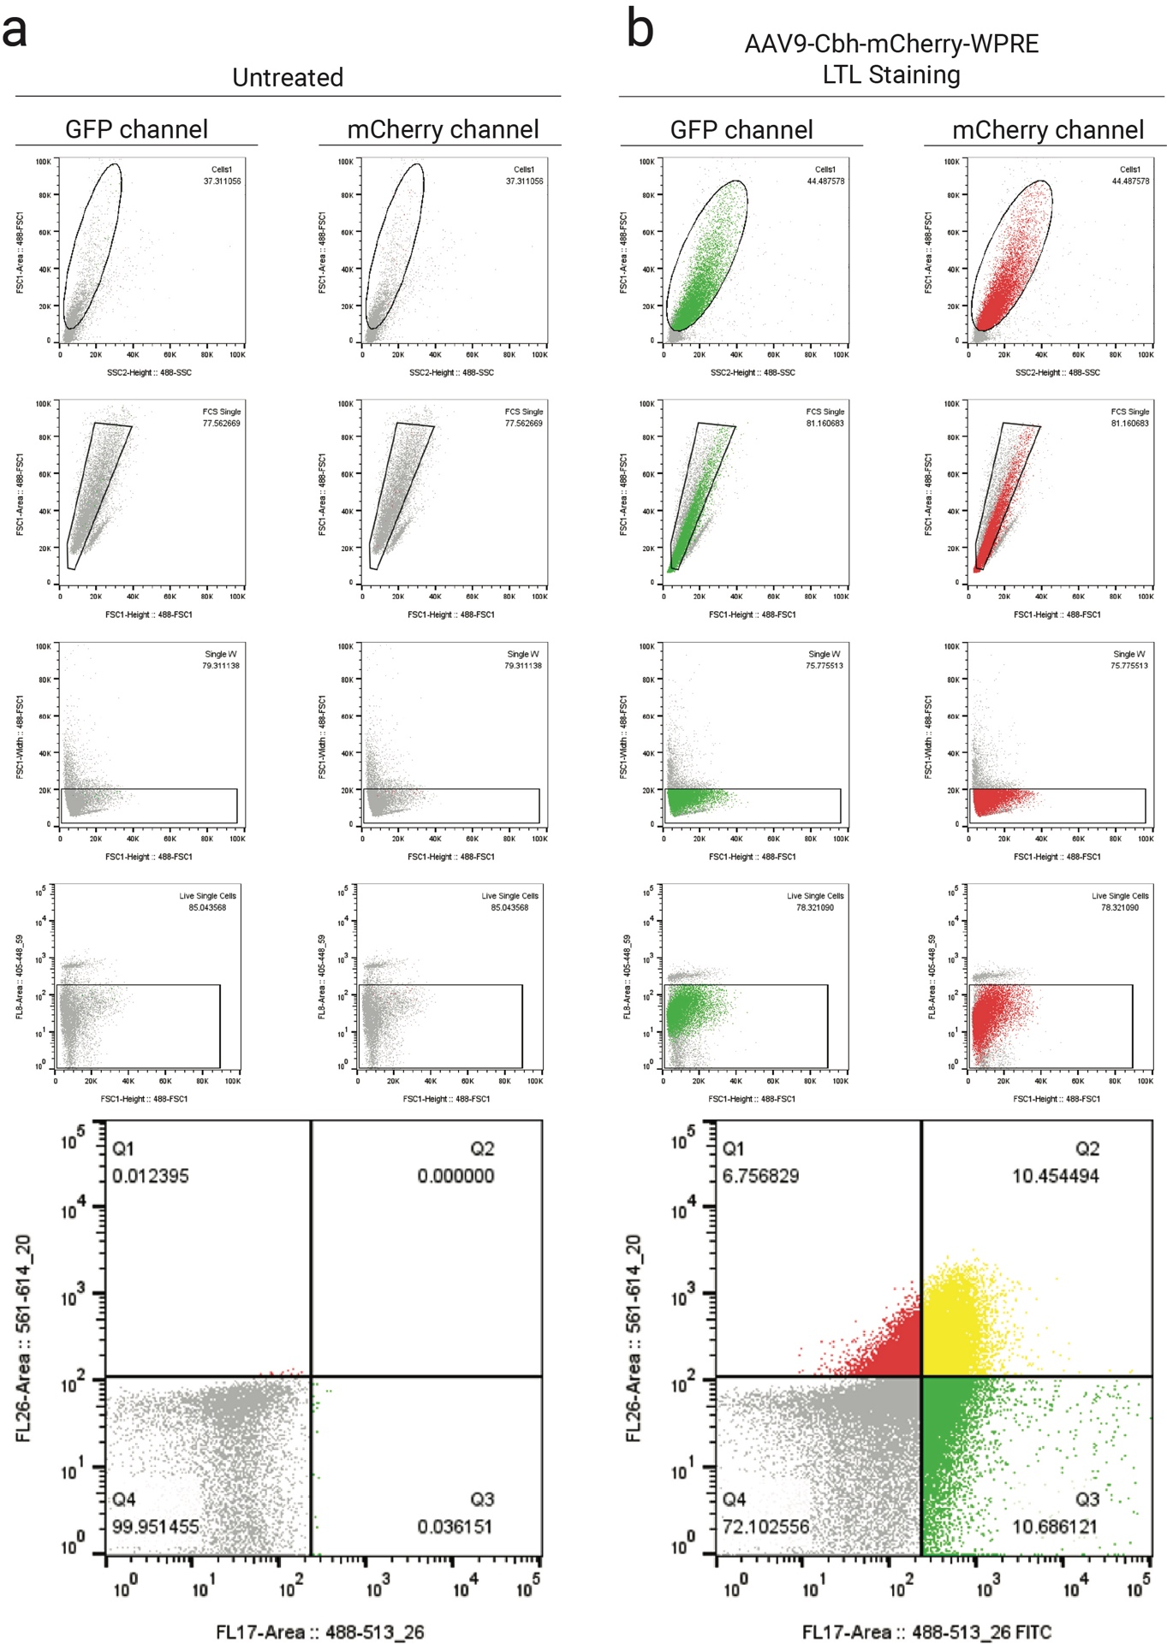
Supplementary Figure 3: Representative flow cytometry gating strategy for LTL and mCherry signal quantification in kidney cells. a, Representative gating for untreated control mouse. b, Representative gating for ssAAV9-CBh-mCherry-WPRE treated mouse and stained with LTL-FITC. For each sample, GFP and mCherry channels were analyzed in parallel to identify cell populations. Sequential gates were applied to exclude debris (first row), select single cells (second and third rows), and gate for viable cells (fourth row). Final dot plots (fifth row) represent two-dimensional analysis of GFP (LTL) and mCherry fluorescence, with quadrants defined as follows: Q1 (LTL+/mCherry-, green), Q2 (LTL=/mCherry+, yellow), Q3 (LTL-/mCherry+, red), Q4 (LTL-/mCherry-, grey). This gating strategy allows for the quantification of mCherry expression specifically within the proximal tubule population (Q2) and across other renal cell types.

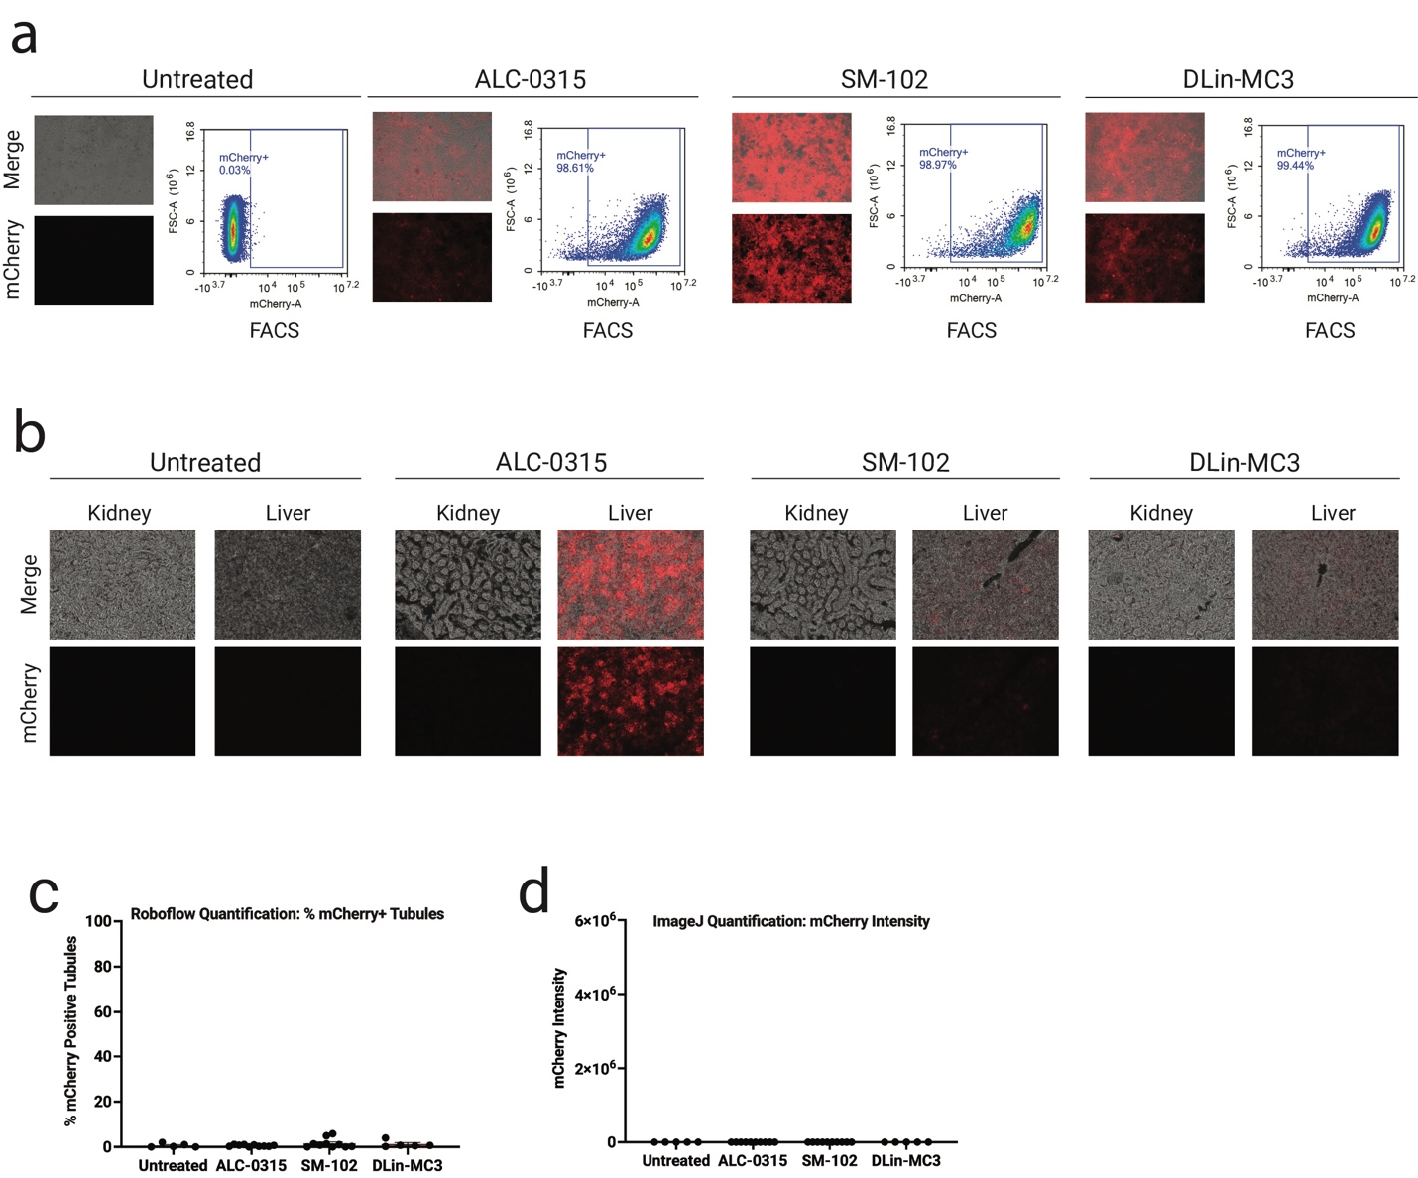
Supplementary Figure 4: FDA-approved LNPs (ALC-0315, SM-102, DLin-MC3) do not transduce kidney efficiently in vivo. a, Representative images of mCherry fluorescence and flow cytometry (FACS) analysis of HEK293T cells incubated in vitro with LNPs, ALC-0315, SM-102, or DLin-MC3, formulated with mCherry-encoding mRNA. b, Representative images of mCherry fluorescence in the kidney and liver of LNP-treated vs. untreated mice. c, Transfection efficiencies in LNP-treated and untreated renal tubules were quantified using Roboflow machine learning-guided image analysis tool. d, mCherry fluorescence intensity in LNP-treated and untreated renal tubules was quantified using ImageJ. Red, mCherry fluorescence. Data are presented as mean ± s.e.m. Statistical analysis was performed using one-way ANOVA. Only statistically significant P values are reported. P < 0.05 was considered statistically significant. Source data and exact P values are provided in the Source Data file.

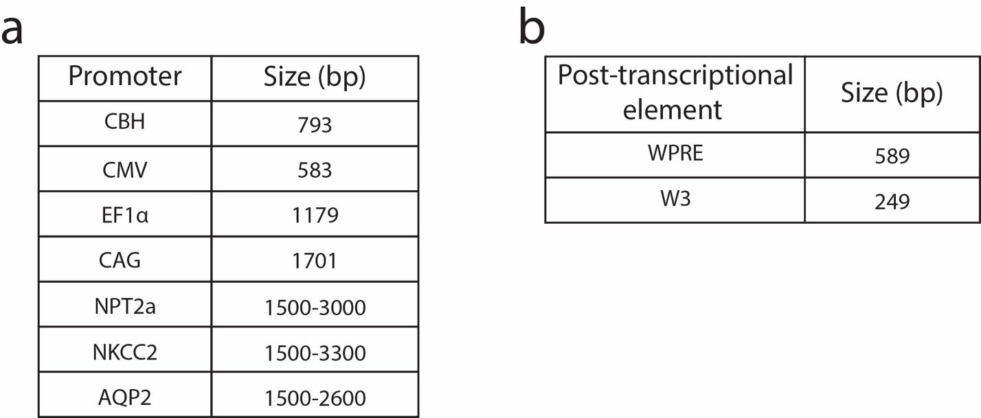
Supplementary Figure 5: Size of promoter and post-transcriptional elements used in this study. a, Estimated size in base pairs (bp) of common (CBH, CMV, EF1α, CAG) and kidney-specific (NPT2a, NKCC2, AQP2) promoters. For kidney-specific promoters, size is given as a range to account for different promoter constructs reported in the literature. b, Approximate size of the post-transcriptional regulatory elements WPRE and W3, which are frequently included in AAV expression cassettes to enhance transcript stability and nuclear export.

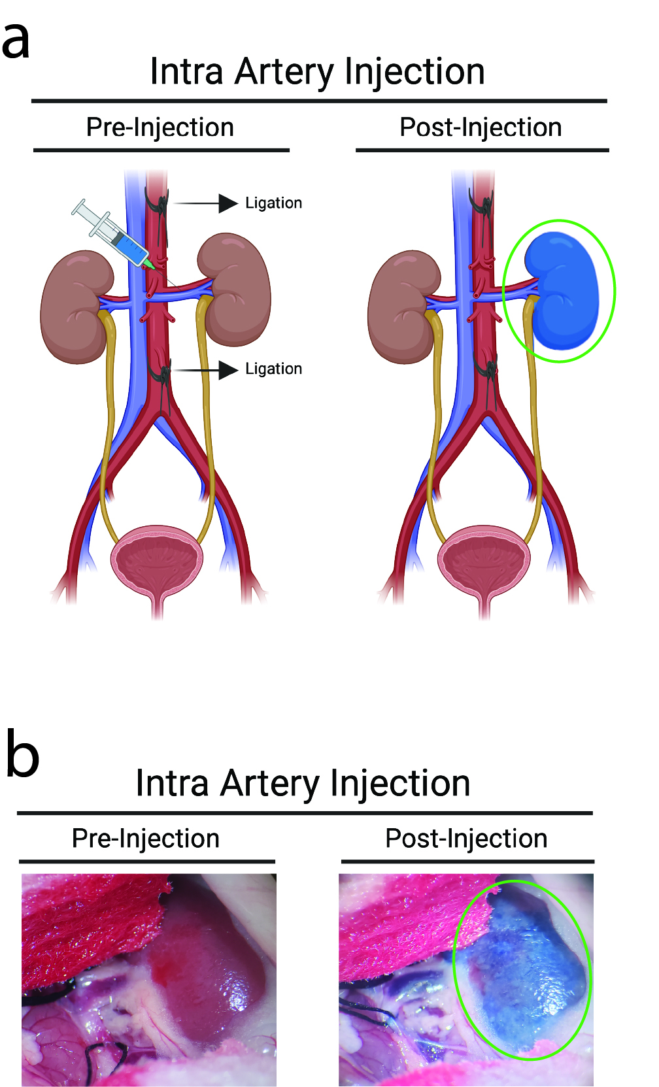
Supplementary Figure 6: Intra-renal artery injection of trypan blue enables targeted delivery to a single kidney a, Diagram showing the procedure for intra artery injection. The aorta and inferior vena cava are ligated below the renal arteries to restrict systemic circulation during injection, allowing targeted delivery to one kidney (green circle). b, Representative images before and after injection of trypan blue. Trypan blue accumulates in the perfused kidney (green circle), confirming successful targeting.

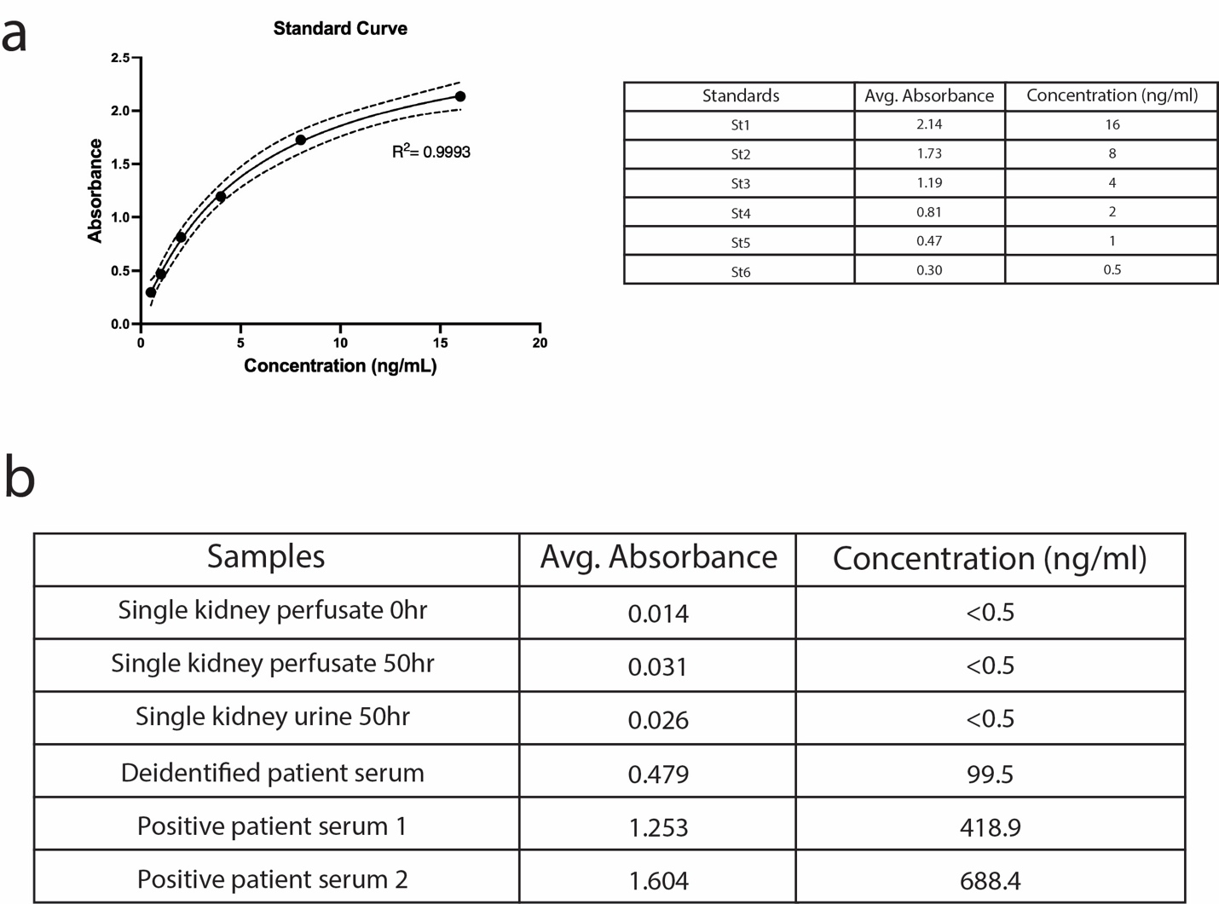
Supplementary Figure 7: The perfusates of the human ex vivo perfusion systems show no detectable anti-AAV9 antibodies. a, Standard curve generated using known concentrations of anti-AAV9 antibodies, showing absorbance values used to calculate sample concentrations. A four-parameter logistic model was used to fit the data. b, Table summarizing average absorbance values and corresponding anti-AAV9 antibody concentrations in various samples. Perfusates and urine, collected at different time points and after AAV9 or AAV.cc47 administration, show absorbance values below the detection limit (<0.5 ng/mL) of the assay, indicating the absence of detectable anti-AAV9 antibodies. In contrast, positive controls and human serum with known anti-AAV9 content fall within the expected detection range.

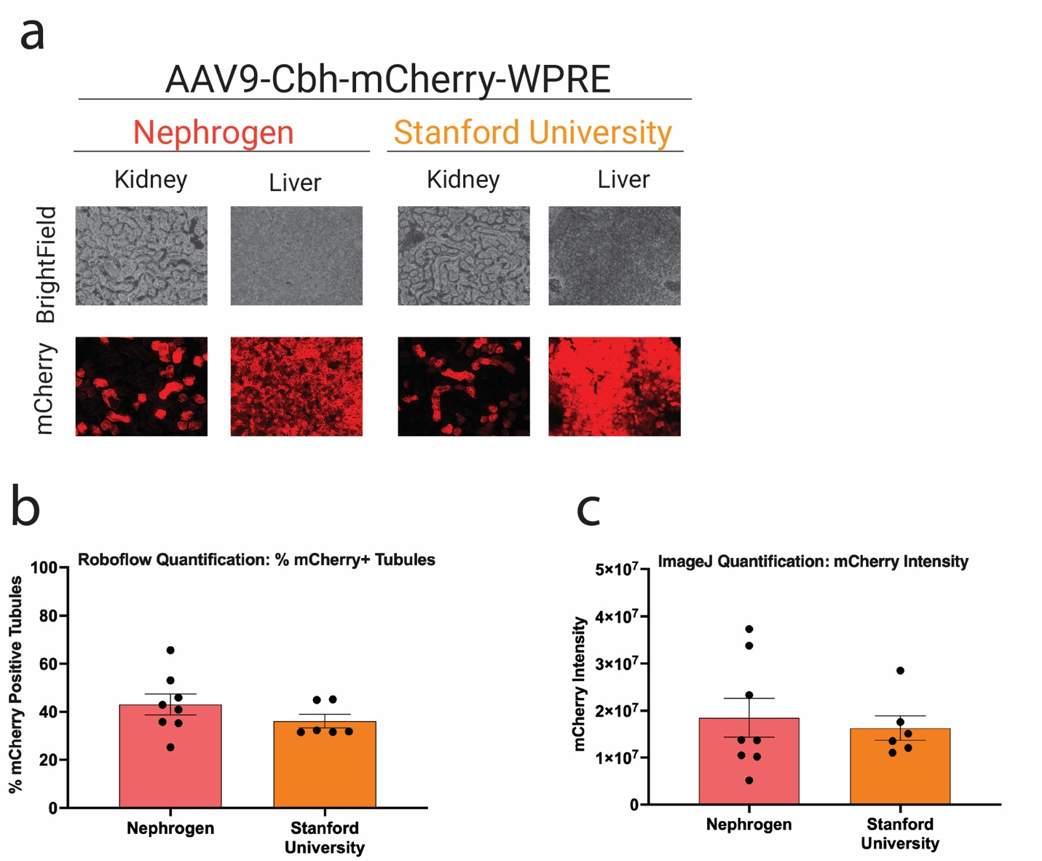
Supplementary Figure 8: Kidney transduction with AAV9-CBH-mCherry via intravenous injection was validated by two different laboratories using C57BL/6J substrains from the east and west coast of the United States. a, Representative images of mCherry fluorescence in the kidney and liver of AAV-treated. b, Transduction efficiencies in AAV-treated renal tubules were quantified using Roboflow machine learning-guided image analysis tool. c, mCherry fluorescence intensity in AAV-treated renal tubules was quantified using ImageJ. Red, mCherry fluorescence. Data are presented as mean ± s.e.m. Statistical analysis was performed using unpaired t test. Only statistically significant P values are reported. P < 0.05 was considered statistically significant. Source data and exact P values are provided in the Source Data file.

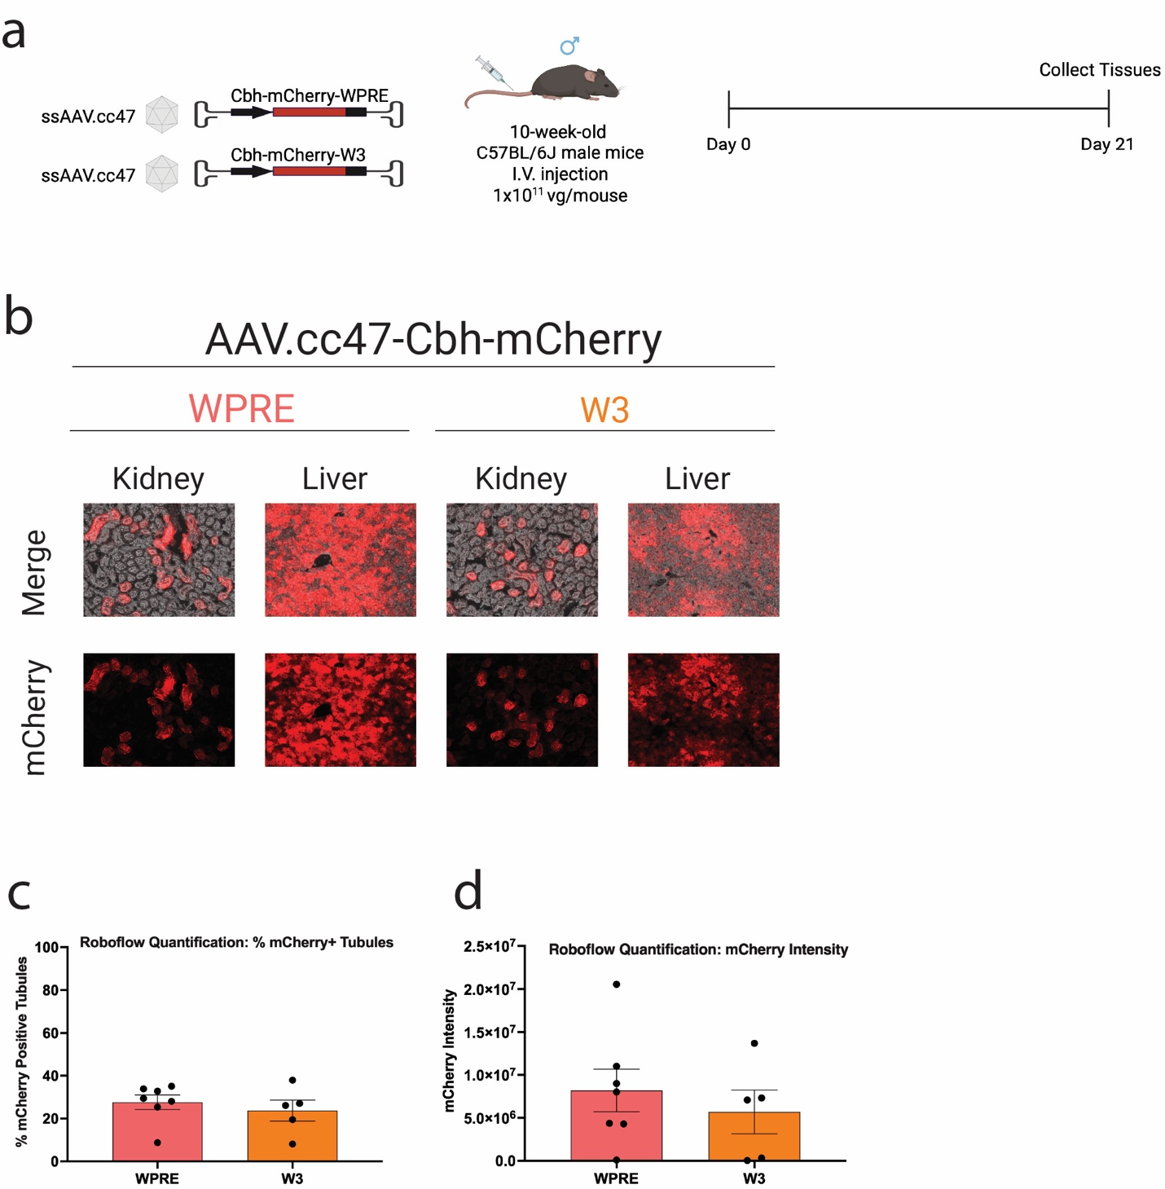
Supplementary Figure 9: WPRE and W3 sequences show comparable kidney transduction with AAV.cc47 capsid in mice. a, Experimental design. Ten-week-old male C57BL/6J mice were injected intravenously with ssAAV.cc47-CBH-mCherry-WPRE or scAAV.cc47-CBH-mCherry-W3 at a dose of 1.0 × 10¹¹ vg/mouse (n = 7 and 5 per group, respectively). Kidneys and liver were harvested three weeks post-injection for downstream analyses. b, Representative images of mCherry fluorescence in the kidney and liver of AAV-treated. c, Transduction efficiencies in AAV-treated renal tubules were quantified using Roboflow machine learning-guided image analysis tool. d, mCherry fluorescence intensity in AAV-treated renal tubules was quantified using ImageJ,. e, mCherry transduction efficiency in kidney cells from AAV-treated mice was quantified by flow cytometry. Red, mCherry fluorescence. Data are presented as mean ± s.e.m. Statistical analysis was performed using unpaired t test. Only statistically significant P values are reported. P < 0.05 was considered statistically significant. Source data and exact P values are provided in the Source Data file.

