#Appendix 1: R(1) code for derivation of priors from expert guesses documented in the IARC monograph
#IARC. Talc and Acrylonitrile. IARC Monogr Identif Carcinog Hazards Hum. 136:1–488. 2025. #https://publications.iarc.who.int/646.(2)
#table below refer to Annex 2 of IARC (2025)
#see main text for details

#START OF R CODE

#Format for each row = expert
#best 2.5%ile 97.5%ile
#from table A2.1

#expert 1
SN_case1=c(0.96, 0.94, 0.98)
SP_case1=c(0.85, 0.80, 0.90)
SN_control1=c(.9, .85, .95)
SP_control1=c(.9, .85, .95)

#expert 2
SN_case2=c(0.75, 0.65, 0.85)
SP_case2=c(0.90, 0.85, 0.95)
SN_control2=c(.65, .6, .7)
SP_control2=c(.9, .85, .95)

#expert 3
SN_case3=c(0.90, 0.85, 0.95)
SP_case3=c(0.85, 0.8, 0.9)
SN_control3=c(.8, .75, .85)
SP_control3=c(.9, .85, .95)

#combine
#average best, lowest and highest of expert guesses for sensitivity in cases
SN_case=rbind(SN_case1, SN_case2, SN_case3)
SN_case_mean=mean(SN_case[,1])
SN_case_low=mean(SN_case[,2])
SN_case_high=mean(SN_case[,3])
c(SN_case_mean, SN_case_low, SN_case_high)

#get parameters of beta distribution of SN cases
install.packages("epiR") #do only once
library("epiR")
SN1=epi.betabuster(mode=SN_case_mean, conf=0.975, imsure="greater than", x=SN_case_low, conf.level = 0.95, max.shape1 = 1000, step = 0.001)
SN1$shape1
SN1$shape2

#average best, lowest and highest of expert guesses for specificity in cases
SP_case=rbind(SP_case1, SP_case2, SP_case3)
SP_case_mean=mean(SP_case[,1])
SP_case_low=mean(SP_case[,2])
SP_case_high=mean(SP_case[,3])
c(SP_case_mean, SP_case_low, SP_case_high)
SP1=epi.betabuster(mode=SP_case_mean, conf=0.975, imsure="greater than", x=SP_case_low, conf.level = 0.95, max.shape1 = 1000, step = 0.001)
SP1$shape1
SP1$shape2

#average best, lowest and highest of expert guesses for sensitivity in controls
SN_control=rbind(SN_control1, SN_control2, SN_control3)
SN_control_mean=mean(SN_control[,1])
SN_control_low=mean(SN_control[,2])
SN_control_high=mean(SN_control[,3])
c(SN_control_mean, SN_control_low, SN_control_high)
SN0=epi.betabuster(mode=SN_control_mean, conf=0.975, imsure="greater than", x=SN_control_low, conf.level = 0.95, max.shape1 = 1000, step = 0.001)
SN0$shape1
SN0$shape2

#average best, lowest and highest of expert guesses for specificity in controls
SP_control=rbind(SP_control1, SP_control2, SP_control3)
SP_control_mean=mean(SP_control[,1])
SP_control_low=mean(SP_control[,2])
SP_control_high=mean(SP_control[,3])
c(SP_control_mean, SP_control_low, SP_control_high)
SP0=epi.betabuster(mode=SP_control_mean, conf=0.975, imsure="greater than", x=SP_control_low, conf.level = 0.95, max.shape1 = 1000, step = 0.001)
SP0$shape1
SP0$shape2

#illustrate
par(mfrow=c(1,2))
n=1000000
sim_SN1=rbeta(n, SN1$shape1, SN1$shape2)
plot(density(sim_SN1), col="red", main="SN in cases (red) and controls (blue)", ylim=c(0,20), xlim=c(0.6, 1), xlab="sensitivity (SN)")
sim_SN0=rbeta(n, SN0$shape1, SN0$shape2)
lines(density(sim_SN0), col="blue")

sim_SP1=rbeta(n, SP1$shape1, SP1$shape2)
plot(density(sim_SP1), col="red", main="SP in cases (red) and controls (blue)", ylim=c(0,20), xlim=c(0.6, 1), xlab="specificity (SP)")
sim_SP0=rbeta(n, SP0$shape1, SP0$shape2)
lines(density(sim_SP0), col="blue")

#END OF R CODE

Figure 1S: Illustration of prior densities of misclassification parameters for ever-use of talc in population-based case-control studies of ovarian cancer risk
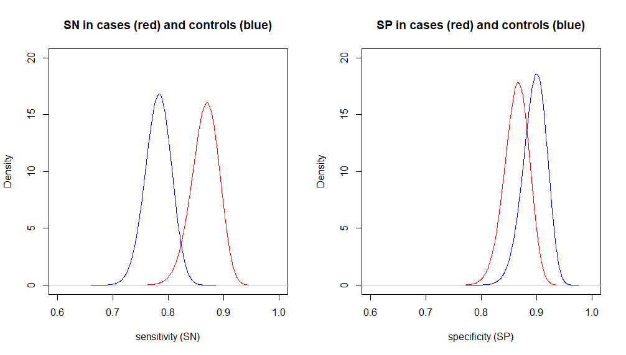

1. Team RDC. R: A language and environment for statistical computing. ISBN 3-900051-07-0. Vienna, Austria: R Foundation for Statistical Computing; 2006 2006.
2. IARC. Annex 2. Quantitative bias analysis for exposure misclassification for the effects of ever versus never use of talc on ovarian cancer. Talc and Acrylonitrile IARC Monographs on the Identification of Carcinogenic Hazards to Humans. 136. Lyon, France: IARC; 2025.

