Appendix 3. Trace plot of model parameters: of bias-adjusted, true, odds ratio ${OR}_{t}$, sensitivities (p) and specificities (q), as well as prevalences ( r ) of controls (subscript 0) and cases (subscript 1)
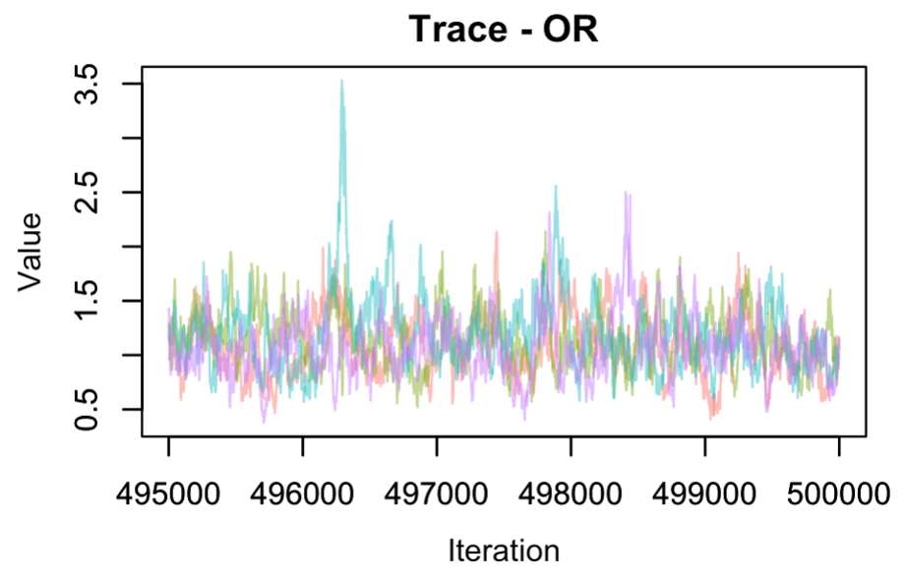 | 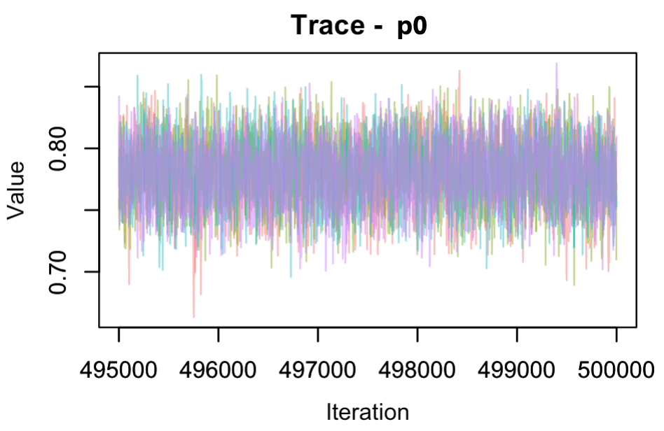 | 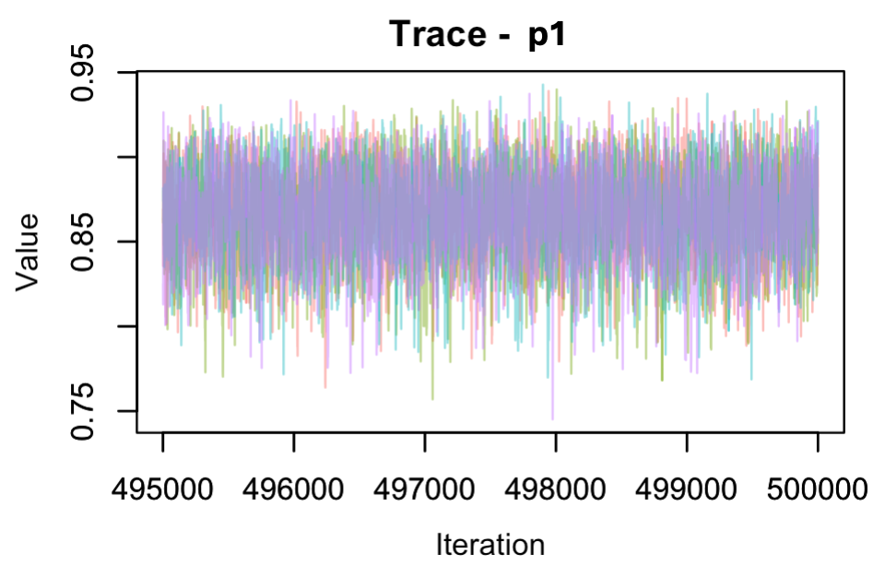
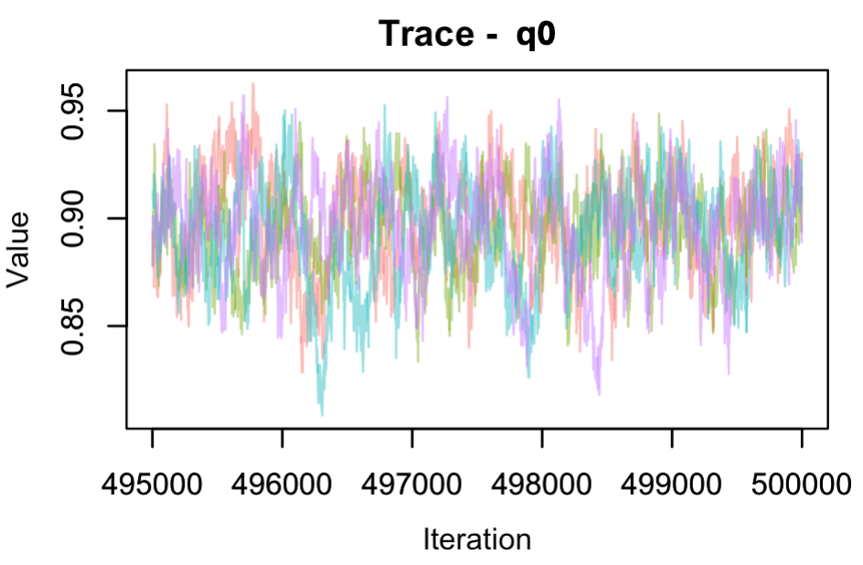 | 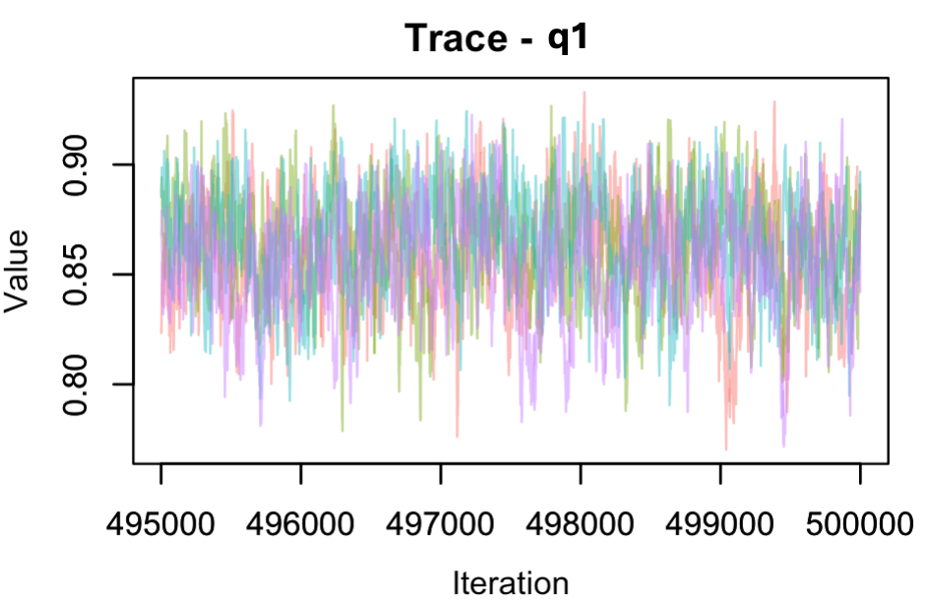 | 