Supplemental materials

Gut microbiota phospholipids regulate intestinal gene expression
and can counteract the effects of antibiotic treatment

Xue-Song Zhang¹*, Meifan Zhang¹, Yujue Wang², Haipeng Sun³, Matthew Scarnati¹, Zhan Gao¹, Yue Sandra Yin¹，Christa Zerbe⁴, Emilia Falcone⁴, Mary C. Lally¹, Jay N. Joshi¹, Sneha Bhattacharya¹, Maria Elena Diaz-Rubio², Disha Bharj¹, Disha Patel¹, Samuel Pan¹, Gabrielle Ro¹, Jessica Grenard⁴, Abigail Armstrong¹, Alexander J. Valvezan¹, Steven Holland⁴, Jennifer Mulle¹, Maria Gloria Dominguez-Bello³, Xiaoyang Su^{2,5}, Martin J. Blaser¹*

¹Center for Advanced Biotechnology and Medicine, Rutgers University,
²Metabolomics Shared Resource, Rutgers Cancer Institute,
³Department of Biochemistry and Microbiology, Rutgers University,
⁴Clinical Center and NIAID, National Institutes of Health,
⁵Department of Medicine, Robert Wood Johnson Medical School, Rutgers University.
* Correspondence: xuesong.zhang@rutgers.edu (XS.Z.), martin.blaser@cabm.rutgers.edu (M.J.B.)

Supplemental Text

Lipidomic analysis of representative gut bacterial strains. We also conducted lipidomic analysis using six cultured gut bacterial strains representing different phyla—Alistipes finegoldii (Bacteroidota), Muribaculaceae (Bacteroidota), Bifidobacterium longum (Actinomycetota), Escherichia coli (Pseudomonadota), Clostridium perfringens (Bacillota), and Lactobacillus murinus (Bacillota). Bray-Curtis distance analysis based on the 391 lipid compounds identified (Table S2) revealed distinct lipid profiles for each (Figure S2A), as did unsupervised clustering (Figure S2B). This analysis provides evidence that gut bacterial taxa contribute distinctively to the overall lipid diversity within the microbiome.

Early-life antibiotic exposure alters lipid profiles of NOD mouse cecal contents, partially restored by cecal microbiota transplant (CMT). A group of 343 (45.9%) were decreased by antibiotics and restored by CMT (Figure S3A, blue box), whereas 99 (13.3%) were increased by antibiotics and restored by CMT (Figure S3A, red box); 1P significantly altered both odd-chain and even-chain profiles compared to control (Figure S3BC), and CMT restored profiles toward control (Figure S3BC). We identified 49 GMPLs affected by the 1P treatment (Figure S3D). Further analysis of the 1P effects on the 747 compounds and the three subgroups defined in Figure 2B, GMPLs (blue boxes), host-produced compounds (yellow box), and diet-derived compounds (green), using fold-difference and statistical significance criteria confirmed the extent of antibiotic impact on lipid profiles, particularly GMPLs (Figures S3EF).

Effects of azithromycin on fecal lipid profiles of human subjects. Unsupervised clustering of the 18 subjects from the 3 groups based on the 728 lipids showed two distinct clusters: Cluster 1 includes 5 of the 6 AZM-exposed subjects and 1 AMX-exposed subject. Cluster 2 includes all 6 control subjects, 4 of the 6 AMX-exposed subjects and 1 AZM-exposed subject (Figure S4B). Among the 59 odd-chain GMLs (Figure 2E), azithromycin significantly decreased 31 (53%) and increased none (Figure S4C). Of the 28 even-chain GMLs (Figure 2F), azithromycin significantly decreased 20 (71%) and increased none (Figure S4C). The lipids affected by the macrolide-treatments in the mouse and human intestinal samples significantly overlapped (Figure3 S3F, S4C). Volcano plot analysis (Figure S4D) confirmed the significant impact of azithromycin on microbially produced lipids, identifying 39 compounds that were decreased, with none increased (Figures 4D, S5; amoxicillin treatment significantly altered only 3 lipids (Figure S5). Phospholipids were the largest group of GMPLs decreased by azithromycin (51%) (Figure S4C), similar to the findings in mice (Figure S3D). Nine (29%) the 31 azithromycin-decreased microbially-produced odd-chain lipid compounds [4 phospholipids, 2 fatty acids, 2 sterol esters, and 1 sterol lipid] also were decreased by tylosin in the mice (Figures S3D, S4C). Thirteen (65%) of the 20 azithromycin-decreased microbially-produced even-chain lipid compounds [7 phospholipids, 3 fatty acids, and 3 sterol esters] also were decreased by tylosin in the mice (Figures S3D, S4C). A notable difference between observations from NOD mouse cecal contents and human fecal experiments is that 10 of 11 microbially-produced sulfonolipids (SL) (Figure 2E) were significantly increased by tylosin in NOD mice (Figure S3D), while all 11 microbially-produced sulfonolipids were significantly decreased by azithromycin in humans (Figure S4C). Thus, microbial odd-chain sulfonolipid production was highly affected by the antibiotic treatment and the initial microbial population in their hosts.
LPG(13:0) showed significantly higher abundance in the cecal contents of conventional mice than in GF mice and in diet identifying it as a GMPL without abundance changes with 1P or CMT in NOD mice, but significantly decreased by azithromycin in human subjects (Figure 3B). Azithromycin significantly decreased the abundance of PG(15:0_15:0) in the human volunteers (Figure 3G). For LPG(16:0) and LPG(18:0), their abundances in mouse cecal contents and in human feces were significantly decreased by the macrolide antibiotics (Figure 3LP). LPG(16:0) was detected in all six representative bacterial strains (Figure S2C left), while LPG(18:0) were present in 5 of 6 (Figure S2C right), but LPG(13:0) and PG(15:0_15:0) were absent. These findings indicate that the effects of antibiotic exposure on gut lipid profiles could be complex and strain-specific.

Supplemental Figures
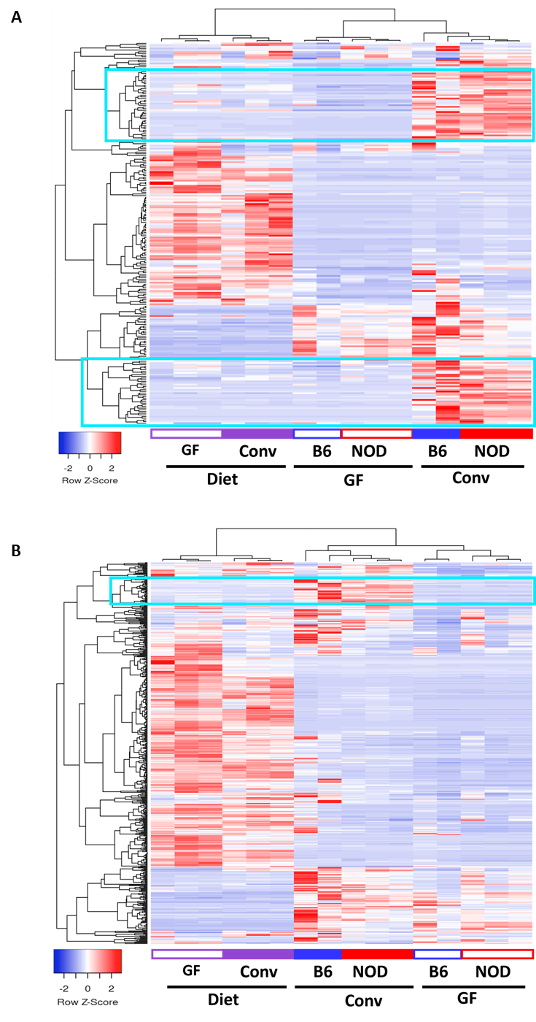
Supplemental Figure 1. Clustering of lipid compounds in diets and in cecal specimens from conventional and germ-free mice in Experiment 1. Unsupervised hierarchical clustering based on 230 odd-chain lipids (A) and 517 even-chain lipids (B): Blue boxes indicate microbially-produced lipid compounds, highly abundant in cecal contents from conventional mice but low in diets and low in cecal contents from germ-free mice.

Supplemental Figure 2. Non-redundant lipid compounds in representative murine intestinal bacterial species. Verification of defined compounds by MS2 with standards in cell pellets from six bacterial species belonging to the four major mammalian intestinal phyla. A) Bray-Curtis distances based on the 391 non-redundant lipid compounds identified in the cell pellets of the 6 bacterial species. B) Unsupervised hierarchical clustering based on the 391 nonredundant lipid compounds across the six strains. Strain-specific lipid compound clusters are highlighted within the boxes. C) Verification of LPG16:0 (Left) & LPG18:0 (Right) by MS2 with standards in cell pellets from the six bacterial species belonging to four major intestinal phyla. Alistipes finegoldii strain 23-018 (Bacteroidota), Muribaculaceae spp. strain MH8C (Bacteroidota), Bifidobacterium longum strain HMXZ001 (Actinomycetota), Escherichia coli strain Nissle 1917 (Pseudomonadota), Clostridium perfringens strain S107 (Bacillota), and Lactobacillus murinus strain 21-100 (Bacillota).

Supplemental Figure 3. Antibiotic effects on cecal content lipid profiles in NOD mice (Experiment 2). A) Unsupervised clustering based on the 747 compounds. Blue box: lipid compounds decreased by 1P (compared with control) and restored by CMT (n=343; 45.9%). Red box: lipid compounds increased by 1P and restored by CMT (n=99, 13.3%). B) Bray-Curtis distances for the 230 identified odd-chain lipid compounds. Significant differences [pairwise PERMANOVA analysis] were found between C & 1P (adjusted p-value =0.003), between 1P & CMT (adjusted p-value =0.006), and between C & CMT (adjusted p-value =0.024). C) Bray-Curtis distances for the 517 even-chain identified compounds. Significant differences [pairwise PERMANOVA analysis] were found between C & 1P (adjusted p-value =0.006), and between 1P & CMT (adjusted p-value =0.012); differences between C and CMT were not significant (adjusted p-value =0.30). D) List of microbially-produced lipids in which 1P significantly altered abundance. E) Volcano plots comparing the impact of treatment on the abundances of the compounds in the Control and 1P groups. Panels: 1) All 747 compounds; 2) 151 microbially-produced compounds identified from Figure 2B [blue boxes]; 3) 83 host-produced compounds [yellow box]; 4) 355 diet-derived compounds [green box]. Blue points represent 1P-decreased compounds, with geometric mean fold-difference >4 compared with Control and log-transformed p-value <0.01. Red points represent 1P-increased compounds, using the same criteria. F) Lists of lipid compounds with abundance significantly altered in antibiotic-exposed- NOD mice, identified in volcano plot analysis; using the criteria of a geometric mean fold-difference >4 compared with Controls and log-transformed p-value <0.01, 36 microbially-produced compounds were significantly altered by 1P exposure, including 30 decreased and 6 increased (Panel Left); 3 host-produced compounds were altered by 1P, including 1 decreased and 2 increased (Panel Right top); and 156 diet-enriched compounds were significantly altered by 1P, including 155 decreased (See Supplemental Table 1) and 1 increased (Panel Right bottom).

Supplemental Figure 4. Antibiotic effects on fecal microbiome and lipid profiles in human volunteers (Experiment 3). A) Fecal α-diversity: Shannon index, depth 14,246 reads. No significant differences observed. B) All 52 microbially-produced lipids differentiated by azithromycin including 31 odd-chain and 20 even-chain compounds were decreased; no compounds were significantly increased by azithromycin. The 22 lipids significantly affected in both antibiotic-treated mice and humans are shown in bold. C) Unsupervised clustering analysis based on 728 non-redundant lipid compounds identified in fecal samples from 18 human subjects. Samples are from three experimental groups of human volunteers: control, azithromycin (AZM)-, and amoxicillin (AMX)-exposure. Two distinct clusters were identified among the subjects. Cluster 1 includes 5 of the 6 AZM-exposed subjects and 2 AMX-exposed subjects. Cluster 2 includes all 6 control subjects, 4 of the 6 AMX-exposed subjects and 1 AZM-exposed subjects. D) Volcano plots showing the impact of azithromycin treatment on the abundances of the nonredundant lipid compounds. Panels: 1) All 728 identified compounds, 2) 150 microbially-produced compounds identified from Figure 2B blue boxes; 3) 79 host-produced compounds from yellow box; 4) 349 diet-derived lipid compounds from green box. E) Fecal metagenomics: normalized number of copies of the genes encoding the key enzymes involved in bacterial (Lyso-)PG biosynthesis before, during, and after the azithromycin treatment. *p<0.05 compared with 1P group; Mann-Whitney U-test.

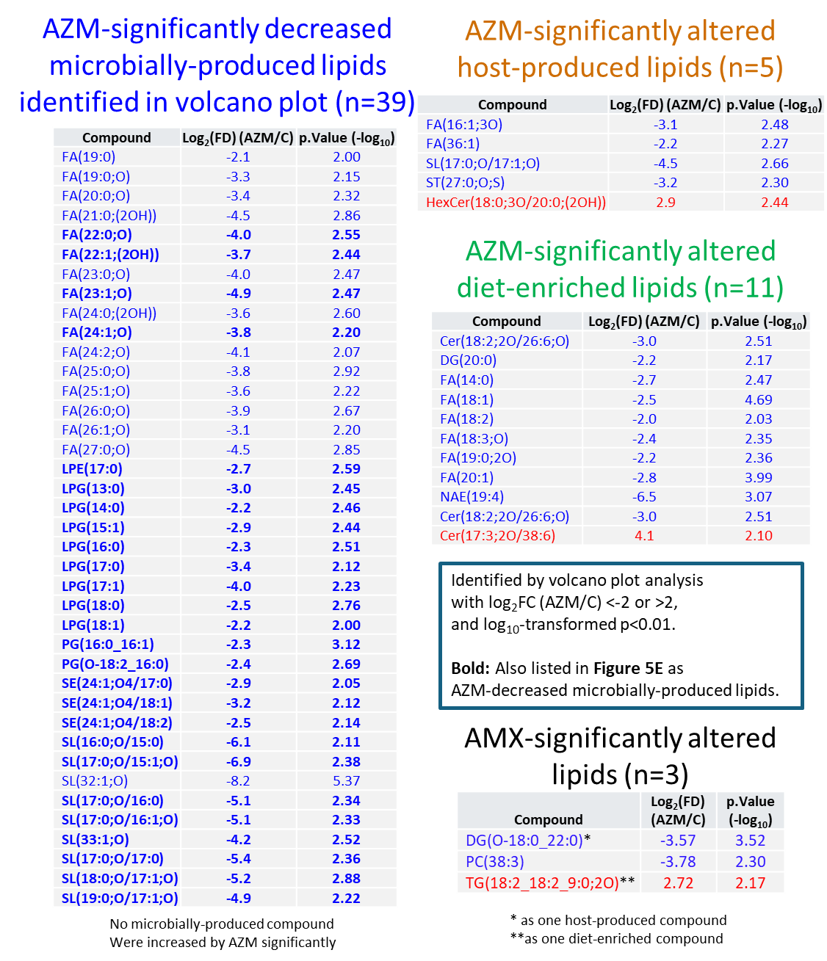

Supplemental Figure 5. Lists of lipid compounds in human subjects significantly altered by antibiotic-exposure, as identified in volcano plot analysis. In the analysis using the criteria of geometric mean fold-difference >4 compared with Control and log-transformed p-value <0.01, 39 microbially-produced compounds were significantly decreased by AZM, and none were increased (Panel Left); 5 host-produced compounds were altered by AZM, including 4 decreased and 1 increased (Panel Right top); and 11 diet-enriched compounds were significantly altered by AZM, including 10 decreased and 1 increased (Panel Right middle). For all 728 compounds, only 3 compounds were significantly altered by AMX, including 2 decreased (1 host-produced compound), and 1 increased (diet-enriched) (Panel Right bottom).
Supplemental Figure 6. Confirmation of the structure of four (lyso-)PG compounds in NOD mouse cecal contents and effects on host immune responses in vitro. A) LPG(13:0), B) PG(15:0_15:0), C) LPG(16:0), and D) LPG(18:0). The normalized intensities of detected fragments (m/z) are plotted for each lipid compound. Peaks in black above the X-axis correspond to the targeted lipid compound; peaks in red below the X-axis represent the reference standard. E) Chemical structure of retinoic acid, and F) its normalized abundances in the three lipidomic analysis experiments. **p<0.01; Mann-Whitney U-test. G) Absence of effects of retinoic acid on NFκB activity in mouse macrophage Raw Blue cells. H) Repressive effects of retinoic acid on LPS-induced NFκB activity in mouse macrophage Raw Blue cells. *p<0.05; **p<0.01; Mann-Whitney U-test. I) Significant effects of retinoic acid on the expression of four innate immune genes in human colonic epithelial HT-29 cells. **p<0.01; Mann-Whitney U-test. J-M) Absence of effects of individual (lyso-)PG compounds on NFκB activity in mouse macrophage Raw Blue cells, without the presence of LPS co-stimulation: J) LPG(13:0); K) PG(15:0_15:0); L) LPG(16:0); M) LPG(18:0).
Supplemental Figure 7. Effects of specific microbially-produced phospholipids (LPG16:0 and LPG18:0) on host mitochondrial respiration in vitro in HT29 cells. Quantitation of basal respiration (A), maximal respiration (B), ATP-linked respiration (C), non-mitochondrial respiration (D), proton leak (E), spare respiration capacity (F), and coupling efficiency (G) in response to LPG16:0 treatment. Corresponding measurements for LPG18:0 treatment: basal respiration (H), maximal respiration (I), ATP-linked respiration (J), non-mitochondrial respiration (K), proton leak (L), spare respiration capacity (M), and coupling efficiency (N). Data represent mean ± SD. Statistical significance determined by Mann-Whitney U-test. *p<0.05, **p<0.01. O) Confocal images of HT29 cells co-cultured with PBS only, LPG16:0, or LPG18:0, with Mitotracker stain (green, left panels) for mitochondria and with Lysotracker (red, middle panels) for lysosomes. Co-localization of Mitotracker and Lysotracker is shown in right panels. P) Effects of LPG(16:0) and LPG(18:0) on mitochondrial morphology in HT29 cells. Mitochondrial length was classified into four categories: <1 µm (fragmented), 1–5 µm (normal), 5–10 µm (elongated), and >10 µm (hyper-elongated). Data represent n = 6 independent assays from 2 independent treatment replicates. Statistical significance determined by Mann-Whitney U-test. *p<0.05.

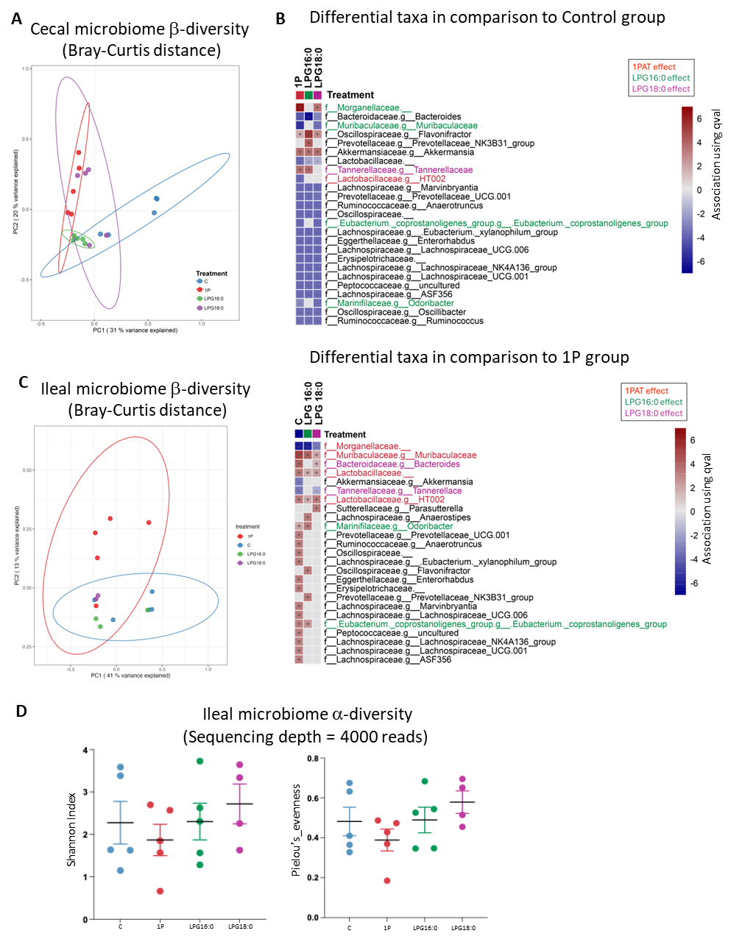
Supplemental Figure 8. Effects of treatment with LPG16:0 or LPG18:0 after 1PAT on intestinal microbiota of NOD mice. A) Principal coordinates analysis (PCoA) of cecal microbiome β-diversity (Bray–Curtis) indicating a significant shift induced by 1P treatment compared to Control, which was partially restored by LPG16:0 and LPG18:0 administration. B) Differentially abundant cecal taxa identified with MaAsLin 2. Top panel: taxa in 1P, LPG16:0, and LPG18:0 groups relative to Control; Bottom panel: taxa in the Control, LPG16:0, and LPG18:0 groups relative to the 1P group. Taxa that were altered from control by 1P but restored by LPG 16:0 or by LPG18:0 are indicated in the colored boxes. Lactobacillaceae g_HT002 was restored by both treatments. C) Principal coordinates analysis (PCoA) of ileal microbiome β-diversity (Bray–Curtis) showing a significant shift induced by 1P treatment compared to Control, which is partially restored by LPG16:0 and LPG18:0 administration. D) Ileal microbiome α‑diversity (Shannon index, and Pielou’s Evenness) indicates no significant effect of the LPG16:0 or LPG18:0 treatments on α‑diversity in the ileum, in contrast to the effects on the cecum (Figure 4A).
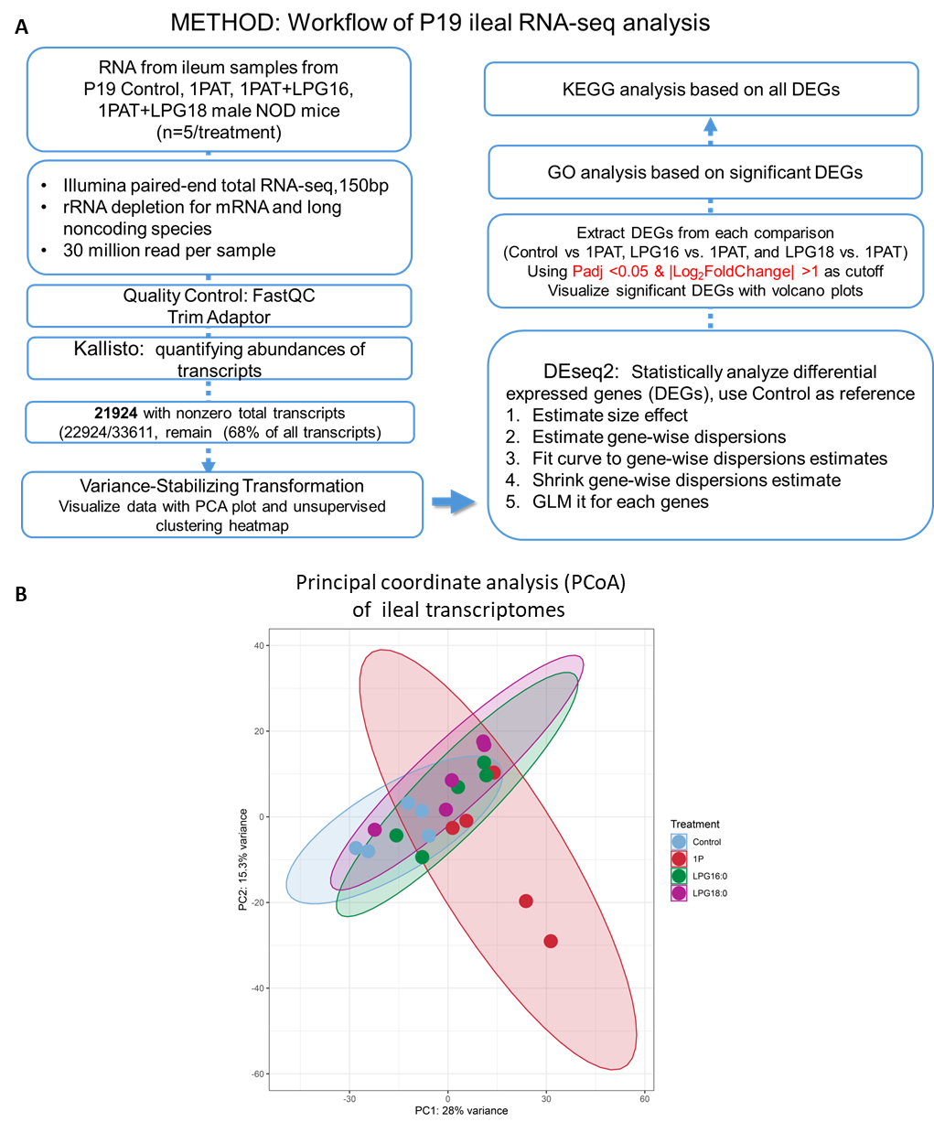
Supplemental Figure 9. Effects of treatment with LPG16:0 or LPG18:0 after 1PAT on ileal gene expression of NOD mice. A) Workflow for RNAseq processing and differential‑expression analysis of ileal transcriptome. B) Principal coordinate analysis (PCoA) of ileal transcriptomes based on variance-stabilizing transformation (VST)-normalized counts for 21,924 transcripts by RNAseq. Statistical significance determined using adjusted p<0.05.
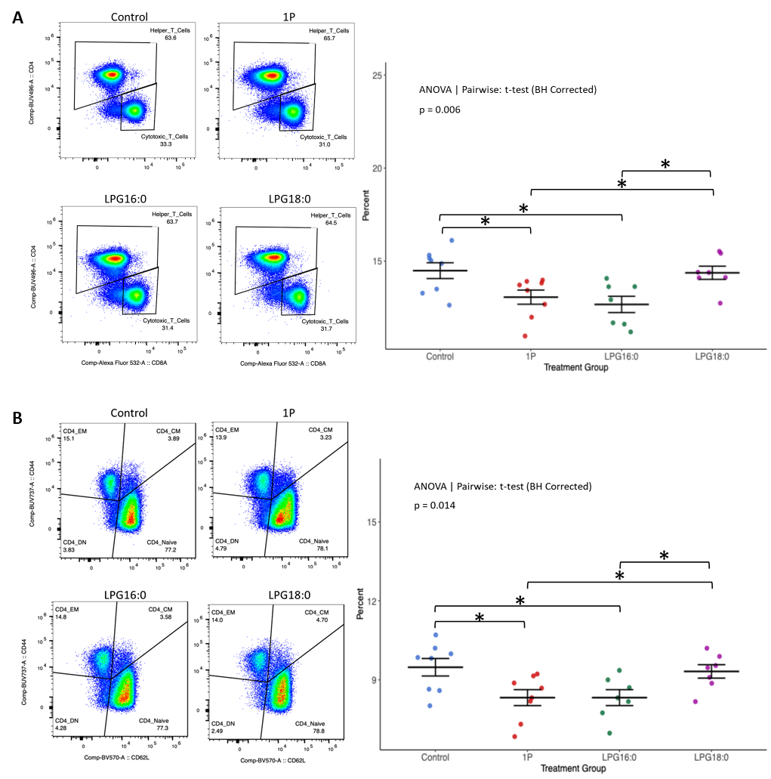
Supplemental Figure 10. Effects of treatment with LPG16:0 or LPG18:0 after 1PAT on ileal gene expression of C57BL/6N mice. A) Representative flow cytometry plots (left) showing the gating strategy for splenic helper T cells in mice receiving lipid administration after 1PAT in four treatment groups (Control, 1P only, or 1P followed by LPG16:0 or LPG18:0), and quantitation (right) of helper T cell percentages among total lymphocytes. B) Representative flow cytometry plots (left) showing the gating strategy for splenic CD4⁺ naïve T cells across the same treatment groups, and quantitation (right) of CD4⁺ naïve T cell percentages among total lymphocytes. Data are presented as mean ± SEM. Statistical analysis was performed using one-way ANOVA followed by pairwise t-tests with Benjamini–Hochberg (BH) correction, *p<0.05.

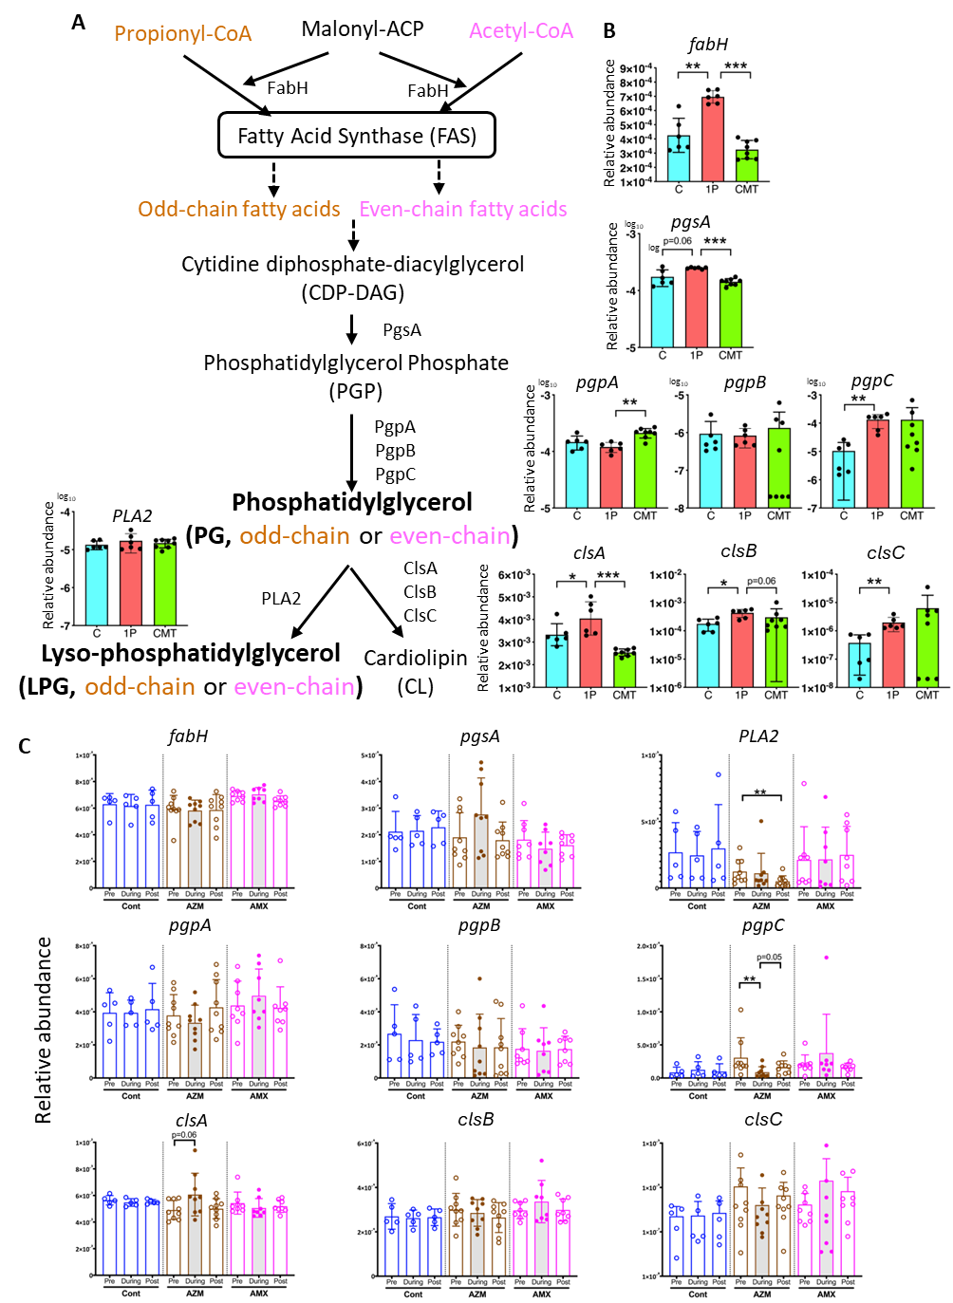
Supplemental Figure 11. Key enzymes in bacterial pathways of phosphatidylglycerol (PG) and lysyl-phosphatidylglycerol (LPG) biosynthesis. A) Organization of the synthetic pathways. The key enzymes include: FabH (β-ketoacyl-ACP synthase III), encoded by fabH ,which plays the critical role in initiating fatty acid synthesis and regulating the formation of both odd-chain and even-chain fatty acid structures in PG and LPG; PgsA (phosphatidylglycerophosphate synthase), encoded by pgsA, which controls the crucial step in bacterial phospholipid biosynthesis, converting cytidine diphosphate-diacylglycerols (CDP-DAG) and glycerol-3-phosphate (G3P) into phosphatidylglycerophosphates (PGP); PgpABC (Phosphatidylglycerophosphatases A, B, C), encoded by pgpA, pgpB, pgpC, respectively, involved in the final step of bacterial PG biosynthesis from PGP. The functional redundancy of the 3 genes, all contributing to PG production enables bacteria to maintain a steady PG supply, crucial for membrane integrity, encoding phospholipase A2 (PLA2) that plays a critical role in phospholipid metabolism by hydrolyzing the sn-2 acyl bond of glycerophospholipids to generate lysophospholipids; ClsABC (Cardiolipin Synthases A, B, C), encoded by clsA, clsB, clsC, respectively, convert PG into cardiolipin (CL). B) Relative abundance of each gene based on metagenomic analysis of the cecal microbiome in NOD mice at P23. Specimens altered by antibiotic exposure (1P) and restored by cecal material transplant (CMT), were compared with control (C). *p<0.05; **p<0.01; ***p<0.0001, compared with control by Mann-Whitney U-test. C) Relative abundance of each gene based on metagenomic analysis of the fecal microbiome of human subjects; before (Pre), during, and after (post) antibiotic treatment. *p<0.05 compared with pre within the same group; Mann-Whitney U-test.

Supplemental Tables

Table S1. Full list of the compounds identified in lipidomic analysis of Experiments 1, 2, and 3 (Attached Excel file Table S1).

Table S2. Abbreviations of lipid compounds used in this study.
Compounds | Common name
CE | Cholesteryl ester
Cer | Ceramide
CL | Cardiolipin
DG | Diradylglycerol
FA | Fatty acid
HexCer | Hexosylceramide
LPA | lysophosphatidic acid
LPC | Lysophosphatidylcholine
LPE | LysoPhosphatidylethanolamine
LPG | Lysophosphatidylglycerol
LPI | Lysophosphatidylinositol
LPS | Lysophosphatidylserine
MG | Monoradylglycerol
NAT | N-acyl taurine
NAE | N-acyl ethanolamine
PA | Phosphatidic acid
PC | Phosphatidylcholine
PE | Phosphatidylethanolamine
PG | Phosphatidyl glycerol
PI | Phosphatidyl inositol
PS | Phosphatidylserine
SE | sterol ester
SL | Sulfonolipid
SM | Sphingomyelin
SP | Sphingolipid
ST | Sterol lipid
TG | Triradylglycerol
Annotation of lipid species: Lipid species are annotated by their sum composition, indicated as follows: Lipid class, total number of carbons in the fatty acyl (FA) moieties, total number of double bonds in the FA moieties (e.g., PC 34:1).

Table S3. Chemical characteristics of the four studied phospholipid compounds and their abundances in the samples from Experiment 1.
Name | Chemical formula | Molecular weight | Fold-differences in abundance
Name | Chemical formula | Molecular weight | FD_{(Conv/GF)} p-valueª | FD_{(Conv/Diet)} p-value^{b}
LPG(13:0) | C₁₉H₃₈O₉P(Na) | 464.5 | 1233 p=0.002 | 192 p=0.016
LPG(16:0) | C₂₂H₄₄O₉P(Na) | 506.5 | 122 p=0.015 | 5.6 p=0.106
LPG(18:0) | C₂₄H₄₈O₉P(Na) | 534.6 | 126 p=0.089 | 22 p=0.212
PG(15:0_15:0) | C₃₆H₇₀O₁₀P(Na) | 716.9 | 1031 p=0.0003 | 34 p=0.004
Retinoic acid^{c} | C₂₀H₂₈O₂ | 300.44 | 1.4 p=0.53 | 1.0 p=0.98
^{a.} Fold-difference between abundances in specimens from conventional and germ-free mice.
^{b.} Fold-difference between abundances in specimens from conventional mice and diet samples.
^{c.} Retinoic acid served as a control lipid compound.

Table S4. The 391 compounds identified in lipidomic analysis of the 6 bacterial strains representative of the major intestinal bacterial taxa (Attached Excel file Table S2).

Table S5. List of 270 Group I genes altered by 1PAT (vehicle-treated) compared to control and restored by LPG16:0 or LPG18:0 (related to Figure 7G&H) (Attached Excel file Table S5).

Table S6. List of 23 Group I genes (of 270) potentially associated with lysosome or mitochondria.
Gene | Biological function | Associated organelle
Anxa13 | Annexin; vesicle trafficking | Lysosome
Fabp2 | Fatty acid-binding protein, lipid transport | Lysosome
Flvcr1 | Iron transporter | Lysosome
Rab11fip5 | Vesicle trafficking adaptor | Lysosome
Samd8 | Sphingomyelin synthase | Lysosome
Tmem144 | Membrane protein, lysosome associated | Lysosome
Gpx2 | Glutathione peroxidase | Lysosome
Marchf3 | E3 ubiquitin ligase | Lysosome
Acox2 | Fatty acid β-oxidation enzyme | Mitochondria
Acsl5 | Long-chain acyl-CoA synthetase | Mitochondria
Efhd1 | Calcium-binding mitochondrial protein | Mitochondria
Glud1 | Glutamate dehydrogenase | Mitochondria
Maob | Monoamine oxidase B | Mitochondria
Mt1 | Metallothionein; stress response | Mitochondria
Ppargc1a | Transcriptional coactivator for mitochondrial biogenesis | Mitochondria
Abcd2 | Peroxisomal transporter, lipid metabolism | Mitochondria
Dmgdh | Dimethylglycine dehydrogenase | Mitochondria
Gsr | Glutathione reductase | Mitochondria
Hspb2 | Heat shock protein; mitochondrial maintenance | Mitochondria
Hspb6 | Heat shock protein; mitochondrial protection | Mitochondria
Nnmt | Nicotinamide N-methyltransferase | Mitochondria
Nos2 | Nitric oxide synthase | Mitochondria
Nlrx1 | NOD-like receptor in mitochondria, immune signaling | Mitochondria & Lysosome
Blue-colored genes were downregulated in 1PAT vs. Control and restored by both LPG16:0 and LPG18:0.
Red-colored genes were upregulated in 1PAT vs. Control and restored by both LPG16:0 and LPG18:0.

Table S7. Antibody panel for spectral flow cytometry analysis of murine immune cells.
Marker | Fluorophore | Clone | Vendor | Cat
L/D | eFluor 780 | - | Thermo Fisher | 65-0865-18
CD45.2 | BUV395 | 104 | BD Biosciences | 564616
TCRb | PE-Cy7 | H57-597 | BD Biosciences | 560729
CD8a | AF532 | 53-6.7 | Thermo Fisher | 58-0081-80
CD4 | BUV496 | GK1.5 | BD Biosciences | 612952
TCRgd | BV510 | GL3 | BD Biosciences | 563218
NK1.1 | BV785 | PK136 | BioLegend | 108749
CD19 | BUV563 | 1D3 | BD Biosciences | 749028
CD11c | BV750 | N418 | BD Biosciences | 747013
CD11b | eFluor450 | M1/70 | Thermo Fisher | 48-0112-82
CD103 | BUV805 | M290 | BD Biosciences | 741948
MHCII | AF700 | M5/114.15.2 | Thermo Fisher | 56-5321-82
F4/80 | BV711 | BM8 | BioLegend | 123147
CD206 | PE | Y17-505 | BD Biosciences | 568273
CD80 | APC | 16-10A1 | BioLegend | 104714
Ly6G | BUV661 | 1A8 | BD Biosciences | 741587
Ly6C | PerCP | HK1.4 | BioLegend | 128028
SiglecF | BV421 | E50-2440 | BD Biosciences | 562681
CD62L | BV570 | MEL-14 | BioLegend | 104433
CD44 | BUV737 | IM7 | BD Biosciences | 612799
IL7R | PerCP-Cy5.5 | A7R34 | BioLegend | 135022
FcεR1α | BUV615 | 1-Mar | BD Biosciences | 751770
Tbet | BV605 | 4B10 | BioLegend | 644817
RORgt | PE-eFluor610 | B2D | Thermo Fisher | 61-6981-82
Foxp3 | FITC | FJK-16s | Thermo Fisher | 11-5773-82
Ki67 | BV 480 | B56 | BD Biosciences | 566109
CD45.1 | BV650 | A20 | BioLegend | 110736
FcBlock | - | 93 | Biolegend | 101320

Table S8. List of primer sequences used for RT-qPCR analysis.
Target | Forward primer | Reverse primer | Source
Mus musculus
18S | CATTCGAACGTCTGCCCTAT | CCTCCAATGGATCCTCGTTA | Zhang et al. 2021¹
GAPDH | TGGTGAAGGTCGGTGTGAAC | CCATGTAGTTGAGGTCAATGAAGG | Lin et al. 2019²
NFkB1 | ATGGCAGACGATGATCCCTAC | CGGAATCGAAATCCCCTCTGTT | Wang et al. 2013³
RORγT | CCGCTGAGAGGGCTTCAC | TGCAGGAGTAGGCCACATTACA | Wang et al. 2013³
PPARγ | GTGATGGAAGACCACTCGCATT | CCATGAGGGAGTTAGAAGGTTC | Wang et al. 2013³
TLR5 | TGGGGACCCAGTATGCTAACT | CCACAGGAAAACAGCCGAAGT | Wang et al. 2013³
CASP1 | ACAAGGCACGGGACCTATG | TCCCAGTCAGTCCTGGAAATG | Wang et al. 2013³
NOS2 | GTTCTCAGCCCAACAATACAAGA | GTGGACGGGTCGATGTCAC | Wang et al. 2013³
REG3γ | ATGCTTCCCCGTATAACCATCA | ACTTCACCTTGCACCTGAGAA | Wang et al. 2013³
MUC2 | AGGGCTCGGAACTCCAGAAA | CCAGGGAATCGGTAGACATCG | Wang et al. 2013³
IL12 | CAATCACGCTACCTCCTCTTTT | CAGCAGTGCAGGAATAATGTTTC | Wang et al. 2013³
ECAM | CTGGCGTCTAAATGCTTGGC | CCTTGTCGGTTCTTCGGACTC | Wang et al. 2013³
ICAM1 | GTGATGCTCAGGTATCCATCCA | CACAGTTCTCAAAGCACAGCG | Wang et al. 2013³
Homo sapiens
18S | GTAACCCGTTGAACCCCATT | CCATCCAATCGGTAGTAGCG | Rho et al. 2010⁴
GAPDH | TGCACCACCAACTGCTTA | GGATGCAGGGATGATGTTC | Rho et al. 2010⁴
NFkB1 | GTCAAAAACGCCACCTCTCAA | CTCGCATGGAATTTGGAACCG | Wang et al. 2013³
RORγT | GTGGGGACAAGTCGTCTGG | AGTGCTGGCATCGGTTTCG | Wang et al. 2013³
IL13 | CCTCATGGCGCTTTTGTTGAC | TCTGGTTCTGGGTGATGTTGA | Wang et al. 2013³
TLR5 | GCCGGTCCTGTGTTTGGAAT | GGTGAGGTTGCAGAAACGATAAA | Wang et al. 2013³
TNFα | GGGTTGGGCAACAAGTATGTC | GGTGTCATCTCGGAGGTAATTCA | Wang et al. 2013³
CASP1 | TTTCCGCAAGGTTCGATTTTCA | GGCATCTGCGCTCTACCATC | Wang et al. 2013³

Supplemental References
1 Zhang, X. S. et al. Maternal cecal microbiota transfer rescues early-life antibiotic-induced enhancement of type 1 diabetes in mice. Cell Host Microbe 29, 1249-1265 e1249, doi:10.1016/j.chom.2021.06.014 (2021).
2 Lin, J. X. et al. CDK5RAP3 inhibits angiogenesis in gastric neuroendocrine carcinoma by modulating AKT/HIF-1alpha/VEGFA signaling. Cancer Cell Int 19, 282, doi:10.1186/s12935-019-0997-5 (2019).
3 Wang, X., Spandidos, A., Wang, H. & Seed, B. PrimerBank: a PCR primer database for quantitative gene expression analysis, 2012 update. Nucleic Acids Res 40, D1144-1149, doi:10.1093/nar/gkr1013 (2012).
4 Rho, H. W. et al. Identification of valid reference genes for gene expression studies of human stomach cancer by reverse transcription-qPCR. BMC Cancer 10, 240, doi:10.1186/1471-2407-10-240 (2010).

