Supplementary Material

Benchmark of open-access star-allele callers to accurately assess haplotypes and phenotypes in pharmacogenetic studies
Marc B. Gros-La-Faige¹, Emmanuelle Génin^{1,2,*}, Anthony F. Herzig^{1,*}

¹Univ Brest, Inserm, EFS, UMR 1078, GGB, F-29200 Brest, France
²CHU Brest, Brest, France
*These authors contributed equally to this work

Table S2. Table of each tool’s capability to call VIP genes.
VIP genes | Aldy | PyPGx | PharmCAT | ursaPGx
ABCB1 | no | yes | no | no
ABCG2 | no | yes | yes | no
ACE | no | no | no | no
ADRB1 | no | no | no | no
ADRB2 | no | yes | no | no
CACNA1S | no | yes | yes | no
CFTR | yes | yes | yes | no
COMT | yes | yes | no | no
CYP2A6 | yes | yes | no | yes
CYP2B6 | yes | yes | yes | yes
CYP2C19 | yes | yes | yes | yes
CYP2C8 | yes | yes | no | yes
CYP2C9 | yes | yes | yes | yes
CYP2D6 | yes | yes | no | yes
CYP3A4 | yes | yes | yes | yes
CYP3A5 | yes | yes | yes | yes
CYP4F2 | yes | yes | yes | yes
DPYD | yes | yes | yes | yes
DRD2 | no | yes | no | no
G6PD | yes | yes | yes | no
GSTP1 | yes | yes | no | no
HLA-B | no | no | no | no
IFNL3 | yes | yes | yes | no
MTHFR | no | yes | no | no
MT-RNR1 | no | no | no | no
NAT2 | yes | yes | no | yes
NUDT15 | yes | yes | yes | yes
RYR1 | no | yes | yes | no
SLC19A1 | no | no | no | no
SLCO1B1 | yes | yes | yes | yes
TPMT | yes | yes | yes | no
TYMS | no | no | no | no
UGT1A1 | yes | yes | yes | no
VKORC1 | yes | yes | yes | no

Figure S1. Accuracy of star-allele callers with the GeT-RM consensus for phenotypes.
a: Upset plot of star-allele caller output for phenotypes (a). True positives (i.e concordant with GeT-RM consensus) are represented in blue, tools using VCF files only are represented in green and tools using VCF and BAM files are represented in red. b: Concordance of each pipeline with GeT-RM consensus for each gene for phenotypes. The average concordance is represented in red. c: Concordance of VCF-only pipelines (green) and VCF & BAM pipelines (red) with GeT-RM for phenotypes. One phenotype is considered concordant in one group if all the pipelines of the group are consistent with GeT-RM. A McNemar test is used to compare the accuracy of each group. d: Pairwise concordance between each pipeline for each gene for phenotypes.
Table S4. McNemar test for difference in concordance between tools for star-allele calling across all genes considered and using WGS data.
tool 1 | tool 2 | p-value
Aldy | PyPGx | 0.81
Aldy | ursaPGx | 0.015
Aldy | PharmCAT | 2.1e-09
PyPGx | Aldy | 0.81
PyPGx | ursaPGx | 0.00010
PyPGx | PharmCAT | 4.4e-14
ursaPGx | Aldy | 0.015
ursaPGx | PyPGx | 0.00010
ursaPGx | PharmCAT | 1.5e-08
PharmCAT | Aldy | 2.1e-09
PharmCAT | PyPGx | 4.4e-14
PharmCAT | ursaPGx | 1.5e-08

If the number of discordant cases was below 25, we applied a correction for continuity for the McNemar test.
We used an exact binomial test to compute p-values when the number of discordant cases was below 10.
Table S5. Table of identified DPYD haplotypes in the full 1KGP dataset (n=3202) for each tool.
This table shows the list of DPYD haplotypes reported by each tool. A haplotype reported by a tool is indicated by ‘1’ in the corresponding case of the table. A haplotype can be unreported for multiple reasons: Some haplotypes are completely absent from the dataset with none of the 1KGP individuals carrying the alternate alleles, inferred by the fact that even Aldy does not report these haplotypes after interrogating the raw alignment files (indicated by ‘0a’ in the table). Other haplotypes are detected by Aldy but by no other tools as the variants are not present in the input VCF for the 1KGP individuals, indicating that the variants were filtered out by quality control on the 1KGP dataset (indicated by ‘0b’ in the table). Finally, some haplotypes can be absent from the set of targeted haplotypes of the tool (indicated by ‘0c’ in the table), or present from the set of targeted haplotypes of the tool but not reported because the method employed by the tool’s pipeline reports another haplotype (indicated by ‘0d’ in the table). The Activity Value column represent the graded activity of the haplotype ranging from 0-1, 0 indicating a complete absence of activity and 1 representing normal activity. The function column indicates the biological or biochemical activity or function of the haplotype as measured by, e.g. in vitro or in vivo assays, or other methods.
Haplotype | Name | Activity Value | Function | Aldy | PyPGx | ursaPGx | PharmCAT
*1 | Reference | 1 | Normal function | 1 | 1 | 1 | 1
rs1801265 | c.85T>C (*9A) | 1 | Normal function | 1 | 1 | 1 | 1
rs1801160 | c.2194G>A (*6) | 1 | Normal function | 1 | 1 | 1 | 1
rs2297595 | c.496A>G | 1 | Normal function | 1 | 1 | 1 | 1
rs17376848 | c.1896T>C | 1 | Normal function | 1 | 1 | 1 | 1
rs1801159 | c.1627A>G (*5) | 1 | Normal function | 1 | 1 | 1 | 1
rs67376798 | c.2846A>T | 0.5 | Decreased function | 1 | 1 | 1 | 1
rs75017182,-rs56038477 | c.1129-5923C>G, c.1236G>A (HapB3) | 0.5 | Decreased function | 1 | 1 | 1 | 1
rs1801158 | c.1601G>A (*4) | 1 | Normal function | 1 | 1 | 1 | 1
rs200296941 | c.1901A>G |  |  | 1 | 0b,c | 0b | 0b,c
rs56038477 | c.1236G>A |  |  | 1 | 0d | 0c | 0d
rs75017182 | c.1129-5923C>G | 0.5 | Decreased function | 1 | 0d | 0d | 0d
rs3918290 | c.1905+1G>A (*2A) | 0 | No function | 1 | 1 | 1 | 1
rs200687447 | c.2482G>A | 1 | Normal function | 1 | 0b | 0b,c | 0b
rs200064537 | c.1260T>A | 1 | Normal function | 1 | 0b | 0b | 0b
rs45589337 | c.775A>G | 1 | Normal function | 1 | 1 | 1 | 1
rs55886062 | c.1679T>G (*13) | 0 | No function | 1 | 1 | 0c | 1
rs199634007 | c.2336C>A | 1 | Normal function | 1 | 1 | 1 | 1
rs183105782 | c.910T>C |  |  | 1 | 0c | 0d | 0c
rs186169810 | c.1314T>G | 0.5 | Decreased function | 1 | 0b | 0b | 0b
rs201035051 | c.2623A>C | 1 | Normal function | 1 | 0b | 0b | 0b
rs61622928 | c.1218G>A | 1 | Normal function | 1 | 1 | 1 | 1
rs115232898 | c.557A>G | 0.5 | Decreased function | 1 | 1 | 0d | 1
rs201785202 | c.1120C>T |  |  | 1 | 0c | 0d | 0c
rs199777072 | c.2485G>A |  |  | 1 | 0c | 1 | 0c
rs6670886 | c.525G>A | 1 | Normal function | 1 | 1 | 1 | 1
rs371587702 | c.194C>T |  |  | 1 | 0b,c | 0b,c | 0b,c
rs72549309 | c.295_298delTCAT (*7) | 0 | No function | 1 | 0b | 0b | 0b
rs575763449 | c.977C>T |  |  | 1 | 0c | 1 | 0c
rs557220418 | c.2599C>T |  |  | 1 | 0b,c | 0b | 0b,c
rs538703919 | c.2074C>T |  |  | 1 | 0b,c | 0b | 0b,c
rs57918000 | c.1371C>T | 1 | Normal function | 1 | 1 | 1 | 1
rs114096998 | c.3067C>A | 1 | Normal function | 1 | 1 | 0c | 1
rs371792178 | c.524C>T |  |  | 1 | 0c | 0c | 0c
rs200562975 | c.451A>G | 1 | Normal function | 1 | 1 | 1 | 1
rs529019871 | c.1963A>G |  |  | 1 | 0b,c | 0b | 0b,c
rs569661196 | c.2141T>C |  |  | 1 | 0b,c | 0b | 0b,c
rs145529148 | c.2915A>G | 1 | Normal function | 1 | 1 | 1 | 1
rs532341730 | c.1272T>A |  |  | 1 | 0c | 1 | 0c
rs570122671 | c.2210C>T |  |  | 1 | 0b,c | 0b | 0b,c
rs144395748 | c.1358C>G | 1 | Normal function | 1 | 0d | 0c | 1
rs143815742 | c.1181G>T | 1 | Normal function | 1 | 0d | 0c | 1
rs146356975 | c.868A>G | 0.5 | Decreased function | 1 | 1 | 0d | 1
rs538336580 | c.394A>T |  |  | 1 | 0b,c | 0b | 0b,c
rs142619737 | c.1615G>A | 1 | Normal function | 1 | 1 | 1 | 1
rs558354142 | c.1718C>T |  |  | 1 | 0c | 1 | 0c
rs72549310 | c.61C>T | 0 | No function | 1 | 0b | 0b | 0b
rs72549305 | c.1108A>G | 1 | Normal function | 1 | 0b | 0b | 0b
rs371313778 | c.2434G>A |  |  | 1 | 0b,c | 0b | 0b,c
rs72975710 | c.1349C>T | 1 | Normal function | 1 | 1 | 0c | 1
rs144935781 | c.1129A>G |  |  | 1 | 0b,c | 0b | 0b,c
rs536577604 | c.467A>G |  |  | 1 | 0b,c | 0b | 0b,c
rs112766203 | c.2279C>T | 0.5 | Decreased function | 1 | 1 | 0c | 1
rs528152707 | c.260G>T |  |  | 1 | 0b,c | 0b | 0b,c
rs527580106 | c.229A>G |  |  | 1 | 0c | 1 | 0c
rs568367673 | c.2300G>T |  |  | 1 | 0b,c | 0b | 0b,c
rs60139309 | c.2582A>G | 1 | Normal function | 1 | 0b | 0b | 0b
rs528430685 | c.1228C>T |  |  | 1 | 0b,c | 0b | 0b,c
rs141726921 | c.772G>A |  |  | 1 | 0b,c | 0b | 0b,c
rs573299212 | c.1073G>A |  |  | 1 | 0b,c | 0b | 0b,c
rs556933127 | c.768T>G |  |  | 1 | 0b,c | 0b | 0b,c
rs201615754 | c.1682G>T | 1 | Normal function | 1 | 0b | 0b,c | 0b
rs199549923 | c.1403C>A | 1 | Normal function | 1 | 0b | 0b | 0b
rs139459586 | c.2978T>G | 1 | Normal function | 1 | 0d | 0d | 1
rs60511679 | c.2195T>G | 1 | Normal function | 1 | 1 | 1 | 1
rs59086055 | c.1774C>T | 0 | No function | 1 | 0b | 0b | 0b
rs188052243 | c.2678A>G |  |  | 1 | 0b,c | 0b | 0b,c
rs56005131 | c.2303C>A | 1 | Normal function | 1 | 0b | 0b | 0b
rs548783838 | c.1931G>A |  |  | 1 | 0b,c | 0b | 0b,c
rs201268750 | c.2934C>A |  |  | 1 | 0b,c | 0b | 0b,c
rs114096998.2 | c.3067C>T |  |  | 1 | 0c | 0c | 0c
rs183385770 | c.1024G>A | 0 | No function | 1 | 0b | 0b | 0b
rs190951787 | c.1577C>G | 1 | Normal function | 1 | 0d | 0d | 1
rs145548112 | c.2161G>A | 1 | Normal function | 1 | 1 | 1 | 1
rs187713395 | c.2039T>C |  |  | 1 | 0b,c | 0b | 0b,c
rs202144771 | c.2977C>T | 1 | Normal function | 1 | 0d | 0d | 1
rs190577302 | c.1054C>G |  |  | 1 | 0b,c | 0b | 0b,c
rs201018345 | c.967G>A | 1 | Normal function | 1 | 0b | 0b | 0b
rs3918289 | c.1905C>G | 1 | Normal function | 1 | 0b | 0b | 0b
rs575853463 | c.2027G>A |  |  | 1 | 0b,c | 0b | 0b,c
rs150036960 | c.46C>G | 1 | Normal function | 0a | 0b | 0b | 0b
rs80081766 | c.62G>A | 1 | Normal function | 0a | 0b | 0b | 0b
rs150385342 | c.313G>A | 1 | Normal function | 0a | 0b | 0b,c | 0b
rs141462178 | c.343A>G | 1 | Normal function | 0a | 0b | 0b | 0b
rs139834141 | c.498G>A | 1 | Normal function | 0a | 0b | 0b | 0b
rs72549308 | c.601A>C | 0 | No function | 0a | 0b | 0b | 0b
rs72549307 | c.632A>G | 0 | No function | 0a | 0b | 0b | 0b
rs72549306 | c.1003G>T (*11) | 1 | Normal function | 0a | 0b | 0b,c | 0b
rs78060119 | c.1156G>T (*12) | 0 | No function | 0a | 0b | 0b | 0b
rs72549303 | c.1898delC (*3) | 0 | No function | 0a | 0b | 0b | 0b
rs1801266 | c.703C>T (*8) | 0 | No function | 0a | 0b | 0b | 0b
rs150437414 | c.929T>C | 1 | Normal function | 0a | 0b | 0b | 0b
rs145112791 | c.934C>T | 1 | Normal function | 0a | 0b | 0b | 0b
rs143154602 | c.1057C>T | 0 | No function | 0a | 0b | 0b | 0b
rs140602333 | c.1180C>T | 1 | Normal function | 0a | 0b | 0b | 0b
rs764666241 | c.1278G>T | 1 | Normal function | 0a | 0b | 0b | 0b
rs142512579 | c.1294G>A | 1 | Normal function | 0a | 0b | 0b | 0b
rs72549304 | c.1475C>T | 0 | No function | 0a | 0b | 0b | 0b
rs111858276 | c.1484A>G | 0 | No function | 0a | 0b | 0b | 0b
rs138391898 | c.1519G>A | 1 | Normal function | 0a | 0b | 0b | 0b
rs148994843 | c.1543G>A | 1 | Normal function | 0a | 0b | 0b | 0b
rs138616379 | c.1775G>A | 0 | No function | 0a | 0b | 0b | 0b
rs145773863 | c.1777G>A | 0 | No function | 0a | 0b | 0b | 0b
rs147601618 | c.1796T>C | 1 | Normal function | 0a | 0b | 0b | 0b
rs55971861 | c.1906A>C | 1 | Normal function | 0a | 0b | 0b | 0b
rs138545885 | c.1990G>T | 1 | Normal function | 0a | 0b | 0b | 0b
rs137999090 | c.2021G>A | 0 | No function | 0a | 0b | 0b | 0b
rs146529561 | c.2186C>T | 1 | Normal function | 0a | 0b | 0b | 0b
rs55674432 | c.2639G>T | 0 | No function | 0a | 0b | 0b | 0b
rs147545709 | c.2656C>T | 1 | Normal function | 0a | 0b | 0b | 0b
rs1801267 | c.2657G>A (*9B) | 1 | Normal function | 0a | 0b | 0b | 0b
rs141044036 | c.2872A>G | 0 | No function | 0a | 0b | 0b | 0b
rs72547602 | c.2921A>T | 1 | Normal function | 0a | 0b | 0b | 0b
rs72547601 | c.2933A>G | 0 | No function | 0a | 0b | 0b | 0b
rs1801268 | c.2983G>T (*10) | 0 | No function | 0a | 0b | 0b | 0b
rs140114515 | c.3049G>A | 1 | Normal function | 0a | 0b | 0b | 0b
rs148799944 | c.3061G>C | 1 | Normal function | 0a | 0b | 0b | 0b

Table S6. McNemar test between data types.
Tool | Data type 1 | Data type 2 | p-value
ursaPGx | genotyping | imputation | 2.7e-19
ursaPGx | genotyping | low-pass + imputation | 3.0e-15
ursaPGx | genotyping | WGS | 5.5e-21
ursaPGx | imputation | genotyping | 2.7e-19
ursaPGx | imputation | low-pass + imputation | 0.18
ursaPGx | imputation | WGS | 0.070
ursaPGx | low-pass + imputation | genotyping | 3.0e-15
ursaPGx | low-pass + imputation | imputation | 0.18
ursaPGx | low-pass + imputation | WGS | 0.0060
ursaPGx | WGS | genotyping | 5.5e-21
ursaPGx | WGS | imputation | 0.070
ursaPGx | WGS | low-pass + imputation | 0.0060
PyPGx | genotyping | imputation | 2.0e-18
PyPGx | genotyping | low-pass + imputation | 1.8e-14
PyPGx | genotyping | WGS | 3.6e-21
PyPGx | imputation | genotyping | 2.0e-18
PyPGx | imputation | low-pass + imputation | 0.12
PyPGx | imputation | WGS | 0.0039
PyPGx | low-pass + imputation | genotyping | 1.8e-14
PyPGx | low-pass + imputation | imputation | 0.12
PyPGx | low-pass + imputation | WGS | 0.00041
PyPGx | WGS | genotyping | 3.6e-21
PyPGx | WGS | imputation | 0.0039
PyPGx | WGS | low-pass + imputation | 0.00041
PharmCAT | genotyping | imputation | 8.4e-29
PharmCAT | genotyping | low-pass + imputation | 3.5e-24
PharmCAT | genotyping | WGS | 9.0e-31
PharmCAT | imputation | genotyping | 8.4e-29
PharmCAT | imputation | low-pass + imputation | 0.15
PharmCAT | imputation | WGS | 0.0039
PharmCAT | low-pass + imputation | genotyping | 3.5e-24
PharmCAT | low-pass + imputation | imputation | 0.15
PharmCAT | low-pass + imputation | WGS | 0.00080
PharmCAT | WGS | genotyping | 9.0e-31
PharmCAT | WGS | imputation | 0.0039
PharmCAT | WGS | low-pass + imputation | 0.00080

If the number of discordant cases was below 25, we applied a correction for continuity for the McNemar test.
We used an exact binomial test to compute p-values when the number of discordant cases was below 10.
Figure S2. Permutation test of the difference between concordance within African-ancestry individuals (AFR) and concordance within European-ancestry individuals (EUR) between the four pipelines for the nine genes observed.
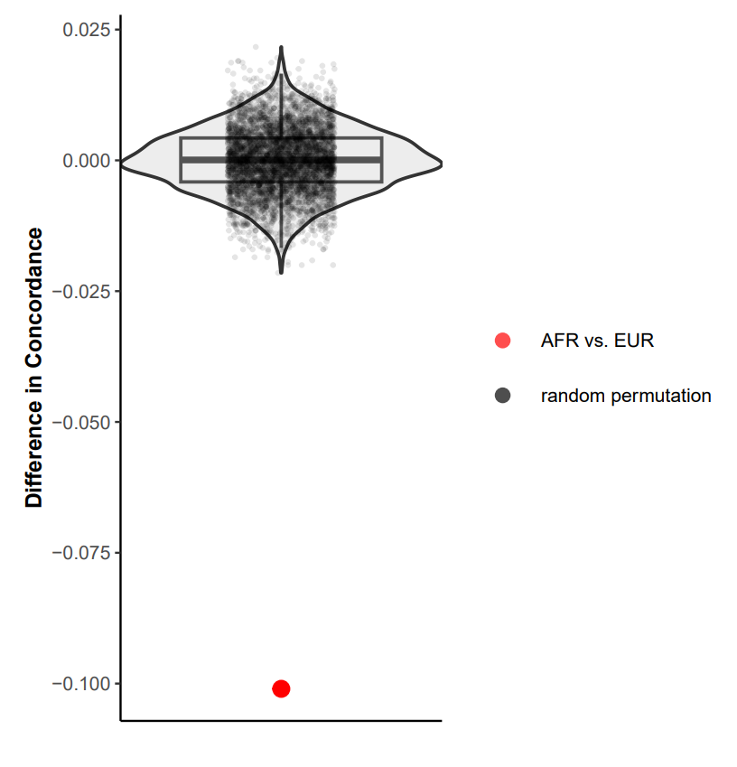
To estimate the distribution under the null hypothesis of this difference, we took the individuals from both populations and assigned them randomly the two population labels AFR and EUR, respecting the true group sizes, and computed the difference observed for n=5000 iterations. The red dot corresponds to the real difference observed.

Table S7. Two-sided permutation test of difference in concordance between each region.
region 1 | region 2 | p-value
EUR | AFR | p<0.0002
EUR | EAS | p<0.0002
EUR | SAS | p<0.0002
EUR | AMR | p<0.0002
AFR | EAS | p<0.0002
AFR | SAS | p<0.0002
AFR | AMR | p<0.0002
EAS | SAS | p<0.0002
EAS | AMR | 0.058
SAS | AMR | p<0.0002

The p-values were computed using a correction for continuity.

Table S8. Accuracy of star-allele callers with the GeT-RM consensus with and without recharacterizations from van der Maas et al³⁵, for diplotypes.
Overall concordance of star-allele callers with GeT-RM consensus for diplotypes
Tool | GeT-RM with recharacterizations (n=682) | GeT-RM without recharacterizations (n=672)
PharmCAT | 77.0% | 72.0%
UrsaPGx | 82.8% | 74.6%
PyPGx | 85.3% | 76.8%
Aldy | 85.6% | 81.2%

The total number of diplotype for each reference panel is indicated in parenthesis.

