Supplementary Material

Benchmark of star-allele caller algorithms to accurately assess haplotypes and phenotypes in pharmacogenetic studies
Marc B. Gros-La-Faige¹, Emmanuelle Génin^{1,2,*}, Anthony F. Herzig^{1,*}

¹Univ Brest, Inserm, EFS, UMR 1078, GGB, F-29200 Brest, France
²CHU Brest, Brest, France
*These authors contributed equally to this work

Figure S1. Accuracy of star-allele callers with the GeT-RM consensus for phenotypes.
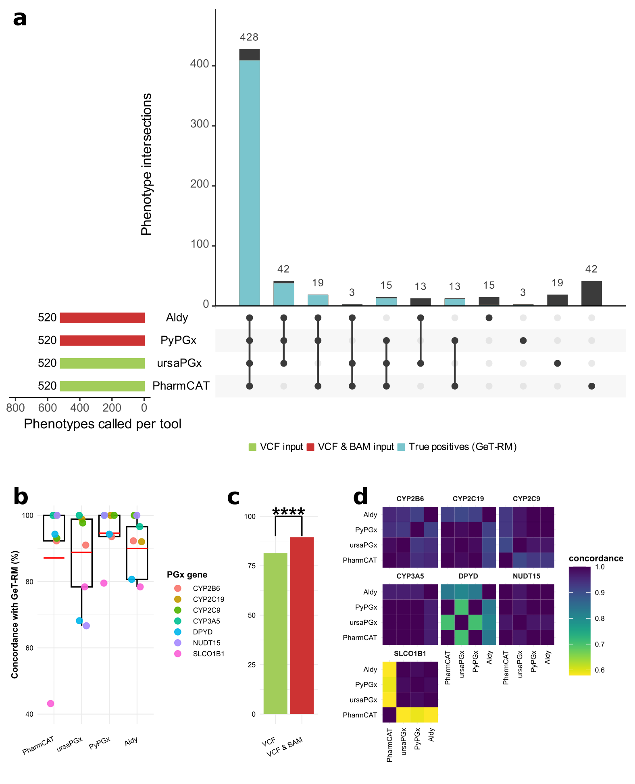
a: Upset plot of star-allele caller output for phenotypes (a). True positives (i.e concordant with GeT-RM consensus) are represented in blue, tools using VCF files only are represented in green and tools using VCF and BAM files are represented in red. b: Concordance of each pipeline with GeT-RM consensus for each gene for phenotypes. The average concordance is represented in red. c: Concordance of VCF-only pipelines (green) and VCF & BAM pipelines (red) with GeT-RM for phenotypes. One phenotype is considered concordant in one group if all the pipelines of the group are consistent with GeT-RM. A McNemar test is used to compare the accuracy of each group. d: Pairwise concordance between each pipeline for each gene for phenotypes.
Figure S2. Permutation test of the difference between concordance within African-ancestry individuals (AFR) and concordance within European-ancestry individuals (EUR) between the four pipelines for the nine genes observed.
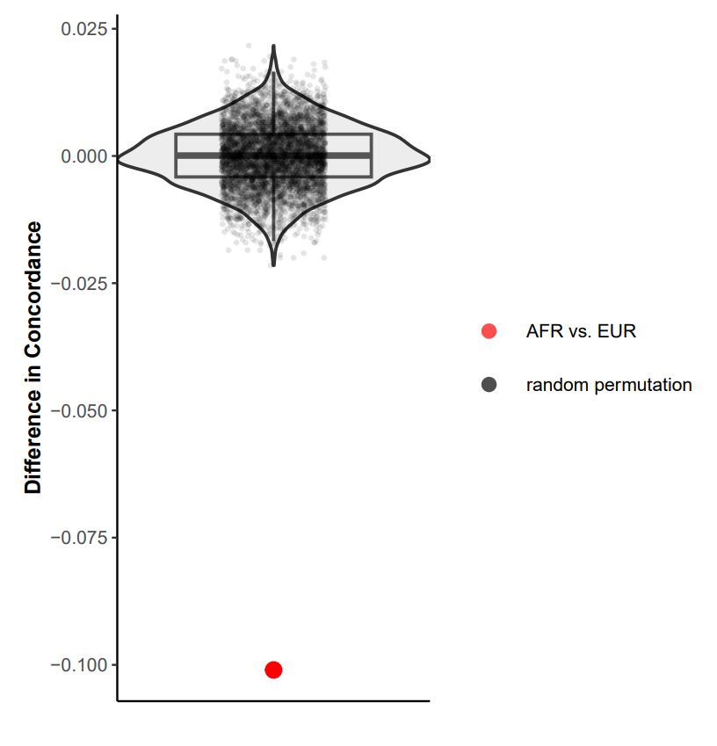
To estimate the distribution under the null hypothesis of this difference, we took the individuals from both populations and assigned them randomly the two population labels AFR and EUR, respecting the true group sizes, and computed the difference observed for n=5000 iterations. The red dot corresponds to the real difference observed.

