Supporting Information

Hierarchical Porous Aero-Cryogels for Wind Energy Enhanced Solar Vapor Generation

Shuai Liª, Xiaochun Yangª, Yingying Heª, Yanan Wangª, Daogui Liaoª, Yunhua Chen^{*b}, Huihong Xie^{*a}, Hongxia Liu^{*a}, Li Zhouª

ª Guangxi Key Laboratory of Optical and Electronic Materials and Devices, and College of Material Science & Engineering, Guilin University of Technology, Guilin 541004, China
^{b} School of Materials Science and Engineering, South China University of Technology, Guangzhou 510640, China

*Corresponding author
E-mail: yhchen0723@gmail.com (Y. Chen), huihong0917@foxmail.com (H. Xie), hliu28551@gmail.com (H. Liu)

1. Characterization
1.1. Measurement of equivalent evaporation enthalpy of water in SVGs
According to a previous study (Zhou, Zhao, Guo, Rosenberger, & Yu, 2019), a control experiment was designed to estimate the actual vaporization enthalpy. Water and A-CGs were simultaneously placed within the same evaporation area in a closed and insulated container. The humidity of the closed environment was kept constant by using silica gel. The actual evaporation enthalpy ($E_{aee}$) of the water in the A-CGs can be estimated as follows:
 | $$U_{in}=E_{0}m_{\text{0}}=E_{aee}m_{g}$$ | (S1)
where $U_{in}$ is the energy input; $E_{0}$ and $m_{0}$ are the evaporation enthalpy under atmospheric pressure (2260 J g⁻¹) and the mass change of water, respectively; $m_{g}$ is the mass change of the A-CGs.
1.2. Measurement of thermal conductivity
The thermal conductivity was measured at room temperature using an IR imaging method (Tao et al., 2018). A sample piece with a thickness of 3.0 mm was sandwiched between two 3.0-mm glasses. The sandwich structure was placed between a heating source and a cooling source, and the temperature at the three interfaces was monitored. The heat transfer rate (q) permeating the sample and the thermal conductivity of sample ($k$) were calculated using the Fourier Equation, as follows:
 | $$q=-k_{1}\frac{T_{2}-T_{1}}{d_{1}}=-k\frac{T_{3}-T_{2}}{d_{2}}$$ | (S2)
where $k_{1}$ is the thermal conductivity of glass (1.05 W m⁻¹ K⁻¹); $T_{1}$, $T_{2}$, $T_{3}$ are the average temperature at the interface between the heating source and the hot glass, the hot glass and the sample, and the cold glass and the sample, respectively; $d_{1}$ and $d_{2}$ (3.0 mm) are the thickness of the glass and sample, respectively.
1.3. Energy balance analysis during evaporation
Solar energy was used as the energy source in the evaporation process, and the input energy flux was 1 kw m⁻² when irradiated by 1 Sun of sunlight. There are five main strategies for energy consumption, as follows (Chen et al., 2019; Li et al., 2020; Xu et al., 2017): (1) water evaporation (${\text{η}}_{\text{th}}$), (2) reflection energy loss (${\text{η}}_{\text{ref}}$), (3) radiation (${\text{η}}_{\text{rad}}$) heat loss from the SVG to the environment, (4) convection (${\text{η}}_{\text{conv}}$) heat loss to the environment and (5) conductive (${\text{η}}_{\text{cond}}$) heat loss to the water.
1) The value of ${\text{η}}_{\text{th}}$ can be determined by Equation 2, as has been discussed in detail in this paper. The ${\text{η}}_{\text{th}}$ of A-CG and A-CG/F is 82.1% and 93.6%, respectively.
2) The ${\text{η}}_{\text{ref}}$ can be obtained using an ultraviolet-visible near-infrared spectrophotometer, and the refection loss is approximately 2%.
3) The${\text{η}}_{\text{rad}}$ was analyzed using the Stefan-Boltzmann Equation, as follows:
 | $$Q_{rad}\text{=}\text{ε}\text{A}σ({T_{1}}^{4}-{T_{2}}^{4})$$ | （S3）
where $Q_{rad}$ represents the heat flux, $\text{ε}$ is the emissive rate (the evaporator has a emissivity of 0.95, as determined by an IR camera), A is the evaporation surface area (approximately 10.17 cm² for A-CG, approximately 8 cm² for the A-CG/F top area, and approximately 10 cm² for the A-CG/F side area), σ is the Stefan-Boltzmann constant (5.670373×10⁻⁸ W m⁻² K⁻⁴), $T_{1}$ is the surface temperature of the SVG (308.25 K for the A-CG, 307.65 K for the A-CG/F top area, 302.15 K for the A-CG/F side area), and $T_{2}$ is the ambient temperature (299.15 K) in this experiment.
 | $${\text{η}}_{\text{rad}}\text{=}\frac{Q_{rad}}{P_{in}}$$ | （S4）
Therefore, based on Equation S3 and S4, the ${\text{η}}_{\text{rad}}$ of A-CG is approximately 5.5%. The ${\text{η}}_{\text{rad}}$ of A-CG/F is approximately 5.8%, including the top surface loss of approximately 4.1% and the side surface loss of approximately 1.7%.
4) The value of ${\text{η}}_{\text{conv}}$ can be calculated based on Newton’s law of cooling.
 | $$Q_{conv}\text{=}\text{h}\text{A}∆T$$ | （S5）
where $Q_{conv}$ is the heat energy, h denotes the convection heat transfer coefficient (approximately 5 W m⁻² K⁻¹) (Li et al., 2020); A represents the surface area; $∆T$ is the difference between the ambient temperature around the evaporator and the surface temperature of the evaporator. Therefore, based on Equation S5, the ${\text{η}}_{\text{conv}}$ value of A-CG is approximately 4.5%. The ${\text{η}}_{\text{conv}}$ of A-CG/F is approximately 5.7%, including the top surface loss of approximately 4.2% and the side surface loss of approximately 1.5%.
5) The heat flux of conduction $Q_{cond}$ can be calculated as follows:
 | $$Q_{cond}\text{=}cm∆T$$ | （S6）
where $Q_{cond}$ denotes the heat energy, $c$ is the specific heat capacity of pure water (4.2 kJ °C⁻¹ kg⁻¹), $m$ represents the weight of bulk water (40 g), and $∆T$ is the increased temperature of the bulk water after stable steam generation (2.5 °C for A-CG, 0.1 °C for A-CG/F). Therefore, the conduction heat loss of A-CG is approximately 11.4%, and the conduction heat loss of A-CG/F is approximately 0.5%.

2. Supplementary Table
Table S1. Cryogel formulation
Sample code | CMC aqueous dispersion (ml) | PANI solution (ml) | Water (ml) | GA (ml)
CG-0 | 12 | 0 | 1.15 | 0.3
CG-2 | 12 | 0.29 | 0.86 | 0.3
CG-5 | 12 | 0.72 | 0.43 | 0.3
CG-8 | 12 | 1.15 | 0 | 0.3

Table S2. Photothermal materials, substrate, working mechanism, energy source and evaporation rate of between our work and other reported SVGs
Photothermal materials | Substrate | SVG above the water surface | Supplemented energy | E. R.* | Ref
CNT* | CNF aerogel | No | No | 1.11 | (Jiang et al., 2018)
CNT | Carbon aerogel | No | No | 1.44 | (Mu et al., 2019)
PHS* | PVA* hydrogel* | No | No | 1.83 | (Tan, Wang, Song, Fang, & Zhang, 2019)
PANI | PEGDA* hydrogel | No | No | 1.40 | (Yin et al., 2018)
rGO* | PVA hydrogel | No | No | 2.50 | (Zhou, Zhao, Guo, Zhang, & Yu, 2018)
PPy | PVA/chitosan hydrogel | No | No | 3.6 | (Zhou et al., 2019)
PPy | PVDF* membrane | No | No | 0.92 | (Wang et al., 2018)
PPy | PVDF* membrane | Yes | No | 1.70 | (Wang et al., 2018)
PPy | Cotton fabric | No | No | 1.54 | (Xiao et al., 2019)
PPy | Cotton fabric | Yes | No | 3.37 | (Xiao et al., 2019)
CB* | PAN aerogel | No | No | 0.83 | (Chen et al., 2020)
CB* | PAN aerogel | Yes | No | 1.31 | (Chen et al., 2020)
CB | Cotton core | Yes | Heat | 1.62 | (Li et al., 2018)
CB | Bacterial Cellulose Aerogel | No | No | 0.84 | (Li et al., 2020)
CB | Bacterial Cellulose Aerogel | Yes | No | 1.82 | (Li et al., 2020)
CB | Bacterial Cellulose Aerogel | Yes | Wind (4 m/s) | 4.32 | (Li et al., 2020)
PANI | CMC hydrogel | No | No | 1.84 | This work
PANI | CMC hydrogel | Yes | No | 2.16 | This work
PANI | CMC hydrogel | Yes | Wind (3 m/s) Heat | 5.67 | This work
*Evaporation rate (E. R.), carbon nanotube (CNT), polymer hollow spheres (PHS), polyvinyl alcohol (PVA), hydrogel (cryogel completely swollen with water), poly(ethylene glycol) diacrylate (PEGDA), reduced graphene oxide (RGO), polyvinylidene fluoride (PVDF).

4. Supplementary figures
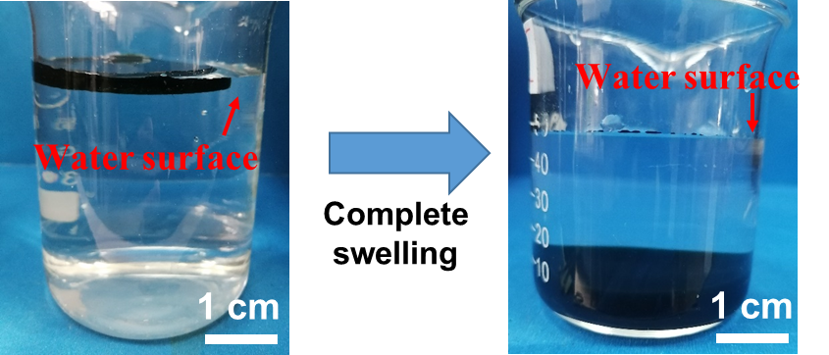
Fig. S1. Cryogel sinking after complete swelling

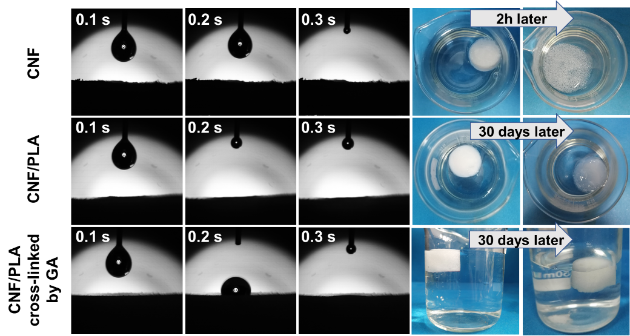
Fig. S2. The water contact angle of CNF aerogel, CNF/PLA aerogel, CNF/PLA aerogel cross-linked by GA and digital photos of aerogels soaked in water for different time

Fig. S3. Compressive stress-strain curves of aerogels
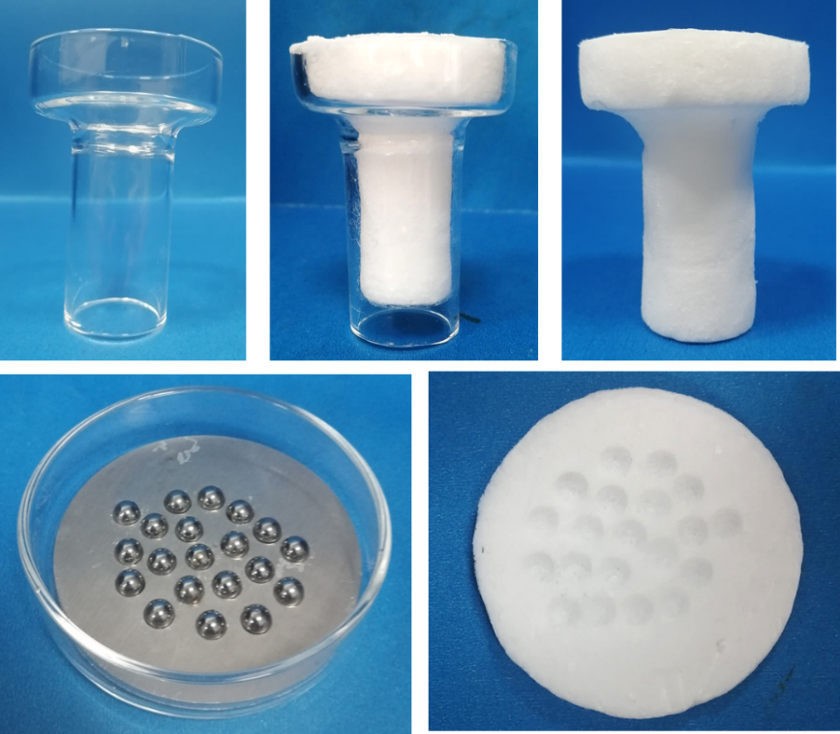
Fig. S4. Aerogels prepared by different molds

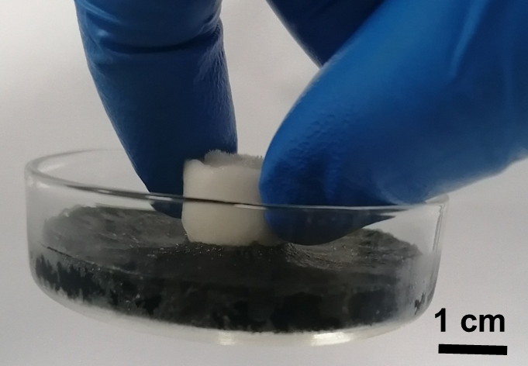
Fig. S5. The aerogel lifts the swollen cryogel and petri dish through strong interface bonding force.

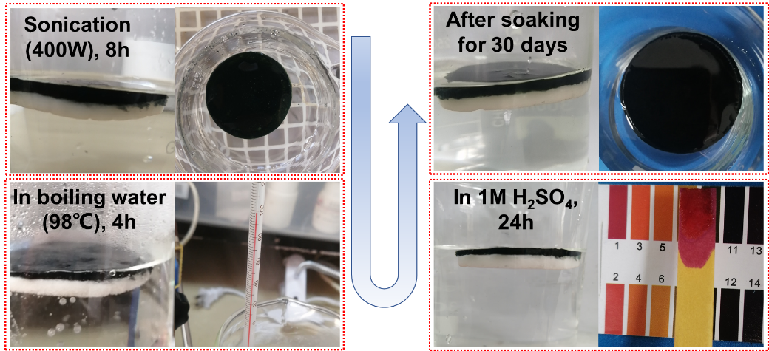
Fig. S6. Aero-cryogels in harsh conditions

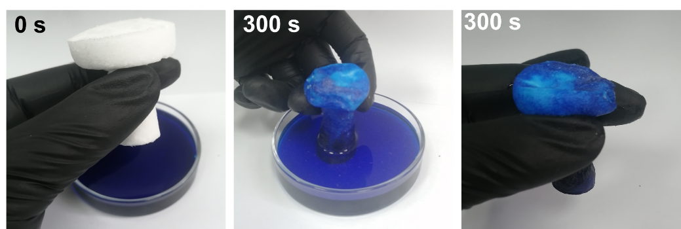
Fig. S7. Water diffusion in GA-crosslinked CNF/PLA aerogel

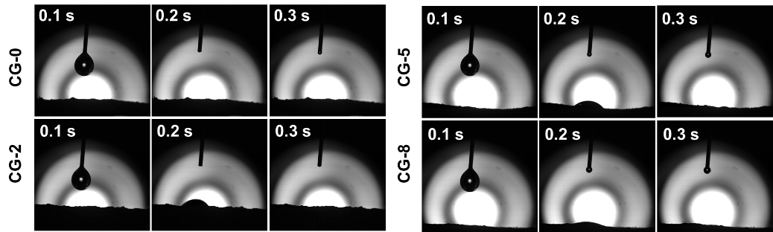
Fig. S8. The water contact angle of CGs

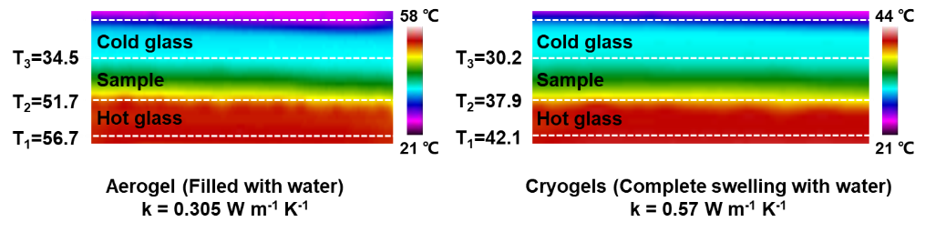
Fig. S9. Thermal conductivities of aerogel filled with water and swollen cryogels

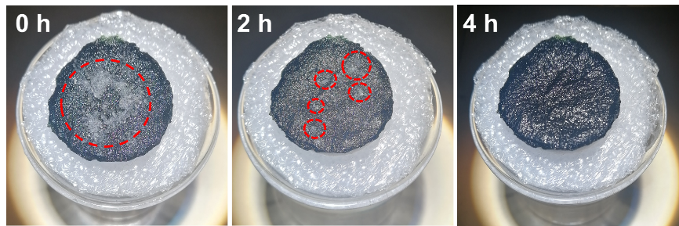
Fig. S10. A-CG/F with salt crystals and the salts were extracted to the 3.5 wt% NaCl solution

Fig. S11. A schematic diagram of an artificial optical device that simulates water evaporation measurement in a windy environment

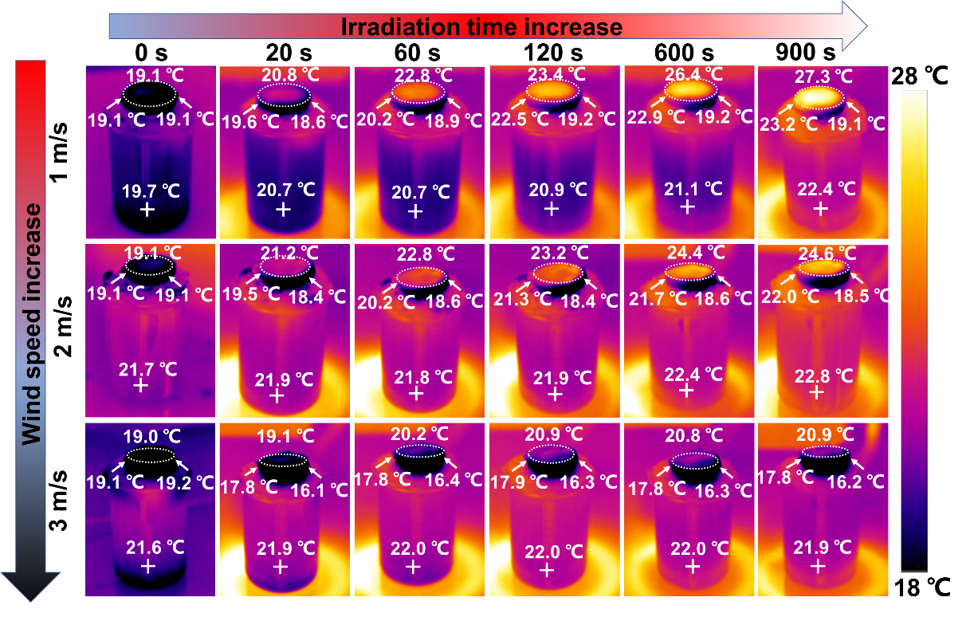
Fig. S12. Infrared thermal images showing temperature distribution of A-CG/F under irradiation of 1 Sun at different wind speeds for 900 s

References
Chen, G., Li, N., He, J., Qiao, L., Li, F., Wang, S., & Xu, X. (2020). Design of self-righting steam generators for solar-driven interfacial evaporation and self-powered water wave detection. Journal of Materials Chemistry A, 8(46), 24664-24674.
Chen, Y., Shi, Y., Kou, H., Liu, D., Huang, Y., Chen, Z., & Zhang, B. (2019). Self-Floating Carbonized Tissue Membrane Derived from Commercial Facial Tissue for Highly Efficient Solar Steam Generation. ACS Sustainable Chemistry & Engineering, 7(3), 2911-2915.
Jiang, F., Liu, H., Li, Y., Kuang, Y., Xu, X., Chen, C., & Hu, L. (2018). Lightweight, Mesoporous, and Highly Absorptive All-Nanofiber Aerogel for Efficient Solar Steam Generation. ACS Applied Materials & Interfaces, 10(1), 1104-1112.
Li, N., Qiao, L., He, J., Wang, S., Yu, L., Murto, P., & Xu, X. (2020). Solar‐Driven Interfacial Evaporation and Self‐Powered Water Wave Detection Based on an All‐Cellulose Monolithic Design. Advanced Functional Materials, 31(7), 2008681.
Li, X., Li, J., Lu, J., Xu, N., Chen, C., Min, X., & Zhu, J. (2018). Enhancement of Interfacial Solar Vapor Generation by Environmental Energy. Joule, 2(7), 1331-1338.
Mu, P., Zhang, Z., Bai, W., He, J., Sun, H., Zhu, Z., & Li, A. (2019). Superwetting Monolithic Hollow-Carbon-Nanotubes Aerogels with Hierarchically Nanoporous Structure for Efficient Solar Steam Generation. Advanced Energy Materials, 9(1), 1802158.
Tan, M., Wang, J., Song, W., Fang, J., & Zhang, X. (2019). Self-floating hybrid hydrogels assembled with conducting polymer hollow spheres and silica aerogel microparticles for solar steam generation. Journal of Materials Chemistry A, 7(3), 1244-1251.
Tao, P., Ni, G., Song, C., Shang, W., Wu, J., Zhu, J., & Deng, T. (2018). Solar-driven interfacial evaporation. Nature Energy, 3(12), 1031-1041.
Wang, Y., Wang, C., Song, X., Huang, M., Megarajan, S. K., Shaukat, S. F., & Jiang, H. (2018). Improved light-harvesting and thermal management for efficient solar-driven water evaporation using 3D photothermal cones. Journal of Materials Chemistry A, 6(21), 9874-9881.
Xiao, P., Gu, J., Zhang, C., Ni, F., Liang, Y., He, J., & Chen, T. (2019). A scalable, low-cost and robust photo-thermal fabric with tunable and programmable 2D/3D structures towards environmentally adaptable liquid/solid-medium water extraction. Nano Energy, 65, 104002.
Xu, N., Hu, X., Xu, W., Li, X., Zhou, L., Zhu, S., & Zhu, J. (2017). Mushrooms as Efficient Solar Steam-Generation Devices. Advanced Materials, 29 (28), 1606762.
Yin, X., Zhang, Y., Guo, Q., Cai, X., Xiao, J., Ding, Z., & Yang, J. (2018). Macroporous Double-Network Hydrogel for High-Efficiency Solar Steam Generation Under 1 sun Illumination. ACS Applied Materials & Interfaces, 10(13), 10998-11007.
Zhou, X., Zhao, F., Guo, Y., Rosenberger, B., & Yu, G. (2019). Architecting highly hydratable polymer networks to tune the water state for solar water purification. Science Advances, 5(6), eaaw5484.
Zhou, X., Zhao, F., Guo, Y., Zhang, Y., & Yu, G. (2018). A hydrogel-based antifouling solar evaporator for highly efficient water desalination. Energy & Environmental Science, 11(8), 1985-1992.

